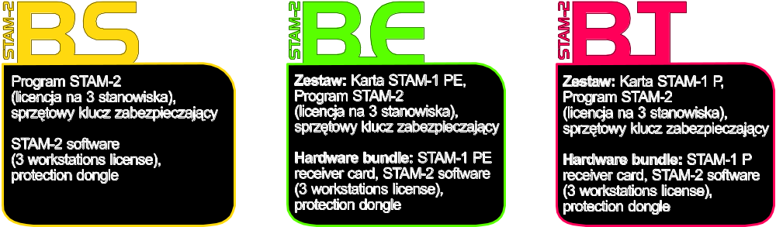

The dongle number,
required to register this software with the Manufacturer:

Minimum hardware requirements for the monitoring station server:
- computer with installed Microsoft Windows 2000 or Microsoft Windows XP operating system
- Pentium II 400 MHz processor
- 128 MB RAM
- CD-ROM
- free PCI slot
- free serial COM port
- free USB port
- monitor with 1024 x 768 resolution support

Minimum hardware requirements for the monitoring station client:
- computer with installed Microsoft Windows 98 SE, Microsoft Windows Millennium Edition (ME), Microsoft Windows 2000 or Microsoft Windows XP operating system (Microsoft Windows 2000 or Microsoft Windows XP recommended)
- Pentium II 400 MHz processor
- 128 MB RAM
- CD-ROM
- monitor with 1024 x 768 resolution support
- sound card

SATEL's goal is to continually improve the quality of its products, which may lead to alterations in their technical specifications and firmware. Current information on the introduced modifications is available on our website.
Please visit us:
http://www.satel.pl

CONTENTS
1. Monitoring station features 3
2. Card description 5
3. Addressing cards 7
4. Installing cards 8
5. Protection dongle 8
6. STAM-2 program installation 9
6.1 Installation of STAM-2 Server program 9
6.2 Installation of STAM-2 Client program 10
6.3 Updating STAM-2 program 12
6.4 Moving STAM-2 program 13
7. Operation and programming of STAM-2 monitoring station 13
7.1 First time run of client program 13
7.1.1 Client program installed on the same computer as server program 14
7.1.2 Client program installed on a computer different from that where server program is installed 14
7.2 Main window of STAM-2 Client program 15
Telephone receiver card 17
Ethernet receiver card 18
7.3 Server configuration 19
7.3.1 „Cards” tab 19
Automatically finding devices 21
Manually defining devices 21
Additional configuration of STAM-1 P, STAM-1 R and STAM-1 K cards 22
Additional configuration of STAM-1 PE and STAM-1 RE cards 22
„Ethernet settings” tab 22
„Reporting” tab 23
Additional configuration of GSM modules 24
7.3.2 „Information” tab 25
Changing TCP/IP port 25
7.3.3 „Actions” tab 26
Server 26
Client 26
7.3.4 „Options” tab 27
7.3.5 „Settings” tab 28
7.4 User accounts 34
7.4.1 Adding new user 36
7.4.2 Editing user 36
7.4.3 Deleting user 37
7.5 Changing password 37
7.6 Mimic boards 37
7.7 Subscribers 39
7.7.1 „Information” tab 40
7.7.2 „Find” tab 41
7.7.3 "Report" tab 42
7.7.4 Subscriber 43
„General” tab 43
„Plans” tab 44
„Identifiers” tab 46
Adding identifiers 47
Editing identifiers 47
„Definitions” Tab for „Contact ID” type of identifiers 47
„Definitions” Tab for „Normal” type of identifiers 49
„Definitions” Tab for „SIA” type of identifiers 50
„Partitions” tab 50
„GSM” tab 54
„Test transmissions” tab 55
„Ethernet” tab 56
„Video verification” tab 58
„Guardx” tab [only STAM-2 PRO] 59
„Nonstandard codes ” tab 60
7.8 Event handling windows 61
7.8.1 Window header 64
7.8.2 Subscriber's data 64
7.8.3 Tabs 65
7.8.4 Actions 67
7.8.5 Comment 67
7.8.6 Buttons 67
7.8.7 Video verification 68
7.9 Event log 69
7.9.1 Event menu 71
7.9.2 Event details 71
Event data 71
Subscriber data 72
Data on event handling method 72
7.9.3 Comments 73
New event 73
To event 74
7.9.4 Filter 74
7.9.5 Archiving events to file 76
7.9.6 Filters 77
Filter manager 77
7.9.7 Service 78
7.10 Status board 79
7.10.1 Find 81
7.10.2 Detailed information 82
7.11 Reports and documentation 83
7.11.1 „Subscriber” tab 83
7.11.2 „User” tab 86
7.11.3 „System” tab 87
7.12 Notes 88
7.12.1 Creating new note 88
8. License agreement 89

The STAM-2 is an advanced solution offered to the companies engaged in the business of monitoring signals derived from security alarm systems. It is available in two variants: basic – STAM-2 BASIC, and extended – STAM-2 PRO. This manual covers both variants of the program.
The STAM-2 monitoring station consists from cards installed in the computer, as well as software which enables management of the signals received by modules. It is possible to receive transmissions sent through telephone line, Ethernet (TCP/IP) or GSM (SMS and CLIP) networks. The STAM-2 program works in WINDOWS environment. It is a client-server type of application which enables incoming events to be handled by some operators on a number of workstations.
Note: Some features in the STAM-2 PRO program are only available, when the ETHM-1 module is connected to the alarm control panel.
If the STAM-2 program version 1.5 or later is to handle events received by the GSM module:
- GSM-4 module must have firmware version 4.11 of 13.05.2009 or later,
- GSM LT-1 module must have firmware version 1.11 of 13.05.2009 or later,
- GSM LT-2 module must have firmware version 2.11 of 13.05.2009 or later,
- "Fax/modem" option must be enabled in the module,
- speed of data transmission through the RS-232 port must be set at 19 200 bps in the module.

Monitoring station features
- easy-to-install cards
- optional expansion of the station by adding more cards
- receiving transmissions sent via telephone line, Ethernet (TCP/IP) network or GSM (SMS, CLIP) network
- detecting telephone line defect (telephone receiver cards), no network cable or communication with Ethernet module (Ethernet receiver cards)
- compatible with:
- GSM-4 and GSM LT-1 / 2 modules (manufactured by SATEL)
- VISONIC RC-4000, VIRGO and MESSER radio stations
- modem
- automatic recognition of one of the following transmission formats:
- Silent Knight, Ademco slow (10 BPS)
- Sescoa, Franklin, DCI, Vertex (20 BPS)
- Silent Knight fast
- Radionics 1400 Hz
- Radionics 2300 Hz
- Radionics with parity 1400 Hz
- Radionics with parity 2300 Hz
- Ademco Express
- Silent Knight, Ademco slow - extended
- Sescoa, Franklin, DCI, Vertex - extended
- Silent Knight fast - extended
- Radionics 1400 Hz - extended
- Radionics 2300 Hz - extended
- Contact ID (CID)
- SIA (telephone cards version 3.00 and higher; Ethernet cards version 3.01 and higher)
- user friendly STAM-2 software, working in WINDOWS environment
- client-server type of application which enables incoming events to be handled by several operators on a number of workstations
- option of smart distribution of events between the workstations
- option to display event handling window at all workstations simultaneously
- capability to handle events repeatedly
- encrypted client-server communication
- monitoring station data stored in an encrypted database file
- defining the program user authority levels
- simplified work of the monitoring station program operator:
- selection of intervention requiring events
- list of program user required actions
- storing program user reactions in memory
- reminder of unhandled events
- saving major operations of the system users into event log
- reporting situations which require intervention:
- alarm
- trouble (including lack of test transmission or transmission at wrong time)
- check for site status correctness (armed, disarmed)
- status overviews of supervised sites:
- alarm reporting systems
- trouble reporting systems – possible verification of troubles occurring in the system
- armed systems – in case of bigger sites: a list of armed partitions
- status of communication with the systems
- cyclic saving of data copy
- capability to create auxiliary database, in parallel with the backup copy
- capability to use the STAM-VIEW interface
- interaction with GuardX INTEGRA alarm system administrator and user program – version 1.08.001 of 15.02.2011 or newer [only STAM-2 PRO]
- capability to connect the video alarm verification unit
- remote control of the site status using the virtual keypad [only STAM-2 PRO]
- capability of creating detailed site plans [only STAM-2 PRO]
- capability to use a map for presentation of the site status [only STAM-2 PRO]
- handling subscribers in simple mode (no control of communication with the subscriber) or extended mode (with control of communication with the subscriber)
- detailed subscribers' data:
- up to a dozen or so identifiers of different types
- any number of information drawings (JPG or PNG files)
- decode tables (each code meaning and event description)
- priority differentiation – order of reporting events which require intervention when events are incoming simultaneously from many subscribers
- patterns of action in case of events which require intervention in partition – up to 5 items
- extended event filtering
- management of event filters
- defining the actions needed to handle events
- option to add comments to the actions
- extended event handling menu
- capability of fast event handling
- archiving events, also to an external file
- system of notes:
- information exchange between users
- defined validity period
- automatic display option
- printing documentation regarding subscribers, reports for subscribers, reports on program users and station system in PDF format
- capability of archiving reports
- selection of language version for STAM-2 Server and STAM-2 Client program

Card description
The card is a complete receiver of data sent by the control panels which enables a supervision center to be organized for monitoring the security system status. It can be installed on board of any PC computer (PCI slot), deriving only +12V power supply and RESET signal from the computer. It is capable of working without the computer, if power supply of approx. +12...15V is provided. The RESET signal is only necessary for operation with the use of computer.
SATEL offers the following cards:
STAM-1 P – base telephone receiver card (available in STAM-2 BT bundle);
STAM-1 R – expansion telephone receiver card;
STAM-1 K – expansion telephone termination receiver card for connecting mimic boards;
STAM-1 PE – base Ethernet receiver card (available in STAM-2 BE bundle);
STAM-1 RE – expansion Ethernet receiver card;
Each telephone receiver card means that it is possible to connect the telephone line, i.e. assign 1 telephone number to the monitoring station. Also, connecting the GSM module to the COM port of the computer denotes that 1 additional telephone number (SMS/CLIP) is assigned to the station. Each Ethernet receiver card means that it is possible to assign 1 IP address to the monitoring station.
The card selection depends on what method of data transmission is used. The cards can be connected with each other, which enables the monitoring station to support different transmission methods and increase the number of telephone lines / IP addresses. The STAM-2 monitoring station may comprise up to 16 interconnected cards (base receiver card + 15 expansion receiver cards of various types). Also, when GSM modules are connected to the computer COM ports, the total number of supported cards and GSM modules is 16.
The STAM-1 K card accepts the STAM-1 PTSA mimic boards which enable visualization of the status of monitored sites by means of LED indicators. One mimic board makes it possible to visualize the status of 64 objects. Additional mimic boards must be used for a greater number of objects. Altogether, 63 mimic boards can be used for 1 monitoring station, which means 4032 visualized objects.

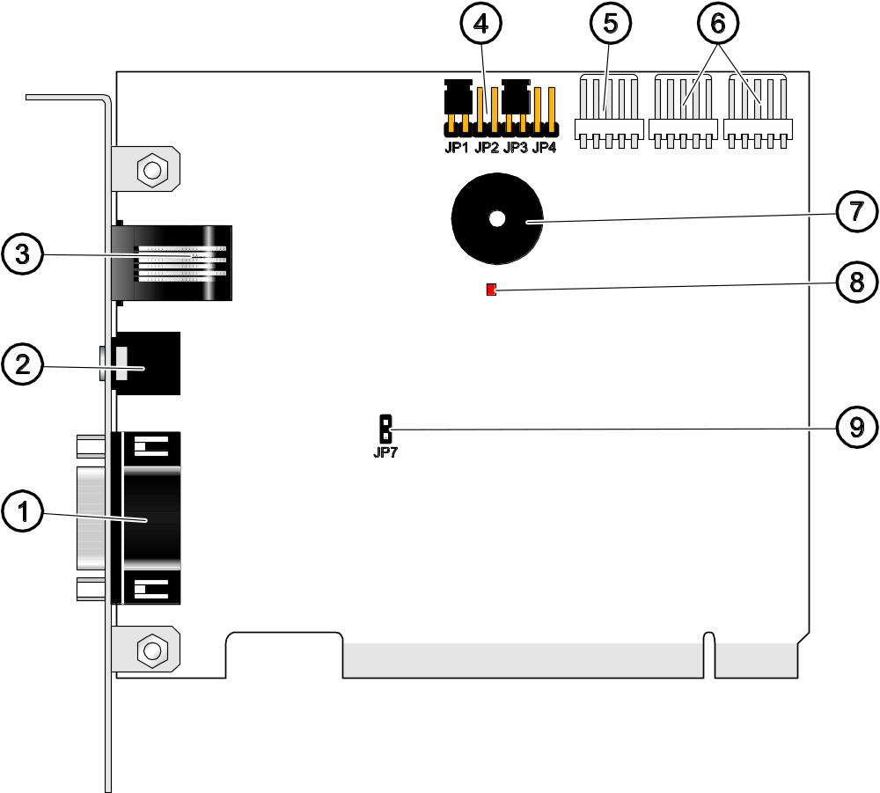
Fig. 1. View of STAM-1 P card. STAM-1 R card has no DB-9 connector (shown in the drawing by digit 1). STAM-1 K card includes a DB-9 connector, which is used to connect the mimic board.

Explanations for Fig. 1:
1 – DB-9 male connector (RS-232 port) which enables the card to be connected to the computer COM port.
2 – headset mini-jack socket to enable telephone line eavesdropping by means of high-resistance loudspeaker or headset.
3 – RJ-11 socket for connecting telephone line.
4 – card address setting pins (see: Addressing cards).
5 – connector for additional control signaling.
6 – connectors for expansion receiver cards (RS-232 and sound for telephone receiver cards).
7 – buzzer.
8 – LED indicator. Lit during connection.
9 – pins to enable/disable telephone line eavesdropping.

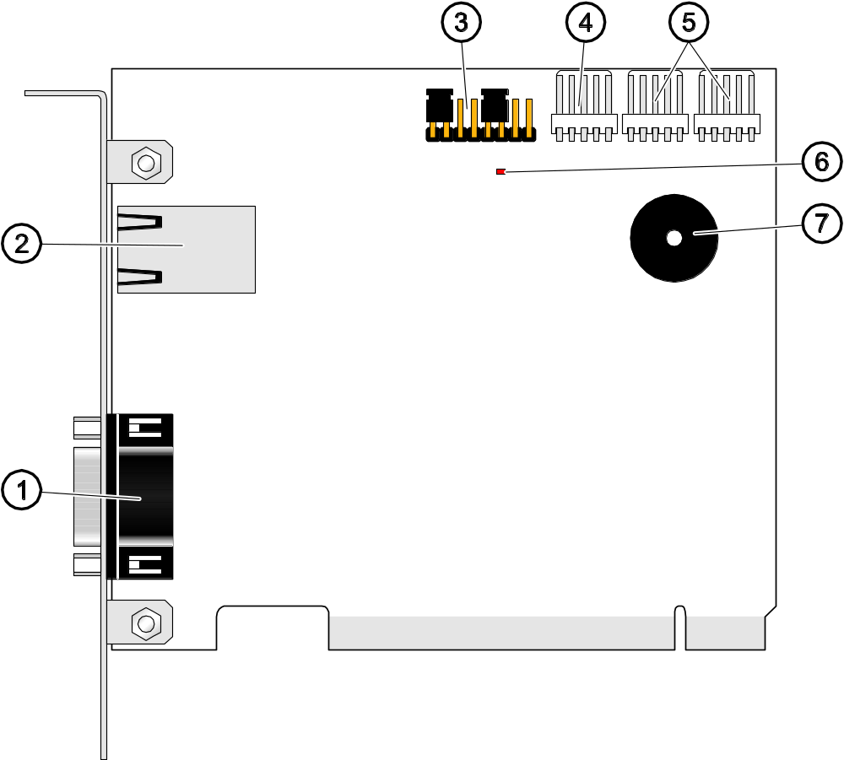
Fig. 2. View of STAM-1 PE card. STAM-1 RE card has no DB-9 connector to connect to the computer COM port (indicated in the drawing by digit 1).

Explanations for Fig. 2:
1 – DB-9 male connector (RS-232 port) which enables the card to be connected to the computer COM port.
2 – RJ-45 socket for connecting the Ethernet network. The socket incorporates two LEDs. The green one indicates network connection and transmission, and the yellow one - network transmission rate (OFF: 10Mb / ON: 100Mb).
3 – card address setting pins (see: Addressing cards).
4 – connector for additional control signaling.
5 – connectors for expansion receiver cards (RS-232 and sound for telephone receiver cards).
6 – LED indicator.
7 – buzzer.

Addressing cards
An individual address must be set for each installed card. The addresses may not be used repeatedly. To set an address, use the pins (see Figures 1 and 2). The pin pairs are designated JP1, JP2, JP3 and JP4. Addressing is carried out by means of jumpers placed on the pins. The pins allow setting addresses from 0 to 15 (in hexadecimal mode: from 0 to F). In order to determine the address of a card, add up the values set on consecutive pin pairs, according to Table 1.

Pin pair | JP1 | JP2 | JP3 | JP4
Numerical value  (after setting the jumper) | 1 | 2 | 4 | 8
Table 1.

Installing cards

Prior to installation of a card in the computer, disconnect the computer from the source of power supply.
The STAM-1 PE (Ethernet receiver base card) and STAM-1 RE (Ethernet receiver expansion card) are dedicated devices designed for work in the local computer networks (LAN). They cannot be connected directly to the public computer networks (MAN, WAN). Connection to the public networks should be effected via a router or xDSL modem.
In order to install the STAM-1 P or STAM-1 PE card in the computer:
- Set the card address (see: Addressing cards).
- Open the computer case.
- Install the card in PCI slot.
- Close the computer case.
- Using the cable included in the bundle, connect the card DB-9 connector to the computer serial COM port.
- Connect the telephone line (STAM-1 P card) or network cable (STAM-1 PE card) to the card socket.
In order to install the STAM-1 R, STAM-1 K or STAM-1 RE extension card in the computer:
- Set the card address (see: Addressing cards).
- Open the computer case.
- Install the card in PCI slot.
- Using the cable delivered with the expansion card, connect the card to the base receiver card or another expansion card.
- Close the computer case.
- Connect the telephone line (STAM-1 R and STAM-1 K cards) or network cable (STAM-1 RE card), or, optionally, the mimic board (STAM-1 K card) to the extension card.
If the card is to be installed outside the computer, proceed in the same way as described above, skipping the steps which refer to installation of the card in computer PCI slot.

Protection dongle
Installation of the STAM-2 server program is impossible without the protection dongle (hardware key). Having installed the server program, leave the dongle in the USB port. If the dongle is removed for more than 30 minutes, it will be unregistered and functionality of the monitoring station will be limited. Such functions as editing subscribers and users accounts, creating reports and configuring the server will be unavailable. 2 weeks after unregistering the dongle, the monitoring station program will stop working.
If your dongle gets damaged, please contact the SATEL Company. Replacement is possible after you return the damaged dongle and pay a small handling charge.
The SATEL Company shall not be held responsible for lost or stolen dongles. If you loose your dongle, you must be prepared for high costs connected with delivery of a new one.

STAM-2 program installation
Insert the CD with installation program into the CD-ROM drive. The welcome screen should appear in a while. Click on the command of chosen program installation and follow the instructions.
If the splash screen fails to appear after the disk is inserted into the CD-ROM drive, the autostart function of your CD-ROM must have been disabled. If this is the case, click twice on the „My computer” icon and, after the resource window opens, on the CD-ROM icon. There is the SetupStam2.exe file on the installation disk. Open it, e.g. by clicking on it twice, to bring up the splash screen.

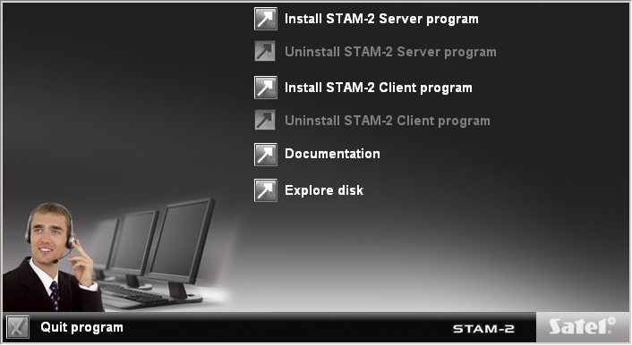
Fig. 3. Welcome screen of the installation package.

Installation of STAM-2 Server program
The server program should be installed on a computer to the serial COM port of which the STAM-1 P or STAM-1 PE card is connected. If the server program finds no STAM-1 P or STAM-1 PE card within a few minutes after being started, it will be terminated.
To begin installation, click on the „Install STAM-2 server program” command. During installation, the protection dongle must be inserted into the computer USB port.
At installation stage, the users of STAM-1 monitoring station can import data from the program. To do so, you must select the option „I have STAM-1 installed and want to import data from it” (see Fig. 4), and then indicate the folder where the STAM-1 program is installed.

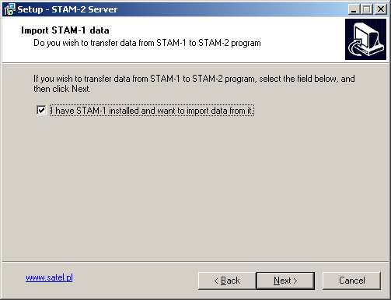
Fig. 4. Importing STAM-1 program data.

Note: The database of STAM-1 monitoring station can only be imported during installation.
The STAM-2 monitoring station needs to be registered within 31 days of the server program installation. After expiry of this period, the server program will stop working. The server installer program offers optional registration at the end of installation procedure. Registration is also possible at a later date on the website www.stam2.satel.pl or by using the form included in the bundle. When filled in, the form should be sent by fax to the number (+48) 58 320 94 01. After registration, SATEL will send a license file to the e-mail address, or to the mailing address (in case of regular postal mail). Installation of the license file will enable the server program to be used without any time limitations.

Installation of STAM-2 Client program
Installation of the client program is possible on the same computer on which the server program has been installed. In addition, it may be installed on any number of workstations, however the server program can support up to 3 or up to 10 clients, depending on the license held.

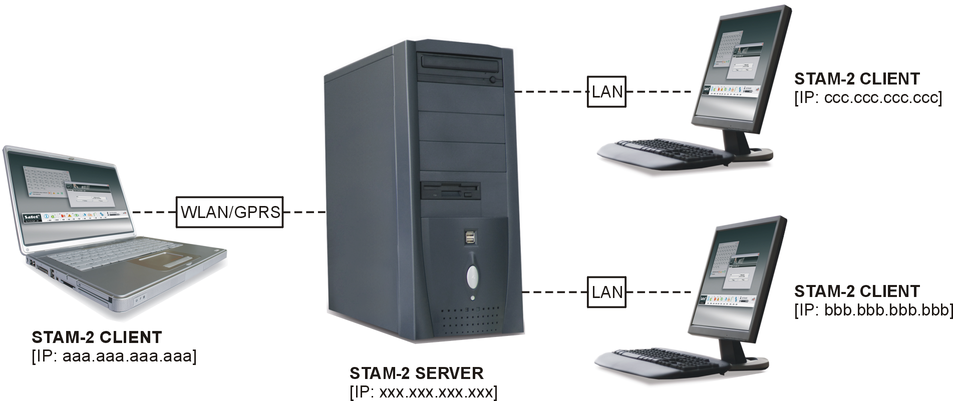
Fig.5. Example of configuration of the STAM-2 monitoring station.

To begin installation, click on the „Install STAM-2 client program” command. The Java Virtual Machine is required for the client program to be operable, therefore it must be installed. The "jre-6u25-windows-i586.exe" installation file can be found on the provided CD in the "java" folder. Double click on the file to start the installation. You can also download the latest version of the Java Virtual Machine from www.java.com/pl/download/.

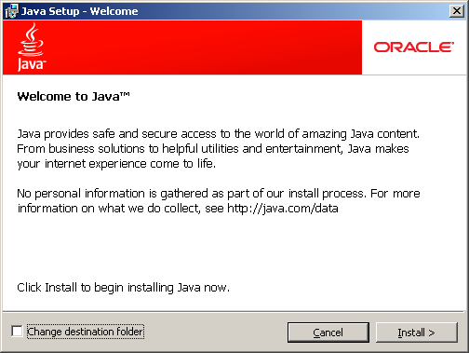
Fig. 6. Installation of Java Virtual Machine.

Installation of the Java Virtual Machine will begin after you click on the "Install" button (see: Fig 6). A window will appear showing the installation progress (see Fig. 7).

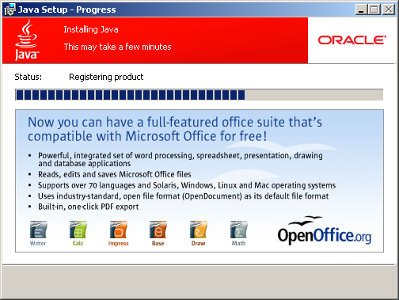
Fig. 7. Progress of installation type of Java Virtual Machine.

After the installation is finished, a window with suitable message will appear (see Fig. 8).

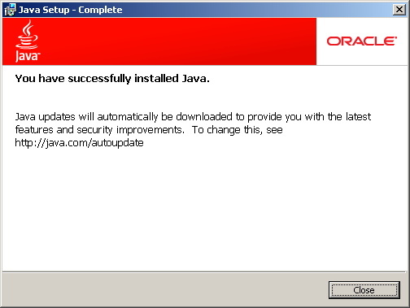
Fig. 8. Installation of Java Virtual Machine completed successfully.

Updating STAM-2 program
In order to update the STAM-2 program, do the following:
- Start the STAM-2 program and check the versions of STAM-2 Server and STAM 2 Client programs, as well as the versions of connected devices. Close the program.
- Download the latest versions of the STAM-2 program and the updating program for phone / Ethernet receiver cards and GSM modules from the www.satel.eu website, and save them to disk.
- In case of any trouble, prepare a backup copy to guarantee data recovery. Copy the "Client" and "Server" folders (including their contents) to a safe place. The default access path is C:\Program Files\Satel\STAM-2.
- Disconnect the telephone lines (for STAM-1 P, STAM-1 R and STAM-1 K cards) and the network cables (for STAM-1 PE and STAM-1 RE cards) from the card slots, so that the monitoring station should not receive any events during the update process.
- Update the firmware of telephone cards, Ethernet cards and GSM modules.
- Reconnect the telephone lines and network cables to the appropriate card slots.
- Start the installation of a new version of the program and follow the instructions. The new version will replace the existing one.
- Run the installed version of STAM-2 program.

Moving STAM-2 program
In the event of transfer of the STAM-2 program from one computer to another, follow these steps:
- Create the "Satel" folder on the new computer, C drive, "Program Files" folder, and then create the "STAM-2" folder in it (C:\Program Files\Satel\STAM-2).
- Copy the "Client" and "Server" folders, including its contents, from the old computer (default access path: C:\Program Files\Satel\STAM-2) and paste them into the created STAM-2 folder.
- Manually create shortcuts to the STAM-2 program on the desktop and in the Start Menu, or install the STAM-2 program, replacing the old version with the new one.
Note: When moving the data, be sure to create appropriate folders for the database backup copy and the auxiliary database on the new computer.

Operation and programming of STAM-2 monitoring station
The STAM-2 server program works as an ordinary application and starts after logging into the system.
You can terminate the server program manually and then restart it. In order to terminate the server program manually, you must:
- Hover the cursor over the server icon displayed on the system taskbar.
- Press the right mouse button – a menu will appear.
- Highlight the „Exit” item and press the left mouse button.
- A window will be displayed. Enter your login and password in the window and then press the „OK” button.
Configuration of the STAM-2 server and operation of the monitoring station can be effected by means of the STAM-2 Client program.

First time run of client program
After starting the STAM-2 Client program, the login window will open (see Fig. 9).
As the program is case-sensitive, make sure when logging in, that the Caps Lock has not been accidentally activated.
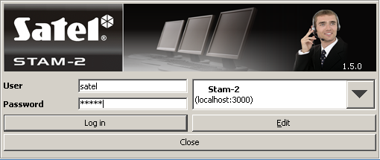
Fig. 9. STAM-2 program login window.

Client program installed on the same computer as server program
In order to log in, enter „satel” as the default password and click on the „Log in” button.

Client program installed on a computer different from that where server program is installed
Before you log in, it is necessary to define the server parameters (address and TCP/IP port of the computer where the STAM-2 server program is installed). For this purpose, click your mouse on the „Edit” button. The „Servers” window will open, displaying the list of defined servers. You can define any number of servers for the client program to work with. By default, the „Stam-2” server is defined (see Fig. 10).

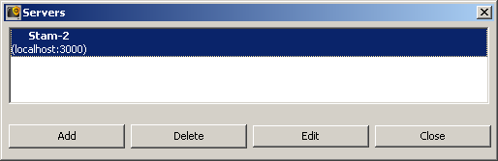
Fig. 10. „Servers” window on first-time run of the program.

Default parameters of the „Stam-2” server allow the user to log in when the STAM-2 Client program is run on the same computer as the STAM-2 Server program. You can edit the server settings (see Fig. 11) after clicking on the „Edit” button, or add a new server after clicking on the „Add” button.
Having defined the server parameters, you can return to the login window. If the name of required server with which you want to communicate is not shown, click on the arrow at the server name. A dropdown list will appear, from which you should select the server the client program is to work with. If the name of required server is shown, enter the default password „satel” and click on the „Log in” button.

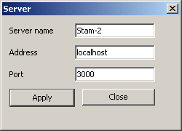
Fig. 11. „Server” window defining parameters of the server with which the client program is to work.

Main window of STAM-2 Client program
After login procedure, the main window of the program will open (see Fig. 12).

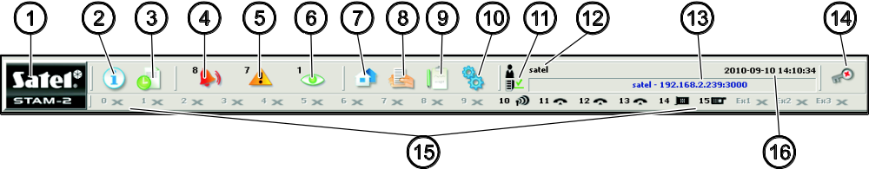
Fig. 12. Main window of STAM-2 Client program
Explanations for Fig. 12:

1
   | Click on the icon to open a window with information on the STAM-2 program and SATEL Company, manufacturer of the program.
2
   | Status board (Alt+T) – Click on the icon (or press Alt+T) to open a window where the status of supervised sites can be checked (alarms, troubles, arm statuses, test transmissions). The window is available to all users.
3
   | Event log (Alt+H) – Click on the icon (or press Alt+H) to open the event log window. The window is available to users with the „viewing” authority level.
4
   | Handle alarms (Alt+1) – The icon is active when there are unhandled alarms. The number at the icon shows how many alarms are still unhandled by the user. Click on the icon (or press Alt+1) to open the "Alarm" tab (unhandled alarms) in the "Event log" window. Available to users with the „handling” authority level.
5
   | Handle troubles (Alt+2) – The icon is active when there are unhandled troubles. The number at the icon shows how many troubles are still unhandled by the user. Click on the icon (or press Alt+2) to open the "Troubles" tab (unhandled troubles) in the "Event log" window. Available to users with the „handling” authority level.
6
   | Handle arm status events (Alt+3) – The icon is active when there are unhandled arm status events. The number at the icon shows how many arm status events are still unhandled by the user. Click on the icon (or press Alt+3) to open the "Wrong arm status" tab (unhandled arm status events) in the "Event log" window. Available to users with the „handling” authority level.
7
   | Subscribers (Alt+A) – Click on the icon (or press Alt+A) to open the window where you can, depending on your authority level, view the list of current subscribers, edit the current subscribers, add new subscribers or remove the existing ones. The window is available to all users.
8
   | Reports and documentation (Alt+R) – Click on the icon (or press Alt+R) to open the window where you can print documentation regarding subscribers, subscriber's reports, reports on program users and station system in PDF format. The window is available to all users, but the scope of possible operations depends on the granted authority level.
9
  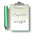 | Notes (Alt+N) – Click on the icon (or press Alt+N) to open the window where you can view notes created by other users or prepare notes for other user. Available to all users.
10
   | Configuration (Alt+K) – Click on the icon (or press Alt+K) to open the menu with the following functions:  Configure server (Alt+K) – The function intended to define the cards and other devices (GSM modules, VISONIC RC-4000 radio stations) supported by the STAM-2 program server. Available to users with the „server configuration ” authority level.  User accounts (Alt+E) – The function makes it possible to view the list of program users, add new users, edit and/or remove the existing ones. Available to users with the „user accounts” authority level.  Change password (Alt+P) – The function allows the currently logged in user to change the code of access to the STAM-2 program. Available to all users. It is recommended that each new user change his/her password so that the supervisor may not know the user password.  Mimic boards (Alt+S) – The function makes it possible to define the lighting mode of LEDs in the mimic boards interfacing with the monitoring station. Available to users with the „mimic boards” authority level.
11
  Client to Server communication status. The icons which may appear here have the following meaning:
  – communication OK
  – communication interrupted
12 | User currently logged in
13 | Data of monitoring station server.
14
   | Click on the icon (or press Alt+X) to open the menu with the following commands:  Help – opening the "Stam-2 Help" window.  Log out user (Alt+L) – after the current user has logged out, a next one can log in.  Minimize (Alt+M) – minimizing the main window of the STAM-2 Client program.  Close (Alt+X) – closing the STAM-2 Client program.
15 | The icons illustrate the devices supported by the monitoring station: telephone / Ethernet receiver cards, radio stations, modems and GSM modules supported by the STAM-2 program server. They can be designated with numbers from 0 to 15 and symbols Ex1, Ex2 and Ex3 (the symbols are only used to designate radio stations, modems and GSM modules). These characters correspond to the address of server supported card or device. The icons have the following meaning:  - telephone card is working properly  - telephone card is receiving ring signal or is being configured  - telephone card has established connection with control panel  - telephone card is receiving data  - no telephone card, or trouble (to check the trouble details, refer to the „Event log” window)  - GSM module is working properly  - GSM module is receiving data (SMS or CLIP type message)  - no GSM module, or trouble (to check the trouble details, refer to the „Event log” window)  - Ethernet card is working properly  - Ethernet card is being configured  - no Ethernet card, or trouble (to check the trouble details, refer to the „Event log” window)  - – radio station is working properly  – no radio station or trouble (for details of the trouble, check the "Event log" window)  Click on the icon of card / station / module to open a window with information on the particular device, the port to which it is connected and its current status. In the event of connected GSM module, the level of signal received by GSM antenna is also displayed.  A grayed out icon means that no card / device has been defined for the given address.  Telephone receiver card  A list of 10 recently received calls is displayed in the window. The list includes the date and time of the call, consecutive number of call on that day and the phone number from which the call was made. Additionally, the "Off-hook" or "On-hook" button is available, depending on whether the receiver card is connected or disconnected. Click on the "Off-hook" button to test the telephone line for correctness, and also to answer the call. Click on the "On-hook" button to end the connection test or to terminate the connection.  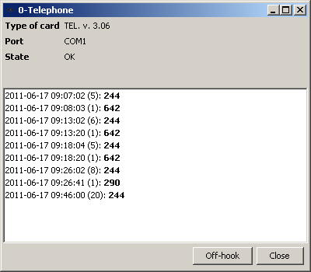  Fig. 13. Window of telephone receiver card with address 0.  Ethernet receiver card  The window will display information on the card – its IP, MAC address, data on the event log and whether the card is configured or not. If the card is currently being configured, it displays a progress indicator for settings, including configuration, subscribers and MAC, as well as information about memory, additional card troubles or error during configuration.  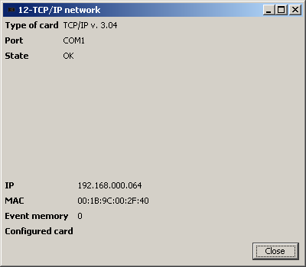  Fig. 14. Window of Ethernet card, address 12.
16 | Current date and time.

Server configuration
The first operation to be carried out after starting the monitoring station program for the first time and logging in, is configuration of the server. In order to configure the server, you must, first of all, define the devices that are to be supported by the monitoring station program. The „Cards” tab in the „Configuration” window is provided for this purpose.

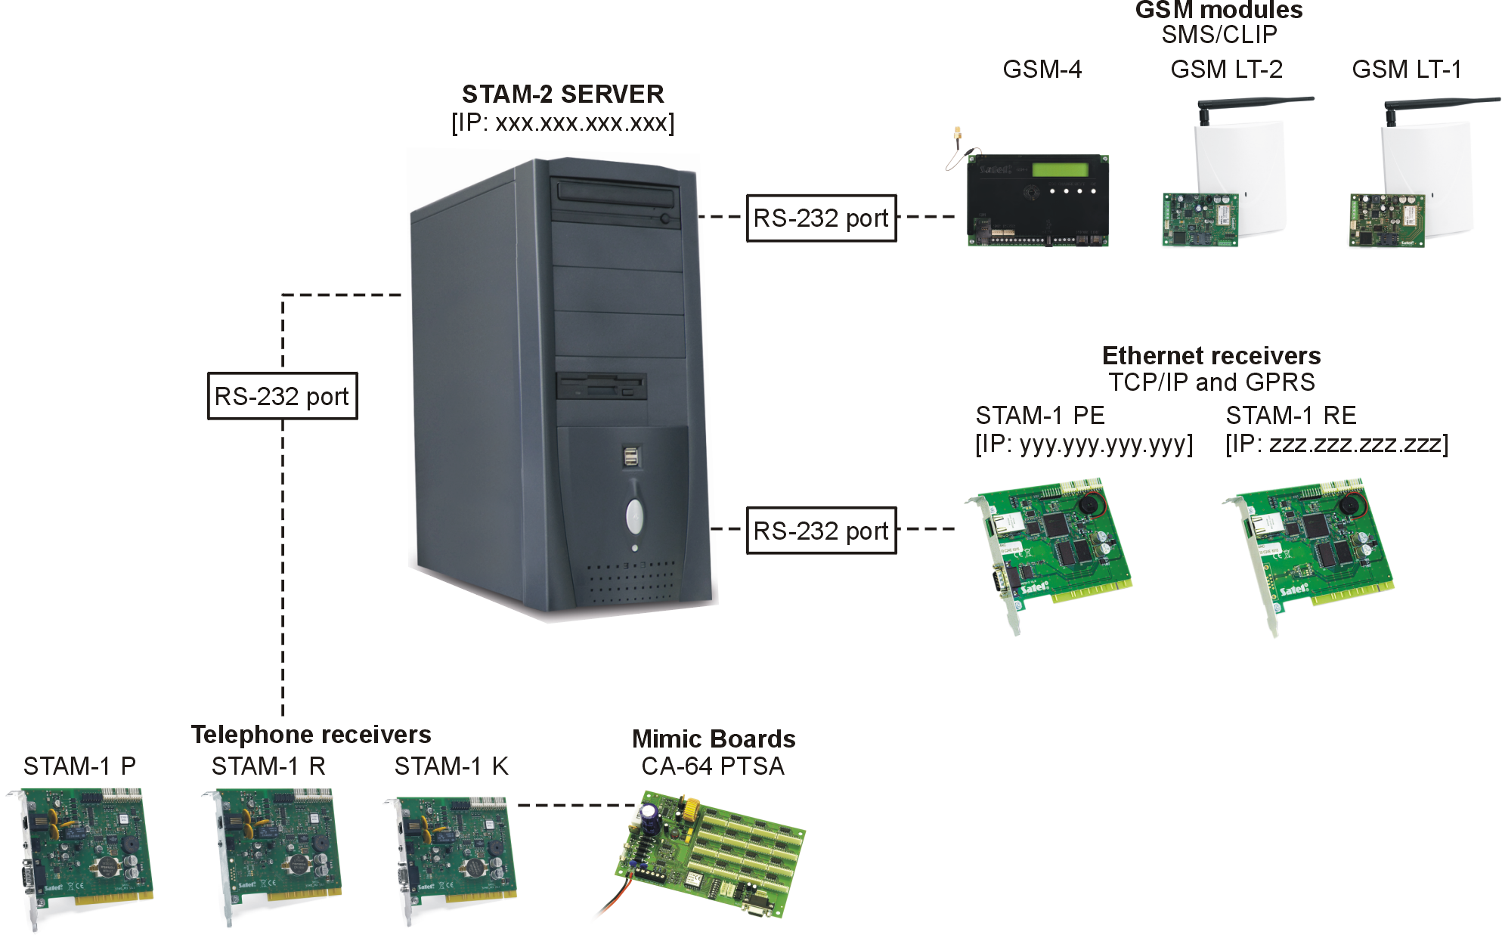
Fig.15. Devices supported by the STAM-2 Server (example).

„Cards” tab
Address – the address set in the card or assigned by default to another device (GSM module, VISONIC RC-4000, VIRGO, MESSER radio stations or modem). It is recommended that you only check boxes next to the addresses which are set in the connected cards, or to which other devices are to be assigned.
Port – the serial COM port of the computer to which the device supported by the monitoring station program is connected. Editing is possible when the adjacent „Address” box is checked.
Device – the type of device connected to the computer COM port (STAM-1 card, GSM module, VISONIC RC-4000, VIRGO or MESSER radio stations, modem). Editing is possible when the adjacent „Address” box is checked.
Buzzer – if this option is enabled and an event is received by the card, the card buzzer will generate an additional audible signal, irrespective of the sounds generated by the computer. The option only refers to the STAM-1 cards. Available after adding cards (automatically or manually).
Attempts – enter in this field the number of failed monitoring attempts which, if occur within the time period defined in the „Time” field, will result in registering the „Failed monitoring attempt” event. If the last monitoring attempt was made by means of the DTMF system and the control panel identifier has been sent, it will be shown at the event. If the preset number of failed monitoring attempts does not occur within the defined period of time, the time counter will be reset, and after another unsuccessful attempt, the time will be counted anew. Values from 0 to 255 minutes can be entered in the „Time” field. Entering 0 will disable control of the unsuccessful attempts to connect to the monitoring station. The option refers to the STAM-1 P, STAM-1 R and STAM-1 K cards. Editing is possible after cards have been added (automatically or manually).

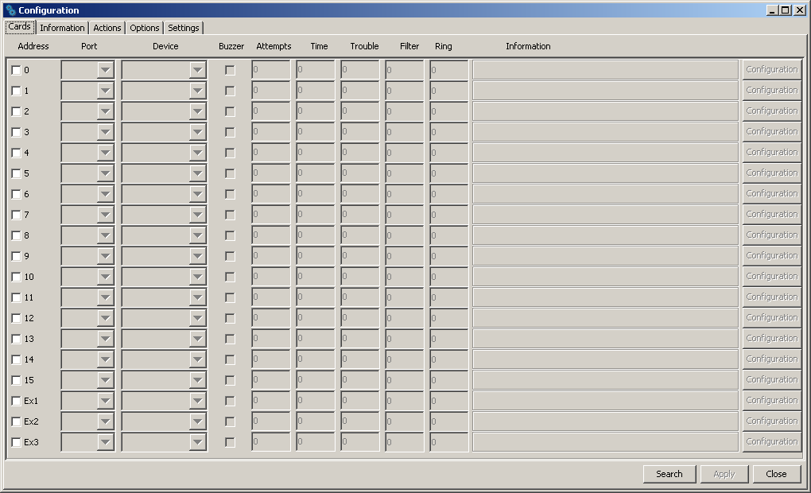
Fig. 16. „Cards” tab in „Configuration” window, before defining devices.

Time – enter in this field the maximum time interval counted from the unsuccessful attempt of the control panel to establish connection with the monitoring station (a ring was received, but no event was received). If more failed connection attempts occur during this time and reach the number defined in the „Attempts” field, the „Failed monitoring attempt” event will be registered. If the last monitoring attempt was made by means of the DTMF system and the control panel identifier has been sent, it will be shown at the event. If the preset number of failed monitoring attempts does not occur within the defined period of time, the time counter will be reset. After another unsuccessful attempt, the time will be counted anew. Values from 0 to 255 minutes can be entered in the „Time” field. Entering 0 will disable control of the unsuccessful attempts to connect to the monitoring station. The option refers to the STAM-1 P, STAM-1 R and STAM-1 K cards. Editing is possible after cards have been added (automatically or manually).
Trouble – enter in this field the maximum time period in minutes, during which the card may receive no events. After expiry of this time, the card trouble will be reported. Values from 0 to 65535 minutes can be entered in the „Trouble” field. Entering 0 will disable control of the events receiving by the card. The option only refers to the STAM-1 cards. Editing is possible after cards have been added (automatically or manually).
Filter – enter in this field the time of filtering the card events in seconds. If several identical events are received within the defined time period (i.e. events with the same identifier and code), only the first event will be added to the event log, the other ones being omitted. Values from 0 to 2550 seconds can be entered in the „Filter” field. Entering 0 will disable the event filtering. The option only refers to the STAM-1 cards. Editing is possible after cards have been added (automatically or manually).
Ring – indicate in this field the number of rings after which the telephone receiver card is to establish connection with the control panel – Off hook. You can enter numbers from 1 to 9. The option refers to the STAM-1 P, STAM-1 R and STAM-1 K cards. Editing is possible after cards have been added (automatically or manually).
Information – information on the type of receiver card with the given address (TEL – telephone, TCP/IP – ethernet) or another device assigned to that address (GSM – GSM module, VISONIC, VIRGO, MESSER – radio stations, MODEM – modem). Additionally, the firmware version of telephone / Ethernet receiver cards and GSM modules is shown. The information is displayed when the devices supported by the monitoring station program have been defined.
Configuration – the button available for STAM-1 P, STAM-1 R and STAM-1 K telephone receiver cards (version 3.00 or higher), the STAM-1 PE and STAM-1 RE Ethernet cards and the GSM modules. Press it to open a window of extra settings (see: Additional configuration of STAM-1 P, STAM-1 R and STAM-1 K, Additional configuration of STAM-1 PE and STAM-1 RE cards and Additional configuration of GSM modules).
Buttons:
Search – the button enabling automatic detection of cards connected to the computer serial COM ports (see: Automatically finding devices).
Apply – the button making it possible to manually add devices supported by the monitoring station program (see: Manually defining devices). The button becomes active on selecting the address for which the device is to be defined, or after deselecting the address to which the device was previously assigned.
Close – button closing the window.

Automatically finding devices
The program can by itself find the cards connected to the computer serial COM ports. To do so, click on the „Search” button in the „Cards” tab of the „Configuration” window, and then select one of the available ports which is to be searched.
The program cannot automatically find the GSM modules, VISONIC RC-4000, VIRGO, MESSER radio stations and modems.
After the connected cards have been found, they must be appropriately configured.

Manually defining devices
The program allows for manually adding all the supported devices. The GSM modules and VISONIC RC-4000, VIRGO and MESSER radio stations as well as modems can only be added manually.
To manually define a device, do as follows:
- Open the „Configuration” window, and the „Cards” tab in it.
- Determine address of the device, checking the appropriate „Address” box. Select any unassigned address for the GSM modules, VISONIC RC-4000, VIRGO and MESSER radio stations as well as modems, in which the address is not set.
- Select the COM port to which the device is connected.
- Select the type of device.
- Click on the „Apply” button.
- Define the „Buzzer”, „Trouble” and „Filter” options for all cards. For the telephone receiver cards, determine the „Time”, „Attempts” and „Ring” parameters. In case of the STAM-1 P, STAM-1 R and STAM-1 K (version 3.00 or higher), the STAM-1 PE and STAM-1 RE cards and GSM modules, click on the „Config.” button to configure additional parameters for these devices (see: Additional configuration of STAM-1 P, STAM-1 R and STAM-1 K, Additional configuration of STAM-1 PE and STAM-1 RE cards and Additional configuration of GSM modules).

Additional configuration of STAM-1 P, STAM-1 R and STAM-1 K cards
When connecting the version 3.00 and higher of phone cards, you have the possibility of additional configuration.
In the upper part of the "Configuration" window, you can change the order of handshakes for phone formats. You can set a different first handshake on each card. This allows you to adjust the device to the control panel transmission format. Selecting the desired handshake will highlight the arrows beside. Click on the "up" arrow to move a particular handshake one position upwards, or click the "down" arrow to move a particular handshake one position downwards, respectively.

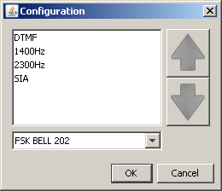
Fig. 17. Additional configuration window for telephone receiver cards, version 3.00 or higher.

At the bottom part of the "Configuration" window, you can select the CLIP service format: FSK BELL 202, FSK V23 or DTMF. This option makes it easy to identify the calling party number. Before choosing the appropriate format, consult the operator to make sure which is the mandatory CLIP standard.

Additional configuration of STAM-1 PE and STAM-1 RE cards
The parameters available for programming depend on the card version. In case of the card version 3.01 and higher (simple monitoring and SIA format), the configuration is performed in two tabs of the "TCP/IP configuration" window. The lower versions of the cards are configured by filling in only the active fields.
IP: – IP address programmed in the card.
MAC: – MAC card number.
Event memory – number of events received by the card, but not sent to the monitoring station program yet.
Configured card – information on configuration status of the Ethernet card.

„Ethernet settings” tab

IP address
DHCP – with the „DHCP” option enabled, the card will automatically download the data regarding IP address, subnet mask and gateway from the DHCP server.
IP address– IP address to be used by the card. This field is available if the function of automatic data downloading from server has been disabled („DHCP” option).
Mask – mask of the subnetwork in which the module is working. This field is available if the function of automatic data downloading from server has been disabled („DHCP” option).
Gateway – network gateway, i.e. IP address of the network device through which other network devices communicate with the Internet or other local networks. This field is available if the function of automatic data downloading from server has been disabled („DHCP” option).

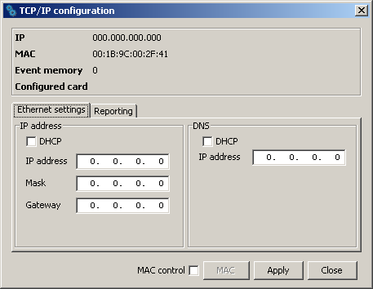
Fig. 18. „Ethernet settings” tab in „TCP/IP configuration” window before defining card parameters.

DNS
DHCP – with the "DHCP" option enabled, the card will automatically download the DNS server address data from the DHCP server.
IP address – DNS server address. The field is available if the function of automatic data downloading from the server has been disabled ("DHCP" option).

„Reporting” tab

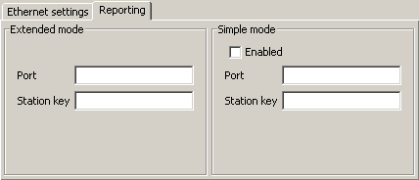
Fig. 19. „Reporting” tab in „TCP/IP configuration” window before defining card parameters.

Extended mode
Parameters defined in this area relate to handling subscribers in extended mode, i.e. with the communications control.
Port – enter the number of the network port intended for communication in this field. Values from 1 to 65535 can be entered. The value must be different from that entered for the other ports. The same port number must be entered in the reporting settings of the subscriber device.
Station key – in this field, a string of 1 to 12 alphanumeric characters which determine the key to be used for data encrypting during communication in the extended mode should be entered. The identical station key must be entered in the reporting settings of the subscriber device.

Simple mode
Parameters defined in this area relate to handling subscribers in the simple mode, i.e. without the communication control. This feature requires connection of the Ethernet cards, version 3.01 and higher.
Enabled – if this checkbox is checked, it will be possible to handle the subscribers in the simple mode.
Port – this field is available if the "Enabled" box is checked. You must indicate the number of the network port on which communication will take place. You can enter values from 1 to 65535. The value must be different from that entered for the other ports. The same port number must be entered in the reporting settings of the subscriber device.
Station key – the field is available if the "Enabled" box is checked. You must enter a sequence of 1 to 12 alphanumeric characters to define the key with which the data will be coded during communication in the simple mode. The same station key must be entered in the reporting settings of the subscriber device.
MAC control – when the option is enabled, the card will only receive transmissions from the devices with defined MAC numbers. This enables the card to be protected from hacking attempts. You can define the MAC numbers after the „MAC” button is pressed.
Buttons:
MAC – pressing the button will open a window where you can define MAC numbers for the devices, from which the card is to receive transmissions. Up to 256 MAC numbers can be defined. The button is active, if the „MAC control” option is enabled.
Apply – the button is active if any changes have been made in the window and enables saving the introduced changes.
Close – closes the window.

Additional configuration of GSM modules
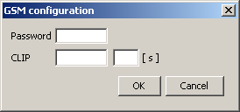
Fig. 20. Additional configuration window for GSM module.

Password – a password for communication with the GSM module connected to the COM port. In case of the GSM-4 module, the password must be identical with that programmed in the module as „DWNL code”. In case of the GSM LT-1 module, enter 111111.
CLIP – a name, on the basis of which the CLIP type messages received from the given GSM module will be identified (a corresponding event code can be assigned to this name at the stage of adding / editing subscriber).
[s] – time period defined in seconds, after which the GSM module will acknowledge receiving the CLIP type message. You can enter values from 0 to 20. Value 00 means the function is disabled.
Buttons:
OK – saves the changes made to the database.
Cancel – closes the window.

„Information” tab
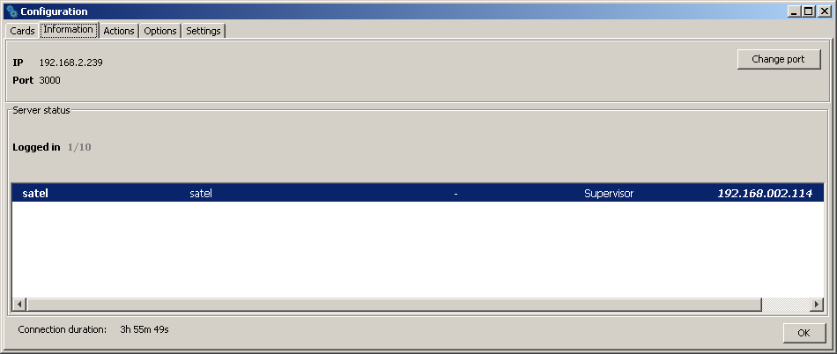
Fig. 21. „Information” tab in „Configuration” window.

The following information is provided in the tab:
- IP address of the computer with installed program of the server to which the client program is connected
- Number of the TCP/IP port through which communication is effected
- Number of users logged in
- Information on the users logged in (first and last name, address, telephone, user status, IP address of the computer from which they logged on)
- Duration of the connection to server
Buttons:
Change port – enables changing of the TCP/IP port number (see: Changing TCP/IP port).
OK – closes the window.

Changing TCP/IP port
In order to change the number of TCP/IP port through which the client-server communication is effected, do as follows:
- Open the „Information” tab in „Configuration” window.
- Click on the „Change port” button.
- A window will be displayed in which you should enter the new port number. It is possible to enter values from 1 to 65535.
- Click your mouse on the „Apply” button.
- If the port is available, a window will be brought where you can accept or cancel the port change. Before the next login, it will be necessary to change the server port settings in the login window (see Fig. 11).

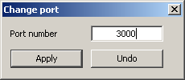
Fig. 22. Window for changing port number.

„Actions” tab
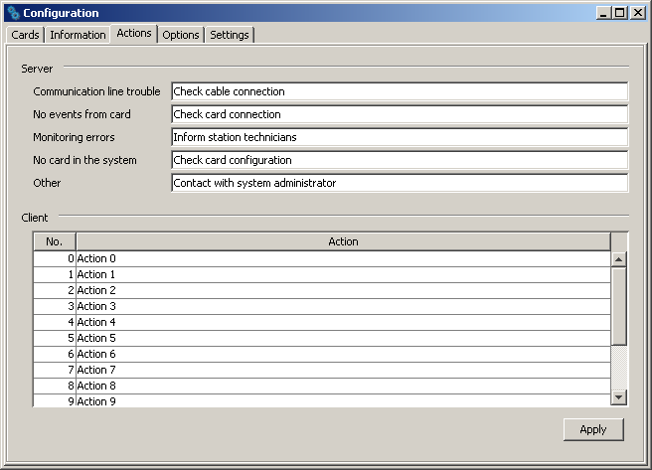
Fig. 23. „Actions” tab in „Configuration” window.

The tab allows the user to define suggested actions that should be taken by the program operator if specified events occur.

Server
In this section you can define actions for the selected system troubles. If this type of event is generated, the texts entered will be displayed in red in the "Actions" section of the event handling window for all computer stations.

Client
You can define a list of actions that will be displayed in the window of each event that requires handling. These actions are presented in black (the actions defined individually for the subscriber are presented in red). The list of actions is local by nature, i.e. it only applies to the computer workstation (the client program) on which it was created. If the same list of actions is to be valid on another computer workstation, copy the "actions.txt" file to that workstation (default access path: C:\Program Files\Satel\STAM-2\Client\src\lang\actions.txt).
Button:
Apply – active after any changes are made to the window and allows to save the changes.

„Options” tab
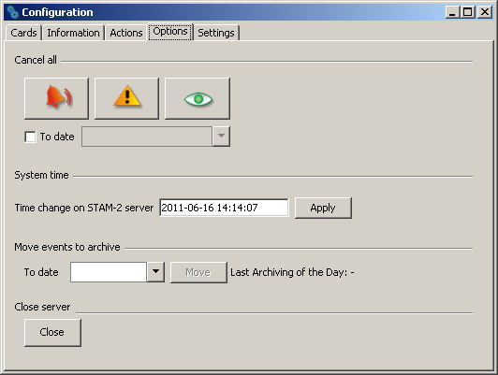
Fig. 24. „Options” tab in „Configuration” window.

Cancel all
Should the need arise to delete all events requiring intervention (alarm, trouble, arm status event), you should choose the button designated with the appropriate icon. Additionally, you can specify a date by which all occurring events of the given type will be deleted. You can define the date using the calendar which will be available when you check the "To date" box.

System time
You can set the time on the server. Enter the date and time in the "Time change on STAM-2 server" field and then confirm the change using the "Apply' button.

Move events to archive
Events can be stored in a dedicated part of the database. To do so, select a specific date in the calendar in the "To date" field and confirm it by pressing the "Move" button. All the events that took place by that time will be moved to the archive. They will be accessible when you select the "Archive" option in the "Filter" window (see: Filter). The archived events will be displayed in the "Event log" window tab. After the archiving is completed, detailed date and time will appear to indicate the last time when the events were moved to the archive.

Close server
You can turn off the server from the computer station on which the server configuration was run. To do so, click on the "Close" button.

„Settings” tab
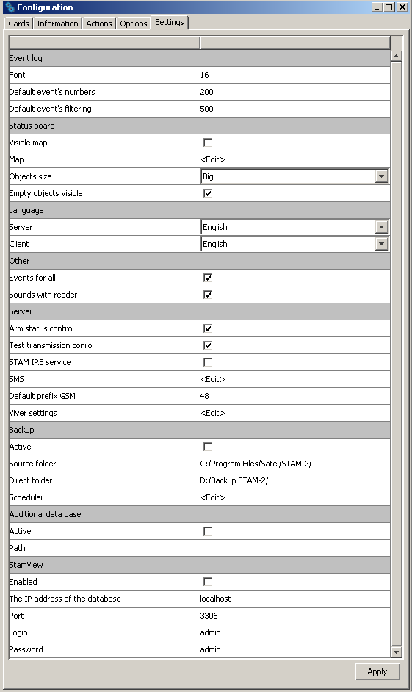
Fig. 25. Default settings in the "Settings" tab, "Configuration" window, STAM-2 PRO program.

Event log
You can define the "Event log" appearance.
Font – the font size that will be used in the event list in the "Event log" window. The default setting is 16.
Default event numbers – the number of events displayed in the "Event log" window. The default setting is 200.
Default event filtering – the number of events meeting the defined criteria, which are displayed in the "Filter" tab in the "Event log" window. The default setting is 500.

Status board
The area where you can define the look of the "Status board" window.
Visible map – if this checkbox id checked, a map is displayed as background in the "Status board" window [only STAM-2 PRO].
Map – hover the cursor over the box and click on it with the left mouse button to open the "Map" window, where you can add a map.

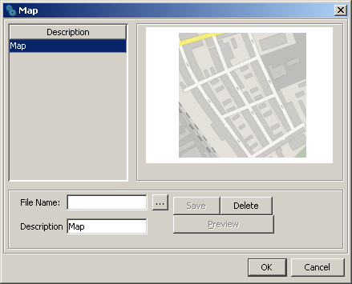
Fig. 26. „Map” window.

File name – add the access path to an image file with map in this field. The program supports JPG and PNG file types.
Description – the field where the map name is to be entered.
Buttons:
– allows you to indicate the access path to the selected image file.
Save – saves the selected image file to the database. The button is active if the access path to the image file has been indicated and a description of the map has been entered.
Delete – deletes the map. The button is active if a map has been loaded.
Preview – allows you to preview a map selected from the list. The button is available if a map has been loaded.
OK – saves the changes made to the database.
Cancel – closes the window.
Objects size – the field allows you to specify the size of icons presenting individual subscribers in the "Status board" window (the options are: small, medium and big). The default size is "Big".
Empty objects visible – if this checkbox is selected, the icons presenting undefined subscribers will be displayed in the "Status board" window. This does not apply when the window displays a map. The option applies to all undefined subscribers whose consecutive number is lower than that of the last-defined subscriber. The box is checked by default.

Language
You can select the language version for the STAM-2 Server and STAM-2 Client program. The programs may have the same or different language version. After selecting the language, click on the "Apply" button, close the program (one or both of them, depending on to which of them the changes have been made) and then restart it, because only then the change of language version will take effect.
Server – in this field you can select the language version for the STAM-2 Server program.
Client – in this field you can select the language version for the STAM-2 Client program.

Other
Events for all – if this box is checked, the handling window will be displayed simultaneously on all workstations when the monitoring station receives an event requiring intervention. When one of the operators takes any action related to the event handling, the window will be closed on the other stations. The box is checked by default.
Sounds with reader – if this box is checked, the events for which the WAV files are placed in the "Sounds" folder will be signaled by a distinctive sound and reader comments in the language chosen for the STAM-2 Client program. The box is checked by default.

Server
Arm status control – if this box is checked, the arm status events received by the monitoring station will require handling. The box is checked by default.
Test transmission control – if this box is checked, the test transmission events received by the monitoring station will require handling. The box is checked by default.
STAM-IRS service – if this box is checked, the power supply unit installed in the STAM-IRS system is constantly monitored. Thus the information on troubles related to the device power supply status will be sent to the monitoring station in the form of events.
SMS – if the GSM module is connected to the monitoring station, the monitoring station can notify subscribers by SMS messages about receiving the alarm code. The SMS message comprises a description of the event (up to 15 characters), the subscriber's name (up to 23 characters) and the subscriber's address (up to 24 characters). The message may contain up to 62 characters. Move the cursor onto the "SMS" field and left click on it to open the "SMS" window, where you can define the parameters of the above described message.

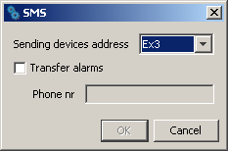
Fig. 27. „SMS” window.

Sending devices address – select in this field the address of the connected GSM module from which you want to send an SMS message notification of receiving the alarm code.
Transfer alarms – if this option is selected, the GSM module will be sending SMS message notifications of receiving the alarm code.
Phone no – in this field, enter the number of GSM phone to which an SMS message is to be delivered to inform that the alarm code is received.
Buttons:
OK – saves the changes made to the database.
Cancel – closes the window.
Default prefix GSM – the field where you should enter the country code. The country code will be added before the cell phone number, to which an SMS message will be sent to notify that the alarm code is received.
Viver settings – when you hover your cursor over the field and left-click on it, the "Viver settings" window will open where you can define the parameters of this device.

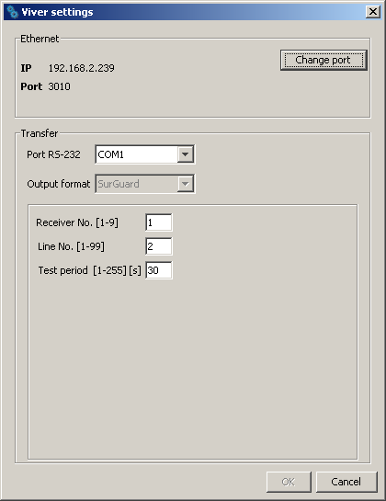
Fig. 28. „Viver settings” window.

Ethernet – information provided in this area relates to:
IP address of the computer where the STAM-2 Server program is installed,
number of the TCP/IP port through which communication takes place.
Button:
Change port – enables changing the TCP/IP port number (see: Changing TCP/IP port).
Transfer – information provided in this area relates to the conversion of events.
Port RS-232 – number of the port through which the events will be sent to another monitoring station.
Output format – the field displays information about SurGuard format in which data will be sent to another monitoring station.
Receiver No. [1-9] – enter in this field the number of receiver the data transfer from which is simulated by the station. Values from 1 to 9 can be entered. By default: 1.
Line No. [1-99] – enter in this field the number of line the data transfer from which is simulated by the station. Values from 1 to 99 can be entered. If the number is between 1-9, then the SurGuard MLR2 format is chosen, if the number is between 10-99, then the SurGuard MLR2E format is chosen. By default: 1.
Test period [1-255] [s] – the parameter is used to control communication with the monitoring station, for which the STAM-2 monitoring station acts as a converter. The time is defined in seconds. Values from 0 to 255 can be entered. By default: 30 s.

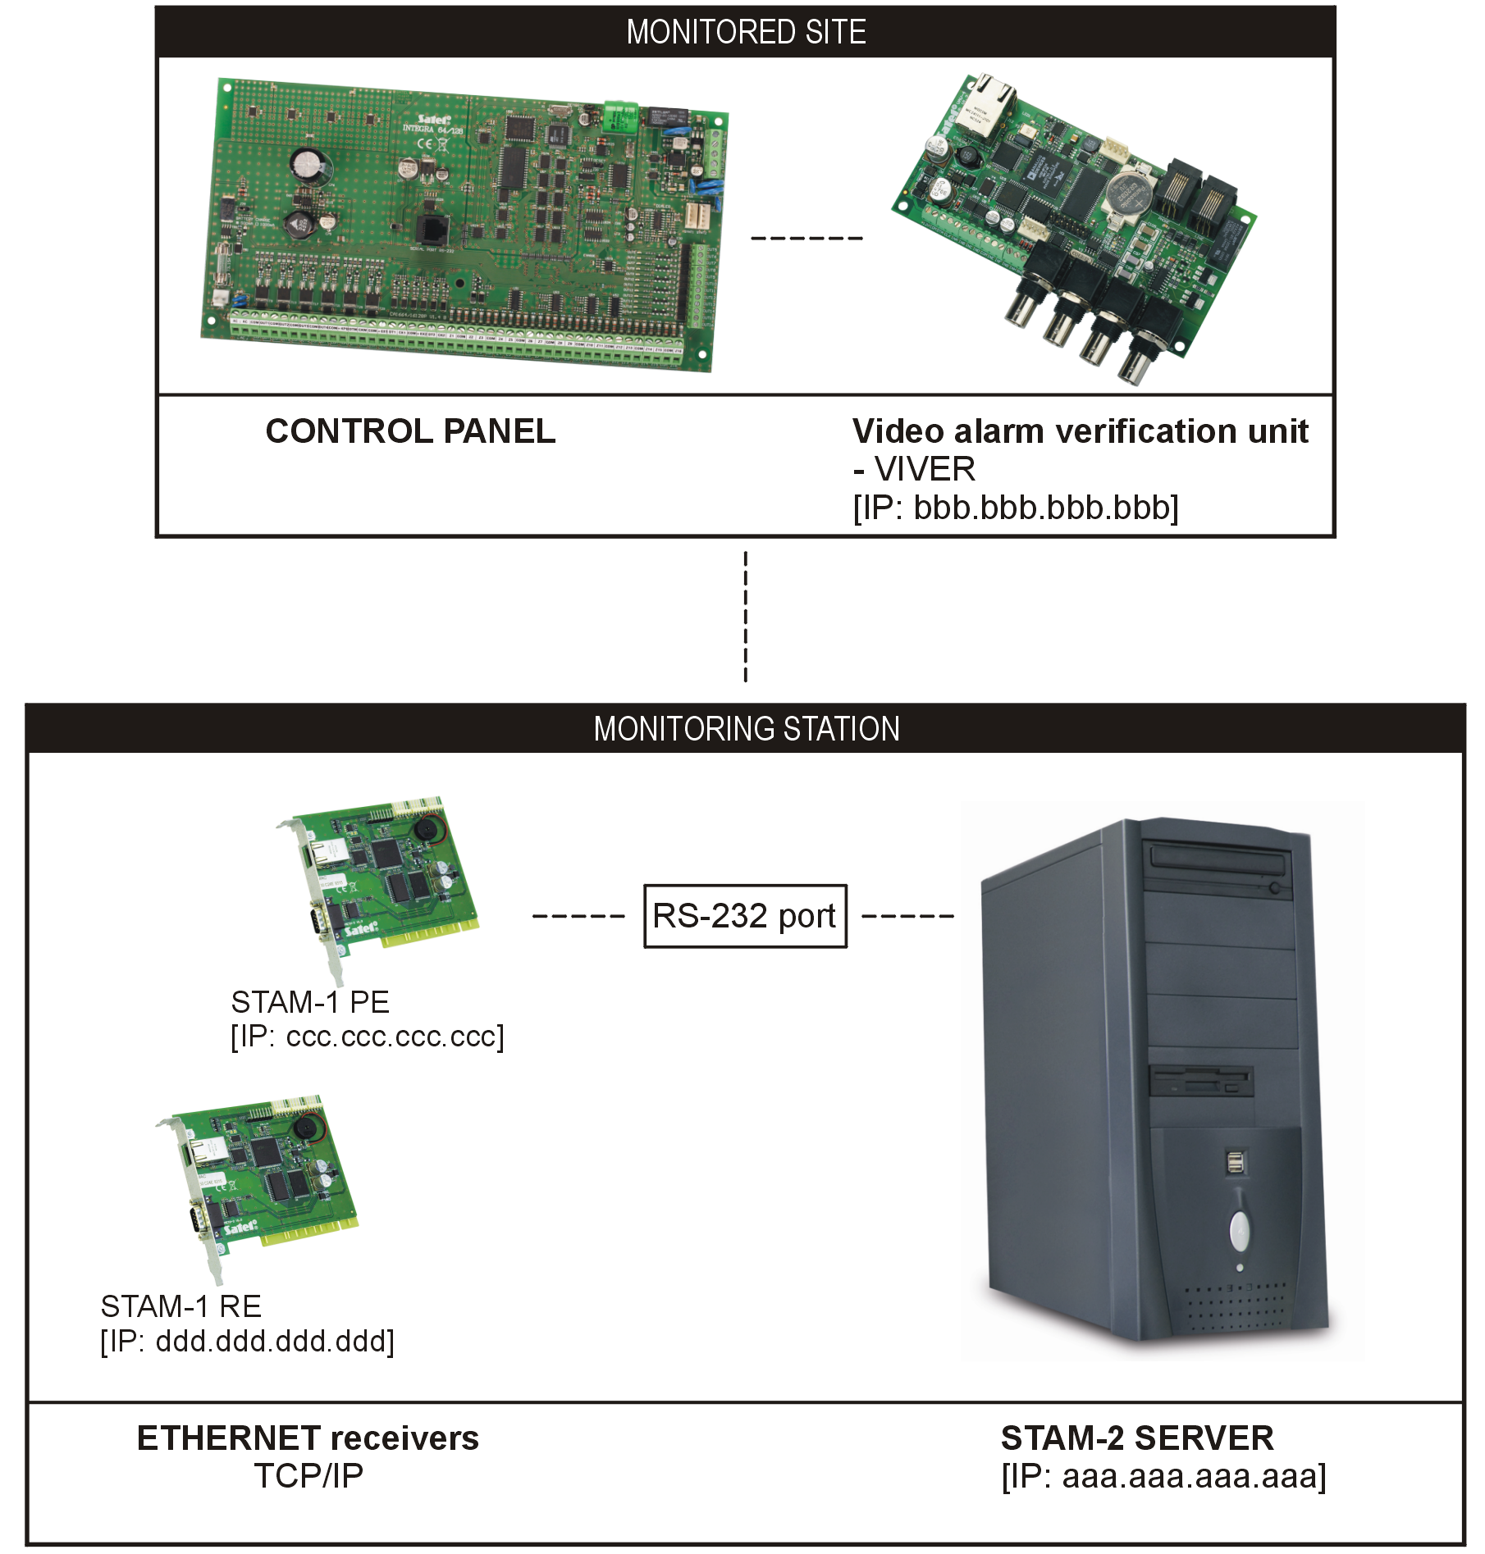
Fig.29. Configuration of the server and VIVER module.

Buttons:
OK – saves the changes made to the database.
Cancel – closes the window.

Backup
The area to define parameters for automatically making backup copy of the database. In case of a primary disk trouble or loss of the database itself, the backup copy will be the source to restore it. At the time of making the backup copy, a window is displayed to inform you about it.
Active – check this box to activate creating a backup copy of the database.
Source folder – enter in this field the access path to the directory where you want the STAM-2 database to be saved. By default: C:/Program Files/Satel/STAM-2.
Direct folder – enter in this field the access path to the directory where the database backup copy is to be saved. It is recommended to create this directory on a different drive than the one on which the STAM-2 database is placed. By default: D:/Backup STAM-2.
Scheduler – hover the cursor onto the field and left-click on it with your mouse to open the "Scheduler" window where you can define a schedule for making the database backup copy.

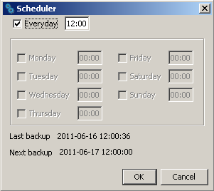
Fig. 30. „Scheduler” window.

Everyday – after you check this box and enter the time in the field next to it, the database backup copy will be created automatically every day at the selected time. When you check this box, the other fields in the window will become inactive.
Weekdays – when you select specific days and enter the time in the field on the right, the database backup copy will be created automatically on selected days of the week at a predetermined time.
Last backup – date and time of making the last database backup copy.
Next backup – date and time of making the next database backup copy.
Buttons:
OK – saves the changes made to the database.
Cancel – closes the window.

Additional database [only for STAM-VIEW users]
The area where you can define parameters for the auxiliary database. All operations and events occurring in the monitoring station, receivers connected to it and sites monitored by it will be saved into the auxiliary database. The auxiliary database is parallel to the database backup copy. In case of failure, it allows you to restore the database and recover the data that have not been saved in the backup.
Active – check the box to activate creating the auxiliary database.
Path – enter in this field the access path to the directory where you want the auxiliary database to be saved. It is recommended to create this directory on a different drive than the one on which the database STAM-2 is placed.
Note: The files of database backup copy and auxiliary database should also be copied to another data storage device. This can be done e.g. with the free Cobian Backup program. This program allows you to create backups of data both locally and via the network (e.g., FTP or shared folders). Thus, in the event of any failure of the operating system or the computer itself, the backup copy will guarantee the recovery of data.

STAM-VIEW [only for STAM-VIEW users]
With this option enabled, it is possible to view the events coming from the site, using the web browser: Mozilla Firefox, Google Chrome and Internet Explorer (version 8.0 or higher). The program uses an external database, which is the continuously synchronized STAM-2 auxiliary base. The user (site owner, installer) logs, based on the name and password (assigned by the company monitoring the site) and the characters from the image. If inactive, the connection is closed after 10 minutes.
Enabled – if this box is checked, the connection between STAM-2 Server and STAM-VIEW programs will be active.
The IP address of the database – enter in this field the IP address of the computer on which the STAM-VIEW database will be located. The default setting is "Localhost".
Port – enter in this field the port number through which communication with the database will be effected. The default setting is 3306.
Login – enter in this field the login name to be used by the STAM-2 Server to get access to the STAM-VIEW database. The default setting is "admin".
Password – enter in this field the password to be used by the STAM-2 Server to get access to the STAM-VIEW database. The default setting is "admin".
Button:
Apply – saves the changes made to the database.

User accounts
The window is available to users with the „user accounts” authority level.
When the monitoring station program is started with its factory settings (first time run), there is one registered user with the name „satel”, and using the password „satel”, who has the „Supervisor” status and nearly all available authorities. You cannot remove this user, or change his status, or cancel his „user accounts” authority.
After the first run, the factory user password „satel” should be replaced with another one.
User – User’s name. Filling this field is necessary. It is recommended that the user’s first and last name (surname) be entered. The user’s name is to be entered when logging into the server program. It is saved in the event log at all events handled by this user. It will be also included in the created reports.
Address – User’s residence address. Filling this field is not necessary. It is recommended to fill it, so that the user can be contacted, if needed. The user’s address is saved in the event log at all events handled by this user.

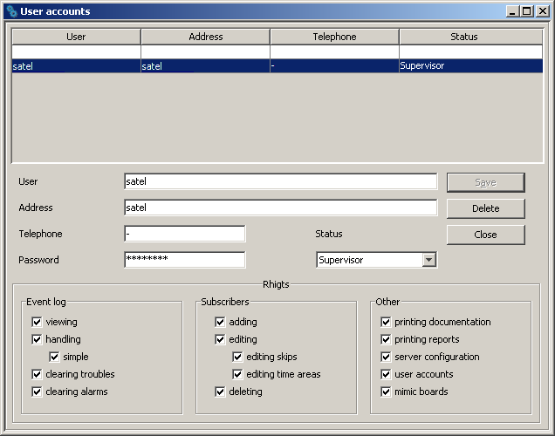
Fig. 31. „User accounts” window at the first time run of the monitoring station program.

Telephone – Number of the user's home or mobile phone. Filling this field is not necessary. It is recommended to fill it, so that the user can be contacted, if needed. The user’s telephone number is saved in the event log at all events handled by this user.
Password – User’s password. Filling this field is necessary. The password is required to log into the server program. It must have at least 4 characters. The program is case-sensitive. After the first login, the user should change the password assigned to him by the person who added him to the user list (see: Changing password).
Status – A status must be granted to each user. By default, a particular authority level is assigned to each status. One of the 3 following statuses can be chosen: „Operator”, „Installer” or „Supervisor”. The „Operator” is only granted the authorities of the „Event log” category. The ”Installer” is given all the authorities included in the „Subscribers” category and, additionally, is authorized to view event log, print reports and documentation. The „Supervisor” is granted all the authorities, except for the simple handling of events. The authorities possessed by the user with a particular status can be freely changed, which practically means that the status is primarily a template, useful when creating and editing users. During the use of the monitoring station program, the status will decide which of the notes sent (see: Notes) will be received by the particular user.
Authorities – The authorities determine the scope of access to the monitoring station program. They are subdivided into three main categories: event log, subscribers and other.
- Event log
- viewing – the user can only view the history of events (he cannot handle the events, unless he has been granted the „handling” authority level).
- handling – the user can only handle events (he cannot view the events log, unless he has been granted the „viewing” authority level, but he can handle the older events by means of the „Status board” window).
- simple handling – the user with the „handling” authority level can handle events in an easy way, i.e. the event will be considered as already handled immediately after the user clicks on the „Handle” button.
- clearing troubles – the user can clear unhandled troubles in the „Status board” window, by clicking twice on the subscriber and opening the detailed information window (when cleared, the troubles will be considered as already handled and inactive).
- clearing alarms – the user can clear unhandled alarms in the „Status board” window, by clicking twice on the subscriber and opening the detailed information window (when cleared, the alarms will be considered as already handled).
- Subscribers
- adding – the user can add new subscribers and restore deleted ones. Unless he has been granted the „editing” authority, the user will not be able to edit the settings of added subscriber after closing the „Subscriber” window.
- editing – the user can edit the existing subscribers.
- editing skips – the user with „adding” or „editing” authorities can define the rules for skipping the incoming events.
- editing time areas – the user with „adding” or „editing” authorities can define the „Time areas” for the subscriber.
- deleting – the user can delete subscribers.
- Other
- printing documentation – the user can print documentation regarding the monitoring station in PDF format.
- printing reports – the user can print subscriber reports, reports on activity of selected program users, as well as event log and system performance statistics in PDF format.
- server configuration – the user can configure the server.
- user accounts – the user can add, edit and remove other users.
- mimic boards – the user can define the lighting mode of mimic board LEDs.

Adding new user
In order to add a new user, do the following:
- Open the „User accounts” window. An empty item in the list, intended for adding new users, will be highlighted as the active field.
- Enter the user name.
- Enter additional information on the user (address, telephone), so that he can be contacted, if necessary.
- Enter the user password.
- Select the user status.
- Click on the „Save” button.

Editing user
In order to change the user settings, do as follows:
- Open the „User accounts” window. An empty item in the list, intended for adding new users, will be highlighted as the active field.
- Click on the user whose data you want to edit.
- Make changes to the user settings.
- Click on the „Save” button.
Note: If the user whose data have been edited is logged in, any changes regarding his name, password or authorities will take effect after logging out of the user.

Deleting user
In order to delete the user, do as follows:
- Open the „User accounts” window. An empty item in the list, intended for adding new users, will be highlighted as the active field.
- Click on the user you want to delete.
- Click on the „Delete” button.
- In the window that will appear, confirm the intention to delete the user by clicking on the „Yes” button.
Note: If the user being deleted is logged in, he will be able to operate the monitoring station program until he logs out.

Changing password
The function is available to all users. It is recommended that each user, after the first login, change the password assigned to him by the person who added him to the user list. In order to change the password, do as follows:
- Open the „Change password” window.

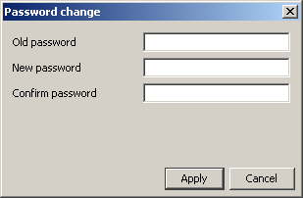
Fig. 32. Password change window.

- Enter the previous password in the „Old password” field.
- Enter the new password in the „New password” field.
- Re-enter the new password in the „Confirm password”.
- Click on the „Apply” button.

Mimic boards
The window enables configuration of the mimic boards connected to the monitoring station.
Number of boards (0-63) – enter in this field the number of mimic boards connected to the monitoring station. Up to 63 mimic boards can be connected (each board illustrates the status of 64 subscribers). Entering 0 will disable support of the mimic boards. Do not enter the greater number of boards than in reality. When you enter a smaller number of boards than in reality, only the indicated number of boards will be supported. Factory default: 0.
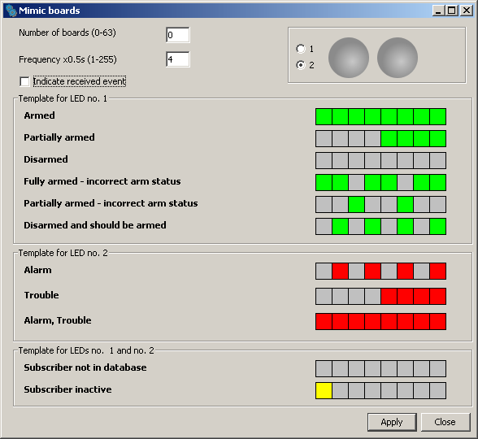
Fig. 33. „Mimic boards” on first-time run of the program.

Frequency x0.5s (1-255) – define in this field with what speed the LED lighting templates are to move. The entered value is multiplied by 0.5 seconds. You can enter values from 1 to 255 seconds. Factory default: 4.
Indicate received event – check this box if the mimic boards are to signal receiving events from the subscriber. Receiving an event will be signaled by the alternate blinking of the subscriber assigned LEDs for 2 seconds. After elapse of this time, the LEDs will indicate the subscriber's status again.
1 – check this box to see how the template will be displayed on one LED. The LED is represented in graphical form.
2 – check this box to see how the template(s) will be displayed on two LEDs. The LEDs are represented in graphical form.
Template for LED 1 – LED 1 lighting template for the following statuses:
- Armed
- Partially armed
- Disarmed
- Armed - wrong status
- Partially armed - wrong status
- Disarmed - wrong status
Template for LED 2 – LED 2 lighting template for the following statuses:
- Alarm
- Trouble
- Alarm, Trouble
Template for LEDs 1 and 2 – LEDs lighting template for the following statuses:
- Subscriber not in database
- Subscriber inactive
Click on the selected template to display it on the LED/LEDs in the upper right-hand corner of the window.
Each template is represented in graphical form on 8 fields. The LED is ON, when the field is selected. To select / deselect the required field, click on it with our mouse pointer.
Buttons:
Apply – saves introduced changes to the database and restarts mimic board LEDs.
Close – closes the window.

Subscribers
The window is available to the users who possess the „Subscribers” category authorities („adding”, „editing” or „deleting”).
The window displays a subscriber list. Depending on the granted authority level, the user can add, edit or delete the subscribers. When editing subscribers, the program remembers the last item from the list as well as the size and width of the displayed window.
No. – subscriber's consecutive number. The number is assigned to the subscriber automatically when he is being added, but it may be changed by the user. In the „Status board” window, the subscribers are sorted by their consecutive numbers.
Name – subscriber's first and last name.
Buttons:
New – active if the user has the „adding” authority. Allows adding new subscribers. If a subscriber data template has been created, you can press the button to create a new subscriber, for which the data from the template will be entered by default (see: description of the "Save as template" button).
Delete – active if the user has the „deleting” authority. Allows deleting subscribers.
Edit – active if the user has the „editing” authority and after the first subscriber is added. Allows editing the existing subscribers' data and settings.
Restore – displayed after deleted subscribers are found (see: „Find” tab), if the user has the „adding” authority. Allows restoring the deleted subscriber (his setting will not be restored).
Filter – opens the "Event log" window with a tab which will display events related to the given subscriber selected in the upper portion of the "Subscribers" window.
Details – opens the "Detailed information" window (see: Detailed information) with information related to the given subscriber.
Plans – opens the "Site plans" window. The window displays a list of plans defined for the specific subscriber. Click on the required plan and press the "Preview" button to familiarize with the plan of monitored site.
Export – used to export subscribers. Highlight the selected subscribers in the list (holding down the Ctrl key and left clicking your mouse) and click on the button. The "Save" window will open, where you can select the location and file name to which the subscribers will be exported.
Import – opens the "Open" window, where you can select the location and file name from which the subscribers will be imported. Only the subscribers with currently non-existent identifiers will be imported.
Cancel – closes the subscribers list window.
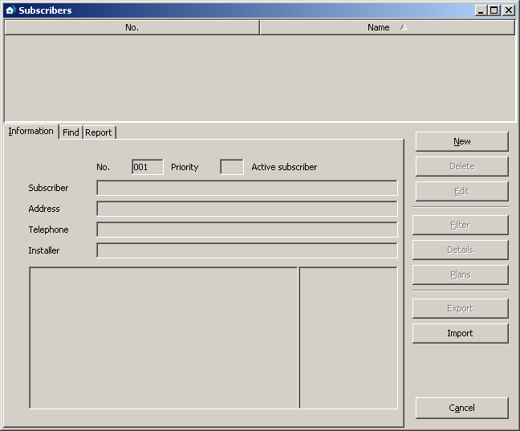
Fig. 34. „Subscribers” window with „Information” tab on first-time run of the program.

„Information” tab
ID – identification number assigned automatically to each new subscriber. This number is unique and will never be assigned again, even if the subscriber is removed.
No. – subscriber's consecutive number. The number is assigned to the subscriber automatically when he is being added, but it may be changed by the user. In the „Status board” window, the subscribers are sorted by their consecutive numbers.
Priority – subscriber's priority. Subscriber's priority is only meaningful when the user wants to handle unhandled events (alarms, troubles or arm status events). The events will then be displayed according to the subscriber's priority. Priority values range from 0 to 9. High-priority events take precedence. If some subscribers have the same priority, precedence will be given to the subscriber's high-priority events which were received first, i.e. remained unhandled for the longest period of time.
Active / Inactive subscriber – information on whether the subscriber is currently active or inactive. If the subscriber is inactive, events received from him require no reaction of the monitoring station operating personnel. These events are automatically saved in the event log as handled. For the inactive subscriber, neither test transmissions, nor consistence of arming/disarming with time areas are checked. The „Status board” displays no information on the inactive subscriber's status.
Subscriber – subscriber's first and last name (or company name).
Address – subscriber's address.
Telephone – subscriber's telephone number.
Installer – data of the company or person who installed the alarm security system at the subscriber's premises, or is currently responsible for maintenance and operability of the system.
Displayed below the „Installer” field is additional information on the subscriber (see: „General” tab). The adjacent field shows a list of identifiers defined for the subscriber (see: „Identifiers” tab).

„Find” tab

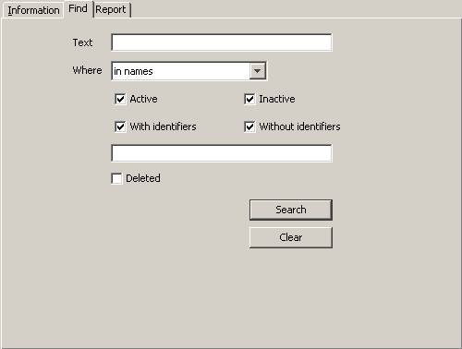
Fig. 35. „Find” tab (part of „Subscribers” window) on the first-time run of the program.

The „Find” tab makes it possible to find any subscriber (also a deleted one).
Text – the field where the character string you are searching for should be entered. The field can be left empty: if this is the case, the search will only be based on the other search criteria defined.
Where – the place where to search for the character string entered into the „Text” field. You can select the following places:
- in names
- in addresses
- in installers
- in information
- anywhere
- in telephone numbers (the program will search all telephone and GSM related fields).
Active – check this box if the subscriber you search for is active. By default, this checkbox is checked.
Inactive – check this box if the subscriber you search for is inactive.
Note: If the „Active” and „Inactive” boxes are checked at the same time, the search will include both categories of subscribers, similarly as when none of the boxes is checked.
With identifiers – check this box if an identifier has been assigned to the subscriber searched for. By default, this checkbox is checked. See also „Identifiers”.
Without identifiers – check this box if no identifier has been assigned to the subscriber searched for.
Note: If the „With identifiers” and „Without identifiers” boxes are checked at the same time, the search will include both categories of subscribers, similarly as when none of the boxes is checked.
Identifiers – this field is available when the „With identifiers” box has been checked. It enables a subscriber to be found on the basis of identifier(s). If the „With identifiers” box is checked and the „Identifiers” remains blank, the search will include all subscribers who possess identifiers.
Deleted – check this checkbox if the subscriber you are searching has been deleted. Checking the box will block access to the boxes: „Active”, „Inactive”, „With identifiers” and „Without identifiers”.
Buttons:
Search – starts searching the database. The list of subscribers who meet the defined criteria will be displayed in place of the list of all subscribers.
Clear – restores default settings of the „Search” tab and brings up the list of all users.

"Report" tab
The "Report" tab provides information about subscribers: consecutive number, name, address, identifiers, and GSM phone numbers. The data can be sorted by column name, as may be required. Additionally, you can move the whole columns, changing their position in relation to each other. To do so, click on the column name and holding down the left mouse button drag the column to the desired location.
Button:
Update – updates the report with the changes recently made to all subscribers' data.
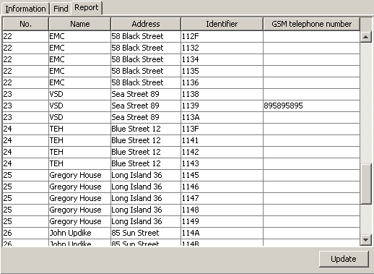
Fig. 36. A report example in "Report" tab (part of "Subscribers" window).

Subscriber
The window allows you to enter the subscriber's data. It will open on pressing the „New” or „Edit” buttons in the „Subscribers” window.
Before entering the data, only the „General” tab is available. The „Plans” and „Identifiers” tabs will only be available after the data are entered into the „Subscriber”, „Address” and „Telephone” fields and then saved, which amounts to adding the subscriber to database. The skipping settings (on right-hand side of the window) are only available when the user has the „editing skips” authority.

„General” tab
ID – identification number assigned automatically to each new subscriber. The number is unique and will never be assigned again, even after the subscriber is removed.
No. – subscriber's consecutive number. The number is assigned to the subscriber automatically when he is being added, but it may be changed by the user. To do so, double-click on the "No." field. When the field text is highlighted, you can change the assigned number. In the „Status board” window, the subscribers are sorted by their consecutive numbers.
Priority – subscriber's priority. Subscriber's priority is only meaningful when the user wants to handle unhandled events (alarms, troubles or arm status events). The events will then be displayed according to the subscriber's priority. Priority values range from 0 to 9. High-priority events take precedence. If some subscribers have the same priority, precedence will be given to the subscriber's high-priority events which were received first, i.e. remained unhandled for the longest period of time. By default, the subscriber's priority is set to 1.
Active – the box must be checked if the subscriber is to be active. By default, the box is checked. If the subscriber is inactive, events received from him require no reaction of the monitoring station operating personnel. These events are automatically saved in the event log as handled. For the inactive subscriber, neither test transmissions, nor consistence of arming/disarming with time areas are checked. The „Status board” displays no information on the inactive subscriber's status.
Subscriber – enter the subscriber's first and last name or company name in this field. The field must be filled in.
Address – enter subscriber's address here. The field must be filled in.
Telephone – enter the subscriber's telephone number in this field. The field must be filled in.
Installer – enter in this field the data of the company or person who installed the alarm security system at the subscriber's premises, or is currently responsible for maintenance and operability of the system.
Additional information – here you can enter additional information on the subscriber, for example, the telephone numbers to which the GSM module will be able to send an SMS message notifying you of the event (see: Tabs in the event handling window section). It is recommended that the data be entered in the following way: first the name of the phone owner, and then the phone number (e.g. John Smith 585656565).
Skipping – options available to users with „editing skips” authority. They allow you to define how to handle the alarm / trouble event codes coming from the subscriber.
Skip nothing – no alarm event will be omitted. Each of them will bring up the alarm window.
Skip identical code – having received an alarm event, the monitoring station will skip alarm events with the same identifier and code over the time period defined in the „Skipping time” field. These events will be automatically saved in the event log as handled. The event details will include information that the code was skipped.

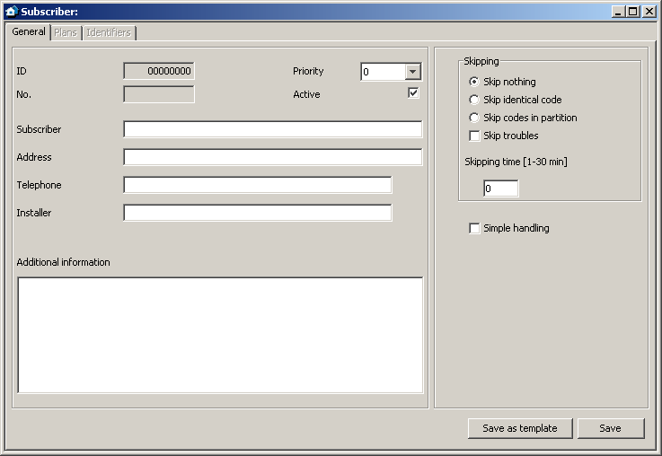
Fig. 37. „Subscriber” window before entering the data.

Skip codes in partition – having received an alarm event, the monitoring station will skip alarm events with the same identifier from the same partition over the time period defined in the „Skipping time” field. These events will be automatically saved in the event log as handled. The event details will include information that the code was skipped. This option can be useful if the subscriber has a few detectors in the room, and alarms from them mean practically one alarm.
Skip troubles – having received a trouble code, the monitoring station will skip trouble events with the same identifier and code over the time period defined in the „Skipping time” field. They will be automatically saved in the event log as handled. The event details will include information that the code was skipped.
Skipping time [1-30 min] – the time counted from the moment of receiving the alarm or trouble event code. Taken into account, if you have enabled one of the following options: „Skip identical code”, „Skip codes in partition” or „Skip troubles”. Values fro m 1 to 30 minutes can be entered. Factory default: 1.
Simple handling – if this box is checked, events received from the subscriber will be considered as handled immediately after the user clicks on the „Handle” button in the event handling window.
Buttons:
Save as template – saves the subscriber related information as a default template for the new subscriber's data.
Save – saves data entered into the database.

„Plans” tab
Any number of plans can be assigned to each subscriber.
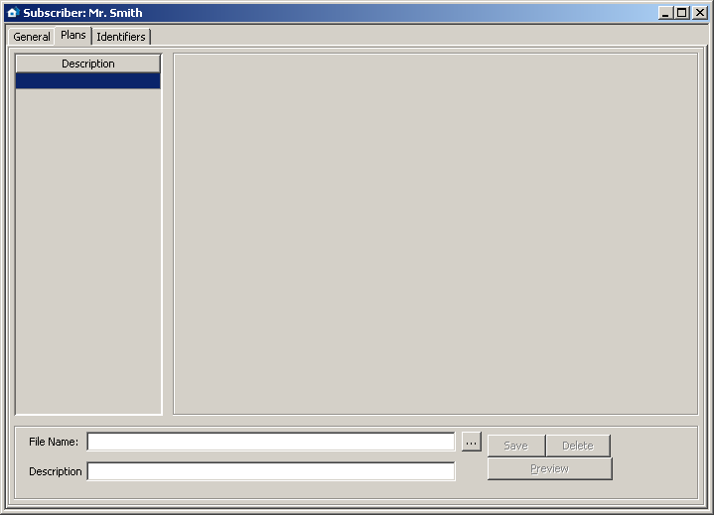
Fig. 38. „Plans” tab in „Subscriber” window, before adding a plan.

File Name – enter in this field the access path to the graphic file with the plan. You can indicate the access path by clicking on the button. The program supports the following file types: JPG and PNG.
Description – the field where you should enter description of the plan.
Buttons:
– enables the access path to the graphic file to be indicated.
Save – saves the selected graphic file into the database, provided that description will be added. The button is active, if the access path to the graphic file has been indicated.
Delete – deletes the selected plan. Click your mouse in the list (column on the left-hand side of the window with plan descriptions) on the plan to be deleted, and then on the „Delete” button.
Zones – displays a list of zones in the site assigned to an identifier in Contact ID format. The list includes identifier, partition number as well as the zone number and description. The button is available after a plan has been loaded [only STAM-2 PRO].
Preview – allows preview of the plan selected from the list. The button is available after several plans have been loaded.
In the STAM-2 PRO program, you can place zones (detectors) on the plan. In order to arrange the detectors, follow these steps:
- Select the given plan from the column on the left-hand side of the window.
- Click on the "Zones" button. A list of zones assigned to the given subscriber will be displayed.
- Double click on each zone name in the list. In the upper left corner of the plan, a pictogram appears in the shape of a small gray circle which symbolizes the given zone.
- Put it on the plan in the place where the detector is.
- Arrange the other detectors in a similar way.
You can check where the given detector has been placed. After selecting one of the zones in the open list, the relevant pictogram on the plan will be highlighted in green. The plan also serves informational purposes. When the monitoring station receives the alarm code from a given zone, the corresponding pictogram will be highlighted in red.

„Identifiers” tab
The tab contains a list of identifiers defined for the subscriber. It allows for adding new identifiers, as well as editing and deleting the existing ones.
Type – the subscriber-assigned identifier can be of the following type:
Normal – identifier for transmission in formats other than Contact ID and SIA.
Contact ID – identifier for transmission in the Contact ID format.
SIA – identifier for transmission in the SIA format.
Reservation – identifier is only reserved for the subscriber. Defining any codes or settings for it is impossible.
Identifier – each subscriber can be assigned any number of identifiers. The identifier has hexadecimal format (digits and letters from A to F). It cannot, however, include the digit 0 inside. See also: Adding identifiers and Editing identifiers.
A change of the identifier type is saved automatically.
A change of the identifier type will delete all the identifier settings.

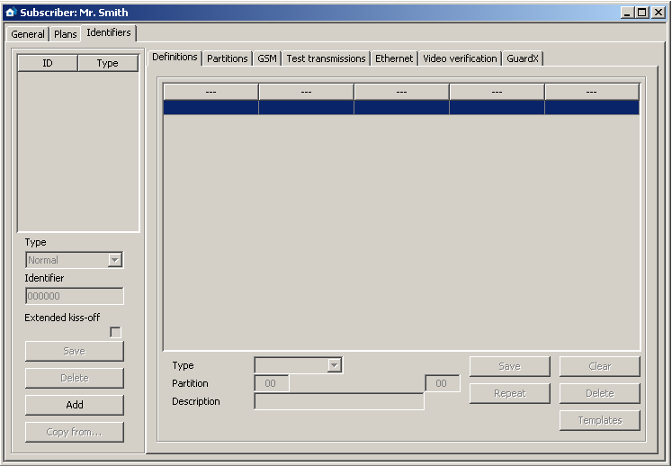
Fig. 39. „Identifiers” tab before adding identifiers.
Extended kiss-off – the option applies to the transmission of Contact ID codes via telephone lines. Some control panels require the extended kiss-off signal upon reception of the code. By default, to speed up communication, short kiss-off signal is used in the STAM-1 telephone receiver cards. The option is available after selecting the „Contact ID” identifier type.
Buttons:
Save – active after manual change of the identifier or activation of the „Extended kiss-off” option. Saves the entered data into the database.
Delete – deletes the selected identifier. Deleting the identifier will also delete all settings referring to this identifier that were entered in all active tabs.
Add – enables adding new identifiers (see: Adding identifiers).
Copy from… – allows you to easily add data related to the identifier settings by copying them from the list of available database identifiers. You can copy all data from the selected identifier or only selected ones.

Adding identifiers
In order to add a new identifier, do as follows:
- Click on the „Add” button.

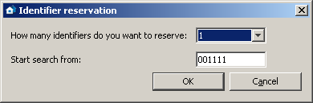
Fig. 40. Reservation of identifiers.

- A window will be displayed in which you must select the number of new identifiers you want to add. It is possible to add from 1 to 10 new identifiers.
- Enter, from what value is the identifier to be searched for.
- Press the „OK” button. The program will automatically search the database and find the identifiers which can be assigned to the subscriber.

Editing identifiers
To edit the existing identifier, do as follows:
- Click your mouse on the identifier you want to edit (the column with identifier list on the left-hand side of the window). It will be displayed in the „Identifier” field.
- Enter the new value in the „Identifier” field.
- Click on the „Save” button. The program will check, if it possible to save the entered identifier. If it is, the changed identifier will be saved. It will retain all the settings entered for the previous identifier in the active tabs.

„Definitions” Tab for „Contact ID” type of identifiers
The tab is available after adding the identifier and selecting the „Contact ID” type. It enables defining additional detailed descriptions for the events received in this format. Defining additional descriptions is not necessary, but it makes operation easier.
Type – select in this field the type of description:
- Zone – the description will refer to the zone of the subscriber's security system. It will overwrite the standard zone name in all events coming from the partition defined in the „Partition” field and referring to this zone. If no partition number is entered in the „Partition” field, the name will appear in all events which refer to this zone, irrespective of from what partition they may come from.
- User – the description will refer to the user of the subscriber's security system. It will overwrite the standard user name in all events received from the partition defined in the „Partition” field and referring to this user. If no partition number is entered in the „Partition” field, the name will appear in all events which refer to this user, irrespective of from what partition they may come from.
- Expander – the description will refer to the expander of the subscriber's security system. It will overwrite the standard user name in all events coming from the partition defined in the „Partition” field and referring to this expander. If no partition number is entered in the „Partition” field, the name will appear in all events which refer to this expander, irrespective of from what partition they may come from.
Partition – enter the partition number in this field. Information entered in the „Description” field will appear at all events referring to the given zone / user / expander and coming from this partition. If the partition number is not entered, this description will appear at all events which refer to the given zone / user / expander.
Zone / User / Expander (the name dependent on the selected description type) – enter in this field the number of zone / user / expander to which the information entered in the „Description” field will be assigned.
Description – enter in this field the name of zone / user / expander (depending on the selected description type). It will appear in events referring to the given zone / user / expander.

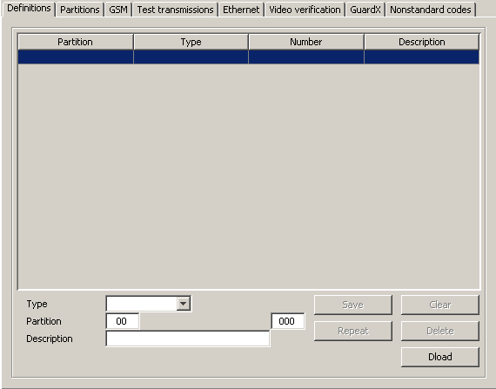
Fig. 41. „Definitions” tab for identifiers type „Contact ID” (part of „Subscriber” window) prior to defining descriptions.

Buttons:
Save – saves the entered descriptions into the database.
Clear – deletes all descriptions defined for the identifier.
Repeat – enables easy addition of a new description with parameters similar to the existing one. For this purpose, click on the description you want to copy, and then on the „Repeat” button. Having entered changes in the selected fields (a change of the zone / user / expander number or partition number is necessary), press the „Save” button.
Delete – deletes the selected description.
Dload – enables downloading of descriptions exported by means of the Dload64 or DloadX program.

„Definitions” Tab for „Normal” type of identifiers
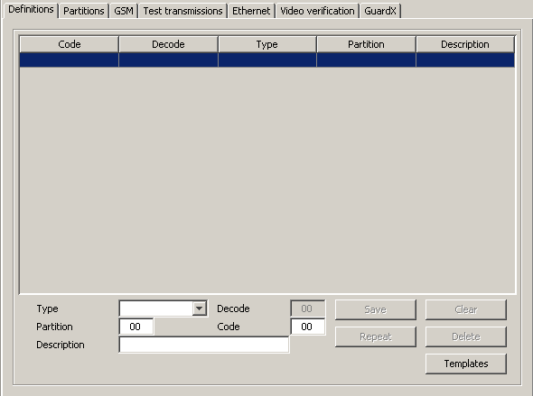
Fig. 42. „Definitions” tab for „Normal” type identifiers (part of „Subscriber” window) before codes are defined.

The tab is available after adding the identifier and selecting the „Normal” type. It enables the defining of event codes.
Type – enter in this field the type of edited code:
- Alarm – the code informs of an alarm at the subscriber's site. It requires intervention of the monitoring station operating personnel (after receiving the code, the alarm handling window will be brought up).
- Arming – the code informs of armed status activation. It requires no intervention of the monitoring station operating personnel, but allows to verify whether the arming occurred within the time interval defined for the „Time areas” (see: „Partitions” tab).
- Disarming – the code informs of armed status deactivation. It requires no intervention of the monitoring station operating personnel, but allows to verify whether the arming occurred within the time interval defined for the „Time areas” (see: „Partitions” tab).
- Trouble – the code informs of a trouble at the subscriber's site. It requires intervention of the monitoring station operating personnel (after receiving the code, the trouble handling window will be brought up).
- Restore – the code informs of the end of the previously reported trouble. It requires no intervention of the monitoring station operating personnel. For this code it is necessary to enter in the „Decode” field the code of the trouble to be restored.
- Test – test transmission code. It requires intervention of the monitoring station operating personnel, unless it is received according to the defined rules (see: „Test transmissions” tab).
- Remark – the code requires no intervention of the monitoring station operating personnel. When received, it will be saved into the event log and audibly signaled.
- Other – the code requires no intervention of the monitoring station operating personnel. When received, it will be saved into the event log.
Decode – the field is available after selecting the „Restore” code type. Enter here the code of the trouble which will be canceled after the „Restore” code type is received.
Partition – enter in this field the number of the partition to be assigned with the code. This enables the codes to be linked to the partitions defined in the subscriber's alarm control panel. In case of certain codes, selection of the partition will affect the reaction pattern of the monitoring station. It applies to the „Alarm” type codes (see „Skip codes in partition” option) and the codes of „Arming” and „Disarming” type (see: Time areas). In addition, for the codes of „Alarm” and „Troubles” type which come from a particular partition, it is necessary to define actions to be taken by the monitoring station personnel after the codes are received (see: Partition actions).
Code – enter a two-character value in the field. Digits and letters from A to F can be used. Digit 0 in the first position means entering one-digit code.
Description – enter in this field verbal description of the event to represent the entered code. The description will be shown in the „Event log” and in event handling windows.
Buttons:
Save – saves entered event codes into the database.
Clear – deletes all event codes defined for the identifier.
Repeat – enables easy addition of a new code with parameters similar to the existing one. For this purpose, click on the code you want to copy, and then on the „Repeat” button. Having entered changes in the selected fields (code change is necessary), press the „Save” button.
Delete – deletes the selected code.
Templates – enables downloading of code templates. They are included in the monitoring station program and can be found in the „templates” folder (a folder of the STAM-2 Client program). The files, which have the WZ1 or WZ2 extension, can be edited by means of any text editor. You can also add your own templates.

„Definitions” Tab for „SIA” type of identifiers
After adding and selecting the "SIA" type identifier, the fields in the tab are not available.

„Partitions” tab
If the window displays only a list of partitions, including the fields to define, edit and delete partitions, use the button to split the window into the list of partitions and the "Partition actions" or "Time partitions" tab.
If the window displays a list of partitions and the "Partition actions" or "Time partitions" tab (depending on which one is currently open), use the button to switch the open tab to fit the entire window height.
If the window displays only the "Partition actions" or "Time partitions" tab, use the button to split window into the list of partitions and the open tab.
If the window displays a list of partitions and the "Partition actions" or "Time partitions" tab, use the button to switch the list of partitions to fit the entire window height.
The tab is available after adding the identifier and selecting one of the three types for it. It contains a list of defined partitions, enables defining new ones (see: Adding new partitions), as well as editing and deleting the existing ones.
Partition 00 is the default partition, created automatically for each identifier. For this partition it is only allowed to define actions in case of alarm and trouble („Partition actions” tab) as well as arming / disarming at wrong time („Actions” in „Time areas” tab). These actions will be considered as default ones for all partitions for which individual actions will not be defined.

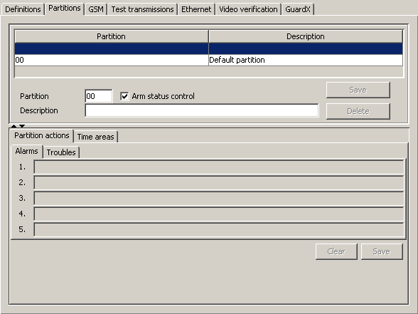
Fig. 43. „Partitions” tab (part of „Subscriber” window) before partitions are defined.

Partition – enter the partition number here. The name entered in the „Description” field will appear at all events coming from this partition.
Arm status control – the option enables / disables verification, whether armed / disarmed status of the partition coincides with the defined time areas („areas” tab). Having checked / unchecked the box, press the „Save” button so that the change can take effect.
Description – enter the partition name in this. This name will appear at all events coming from the partition with the number entered into the „Partition” field.

Adding new partitions
In order to add a new partition, do as follows:
- Click on a blank field in the partition list.
- Enter the partition number in the „Partition” field.
- Enter the partition name in the „Description” field.
- Select or deselect the „Arm status control”, as may be required.
- Click on the „Save” button. The new partition will appear in the list. Click your mouse on the partition and you may proceed to defining the rest of its parameters.
Buttons:
Save – saves changes referring to the partition (partition number, description, „Arm status control”) into the database.
Delete – deletes selected partition.

„Partition actions” tab
Alarms – you can define up to 5 actions to be taken by the operator of the monitoring station program upon receipt of the alarm event from the selected partition. The action list in red will be displayed in the event handling window, in the actions section. If no actions have been defined in case of alarm, the list of actions defined for the default partition will be displayed. The action list for the default partition should be defined.
Troubles – you can define up to 5 actions to be taken by the operator of the monitoring station program upon receipt of the trouble event from the selected partition. The action list in red will be displayed in the event handling window, in the actions section. If no actions have been defined in case of trouble, the list of actions defined for the default partition will be displayed. The action list for the default partition should be defined.
Buttons:
Clear – deletes all actions defined for the partition in case of alarm or performance trouble.
Save – saves actions defined for the partition in case of alarm or trouble to the database.

„Time areas” tab
The „time area” is a time interval during which the partition should be armed or disarmed. The program of monitoring station will check whether the partition status corresponds to its predetermined status. If there is any inconsistence, the event window will be displayed to inform the operating personnel thereof. The window is displayed in two cases: at the beginning of the defined time interval and upon receipt of the event informing that the partition status has been changed to one which is inconsistent with the defined status (e.g. the partition has been armed when it should be disarmed, or armed when it should be disarmed). When defining the time areas, remember to leave undefined periods between the times of armed and disarmed status, when the partition status will not be monitored, so that the partition can be armed / disarmed.
Definitions – the tab contains a list of defined time areas. It enables defining new partitions, as well as editing and deleting the old ones.
- Arm status – select in this field whether the system is to be armed within the defined time interval, or not.
- From – select in this field from which day of the week the system status is to be monitored. Indicate the exact time from which the system status will be monitored.
- To – select in this field to which day of the week the system status is to be monitored. Indicate the exact time to which the system status will be monitored.
Buttons:
Save – saves the defined time areas into the database.
Clear – enables all defined time areas to be cleared.
Repeat – enables easy addition of a new time areas with parameters similar to the existing one. For this purpose, click on the definition of the time area you want to copy, and then on the „Repeat” button. Having introduced changes to the selected fields, press the „Save” button.
Delete – enables deletion of the selected time area.
Exceptions – the tab contains a list of exceptions, i.e. time intervals within which the time area definitions will be disregarded.
- Arm status – select in this field whether the exception defined will refer to armed status or disarmed status.
- [Everyday] From – determine in this field the time from which the partition status will not be monitored everyday.
- [Everyday] To – determine in this field the time to which the partition status will not be monitored everyday.
- [Valid] From – define in this field the date from which the exception is to be effective.
- [Valid] To – define in this field the date to which the exception is to be effective.
- Automatic deletion – check this box if the exception is to be deleted on the specified day. When checked, a field will be available where you should enter exact time of the automatic deletion.
Buttons:
Save – saves the defined exception into the database.
Clear – deletes all defined exceptions.
Repeat – enables easy addition of a new exception with parameters similar to the already existing one. To do so, click on the exception you want to copy, and then on the „Repeat” button. Having introduced changes to the selected fields, press the „Save” button.
Delete – deletes the selected exception.
Actions – in this tab, you can define actions which should be taken by the operator of the monitoring station program when the arm status window is displayed.
- Disarmed and should be armed – you can define up to 5 actions to be taken by the operator of the monitoring station program when the window is brought up with information that the partition is disarmed, although it should be armed. The action list in red will be displayed in the event handling window, in the actions section. If for the particular partition have been defined no actions in case of such an event, a list of actions defined for the default partition will be displayed. The list of actions the default partition should be defined.
- Fully armed – incorrect arm status – you can define up to 5 actions to be taken by the operator of the monitoring station program when the window is brought up with information that the partition is armed, although it should be disarmed. The action list in red will be displayed in the event handling window, in the actions section. If for the particular partition have been defined no actions in case of such an event, a list of actions defined for the default partition will be displayed. The list of actions the default partition should be defined.
Buttons:
Clear – deletes all defined actions.
Save – saves the defined actions into the database.

„GSM” tab
The tab is available after identifier is added and one of the three types is selected for it. It allows to define the subscriber's GSM telephone number and the SMS or CLIP type messages which can be received by the GSM module from the subscriber. Corresponding event codes should be assigned to these messages.
GSM telephone number – enter in this field the GSM telephone number, by means of which control panel communicates with the GSM module of the monitoring station, and then click on the "Save" button. Based on this number, the monitoring station program will identify the subscriber. The number presentation function must be enabled in the subscriber's GSM telephone.
Deleting the GSM telephone number amounts to deleting all settings defined for this number (SMS and CLIP type messages and codes assigned to them).

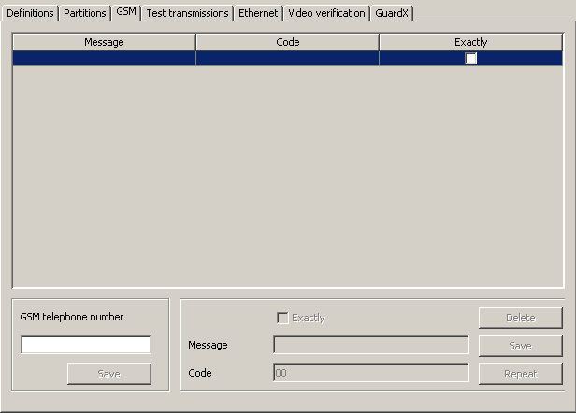
Fig. 44. „GSM” tab (part of „Subscriber” window) before entering the subscriber's GSM telephone number.
Exactly – the option refers to SMS messages. If enabled, the received SMS content must precisely correspond to the character string entered into the „Content” field. If disabled, other characters may appear before and after this character string. The field is available after saving the GSM telephone number.
Message – enter in this field the character string which must occur in the SMS message, or the name predefined for the CLIP type messages received from this telephone (see: Additional configuration of GSM modules). Receiving the defined SMS or CLIP message will be recognized by the monitoring station program as receiving the event code. The field is available after saving the GSM telephone number.
Code – enter in this field what kind of event code is to be generated on receiving the SMS or CLIP type message defined in the „Content” field. The field is available after saving the GSM telephone number.
Buttons:
Delete – deletes the selected messages from the list.
Save – saves the data entered into the database.
Repeat – allows to add a new message with parameters similar to those of the already existing one. To do so, click on the message you want to duplicate, and then on the "Repeat" button. After making changes in selected fields (you need to change the content), click on the "Save" button.

„Test transmissions” tab
The tab is available after adding identifier and selecting one of the types for it.
Active – select this box if the monitoring station program is to monitor receiving test transmissions.
Type – select in this field the test transmission type:
- After time – the test transmission must be received exactly after elapse of a specified time period from the last transmission (irrespective of whether it was a test transmission, or another event was sent). If the test transmission fails to be received after defined time (taking into account preprogrammed tolerance), or is received earlier, the station program will display the trouble handling window with appropriate information.
- On time – the test transmission must be received every specified number of days at the defined time. If the test transmission fails to be received at the defined time (taking into account preprogrammed tolerance), or is received earlier, the station program will display the trouble handling window with appropriate information. Receiving the test transmission at another time or on another day will also result in trouble being reported. The first test transmission must be received before expiry of the time defined in the „Days” field. Receiving it is recognized as synchronization of the control panel and the monitoring station.
- In time – any transmission must be received within the defined time interval. The time is counted from the last transmission (irrespective of whether it was a test transmission, or another event was sent). If no transmission is received within the defined time interval (taking into account preprogrammed tolerance), the station program will display the trouble handling window with appropriate information.
Days – define in this field the number of days. The maximum value that can be entered is 31 days. In case of the „On time” transmission, entering 0 or 1 will be interpreted in the same way, i.e. as defining transmissions to be received every day at the specified time.
Hours – define in this field the number of hours and minutes for the „After time” and „In time” transmissions, or the hour and minutes for the „On time” transmissions.
Tolerance – define in this field the tolerance in minutes with which the transmission can be received. It is recommended that the tolerance be defined, as the transmission may be received, for a variety of reasons, a little earlier or later (e.g. because of busy status of the telephone line, the control panel was unable to establish connection, the control panel clock out of synchronization with the monitoring station clock, etc.). The maximum tolerance value is 120 minutes.

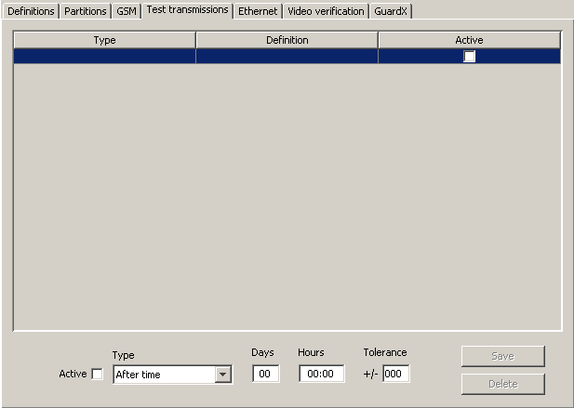
Fig. 45. „Test transmissions ” tab (part of „Subscriber” window) prior to defining test transmissions for the subscriber.

Buttons:
Save – saves the data entered into the database.
Delete – deletes the selected transmission from the list.

„Ethernet” tab
The tab is available after one type of identifier is added to it. The tab parameters should be defined for the subscriber's system identifier.
Note: Fill in the fields in the "Ethernet" tab when defining subscribers handled in the extended mode. Leave the fields blank for subscribers handled in the simple mode.
ETHM key – enter in this field a sequence of 1 to 5 alphanumeric characters identifying the Ethernet module. It must correspond to the ETHM key defined in the subscriber's control panel.
No. – consecutive number assigned automatically when you click on the „Save” button. It can be a number from the range of 0 to 255. One Ethernet card can support up to 256 subscribers.

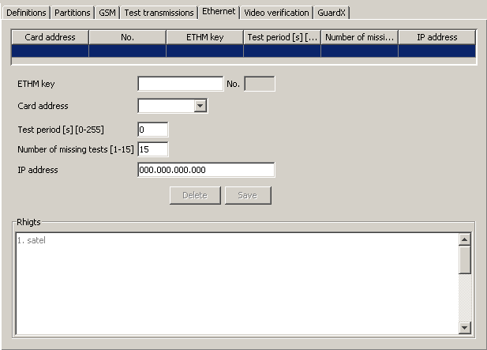
Fig. 46. „Ethernet” tab (part of „Subscriber” window) before entering data in the STAM-2 PRO program.

Card address – select in this field address of the STAM-1 Ethernet card to which the subscriber will be assigned.
Test period [s] [0-255] – determine in this field the time between successive communication tests. Values from 0 to 255 seconds can be entered. Entering 0 means that the communication test will be disabled. Factory default: 0.
Number of missing tests [1-15] – determine in this field, how many unsuccessful communication tests are required before trouble is reported (the trouble handling window will be displayed). Values from 1 to 15 can be entered. Factory default: 0.
Note: Caution is advisable when selecting parameters to be entered in the „Test period” and „Number of missing tests” fields. If you enter low values in both fields, the frequency of reported troubles may increase, which not necessarily means any actual communication problems.
IP address – IP address of the Ethernet module through which it will be possible to control the site state using the virtual keypad. It can be entered in the form of an IP address (four decimal numbers separated by dots) or in the form of a name [only STAM-2 PRO].
Buttons:
Delete – deletes all data.
Save – saves entered data into the database.
In case of the STAM-2 PRO program, you can specify additional rights for the users. In the lower part of the "Ethernet" tab, the "Rights" window is situated. The window contains the list of all users who are allowed to control the site state using the virtual keypad. This list will be available for editing after the data which define the Ethernet module are entered and saved. Click on the name of the user to select it and grant access privileges to the user. In order to remove user permissions, deselect the user name.

„Video verification” tab
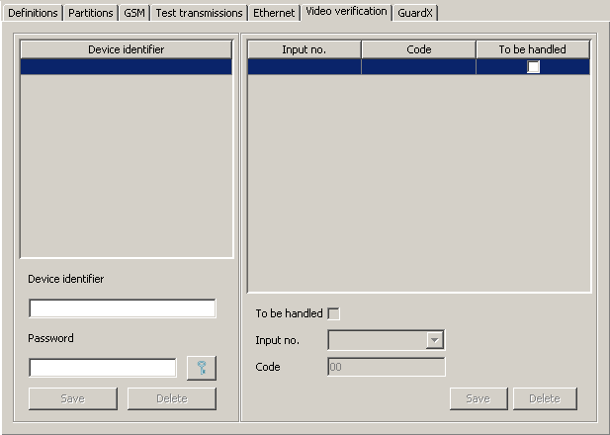
Fig. 47. „Video verification” tab (part of „Subscriber” window) before entering data.

The tab is available after an identifier is added and one of the types selected for it.
Device identifier – identifier defined in the VIVER module, which sends information about the zone violation.
Password – password to log in the module to the monitoring station. You can enter from 1 to 16 alphanumeric characters (numbers, letters and special characters).
Buttons:
– click on this button to see the password entered.
Save – saves the data entered into a database.
Delete – deletes all data.
Note: Editing the parameters below is only possible after the device identifier and password have been defined.
To be handled – check this box if the event generated after violating the module input is to be handled.
Input no. – the field where you should indicate the input number. There are four inputs on the module board – A, B, C and D, to which the camera is to be connected and the TEST input to check the test transmissions.
Code – enter in this field the event code that is to be generated after activating a specific input of the visual alarm verification module.
Buttons:
Save – saves the data entered to the database.
Delete – deletes all data.

„Guardx” tab [only STAM-2 PRO]
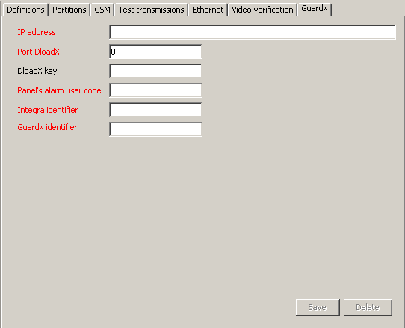
Fig. 48. „GuardX” tab (part of „Subscriber” window) before entering data.

Note: The tab is available at all times, while the changes will only be saved after an identifier is defined.
It allows you to define the appropriate settings necessary for correct communication of the STAM-2 monitoring station with the GuardX program, version 1.08.001 of 02.15.2011 or later. Before entering the data, the names of fields to be filled in are displayed in red. When the fields are filled in, they change their color to black. The field name will also remain red if you type in an invalid value.
IP address – enter in this field the IP address used by the Ethernet module connected to the control panel. It can be entered as a name or in numerical form.
Port DloadX – enter in this field the TCP port number, which is defined in the INTEGRA series control panel for communication with the DloadX program. It will be used for communication between the GuardX program and the control panel. You can enter a value from 1 to 65535. It must be different from that entered for the other ports.
DloadX key – enter in this field a sequence of 1 to 12 alphanumeric characters for the key that was defined in the INTEGRA control panel for data encryption during communication with the DloadX program. It will be used to encrypt data during communication between the control panel and the GuardX program.
Panel’s alarm user code – enter in this field the user code which will be used by the GuardX program during communication with the control panel. The same code must be entered in the panel settings.
Integra identifier – enter in this field the identifier of the INTEGRA series control panel with which the GuardX program will communicate. It consists of 10 characters.
GuardX identifier – the identifier of the computer on which the GuardX program is installed. It consists of 10 characters. The same identifier must be entered in the control panel settings.
Buttons:
Save – saves the data entered to the database.
Delete – deletes all data.

„Nonstandard codes ” tab

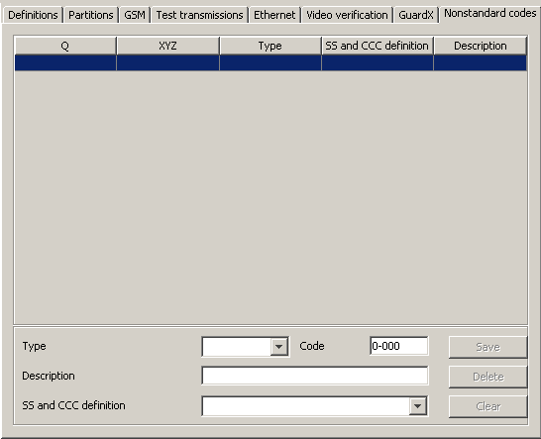
Fig. 49. „Nonstandard codes” tab (part of „Subscriber” window) before defining nonstandard Contact ID codes.

The tab is available after adding identifier and selecting „Contact ID” type. It allows to define nonstandard codes of events sent in Contact ID format.
Type – select in this field the type of edited code:
- Alarm – the code informs of an alarm at the subscriber's site. It requires intervention of the monitoring station operating personnel (after receiving the code, the alarm handling window will be displayed).
- Arming – the code informs of arming. It requires no intervention of the monitoring station operating personnel, but allows to verify whether the arming occurred within the time interval defined for the „Time area” („Partitions” tab).
- Disarming – the code informs of disarming. It requires no intervention of the monitoring station operating personnel, but allows to verify whether the disarming occurred within the time interval defined for the „Time area” („Partitions” tab).
- Trouble – the code informs of a trouble at the subscriber's site. It requires intervention of the monitoring station operating personnel (after receiving the code, the trouble handling window will be displayed).
- Restore – the code informs of the end of previously reported trouble. It requires no intervention of the monitoring station operating personnel.
- Test – test transmission code. It requires intervention of the monitoring station operating personnel, unless it has been received according to the defined rules (see: „Test transmissions” tab).
- Remark – the code requires no intervention of the monitoring station operating personnel. When received, it will be saved in the event log and audibly signaled.
- Other – the code requires no intervention of the monitoring station operating personnel. When received, it will only be saved in the event log.
Code – enter in this field 4 digits, which have the Q-XYZ format, where:
- Q – digit 1, 3 or 6 (by default: 1 – new event or disarming, 3 – end event or arming, 6 – repeat event).
- XYZ – 3-character code of event.
Description – enter in this field a verbal description of the event which will be represented by the entered code. This description will be displayed in the „Event log” and in the event handling windows.
SS and CCC definition – select in this field how the last five characters of the received code should be interpreted (the whole code format is Q-XYZ-SS-CCC):
- Partition – SS denotes partition number, CCC will be disregarded.
- Partition and zone – SS denotes partition number, CCC denotes zone number.
- Partition and user – SS denotes partition number, CCC denotes user number.
- User – SS will be disregarded, CCC denotes user number.
- Partition and expander – SS denotes partition number, CCC denotes expander number.
- System – SS and CCC will be disregarded.
Buttons:
Save – saves event codes entered into the database.
Delete – deletes selected code.
Clear – deletes all event codes defined for the identifier.

Event handling windows
The handling windows are available to users with the „handling” authority level.
The events can be handled in two ways (depending on the settings – see: „Settings” tab):
- smart distribution of events between workstations. After the monitoring station receives an intervention requiring event, the STAM-2 Server program will decide on which workstation to display the handling window. Taken into account is the number of events queued up for handling on each of the workstations. The handling window will be displayed on the workstation with the shortest queue of events waiting to be processed.
- display of events on all workstations simultaneously. When the monitoring station receives an event that requires intervention, the handling window will be displayed simultaneously on all workstations. At the moment when one of the operators takes any action related to the event handling, the window will be closed at the other operators' workstations.
If the handling window of the previously received event is currently open, the new handling window will not be displayed until it closes. Information on the events unhandled is displayed in the main bar of the STAM-2 Client program (see: Main window of STAM-2 Client program). Flashing icons indicate that there are new events to be handled (not displayed on the screen), and the number next to the icon indicates their quantity. The icon stops flashing, if the handling window is displayed at any of the operators' workstations. A click on the selected icon („Alarm handling”, „Trouble handling” or „Arm status event handling”) will bring up successively the handling windows for events which have been received, but still remain unhandled. The order of display depends on the subscribers' priority and the event receipt time (precedence is taken by the high-priority events which were received first, i.e. remain unhandled for the longest period of time).
Additionally, the handling window will be displayed when a user with the „handling” authority level clicks twice on an unhandled event in the „Event log” window.
You can re-handle the events that have already been handled. To do so, use the "Handle" function available in the drop-down menu which opens when you right-click on an already handled event (see: Event menu).
Note: Pressing simultaneously the Ctrl + Backspace keys will disable the automatic display of the successive event handling windows. Restarting the function is only possible after you manually handle any event.
There are 3 kinds of handling windows for 3 types of events that require intervention. The windows differ in their header color:
Alarm – window header in red. Refers to the alarm event received from the subscriber.
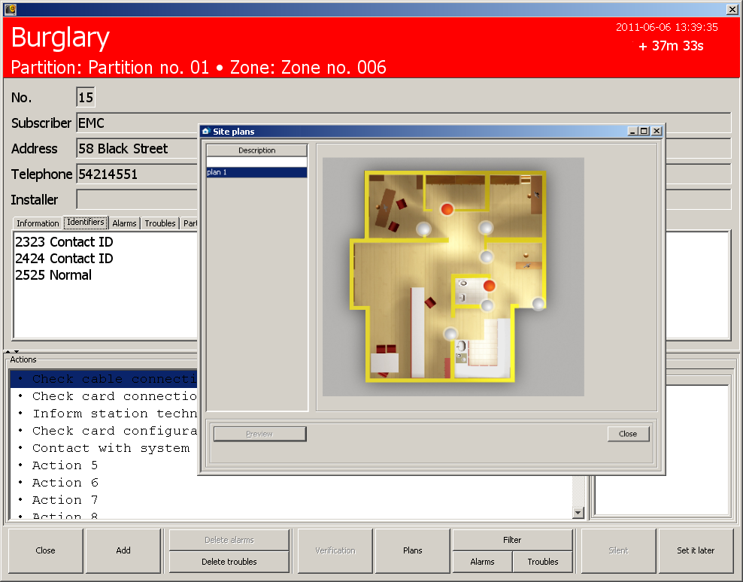
Fig. 50. Example of alarm handling window with open plan of the site where an alarm occurred (only STAM-2 PRO).

Trouble – window header in yellow. Refers to the trouble event, received from the subscriber or generated by the monitoring station (system).

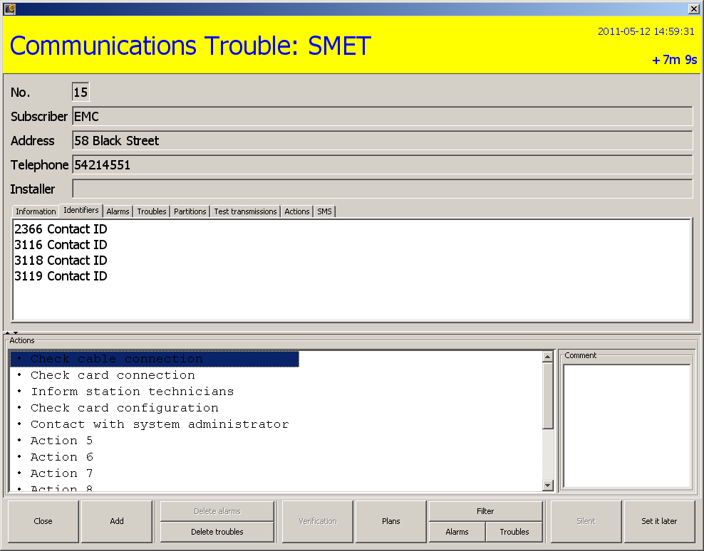
Fig. 51. Example of trouble handling window.

Arm status – window header in dark-blue. Refers to the event generated by the monitoring station (system), which informs of inconsistency between the actual status and the status defined for the partition (partition is armed, and should be disarmed; partition is disarmed and should be armed).
If the window displays the subscriber data, tabs, as well as "Actions" and "Comment", use the button to switch the subscriber data and tabs to fit the entire window height.
If the window only displays the "Actions" and "Comment", using the button will split the window into the subscriber data, tabs, as well as "Actions" and "Comment".
If the window displays the subscriber data, tabs, as well as "Actions" and "Comment", use the button to switch the "Actions" and "Comment" to fit the entire window height.
If the window only displays the subscriber data and tabs, using the button will split the window into the subscriber data, tabs, as well as "Actions" and "Comment".
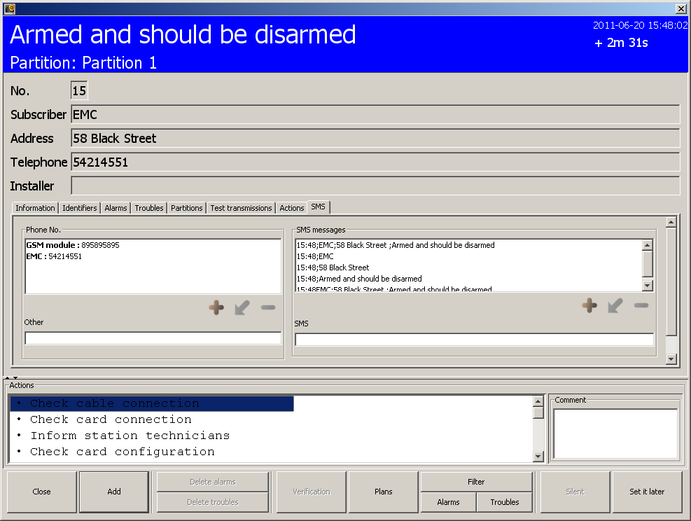
Fig. 52. Example of arm status handling window.

Window header
The handling window header displays the following information:
- Type of event requiring intervention,
- Monitored site data – information displayed in case of events received from the subscriber:
- Partition – partition name.
- Expander – expander name.
- User – name of the security system user.
- Zone – zone name.
- Date and time of the event occurrence,
- Time elapsed from the event occurrence up to the present moment.

Subscriber's data
If the event relates to a subscriber, information about the subscriber is displayed under the header:
- No. – subscriber's consecutive number.
- Subscriber – subscriber's name
- Address – subscriber's address.
- Telephone – subscriber's telephone number.
- Installer – data of the company or person who has installed the security system at the subscriber's site, or is at the present time responsible for maintenance and operability of the system.

Tabs
The following tabs are available for each event:
Information – subscriber's data entered into the "Additional information" field (see: „General” tab in "Subscriber" window).
Identifiers – a list of identifiers defined for the given subscriber.
Alarms – a list of unhandled alarms for the given subscriber. The list includes the following information: date and time of the event, identifier, event description, number of partition and zone / expander / user.
Troubles – a list of unhandled troubles for the given subscriber. The list includes the following information: date and time of the event, identifier, event description, number of partition and zone / expander / user, information on activity and trouble handling.
Partitions – a list of partitions assigned to all identifiers of the given subscriber. The following data are provided:
- identifier,
- partition number,
- partition description,
- information on defined arm status:
- armed / disarmed,
- should be armed / should be disarmed,
- ??? (if the "Arm status control" option is disabled for the partition or the information on partition arm status is not received by the monitoring station).
Test transmissions – a list of test transmissions defined for all identifiers of the given subscriber. The following information is provided: identifier, type of transmission, defined time and tolerance with which the transmission can be received, test status, date and time of the next transmission.
Actions – a list of actions taken by the user when handling the event. The following information is provided: consecutive number of action, date and time of its execution, delay, i.e. the time elapsed since the event was received to execution of the action, user name, action description, a comment typed in by the user.
SMS – tab where you can define the relevant parameters required to notify specified people about the event, and start test transmissions of the GSM receivers to check them for correct communication with the station. If the function is to work, the GSM module must be connected to the station and programmed as an SMS message sending device ("Configuration" window, "Settings" tab - "SMS").

Phone No.
Presented are:
- names and phone numbers saved in the subscriber's "Additional information",
- phone number entered in the "Telephone" field with the subscriber's name (see: „General” tab).
The list of phone numbers can make a permanent contacts book. If it is empty, enter the phone number(s) to which an SMS message is to be sent. In this way, the defined contacts book will be displayed locally (on the given computer workstation) in each event handling window.
The operator can perform the following actions:
- Add a telephone number:
- click on the button to open the "New phone number" window,
- enter in the window the owner name and the phone number to which an SMS message is to be sent and confirm with the "OK" button.
Note: You cannot add a phone number without entering the name of phone owner.
- Change the already entered name and phone number:
- select the name and phone number,
- click on the button to open the "New phone number" window,
- correct the name and phone number in the window and confirm using the "OK" button.
- Remove the name and phone number:
- select the name and phone number,
- click on the button,
- the selected name and phone number will be permanently deleted.
- Add a phone number which will not be saved:
- enter the phone number in the "Other" field.

SMS messages
The program offers 5 different, automatically created messages, which can include:
- data of the subscriber for which the event was generated,
- information on the event itself.
The operator can perform the following actions:
- Send an SMS message:
- select the required number or add a new one in the "Phone No." window,
- select a message in the "SMS messages" window,
- click on the "Send SMS" button.
- Send an SMS message that will not be saved:
- select the required number or add a new one in the "Phone No." window,
- enter the message text in the "SMS" field,
- click on the "Send SMS" button.
- Remove an SMS message suggested by the program:
- select a message in the "SMS messages" window,
- click on the button,
- the selected message will be permanently removed.
- Add own SMS message:
- click on the button to open the "New text message" window,
- enter the text of message in the window and confirm using the "OK" button.
- Change the added SMS message:
- select a message in the "SMS messages" window,
- click on the button to open the "New text message" window,
- correct the message text in the window and confirm with the "OK" button.
Notes:
- You cannot edit the message suggested by the program.
- The edited new message replaces one of the message templates.
- The new message cannot be reedited.

Actions
The window displays the list of actions that can be taken by the user who is handling the event. Depending on their type, the actions can be presented as follows:
- black – defined locally, for the given computer workstation (see: „Actions” tab in "Configuration" window),
- red – for all computer workstations:
- actions defined for the given subscriber that the operator can perform when handling alarms, troubles and arm status events (see: „Partition actions” tab in "Subscriber" window),
- actions defined for the selected system troubles (see: „Actions” tab in "Configuration" window).
- grayed out – actions already taken by the operator.

Comment
You can add an additional comment to the selected action. To do so, select the specific action, hover your mouse over the "Comment" window area, click and type in the text. Then use the "Add" button to confirm the action and the comment entered. It will appear with the selected action in the "Actions" tab and in the detailed list of actions taken in the "Event log" window.
Note: You cannot add any comment to the already performed action.

Buttons
Close – ends handling the event and closes the window.
Add – adds the selected action to the list of actions taken, including the comment to each action entered in the field next to it. The selected action and added comment will appear in the "Actions" tab, and in the detailed list of actions taken in the "Event log" window at each specific event.
Delete alarms – available to the users with "handling" and "clearing alarms" rights. It is only active when there are some unhandled alarms for a given subscriber. The button clears all unhandled alarms. The "Alarm cleared manually" action will appear in the list of activities carried out for this event.
Delete troubles – the button is available to the users with "handling" and "clearing troubles" rights. It is only active when there are some unhandled troubles for a given subscriber. The button clears all unhandled troubles. The "Trouble cleared manually" action will appear in the list of activities carried out for this event.
Verification – the button is active, if the event involved visual verification of the alarm and has been registered by the connected camera. It opens the "Video verification" window (see: Video verification).
Plans – opens the „Site plans” window of the given subscriber.
Filter – the button is available to users having the „viewing” authority. It opens the „Event log” window with the tab in which 3000 recent events received by the station and assigned to the given subscriber will be displayed.
Alarms – the button is available to users having the „viewing” authority. It opens the „Event log” window with the tab in which 3000 recent alarms received by the station and assigned to the given subscriber will be displayed.
Troubles – the button is available to users having the „viewing” authority. It opens the „Event log” window with the tab in which 3000 recent troubles received by the station and assigned to the given subscriber will be displayed.
Silent – mutes the sound signal of alarm / trouble / arm status event.
Set it later / – postpones the event handling.

Video verification
The window displays images sent by the VIVER module (the image appears a few seconds after opening of the window). At the top of the window, the following information is provided:
- date and time when event was received,
- name, identifier and code of the event,
- subscriber's consecutive number,
- subscriber's name.

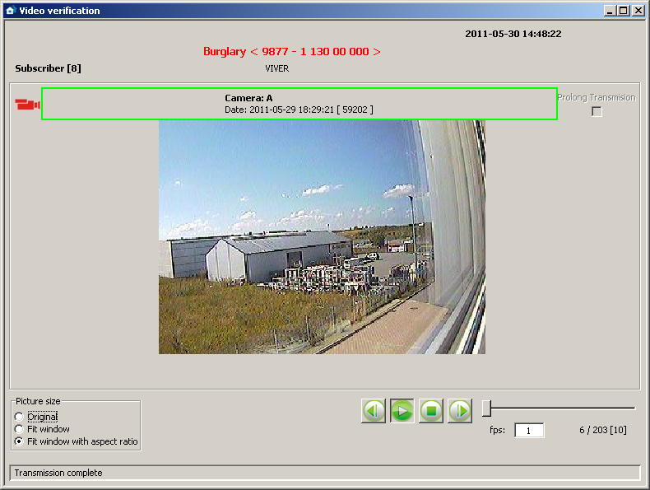
Fig. 53. „Video verification” window.

Camera name, date and time of the image are shown in the frame, the color of which has the following meaning:
green – image made before the event,
red – image made after the event,
blue – "live view" from the camera.
Prolong transmission – if enabled, this option provides you with "live" preview functionality. The transmission time can be extended up to 20 minutes (the preview time is defined by the "Maximum view time" parameter in the VIVER program).
Picture size – you can choose (only during playback) one of the three options: "Original", "Fit window" and "Fit window with aspect ratio". The event handling person can thus adjust the size of the video signal to the size of the image window. By default, the "Fit window with aspect ratio" option is preset.
Buttons:
– rewinds through the recording during playback. Click on the button to move the recording one frame backward.
– starts playback of the recorded video.
– stops playback of the recorded video.
– fast-forwards through the recording during playback. Click on the button to move the recording one frame forward.
The slider next to the buttons makes it easy to scroll through the image sequence.
Fps (frames per second) – the number of frames per second. Factory default: 1.
Next to this field, you can find indication which frame is played at any given time, against the total number of video frames.
On the bar at the window bottom, the following messages may appear:
VAV device online – active connection between the VIVER module and the station.
Transmission complete – no transmission from the VIVER module.

Event log
The window is available to users having the „viewing” authority in the „Event log” category. When opened, the window will display 200 recent events. Events are displayed in the ascending order, from oldest (top) to newest (bottom). If within 5 minutes of the event selection no other event is selected, the last received event will be automatically selected after this time elapses.
Address – address of the device by which the event was received. Events with no card address are system events, generated by the monitoring station program.
Date – date and time when the event was received.
ID – identifier with which the event was received. Some of the system events have an identifier, and the other have not. The events with an identifier relate to:
- arm status,
- no test transmission,
- test transmission at wrong time,
- loss / restore of TCP / IP module communication with control panel,
- loss / restore of communication with TCP / IP module,
- attempt to establish connection with the station through the TCP / IP module.
Code – event code. In case of some events, the following information is given instead of the code:
- USER – in case of the events of "Comment", "Backup created" and "Service start / end" type,
- SYSTEM – in case of system events,
- GSM – in case of the events which inform that SMS message or ring signal (CLIP type message) has been received by the GSM module
- sequence of letters and / or digits – in case of the "Unknown subscriber – no identifier in database" type of events and the events generated for SIA type identifiers.

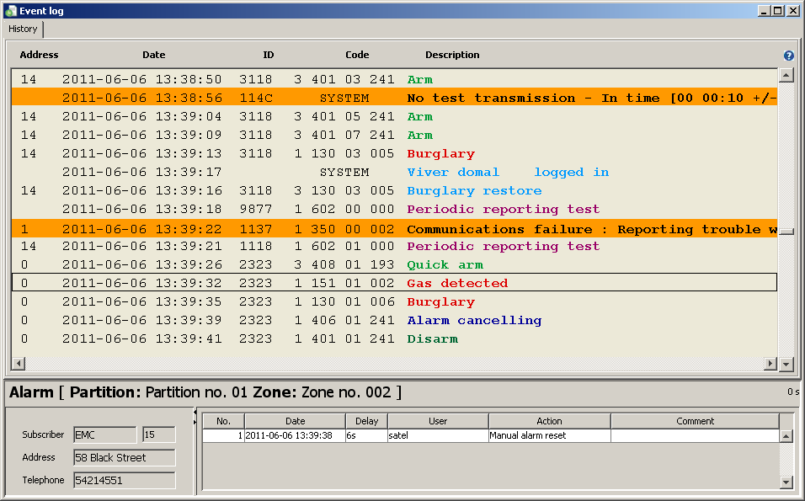
Fig. 54. „Event log” window.

Description – verbal description of the event. Different types of events can be recognized by the description color:
 (red) – „Alarm” type events.
 (light green) – „Arming” type events.
 (dark green) – „Disarming” type events.
 (orange) – „Trouble” type events.
 (brown) – „Restore” type events.
 (violet) – „Test” type events.
 (navy blue) – „Remark” type events and events notifying that SMS message or ring signal (CLIP type message) has been received by GSM module.
 (light blue) – „Other” type events and system events referring to program operation.
 (pink) – comment added by the user.
 (olive) – system events referring to arm status (see: „Time areas” tab).
– pictogram next to the description of the event related to the visual alarm verification.
If the event needs to be handled („Alarm” and „Trouble” type events and arm status system events), the color of the displayed text is white or black, but the whole event is highlighted in color assigned to this type of events.
Note: The events of alarms and troubles which have been cleared are displayed in the event log as handled.
– hover your cursor over the icon to display information about the number of events contained in the given tab.
delay (displayed in the lower right corner above the data on event handling manner) – the time elapsed since receiving the event by the card to receiving it by the computer.
Having selected the required event with your mouse pointer, click twice on it, or press the „Enter” button to:
- display the handling window in case of unhandled events (see: Event handling windows), provided that the user has the „handling” authority
- display the ”Detailed information” window with event details in case of events which are already handled or do not require handling (see: Detailed information)

Event menu
Click on the event with the right mouse button to display menu with the following functions:
Information – click on this item to display the “Detailed information” window (see: Detailed information).
Handle – this feature only relates to the events that require handling. It is visible in the menu of event that has already been handled, and that which is only waiting to be handled. Click on this item to display the handling window for the given event (see: Event handling windows).
Handle – finish (Ctrl+Z) – this feature only relates to the events that require handling. It is visible in the menu of event that has not yet been handled. Click on this item, or press simultaneously Ctrl + Z to handle the event without displaying the handling window.
Verification – this function is only active when the event related to visual alarm verification and video has been recorded owing to the connected camera. A red camera pictogram is displayed in the "Event log" window at the event description (see: Video verification).
Comments – click on this item to display a list with two functions to choose from: "New event" and "To event" (see: Comments).
Filter – click on this item to display the „Filter” window (see: Filter).
Filters – click on this item to display a selection list of items (see: Filters).
Status board – click on this item to display the „Status board” window.
Edit – click on this item to display a window for editing the data of subscriber, to whom the selected event concerned.
Service – click on this item to display the "Service" window (see: Service).
Font – click on this item to select smaller or larger font to be used in the "Event log" window.
Colors – click on this item to select color scheme used to display the list of events in the "Event log". There are two graphic styles: "STAM1" and "STAM2" to choose from.
Save as pdf – the function allows you to create a report of the events in PDF format. Click on this item to display the "Save" window where you can choose / create a folder to save the report. The report consists of all events in a given tab.

Event details
Displayed under the event list is additional information on the selected event. The information may include:

Event data
Event type – information on the event type is always displayed. Additionally, a description defined for this event is given.
- Alarm – alarm at the monitored site.
- Arming – arming at the monitored site.
- Disarming – disarming at the monitored site.
- Trouble – trouble at the monitored site or at the monitoring station.
- Restore – end of trouble.
- Test – test transmission.
- Remark
- SMS – event informing that SMS message has been received by the monitoring station GSM module.
- Telephone – event informing that ring signal (CLIP type message) has been received by the monitoring station GSM module.
- Other
- Log-in – system event informing that user has logged in the STAM-2 program.
- Log-out – system event informing that user has logged out of the STAM-2 program.
- Comment – a comment added by the user
- Wrong arm status – system event informing that the site arm status is inconsistent with the defined time areas.
Monitored site data – information displayed in case of events received from the subscriber:
- Partition: name
- Expander: name
- User: name
- Zone: name
- Phone nr: number

Subscriber data
Displayed in tabular form is basic information on the subscriber, to whom the selected event relates. The information includes:
- Subscriber – subscriber's name
- Subscriber's consecutive number,
- Address – subscriber's address.
- Telephone – subscriber's telephone number.

Data on event handling method
Displayed in tabular form is information on how the selected event is handled. The information includes:
- No. – consecutive number of the executed action,
- Date – date and time when the action was executed,
- Delay – difference between the time of receiving the event by the monitoring station and its handling by the operator,
- User – name of the operator who handled the event,
- Action – description of the actions taken in connection with receiving an event that requires handling, and information on canceling the trouble.
- Comment – comment added to the actions in the event handling window (see: Comment).
Select an action with your mouse pointer and right-click on it to display a menu with two functions available:
Details – select this function to display the "Details" window, where all information about the selected action is available.
Set the width – select the function to automatically adjust the column width to fit the length of the texts contained in them.

If the window next to the event log and event data shows:
- the data on subscriber and event handling method, using the button will switch the subscriber data to fit the entire width of the window.
- only the data on event handling method, using the button will split the window into the subscriber data and the data on event handling method.
- the data on subscriber and event handling method, using the button will switch the data on event handling method to fit the entire width of the window.
- only the subscriber data, using the button will split the window into the subscriber data and the data on event handling method.

Comments

New event
Selecting this command will display the "Comment" window, so you can add a comment type event or generate a trouble event for selected site with the content of the comment entered (e.g. in order to provide information to the operators). If the operator does not choose another subscriber, the new event will be added to the event log of the subscriber to whom the event (from the level of which the operator selected the "Comments" option) related. In the "Event log" window, the new event will be displayed without an assigned identifier and code, with the USER information and a description in the form of content entered in the appropriate field. In addition, the trouble will appear as an event to be handled. In the table of data relating to the event handling method (see: Event details), the "Comment added" action and all information concerning this action will appear.

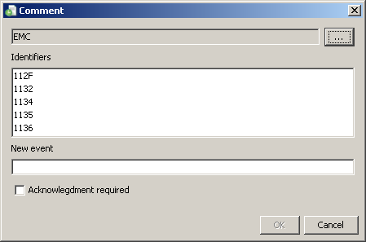
Fig. 55. „Comment” window when creating a new event.

Subscriber – the name of the subscriber to whom the event from the level of which the "New event" command was selected is assigned. The subscriber data will be displayed in the "Event log" window in the subscriber data table (see: Event details) at the new event.
– a click on the button will enable you to select another subscriber to whose event log the newly created event will be added.
Identifiers – the field displays identifiers assigned to the subscriber whose name appears in the field above.
New event – enter in this field the content of event being added, which will appear in the "Event log" window.
Acknowledgment required – selecting this option will generate a new trouble event which requires handling, with the same name as that entered in the "New event" field.
Buttons:
OK – saves the changes made to the database.
Cancel – closes the window.

To event
After selecting this command, the "Comment" window will be displayed. Using this window, you can add a comment to the event, whose content is displayed in the "Event log" window in the table of data related to the event handling method (see: Event details) in the "Action" column, together with all information relating to this action.

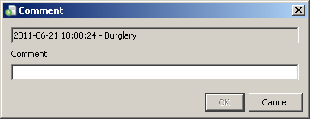
Fig. 56. „Comment” window when creating comment to an event.

Event – the field displays data on the event to which a comment is to be added: the time it was received by the monitoring station and its description.
Comment – enter in this field the content which will be displayed as an action taken when handling the chosen event.
Buttons:
OK – saves the changes made to the database.
Cancel – closes the window.

Filter
The filter allows to define criteria, on the basis of which events are to be displayed in a new tab in the „Event log” window. After opening, the „Event log” window will display 200 recent events. Using the „Filter” window makes it possible to display a greater number of events and precisely specify which events are to be displayed.
Filter – enter in this field the name to be given to the new tab in the „Event log” window.
You can select the following criteria of displaying events, by selecting the adjacent box:
Subscriber – events referring to the subscriber:
- with a specific identification number – ID,
- with a consecutive number – No.
- with a specific name – Name.
You can select only one criterion that must be checked and its value entered in the adjacent field. The events will include both those received from the subscriber and the system events generated in connection with this subscriber.
Identifier – events with a specified identifier. Enter the identifier in the field obok.
Partition – events coming from the given partition. Enter the partition name in the field nearby.
Card address – events referring to the monitoring station device with a specified address. Select an address from the dropdown list in the field nearby. The events will include both events received by the selected device and the system events generated in connection with this device.
System – system events.
Unhandled – unhandled events.
Video verification – events related to the visual alarm verification.
Program user – system events referring to the program user. Enter the user name in the field below.
Description – events which contain a specified text in their description. This text is to be entered in the field below. If the „Description” option is selected but no text is entered into the field below, all events will be displayed.

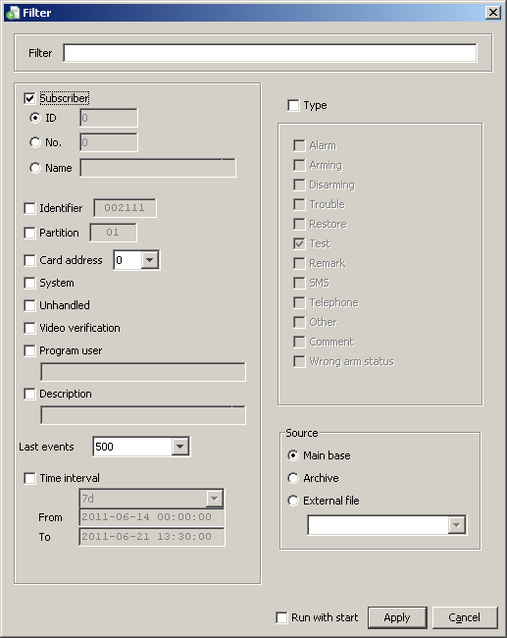
Fig. 57. „Filter” window.
Last events – the last events that have been received by the monitoring station. You can select 10, 50, 100, 500, 1000, 2000 and 3000 of the last events. By default, the 500 last events is preset.
Time interval – events received within the time period defined in the fields below. There are 2 options to choose from:
- you can select a specific number of hours (h) or days (d).
- you can define a time interval in the "From" and "To" fields, indicating exact date and time.
Type – events of a specific type. Define the type by selecting the box next to description:
- Alarm
- Arming
- Disarming
- Trouble
- Restore
- Test
- Remark
- SMS
- Telephone
- Other
- Comment
- Wrong arm status
Source – events coming from a specific place where they are stored. You have 3 options to choose from:
Main base – all events saved to the program database.
Archive – events stored in the archive.
External file – events archived by means of the StamArchiver.exe program, stored in an external file (see: Archiving events to file).
Run with start – if this option is selected, the "Event log" window will open together with a tab which will display events according to the criteria selected for the given filter. This will be the case only if the selected filter is saved to the program database.
Buttons:
Apply – displays a new tab with events meeting the new filter requirements.
Cancel – closes the window without saving the changes made.

Archiving events to file
The "Server" catalog (default access path: C:\Program Files\Satel\STAM-2\Server) contains the StamArchiver.exe program. It is a tool for archiving events that will be saved to an external file. Access to them will only be possible by means of the "Filter" function in the "Event log" window. In order to perform archiving, close the STAM-2 server program and run the application. A window will open where you can enter the following parameters:
Administrator Login – login of the user having the "Supervisor" status.
Password – password of the user having the "Supervisor" status.
From date / To date – time interval the events from which will be moved to an external file. The time of starting and ending the archiving for the selected date is 0:00. For example, for archiving the year 2010 events, set the time period from 01.01.2010 to 01.01.2011
Target directory – access path to the directory in which the archived events will be saved. You can also use the button next to this field, which will allow you to select or create a directory for saving events.
Name of backup – name of the file where the events will be archived.
Comment – text that will appear at the file name in the "External file" field in "Filter" window.
Vacuum (defragmentation of the data base) – selecting this option will minimize the size of the database file during the archiving of events.

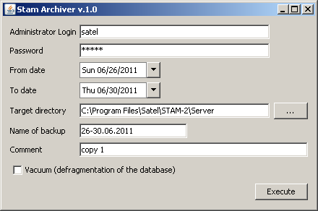
Fig. 58. Stam Archiver program window.

Button:
Execute – the button allows you to perform the archiving of events. After using the button, a message will be displayed to prompt you to make a database backup copy (STAM.db). Make the backup copy, if necessary, and click on the "OK" button. Another message will appear indicating that the backup process may take more than an hour. A next click on the "OK" button will open the window which shows the archiving progress. If the program detects any errors during the archiving, it will indicate it with a relevant message. After completion of the archiving process, a window with suitable information will appear. If the database does not contain any events meeting the defined parameters, the archiving process will not start. In such a case, close the progress window with the "ESC" button, and the program window with the button.

Filters
When you select this command, a menu will appear with the following functions:
[Filter name] – after saving the defined filter(s), their names will be displayed at that place. Click on the selected name to open a tab in the "Event log" window with the events filtered according to the settings of selected filter, or the user will be automatically moved to it (if the "Run with start" option was selected when creating the given filter). The tab name will be the name of the filter.
Save present – click on this item to save the parameters of the currently edited filter. Its name will appear in the dropdown list after you click on the "Filters" item.
Filter manager – click on this item to open the "Filter manager" window.

Filter manager
This window is used for management of the saved filters.

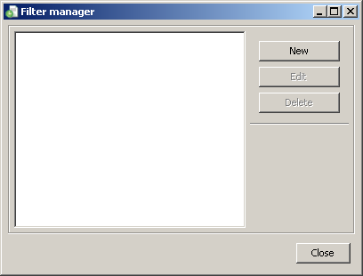
Fig. 59. „Filter manager” window.

Buttons:
New – opens the "Filter" window.
Edit – the button is available after adding a new filter and selecting its name in the main part of the window. It opens the "Filter" window for data editing.
Delete – the button is available after adding a new filter and selecting its name in the main part of the window. It removes the selected filter.
Close – closes the window.

Service
If the operator considers it necessary (for example, during maintenance of the object), he can disable a subscriber for duration of service work. The subscriber will be inactive during the service work for a time period specified by the operator (see: „General” tab). After selecting an option in the event menu, the "Service" dialog will be displayed.

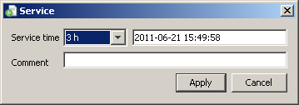
Fig. 60. „Service” window.

Service time – you can select a specified number of hours (h).
Date – date and time of completion of the service work. Both values are defined automatically, taking into consideration the number of hours ahead, indicated in the "Service time". The service may be terminated earlier, after using the "Service end" option, available in the "Status board" window (see: Status board).
Comment – the field to enter the text that will appear in the "Event log" window in the table of data related to the event handling method (see: Event details) in the "Comment" column.
Buttons:
Apply – saves the settings of the service work time to the database.
Cancel – closes the window without saving the changes made.
Programming the service time for the given subscriber will generate an event that appears in the "Event log" window without an assigned identifier and code, with the USER information and description of the start or end of the service. In case of the start of service event, the name of the operator who entered the subscriber into the service mode is shown. In case of the end of service, the event that will be generated is dependent on the time of ending. If the service ends in accordance with the settings, a system event is generated indicating the completion of service. In case of an early service termination, 2 events will appear in the "Event log" window: one indicating the termination of service by the operator and the other, a system event, indicating the end of service.

Status board
The window is available to all users, but the settings may only be configured by a user having the "server configuration" right. Each subscriber is represented by means of a field with its consecutive number and an appropriate icon, graphically illustrating the subscriber's status. By clicking on one of the icons at the bottom of the window, the user can determine which information is to be currently displayed by means of the icons:
- alarms
- troubles
- arm statuses
- test transmissions

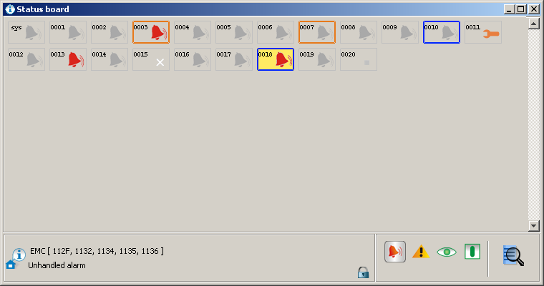
Fig. 61. „Status board” window with examples of subscriber statuses. Icons inform of unhandled alarms at subscribers Nos. 3, 13 and 18. Dark blue borders around subscriber fields Nos. 10 and 18 indicate unhandled arm status. Orange border around subscriber field Nos. 3 and 7 indicates unhandled trouble. The icon at subscriber No. 11 indicates that the subscriber is inactive due to service work.
Icon descriptions:
- no subscriber with this consecutive number
- subscriber inactive
- no unhandled alarm events from the subscriber
- there are unhandled alarm events from the subscriber
- no unhandled trouble events from the subscriber
- there are unhandled trouble events from the subscriber, but the troubles are inactive
- there are active troubles at subscriber's site, but events related to them are handled
- there are unhandled trouble events from the subscriber, and the troubles are active
- subscriber's security system is disarmed (if the icon is flashing, the status is inconsistent with that defined in the „Time areas” tab and the system should be armed)
- subscriber's security system is armed (if the icon is flashing, the status is inconsistent with that defined in the „Time areas” tab and the system should be disarmed)
- security system is partially armed (if the icon is flashing, the status of at least one partition is inconsistent with that defined in the „Time areas” tab)
- no arm status event has been received from the subscriber and the security system arm status remains unknown (if the icon is flashing, the system should be armed/disarmed, according to the settings defined in the „Time areas”)
- no defined test transmissions for the subscriber
- test transmissions were received at the expected time
- no test transmission
- control panel and monitoring station have not been synchronized yet (no test transmission or another event was received, but the time period after which the lack of test transmission would be reported, has not expired yet)
- waiting for test transmission (according to the settings, taking tolerance into account, the transmission is about to come)
– subscriber is inactive for duration of service work.
– icon, next to which information on the subscriber (name, identifiers) and explanations for the icon will be displayed, after clicking on the icon field assigned to the subscriber.
– icon indicating that the objects placed on the status board are locked. A double-click will change it into the icon [only in STAM-2 PRO].
– icon indicating that the objects placed on the status board are unlocked. The function only works after setting the monitored site map, on which objects can be arranged as required. Double click on the icon to lock it again [only in STAM-2 PRO].
 – click on the icon to display the "Find" window (see: Find).

A color border can appear around the icon field:
- red color – if trouble, arm status or test transmission icons are being displayed, and there are unhandled alarms.
- dark blue color – if alarm, trouble or test transmission icons are being displayed, there are no unhandled alarm, but there are unhandled arm status events.
- orange color – if alarm, arm status or test transmission icons are being displayed, there are no unhandled alarms or arm status events, but there are unhandled troubles.
The icon fields are arranged according to the consecutive number assigned to the subscribers (see: Subscribers).
Click twice on the icon field, or select the required field with the mouse cursor and press the „Enter” button to display the „Detailed information” window.
Right click on the field with the icon assigned to the given subscriber to display the menu with the following functions:
Details – click on this item to display the "Detailed information" window with data on the selected subscriber (see: Detailed information).
GuardX – click on this item to open the "GuardX" window. It will display a list of identifiers for which the necessary parameters have been defined to connect to the GuardX program. Once you have selected the required identifier, together with the settings assigned to it, click on the "OK" button. The first time you connect to the GuardX program, the "Open" window will appear. Indicate the directory where the GuardX program is installed and run the application [only STAM-2 PRO].
Keypad – click on this item to display the "Keypad" window. If parameters have been suitably defined for the virtual keypads (see: „Ethernet” tab), their list will appear in the window. Select the required keypad and click on the "Connect" button to get access to the virtual keypad [only STAM-2 PRO].
Plans – click on this item to open the "Site plans" window, where the plan assigned to the selected subscriber will be displayed.
Filter – click on this item to open the "Event log" window with a tab where events related to the given subscriber will be displayed.
Edit – click on this item to open the selected subscriber window, where you can edit the subscriber's data.
Service – click on this item to display a menu with three functions:
Service – will display the "Service" window (see: Service).
Service end – will terminate the service immediately.
Site list – will open the "Site list" window with a list of subscribers who are inactive for duration of service work. Along with the subscriber's identification number and name, the time until which the service work will last is indicated (exact date and time).
Show on mimic board – click on this item to light up the LED corresponding to the selected subscriber on the mimic board.

Find
The function sets criteria for subscriber or identifier searching.
Subscriber – searching in the "Status board" for subscribers with a specified identification number – ID, consecutive number – No. or a specified name. You can only choose one criterion which should be entered in the field on the right.
Identifier – searching in the "Status board" for subscribers with a specified identifier which should be entered in the field below.

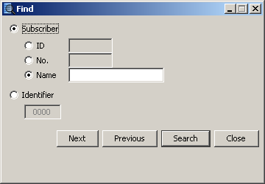
Fig. 62. „Find” window.
Buttons:
Next – shows in the "Status board" the next subscriber following that currently indicated, who meets the set search criteria.
Previous – shows in the "Status board" the subscriber preceding that currently indicated, who meets the set search criteria.
Search – searches for subscribers with specified criteria among the status board subscribers.
Close – closes the window.

Detailed information
Displayed in the upper part of the window is information on the subscriber (compare: „General” tab in the „Subscriber” window):
No.
Subscriber
Address
Telephone
Installer
The following tabs are provided in the lower part of the window:
Information – additional information on the subscriber (compare: „General” tab in the "Subscriber" window).
Identifiers – all identifiers assigned to the subscriber.
Alarms – list of alarm events received from the subscriber, which have not be handled yet.
Troubles – list of trouble events received from the subscriber, which:
- have not been handled, and no trouble restore event has been received (trouble unhandled and active),
- have not been handled, but trouble restore event has been received (trouble unhandled but inactive),
- have been handled, and no trouble restore event has been received (trouble handled but active).
Partitions – list of partitions defined for the subscriber, including information on the actual status of the given partition (armed / disarmed / unknown status), and what the status should be according to the settings defined in the „Time areas” tab (should be armed / should be disarmed / no status defined).
Test transmissions – list of test transmissions defined for the subscriber, including information on the transmission status (correct / incorrect / none).
Buttons:
Handle – available in the „Alarms” and „Troubles” tabs to users having the „handling” authority. It is active if there are unhandled events. Opens the handling window.
Delete – available in the „Alarms” tab to users having the „alarm clearing” authority, and in the „Troubles” tab to users having the „trouble clearing” authority. Enables unhandled alarms / troubles to be cleared. Clearing an alarm / trouble means that the event will be considered as handled (in case of an active trouble, it will be considered as inactive). It is active if there are unhandled events.
Delete all – available in the „Alarms” tab to users having the „alarm clearing” authority, and in the „Troubles” tab to users having the „trouble clearing” authority. Allows to clear all unhandled alarms / troubles with the same identifier as the selected event. It is active if there are unhandled events.
Filter – opens the „Event log” window with the tab in which the subscriber events last 3000 will be displayed.
Plans – opens the „Site plans” window.
Close – closes the window.

Reports and documentation
The window is available to all users, but the scope of operations that can be done therein depends on the user's authority level. It enables printing in PDF format subscribers' reports, reports on work of selected program users, as well as event log and operation statistics of the system (users with the „report printing” authority) and monitoring station documentation (users with the „documentation printing” authority).

„Subscriber” tab
The tab makes it possible to print subscribers' reports and documentation regarding subscribers.
Documentation – select this field if documentation is to be printed.
Report – select this field if report is to be printed.
Subscribers – name of the area where you can set parameters to enable selection of subscriber(s) for whom the report or documentation is to be printed out.
Buttons:
 – used to indicate the access path to the folder to which reports or documentation will be generated. The path will be saved in the adjacent field.
Subscribers – opens the "Subscribers" window, which displays a list of subscribers. The names of subscribers can be sorted by a filter at the top of the window. To print a report or documentation of one or more subscribers, hold down the Ctrl key and left click on the subscribers to select their name, and then confirm your selection using the "Apply" button.
Identifiers – available when you select the subscriber's name in the field above. It opens the "Identifiers" window in which a list of identifiers assigned to the subscriber is available. All identifiers are highlighted. In order to select only some of them, hover your mouse cursor over the identifier to deselect it. Once you confirm your selection using the "Apply", only the selected identifiers will be displayed at the subscriber's name. This means that only the selected subscriber's data will be included in the report.
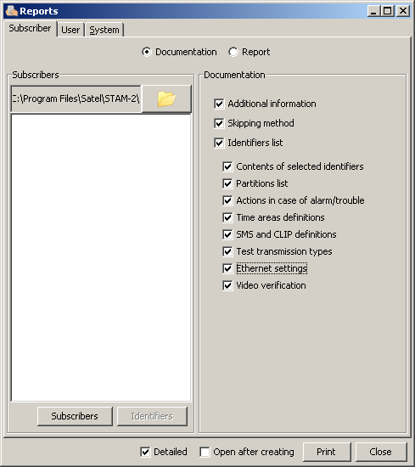
Fig. 63. „Subscriber” tab in „Reports” window with „Documentation” field selected.

Documentation – options available after selecting the „Documentation” field. Use them to determine which data will be included in the report:
- Additional information
- Skipping method
- Identifiers list
- Contents of selected identifiers
- Partitions list
- Actions in case of alarm/trouble
- Time areas definitions
- SMS and CLIP definitions
- Test transmission types
- Ethernet settings
- Video verification

Report – options available after the „Report” field is selected. They allow to define which event types will be included in the report:
- Alarm
- Arming
- Disarming
- Trouble
- Restore
- Test
- Remark
- SMS
- Telephone
- Other
- Comment
- Wrong arm status
Time interval – available, after „Report” field is selected. Define the time interval of the report in the „From” and „To” fields. By default, the time range is set at one week.
Archive – selecting this field allows you to print the report with the given subscriber related events, which can be found in the archive.

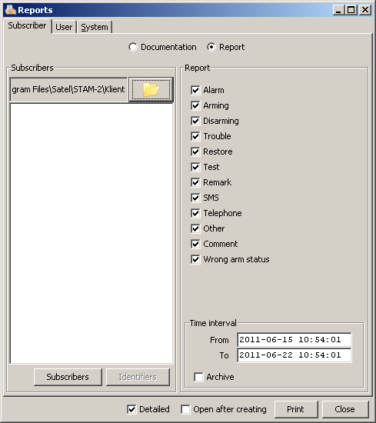
Fig. 64. „Subscriber” tab in „Reports” window with „Report” field selected.

„User” tab
The tab makes it possible to print reports on program users' work.
Operator – the field allows selection of the program user to whom the report is to refer.
What should be printed – these options enable you to define which additional information (except for the user's name, address, telephone and status) is to be included in the report:
- Alarms handled
- Troubles handled
- Arm status events handled
- Shift starts and ends
- Comments
- Statistics
Time interval – time range of the report is to be defined in the „From” and „To” fields. By default, the time range is set at one week.

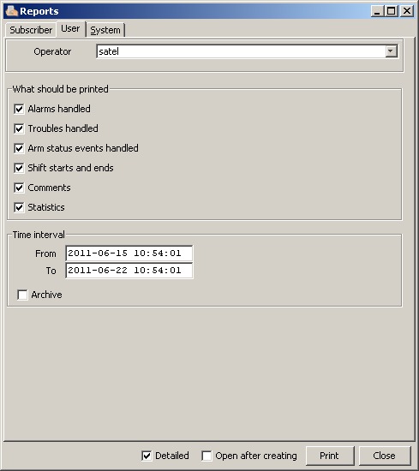
Fig. 65. „User” tab in „Reports” window.

Archive – selecting this field allows you to print the report with the given user related events, which can be found in the archive.

„System” tab

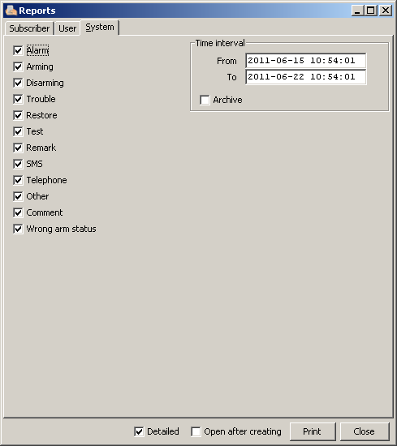
Fig. 66. „System” tab in „Reports” window.

The tab enables printing reports on the monitoring station performance.
You can define in this window which event types will be included in the report:
- Alarm
- Arming
- Disarming
- Trouble
- Restore
- Test
- Remark
- SMS
- Telephone
- Other
- Comment
- Wrong arm status
Time interval – time interval of the report is to be defined in the „From” and „To” fields. By default, the time range is set at one week.
Archive – selecting this field allows you to print the report with the monitoring station operation related events, which can be found in the archive.
Detailed – if this option is selected, the reports will be generated together with a list of actions taken by the operators when handling events.
Open after creating – if this option is selected, the report will be automatically opened after being generated.
Buttons:
Print – generates report to a selected file.
Close – closes the window.

Notes
The window is available to all users. It consists of two parts.
In the first part of the window, a list of notes created by all users of the program is displayed in a tabular form. The list includes the following information: consecutive number of the note, date and time of making the note, name of the user who made the note, as well as its title. Depending on the needs, the displayed data can be sorted by columns. Additionally, the whole columns can be moved in relation to each other. To do so, click your mouse cursor on a column name and holding down the left mouse button drag the column to a selected location. The displayed notes can be edited or deleted. You can also add new ones.
In the second part of the window, named "Message", you can highlight a selected note in the upper table to display information contained in the note.
Buttons:
Update – updates the list of notes.
On time – the window with a list of received „On time” notes will be displayed. Click on the „Clear” button in the window to delete the notes.
New – opens the window in which a new note can be created.
Edit – allows you to edit the already existing „Normal” type notes. Active when a note is selected in the window.
Delete – deletes the selected note. Active when a note is selected in the window.
Close – closes the window.

Creating new note
Click on the "New" button to display a window where the user can create a new note. There are 2 types of notes:
- Normal – to be sent to the concrete person or a certain group of persons immediately after being created. You can also select by whom the note can be deleted.
- On time – to be sent to the concrete person or a certain group of persons, but activated at the defined time during the specified time interval on the selected days of week. Selecting this type of note activates the fields you can use to select for whom the note is intended and set the precise time interval (time, date, weekday) determining when the note is to be delivered.
Note: In the "Title" field, note window, the html format is supported by the program. Thus you can, for instance, make the note title bold and colored. For example: entering the <html><font color=ff0000><b>title</b></font></html> text means that the note title will be red (ff0000) and bold (b).
Buttons:
Save – saves the changes made to the database.
Close – closes the window.

License agreement
- SATEL Sp. z o.o., a limited liability company, having its registered office at 79 Schuberta Street, 80-172 Gdansk, Poland, entered in the Register of Entrepreneurs kept by the District Court Gdansk-North in Gdansk, 7th Economic Department of the National Court Register (KRS), under KRS number 0000178400, NIP taxpayer number 584-015-40-38, share capital PLN 1,830,000 (hereinafter the "Licensor") hereby grants a nonexclusive license to use the STAM-2 program, hereinafter called the "Program", supporting operation of the computer installed base receiver card of STAM-1 P or STAM-1 PE monitoring station, hereinafter called the Device, in the following fields of use:
  - loading the Program into the computer memory and replicating the Program in the computer memory;
  - adapting the Program, without changing its source codes, for the Licensee's hardware platform and configuration,
- however, exclusively for the use of the Device according to its intended purpose.
- The License shall be granted to each Owner of the Device. The granted License may not be transferred, including sub-license, lease or rental to third parties in any way, but only with transfer of the title of ownership to the Device.
- The License is granted against payment by the Licensee of the one-time license fee, fixed on the basis of the current price-list of the Licensor.
- The „STAM-2 Server” program may only be installed on one computer, while the „STAM-2 Client” program - on several computers, however the „STAM-2 Client” may only be simultaneously used on the number of workstations specified in the invoice received from the Licensor.
- The right to use the Program is defined by the hardware key and the unique LICENSE CODE which are assigned to the Licensee. The license code 1) shall determine the Licensee's authority level, as well as some options of the Program, and 2) shall be made available to third parties in no other way than together with the Device, in accordance with Item 2 above. The license code makes it possible to use the Program on the computer intended for installation of the Program. Such a code will be assigned only once. In justified cases, for example, hardware failure or replacement, or as specified below, the code may be assigned once more.
  - Having installed the Program, the Licensee shall register the Program, by means of the Licensor's website, fax or mail, by sending to the Licensor the individual serial number of the hardware key assigned to the Licensee, based on which the Licensor will create a unique license code for each installation. The code will be sent to the Licensee by e-mail, or by means of anther data carrier. In order to make the Program operable, the code must be entered into the Program.
  - During 30 days of the installation, the Program will work without the license code, and afterwards the hardware key will be permanently disabled by the Program. In this state, the Program will be functioning for a certain period of time and then it will be blocked. Should this happen, the Licensee must purchase a new hardware key and install it in the Program (losing the data of supervised facilities and the history of events). In this case, the Licensee shall carry out another installation against payment, as provided for in the current price-list of the Licensor.
  - The Licensor shall make sure that the hardware key remains permanently in the computer on which the „STAM-2 Server” Program is running, as lack of the key will cause unregistration thereof. In such a case, to ensure further operation of the Program, the Licensee shall be obliged to purchase a new hardware key from the Licensor and carry out another installation against payment, as provided for in the current price-list of the Licensor.
- The Licensor may make Program updates available to the Licensee, provided they are created, for a period of 12 months from the Program purchase date. After expiry of the twelve months from the Program purchase date, the updates can be provided to the Licensee against payment, according to the current price-list of the Licensor. The Licensee shall make no claims in relation to the Licensor for creating updates or upgrades to the Program. Updates and upgrades will be made available to the Licensee in accordance with the Licensor's work process and trade policy.
- The Program shall be delivered and may only be used in the form of computer readable resultant code. In particular, the Licensee shall not be allowed to:
  - disassemble, decompile, translate or try to otherwise reverse engineer the source code of the Program, or create derivations of the Program or components thereof, even if such actions result from the intention to repair errors or run an inoperative Program;
  - remove, alter or cover copyright information and notices of intellectual property rights that are in the Program;
  - create derivative programs (works), make copies, translate, adapt, change layout, or otherwise modify or disseminate the Program (in electronic form or otherwise), or any copy, adaptation, transcription, or mixed version thereof;
  - make the Program or copies thereof available to third parties, regardless of the purpose of such actions, including the service purposes or repair of other defects, unless it is necessary for using the Program or the Device by the Licensee, according to their intended purpose, or the service or repair of defects is to be carried out by an entity authorized by the Licensor.
- Materials for the Licensee are attached to the Program in electronic form (as Help files) only to facilitate the use of the authorized version of the Program by the Licensee. The Licensee shall have no right to use, copy, modify or disseminate the end user materials, make adaptations, transcriptions or mixed versions thereof for any other purpose without previous explicit authorization from the Licensor.
- Any liability of the Licensor for defects of the Program and materials attached thereto, including liability under the guarantee and warranty for physical defects shall be excluded, except for the warranty for legal defects. In particular, the Licensor shall bear no liability for any damages or errors caused by the Program, both direct and consequential, loss of profit, etc. Specifically, the Licensor does not guarantee that the Program will work faultlessly in all circumstances. The Licensor guarantees no compatibility of the Program with subsequent updates or versions of the software environment the Program works in. Furthermore, the Licensor gives no guarantee as to merchantability or suitability for a particular purpose. Also, the Licensor does not guarantee that 1) the Program will meet the needs or expectations of the Licensee; that 2) the Program use will be trouble-free; nor that 3) the irregularities, if any, will be or can be rectified. The Program is delivered on the „AS IS” basis, without any explicit or implied guarantee of fitness for particular purposes. The Licensor's liability which under mandatory legal provisions can not be excluded by this clause, shall be limited to the amount of one-time paid license fee.
- The Licensor acknowledges that this Agreement shall not make him Owner of or grant him any ownership rights to the Program, or any related patents, copyrights, trademarks or other intellectual or industrial property rights whatsoever, except for the rights arising from the granted license.
- The Licensor shall retain the copyrights to all copies of the Program recorded on the original data carriers, and to the subsequent copies of the Program made at any time whatsoever, irrespective of the form or data carriers on which the original or other copies were recorded.
- This License does not mean the sale of the original or any next copy of the Program. This License shall not assign to the Licensee the title of ownership to the Program, or to the copyrights to the Program, but only the limited right to use the Program.
- The Licensee may, without consent of the Licensor, make for his own needs one backup copy of the Program for archive purposes, however such copy may not be used simultaneously with the Program. When making the backup copy, the Licensee shall be obliged to reproduce on that copy the reservation of the Licensor's copyrights or any other suitable notices that were on the original Program. The Licensee is entitled to make copies of the user documentation. This provision does not infringe upon the Licensee's rights arising from Art. 75 of the Law on Copyright and Derivative Rights of 4 February 1994.
- The Licensee shall make every effort to prevent infringement upon the Licensor's rights.
- The Licensor shall have the right to terminate the license granted to the Licensee if the Licensee violates these terms and conditions of the license. If the license is terminated by the Licensor, the Licensee shall be obliged to immediately return to the Licensor the Program carriers being in Licensee's possession and remove the Program from the computer memory. Termination of the license shall not result in refund of the sum paid for the license.
- All declarations, notices and applications made by the Parties shall only be made in written form, or else the notices and applications shall have no legal or actual effect.
- These terms and conditions of the license constitute the exclusive basis for the rights and obligations of the Parties to the extent of the subject-matter hereof and supersede any and all previous arrangements and settlements between the Parties in this respect.
- The applicable law shall be the Polish law. The court competent to settle disputes shall be the Court in Gdansk.
- Installation of the Program shall mean acceptance of the terms and conditions of this Agreement by the Licensee.

SATEL sp. z o.o.
ul. Schuberta 79
80-172 Gdańsk
POLAND
tel. + 48 58 320 94 00
info@satel.pl
www.satel.pl



MONITORING STATION
STAM-2/STAM-2 PRO


USER MANUAL
Program version 1.5.0 stam2_f_en 05/11
druk:
62,63,0,61,60,1,2,59,58,3,4,57,56,5,6,55,54,7,8,53,52,9,10,51,50,11,12,49,48,13,14,47,46,15,16,45,44,17,18,43,42,19,20,41,40,21,22,39,38,23,24,37,36,25,26,35,34,27,28,33,32,29,30,31

