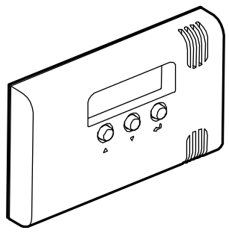


TD-1
PROGRAMMABLE TEMPERATURE DETECTOR
td-1_en 04/11

Applications
The detector can measure temperature and can be used to provide information on:
- too low temperature, e.g. in greenhouses, flower shops, children's rooms, etc.;
- too high temperature, e.g. in cold rooms, warehouses or spaces where high temperatures can cause malfunction of electrical equipment, etc.;
- too rapid temperature change, e.g. a quick temperature rise in cold room, etc.

Features
- Supports two independent temperature sensors:
- built-in sensor,
- probe connected to a terminal on the electronics board.
- The probe can be mounted outdoors.
- Temperature measurement range from - 35 °C to + 60 °C.
- Programming of two critical temperature thresholds for each of the sensors:
- high (H) – warning of temperatures higher than the defined threshold temperature;
- low (L) – warning of temperatures lower than the defined threshold temperature.
- Programming permissible temperature change at a specific time for each of the sensors – warning about too rapid a change in temperature.
- Optional connection of a bistable switch (instead of the probe), which will enable toggling between the two sets of critical parameters for the internal sensor.
- Four-digit LED display.
- Programming using three buttons.
- 2 programmable relay outputs.
- Built-in sounder.
- Tamper protection against opening the enclosure.
- Small enclosure with attractive design.
- Supply voltage 12 V DC (±15%).

Electronics board description
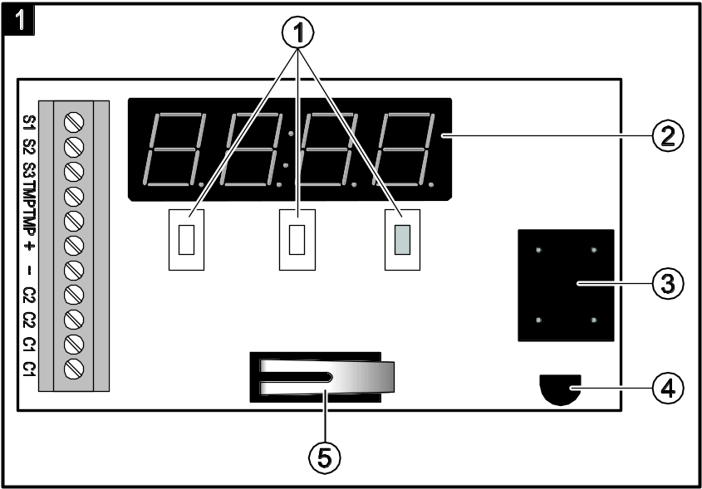
Fig. 1. Detector PCB.
 buttons for navigating through menus and programming.
 LED display.
 sounder.
 temperature sensor.
 tamper contact.

Description of terminals:
S1 ÷ S3 - input for connecting an external sensor or bistable switch.
TMP - tamper contact.
+ - power input (12 V DC ±15%).
- - common ground.
C2 - relay output 2.
C1 - relay output 1.

Installation

All electrical connections may only be made with disconnected power supply.
The tools to be useful during installation include:
- flat blade screwdriver, 1 mm,
- tweezers,
- precision pliers.
The TD-1 detector should be installed in closed spaces with normal air humidity. The waterproof probe can be installed outdoors.
- Open the enclosure and remove the electronics board.
- Make the openings for screws and wires in the enclosure base.
- Pass the wires through the prepared openings.
- Fix the enclosure base to the wall
- Fasten the electronics board.
- Connect an external probe (Fig. 2: S1 – brown wire and the screen, S2 – green wire, S3 – white wire) or a bistable switch (Fig. 3). The S1-S3 input must be configured during programming (see description of the function F9 p. 5).

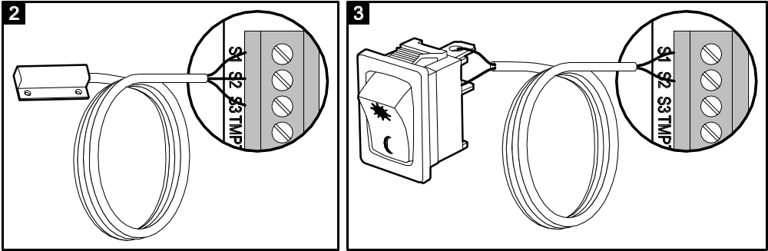

- Connect the power wires to the terminals “+” and “-”.
- Connect the devices to be controlled by the detector to the relay terminals. The outputs must be configured during programming (see descriptions of the functions F10 p. 6, F11 p. 6, F13 p. 6 and F14 p. 7).
- Close the enclosure.
- Turn on the detector power.
- Program the detector as needed.

Operation
The display always shows the current temperature. If the external probe is connected, you can use the and buttons to select the sensor the temperature from which will be presented.
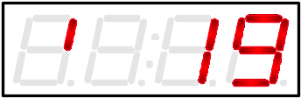 | temperature from the internal sensor.
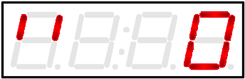 | temperature from the external sensor.
If a bistable switch is connected, the display will present the temperature from internal sensor and information about the currently enabled set of critical parameters.
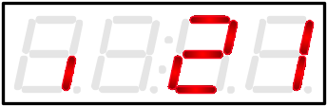 | the first set.
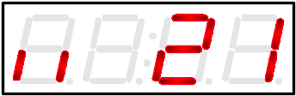 | the second set.
The following messages may be also displayed:
 | internal sensor fault.
 | the external sensor is faulty or disconnected. This message can be displayed in the event of incorrect configuration of the S1-S3 input (see description of the function F9 p. 5).
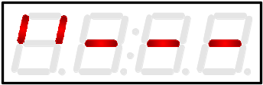 | the external probe is not supported by the detector (see description of the function F9 p. 5).

Sound signaling
1 short beep – pressing the or button,
3 short beeps:
- obtaining an access to installer menu;
- pressing the  button;
- automatic exit from the menu.
intermittent tone – alarm.

Alarm
In case of an alarm, the display will show alternately: the current temperature and the name of function in which the critical parameters have been defined. To turn the audible alarm off, press the button. The function name will be displayed until the temperature conditions return to the acceptable range.

Programming
Notes:
- If no button is pressed for 45 seconds, the menu will be automatically exited (changes that have not been accepted will not be saved).
- If the S1-S3 input supports a bistable switch (see F9 function description), the critical parameters programmed for the external sensor will become a second set of critical parameters for the internal sensor.

User menu
The user functions allow programming the low and high temperature thresholds. The temperature thresholds are distinguished as follows:
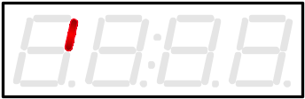 | high temperature threshold for the internal sensor;
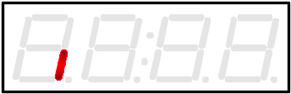 | low temperature threshold for the internal sensor;
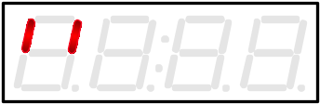 | high temperature threshold for the external sensor;
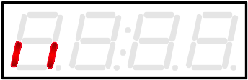 | low temperature threshold for the external sensor.

- To gain access to the user functions, press and hold down the button for about 4 seconds.
- Select the threshold to be programmed, using the and buttons. Confirm with the button. The temperature digits will start flashing.
- Set the desired temperature value, using the and buttons. Confirm with the button.
- Program the other temperature thresholds in the same way.
- Scroll through the functions until the END message appears. Press the button to exit the menu.

Installer menu
- In order to gain access to the installer functions, press and hold down the and buttons simultaneously for about 10 seconds. Function F1 will be displayed.
- To scroll through the list of functions, use the and buttons.
- To start the selected function, press the button.
- To edit the parameters of the function, use the and buttons.
- Use the button to confirm the changes made.
- To exit the edit mode, scroll the functions until the END message and press the button.

The functions allow you to program:
F1 - high temperature threshold for the internal sensor.
F2 - low temperature threshold for the internal sensor.
F3 - high temperature threshold for the external sensor.
F4 - low temperature threshold for the external sensor.
F5 - permissible temperature variation range for the internal sensor (from 1 to 10 °C).
F6 - time period during which the temperature variation programmed with function F5 can take place (from 2 to 60 minutes).
F7 - permissible temperature variation range for the external sensor (from 1 to 10 °C).
F8 - time period during which the temperature variation programmed with function F7 can take place (from 2 to 60 minutes).
Note: The rate of temperature change will be controlled properly, if the parameters are programmed in functions F5 and F6 for the internal sensor, and in functions F7 and F8 – for the external sensor. The rate of temperature change is analyzed every minute.
F9 - input S1-S3 function.
F10 - relay output 1 function.
F11 - relay output 2 function.
F12 - alarm.
F13 - relay output 1 type.
F14 - relay output 2 type.

Description of selected functions

F9 – S1-S3 input function
on ıı - support for external probe.
InCo - support for bistable switch. Temperature measurement will only be effected by the internal sensor. It will be possible to turn on the first or the second set of critical parameters (high and low temperature threshold, permissible rate of temperature change), as may be required.
oFFıı - input unused.

F10 – relay output 1 function
1 Lı - active after crossing the low temperature threshold of the internal sensor.
1 Hı - active after crossing the high temperature threshold of the internal sensor.
1 Lıı - active after crossing the low temperature threshold of the external sensor.
1 Hıı - active after crossing the high temperature threshold of the external sensor.
1LHı - active after crossing the low or high temperature threshold of the internal sensor.
1LHıı - active after crossing the low or high temperature threshold of the external sensor.
1 Gı - active when the temperature change was faster than that allowed for the internal sensor.
1 Gıı - active when the temperature change was faster than that allowed for the external sensor.
1oFF - disabled.

F11 – relay output 2 function
2 Lı - active after crossing the low temperature threshold of the internal sensor.
2 Hı - active after crossing the high temperature threshold of the internal sensor.
2 Lıı - active after crossing the low temperature threshold of the external sensor.
2 Hıı - active after crossing the high temperature threshold of the external sensor.
2LHı - active after crossing the low or high temperature threshold of the internal sensor.
2LHıı - active after crossing the low or high temperature threshold of the external sensor.
2 Gı - active when the temperature change was faster than that allowed for the internal sensor.
2 Gıı - active when the temperature change was faster than that allowed for the external sensor.
2oFF - disabled.

F12 – alarm
S Lı - on crossing the low temperature threshold of the internal sensor.
S Hı - on crossing the high temperature threshold of the internal sensor.
S Lıı - on crossing the low temperature threshold of the external sensor.
S Hıı - on crossing the high temperature threshold of the external sensor.
SLHı - on crossing the low or high temperature threshold of the internal sensor.
SLHıı - on crossing the low or high temperature threshold of the external sensor.
S Gı - when the temperature change was faster than that allowed for the internal sensor.
S Gıı - when the temperature change was faster than that allowed for the external sensor.
SoFF - disabled.

F13 – relay output 1 type
1 NO - normally open.
1 NC - normally closed.

F14 – relay output 2 type
2 NO - normally open.
2 NC - normally closed.

Restoring factory settings
In order to restore the factory settings, turn off the power and then turn it on again while holding down the and keys.

Specifications
Supply voltage 12 V DC ±15%
Standby current consumption 15 mA ±20%
Maximum current consumption 50 mA
Relay contacts rating (resistive load) 1 A / 30 V DC
Environmental class III
Working temperature range - 35°C...+ 60°C
Enclosure dimensions 48 x 78 x 18 mm
Weight 108 g

The declaration of conformity may be consulted at www.satel.eu/ce

SATEL sp. z o.o.
ul. Schuberta 79
80-172 Gdańsk
POLAND
tel. + 48 58 320 94 00
info@satel.pl
www.satel.eu

druk (2 na 1):
8,1,2,7,6,3,4,5

