 | INDOOR SIREN  SPW-250 | 
spw250_en 07/09
The SPW-250 indoor siren is designed for operation in the intruder alarm systems.

Features
- Acoustic alarm generated by means of piezoelectric transducer.
- Battery back-up power supply.
- Alarm by main power failure.
- Tamper protection against opening and removing from the mounting surface.
- Housing made of PC LEXAN high-impact polycarbonate, featuring a very high mechanical strength.

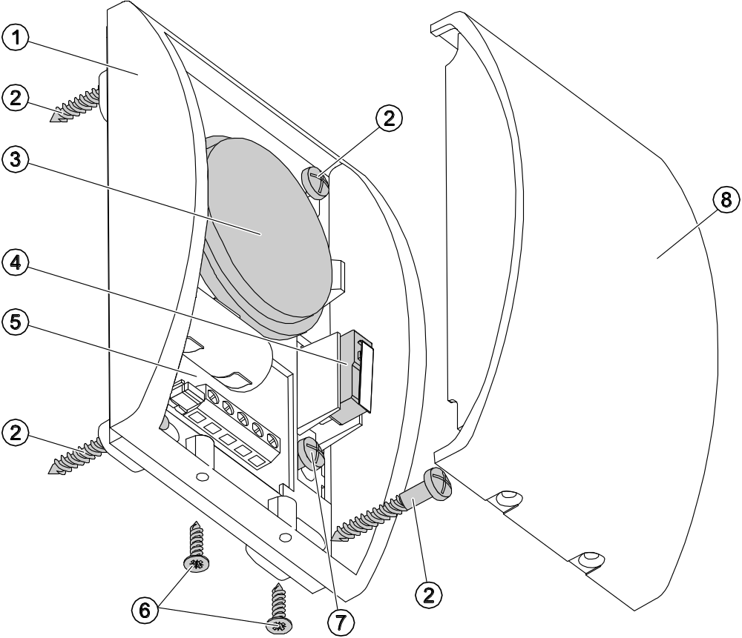
Fig. 1. View of the indoor siren.

Explanations for Fig. 1:
1 - housing base.
2 - screws securing the siren to its mounting surface.
3 - piezoelectric transducer.
4 - tamper contact.
5 - electronics board.
6 - screws locking the cover.
7 - screw fixing the housing tamper element to mounting surface.
8 - cover.

Description of Electronics Board

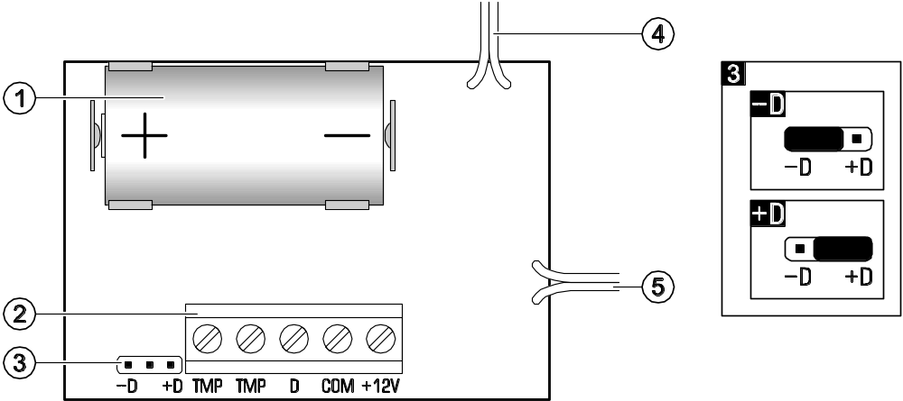
Fig. 2. View of electronics board and selection of signaling control method.

Explanations for Fig. 2:
1 - battery.
2 - terminals:
TMP - tamper contact (NC).
D - control input.
COM - common ground.
+12V - supply input.
3 - pins for selecting the way of sound signal triggering:
-D - by removing common ground (common ground control);
+D - by removing +12 V voltage (+12 V DC ±15% voltage control).
4 - cables to piezoelectric transducer.
5 - cables to tamper contact.

Description of Operation
The indoor siren requires power supply from a 12 V ±15% DC voltage source. The acoustic alarm will be triggered on loss of the control signal fed to the terminal D (depending on the configuration: common ground or +12 V DC voltage) and continues until the signal is restored. Additionally, the signaling will be set off if the cables are disconnected (external power supply is lost). In this case the alarm will continue until the battery is discharged or external power supply is restored.
In case of the alarm control panels manufactured by SATEL, it is recommended that the low-current reversed polarity output (the jumper in siren set to –D position) be used for control.

Installation and Connection
- The siren may only be used indoor.
- The siren should be installed on a flat surface by means of screws and expansion bolts.
- All connections should only be made after the alarm system power supply has been disconnected.
- Install the battery inside the siren only after all installation work is completed and the alarm system power supply turned on. If the battery is installed before the external power supply is turned on, alarm will be triggered.

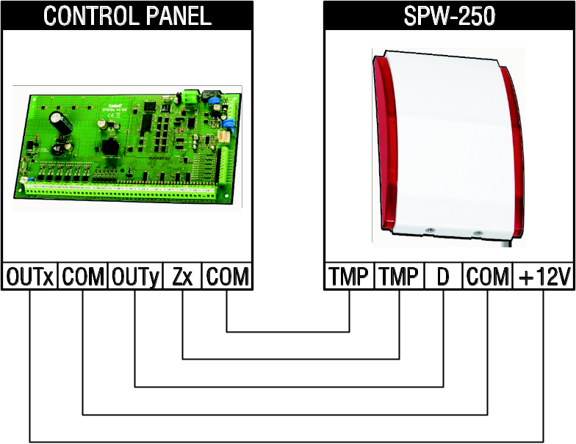
Fig. 3. Way of connecting the siren to the alarm control panel. OUTx – control panel output with power supply function. OUTy – control panel output for signaling control. Zx – control panel zone programmed as 24h tamper.

Note: Reversed polarity must be programmed for SPW-250 siren control outputs in the SATEL made control panels.

Specifications
Power supply voltage 12 V DC ±15%
Current consumption, stand-by 10 µA
Current consumption, maximum 90 mA
Sound pressure level (at 1 m distance) up to 120 dB
Backup battery lithium battery, CR123A 3 V
Standards complied with EN50130-4, EN50130-5
Environmental class according to EN50130-5 II
Operating temperature range -10...+55 °C
Weight 160 g

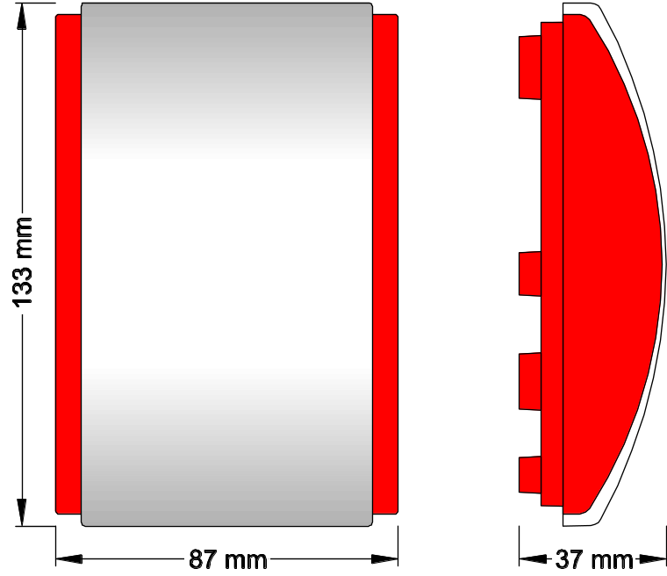
Fig. 4. Indoor siren dimensions.

Always use the CR123A 3V lithium batteries.
Service representative should periodically check the battery status within the scope of maintenance work.
Be particularly careful when replacing the battery. If inappropriately done, replacement of the battery may lead to a risk of explosion. The Manufacturer bears no responsibility for any consequences of incorrect replacement of the battery.
The used batteries must not be discarded, but should be disposed of in accordance with the existing rules for environment protection.

The latest EC declaration of conformity and product approval certificates can be downloaded from www.satel.pl

SATEL sp. z o.o.
ul. Schuberta 79
80-172 Gdańsk
POLAND
tel. + 48 58 320 94 00
info@satel.pl
www.satel.eu

druk (4 na 1):
4,1,4,1,2,3,2,3

