CONFIGURATION TOOL
1: Hardware Configuration Tool
2: <powitanie>
<b>Welcome in the Satel Hardware Configuration Tool!</b>
<br/>
<br/>
This tool facilitates designing of alarm systems based on Satel products. The Hardware Configuration Tool helps to select proper devices, calculates the current balance and creates cost calculations with
<br/>
the final offer for our Clients. We hope the Configuration Tool will meet your expectations and become an ideal tool for designing security systems.
<br/>
<br/>
<font size="9">
<br/>
<br/>
<br/>
<b>UWAGA!</b>
<br/>
An alarm system must be configured by an installer. In order to create a design ensuring correct operation and taking advantage of the broad range of possibilities offered by Satel equipment, specialist expertise is required. In case a system is configured by a person lacking proper experience, the design assumptions should be verified by an installer. The Configuration Tool and the materials obtained as a result of its operation as well as the results of its operation are made available by Satel without any guarantees. The results displayed by the Configuration Tool should be used only for informational purposes.
</font>
</powitanie>
3: Updating
4: OK
5: OK
6: Yes
7: No
8: Cancel
9: Update
10: Skip
11: Do not display this message in the future
12: ver.
13: <przycisk_Nowy_projekt>
New design
<br/>
of an alarm system
</przycisk_Nowy_projekt>
14: New design of an alarm system
15: NEW ALARM SYSTEM
16: Open
17: Open
18: Help
19: Help
20: floor
21: Project name
22: Picture
23: New project
24: Open project
25: Save project
26: Print
27: TOOLS
28: Select / Move
29: Move picture
30: Show details
31: Remove selected element
32: Zoom in / Zoom out image
33: Zoom in
34: Zoom out
35: STOREYS
36: Storey details
37: Add floor
38: Remove floor
39: Move up
40: Move down
41: ALARM SYSTEM
42: CURRENT BALANCE
43: Device name
44: Number
45: Current
46: Sum
47: Battery supply operating time
48: Total battery capacity should be
49: Total
50: Power supply capacity
51: CALCULATING OPTIONS
52: Calculate according to average current consumption
53: Calculate according to maximum current consumption
54: Balance details
55: SYSTEM COST
56: Cost estimate
57: Change calculation method
58: SYSTEM ELEMENTS
59: ADDITIONAL ELEMENTS
60: PRICE LIST
61: Element name
62: unit
63: Net price
64: Gross price
65: Discount
66: <kol_cena_po>
Net price
<br/>
after discount
</kol_cena_po>
67: VAT
68: <kol_w_netto>
Value
<br/>
net
</kol_w_netto>
69: <kol_w_vat>
Value
<br/>
VAT
</kol_w_vat>
70: <kol_w_brutto>
Value
<br/>
gross
</kol_w_brutto>
71: Profit margin
72: Net value
73: Gross value
74: Add new element
75: Remove selected element
76: System elements
77: Additional elements
78: Price list
79: Insert name...
80: DOCUMENTS TO PRINT OUT
81: Alarm system plan
82: List of devices including prices
83: Current balance
84: Catalogue Datasheets
85: Print
86: Preview
87: SATEL alarm system configuration for your project.
88: www.satel.pl
89: PROPERTIES
90: <o_producent>
The manufacturer reserves the right to change equipment specifications and technical data without notice.
<br/>
The product picture may be different from the actual product.
</o_producent>
91: TECHNICAL DATA
92: LEGEND
93: PREVIEW
94: Close preview
95: Next page
96: Previous page
97: zoom in page
98: zoom out page
99: ZONES
100: Uncheck all
101: Check all
102: Choose zone
103: Zone not available in the control panel
104: SEARCH
105: Input symbol
106: Find device
107: In enclosure
108: Close
109: Design
110: Save
111: Product description
112: Technical data
113: mA
114: Ah
115: pcs.
116: $, €
117: h
118: The “Project name” field not filled in.
119: No picture
120: Zone not available in the control panel.
121: Choose zone.
122: Control panel not selected.
123: <kom_6>
Insufficient capacity of power supplies in the system.
<br/>
It is recommended that expansion modules with a power supply be added.
</kom_6>
124: Only one keypad may be added to MICRA.
125: No inputs in the keypad bus.
126: No space in the bus.
127: No control panel.
128: No available wireless inputs.
129: No available inputs in the control panel.
130: <kom_13>
No available inputs in the control panel.
<br/>
Add input expansion module.
</kom_13>
131: No available outputs in the control panel.
132: <kom_15>
No available outputs in the control panel.
<br/>
Add output expansion module.
</kom_15>
133: No available synthesizer inputs.
134: System already includes remote control keyfob receiver.
135: Not possible to add more remote control keyfobs.
136: No inputs to address.
137: No addressable inputs. Add the CA-64 ADR expansion module to obtain more inputs.
138: Not possible to simulate more telephone lines.
139: No inputs for the reader. Add the INT-R expansion module.
140: <kom_23>
While adding an expansion module, pay attention to
<br/>
the limits resulting from the maximum
<br/>
number of control panel inputs and outputs.
</kom_23>
141: No available inputs.
142: <kom_25>
A storey cannot be removed.
<br/>
The selected level features devices
<br/>
operating in connection with other system elements.
</kom_25>
143: Remove device
144: <kom_27>
No connection with server.
<br/>
<br/>
In order to update the Configuration Tool, connects your computer
<br/>
to the Internet.
</kom_27>
145: <kom_28>
Update now?
<br/>
<br/>
New elements to install
</kom_28>
146: The control panel [NAZWA] may be assigned to maximum [ILOSC_STREF] zones.
147: Save changes in the [NAZWA_PROJEKTU] project?)
148: <s_kom_3>
Alarm system already has a control panel installed
<br/>
[NAZWA_CENTRALI].
</s_kom_3>
149: Specify the number of inputs to connect [SYMBOL].
150: <s_kom_5>
More input expansion modules cannot be connected
<br/>
to [NAZWA_CENTRALI] control panel.
</s_kom_5>
151: <s_kom_6>
More output expansion modules cannot be connected
<br/>
to [NAZWA_CENTRALI] control panel.
</s_kom_6>
152: Only one wireless system controller can be connected to [NAZWA_CENTRALI] control panel.
153: Only one [SYMBOL] expansion module may be connected to [NAZWA_CENTRALI] control panel.
154: Specify how many pieces [SYMBOL] should be added.
155: <s_kom_10>
Removing [SYMBOL] control panel will result in removing all devices connected with it.
<br/>
<br/>
Remove the control panel anyway?
</s_kom_10>
156: <s_kom_11>
Cannot remove [OBJ_SYMBOL].
<br/>
Device operates with other system elements.
</s_kom_11>
157: <s_kom_12>
Connection impossible.
<br/>
<br/>
[SYMBOL] operates with: [LISTA_WYMAGANYCH]
</s_kom_12>
158: Cannot move [SYMBOL] from the enclosure.
159: Search result
160: Alarm control panel
161: ABAX wireless system
162: ACCO system
163: Keypads
164: Detectors
165: Sirens
166: Communication and notifications
167: Enclosures
168: Accessories
169: RS communication
170: Survey tools
171: Readers
172: Transponders
173: Code locks
174: Power supply
175: Expansion modules
176: Remote control keyfobs
177: Radio lines
178: Sets
179: BURGLARY AND PANIC ALARM SYSTEMS
180: ACCESS CONTROL
181: MONITORING
182: ABAX Bidirectional Wireless System
183: ACCO Access Control System
184: ACCESSORIES
185: Detectors
186: Alarm control panel
187: Communication and notifications
188: Receiver cards
189: Software
190: ENCLOSURES
191: Radio remote controller
192: Sirens
193: Back-up power supply
194: The control panels belonging to the INTEGRA family are the most advanced devices offered by SATEL. The family includes five control panels based on a uniform hardware-software architecture. Each of them comes in a different size and offers different extension capabilities. Versatility of these devices makes it possible to use them not only in burglary and panic alarm systems but also in access control and intelligent building management systems.

195: VERSA is a series of cutting-edge alarm control panels dedicated for security systems operating small offices and commercial facilities, houses and flats. The feature differentiating them from other devices of this class is the possibility of introducing versatile wired and wireless extensions and operation of modern communication and notification media.

196: The MICRA alarm module is a device used to secure small facilities (summer houses, kiosks, technical containers or workshops), i.e. in situations when, apart from local alarming, effective transmission of information regarding the present danger is required. The possibility of connecting traditional detectors and sirens, ensuring notifications and monitoring in the GSM/GPRS networks and controlling the system by means of dedicated remote control keyfobs or mobile phones makes MICRA a solution which may successfully replace an alarm control panel of numerous capabilities in applications where effectiveness and simplicity are required.

197: The ABAX wireless system controller is used to extend any wired alarm system with wireless elements. The uncompromising solutions employed in its design, i.e. bidirectional communication and message encryption, ensure higher security levels.

198: The ABAX system is used to extend any wired alarm system with wireless elements. The uncompromising solutions employed in its design ensure higher security levels.

199: Due to the growing market demand on standalone access control systems, SATEL engineers have designed a flexible solution meeting the requirements of a broad range of Clients. The ACCO system is based on the network of standalone door controllers ensuring the possibility of centralised management. This combination of tried-and-tested hardware and software technologies with the well-thought-out concept of the overall solution ensures the highest possible quality and flexibility guaranteeing system adjustment to individual needs.

200: INT-KSG sensoric keypad is aimed at central control panels from the INTEGRA family. This new keypad features significant changes in the user interface. Additionally, the silicone keyboard has been replaced with a capacitative sensor matrix, thanks to which the device reacts to the user’s touch on the marked fields.

201: The extension modules for INTEGRA control panels constitute an important part of the SATEL product range. They make it possible to extend the alarm control panels’ functionalities and adjust the system to individual needs. Apart from extending the number of control panel inputs and outputs, they make other functions available, e.g. access control.

202: The VERSA LED keypad ensures full control over an alarm system. Thanks to its LED indicators, users find it easy to gain access to the basic system status information.

203: The VERSA LCD keypad ensures full and convenient control over an alarm system. Thanks to its clear text messages and intuitive menu, a user may easily handle even the most advanced control panel features.

204: PIR motion sensors are the most popular method of detecting motion in enclosed spaces where room temperature is maintained. This results mostly from their effectiveness, reliability and easy operation.

205: The wireless keyboard for the MICRA system makes it possible to arm and disarm the system and control the devices connected to the module without the necessity of having own remote control. Thanks to this, it is a perfect solution for locations in which several persons operate the system.

206: Smoke and heat detector which allows early detection of possible fire. Apart from transferring the hazard information to the control panel, the MSD-300 detector may warn about hazards by means of an inbuilt siren. In contrast to typical smoke detectors, this device reacts not only to visible smoke but also rapid temperature increase thus ensuring better protection against fire.

207: This magnetic detector of open doors and windows represents the "first line of defence". With the MMD-300, the alarm system will react to intrusion before the intruder manages to get into the protected area.

208: This magnetic detector of open doors and windows represents the "first line of defence". With the MMD-300 BR, the alarm system will react to intrusion before the intruder manages to get into the protected area.

209: Motion detector, whose function is to detect an intruder moving within the system protected area. Owing to its pet immunity, the MPD-300 can provide protection even if small animals, such as small dogs or cats, are moving in its coverage range at the time of supervision. A lithium battery used to power the device ensures many years of work without having to replace it, so the system is as easy to use as the traditional wired solutions.

210: PIR motion sensors are the most popular method of detecting motion in enclosed spaces where room temperature is maintained. This results mostly from their effectiveness, reliability and easy operation. In the Pet version, the detectors are equipped with technological solutions enabling them to ignore movement of small pets.

211: A unique design combining a reliable PIR detector with an emergency illumination module in one enclosure. Apart from detecting intruders, it may provide additional illumination for traffic routes and supply soft light, e.g. while watching TV.

212: Intruder detectors constitute an important part of the SATEL product offer. A broad range of motion detectors is complemented by other devices, i.e. glassbreak detectors, magnetic reed relay detectors or gas detectors. Constant R&D activities connected with the detection area result in improving the existing designs and introducing absolutely new devices employing breakthrough technologies.

213: Dual motion detectors employing the PIR and microwave detection path are perfect solutions for motion detection in rooms where difficult ambient conditions are present, e.g. sudden temperature spikes or draughts. Thanks to an independent analysis of different physical phenomena, they are not vulnerable to typical disturbances thus guaranteeing reliable operation and effective protection.

214: DG-1 series gas detectors have been designed for early detection of hazards resulting from gas presence in rooms. Digital signal processing and high-quality semi-conducting sensors ensure parameter repeatability and reliable detection.

215: Flood detectors are designed for early leak detection in areas with water installations, for example, in the kitchen, bathroom or laundry room. The external probe is connected to the detector using a flexible cable, which simplifies installation even in hard to reach places.

216: INDIGO acoustic glassbreak detectors are designed to ensure perimeter protection for rooms which can be entered after breaking the glass in windows or doors. Owing to their digital two-line signal analysis, they are highly effective and reliable.

217: Magnetic detectors provide basic perimeter protection for windows and doors. The range of available enclosures is so broad that it is possible to perfectly adjust the device to a given application.

218: VD-1 vibration detectors ensure perimeter protection of windows and doors vulnerable to forced entry attempts. The digital analysis with multiple-stage regulation makes it possible to easily adjust them to a given application.

219: The panic and burglary alarm equipment offered by SATEL is complemented with several accessories which might be used to build a complete system.

220: An effective and reliable siren is one of the key elements of an alarm system. Satel offers several siren models making it possible to easily adjust a device to given requirements. All sirens have such common features as high quality of materials used and advanced technology guaranteeing their reliability.

221: The CA-64 SM module is used to replay preset voice messages by means of the phone notification feature. It effectively provides clear remote information regarding system events.

222: Effective notification tools play a key role in modern alarm systems. SATEL offers a range of devices designed to reliably transfer alarm information through telephone networks (POTS and ISDN), GSM mobile telephony networks or Ethernet.

223: The ETHM-1 module provides an effective TCP/IP communication channel for advanced SATEL alarm control panels (INTEGRA and VERSA). It facilitates monitoring through the Internet and remote programming of control panels.

224: A monitoring station is to effectively and immediately receive information from supervised facilities and promptly react to the received information regarding system events. In its attempt to meet the market expectations, SATEL has designed several products making it possible to commission a cutting-edge monitoring centre utilising different communication channels and providing the specialists in the security industry with professional and comprehensive tools ensuring high operating capacity.

225: The module operates with INTEGRA and VERSA series control panels providing voice notifications, i.e. replaces the CA-64 SM synthesizer expansion module. As far as VERSA control panels with software version 1.02 or newer, the module provides the call reply and phone control features.

226: Enclosures constitute another group of products on offer. Their design is adapted to SATEL control panels and all auxiliary modules. The enclosures are designed to operate in interior areas. Metal enclosures undergo chemical processing (phosphate conversion coating) guaranteeing good adherence of coatings and long-term anti-corrosion protection.

227: Enclosures constitute another group of products on offer. Their design is adapted to SATEL control panels and all auxiliary modules. The enclosures are designed to operate in interior areas. They are made of high-quality plastics ensuring high mechanical resistance and aesthetic qualities throughout the whole product lifecycle.

228: Enclosures constitute another group of products offered by SATEL. Their design is adapted to all SATEL control panels and auxiliary modules. The enclosures are designed to operate in interior areas. They are made of high-quality plastics ensuring high mechanical resistance and aesthetic qualities throughout the whole product lifecycle.

229: Back-up power supplies are responsible for autonomous system operation in the event of power failure. SATEL offers switched-mode power supplies (SMPS) ensuring reliability, effectiveness and possibility of remote supervision over the power supply status.

230: INTEGRA and VERSA control panel input modules make it possible to increase the number of inputs available to connect intrusion detectors and automation equipment. Owing to the impulse analysis feature, these expansion modules may be used to directly connect vibration and roller shutter detectors.

231: The INT-ORS module is a specialised expansion module for relay outputs facilitating direct control of 230 V devices, e.g. in automatic control systems. Thanks to its enclosure which may be fitted on DIN 35 mm rails, it may be easily integrated with other electric equipment elements.

232: The expansion module for INTEGRA control panels facilitates connection of card and/or iButton chip readers in order to ensure access control and arm/disarm the zone stand-by mode. The INT-R expansion module operates in conjunction with INTEGRA and CA-64 alarm control panels.

233: The INT-RX module makes it possible to use the 433 MHz remote control keyfobs made by SATEL to control systems based on INTEGRA and VERSA control panels. Thanks to digital communication with a control panel, it ensures precise identification of the system user operating the remote control keyfob, which enhances system safety.

234: INT-KNX makes it possible to combine advanced features of an INTEGRA-based system with the KNX network. This combination not only allows INTEGRA to control KNX actuators, but also enables KNX to send information back to the INTEGRA control panel. Thus the combination of INTEGRA flexibility with wide KNX devices portfolio greatly enhances the functionality of both installations.

235: A universal remote control keyfob controlling the MICRA system operation. It enables the user not only to easily arm and disarm the systems stand-by mode but also helps to call for help (panic alarm activation) or control other devices connected to the MICRA system, e.g. entry gates. Its additional advantages include customisation of individual buttons in order to adapt it to personal needs.

236: Universal radio controllers are useful in all applications requiring remote control of equipment operation. Satel offers a range of controllers operating with 433 MHz frequency which may control max. four different devices. Owing to additional features, SATEL controllers perfectly operate in conjunction with alarm systems. They provide not only stand-by mode arming/disarming feature but also the functions of triggering the entry delay or panic alarms.

237: For [SYMBOL] to add an antenna.

HELP

Table of contents
• Step by step
• Updating
• Start window
• New project of the alarm system
• Side menu
• Equipment menu
• Documents to print out
• Printout preview
• Storeys
• Current balance
• System elements
• Additional elements
• Price list
• Device details
• Enclosure

Step by step
Step 1:
Double-click the icon to start the Configuration Tool. If your application version is not valid, a message specifying the elements to be updated is displayed on the screen. Click “Update” to start the updating process (Internet connection required). If you have the latest application version, the [ Start window ] is displayed where you can create a new alarm system design, open a previously saved design or navigate to the “Help” window. For example, click „New alarm system design.”
Step 2:
After opening the [ New alarm system design ] window, type the design name and click to select the design drawing saved on your computer. It is used to locate individual alarm system elements. The Configuration Tool supports three types of graphic files, i.e. bmp, jpg and png. After filling in all fields, click .
Step 3:
The selected drawing is loaded on the screen. The [ Side menu ] appears on the left side of the screen and the [ Equipment menu ] is displayed on the bottom of the screen. You will need these menus for further operation.
Step 4:
Select the button from the side menu in the storeys. The [ Storeys ] window opens where you can provide the name of a given storey. You can also click to add a new storey. The window with hard disk resources opens. Select another design drawing and click “Open”. In order to name other storeys, proceed in the same way as for the first storey.
Step 5:
Now you can start designing the alarm system. From the [ Equipment menu ] select the control panel constituting the basis for your alarm system. Press and hold the left mouse button to drag the control panel into the design drawing. Drop the control panel to add it to the design. It automatically appears on the “Alarm system” list in the [ Side menu ] together with the number of pieces necessary for the system. Use the same method to add other devices to your design. If a given device cannot be added, the application displays a detailed message informing about the missing elements necessary to connect a given device to the created system. Add a given product to the drawing and continue designing your system.
Step 6:
In order to keep your design orderly, you must locate the selected control panel in an enclosure. Select a given enclosure from the “Enclosures” category. Add it to the design drawing and double-click the colourful point. The [ Enclosure ] window opens to provide the list detailing the elements located in the enclosure. Select the point presenting your control panel from the design, press and hold the left mouse button and drag it to the list of enclosures. Your control panel has just been added to the enclosure. Use the same procedure to add other devices, i.e. drag them from the [ Equipment menu ] to the list in the [ Enclosure ] window located on your design.
Step 7:
While adding other system elements, they may be assigned to individual zones. Check a given point on the design drawing or press and hold the Shift key to check several points. Next, in the [ Side menu ] in the “Zones” section, select the section to which a given device is to be assigned by highlighting it with orange colour. In order to hide a device assigned to a given zone, uncheck all devices and, next, uncheck the zone marked in green.
Step 8:
After locating all necessary devices in the drawing, define the duration of system operation on the battery supply. In the [ Side menu ] click the button in the “Current balance” section. In the opened [ Current balance ] window, select “Battery supply operating time" to define the number of hours of the system operation. The Configuration Tool automatically calculates the battery capacity necessary for the system to operate during the specified period. Then the application displays a message informing about adding new items in the [ Additional elements ] field.
The [ Current balance ] window may also be used to specify the type of current taken into account while calculating the current balance. You may select one of the following options: “Calculate according to average current consumption” and “Calculate according to maximum current consumption” .
Step 9:
Go to the [ System elements ] menu. In the [ Side menu ] click in the “System cost” field. The displayed window provides detailed information regarding prices of individual devices and their total value. The values are suggested net prices provided by the manufacturer. The “Discount” field enables you to provide a given value of the discount for the devices included in the design. The Configuration Tool calculates all values automatically including the discount.
Step 10:
You may also add additional elements, e.g. wiring, labour or the first service inspection. To this end, click to go to the [ Additional elements ] window. Click to add a new element. The “Enter name...” item is added to the list. Left-click it to edit the following data: element name, quantity, measurement unit, net price and VAT. The other fields are filled in automatically. If you want to remove an unnecessary element, check the item on the list and click . Insert the required values in the “Discount” field. It applies to all additional elements. The Configuration Tool calculates all values automatically including the discount.
Step 11:
When the design is finished, you can print out the complete offer. Click in the [ Side menu ]. The “Documents to print out” window is displayed to specify the documents included in the offer. Click to preview the complete offer before it is printed out.

Updating
The “Updating” window enables you to update the Configuration Tool to the latest version.
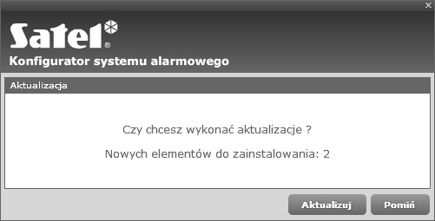
Starting the updating process
When the Configuration Tool is started, its current version is checked (Internet connection required). If a new version is detected, the application displays a message informing about the number of new elements to install. If your computer is not connected to the Internet, the application displays a message informing about the lack of server connection.
Start the updating process.
Skip the updating process.

Updating
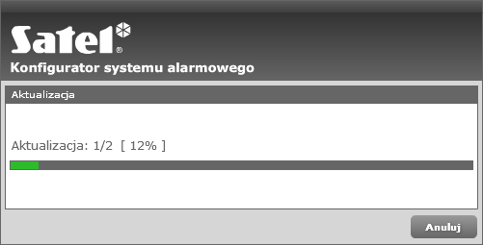
The green bar shows progress of the updating process
Cancel the updating process and go to the [ Start window ].

Start window
After starting the Configuration Tool, the start window is displayed. It offers three options: “New alarm system design”, “Open” and “Help”.
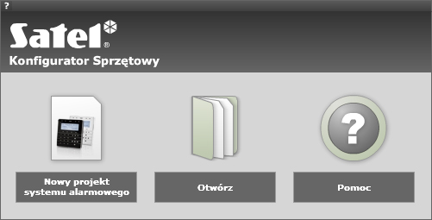
New alarm system design
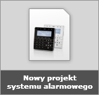
Click the “New alarm system design” button to open the window in which you can insert the design name and select a drawing from the hard disk in which the system may be designed. The Configuration Tool prepares a list of devices you can use. The list contains devices necessary to create a fully operational alarm system.
Open
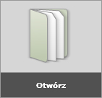
Click the “Open” option to open a previously saved design in order to modify it.
Help
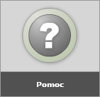
Click the “Help” option to open the help window providing detailed information on the Configuration Tool operation.

New alarm system design
Click the “New alarm system design” option in the start window to open the window in which you must provide the design name and select the drawing in which the system may be designed.
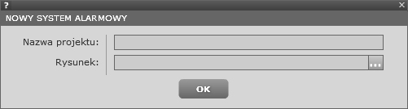
Design name
Click the “Design name” field to insert the name identifying a given project (up to 256 characters).
Drawing
Click the field of the button to add a drawing. The window displaying the hard disk contents appears on the screen. Select a given drawing in which the system may be designed. The Configuration Tool supports *.jpg, *.bmp and *.png graphics files.
OK button
Click "OK" to verify the inserted data. If the data is correct, the Configuration Tool goes to the alarm system edition feature. In case any field is not filled in, the application displays a message informing about the fields that must be completed.

Side menu
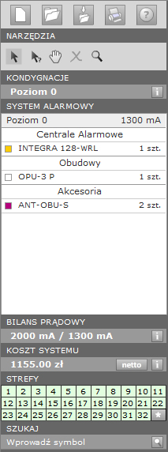
Basic options
“New design” enables you to go to the start window and start a new design.
“Open design” enables you to open a previously saved design. Click the button to open a window displaying the hard disk resources. Open a design selecting a file with the *.spc extension and click “Open”.
“Save design” enables you to save a created design. Click this button to open a window displaying the hard disk resources. In order to save a design, select its proper location and click “Save”.
“Print” enables you to print out a created design. Click this button to open the “Documents to print out” window.
“Help” enables you to open the help window providing detailed information on the Configuration Tool operation.

Tools
“Select / Move” enables you to select points on a drawing. Press and hold the left mouse button to move selected points.
“Show details” enables you to open a window displaying details regarding a given device featuring general information regarding this device and its technical data. Left-click a point or device photo in the menu to open the details menu.
“Move drawing” enables you to move the drawing in any direction after you press and hold the left mouse button on the drawing.
“Remove” enables you to delete the selected points from a drawing. The button becomes active after the pint to be removed is selected.
“Enlarge / Reduce” enables you to open the submenu in order to zoom the drawing in (click ) or zoom it out (click ). The modification scale expressed as a percentage value in visible in the field. The same effect is achieved using the scroll button on your mouse.

Storeys
The “Storeys” menu displays the name the name of the storey whose configuration is modified.
“Storey details” enables you to open the “Storeys” window in which you may edit, add and remove storeys as well as manage their order.

Alarm system
The “Alarm system” menu features the list of storeys, categories and devices used in the design.
Storey bar includes information regarding the storey name and current necessary to supply the devices located on this level. Left-click a given storey to switch to another one.
Category bar includes information regarding the name of the category to which the devices included in the design belong.
Device bar includes information regarding the colour of the device presented in the drawing, device symbol and number of pieces necessary on a given storey. Slide the mouse pointer on the bar to open the device preview window featuring technical details. Left-click the bar to select all devices with a given name in the drawing.

Current balance
The “Current balance” menu provides information regarding power supply capacity and current demand for individual devices included in the design. The data is displayed in the following format: [power supply capacity mA / required current mA].
The “Balance details” option opens the “Current balance” window presenting detailed information regarding the device current demand.

System cost
The “System cost” menu presents prices of all devices included in the design plus additional elements necessary for its correct operation.
The “Cost estimate” option opens the “System elements” window featuring detailed information regarding the prices of individual devices.

Zones
The “Zones” menu presents zones to which individual devices may be assigned.
Inactive zone. Shows no zone in a given control panel.
Active zone. Shows an enabled zone highlighting the points assigned to it in the drawing.
Inactive zone. Shows a disabled zone hiding the points assigned to it in the drawing.
Assigned zone. Shows how a device is assigned to the selected zone.
Button checking/unchecking all zones.

Search
The “Search” menu enables you to insert the name of the device you are searching for.
Click “Find device” to search for devices with a given name. The search results are displayed in the equipment menu.

Equipment menu
The equipment menu displays all devices necessary to create a complete alarm system.
The devices are divided into categories to make the product identification process easier and faster.
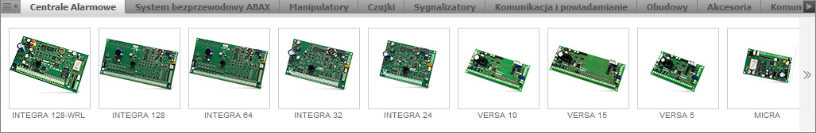
Equipment menu
Click a button on the category bar to switch between categories.
After a given control panel is located in the drawing, the Configuration Tool hides the devices which do not operate with it.
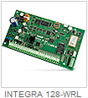 | The active product picture enables you to add a given device to the design.  Left-click a given product to add it, drag it onto the drawing and release the mouse button.
This button enables you to move categories to the left.
If the category is moved to the very end, the button disappears.
This button enables you to move categories to the right.
If the category is moved to the very beginning, the button disappears.
This button enables you to move devices to the left.
If the device is moved to the very end, the button disappears.

This button enables you to move devices to the right.
If the device is moved to the very beginning, the button disappears

 | It enables you to open the category window in which you may select the categories displayed in the design drawing.

Documents to print out
The “Documents to print out” window enables you to select the documents to be printed out from the list.
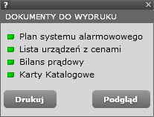
Documents to print out
When an option is highlighted with green colour, the selected item is added to the list of documents to be printed out.
When an option is highlighted with light green colour, the selected item is not added to the list of documents to be printed out.
The “Preview” button enables you to go to the preview mode in which you may view the documents selected for printing out.
The “Print” starts the printing process for the selected documents.

Print preview
The “Print preview” window enables you to view documents selected to be printed out.
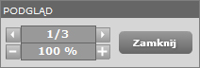
Print preview
This button enables you to go to the next document.
This button enables you to the previous document.
This field shows the current page of the viewed documents and the number of all documents.
This button enables you to enlarge a given document.
This button enables you to reduce a given document.
This field shows the current document enlargement status.
This button enables you to close the print preview mode.

Storeys
The “Storeys” window enables you to manage the storeys in a building.
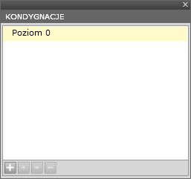
Storeys
Neutral position on the list.
Currently selected storey.
Storey name edition mode. Double-click a storey name to go to the edition mode.
This button enables you to add a new storey. Click it to open the window displaying the hard disk resources. There you can choose a proper storey drawing.
This button enables you to change the order of storeys. Click it to move the selected storey one level up. The button becomes inactive if a storey cannot be moved to a higher level.
This button enables you to change the order of storeys. Click it to move the selected storey one level down. The button becomes inactive if a storey cannot be moved to a lower level.
This button enables you to delete the selected storey.

Current balance
The “Current balance” window displays detailed information regarding the current demand of the whole system and its individual elements.
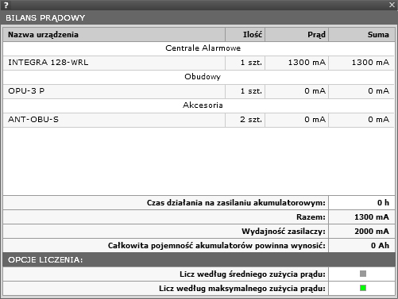
Battery supply operating time
This field may be edited. It enables you to specify the number of units of time during which the system is to be supplied from batteries. The Configuration Tool automatically calculates the total battery capacity and displays it in the “Total battery capacity should be” field.
Total
The total demand on current for all devices used in the design.
Power supply capacity
The total capacity of the power supplies used in the design.
Total battery capacity should be:
This field presents the total capacity of batteries enabling the system to operate during the period given in the “Battery supply operating time”.
Calculating options
• “Calculate according to average current consumption” – selecting this option results in calculating the current consumed by all the devices used in the design on the basis of their average current consumption.
• “Calculate according to maximum current consumption” – selecting this option results in calculating the current consumed by all the devices used in the design on the basis of their average maximum consumption.

System elements
The “System elements” window presents detailed information regarding the prices of individual elements used in the system.
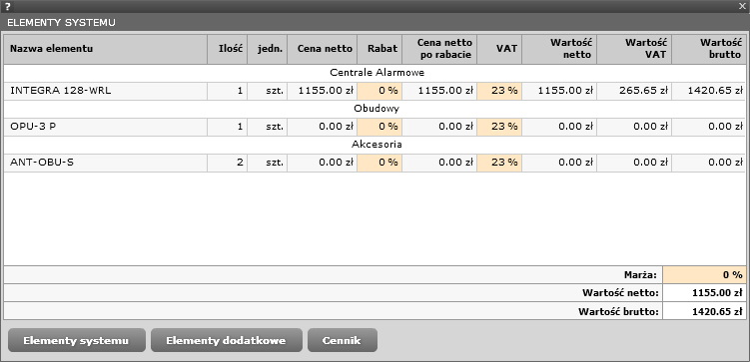
Discount
This field may be edited. It enables the user to insert the percentage value of a discount for the investor
as regards the devices used in the design.
VAT
This field may be edited. It enables the user to insert the percentage value VAT for the devices used in the design.
Profit margin
This field may be edited. It enables the user to insert the percentage value of the profit margin for the investor
as regards the devices used in the design.
Net value
Total net prices of all devices used in the design including the discount specified by the user.
Gross value
Total gross prices of all devices used in the design including the discount specified by the user.
Buttons
This button enables you to go to the "System elements" window and edit the data.
This button enables you to go to the "Additional elements" window and edit the data.
This button enables you to go to the "Price list" window where the net prices suggested by
the manufacturer are provided.

Additional elements
The "Additional elements" window present detailed information regarding the prices of elements and services added by the user.
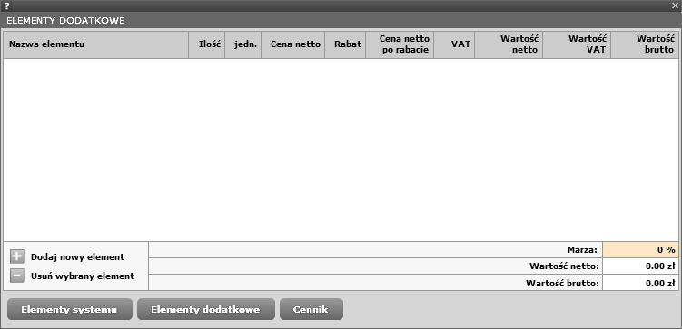
Add new element
Click this button to add a new line to the list of elements. Any new element may be edited by clicking the following fields: “Element name”, “Quantity”, “Unit”, “Net price”, “Discount” and “VAT”. The remaining fields are automatically filled in.

Remove selected element
Click this button to remove a selected element. In order to select an element for removal, left-click the line in order to highlight it with green colour.

Net price
This field may be edited. It enables you to insert the net price of the elements added to the design.
Discount
This field may be edited. It enables you to insert the percentage value of the discount for the investor for the elements added to the design.
VAT
This field may be edited. It enables you to insert the percentage value of VAT for the devices used in the design.
Profit margin
This field may be edited. It enables you to insert the percentage value of the profit margin for the investor for the elements added to the design.
Net value
Total net prices of all elements used in the design including the discount specified by the user.
Gross value
Total gross prices of all elements used in the design including the discount specified by the user.
Buttons
This button enables you to go to the "System elements" window and edit the data.
This button enables you to go to the "Additional elements" window and edit the data.
This button enables you to go to the "Price list" window where the net prices suggested by the manufacturer are provided.

Price list
The “Price list” window presents the prices of all devices available in the Configuration Tool.
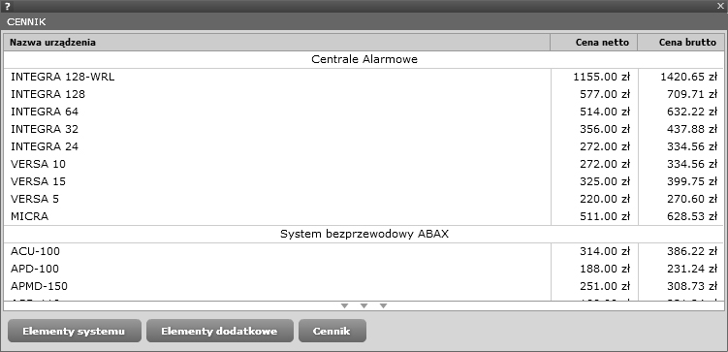
Buttons
This button enables you to go to the "System elements" window and edit the data.
This button enables you to go to the "Additional elements" window and edit the data.
This button enables you to go to the "Price list" window where the net prices suggested by
the manufacturer are provided.

Device details
The “Device details” window displays a detailed description and technical data of the selected device.
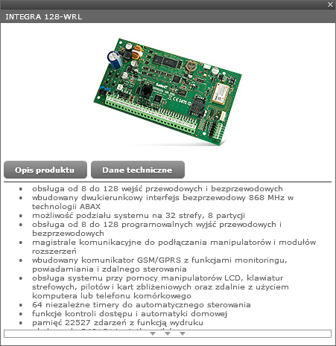
Buttons
This button enables you to go to the detailed description of device functionality.
This button enables you to go to the device technical data.

Enclosure
The “Enclosure” window presents the elements located in the enclosure.
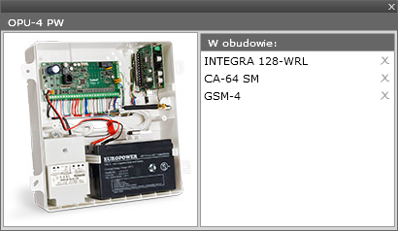
Enclosure
In order to open the window displaying the enclosure added to the design, use the left mouse button to double-click the field in the design drawing.
Adding an element to the enclosure
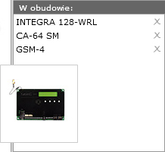 | In order to add a new element to the enclosure, drag the selected device from the equipment menu into the enclosure list. You may also move a device from the drawing to the enclosure dragging a given item from the design drawing to the enclosure list.

Removing an element from the enclosure
Click this button to remove the selected item from the enclosure list and the design.

INSTALLER

Hardware Configuration Tool - Installer
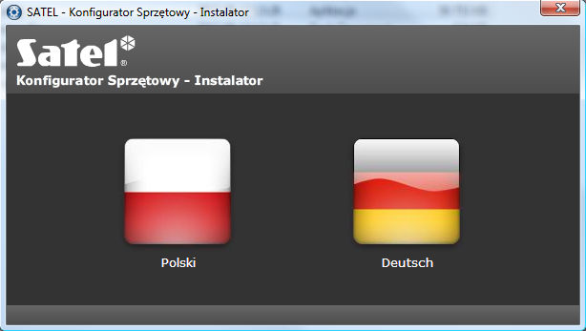

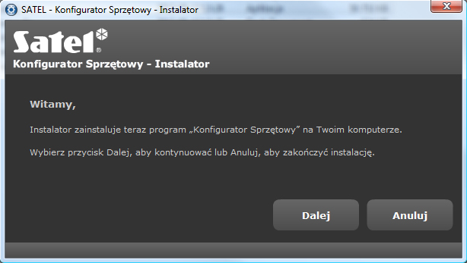

Welcome!
The installer will install the “Hardware Configuration Tool” software on your computer.
Click “Next” to continue or “Cancel” to finish the installation.

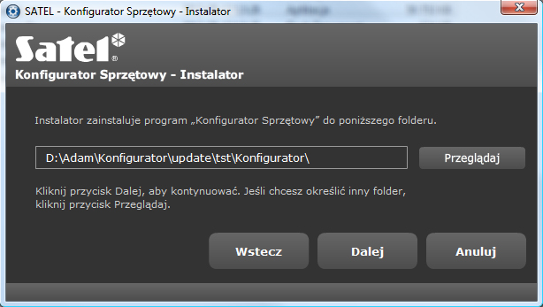

The Installer will install the “Hardware Configuration Tool” software in the folder below.
Click “Next” to continue. If you want to choose a different folder, click “Browse”.
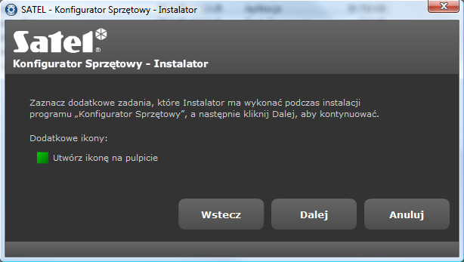
Check the boxes for additional tasks to be done by the Installer during the “Hardware Configuration Tool” installation process and click “Next” to continue.
Additional icons:
Create an icon on the desktop.

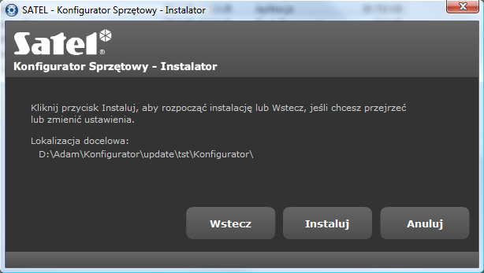
Click “Install” to start installation or “Back” to change the settings.
Target folder:
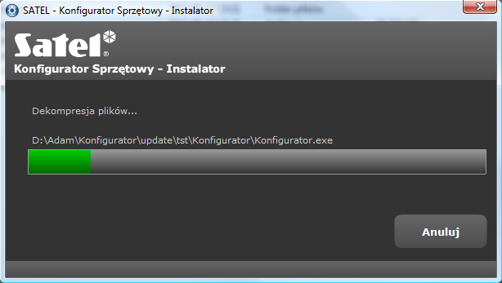
Decompressing files...

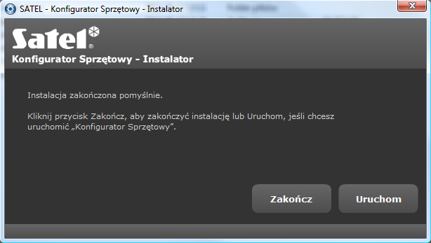
Installation successful!
Click “Finish” to complete the installation or “Run” to start the
“Hardware Configuration Tool”.

Next, Cancel, Back, Install, Finish, Run, Browse

