WARNINGS

The module should only be installed by qualified personnel.

Read carefully this manual before proceeding to installation.

Making any construction changes or unauthorized repairs, especially replacement of subassemblies and components, is forbidden.

Due to the specific character of data transmission using GPRS technology and possible costs involved, it is advisable to install in the converter a SIM card with tariff plan providing for at least 10 MB monthly data transfer.

DECLARATION OF CONFORMITY |  |  | 
Product:  GPRS-T1 - telephone line monitoring to GPRS/SMS/CLIP transmissions converter | Manufacturer: SATEL spółka z o.o.  ul. Schuberta 79  80-172 Gdańsk, POLAND  tel. (+48 58) 320-94-00  fax (+48 58) 320-94-01
Product description: Converter module that enables GPRS/SMS/CLIP reporting for control panels with analog telephone line monitoring dialer, intended for intruder alarm systems.
The product is in conformity with the following EU Directives:
RTTE 1999/5/EC
EMC 2004/108/EC
LVD 2006/95/EC
The product meets the requirements of harmonized standards:
EN 50130-4:1995/A1:1998/A2:2003, EN 61000-6-1:2007, EN55022:2006/A1:2007, EN 61000-6-3:2007, EN 60950-1:2006, EN 301 489-7:V1.3.1, EN 301 489-1:V1.8.1, EN 301 511 V9.0.2, 3GPP TS 51.010-1 V5.10.0
Gdańsk, Poland 2009-11-05 |  |   Head of Test Laboratory:  Michał Konarski
The latest EC declaration of conformity and product certificates can be downloaded from our website www.satel.pl

SATEL's goal is to continually improve the quality of its products, which may result in alterations of their technical specifications and firmware. Current information on the introduced modifications is available on our website.
Please visit us at:
http://www.satel.pl

The GPRS-T1 converter is a device dedicated for use in intruder alarm systems for the purpose of reporting and messaging via the GSM networks. The event codes received in the telephone format can be converted to the form transmittable with the use of GPRS technology or to the SMS message format. Using the GPRS technology makes it possible to send the codes to the STAM-2 monitoring station or SMET-256 converter. The codes in SMS format can be sent to any monitoring station which supports the SMS reporting feature. Apart from the event code conversion function, the device offers the capability of using SMS messages or CLIP service for notification about occurrence of selected events.
In order to execute some functions, the converter makes use of the features offered by the CLIP service, which enables identification of the calling party and presentation of its telephone number. Thus, test transmissions can be generated and sent without incurring any costs whatsoever.

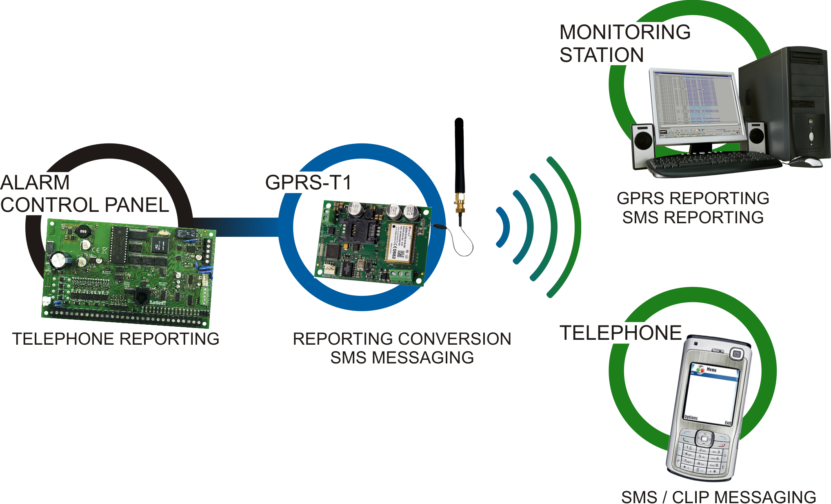
Fig. 1. Basic applications of the converter.

Converter features
- Simulation of telephone monitoring station.
- Receiving reporting codes sent in DTMF telephone format (Ademco Express or Contact ID) or in SIA format.
- Conversion and retransmission of event codes to two monitoring stations.
- Acknowledgment of event receipt:
- after sending SMS message (code conversion to SMS format);
- after acknowledgment of event receipt by the monitoring station (code conversion to GPRS transmittable form);
- immediately on receiving the event (SMS messaging and CLIP service).
- Capability to automatically replace the GPRS transmission with SMS message, if there are problems with GPRS transmission.
- Encrypted transmission of events sent with the use of GPRS technology.
- Notification by means of SMS messages or CLIP service about 32 selected events.
- Periodical test transmissions for checking availability of the converter:
- to selected telephone numbers (with the use of SMS message or CLIP service);
- to monitoring stations.
- Capability of generating additional test transmissions:
- after identification of the calling party's telephone number (CLIP service);
- after receiving command from the GPRS-Soft program.
- Option to check the status of available resources and account validity of the SIM card installed in the module.
- Indicator of GSM signal level received by industrial cellular telephone and an indicator of troubles connected with logging into the GSM network .
- Output for signaling problems with logging into the GSM network.
- Converter configuration:
- locally – through the RS-232 (TTL) port;
- remotely – through the GSM network (GPRS technology).
- Automatic module restart.
- Power supply with 12 V DC (±15%).

Description of electronics board

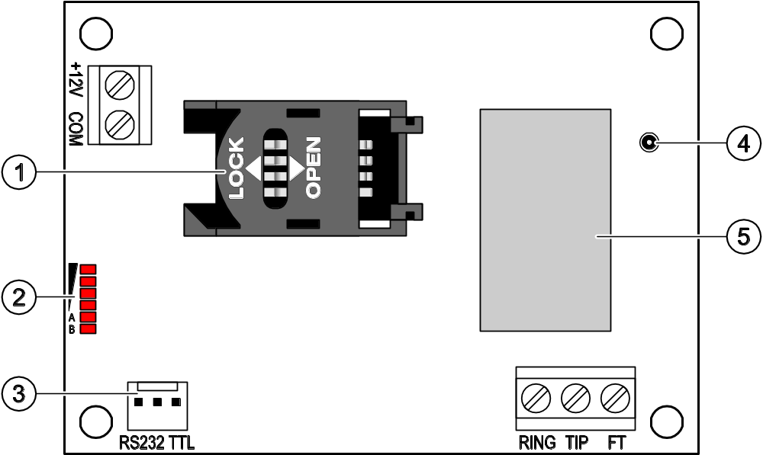
Fig. 2. View of converter electronics board.

Explanations for Figure 2:
1 - SIM card socket. It is not recommended to insert the SIM card into its socket before programming the card PIN code in the converter. If the event codes are to be sent with the use of GPRS technology, the GPRS service must be activated for the SIM card installed in the converter.
2 - LEDs indicating the converter status. LED A is blinking when GPRS transmission is going on. LED B is blinking when SMS message is being sent or the converter is calling (CLIP test transmission). The other LEDs indicate the level of signal received by the GSM telephone. LEDs A and B blinking simultaneously indicate logging into the GSM network. In case of an unsuccessful GSM network login, blinking of the other LEDs provides information on the troubles (see: Fig. 3).
3 - RS-232 port (TTL standard) enabling the converter to be connected to the PC computer (connection can be made with cables included in the set manufactured by SATEL and designated DB9FC/RJ-KPL).
4 - antenna socket.
5 - GSM industrial telephone.


Fig. 3. Examples of LED indicated statuses. A (LED A is blinking, the other LEDs are lit up) – GPRS transmission is going on; signal level: 3. B (LED B is blinking, the other LEDs are lit up) – SMS message is being sent or converter is calling (CLIP test transmission); signal level: 4. C (LEDs are blinking) – logging into GSM network. D (LEDs are blinking) – logging into GSM network has failed; missing SIM card. E (LEDs are blinking) – logging into GSM network has failed; missing PIN code. F (LEDs are blinking) – logging into GSM network has failed; invalid PIN code. G (LEDs are blinking) – logging into GSM network has failed; SIM card has been blocked after three attempts to use an invalid PIN code (PUK code must be used to unblock the SIM card).

Description of terminals:
+12V - power supply input (12 V DC ±15%).
COM - common ground.
TIP, RING - terminals for connecting the control panel telephone communicator.
Note: Do not connect the telephone exchange or any devices simulating the analog telephone line to the TIP and RING terminals.
FT - OC type output, indicating a problem with logging into the GSM network. It activates approx. 2 minutes of the problem occurrence. When active, it is shorted to common ground and remains in this state until logging into GSM network. The problem with logging into the GSM network can be caused by:
- unavailability of GSM network (out of range),
- missing or damaged antenna,
- entering an invalid PIN code,
- missing SIM card,
Some additional information can be provided by LEDs on the electronics board (see: Fig. 3).

Installation
All electrical connections may only be made with disconnected power supply.
It is not recommended to power up the device with disconnected antenna.
The GPRS-T1 converter should be installed indoors, in spaces with normal air humidity. When selecting the installation place, take into consideration that thick walls, metal partitions, etc. will reduce the radio signal range. Installation in close vicinity of electrical systems is not recommended, as it may adversely affect the device performance.
The module power supply source should provide sufficient output current and be equipped with a battery.
The following installation procedure is recommended:
- Connect the antenna to the socket on electronics board. Be careful not to damage the socket.
- Connect the terminals of control panel telephone communicator with the TIP and RING converter terminals.
- Connect the power leads to the +12V and COM terminals.
- Connect the computer to the converter RS-232 (TTL) port (see: section "Local programming through RS-232 (TTL) port").
- Turn on the converter power supply.
- Using the GPRS-Soft program, define PIN code for the SIM card to be installed in the converter.
- Turn off the converter power supply.
- Insert the SIM card into the socket (see: Fig. 4).
- Turn on the converter power supply. Logging the telephone into the GSM network may take a few minutes.
Note: If the SIM card PIN code is inconsistent with that defined in converter settings, the inconsistency will be indicated by the electronics board LEDs (see: Fig.3 Example F). The second attempt of using the PIN code will be made after 30 seconds. After the third attempt to use the invalid PIN code, the SIM card will be blocked. In order to enter the PUK code and unblock the SIM card, remove it and insert into the mobile phone.

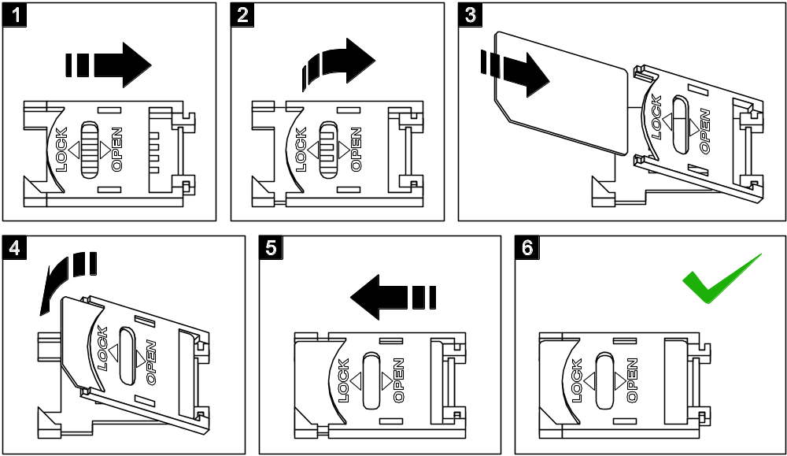
Fig. 4. Installing the SIM card.

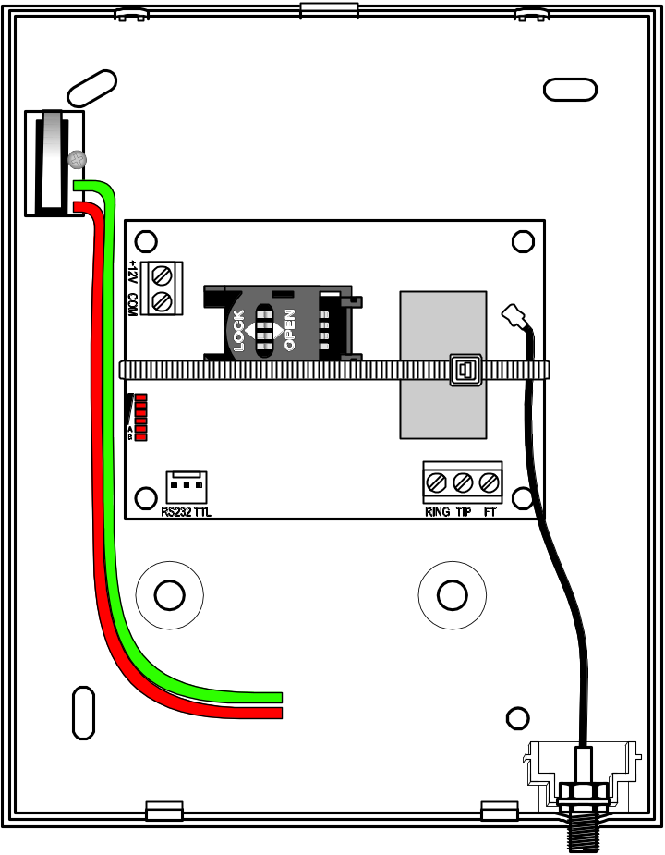
Fig. 5. GPRS-T1 module in housing, secured with a plastic strap.

Note: Before you begin using the module, remove the plastic strap protecting the device during transport. Be careful when removing the strap, so as not to damage any components on the electronics board.

Programming and configuring the converter
The GPRS-Soft program is used for programming and configuring the converter. The program is delivered free of charge with the device. Communication between the program and the converter can be effected locally or remotely. The converter with factory default settings can only be programmed locally.

Local programming through RS-232 (TTL) port
The serial COM port of the computer must be connected with the RS-232 (TTL) port on the converter electronics board. The cables for making this connection are available as a set designated DB9FC/RJ-KPL. Indicate in the GPRS-Soft program the computer COM port to be used for communication with the converter. To do so, click on the "Configuration" button (see: Fig. 6 and explanations for the figure) and, in the window that will open, select one of the available computer COM ports. After activation of the selected COM port, the program will establish communication with the converter.

Remote programming using GPRS technology
During the remote programming of the converter, all functions that require the use of GSM telephone will be disabled.
Remote programming is possible when the "Remote programming" option is enabled in the converter and the following items have been programmed:
- PIN code;
- Access Point Name (APN) for Internet GPRS connection;
- user name for Internet GPRS connection;
- password for Internet GPRS connection;
- DNS server IP address which is to be used by the converter (the DNS server address requires no programming, if the computer address is entered in numerical format – 4 decimal numbers separated by dots);
- initialization code for computer connection.
Note: APN, user name, password and DNS server address can be obtained from the GSM network operator.
The computer on which the GPRS-Soft program will be running must have its IP address visible in the Internet (so-called public IP address). Otherwise, the network server port must be redirected to that computer, so as to make connection with the computer possible.
In order to establish communication between the converter and the computer, do the following:
- Start the GPRS-Soft program.
- Click on the "Configuration" button (see: Fig. 6 and explanations for the figure) and, in the window that will open, enter the number of TCP port selected for communication with the converter. The number will have to be included in the body of SMS message which will be sent to the converter GSM telephone number to initialize communication .
- Click on the button (see Fig. 6). In the menu that will open, select "TCP/IP" to activate the server.
- Send SMS message to the converter GSM telephone number. The SMS message should have the following form: xxxx=aaaa:p= ("xxxx" is the converter defined code to initialize communication with GPRS-Soft program – "Initiating SMS"; "aaaa" is the address of the computer with which the converter is to establish communication, shown numerically or as a name; "p" stands for the number of network port through which communication with the GPRS-Soft program is to be effected). The converter will connect to the computer whose address was given in the SMS message.

Description of the program

Main menu

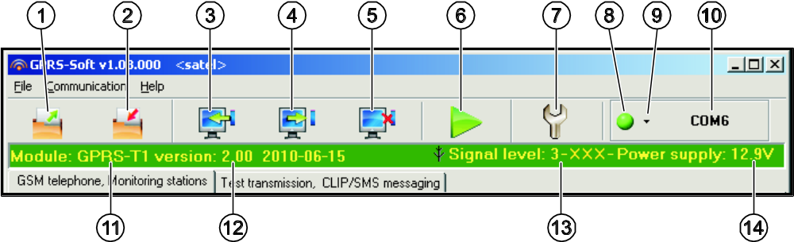
Fig. 6. Main menu of GPRS-T1 program.

Explanations for Figure 6:
1 - Read from file – button enables loading configuration data from file.
2 - Write to file – button enables saving configuration data to file.
3 - Read – button enables reading data from the module.
4 - Write – button enables saving data to the module.
5 - Abort – button enables terminating the data reading/writing.
6 - Start test transmission – button starts sending the converter test transmission (in case of remote programming, the test transmission will only be sent after completion of the communication with the converter).
7 - Configuration – button enables opening the "Connection" window. The window enables configuration of parameters relating to the mode of communication between program and converter:
- select the computer COM port through which local programming is to be effected;
- enter the number of TCP port to be used for remote programming of the converter. Values from 1 to 65535 can be entered.
8 - Connection – depending on the mode of communication with converter, selected using the button, click on the button to:
- enable/disable the computer COM port (local programming through RS-232 port);
- activate/deactivate the server (remote programming with the use of GPRS technology and TCP/IP protocol) – a click on the button will simultaneously open a window indicating the server status.
The button color indicates the current communication status:
- – green – computer COM port enabled / server active;
- – gray – computer COM port disabled / server inactive.
9 - button for selecting the mode of communication with the converter: local programming through the RS-232 port or remote programming with the use of GPRS technology and TCP/IP protocol.
10 - information on the mode of communicating with the converter:
- COMn (n = COM port number) – communication through the RS-232 port;
- TCP/IP – communication with the use of GPRS technology.
11 - module name.
12 - version of module program (version number and build date).
13 - level of signal received by the GSM antenna and the name of service provider used by the converter. If the converter telephone has failed to log into the GSM network, the icon will be displayed here to indicate trouble.
14 - current level of converter supply voltage.

"GSM telephone, Monitoring stations" tab

Programming
GPRS-T1 identifier – a sequence of 1 to 8 alphanumeric characters to identify the converter. Communication between the program and the converter is only possible when the identifier entered in this field is consistent with that stored in the converter. No identifier is preprogrammed in the converter with factory default settings. Communication with such a module can be established without entering any identifier in the program, but as soon as the connection is established, the program will automatically generate a random identifier. It can be saved into the converter or enter another one and save it.
Remote programming – enable this option if remote programming of the module with the use of GPRS technology is to be available.
Initiating number only from list of telephone numbers for messaging – if this option is enabled, the SMS message initiating the remote programming must be sent from a telephone whose number is stored in the converter memory in the list of telephone numbers for messaging.
Initiating SMS – a code which must be included in the SMS message sent to the converter GSM telephone number, so that the converter can make an attempt to connect to the computer whose IP address and communication port are indicated in the SMS message.

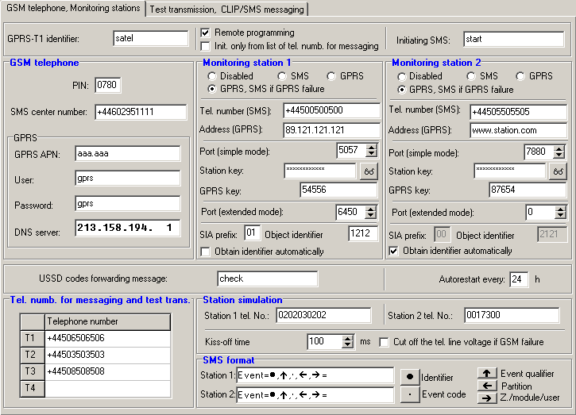
Fig. 7. "GSM telephone, Monitoring stations" tab.

GSM telephone
PIN – SIM card PIN code.
Note: Entering invalid PIN code may result in blocking the SIM card.
SMS center number – telephone number of the Short Message Service Center, which delivers SMS messages. Entering the number is necessary if the converter is to send SMS messages. The number stored in the converter must be suitable for the network in which the GSM telephone is working (depending on the SIM card installed in the converter).
GPRS APN – Access Point Name for Internet GPRS connection.
User – user name for Internet GPRS connection.
Password – password for Internet GPRS connection.
Note : APN, user name and password must be defined, if GPRS data transmission (event codes, programming) is to be available.
DNS server – DNS server IP address which is to be used by the converter. The DNS server address is necessary when GPRS technology is used for sending data, if the address of the device to which the converter is to connect (monitoring station, computer with GPRS-Soft program) has been entered as a name. If all addresses are given in the IP address form (4 decimal numbers separated by dots), programming the DNS server address is not required.

Monitoring station 1 / Monitoring station 2
Notes:
- Using GPRS technology, event codes can be sent to the STAM-2 monitoring station or to the SMET-256 converter.
- Communication with the subscriber sending event codes with the use of GPRS technology should be tested by the monitoring station as rarely as possible (if a value lower than 1 minute is entered in the “Test period” field of the monitoring station, the time will be rounded up by the converter to 1 minute). It is recommended that the maximum value be set, i.e. 255 seconds.
- If the converter is to send event codes using GPRS technology, an adequate number of attempts to connect to the monitoring station is to be programmed in the control panel. Thus the converter will have time for receiving event receipt acknowledgement from the monitoring station .
Disabled – if this option is selected, event codes will not be sent to the monitoring station.
SMS – if this option is selected, event codes will be sent to the monitoring station in the form of SMS messages.
GPRS – if this option is selected, event codes will be sent to the monitoring station with the use of GPRS technology.
GPRS, SMS if GPRS failure – if this option is selected, event codes will be sent to the monitoring station with the use of GPRS technology, but after a failed attempt of sending events (lack of receipt acknowledgement from the monitoring station), the event code will be sent in the form of SMS message.
Tel. number (SMS) – GSM telephone number used by the monitoring station for receiving SMS messages. Must be preceded by the country code.
Address (GPRS) – address of the monitoring station. It can be entered in the IP address form (4 decimal numbers separated by dots) or as a name.
Port (simple mode) – number of TCP port through which communication with the monitoring station will be effected. The port number must be the same as that programmed in the monitoring station for managing subscribers in the simple mode.
Port (test) – number of TCP port at which communication with the monitoring station will be checked. You can enter values from 1 to 65535. The port number must be the same as that programmed in the monitoring station for managing subscribers in the extended mode. If you select 0, the function will be disabled.
Station key – enter in this field a string of 1 to 12 alphanumeric characters (digits , letters and special characters) which define the key for coding the data to be sent to the monitoring station. It must be consistent with that defined in the monitoring station for managing subscribers in the simple mode.
GPRS key – a string of 1 do 5 alphanumeric characters identifying the converter. It must be consistent with that defined in the monitoring station ("ETHM/GPRS key").
Port (extended mode) – number of TCP port at which communication with the monitoring station will be checked. The port number must be the same as that programmed in the monitoring station for managing subscribers in the extended mode.
SIA prefix– 2 characters which, in case of the SIA format, will precede the "Object identifier". Thus you can obtain an identifier consisting of 6 characters. 2 hexadecimal characters (digits or letters from A to F) can be programmed. Entering 00 means that no prefix will be added. Is not recommended to use the digit 0 in the prefix.
Object identifier – enter in this field 4 characters (digits or letters from A to F) which will serve as an identifier during the test transmissions sent by the converter (the test transmissions sent by the control panel and then converted can have a different identifier). Do not enter value 0000 (the converter will not be sending test transmissions to the monitoring station). Using digit 0 in the identifier is not recommended.
Obtain identifier automatically – select this box, if the control panel identifier is to be used by the converter for converter's own test transmissions. Enabling this option is not recommended when several identifiers are used by the control panel for reporting purposes (the identifier used in the converter test transmission will be that recently used by the control panel, which means that the converter test transmissions can be sent with different identifiers).

Module status
USSD codes forwarding message – content of the control command that must precede the USSD code in SMS message being sent to the module. The USSD codes make it possible e.g. to check the account status of SIM card installed in the module. The form of SMS message must be: xxxx=yyyy=, where "xxxx" is the control command, and "yyyy" – the USSD code served by the operator of GSM network in which the telephone is used (it depends on the SIM card installed in the module). Having received such an SMS message, the module will execute the USSD code contained therein. The answer received from the operator is sent in the form of SMS message to the telephone number from which the control command was sent.
Note: Using the advanced functions available due to the USSD service (when menu is presented in reply to the code entered) is not recommended.
Autorestart every – if the restart of module settings is to be periodically repeated, you must define every how many hours it is to happen. The first restart of module settings will occur after the programmed time has elapsed since the settings were written to the module. If 0 is entered, the function will be disabled.

Station simulation
Station 1 tel. number / Station 2 tel. number – enter in this field the telephone number defined in the control panel for the given monitoring station. The converter will simulate receiving the event codes by that station. If both telephone numbers are programmed and the control panel will dial another number, the converter will generate a busy signal. If one of the numbers is not programmed, the converter will be answering all the control panel calls. The event codes received after the control panel has dialed the programmed telephone number will be sent to the monitoring station for which the number is programmed. The codes received after the control panel has dialed any other number will be sent to the monitoring station for which no telephone number is programmed. If no telephone number has been programmed, all the received event codes will be sent to Station 1.
Kiss-off time – duration of the signal generated by the converter to acknowledge receipt of the events from control panel. The entered value must be suitable for the control panel settings (selected reporting format). Values ranging from 100 to 2550 ms can be programmed (by default: 600 ms).
Cut off the telephone line voltage if GSM failure – if this option is enabled and the converter GSM telephone fails to log into the GSM network, voltage in the telephone line simulated by the converter will be disconnected (the control panel will report a telephone line failure).

SMS format
The format of SMS messages for SMS reporting must be defined according to the monitoring station requirements. The default SMS messages format programmed in the converter corresponds to the factory default settings of the STAM-2 monitoring station (program version 1.2.0 or later). The symbols used for programming the SMS format have the following meaning:
 - identifier;
 - event qualifier;
 - event code;
 - partition;
 - zone/module/user.
For the Ademco Express format only identifier and event code is sent. Question marks will be sent instead of the other information.

Telephone numbers for messaging and test transmissions
It is possible to program 4 telephone numbers to which the converter will be able to send SMS messages if specific event codes are received, and also to send test transmissions. The telephone number must be preceded by the country dialing code.

"Test transmissions, CLIP / SMS messaging" tab

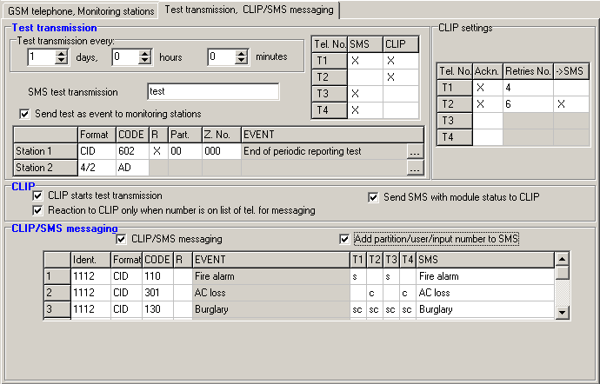
Fig. 8. "Test transmissions, CLIP / SMS messaging" tab.

Test transmissions
The converter can send its own test transmissions (irrespective of the test transmissions sent by the control panel and re-sent by the converter). The converter test transmissions may be sent periodically at defined time intervals, and also can be generated after identification of the telephone number of the calling party (CLIP service) or after receiving a command from the GPRS-Soft program. The test transmission can have a form of SMS message sent to the selected telephone numbers, can be realized with the use of CLIP service to the selected telephone numbers or can be sent in the form of event code to the monitoring station.
Test transmission every – if the converter test transmission is to be of periodical nature, you have to program every how may days, hours and minutes it should be sent. The first test transmission will be sent after the preset time since saving the settings in the converter has elapsed.
Note : If an extra test transmission (using the CLIP service or the GPRS-Soft program command) is generated, the time before sending the periodical test transmission will be counted from the beginning.
SMS test transmission – enter in this field the SMS message body which will be sent as the converter test transmission to the selected telephone numbers.
Note: If you have defined the time period after which the test transmission is to be sent, and the "SMS test transmission" field remains blank, SMS messages containing information on the module status will be sent – as test transmissions – to the selected telephone numbers (see: "Send SMS with module status to CLIP" option).
Send test as event to monitoring stations – if this option is enabled, the converter test transmission can be sent to the monitoring stations. The method of sending the event code (SMS, GPRS) depends on the rules defined for each monitoring station in the "GSM telephone, Monitoring stations" tab. It is necessary to define the event code to be sent.

Event codes for converter test transmission
The table makes it possible to define the codes which will be sent to the monitoring stations for the converter test transmission.
Format – format in which the event code will be sent. The formats you can select from are 4/2 (for Ademco Express) or CID (Contact ID). Click twice on the format field to change the displayed format. If the last converted event was in the SIA format, this format will be shown in the field.
Code – event code. For the 4/2 format, 2 characters (digits or letters from A to F) should be programmed, and for the Contact ID – 3 digits. In case of the Contact ID format, you can use the code editor. To open the code editor window, click on the button designated with three dots, available in the "Event" field.
R – the field refers to the event code to be sent in the Contact ID format. The additional digit in the Contact ID format indicates whether it is a new event/disarming, or a new restore/arming. Select this field, if the event code is to denote new restore/arming (click on the field twice to select/deselect it).
Part. – the field refers to the event code to be sent in the Contact ID format. Enter in this field the partition number which will be included in the event message sent to the monitoring station.
Zone n. – the field refers to the event code to be sent in the Contact ID format. Enter in this field the zone number which will be included in the event message sent to the monitoring station.
Event – this field is to be used in case of the Contact ID format. It displays description of the event whose code is entered in the "Code" field. A button designated with three dots, which opens the editor of Contact ID codes, is also available in the "Event" field.
Note: The test transmission will be sent as an event, if the following parameters and options are programmed for the monitoring station:
- GPRS reporting (see section "Starting GPRS reporting") or SMS reporting (see section "Starting SMS reporting") is activated,
- object identifier different from "0000" is programmed or "Obtain identifier automatically" option is enabled,
- reporting format is programmed,
- event code different from "00" for 4/2 format or from "000" for Contact ID format is programmed.

Test transmissions to be sent to telephone numbers
The table allows to define the form in which the test transmissions will be sent to the telephone numbers programmed in the "GSM telephone, Monitoring stations" tab. Click twice on the chosen field to select/deselect it (the field is selected if the "x" symbol is displayed in it).
SMS – select this field, if the converter test transmission is to be sent to the selected telephone number in the form of SMS message.
CLIP – select this field, if the converter test transmission for the selected telephone number is to be realized with the use of CLIP service (the converter will dial the programmed number and then will be trying for 30 seconds to get through – the converter telephone number will be displayed in the telephone).
Note : Do not answer any call from the converter, if the CLIP test transmission is to be effected without incurring any costs.

CLIP settings
The table makes it possible to determine in detail how the CLIP test transmissions are to be sent to the four telephone numbers programmed in the "GSM telephone, Monitoring stations" tab. Click twice on the chosen field to select/deselect it (the field is selected, if "x" symbol is displayed in it).
Acknowledgement – select this field if the converter is to wait for the acknowledgement of receipt of test transmission using the CLIP service. In order to acknowledge receiving the CLIP test transmission, reject the call coming from the converter.
Retries number – if the "Acknowledgement" field is selected, the test transmission with the use of CLIP service can be conducted a specified number of times. Values from 1 to 15 can be programmed. Acknowledgement of the CLIP test transmission receipt will make the module stop repeating such a transmission (e.g. if the test transmission is programmed to be repeated 5 times, but it is already received at the first attempt, the converter will not send the other 4 transmissions).
-> SMS – if the "Acknowledgement" field is selected and receiving the CLIP test transmission is not acknowledged, the converter may send a "CLIP failed" SMS message to the selected telephone number.

CLIP
CLIP starts test transmission – if this option is enabled, it is possible to send a test transmission with the use of CLIP service. Call the converter telephone number and after hearing the dialing tone, hang up – the converter will identify the telephone number of the calling party and send a test transmission according to the preprogrammed settings.
Send SMS with module status to CLIP – if this option is enabled, it is possible to obtain information about the converter status with the use of CLIP service. Call the converter telephone number and after hearing the dialing tone, hang up – the converter will identify the telephone number of the calling party and send to that number an SMS message containing the following information:
- module name;
- version of converter software (version number and date of build);
- current level of signal received by the antenna;
- current supply voltage value.
Reaction to CLIP only when number is on list of telephones for messaging – if this option is enabled, the converter will only send test transmission or SMS message with status information when the telephone number, identified owing to the CLIP service, is one of the numbers programmed in the “GSM telephone, Monitoring stations” tab on the “Telephone numbers for messaging and test transmissions” list.
Note : If the “Reaction to CLIP only when number is on list of telephones for messaging” option is not enabled, the test transmissions and SMS messages with information on device status:
- for the numbers in the list, they will be sent by the converter immediately,
- for the numbers not in the list, they can be sent by the converter every 10 minutes at the most.

CLIP / SMS messaging
The GPRS-T1 converter may be used not only for reporting, but also for notification purposes. The notification is effected by means of SMS messages, CLIP service, or both at the same time. You can define up to 32 events and the SMS message content for each of them. If a specified event code is received by the converter, the messaging is executed. The CLIP / SMS messaging is functioning independently of the reporting function. It is not available in case of the SIA format codes.
CLIP / SMS messaging – enable this option, if the converter is to inform by means of CLIP service/ SMS messages about receiving selected event codes.
Add partition/user/input number to SMS – this option refers to the event codes in Contact ID format. If this option is enabled, the number of partition where the event occurred and the user number or the number of input which caused the event occurrence will be automatically added to the SMS message sent by the converter to inform about receipt of the selected event code.
Ident. – identifier that must be received together with the event code, so that the converter can send an SMS message. Enter in this field 4 characters (digits or letters from A to F). If the identifier value entered in this field is "0000", no SMS message will be sent. Programming the "FFFF" identifier value means that receipt of any identifier preceding the event code will result in sending an SMS message.
Format – format in which the event code must be received, so that the converter can send an SMS message. You can select the 4/2 format (for Ademco Express) or the CID format (Contact ID). Click twice on the format field to change the displayed format.
CODE – event code, the receipt of which will result in sending a preprogrammed SMS message. 2 characters (digits or letters from A to F) are to be programmed for the Ademco Express format, and 3 digits for the Contact ID format. In case of the Contact ID format you can use the code editor. To open the code editor window, click on the button designated with three dots, available in the "EVENT" field.
R – the field refers to the event code to be sent in the Contact ID format. The additional digit in the Contact ID format indicates whether it is a new event/disarming, or a new restore/arming. Select this field, if the event code is to denote new restore/arming (click on the field twice to select/deselect it).
EVENT – this field is to be used in case of the Contact ID format. It displays description of the event whose code is entered in the "CODE" field. A button designated with three dots, which opens the editor of Contact ID codes, is also available in the "Event" field.
T1 ... T4 – define to which telephone numbers (see: numbers programmed in the "GSM telephone, Monitoring stations" tab in the “Telephone numbers for messaging and test transmissions” list) and how the messaging about receiving the event code is to be executed. You can choose from the following options:
- blank field – no messaging,
- s – SMS messaging,
- c – CLIP service notification,
- sc – notification by means of SMS messages and CLIP service.
SMS – enter in this field the contents of SMS message which will be sent after receiving the selected event code. The message may be composed of up to 24 characters.

Starting GPRS reporting
Parameters and options that that must be programmed so that the converter can send the received event codes with the use of GPRS technology are available in the "GSM telephone, Monitoring stations" tab.
- Enter the GPRS communication parameters:
- Access Point Name (APN) for Internet GPRS connection;
- user name for Internet GPRS connection;
- password for Internet GPRS connection;
- DNS server IP address which is to be used by the converter (the DNS server address requires no programming, if the IP address is entered for the monitoring station).
- Configure parameters of the monitoring station(s):
- select the "GPRS" option;
- enter the monitoring station address ("Address (GPRS)" field);
- enter the number of TCP port through which communication with the monitoring station will be effected;
- enter the encryption key for data to be sent to the monitoring station (“Station key”);
- enter the GPRS key.
- Program the parameters relating to the monitoring station simulation:
- enter the telephone number defined in the control panel for the monitoring station which is to be simulated by the converter;
- define duration of the signal generated by the converter to acknowledge the receipt of events from the control panel (“Kiss-off time” field);
- define whether the converter is to simulate a telephone line failure, if the GSM telephone fails to log into the GSM network (“Cut off the telephone line voltage if GSM failure” option).

Starting SMS reporting
All parameters and options that must be programmed, if the converter is to send the received event codes by means of SMS messages, are available in the "GSM telephone, Monitoring stations" tab.
- Enter the telephone number of Short Message Service Center ("SMS center number" field).
- Configure parameters of the monitoring station(s):
- select the "SMS" option;
- enter the GSM telephone number through which the monitoring station receives SMS messages ("Tel. number (SMS)" field).
- Program the parameters related to the simulation of monitoring station:
- enter the telephone number defined in the control panel for the monitoring station which is to be simulated by the converter;
- define duration of the signal generated by the converter to acknowledge the receipt of events from the control panel (“Kiss-off time” field);
- define whether the converter is to simulate a telephone line failure, if the GSM telephone fails to log into the GSM network (“Cut off the telephone line voltage if GSM failure” option).
- Define the SMS message format in which the received event codes will be sent to the monitoring station.

Starting CLIP / SMS messaging
The CLIP / SMS messaging is conducted irrespective of the monitoring. The converter does not have to forward the received event codes to the monitoring station (the “Disabled” option can be selected for both monitoring stations) in order to notify about receiving the selected event codes by means of SMS messages, CLIP service, or both at the same time. In such a case, the converter will acknowledge the receipt of each event code, while messaging about receiving the selected codes only.
- Enter the telephone number of Short Message Service Center ("SMS center number" field in the "GSM telephone, Monitoring stations" tab).
- Program the parameters relating to the monitoring station simulation ("GSM telephone, Monitoring stations" tab):
- enter the telephone number defined in the control panel for the monitoring station which is to be simulated by the converter;
- define duration of the signal generated by the converter to acknowledge the receipt of events from the control panel (“Kiss-off time” field);
- define whether the converter is to simulate a telephone line failure, if the GSM telephone fails to log into the GSM network (“Cut off the telephone line voltage if GSM failure” option).
- Enter the telephone numbers to which CLIP / SMS messaging is to be effected by the converter (“Telephone numbers for messaging and test transmissions” table in the " GSM telephone, Monitoring stations" tab).
- Select the "CLIP / SMS messaging" box ("Test transmissions, CLIP / SMS messaging" tab).
- In case of event codes received in the Contact ID format, you can additionally enable the "Add partition/user/input number to SMS" option ("Test transmissions, CLIP / SMS messaging" tab).
- Define which events are to be reported by the converter, to which telephone numbers and in what way ("Test transmissions, CLIP / SMS messaging" tab):
- enter the identifier that must be received with the event code, so that the converter can effect the CLIP / SMS messaging ("Ident." field);
- define the format in which the event code must be received, so that the converter can effect the CLIP / SMS messaging („Format” field);
- enter the event code, the receipt of which will result in initiating CLIP service / in sending a preprogrammed SMS message (for the Contact ID format, you can use the code editor that is accessible by clicking on the button designated with three dots, available in the "EVENT" field);
- in case of event codes received in the Contact ID format, define whether it is a new event/disarming, or a new restore/arming (field "R");
- select the telephone numbers to which notification by means of CLIP service / SMS message about receiving the event code is to be sent ("T1", "T2", "T3" and "T4" fields);
- enter the SMS message contents which will be sent after receiving the selected event code ("SMS" field).
Note : The lower bar of the GPRS-Soft program displays information on the event recently received by the converter. Programming the appropriate event code will be easier, if the event to be notified by the converter is called up in the control panel.

Restoring factory default settings
In order to restore the converter factory settings, select the "Communication" command in the menu bar, and then, in the menu that will be displayed, select the "Factory default settings" function. A message will be displayed in which you should confirm your intention to restore the converter factory defaults.

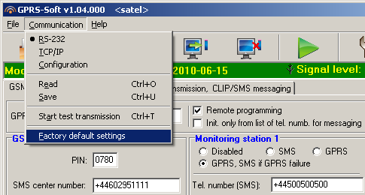
Fig. 9. "Factory default settings" function in the "Communication" menu.

Most parameters in the factory default settings are not defined, and the options are not enabled. Only the following parameters are defined:
"GSM telephone, Monitoring stations" tab
Monitoring station 1 / 2:
Disabled – the field is selected
Kiss-off time – 600 ms
SMS format – Event = , , , ,  =
"Test transmissions, CLIP / SMS messaging" tab
CLIP:
Reaction to CLIP only when number is on list of tel. for messaging – the option is enabled
CLIP / SMS messaging:
Format – 4/2

Technical data
Supply voltage 12 V DC ±15%
Current consumption, standby 50 mA
Current consumption, max. 180 mA
Power supply required output current, min. 2 A
Current-carrying capacity, FT output 50 mA
Environmental class II
Working temperature range -10...+55 °C
Electronics board dimensions 80 x 57 mm
Weight 184 g



Monitoring Converter
GPRS-T1

Program version 2.00 gprs-t1_en 10/10

SATEL sp. z o.o.
ul. Schuberta 79
80-172 Gdańsk
POLAND
tel. + 48 58 320 94 00
info@satel.pl
www.satel.pl
druk (2 na 1):
18,19,0,17,16,1,2,15,14,3,4,13,12,5,6,11,10,7,8,9

