WARNINGS
The module should be installed by qualified personnel.

Read carefully this manual before proceeding to installation.

Changes, modifications or repairs not authorized by the manufacturer shall void your rights under the warranty.

FreeRTOS is used in this device (www.freertos.org).

SATEL's goal is to continually upgrade the quality of its products, which may result in some changes of their technical specifications and firmware. The current information on the introduced modifications is available on our website.
Please visit us:
http://www.satel.eu

The declaration of conformity may be consulted at www.satel.eu/ce

The following symbols may be used in this manual:
 - note;
 - caution.

CONTENTS
1 General 2
2 Field of application 2
3 Electronics Board 3
4 Setting address 3
4.1 Module connected to INTEGRA / INTEGRA Plus control panel 4
4.2 Module connected to VERSA control panel 4
5 Installation 4
6 Configuring the settings 6
6.1 Module connected to INTEGRA / INTEGRA Plus control panel 6
6.1.1 Module parameters and options 6
6.1.2 IP filter 9
6.1.3 User functions 12
6.1.4 Virtual keypad 12
6.1.5 Macro commands 14
6.2 Module connected to VERSA control panel 22
6.2.1 Module parameters and options 22
6.2.2 Messaging 25
6.3 Virtual keypad 27
6.3.1 Module connected to INTEGRA / INTEGRA Plus control panel 27
6.3.2 Module connected to VERSA control panel 29
6.4 User functions [INTEGRA / INTEGRA Plus] 29
6.5 Macro commands [INTEGRA / INTEGRA Plus] 29
6.5.1 Groups 30
6.5.2 Definitions 31
6.5.3 Defining macro commands 33
6.5.4 Exporting macro file 37
7 Remote programming / operating of control panel via Ethernet 37
7.1 GUARDX program 38
7.1.1 Configuring the GUARDX program settings 38
7.1.2 Initiating connection from GUARDX program 39
7.1.3 Initiating connection from keypad (through control panel) 40
7.1.4 Establishing connection via the SATEL server 40
7.2 Web browser 41
7.2.1 ETHM-1 Plus module settings 41
7.2.2 Configuring computer 41
7.2.3 Establishing the communication 41
7.3 Mobile device 42
7.3.1 Configuring the settings in INTEGRA CONTROL application (Android) 42
7.3.2 Configuring the settings in INTEGRA CONTROL application (iOS) 46
7.3.3 ETHM-1 Plus module settings 47
7.3.4 Establishing the communication 47
8 Specifications 48

General
The ETHM-1 Plus module enables the INTEGRA Plus, INTEGRA and VERSA alarm control panels to communicate via the Ethernet network. The data transmission is encrypted by means of an advanced algorithm based on 192-bit key.
The module firmware can be updated using the application available on www.satel.eu

Field of application
- Control panel configuration using the DLOADX program from a computer with Internet access.
The feature is available for the INTEGRA Plus, INTEGRA (firmware version 1.03 or newer) and VERSA (firmware version 1.01 or newer) control panels.
- Management of the alarm system using the GUARDX program from a computer with Internet access.
The feature is available for the INTEGRA Plus and INTEGRA (firmware version 1.03 or newer) control panels.
- Operation and configuration of the control panel using a web browser which supports Java applications.
The feature is available for the INTEGRA Plus and INTEGRA (firmware version 1.03 or newer) control panels.
- Operation and configuration of the control panel using the INTEGRA CONTROL / MobileKPD / MobileKPD-2 / MobileKPD-2 Pro application from a mobile device with Internet access. The mobile device acts as an additional keypad for the alarm system.
The feature is available for the INTEGRA Plus and INTEGRA (firmware version 1.03 or newer) control panels.
- Operation of the control panel using the VERSA CONTROL application from a mobile device with Internet access.
The feature is available for the VERSA (firmware version 1.04 or newer) control panels.
- Reporting events from the control panel to the monitoring station via the Ethernet network. This contributes considerably to reducing the costs of reporting.
The feature is available for the INTEGRA Plus, INTEGRA (firmware version 1.04 or newer) and for the VERSA (firmware version 1.01 or newer) control panels.
- Notification of events in the alarm system using e-mail messages. The message body is generated automatically (it corresponds to the description in the event log in case of INTEGRA Plus system).
The feature is available for INTEGRA Plus (firmware version 1.13 or newer) and VERSA (firmware version 1.04 or newer) control panels.
- Integration of the control panel with other systems, due to the open protocol for communication over Ethernet. It is a dedicated solution for companies engaged in integration of the object-oriented systems, which requires development of own software.
The feature is available for the INTEGRA Plus and INTEGRA (firmware version 1.06 or newer) control panels.
For additional information on the open communication protocol, please visit www.satel.eu

Electronics Board

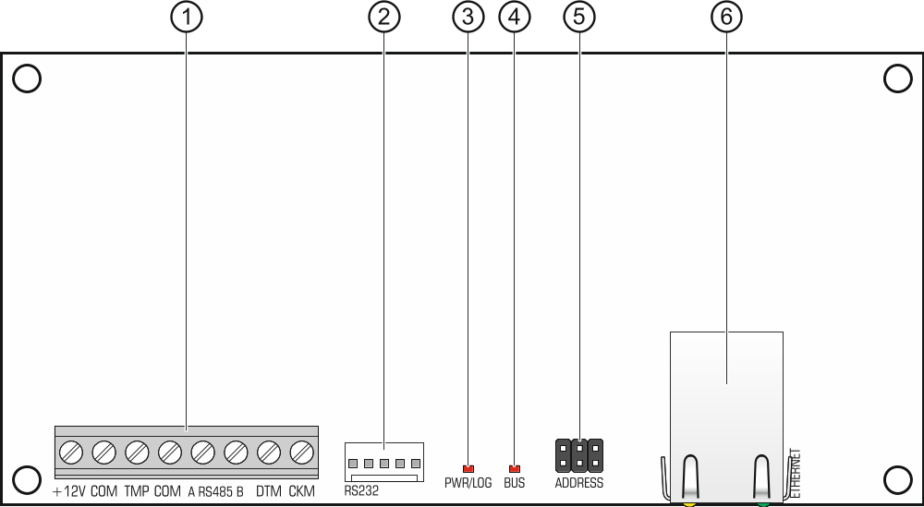
Fig. 1. Module electronics board.

 terminals:
+12V - +12 V DC power input.
COM - common ground.
TMP - tamper input (NC) – if not used, it should be shorted to common ground.
A RS485 B - terminals provided for future applications (RS-485).
DTM - data (communication bus).
CKM - clock (communication bus).
 RS-232 port.
 PWR/LOG LED:
OK – power OK,
blinking – control panel being programmed or operated by means of the module.
 BUS LED – blinking LED indicates that data exchange with the control panel is in progress.
 pins for setting the module address (see “Setting address”).
 RJ-45 connector for Ethernet network. It is provided with two LEDs:
green – indicates connection to the network and data transmission,
yellow – indicates negotiated transmission rate (ON: 100 Mb; OFF: 10 Mb).

Setting address
To set an address, you must place jumpers across the ADDRESS pins. Table 1 shows how to use jumpers in order to set a specific address ( - jumper on; - jumper off).

Address | 0 | 1 | 2 | 3 | 4 | 5 | 6 | 7
Pins status
Table 1.

Module connected to INTEGRA / INTEGRA Plus control panel
Set an address in the module within the range:
- from 0 to 3, if it is connected to INTEGRA 24 or INTEGRA 32 control panel,
- from 0 to 7, if it is connected to another INTEGRA or INTEGRA Plus control panel.
The address set must be different from that in the other devices connected to the keypad bus of the control panel (the control panel does not support devices with the same address).

Module connected to VERSA control panel
Set address 4 in the module. No keypad with the address 4 may be connected to the control panel.

Installation
Disconnect power before making any electrical connections.
The device is designed to be used only in the local area networks (LAN). It must not be connected directly to the public computer network (MAN, WAN). For establishing connection with public networks, use a router or xDSL modem.
The device is designed for installation indoors, in spaces with normal air humidity.
- Secure the module electronics board in the enclosure. The module should be installed in the same enclosure as the control panel. This will facilitate connecting the RS-232 ports of control panel and module, which is required, if the control panel is to be configured via Ethernet using the DLOADX program.
- Set the module address (see “Setting address”).
- Connect the +12V, COM, DTM and CKM module terminals to the control panel terminals (Fig. 2). It is recommended that an unshielded non-twisted cable be used for making the connection. If you use the twisted-pair type of cable, remember that CKM (clock) and DTM (data) signals must not be sent through one twisted-pair cable. The wires must be run in one cable.

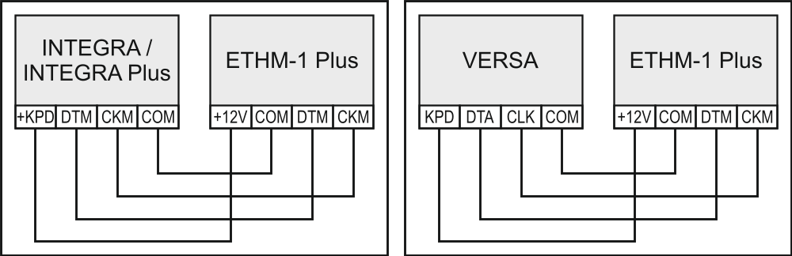
Fig. 2. Connecting the module to the control panel.

- If the module is to supervise the enclosure tamper switch, connect the tamper switch wires to the TMP and COM terminals. Otherwise, connect the TMP terminal to the module COM terminal.
- Connect the module to the Ethernet network. Use a cable compliant with the 100Base-TX standard (identical as for connecting the computer to the network).
- Power on the alarm system.
- Start the identification function in the control panel (see the control panel installer manual). The module will be identified as “ETHM-1”.
- Configure the module (see “Configuring”).
- If the control panel is to be configured via the module using the DLOADX program, connect the module RS-232 port to the control panel RS-232 port. Depending on the control panel, use the following cable to make the connection:
INTEGRA with connector socket of PIN5 type: PIN5/PIN5 (Fig. 3)
INTEGRA with connector socket of RJ / INTEGRA Plus type: RJ/PIN5 (Fig. 4)
VERSA: PIN5/RJ-TTL
The above mentioned cables are available in SATEL's product offering.

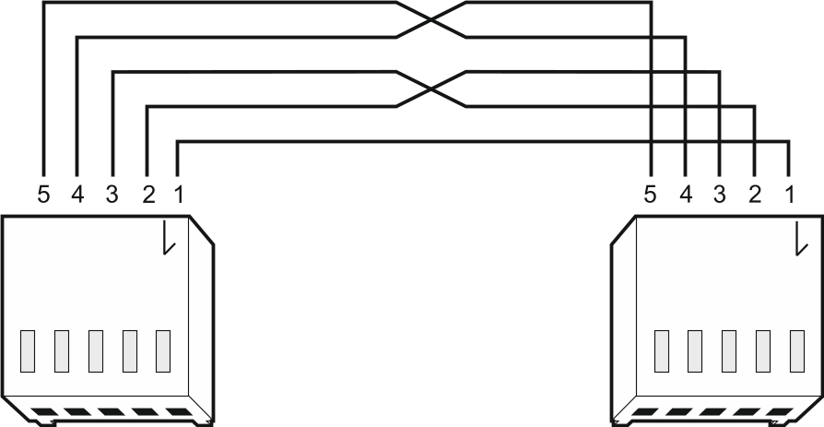
Fig. 3. Wiring diagram of the cable connecting RS-232 ports of ETHM-1 Plus module and INTEGRA control panel with PIN5 connector socket.

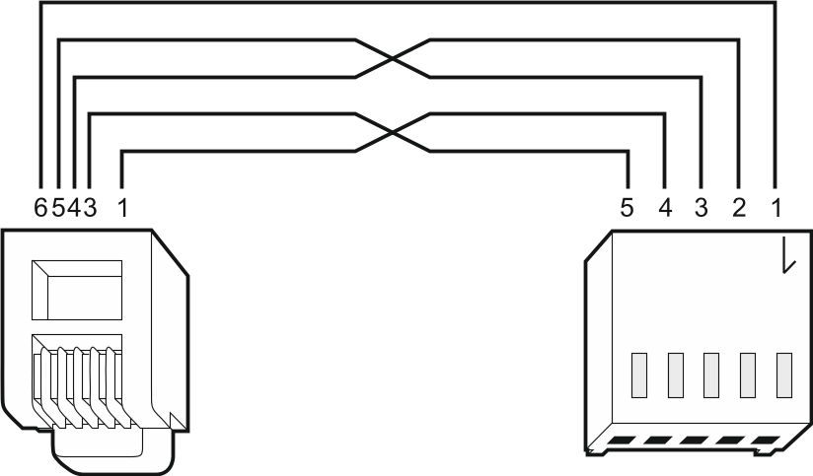
Fig. 4. Wiring diagram of the cable connecting RS-232 ports of ETHM-1 Plus module and INTEGRA / INTEGRA Plus control panel with RJ type connector socket.

Configuring the settings
The module settings differ, depending on the control panel to which the module is connected.

Module connected to INTEGRA / INTEGRA Plus control panel

Module parameters and options
You can configure parameters and options of the module using:
- LCD keypad: Service mode Structure Hardware LCD keypads Settings [module name],
- DLOADX program: →“Structure” window →“Hardware” tab →“Keypads” branch →[module name] →“ETHM-1” tab (Fig. 5).
Shown in square brackets are the names of parameters and options as they are presented on the LCD keypad display.
Name – individual name of the device (up to 16 characters).
Tamper signaled in part. [Tamper in part.] – partition where alarm will be triggered in the event of module tamper.
Obtain IP address automatically (DHCP) [DHCP] – if this option is enabled, the module will automatically download data on IP address, subnet mask and gateway from the DHCP server (in such a case, you do not have to program these parameters).
The IP address assigned to the module can be read:
- in the keypad: using the IP/MAC ETHM-1 user function available in the Tests submenu. For a detailed description of the function please refer to the user manual for the control panel.
- in the DLOADX program: below the module parameters and options (Fig. 5).
IP address – module IP address.
Subnet mask [Netmask] – the mask of the subnet in which the module is working.
Gateway – IP address of the network device through which the other devices in the local network can communicate with devices in other networks.
Obtain DNS server address automatically [DHCP-DNS] – if this option is enabled, the DNS server IP address is downloaded automatically from the DHCP server. The option is available, when the Obtain IP address automatically (DHCP) option is enabled.
DNS server – IP address of the DNS server which is to be used by the module. It can be programmed, if the Obtain DNS server address automatically option is disabled.

DLOADX
DLOADX->ETHM-1 connection [Connect DLOADX] – if this option is enabled, it is possible to initiate connection with the control panel via Ethernet from the DLOADX program.
Port [Port (DLOADX)] – number of the TCP port used for communication with the DLOADX program. You can enter values from 1 to 65535. The value must be different from that entered for the other ports. Default value: 7090.
DLOADX key [Key (DLOADX)] – a string of up to 12 alphanumeric characters (digits, letters and special characters) used for data encryption during communication between the control panel and the computer with DLOADX program via Ethernet.
DLOADX server [DLOADX IP] – address of the computer running the DLOADX program. If the computer is not in the same local network, it must be a public address. You can enter either the IP address or the domain name.
In the LCD keypad, the function for programming address of the computer with DLOADX program is available in the user menu, Change options submenu (available to service and administrators).

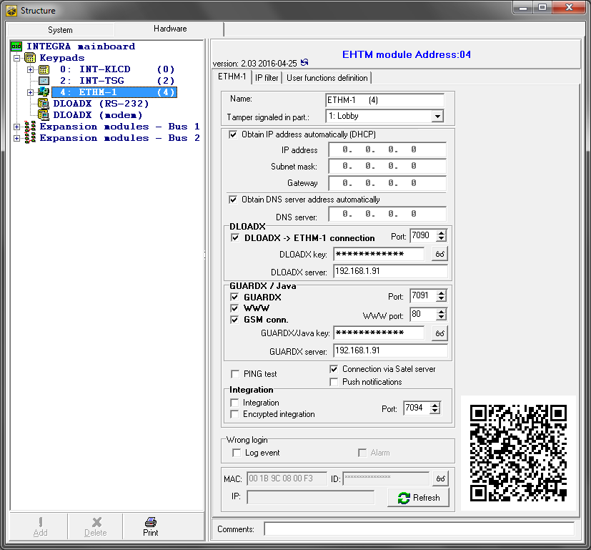
Fig. 5. DLOADX program: parameters and options of ETHM-1 Plus module connected to INTEGRA / INTEGRA Plus control panel.

GUARDX / Java
GUARDX [Connect GUARDX] – if this option is enabled, it is possible to initiate connection with the control panel via Ethernet from the GUARDX program.
WWW [Connect Intern.] – if this option is enabled, it is possible to initiate connection with the control panel via Ethernet from the web browser.
GSM conn. [Connect GSM] – if this option is enabled, connection with the control panel via Ethernet can be initiated from the INTEGRA CONTROL / MobileKPD / MobileKPD-2 / MobileKPD-2 Pro application.
Port [Port (others)] – number of the TCP port used for communication with:
- GUARDX program,
- JAVA application in the web browser,
- INTEGRA CONTROL / MobileKPD / MobileKPD-2 / MobileKPD-2 Pro in the mobile device.
You can enter values from 1 to 65535. The value must be different from that entered for the other ports. Default value: 7091.
WWW port – number of the TCP port used for communication with the web browser. You can enter values from 1 do 65535 The value must be different from that entered for the other ports. Default value: 80.
GUARDX/Java key [Key (others)] – a string of up to 12 alphanumeric characters (digits, letters and special characters) used for data encryption during communication between the control panel and:
- GUARDX program,
- JAVA application in the web browser,
- INTEGRA CONTROL / MobileKPD / MobileKPD-2 / MobileKPD-2 Pro in the mobile device.
GUARDX server [GUARDX IP] – address of the computer running the GUARDX program. If the computer is not used in the same local network, it must be a public address. You can enter either the IP address or the domain name.
In the keypad, the function for programming address of the computer with GUARDX program installed is available in the user menu, Change option submenu (available to service and administrators).

PING test
PING test – if this option is enabled, the module can perform a communication test using the ping command sent to the indicated network device. Parameters related to the communication test should be programmed in the control panel:
LCD keypad: Service mode Options PING test,
DLOADX program: →“Structure” window →“Hardware” tab →“Keypads” branch.

SATEL server
Connection via Satel server [SATEL server] – if this option is enabled, the control panel connects to the SATEL server via the Ethernet module, while the SATEL server makes it possible to establish communication with the control panel (Connection Establishing Service). For communication vie the SATEL server, you do not need to additionally configure the network device through which the module connects to the public network.
For establishing communication with the SATEL server, the DNS server must be used.
For communication via the SATEL server, the ports of 1024-65535 range are used as outgoing ports. These ports must not be blocked.
Push notifications – if this option is enabled, the INTEGRA CONTROL application can provide information about alarm system events by means of push notifications.

Integration
Integration [Integrate] – if this option is enabled, the module can be used for integration of the alarm control panel with other systems.
Encrypted integration [Coded integr.] – if this option is enabled, communication with other systems is encrypted. The integration encryption key should be programmed in the control panel:
LCD keypad: Service mode Options Integrate key,
DLOADX program: →“Options” window →“Service” tab.
Port [Port (integr.)] – number of the TCP port used for integration. You can enter values from 1 do 65535. The value must be different from that entered for the other ports. Default value: 7094.

Wrong login
Log event [Fail. – event] – if this option is enabled, all unauthorized attempts to connect to the module are written to the event log.
Alarm [Fail. – alarm] – if this option is enabled, any unauthorized attempt to connect to the module will trigger the tamper alarm. The option is available, if the Log event option is enabled.

Information
MAC – module hardware address.
ID – identifier assigned to the module for the purposes of communication via the SATEL server. The ID number is assigned automatically by the SATEL server.
IP – local address / public address of the module.
Refresh – pressing the button will update information presented in the MAC, ID and IP fields.
If the module is to be used in another alarm system, the hitherto used ID number must be deleted. You can do it using the Change ID function available from the keypad (Service mode Structure Hardware  LCD keypads  Settings [module name] Change ID), if the control panel is connected to the SATEL server. Having deleted the old ID number, the control panel will receive a new one. The INTEGRA CONTROL applications using the old ID number will be unable to connect to the control panel.
In the DLOADX program, the QR code for future use is displayed next to the settings.

IP filter
The module connected to the INTEGRA / INTEGRA Plus control panel with firmware version 1.15 offers IP filter. Using IP filtering allows you to enhance security level of the alarm system. Establishing connection with the Ethernet module (alarm control panel) will only be possible from defined IP addresses or subnets. You can configure the IP filtering settings using the DLOADX program (→“Structure” window →“Hardware” tab →“Keypads” branch →[module name] →“IP filter” tab). IP filtering does not apply to communication with the SATEL server.

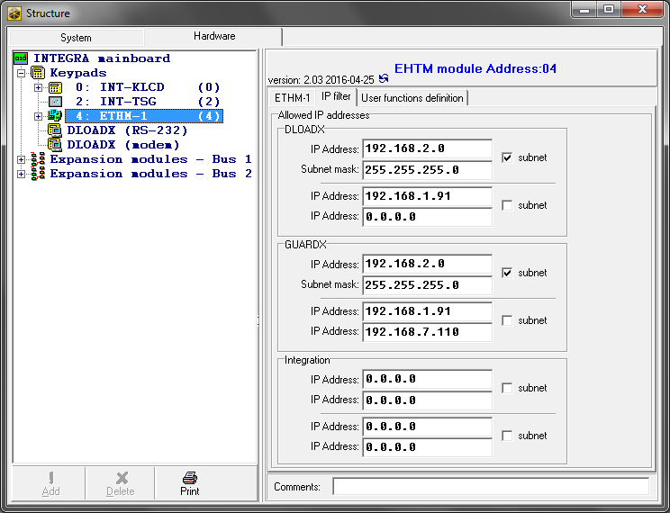
Fig. 6. DLOADX program: “IP filter” tab.

You can configure IP filtering for the incoming connections:
- from DLOADX program,
- from GUARDX program (applies also to web browser and mobile application),
- as part of integration.
In each case you can define the filtering rules in one of the following configurations:
- up to 4 allowed IP addresses,
- 1 allowed subnet and up to 2 allowed IP addresses,
- up to 2 allowed subnets.
To activate the filtering feature, enter a value in one of the four fields available for the given type of incoming connections.
IP Address – if the subnet option is disabled: the network address from which connection with the Ethernet module can be established. If the subnet option is enabled: the IP address used for defining the subnet from which connection with the Ethernet module can be established.
subnet – if the option is enabled, you can define the subnet from which incoming connections will be received by the module.
Subnet mask – mask used for separating the portion defining subnet from the IP address.

Filtering by IP address
In the IP Address field, enter the network address from which establishing connection with the module (control panel) is to bed possible. The subnet option on the right-hand side of the field must not be selected.
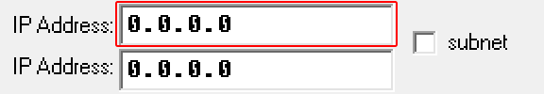
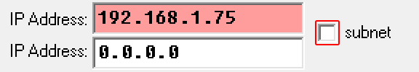

Filtering by subnet
- Select the subnet option. Description of one of the IP Address fields will change to Subnet mask. From now on, the IP Address and Subnet mask fields constitute a pair.
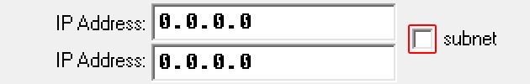
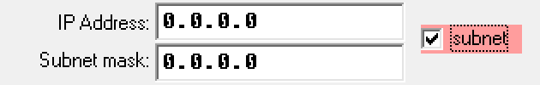
- Enter the address to be used to define the subnet.
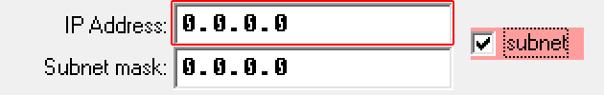
- Enter the mask to be used to separate the portion defining subnet in the IP address.
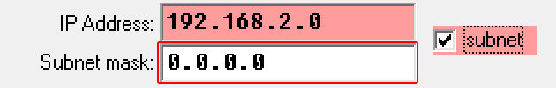
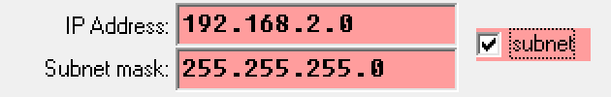

User functions
If the INTEGRA CONTROL / MobileKPD-2 / MobileKPD-2 Pro application is used in the mobile device, the virtual keypad allows you to quickly start user functions after entering the code and pressing an arrow key. The functions can be assigned to individual keys using:
- LCD keypad: Service mode Structure Hardware LCD keypads Settings [module name] Code+arrows,
- DLOADX program: →“Structure” window →“Hardware” tab →“Keypads” branch →[module name] →“User functions definition” tab (Fig. 7).

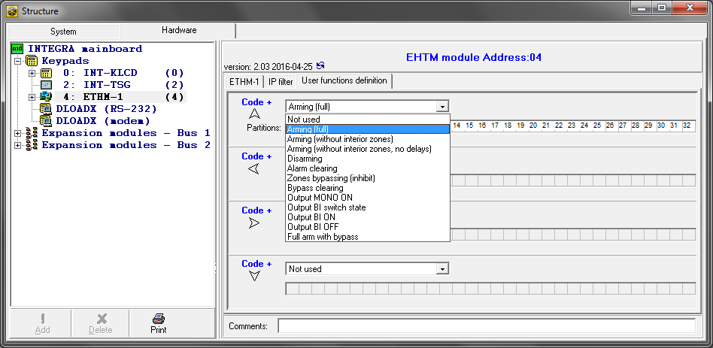
Fig. 7. Program DLOADX: “User functions definition” tab.

Virtual keypad
The virtual keypad allows you to operate and program the alarm system in much the same way as using a physical keypad. You can use the virtual keypad in the DLOADX and GUARDX programs, web browser and in the mobile device (after installation of the INTEGRA CONTROL / MobileKPD / MobileKPD-2 / MobileKPD-2 Pro application).

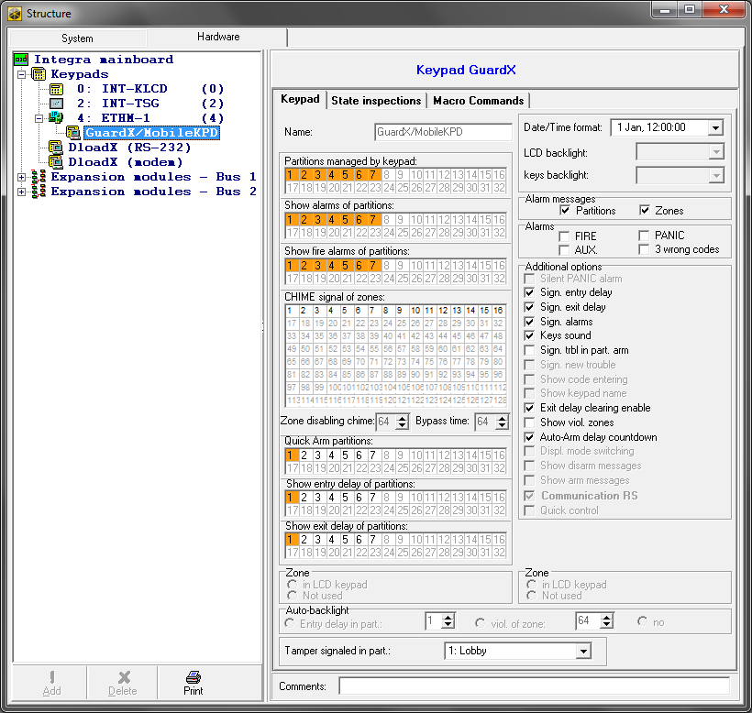
Fig. 8. DLOADX program: parameters and options of the virtual keypad available in GUARDX program, web browser or mobile device.

Parameters and options of the virtual keypad available in the DLOADX program can be programmed using:
- LCD keypad: Service mode Structure Hardware LCD keypads Settings DLOADX RS,
- DLOADX program: →“Structure” window →“Hardware” tab →“Keypads” branch →“DLOADX (RS-232)” item.
Settings of the virtual keypad available in the GUARDX program, web browser or mobile device can be programmed using:
- LCD keypad: Service mode Structure Hardware LCD keypads Settings GUARDX addr. n [n = module address],
- DLOADX program: →“Structure” window →“Hardware” tab →“Keypads” branch →[module name] branch →“GUARDX/MobileKPD” item (Fig. 8).
For description of the keypad parameters and options, please refer to the programming manual for INTEGRA / INTEGRA Plus control panel (only some of these parameters and options are available for the virtual keypad).

Macro commands
The INTEGRA CONTROL / MobileKPD-2 Pro application allows to control the alarm system by means of macro commands, thus making it possible to quickly and easily run a number of different functions by touching just a few keys. The macro commands can be defined in the DLOADX program (→“Structure” window →“Hardware” tab →“Keypads” branch →[module name] branch →“GUARDX/MobileKPD” item →“Macro Commands” tab).
Defined macro commands can be automatically downloaded by the INTEGRA CONTROL / MobileKPD-2 Pro application after establishing connection with the ETHM-1 Plus module.
Macro commands can be loaded into the application without establishing connection with the module. The file containing macro commands can be exported, and then saved to the mobile device memory (to transfer the file, you can use a memory card or other solutions available for the given device). This method allows you to use macro commands defined for the INT-KSG keypad in the INTEGRA CONTROL / MobileKPD-2 Pro application. Instead of a file with macro commands defined for the ETHM-1 Plus module, you can load a file with macro commands defined for the LCD keypad.
The data related to macro commands are stored in the module memory. Before you start defining the macro commands, click on the “Read” button in the “Macro commands” tab to read the data from the module. Having defined the macro commands, click on the “Write” button in the “Macro commands” tab to write the data to the module. The macro command related data are not read / written when you click on the  button in the main menu of DLOADX program.

Groups

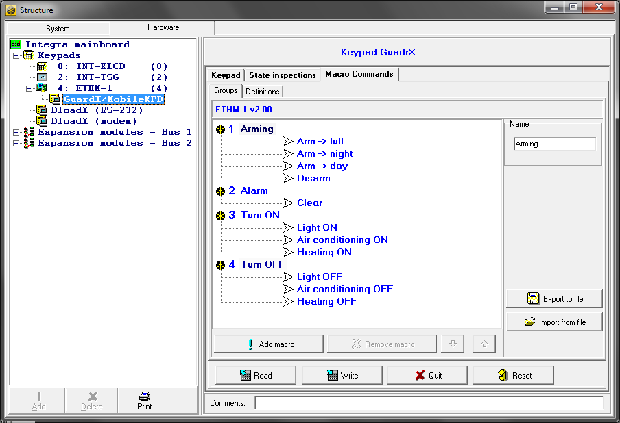
Fig. 9. DLOADX program: “Groups” tab.

The macro commands which are to be available to the mobile device users must be assigned to one of the four groups. You can assign up to 16 macro commands to the groups. The DLOADX program presents the macro command groups and the macro commands assigned to them in the tree form.
Name – name of the macro command group (up to 8 characters). It is presented on the macro key.
Add macro – button available after you click on a macro command group. Clicking on the button will display a list of defined macro commands. Click on the name to add the macro command to the group.
Remove macro – click on the button to delete the selected macro command from the group.
– click on the button to move the highlighted macro command down within the group.
– click on the button to move the highlighted macro command up within the group.
Read – click on the button to read the macro command related data from the module.
Write – click on the button to write the macro command related data to the module.
Quit – click on the button to cancel reading or writing the macro command related data.
Reset – click on the button to delete all the defined macro commands (and restore factory default settings).
Export to file – click on the button to export defined macro commands to a file. The file with macro commands can be loaded into the INTEGRA CONTROL / MobileKPD-2 Pro application or imported to another ETHM-1 Plus module or to a INT-KSG keypad (i.e. macro commands can be copied between the devices).
Import from file – click on the button to import macro commands from a file.

Definitions
Macro commands can be created and configured in the “Definitions” tab. The macro command is a sequence of actions, composed of single commands, which are to be done by the control panel when running the macro command.
New macro – click on the button to create a new macro command.
Remove macro – click on the button to remove the selected macro command.
Name – individual macro command name (up to 32 characters).
Code – the code which is to be used for authorization when executing commands contained in the macro command. The code must have an appropriate authority level for execution of such commands to be possible. The code is presented as a string of asterisks.
If the code turns out to be incorrect when running macro commands (e.g. it was changed in the meantime), the user will be able to enter the correct code. It will be automatically saved to the device memory (to replace the invalid code).
Authorization required – if this option is enabled, the macro command will only be run after user authorization by means of code. The code entered in the “Code” field will be ignored.
Disabl. if armed – if this option is enabled, the macro command will not be available, if any of the partitions managed by the virtual keypad is armed.
Autoexecute – if this option is enabled and there is only one macro command in the group, the macro command will be run immediately on tapping the macro key (if the Authorization required option is enabled, user authorization by means of code will be required).
Commands list – commands assigned to the currently highlighted macro command. The and buttons allow you to change the order of commands (moving the highlighted command up and down).
Add – click on the button to add to the list a new command, selected in the “Command” field.
Change – click on the button to save the changes to the command parameters which were made after adding the command to the list (otherwise, the changes made will not be saved).
Delete – click on the button to remove the highlighted command from the list.

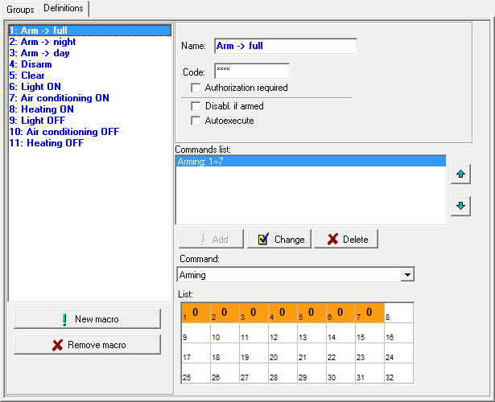
Fig. 10. DLOADX program: “Definitions” tab.

Command – function executed by the control panel, which can be assigned to the macro command. To display the list of all available functions, click on the button. Depending on which function you have selected:
Arming – highlight the partitions which are to be armed (double-click on the field designated by the partition number) and define the arming mode (next clicks on the field designated by the partition number; the digit inside the field has the following meaning: 0 - fully armed; 1 – fully armed+bypasses; 2 – armed without interior; 3 - armed without interior and without entry delay).
Disarming – highlight the partitions which are to be disarmed (double-click on the field designated by the partition number).
Alarm clearing – highlight the partitions in which alarm is to be cleared (double-click on the field designated by the partition number).
Bypass zones – highlight the zones which are to be inhibited (double-click on the field designated by the zone number).
Unbypass zones – highlight the zones which are to be unbypassed (double-click on the field designated by the zone number).
Outputs ON – highlight the outputs which are to be activated (double-click on the field designated by the output number).
Outputs OFF – highlight the outputs which are to be deactivated (double-click on the field designated by the output number).
Change outputs state – highlight the outputs whose status is to be changed (double-click on the field designated by the output number).
KNX telegram – program the following parameters of KNX telegram:
INT-KNX module – INT-KNX module which is to send the telegram.
Group address – the group address which will be inserted in the telegram.
Type – the telegram type.
Value – the value that will be inserted in the telegram (parameter available for some types of the telegram).
Priority – telegram priority (if two elements of the bus start transmitting simultaneously, the telegram with higher priority will be sent first).
Exit delay clearing (no additional parameters to configure).
Quick arm – select the arming mode which is to be activated.
The partitions must be controlled by user code.
The zones must not have the Bypass disabled option enabled.
The outputs must be the 24. MONO Switch, 25. BI Switch, 105. Shutter up, 106. Shutter down or Remote switch type (they need not be assigned to any group of outputs).
Using the INTEGRA CONTROL / MobileKPD-2 Pro application, you can control the KNX system, if the INT-KNX module is connected to the control panel.

Defining macro commands
- Click on the “Read” button to read the macro command related data from the module.
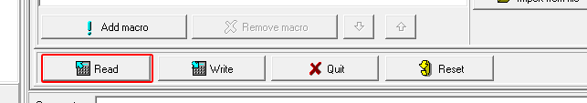
- Click on the “Definitions” tab.
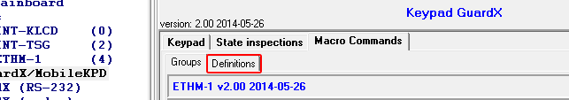
- Click on the “New macro” button. A new macro command will appear on the list.
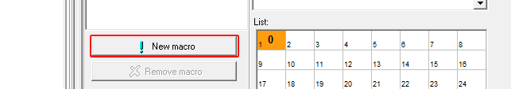
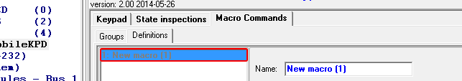
- Enter a name for the new macro command.
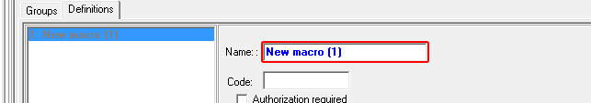
- If the macro command is to be run without entering the code by the user, enter a code having appropriate authority level.
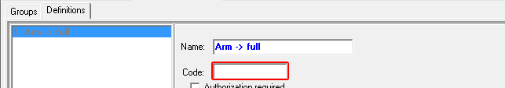
- If running a macro command is to be each time preceded by user authorization, enable the Authorization required option.
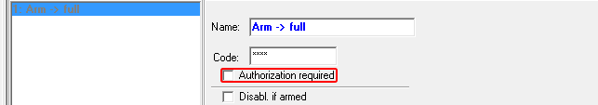
- If the macro command is to be unavailable when any of the partitions managed by the keypad is armed, enable the Disabl. if armed option.

- If the macro command is to be run immediately on tapping the macro key, enable the Autoexecute option (in such a case, only this one macro command is to be assigned to the group).

- Click on the button and select the function the new macro command is to execute.
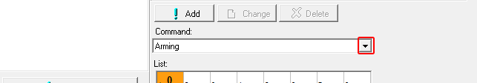
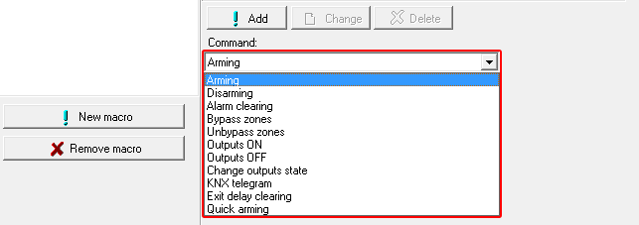
- Configure the command parameters.
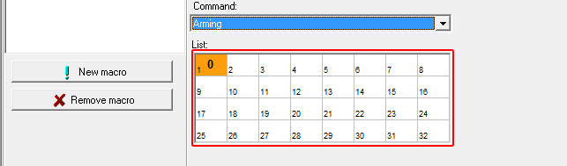
- Click on the “Add” button. A new command will appear on the list of commands assigned to the macro command. You can still modify parameters of the command after clicking on it (having made the changes, click on the “Change” button).
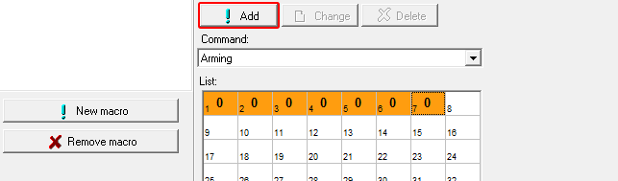
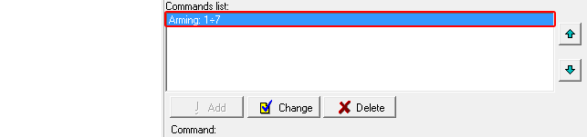
- Repeat the steps 9-11, if you want to add next commands.
- Click on the “Groups” tab.
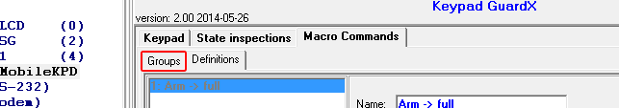
- Click on the group you want to edit.
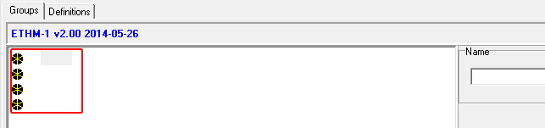
- Enter the group name.
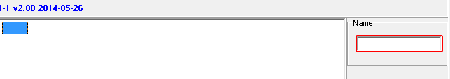
- Click on the “Add macro” button. A list of all defined macro commands will be displayed.
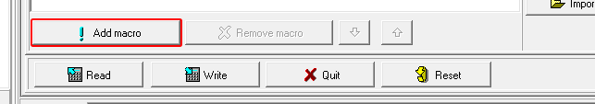
- Click on a macro command to add it to the group. The macro command will be put in the tree under the group.
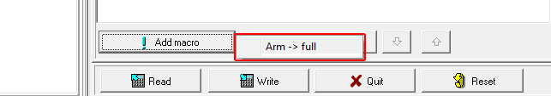
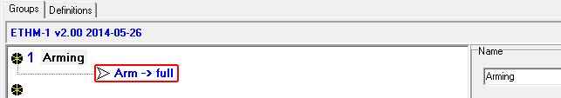
- Click on the “Write” button to write the macro command related data to the module.
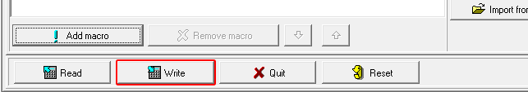

Exporting macro file
If the INTEGRA CONTROL / MobileKPD-2 Pro application is to run macro commands which have been defined for the INT-KSG keypad, the following operations must be carried out in the “Macro Commands” tab for the INT-KSG keypad.
- Click on the “Groups” tab.
- Click on the “Export to file” button.
- In the window that will be displayed, enter the file name and then click on the “Save” button. Before you click on the “Save” button, you can indicate a location other than the default one, to which the file is to be saved.
- In the window that will be displayed, enter the file encryption code (up to 24 alphanumeric characters), and then click “OK”. The file encryption code will be required during loading of macro commands by the INTEGRA CONTROL / MobileKPD-2 Pro application.
- A window will be displayed to inform you that the file has been saved.

Module connected to VERSA control panel

Module parameters and options
Parameters and options of the module can be configured using:
- LCD keypad: Service mode 2. Hardware 1. Kpds. & exps. 2. Settings [module name],
- DLOADX program: →“Versa – Structure” window →“Hardware” tab →“Expansion modules” branch →[module name] (Fig. 11).
Shown in square brackets are the names of parameters and options as they are presented on the LCD keypad display.
Name – individual name of the device (up to 16 characters).
Tamper signaled in part. [Tamper in p.] – partition where alarm will be triggered in the event of module tamper.

DLOADX
DLOADX server [DLOADX] – address of the computer running the DLOADX program. If the computer is not in the same local network, it must be a public address. You can enter either the IP address or the domain name.
Port [DLOADX port] – number of the TCP port used during communication between control panel and a computer with DLOADX program via Ethernet. You can enter values from 1 to 65535. The value must be different from that entered for the other ports. Default value: 7090.
DLOADX key – a string of up to 12 alphanumeric characters (digits, letters and special characters) which is used for data encryption during communication between control panel and computer with DLOADX program via Ethernet.

ETHM
Obtain IP address automatically (DHCP) [DHCP] – if this option is enabled, the module will automatically download data on IP address, subnet mask and gateway from the DHCP server (in such a case, you do not have to program these parameters).
The IP address assigned to the module can be read in the LCD keypad using the Module ver. user function available in the Tests submenu. For a detailed description of the function please refer to the user manual for the control panel.
IP address – module IP address.
Subnet mask [Netmask] – the mask of the subnet in which the module is working.
Gateway – IP address of the network device through which the other devices in the local network can communicate with devices in other networks.
Obtain DNS server address automatically [DHCP-DNS] – if this option is enabled, the DNS server IP address is downloaded automatically from the DHCP server. The option is available, when the Obtain IP address automatically (DHCP) option is enabled.
DNS server – IP address of the DNS server which is to be used by the module. It can be programmed, if the Obtain DNS server address automatically option is disabled.
Address to test [PING] – address of the device to which a ping command to test communication is to be sent by the module. You can enter IP address or domain name.
Period [PING period] – the time interval between successive communication tests using the ping command. If value 0 is programmed, the communication test is disabled.
Tries no. before trouble [PING tries] – the number of failed communication tests (the module received no answer to the ping command sent), after which the trouble will be reported. If value 0 is programmed, the communication test is disabled.

Dloadx
DLOADX->ETHM-1 connection [DLOADX→ETHM-1] – if this option is enabled, it is possible to initiate connection with the control panel via Ethernet from the DLOADX program.
Port [DLOADX port] – number of the TCP port used for communication with the DLOADX program. You can enter values from 1 to 65535. The value must be different from that entered for the other ports. Default value: 7090.
DLOADX server [DLOADX] – address of the computer running the DLOADX program. If the computer is not in the same local network, it must be a public address. You can enter either the IP address or the domain name.
DLOADX key [DLOADX key] – a string of up to 12 alphanumeric characters (digits, letters and special characters) defining the key for data encryption during communication with the DLOADX program.

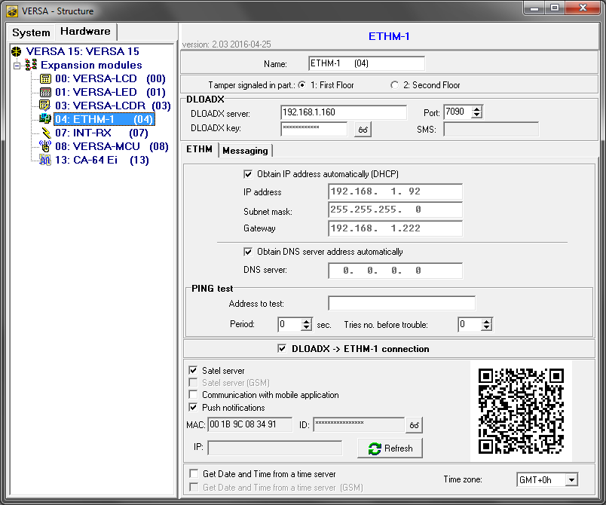
Fig. 11. DLOADX program: parameters and options of the ETHM-1 Plus module connected to VERSA control panel.

PING test
Address to test [PING] – address of the device to which a ping command to test communication is to be sent by the module. You can enter IP address or domain name.
Period [PING period] – the time interval between successive communication tests using the ping command. If value 0 is programmed, the communication test is disabled.
Tries no. before trouble [PING tries] – the number of failed communication tests (the module received no answer to the ping command sent), after which the trouble will be reported. If value 0 is programmed, the communication test is disabled.
Satel server [SATEL server LAN] – if this option is enabled, the control panel connects to the SATEL server via the Ethernet module, while the SATEL server makes it possible to establish communication with the control panel (Connection Establishing Service). For communication vie the SATEL server, you do not need to additionally configure the network device through which the module connects to the public network.
For establishing communication with the SATEL server, the DNS server must be used.
For communication via the SATEL server, the ports of 1024-65535 range are used as outgoing ports. These ports must not be blocked.
Communication with mobile application [Mobile app.] – if this option is enabled, communication with the control panel can be established from the mobile application. The option is available if the Satel server option is enabled.
MAC – information on module hardware address.
ID – information on individual identification number for the purpose of communication via the SATEL server (programming by means of DLOADX program, operating by means of VERSA CONTROL application). The ID number is assigned automatically by the SATEL server.
If the module is to be used in another alarm system, the hitherto used ID number must be deleted. It can be done from the keypad, when programming the Ethernet module, in the last step, if the control panel is connected to the SATEL server. Having deleted the old ID number, the module will receive a new one. The VERSA CONTROL applications using the old ID number will be unable to connect to the control panel.
IP – information on the module local / public address.
Refresh – pressing the button will update information presented in the MAC, ID and IP fields.
Get Date and Time from a time server [Time from srvLAN] – if the option is enabled, the control panel clock will be synchronized with the time server once a day.
For communication with the time server, the DNS server must be used.
Time zone – difference between the universal time (GMT) and the zone time. The parameter is required, if the control panel clock is to be synchronized with the time server.
In the DLOADX program, the QR code for future use is displayed next to the settings.

Messaging

E-mail messaging
E-mail messaging – if the option is enabled, the control panel can notify of occurrence of specified events by means of e-mail messages.
Email address – e-mail address to which messages are to be sent for notification of events.
ON – with this option enabled, it will be possible to send messages to the given e-mail address for notification of events.
Events type – define of which events the given e-mail address is to be notified.
Part. – define the partitions, about the events from which the given e-mail address is to be notified.

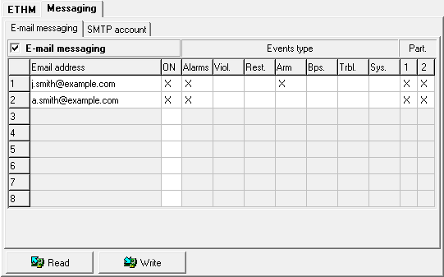
Fig. 12. DLOADX program: configuring the e-mail messaging.

SMTP account
It is required to have an e-mail account so as to enter its parameters in the DLOADX program for the purpose of e-mail messaging.
Mail server (SMTP) – address of outgoing mail server.
Server port – number of outgoing mail port.
User name – name of the e-mail account used for authorization by the SMTP server (login to e-mail account).
Password – the password used for authorization by the SMTP server.
Encryption – you can define if and how the outgoing mail is encrypted:
none – outgoing mail is not encrypted.
STARTTLS – outgoing mail will be encrypted using the STARTTLS protocol.
SSL/TLS – outgoing mail will be encrypted using the SSL/TLS protocol.
Subject – subject of the e-mail message. It will be inserted in each e-mail message to be sent.
Sender address – e-mail address which will be inserted in the outgoing e-mail message as the sender address. If this field is blank, the name of e-mail account will be treated as the sender address.

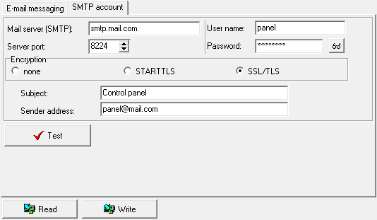
Fig. 13. DLOADX program: entering the data of e-mail account that will be used for e-mail messaging. The presented settings are just an example.

Virtual keypad
The virtual keypad allows you to operate and program the alarm system in much the same way as using a physical keypad.

Module connected to INTEGRA / INTEGRA Plus control panel
You can use the virtual keypad in the DLOADX and GUARDX programs, web browser and in the mobile phone (after installation of the MobileKPD / MobileKPD-2 / MobileKPD-2 Pro application).

Fig. 7. DLOADX program: parameters and options of the virtual keypad available in GUARDX program, web browser or mobile phone.

Parameters and options of the virtual keypad available in the DLOADX program can be programmed using:
- LCD keypad: Service mode Structure Hardware LCD keypads Settings DLOADX RS,
- DLOADX program: →“Structure” window →“Hardware” tab →“Keypads” branch →“DLOADX (RS-232)” item.
Settings of the virtual keypad available in the GUARDX program, web browser or mobile phone can be programmed using:
- LCD keypad: Service mode Structure Hardware LCD keypads Settings GUARDX addr. n [n = module address],
- DLOADX program: →“Structure” window →“Hardware” tab →“Keypads” branch →[module name] branch →“GUARDX/MobileKPD” item (Fig. 8).
For description of the keypad parameters and options, please refer to the programming manual for INTEGRA / INTEGRA Plus control panel (only some of these parameters and options are available for the virtual keypad).

Module connected to VERSA control panel
You can use the virtual keypad in the DLOADX program. Parameters and options of the virtual keypad cannot be configured.

User functions [INTEGRA / INTEGRA Plus]
If the MobileKPD-2 / MobileKPD-2 Pro application is used in the mobile phone, the virtual keypad allows you to quickly start user functions after entering the code and pressing an arrow key. The functions can be assigned to individual keys using:
- LCD keypad: Service mode Structure Hardware LCD keypads Settings [module name] Code+arrows,
- DLOADX program: →“Structure” window →“Hardware” tab →“Keypads” branch →[module name] →“User functions definition” tab (Fig. 7).

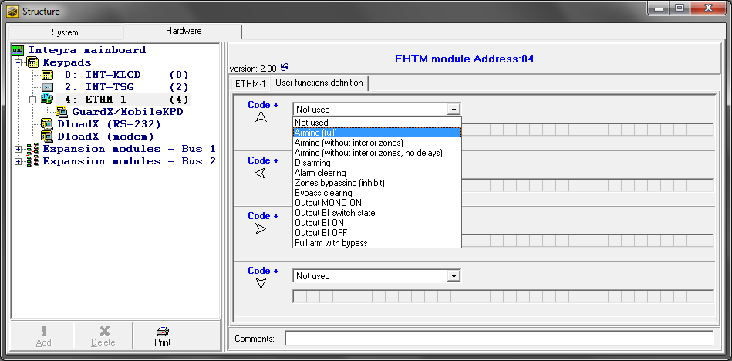
Fig. 8. Program DLOADX: “User functions definition” tab.

Macro commands [INTEGRA / INTEGRA Plus]
The MobileKPD-2 Pro application allows to control the alarm system by means of macro commands, thus making it possible to quickly and easily run a number of different functions by touching just a few keys. The macro commands can be defined in the DLOADX program (→“Structure” window →“Hardware” tab →“Keypads” branch →[module name] branch →“GUARDX/MobileKPD” item →“Macro Commands” tab).
Defined macro commands will be automatically downloaded by the MobileKPD-2 Pro application after establishing connection with the ETHM-1 Plus module.
Macro commands can be loaded into the application without establishing connection with the module. The file containing macro commands can be exported, and then saved to the telephone memory (to transfer the file, you can use a memory card or other solutions available for the given phone). This method allows you to use macro commands defined for the INT-KSG keypad in the MobileKPD-2 Pro application. Instead of a file with macro commands defined for the ETHM-1 Plus module, you can load a file with macro commands defined for the LCD keypad.
The data related to macro commands are stored in the module memory. Before you start defining the macro commands, click on the “Read” button in the “Macro commands” tab to read the data from the module. Having defined the macro commands, click on the “Write” button in the “Macro commands” tab to write the data to the module. The macro command related data are not read / written when you click on the button in the main menu of DLOADX program.

Groups

Fig. 9. DLOADX program: “Groups” tab.

The macro commands which are to be available to the keypad users must be assigned to one of the four groups. You can assign up to 16 macro commands to the groups. The DLOADX program presents the macro command groups and the macro commands assigned to them in the tree form.
Name – name of the macro command group (up to 8 characters). It is presented on the macro key.
Add macro – button available after you click on a macro command group. Clicking on the button will display a list of defined macro commands. Click on the name to add the macro command to the group.
Remove macro – click on the button to delete the selected macro command from the group.
– click on the button to move the highlighted macro command down within the group.
– click on the button to move the highlighted macro command up within the group.
Read – click on the button to read the macro command related data from the module.
Write – click on the button to write the macro command related data to the module.
Quit – click on the button to cancel reading or writing the macro command related data.
Reset – click on the button to delete all the defined macro commands (and restore factory default settings).
Export to file – click on the button to export defined macro commands to a file. The file with macro commands can be loaded into the MobileKPD-2 Pro application or imported to another ETHM-1 Plus module or to a INT-KSG keypad (i.e. macro commands can be copied between the devices).
Import from file – click on the button to import macro commands from a file.

Definitions
Macro commands can be created and configured in the “Definitions” tab. The macro command is a sequence of actions, composed of single commands, which are to be done by the control panel when running the macro command.
New macro – click on the button to create a new macro command.
Remove macro – click on the button to remove the selected macro command.
Name – individual macro command name (up to 32 characters).
Code – the code which is to be used for authorization when executing commands contained in the macro command. The code must have an appropriate authority level for execution of such commands to be possible. The code is presented as a string of asterisks.
If the code turns out to be incorrect when running macro commands (e.g. it was changed in the meantime), the user will be able to enter the correct code. It will be automatically saved to the phone memory (to replace the invalid code).
Authorization required – if this option is enabled, the macro command will only be run after user authorization by means of code. The code entered in the “Code” field will be ignored.
Disabl. if armed – if this option is enabled, the macro command will not be available, if any of the partitions managed by the virtual keypad is armed.
Autoexecute – if this option is enabled and there is only one macro command in the group, the macro command will be run immediately on tapping the macro key (if the Authorization required option is enabled, user authorization by means of code will be required).
Commands list – commands assigned to the currently highlighted macro command. The and buttons allow you to change the order of commands (moving the highlighted command up and down).
Add – click on the button to add to the list a new command, selected in the “Command” field.
Change – click on the button to save the changes to the command parameters which were made after adding the command to the list (otherwise, the changes made will not be saved).
Delete – click on the button to remove the highlighted command from the list.

Fig. 10. DLOADX program: “Definitions” tab.

Command – function executed by the control panel, which can be assigned to the macro command. To display the list of all available functions, click on the button. Depending on which function you have selected:
Arming – highlight the partitions which are to be armed (double-click on the field designated by the partition number) and define the arming mode (next clicks on the field designated by the partition number; the digit inside the field has the following meaning: 0 - fully armed; 1 – fully armed+bypasses; 2 – armed without interior; 3 - armed without interior and without entry delay).
Disarming – highlight the partitions which are to be disarmed (double-click on the field designated by the partition number).
Alarm clearing – highlight the partitions in which alarm is to be cleared (double-click on the field designated by the partition number).
Bypass zones – highlight the zones which are to be inhibited (double-click on the field designated by the zone number).
Unbypass zones – highlight the zones which are to be unbypassed (double-click on the field designated by the zone number).
Outputs ON – highlight the outputs which are to be activated (double-click on the field designated by the output number).
Outputs OFF – highlight the outputs which are to be deactivated (double-click on the field designated by the output number).
Change outputs state – highlight the outputs whose status is to be changed (double-click on the field designated by the output number).
KNX telegram – program the following parameters of KNX telegram:
INT-KNX module – INT-KNX module which is to send the telegram.
Group address – the group address which will be inserted in the telegram.
Type – the telegram type.
Value – the value that will be inserted in the telegram (parameter available for some types of the telegram).
Priority – telegram priority (if two elements of the bus start transmitting simultaneously, the telegram with higher priority will be sent first).
Exit delay clearing (no additional parameters to configure).
Quick arm – select the arming mode which is to be activated.
The partitions must be controlled by user code.
The zones must not have the Bypass disabled option enabled.
The outputs must be the 24. MONO Switch, 25. BI Switch, 105. Shutter up, 106. Shutter down or Remote switch type (they need not be assigned to any group of outputs).
Using the MobileKPD-2 Pro application, you can control the KNX system, if the INT-KNX module is connected to the control panel.

Defining macro commands
- Click on the “Read” button to read the macro command related data from the module.
- Click on the “Definitions” tab.
- Click on the “New macro” button. A new macro command will appear on the list.
- Enter a name for the new macro command.
- If the macro command is to be run without entering the code by the user, enter a code having appropriate authority level.
- If running a macro command is to be each time preceded by user authorization, enable the Authorization required option.
- If the macro command is to be unavailable when any of the partitions managed by the keypad is armed, enable the Disabl. if armed option.
- If the macro command is to be run immediately on tapping the macro key, enable the Autoexecute option (in such a case, only this one macro command is to be assigned to the group).
- Click on the button and select the function the new macro command is to execute.
- Configure the command parameters.
- Click on the “Add” button. A new command will appear on the list of commands assigned to the macro command. You can still modify parameters of the command after clicking on it (having made the changes, click on the “Change” button).
- Repeat the steps 9-11, if you want to add next commands.
- Click on the “Groups” tab.
- Click on the group you want to edit.
- Enter the group name.
- Click on the “Add macro” button. A list of all defined macro commands will be displayed.
- Click on a macro command to add it to the group. The macro command will be put in the tree under the group.
- Click on the “Write” button to write the macro command related data to the module.

Exporting macro file
If the MobileKPD-2 Pro application is to run macro commands which have been defined for the INT-KSG keypad, the following operations must be carried out in the “Macro Commands” tab for the INT-KSG keypad.
- Click on the “Groups” tab.
- Click on the “Export to file” button.
- In the window that will be displayed, enter the file name and then click on the “Save” button. Before you click on the “Save” button, you can indicate a location other than the default one, to which the file is to be saved.
- In the window that will be displayed, enter the file encryption code (up to 24 alphanumeric characters), and then click “OK”. The file encryption code will be required during loading of macro commands by the MobileKPD-2 Pro application.
- A window will be displayed to inform you that the file has been saved.

Remote programming / operating of control panel via Ethernet
To enable communication with the control panel to be established from outside of the local network, the module must have a permanent public address.
After three consecutive attempts to establish communication with the module using an incorrect key, the module will stop responding for approx. 20 minutes to any attempts to establish communication from the given IP address.
For information related to configuring the control panel by means of the DLOADX program via the Ethernet network, please refer to the control panel programming manuals.

GUARDX program
Connection between the GUARDX program and the control panel via the ETHM-1 Plus module can be established using one of the following ways:
- Connection initialized from the GUARDX program. If communication takes place in a wide area network, the Ethernet module must have a public IP address.
- Initiating the connection from the keypad (through the control panel). The alarm system can be managed remotely only with the knowledge of the control panel user, from the address programmed in the control panel. If communication takes place in a wide area network, the computer with GUARDX program module must have a public IP address.
- Establishing connection via the SATEL server (Connection Establishing Service). The control panel can be operated from any location. No public IP address is required for the control panel or the computer with GUARDX program.

Configuring the GUARDX program settings
To configure the settings related to communication with the alarm system, click on the “Configuration” button in the startup window of GUARDX program (Fig. 14).

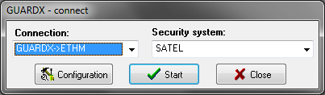
Fig. 14. GUARDX program: startup window.

“Communication Identifiers” tab
Panel’s identifier – identifier of the alarm control panel. It must consist of 10 characters (digits or letters from A to F).
PC identifier – identifier of the computer with GUARDX program. It must consist of 10 characters (digits or letters from A to F).
You must enter the same identifiers in the GUARDX program and in the control panel.

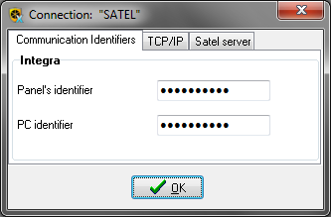
Fig. 15. GUARDX program: “Communication Identifiers” tab in “Connection” window.

“TCP/IP” tab
Server (ETHM-1 address) – address of the Ethernet module. If the Ethernet module is not in the same local network as the computer with GUARDX program, it must be a public address. You can enter either the IP address or the domain name.
Server port – the number of TCP port used during communication between the control panel and computer with GUARDX program.
Server key – a string of up to 12 alphanumeric characters (digits, letters and special characters) used for data encryption during communication between the control panel and the computer with GUARDX.

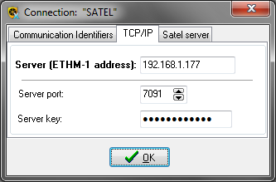
Fig. 16. GUARDX program: “TCP/IP” tab in “Connection” window.

“Satel sever” tab
ETHM-1 MAC – hardware address of Ethernet module.
ETHM-1 ID – individual identification number of the Ethernet module for the purpose of communication via the SATEL server.

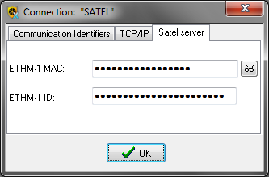
Fig. 17. GUARDX program: “Satel server” tab in “Connection” tab.

Initiating connection from GUARDX program

ETHM-1 Plus module settings
- Enable the GUARDX option.
- Enter the TCP port number, if it is to be different from 7091.
- Enter the data encryption key (GUARDX/Java key).

GUARDX program settings
- Enter the ETHM-1 Plus module address.
- Enter the TCP port number which will be used for communication.
- Enter the data encryption key (identical to that in the module).

Establishing the communication
- In the startup window (Fig. 14), “Connection” field, select “GUARDX -> ETHM” (Fig. 14), and then click on the “Start” button.
- In the window that will be displayed after establishing communication, enter the code of administrator / user of the control panel.

Initiating connection from keypad (through control panel)

ETHM-1 Plus module settings
- Enter the TCP port number, if it is to be different from 7091.
- Enter the data encryption key (GUARDX/Java key).
- Enter the address of the computer with GUARDX program (GUARDX server).

GUARDX program settings
- Enter the TCP port number which will be used for communication.
- Enter the data encryption key (identical to that in the module).

Establishing the communication
- In the startup window (Fig. 14), “Connection” field, select “GUARDX <- ETHM”, and then click on the “Start” button.
- Start in the keypad the ETHM-1 – GUARDX function ([code] Downloading ETHM-1 – GUARDX). The function is available to the service, administrator and user having the Downloading starting right.
- In the window that will be displayed after establishing communication, enter the code of administrator / user of the control panel.

Establishing connection via the SATEL server

ETHM-1 Plus module settings
- Enable the GUARDX option.
- Enter the data encryption key (GUARDX/Java key).
- Enable Connection via Satel server option.

GUARDX program settings
- Enter the data encryption key (identical to that in the module).
- Enter the MAC address of the ETHM-1 Plus module.
- Enter the ID number of the ETHM-1 Plus module (identifier assigned to the module for the purposes of communication via the SATEL server).

Establishing the communication
- In the startup window (Fig. 14), “Connection” field, select “TCP/IP: SATEL server”, and then click on the “Start” button.
- In the window that will be displayed after establishing communication, enter the code of administrator / user of the control panel.

Web browser

ETHM-1 Plus module settings
- Enable the WWW option.
- Program the key for data encryption during communication with the JAVA application in the web browser (GUARDX/Java key).
- Enter the number of TCP port which will be used for communication with the web browser, if it is to be different from 80 (WWW port).
- Enter the number of TCP port which will be used for communication with the JAVA application in the web browser, if it is to be different from 7091.

Configuring computer
The Java Virtual Machine must be installed on your computer. You can download it from www.java.com
It is recommended that the 32-bit version of Java Virtual Machine be installed.

Establishing the communication
- Start the web browser.
- In the address field, enter the IP address of ETHM-1 Plus module, and then press ENTER.
If a port other than 80 is to be used for communication between the module and the web browser, the address entered must be followed by a colon and the port number.
- When the login page displays (Fig. 18), enter in the corresponding fields:
- data encryption key (GUARDX/Java key),
- TCP port number (identical to that programmed in the module for communication with the JAVA application in the web browser – except where communication occurs through a network device on which redirection to another port takes place),

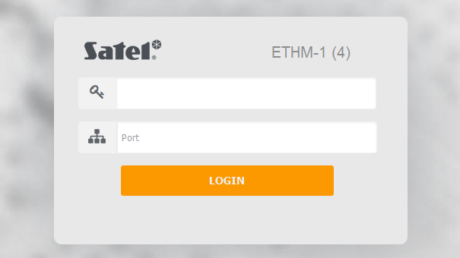
Fig. 18. Web browser: login page.

- Click on the “LOGIN”.
- The virtual keypad will be displayed in the browser (Fig. 19).

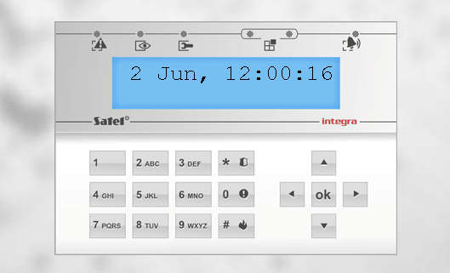
Fig. 19. Web browser: virtual keypad.

Mobile device
The INTEGRA / INTEGRA Plus alarm system can be operated and configured from a mobile device, if the INTEGRA CONTROL / MobileKPD / MobileKPD-2 / MobileKPD-2 Pro application is installed. The application can be downloaded at www.satel.eu (select the application suitable for your mobile device), from the internet stores “Google play” (Android system devices) or “App Store” (iOS system devices).
All mobile applications enable direct connection to the Ethernet module to be established. If communication takes place in a wide area network, the Ethernet module must have a public IP address assigned to it.
The INTEGRA CONTROL application makes it possible to establish connection via the SATEL server (Connection Establishing Service). If this is the case, the Ethernet module needs no public address.

Configuring the settings in INTEGRA CONTROL application (Android)
When you launch the application for the first time, the “Add control panel” screen will be displayed. It allows you to configure the settings required for establishing connection to the control panel.

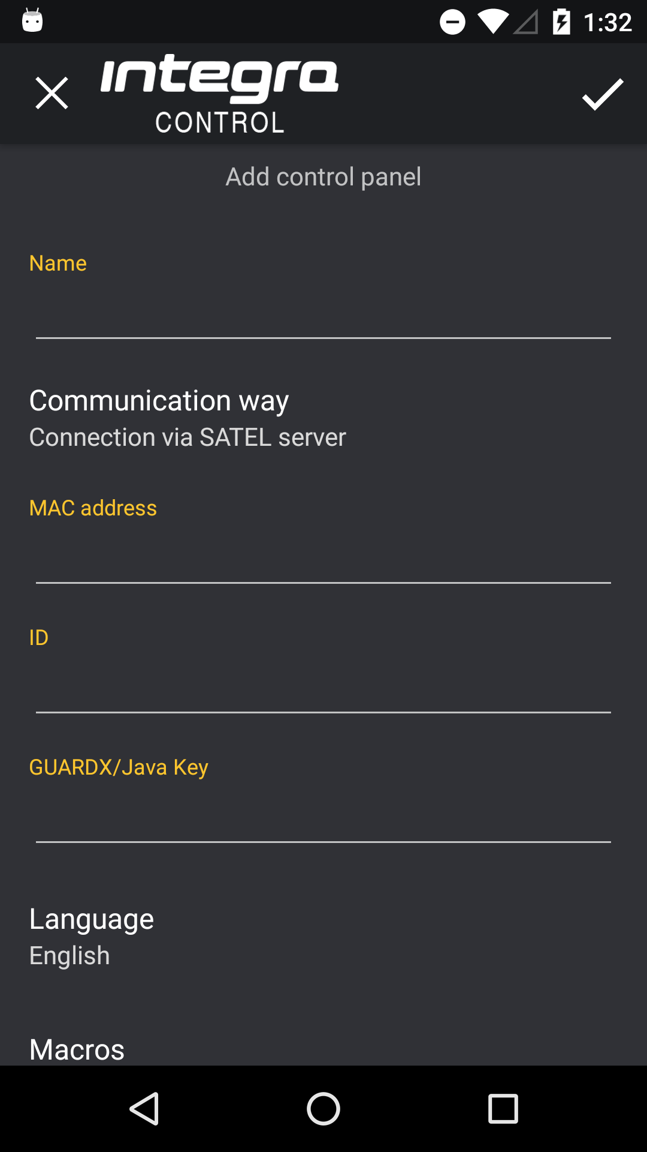
Fig. 20. INTEGRA CONTROL application (Android system): “Add control panel” screen before entering data.

- Enter the name for alarm system. The name helps to identify the system when the application is in use (you can define settings for multiple alarm systems).
- Specify the method of communication. The default settings provide for communication via the SATEL server. If the application is to connect directly to the Ethernet module, touch the screen in the “Communication way” area and change the settings.

Configuring the settings for communication via SATEL server

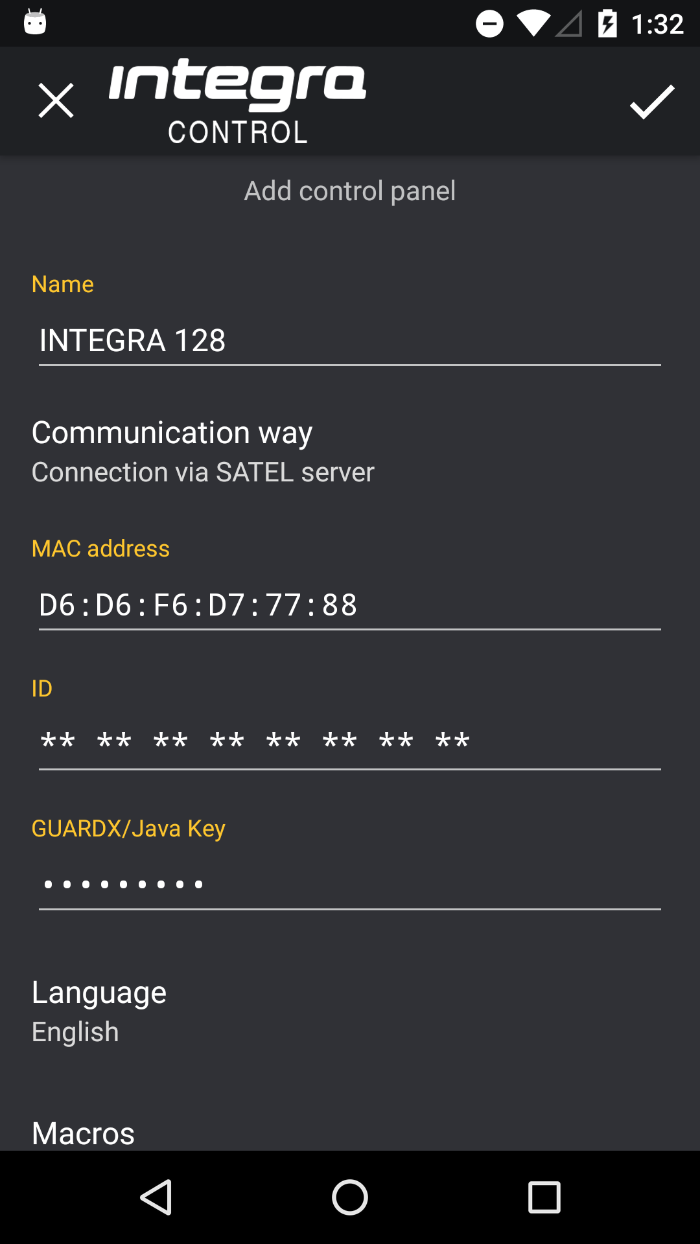
Fig. 21. INTEGRA CONTROL application (Android system): “Add control panel” screen with an example of settings for communication via SATEL server.

- Enter the MAC address of the ETHM-1 Plus module.
- Enter the ID number of the ETHM-1 Plus module (identifier assigned to the module for the purposes of communication via the SATEL server).
The user can check the MAC address and ID using the LCD keypad (IP/MAC ETHM-1 user function available in the Tests submenu – for more information regarding this function, refer to the control panel user manual).
- Enter the data encryption key – identical to that in the module (GUARDX/Java key).
- Define how the macro commands should be handled. Default settings provide for importing macro commands from the module (they will be downloaded during the first connection). If the macro commands are not to be imported or are to be imported from file, touch the screen in the “Macros” area and change the settings. If you select import from file, you will have to indicate location of the file containing macro commands.
- Tap , to write settings.

Configuring the settings for communication directly with the module

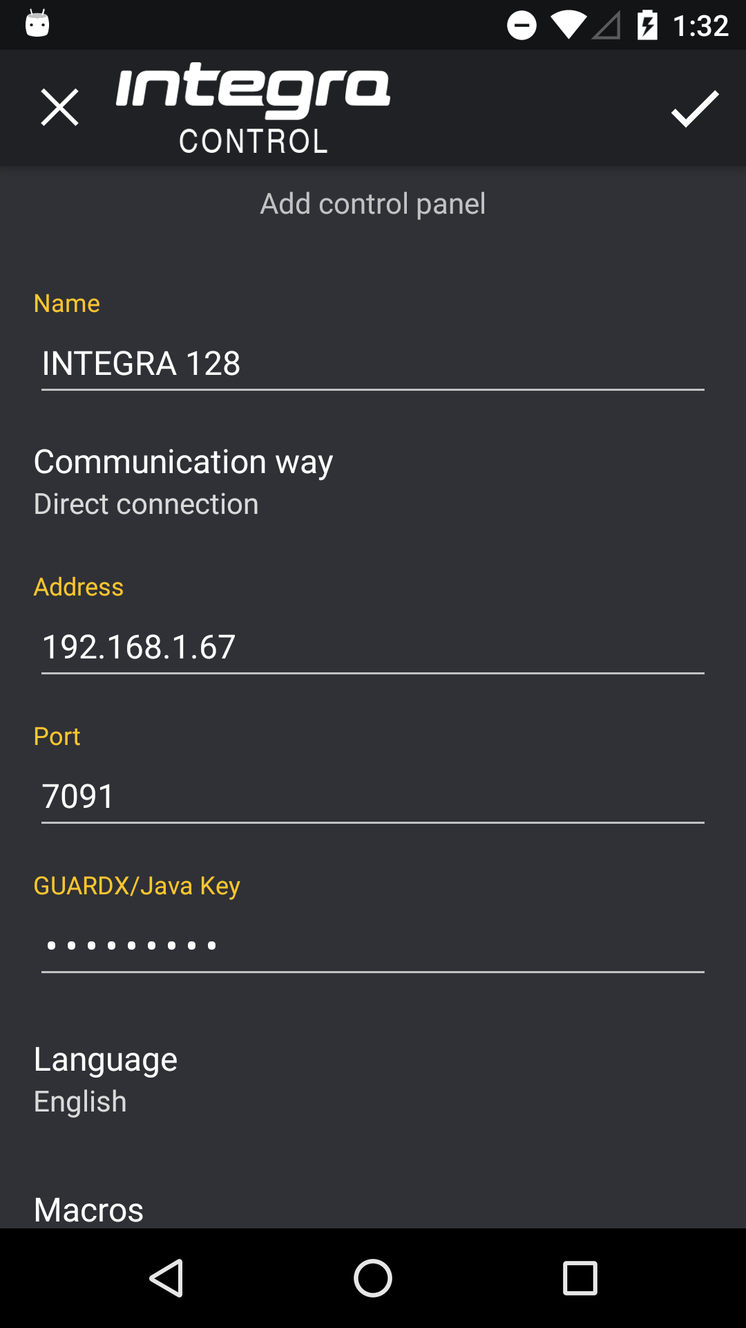
Fig. 22. INTEGRA CONTROL application (Android system): “Add control panel” screen with an example of settings for communication directly with the module.

- Enter the ETHM-1 Plus module address.
- Enter the TCP port number, if it is to be different from 7091.
- Enter the data encryption key – identical to that in the module (GUARDX/Java key).
- Define how the macro commands should be handled. Default settings provide for importing macro commands from the module (they will be downloaded during the first connection). If the macro commands are not to be imported or are to be imported from file, touch the screen in the “Macros” area and change the settings. If you select import from file, you will have to indicate location of the file containing macro commands.
- Tap , to write settings.

Configuring the settings in INTEGRA CONTROL application (iOS)
When you launch the application for the first time, the “Systems” tab will be displayed.
- Tap “Edit”.
- Tap “New”.

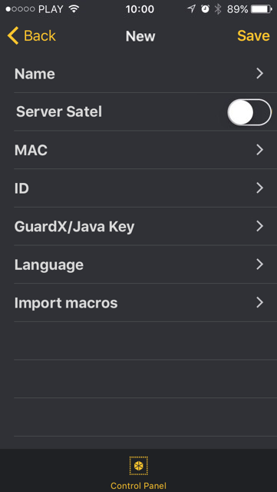
Fig. 23. INTEGRA CONTROL application (iOS system): screen with communication settings before entering data.

- Enter the name for alarm system. The name helps to identify the system when the application is in use (you can define settings for multiple alarm systems).
- Specify the method of communication. The default settings provide for communication directly with the Ethernet module. If the application is to connect via the SATEL server, enable the “Server Satel” option.

Configuring the settings for communication directly with the module
- Enter the ETHM-1 Plus module address.
- Enter the TCP port number
- Enter the data encryption key – identical to that in the module (GUARDX/Java key).
- Define language of the control panel.
- Define how the macro commands should be handled. Default settings provide for importing macro commands from the module (they will be downloaded during the first connection). If the macro commands are not to be imported or are to be imported from file, touch the screen in the “Import macros” area and change the settings.
- Tap “Save”, to write the settings.

Configuring the settings for communication via SATEL server
- Enter the MAC address of the ETHM-1 Plus module.
- Enter the ID number of the ETHM-1 Plus module (identifier assigned to the module for the purposes of communication via the SATEL server).
The user can check the MAC address and ID using the LCD keypad (IP/MAC ETHM-1 user function available in the Tests submenu – for more information regarding this function, refer to the control panel user manual).
- Enter the data encryption key – identical to that in the module (GUARDX/Java key).
- Define language of the control panel.
- Define how the macro commands should be handled. Default settings provide for importing macro commands from the module (they will be downloaded during the first connection). If the macro commands are not to be imported or are to be imported from file, touch the screen in the “Import macros” area and change the settings.
- Tap “Save”, to write the settings.

ETHM-1 Plus module settings
- Enable the GSM conn. option.
- Enter the data encryption key (GUARDX/Java key).
- If connection is to be established via the SATEL server, enable the Connection via Satel server option.
- If connection is to be established directly with the module and the TCP port to be used is different from 7091, enter the appropriate port number.

Establishing the communication

INTEGRA CONTROL / MobileKPD-2 / MobileKPD-2 Pro
Tap the name of the alarm system. The virtual keypad will be displayed.

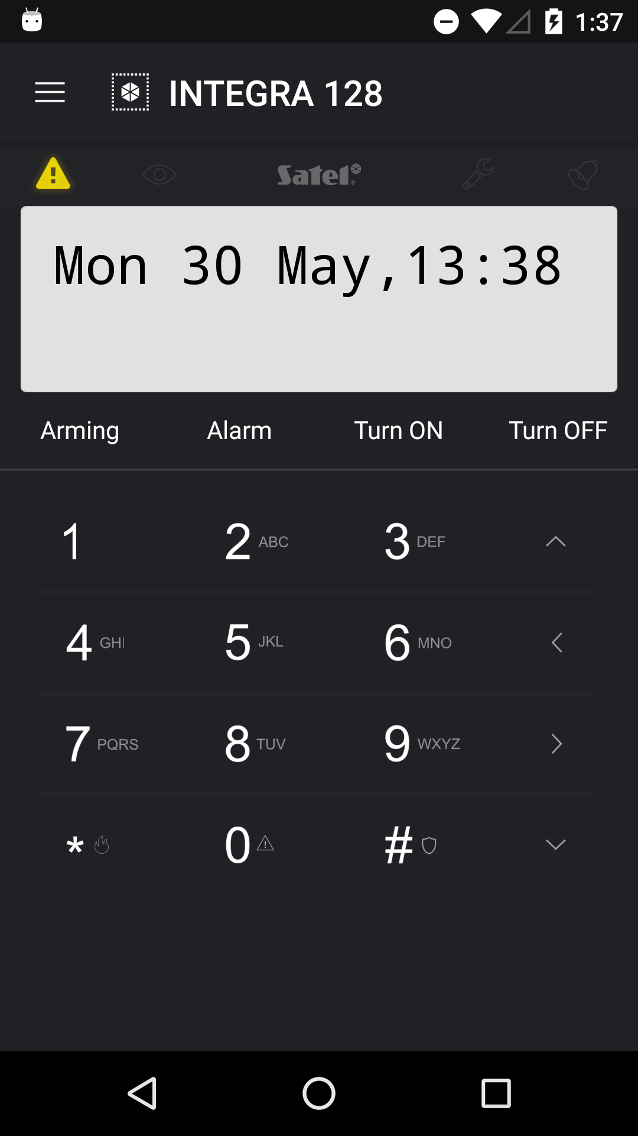
Fig. 24. INTEGRA CONTROL application (Android system): virtual keypad.

MobileKPD
- Using phone keys, select an alarm system from the list.
- Select: →“Options” →“Start”.
- Elements of the virtual keypad will be shown on the display.

Specifications
Supply voltage 12 V DC ±15%
Standby current consumption 70 mA
Maximum current consumption 80 mA
Environmental class according to EN50130-5 II
Operating temperature range -10...+55 °C
Maximum humidity 93±3%
Dimensions 68 x 140 mm
Weight 64 g



Ethernet communication module
ETHM-1 Plus



Firmware version 2.03 ethm1_plus_en 06/16

SATEL sp. z o.o.
ul. Budowlanych 66
80-298 Gdańsk
POLAND
tel. + 48 58 320 94 00
info@satel.pl
www.satel.eu
druk: (2 na 1)
26,27,0,25,24,1,2,23,22,3,4,21,20,5,6,19,18,7,8,17,16,9,10,15,14,11,12,13

