IMPORTANT
The controller incorporates electronic components sensitive to electrostatic discharges. Prior to installation, remove the electrostatic discharges and avoid touching the controller board components in the process of installation.
Do not deform the controller antenna, as this may adversely affect the quality of radio communication.

DECLARATION OF CONFORMITY |  |  | 
Product:  ACU-100 – Controller of ABAX Wireless System |  | Manufacturer: SATEL sp. z o.o.  ul. Schuberta 79  80-172 Gdańsk, POLAND  tel. (+48 58) 320-94-00  fax. (+48 58) 320-94-01
Product description: The ACU-100 wireless system controller designed for interaction with other elements of the ABAX wireless system. The device operates in the 868.0 MHz – 868.6 MHz frequency band, and is supplied from a 12 V DC source. The controller is intended to be used in burglary and panic alarm systems and can be connected to any type of the alarm control panel.
This product conforms to the following EU Directives:
R&TTE 1999/5/EC
This product meets requirements of the harmonized standards:
R&TTE: ETSI EN 300 220-1: v.1.3.1; ETSI EN 300 220-3: v.1.1.1;
EMC: ETSI EN 301 489-1: v.1.5.1.; EN 301 489-3: v.1.4.1
Safety: EN60950-1:2001
Notified body taking part in conformity evaluation:
Identification No.: 1471
Gdańsk, Poland 2005-07-15 |   Head of Test Laboratory:  Michał Konarski
The list of countries where the ACU-100 has been approved for use – please see the website www.satel.pl

The SATEL Company sets itself an objective to continually enhance quality of its products, which can entail changes to their technical specifications and software.
Information on the introduced modifications can be found on our web site.
Please visit us at:
http://www.satel.eu

New features of the ACU-100 controller with firmware version 3.00
- Support for a new wireless device by the controller interacting with the INTEGRA control panel with firmware version 1.09 or later:
- ATD-100 – wireless temperature detector.
- Option to select whether the AMD-102, ATD-100 or AVD-100 detector will take one or two positions in the list of wireless devices, if the controller operates with the INTEGRA with firmware version 1.09 or later.
CONTENTS
1. General 4
2. Description of ACU-100 wireless system controller 4
2.1 Electronics board 4
2.2 Functions of DIP-switches 6
2.3 Control inputs 6
2.4 Outputs 8
2.5 Functional outputs 8
3. Wireless devices interfacing with the controller 9
3.1 ACX-100 Input & output expansion module 9
3.2 ACX-200 Hardwired zone / output expander 9
3.3 ACX-201 Hardwired zone / output expander with power supply 9
3.4 APD-100 Wireless passive infrared detector 9
3.5 APMD-150 Wireless dual motion detector 10
3.6 AMD-100 Wireless magnetic detector with additional input 10
3.7 AMD-101 Wireless magnetic detector with additional independent input 10
3.8 AMD-102 Wireless magnetic contact with input for roller shutter detector 10
3.9 AGD-100 wireless glass-break detector 10
3.10 AFD-100 Wireless water flood detector 11
3.11 AVD-100 Wireless vibration detector and magnetic contact 11
3.12 ASD-100 Wireless smoke and heat detector 11
3.13 ARD-100 Wireless reorientation detector 11
3.14 ATD-100 Bezprzewodowa czujka temperatury 11
3.15 ASP-105 Wireless outdoor siren 11
3.16 ASP-205 Wireless indoor siren 12
3.17 APT-100 Bidirectional keyfob 12
3.18 ASW-100 E 230 V AC Wireless controller 12
3.19 ASW-100 F 230 V AC Wireless controller 12
3.20 ARF-100 Radio signal level tester 12
4. Installation 13
4.1 Installation of ACU-100 wireless system controller 13
4.2 Connecting LCD keypad to the controller 13
4.3 Connecting computer to the controller 14
4.4 Connecting the ACX-100 input & output expansion modules 15
4.5 Adding new wireless devices 17
4.5.1 Dload10 and DloadX programs 17
4.5.2 LCD keypad connected to the controller 17
4.5.3 LCD keypad of INTEGRA alarm system 18
4.6 Removal of wireless devices 19
4.6.1 Dload10 and DloadX programs 19
4.6.2 LCD keypad 19
5. Hardwired zone/output expanders in ABAX system 19
5.1.1 Configuration of ACX-200 or ACX-201 expander zones/outputs for ACU-100 controller operation with INTEGRA or VERSA control panel 20
5.1.2 Configuration of ACX-200 expander zones/outputs for ACU-100 or ACX-201 controller operation with CA-64 control panel 20
5.1.3 Configuration of ACX-200 or ACX-201 expander zones/outputs for ACU-100 controller operation with other control panels 20
6. Wireless detectors in ABAX system 21
6.1 Additional detector parameters to be configured 22
7. Sirens in ABAX system 23
7.1 Description of ASP-105 siren functioning 24
7.2 Description of ASP-205 siren functioning 24
7.3 Additional siren parameters to be configured 25
8. ASW-100 230V AC wireless controllers in ABAX system 25
9. Radio signal level tester in ABAX system 26
10. Interaction with alarm control panels 27
10.1 Expander of wireless devices for INTEGRA series control panels 27
10.2 Addressable zone expander for CA-64 control panel 30
10.3 Zone expander for CA-10 control panel 31
10.4 Wireless device module interfacing with any alarm control panel 33
11. Programming and diagnostics 34
11.1 LCD keypad of INTEGRA security system 35
11.2 LCD keypad of VERSA alarm system 35
11.3 DloadX program 36
11.4 LCD keypad connected to controller 37
11.4.1 Service mode of keypad connected to the controller 38
11.5 Dload10 program 38
11.6 Description of functions, options and commands 41
12. Configuration of additional parameters and options in wireless devices 44
12.1 DloadX or Dload10 program 44
12.1.1 APD-100 detector 44
12.1.2 APMD-150 detector 45
12.1.3 AMD-100 and AMD-101 detectors 45
12.1.4 AMD-102 detector 45
12.1.5 AGD-100 detector 45
12.1.6 AVD-100 detector 45
12.1.7 ASD-100 detector 45
12.1.8 ARD-100 detector 46
12.1.9 Czujka ATD-100 46
12.1.10 ASP-105 siren 46
12.1.11 ASP-205 siren 46
12.1.12 ASW-100 E and ASW-100 F controllers 47
12.2 LCD keypad 47
12.2.1 APD-100 detector 47
12.2.2 APMD-150 detector 47
12.2.3 AMD-100 and AMD-101 detector 47
12.2.4 AMD-102 detector 47
12.2.5 AGD-100 detector 48
12.2.6 AVD-100 detector 48
12.2.7 ASD-100 detector 48
12.2.8 ARD-100 detector 48
12.2.9 Czujka ATD-100 48
12.2.10 ASP-105 siren 48
12.2.11 ASP-205 siren 49
12.2.12 ASW-100 E and ASW-100 F controllers 49
13. Restoring controller default settings 49
14. Specifications 49
15. History of the manual updates 51

General
The ACU-100 controller allows communication between any alarm control panel and the ABAX system wireless devices. It enables wire-operated security systems to be expanded by addition of wireless devices. The ABAX system is based on two-way communication. All messages sent by the devices are acknowledged, which ensures that the equipment status information will reach the controller and allows online check of the devices for their presence in the system. Configuration of parameters and testing of the wireless devices is performed by radio, without the need to dismantle their housings. Coded communication between the units takes place within the frequency band of 868.0 MHz – 868.6 MHz.

Description of ACU-100 wireless system controller
The ACU-100 controller supervises and coordinates operation of up to 48 wireless devices. The status of devices is signaled on the OC type outputs. It can also be transmitted to the control panel through the communication bus.
The controller settings and wireless equipment parameters are programmed by means of an LCD keypad or a PC computer.

Electronics board
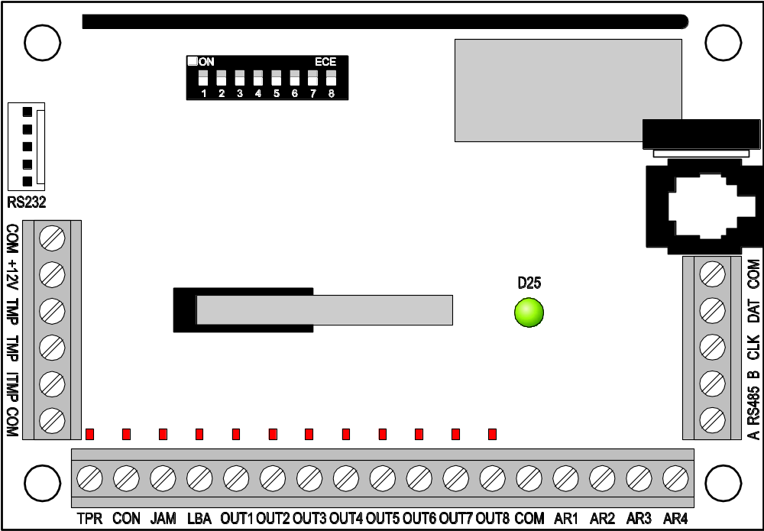
connector socket for LCD keypad
output status LEDs
tamper contact
DIP-switches
screen
buzzer
port RS-232
antenna
operating status LED
Fig. 1. Schematic view of ACU-100 controller PCB.

Description of terminals:
COM - common (ground)
+12V - power supply input
TMP - controller tamper terminals (NC)
ITMP - input for connecting controller tamper circuit
TPR - information output – tampers
CON - information output – no radio communication with wireless devices
JAM - information output – radio jamming
LBA - information output – problems with wireless devices power supply or with supply output overload in the ACX-201 expander.
OUT1…OUT8 - information output – wireless equipment status
AR1…AR4 - control inputs
A RS485 B - RS-485 port terminals (not used)
CLK, DAT - communication bus
The tamper contact reacts to of the controller housing being opened. You can use the TMP terminals in two ways:
- connect the terminals to the tamper circuit of the control panel;
- connect one of the TMP terminals to the ITMP tamper circuit input, and the other to the COM ground terminal – information of the controller tamper will be fed to the TPR output and to the communication bus.
Note: If the TMP terminals are not connected to the controller tamper circuit, the ITMP terminal must be shorted to the common ground.
The package of DIP-switches on the board is used to set individual addresses of the devices and to configure some working parameters of the controller (see Functions of DIP-switches).
The LED indicates the controller status. The mode of lighting depends on the controller working configuration:
- interaction with CA-64, INTEGRA or VERSA alarm control panels:
  - green steady light – no communication with the control panel;
  - green blinking light – correct communication with the control panel.
- interaction with other alarm control panels:
  - green steady light – normal operation of the controller;
  - green blinking light – synchronization in the process;
  - alternate green and red blinking light – occurrence of one of the problems signaled on functional outputs (see: Functional outputs).
The buzzer informs of occurrence of one of the problems signaled on functional outputs (it does not apply to the controller interfacing with the INTEGRA or VERSA series alarm control panels).
The RS-232 port with optoisolation enables a PC computer with Dload10 program to be connected for the time of programming.
The RJ socket is used to connect an LCD keypad for the time of programming. The controller interfaces with LCD keypads for operating the CA-64 or INTEGRA series control panels.
Notes:
- The controller cannot be simultaneously programmed by means of computer and LCD keypad.
- When working with the INTEGRA or VERSA alarm control panels, the controller can be programmed by means of the control panel, with no need for connecting the keypad or computer to the controller sockets.
The communication bus (CLK, DAT) of the controller enables direct connection to the control panel communication bus (INTEGRA, VERSA, CA-64, CA-10) or expansion of the system by adding the ACX-100 input/output expansion modules.

Functions of DIP-switches
 | DIP-switch number
Controller function | 1 | 2 | 3 | 4 | 5 | 6 | 7 | 8
Wireless device module for all control panels | I₁ | I₂ | I₃ | x | P | 0 | 0 | 0
Expander for CA-10 with 1 keypad (6 zones) | A | B | C | D | P | 1 | 0 | 0
Expander for CA-10 with 2 keypads (4 zones) | A | B | C | D | P | 0 | 1 | 0
Expander for CA-10 with 3 keypads (2 zones) | A | B | C | D | P | 1 | 1 | 0
Addressable zone expander for CA-64 | A₁ | A₂ | A₃ | A₄ | A₅ | P | 0 | 1
Wireless device expander for INTEGRA or VERSA control panels | A₁ | A₂ | A₃ | A₄ | A₅ | x | 1 | 1
Table 1. The way of using DIP-switches for controller configuration.

0 – DIP-switch in OFF position
1 – DIP-switch in ON position
P – selection of controller programming mode:
- DIP-switch in OFF position – through RS-232 port (Dload10 program)
- DIP-switch in ON position – by means of LCD keypad
I₁, I₂, I₃ – DIP-switches for setting the number of ACX-100 modules connected to the computer. To determine this number, tot up the values set on individual DIP-switches as per Table 2.

DIP-switch number | 1 | 2 | 3
Numerical value  (for switch in ON position) | 1 | 2 | 4
Table 2.

The controller accepts up to 5 input/output expansion modules, hence if a higher value is set on the DIP-switches, it will be also recognized as 5.
A, B, C, D – DIP-switches for setting the controller address in the same way as with the CA-10 zone expanders. When in the ON position, the switch value is 1.
A₁, A₂, A₃, A₄, A₅ – DIP-switches for setting the controller address. In order to determine the controller address, add up the values set on individual DIP-switches as per Table 3.

DIP-switch number | 1 | 2 | 3 | 4 | 5
Numerical value  (for switch in ON position) | 1 | 2 | 4 | 8 | 16
Table 3.

x – unused DIP-switch

Control inputs
If the controller is working as an expander with the INTEGRA or VERSA control panel, you are not required to know how the control inputs operate, because they need not be connected to the control panel (all information will be sent to the control panel via communication bus).
The ACU-100 PCB incorporates 4 control inputs dedicated to controlling the operation of wireless devices (detectors, sirens, etc.).The controller inputs can be programmed as NO (normally open) or NC (normally shorted to ground). Changing the input status (shorting to or isolating from ground) has effect on operation of the wireless devices controlled by that input (for each wireless device registered in the controller you must indicate an input which will control its operation).
The number of inputs can be increased by connecting the ACX-100 expansion modules to the controller. The number of control inputs in the ABAX system can be up to 24 (controller + 5 ACX-100 modules).
In order to control the ACU-100 controller inputs you can use any alarm control panel outputs (OC, high-current, low-current, relay type). Where the control is effected by means of the high-current output of a SATEL-made control panel, it is necessary to connect a 1.1kΩ resistor to the controller input (see Fig. 2).

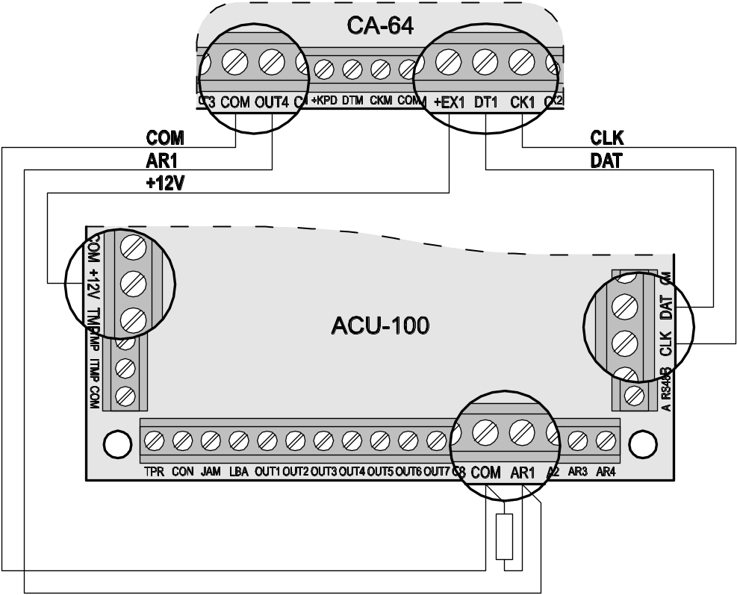
1.1 kΩ
OUT4 – reversed polarity (0 V when active)
AR1 – NO type
Fig. 2. Example of connecting the high-current output of SATEL-made control
panel to the control input.

The control panel outputs which are to control the ACU-100 controller inputs should be properly configured (their type, polarity, cutoff time, etc.). The type of wireless devices whose operation is controlled by the input must be primarily taken into account.
To control operation of the wireless detectors, the control panel output can be programmed e.g. as the Arm status. Arming the control panel will switch the detectors into the active mode, and disarming – into the passive mode (detector operating modes are described in section Wireless detectors in ABAX system). It should be remembered that activation/deactivation of the detectors is delayed in relation to arming/disarming (see: Wireless detectors in ABAX system).
By having programmed the exit time in the control panel, you can avoid delay in activating the detectors in relation to arming. The output programmed as the Arm status will only get active after expiry of the exit time. However, some control panels allow you to choose another function, which activates the output immediately after arming command is given to the control panel. For example, the output can be programmed in the CA-10 as type 35: Power supply on armed mode, and in the CA-64 as type 42: Power supply in armed state. The delay effect in activating the detectors as against the arming can only be avoided when the exit time exceeds the Response period.
When controlling the detectors, the input of the controller can also be programmed as always active. In this case the detectors will remain permanently in active state.
In order to control the operation of sirens, you should connect the control panel alarm signaling output to the controller input. Activating the control panel output will trigger the siren.

Outputs
If the controller is working as an expander with the INTEGRA, VERSA or CA-64 control panels, you are not required to know how the outputs operate, because they need not be connected to the control panel (information from wireless devices will be sent to the control panel via communication bus).
The PCB of the ACU-100 controller incorporates eight OC type outputs, to which wireless devices are assigned. Any number of wireless devices can be assigned to one output. The number of outputs can be increased by connecting the ACX-100 expansion modules to the controller. The maximum number of outputs 48 (controller + 5 ACX-100 modules).
The output activates after receiving suitable information from a wireless device assigned to it, the information depending on the device type:
- the wireless detectors signal violations;
- the ASP-105 siren inform of a discharged battery and a failure of +12 V DC external power supply;
- the ASP-205 sirens inform of battery discharge;
- the ACX-200 and ACX-201 expanders signal zone violation;
- the ASW-100 E and ASW-100 F controllers inform that the button was depressed in Mode 0 or the electric circuit was closed in Mode 1 and 2.
The outputs can be programmed as NO (normally open) or NC (normally shorted to ground). All the outputs (of the controller and the ACX-100 modules connected to it) are being programmed at the same time. Depending on how the outputs have been programmed, activation of the output is indicated as follows:
- LED assigned to the output comes ON (outputs programmed as the NO type);
- LED assigned to the output comes OFF (outputs programmed as the NC type).
The outputs can be connected to the control panel zones.

Functional outputs
If the controller is working as an expander with the INTEGRA or VERSA control panels, you are not required to know how the functional outputs operate, because they need not be connected to the control panel (all information will be sent to the control panel via communication bus).
The ACU-100 controller PCB incorporates four OC type outputs to signal:
TPR – wireless device tampers, lack of communication with ACX-100 modules, and also controller tampers (provided the TMP terminals are connected to the controller tamper circuit);
CON – lack of communication with wireless devices;
JAM – jamming the radio signal for the ABAX system to the degree which makes communication impossible;
LBA – problems with power supply of a wireless device: low battery, discharged storage battery, or loss of external power supply. If the ACX-201 expander is registered in the controller, overload of the expander AUX1, AUX2 supply outputs is additionally signaled at this output.
Depending on how the outputs have been programmed (see Outputs), activation of the functional output is indicated as follows:
- LED assigned to the output comes ON (outputs programmed as the NO type);
- LED assigned to the output comes OFF (outputs programmed as the NC type).
After connecting the functional outputs to properly programmed zones of the control panel (zone type, function, etc.), the control panel may signal occurrence of some problems in the ABAX system. The problems can be diagnosed by means of LCD keypad or computer connected to the controller.
Connecting the TPR output to the CA-64 control panel is unnecessary, since information on tampers of wireless devices is transmitted through the communication bus.

Wireless devices interfacing with the controller

ACX-100 Input & output expansion module
- 4 control inputs
- 8 outputs, OC type
- communication bus
- tamper contact
- power supply: direct voltage 12 V (±15%)

ACX-200 Hardwired zone / output expander
- 4 zones
- 4 relay outputs
- tamper contact
- power supply: direct voltage 12 V (±15%)

ACX-201 Hardwired zone / output expander with power supply
- 4 zones
- 4 relay outputs
- switching mode power supply (1.2 A capacity)
- battery charging and control system
- power supply: 18 V AC

APD-100 Wireless passive infrared detector
- digitally processed signal from pyroelement
- high resistance to interference
- adjustable detection sensitivity
- option of immunity to pets up to 15 kg in weight (detectors with firmware version 2.01 or later)
- remote configuration of parameters
- changeable Fresnel lenses
- tamper contacts
- power supply: lithium battery, CR123A 3V

APMD-150 Wireless dual motion detector
- microwave (MW) sensor and double pyroelectric (PIR) element
- advanced power management
- high immunity to interference and false alarms
- independent sensitivity adjustment for PIR and MW
- remote configuration
- tamper contacts
- power supply: lithium battery, CR123A 3V

AMD-100 Wireless magnetic detector with additional input
- two reed switches
- input to connect any outdoor detector of NC type
- remote configuration of parameters
- tamper contact
- power supply: lithium battery, CR123A 3V

AMD-101 Wireless magnetic detector with additional independent input
- two reed switches
- individually identifiable input to connect any outdoor detector of NC type
- remote configuration of parameters
- tamper contact
- power supply: lithium battery, CR123A 3V

AMD-102 Wireless magnetic contact with input for roller shutter detector
- two reed switches
- individually identified input for connecting a roller shutter detector or NC type detector
- remote configuration of parameters
- tamper contact
- power supply: lithium battery, CR123A 3V

AGD-100 wireless glass-break detector
- detection of breaking plate, laminated or tempered glass
- multi frequency digital signal analysis
- detection sensitivity adjustment
- remote configuration
- tamper contact
- power supply: lithium battery, CR123A 3V

AFD-100 Wireless water flood detector
- external sensor
- tamper contact
- power supply: lithium battery, CR123A 3V

AVD-100 Wireless vibration detector and magnetic contact
- advanced processing of piezoelectric sensor signal
- vibration detection sensitivity adjustment
- remote configuration
- tamper contact
- power supply: lithium battery, CR123A 3V

ASD-100 Wireless smoke and heat detector
- optical sensor for visible smoke detection
- heat sensor which responds to the temperature rising above a predetermined threshold, as well as to a high speed of temperature rise
- sensitivity range selection according to EN54
- remote configuration
- acoustic and optical alarm indication
- power supply: lithium battery, CR123A 3V

ARD-100 Wireless reorientation detector
- accelerometer to analyze acceleration and gravitation
- memorizing the position when switched over to active mode or when test mode is activated
- remote configuration of parameters
- tamper contact
- power supply: lithium battery, CR123A 3V

ATD-100 Wireless temperature detector
- digital temperature sensor
- up to two programmable temperature thresholds
- remote configuration
- tamper contact
- power supply: lithium battery, CR123A 3V
Note: The ATD-100 detector is only supported by the controller interfacing with the INTEGRA control panel, firmware version 1.09 or later.

ASP-105 Wireless outdoor siren
- optical and acoustic signaling, triggered independently by radio
- acoustic signaling: piezoelectric transducer
- remote configuration of acoustic signaling
- optical signaling: LED indicators
- tamper contact
- power supply: direct voltage 12 V (±15%)
- emergency power supply: 6 V 1.2 Ah battery

ASP-205 Wireless indoor siren
- acoustic signaling: piezoelectric transducer
- optical signaling: LED indicators
- remote configuration of 2 signaling modes
- tamper contact
- power supply: lithium battery CR123A 3V

APT-100 Bidirectional keyfob
- controls the INTEGRA or VERSA alarm system
- 5 buttons for starting up to 6 selected functions
- 3 LEDs to indicate the alarm system status
- sound signaling of keypress and transmission reception acknowledgement
- power supply: CR2032 3V lithium battery
Note: The APT-100 key fob is only supported by the controller interacting with the INTEGRA (version 1.06 or later) or VERSA (version 1.01 or later) control panels. Description of how the key fobs should be added to the users or configured – please see the user manuals for respective control panels.

ASW-100 E 230 V AC Wireless controller
- remote switch ON/switch OFF of devices to be connected to 230 V sockets
- type of controller socket: E
- button for manual control of 230 V electric circuit
- LED indicator of controller status
- power supply: 230 V AC

ASW-100 F 230 V AC Wireless controller
- remote switch ON/OFF of devices to be connected to 230 V sockets
- type of controller socket: F
- button for manual control of 230 V electric circuit
- LED indicator of controller status
- power supply: 230 V AC

ARF-100 Radio signal level tester
- checking the level of radio signal received by controller from tester, or by tester from controller
- simulating radio communication of devices to be supplied from battery or external sources
- LED indicator showing the radio signal level
- buzzer
- power supply: alkaline battery 9 V 6LR61

Installation
The ABAX two-way wireless system should be installed so as to ensure a suitable level of radio signal from devices working together with the controller. This will allow the communication problems to be avoided.
All electrical connections may only be made with power supply disconnected.
Before proceeding to the system installation you should plan the arrangement of all the devices. The installation place for the controller should be chosen so that all devices to be supervised by it are within its range. It is recommended that the controller and the wireless devices be mounted at a high position, which will enable a better range of radio communication to be reached, while avoiding a risk of incidental masking of the controller and devices by people moving around the facility.
Before permanently mounting the system components, you should check the level of signal received by the controller from individual devices. A helpful instrument for checking the signal level is the SATEL-made ARF-100 tester. If the signal level from a particular unit is too low (less than 40%), a change of the device position will be necessary. At times, it is sufficient to move the device some ten to twenty centimeters to get a significant improvement of the signal quality. Having reached the optimal level of radio signal from all devices, you can proceed to permanently mounting them in position.
Several ACU-100 controllers can work within each other's range. Automatic synchronization with the wireless systems already in use is always performed when the controller is switched on, and after each operation of addition/removal of supported devices. The synchronization is performed automatically. The number of wireless devices already working within the range of each other depends on the Response period (see Description of functions, options and commands) and can vary from 150 to 450. The higher the response frequency, the lower the number of devices that can work within each other's range.
Recommendations for installation of particular wireless devices can be found in the manuals delivered with respective devices.

Installation of ACU-100 wireless system controller
The ACU-100 controller should be installed indoors, in spaces with normal air humidity. Its electronics board is mounted in the OPU-1 A plastic housing. Before fastening the controller to the wall, make inlets/outlets in the rear wall of the housing for cables to connect the controller to the control panel or ACX-100 expansion modules.
Caution: The cables should not be laid in the close vicinity of the antenna, as this may cause radio communication interference.
Temporary connection of LCD keypad or computer is required for programming or diagnosing the controller, if it not operates together with the INTEGRA or VERSA control panels.

Connecting LCD keypad to the controller
The LCD keypad must be connected to the RJ socket with four-wire cable. Connection of the keypad communication bus to the RJ socket is shown in Fig. 3.
Address of the keypad to be connected to the ACU-100 controller must be set as 0.
If properly connected, the keypad will display a message, the upper line of which will include the device name and program version info. If the  [TROUBLE] LED goes on in the keypad, one of the functional outputs is active. In order to start the service mode, the service code must be entered. The service mode is indicated by lighting of the [SERVICE] LED.

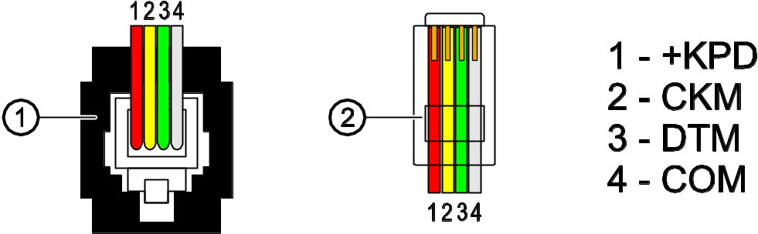
Fig. 3. Sequence of wires in the plug connecting LCD keypad with controller.
1 – view of plug in the socket. 2 – view of plug from the pins side.

If the a.m. message fails to appear on the display after connection, you should:
- check that the option of programming by means of LCD keypad has been selected on the controller DIP-switches;
- check that the cables connecting the keypad with controller have been properly connected;
- check that address 0 has been set in the LCD keypad.
In order to check the keypad address and, if necessary, to change it:
- Disconnect the +KPD keypad power supply and the data bus cables (CKM, DTM).
- Short the CKM, DTM keypad terminals.
- Connect the keypad power supply.
- The keypad address will be displayed:

n=0...7, current address of the keypad
Fig. 4. Programming the keypad address.
- Change the address to 0, if necessary. The keypad will acknowledge performance of the function with four short and one long beeps.
- Connect the keypad to the ACU-100 controller as required (CKM, DTM).

Connecting computer to the controller
If the ACU-100 controller is to be programmed by means of a computer, the computer must be connected to the RS-232 port. Connection between the controller RS-232 port and the computer port should be made as shown in the picture below (you can buy a ready-made cable manufactured by SATEL).
Notes:
- Do not short or touch the RS-232 port with your fingers.
- Prior to connecting the cable, remove preliminarily the electrostatic charge, e.g. by touching a grounded piece of equipment (faucet, heater, etc.) with top of your palm.
- It is recommended that the cable be first connected to the controller port.

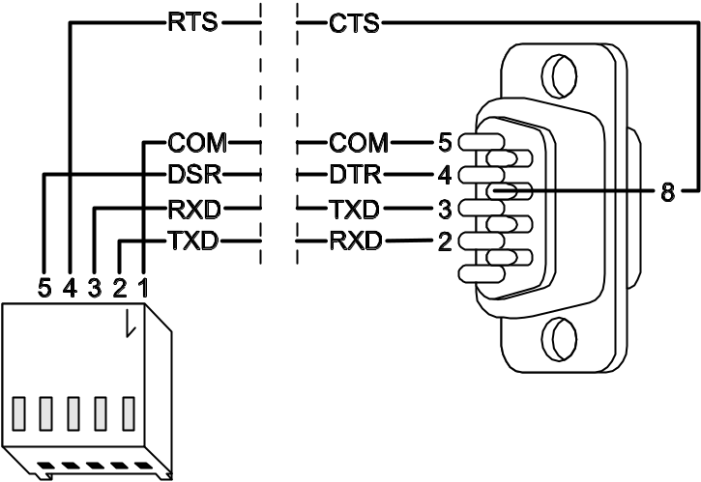
Fig. 5. Connection of computer to the controller serial port. PIN5 plug is shown on the left. DB-9 female plug is shown on the right, as seen from solder side.

If the Dload10 program fails to communicate with the computer after connection of the RS-232 port, you should:
- check that the option of programming by means of RS-232 port has been selected on the controller DIP-switches;
- check that the port through which the computer communicates with the controller has been properly selected in the Dload10 program;
- check that the cables connecting the computer with controller have been properly connected.

Connecting the ACX-100 input & output expansion modules
The ACU-100 controller communication bus can accept up to five ACX-100 input & output expansion modules. The modules can only be connected when the controller is configured as a wireless device module interfacing with any alarm control panel.

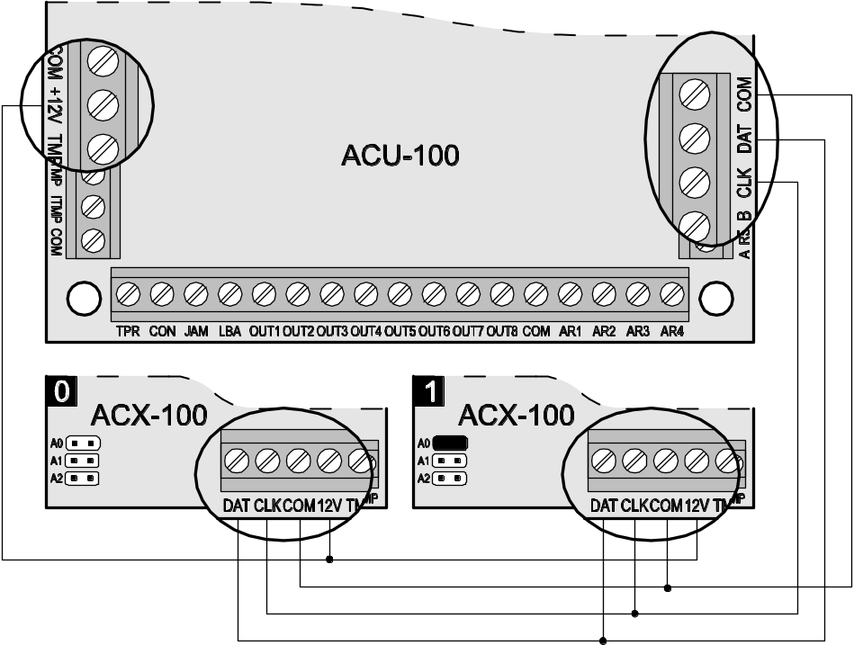
Fig. 6. Example of connecting two ACX-100 modules (addresses 0 and 1) to ACU-100 controller.

The ACX-100 expansion modules should be connected to the controller bus in parallel. The connection can be made by means of the typical unscreened straight-through cable, as used in the security alarm systems (using the "twisted pair" type of cable is not recommended). When connecting the modules, remember to set the correct number of ACX-100 modules connected to the controller on the controller DIP-switches. Lack of communication with the module will be signaled on the TPR output as tamper.
Each module connected to the bus must have a different address set from the range 0 to 4. These addresses must correspond to the number of a next module, as shown in Table 4. If one ACX-100 module is connected to the controller, it must have address 0 set, if two, one of them must have address 0 set, and the other address 1, etc.
The numeration of control inputs and outputs of the expansion module in the system depends on the address set in it (see: table 4).

Consecutive module number | Module address | Control input numbers | Output numbers
1 | 0 | 5–8 | 9–16
2 | 1 | 9–12 | 17–24
3 | 2 | 13–16 | 25–32
4 | 3 | 17–20 | 33–40
5 | 4 | 21–24 | 41–48
Table 4.

The module TMP terminals must be connected to the control panel tamper circuit.

Adding new wireless devices
Notes:
- The procedure of adding wireless devices for the controller interacting with the VERSA control panel is described in the installer manual of the control panel.
- If the controller operates with the INTEGRA control panel, firmware version 1.09 or later, you can select in case of some wireless devices whether it will take one or two positions (channels) in the list of devices. Depending on the device, if one position is selected:
AMD-102 – only additional inputs will be supported (roller shutter and NC);
ATD-100 – you will only be able to program one temperature threshold;
AVD-100 – only vibration detector will be supported.

Dload10 and DloadX programs
In order to add a new wireless device to the system, do the following:
- Press the New device button in the program.
- A window will appear, in which you should enter the 7-digit serial number of the device being added. The serial number can be found on the electronics board or on the housing. Each ARF-100 tester has the serial number 0000500.
- Depending on which device is to be added to the system:
- turn on power supply of the ACX-200 or ACX-201 expander,
- turn on the ARF-100 tester,
- plug the ASW-100 E/ASW-100 F wireless controller into the 230 V socket,
- install the battery in ASD-100 detector,
- violate (open) the tamper contact in case of the other devices.
If an invalid serial number has been entered, you will be informed of it by a suitable message. Then you should enter the correct serial number and repeat the above mentioned step.
- A confirmation message will be displayed that a new device has been added. In case of the DloadX program (version 1.09 or later):
- suggested name for the zone/output assigned to the device will appear (the name is editable);
- you can select for some devices whether it take one or two positions in the list of devices (INTEGRA firmware version 1.09 or later).
- Click your mouse on the „OK” button to finish the procedure of new device addition. You can cancel addition of the new device by pressing the „Abort” button. You can also add a next wireless device by pressing the „Next” button.
Note: If the ACU-100 controller is configured for operation as the expander with the CA-64 or INTEGRA control panels, the procedure of adding new wireless devices to the system must be followed by the procedure of expander identification in the control panel.

LCD keypad connected to the controller
In order to add a new wireless device to the system, do the following:
- Start the New device function.
- Enter the 7-digit serial number of the device to be added and press the [#] key. The serial number can be found on the electronics board or on the housing. Each radio signal level tester has the serial number 0000500.
- Depending on which device is to be added to the system:
  - turn on power supply of the ACX-200 or ACX-201 expander,
  - turn on the ARF-100 tester,
  - plug the ASW-100 E/ASW-100 F wireless controller into the 230 V socket,
  - install the battery in ASD-100 detector,
  - violate (open) the tamper contact in case of the other devices.
If the entered serial number is inconsistent with that of the device being added, or the device with such serial number has already been registered, a suitable message will be displayed and automatic return to the main menu will follow.
- A message will confirm addition of the new device with the serial number shown on the display. Press the [#] key to finish the procedure of adding the new device. You can cancel the new device addition by pressing the [*] key.

LCD keypad of INTEGRA alarm system
In order to add a new wireless device to the system, do the following:
- Start the function New device (→Service mode →Structure →Hardware →Expanders →Settings →controller name → New device).
- Enter the 7-digit serial number of the device and press the [#] key. The serial number can be found on the electronics board or on the housing. Each radio signal level tester has the serial number 0000500.
If a device with the entered serial number is already registered in the system, the keypad will signal it by 3 long beeps and will fail to proceed to the next step of the procedure.
- After the „Open device tamper” is displayed:
  - turn on power supply of the ACX-200 or ACX-201 expander,
  - turn on the ARF-100 tester,
  - plug the ASW-100 E/ASW-100 F wireless controller into the 230 V socket,
  - install the battery in ASD-100 detector,
  - violate (open) the tamper contact in case of the other devices.
If the serial number of the device to be added is different from the one previously entered, a suitable information message will be displayed. Press the [*] key and then start the procedure of device addition from the beginning.
- The new device name and serial number will be displayed. Press the key 1 to proceed to the next step of the procedure (press any other key to terminate the procedure of adding a new device).
- If there is an option to select one or two positions (channels) for the device in the list of devices, a suitable message will be displayed. Press the key 1 to select one channel. Press the key 2 to select two channels.
- A list of system zones which can be assigned to the device will be displayed. Select one of them (use the  and  keys to scroll the list) and press the [#] key (press the [*] key to terminate the procedure of new device addition). If the device takes up more than one zone in the system (e.g. AMD-101 magnetic detector, AVD-100 wireless vibration detector and magnetic contact, ASP-105 and ASP-205 sirens, or ACX-200 and ACX-201 expanders), additional zones will be automatically assigned to it (subsequent in order to the indicated one).
- Automatic identification of the expanders will be carried out (and a suitable information message will be displayed).
- A suggested name for the zone/output assigned to the device will be displayed. The name can be changed. Press the [#] key to save the new name. Press the [*] key to stop the name assignment procedure (the zone/output will then be given a name composed of the name and serial number of the device). If the device uses several inputs/outputs, the procedure will be repeated for them.

Removal of wireless devices
Note: The procedure of removing wireless devices for the controller operating with the VERSA control panel is described in the installer manual of the control panel.

Dload10 and DloadX programs
In order to remove a wireless device from the system by means of the Dload10 or DloadX programs do the following:
- Click on the device you want to be removed.
- Press the "Remove device" button.
- Following the displayed instruction, press the "Yes" button to confirm your intention to remove the device. The device will be removed.
Note: If the ACU-100 controller is configured for operation of the expander with CA-64 or INTEGRA control panels, a new identification of expanders must be carried out after completion of the procedure of removal of a new wireless device from the system.

LCD keypad
In order to remove a wireless device from the system by means of the LCD keypad you should:
- Start the Remove device function.
- Select from the list the device to be removed from the system and press [#].
- Following the displayed instruction, press the key with digit 1, to remove the device. Removal of the device will be acknowledged by the keypad with four short and one long beeps.
Note: Pressing any key instead of the key [1] will take you back to the selection list of wireless devices.

Hardwired zone/output expanders in ABAX system
The hardwired zone/output expander (ACX-200 or ACX-201) takes up 4 positions on the list of devices supported by the controller. Up to 12 hardwired zone/output expanders can work together with the ACU-100 controller. The expander provides real-time information on the zone status. The controller sends to the expander commands to change the status of outputs (in real time) and to modify the settings of zones (during polling). Data related to configuration of one zone are sent during one response period, hence 4 response periods are needed to send information on the settings of 4 zones (more than 2 minutes can elapse from the moment the new settings are programmed to the moment they are actually saved in the expander, if the response period is 36 seconds). The settings of expander zones are stored in non-volatile memory, hence the loss of power supply will not mean any loss of preprogrammed settings.
Note: If the communication with the ACU-100 controller is lost, all of the previously activated outputs will enter the inactive state after 20 response periods.
Additionally, the ACX-201 expander will transmit information on:
- status of AUX1, AUX2 supply outputs – overload information is sent when the AUX1 or AUX2 output load exceeds 0.5 A.
- battery status – battery discharge information is sent when the battery voltage drops below 11 V for longer than 12 minutes (3 battery tests). This information will be sent to the controller until the battery voltage rises above 11 V for longer than 12 minutes (3 battery tests).
- AC supply status – power supply loss information is sent when the AC supply loss is lasting longer than 30 seconds. Power restore is reported with the same delay.
When working in conjunction with the INTEGRA or VERSA control panel, information on these troubles is sent through the communication bus. The troubles can be viewed by means of the keypad, or DloadX or GuardX program.
When working with other control panels, information on these troubles is transmitted through the LBA function output.
In order to check the trouble by means of the LCD keypad connected to the controller, start the Battery status function (Service mode →Tests →Battery status). The first device on the list in which a problem has been diagnosed will be displayed. The ACX-201 expander occupies 4 positions on the list of devices. The "Low battery" message for the first item occupied by the expander means overloading of the AUX1 or AUX2 supply output; for the second item – discharged battery; for the third item – loss of AC supply.
The battery status information in the Dload10 program is displayed in on-line mode. The information display logic is identical to that in the LCD keypad connected to the controller. The first item on ten list in the "Battery" column refers to the status of AUX1 & AUX2 supply outputs, the second one – to the battery status, and the third one – to the AC supply status.
Note: The EN50131-3 standard requires that zones must react to signals lasting more than 400 ms. It means in case of the ACX-200 expander that no values exceeding 300 ms should be entered when programming the sensitivity (the higher the value, the lower the sensitivity).

Configuration of ACX-200 or ACX-201 expander zones/outputs for ACU-100 controller operation with INTEGRA or VERSA control panel
The expander occupies 4 zones and 4 outputs in the security alarm system. Parameters of the zones and outputs are to be programmed in the same way as those of the other hardwired zones and outputs of the control panel. However, it should be borne in mind that the actual sensitivity of the zones may be different from that programmed in the control panel:
- from 20 ms to 140 ms – it corresponds to sensitivity programmed in the control panel;
- over 140 ms – only some values are available: 300 ms, 500 ms, 700 ms, etc. every 200 ms (the programmed value is rounded off to that supported by the expander).

Configuration of ACX-200 expander zones/outputs for ACU-100 or ACX-201 controller operation with CA-64 control panel
The expander occupies 4 zones in the alarm system. Parameters of the zones are to be programmed in the same way as those of the other hardwired zones of the control panel. The Dload64 program or the alarm system keypad can be used for this purpose. You must take into account the same limitations regarding the zone sensitivity as in case of the expander working together with the INTEGRA or VERSA control panel.
In order to configure the expander outputs, indicate the corresponding ACU-100 control inputs, which will control the expander outputs. It can be done by means of the LCD keypad connected to the controller, or through the Dload10 program. The control inputs should be connected to the suitably programmed outputs of the control panel.

Configuration of ACX-200 or ACX-201 expander zones/outputs for ACU-100 controller operation with other control panels
Programming the zones/outputs of the expander is possible by using the keypad connected to the controller or by means of the Dload10 program.
It is necessary that operating configuration of the detector connected to the expander be determined and sensitivity defined for each expander zone. Additionally, the expander zones should be assigned to the selected controller outputs. Irrespective of how the expander zones will be programmed, the control panel zones to which the ACU-100 controller outputs will be connected, are to be configured as NO or NC type (see also section Interaction with alarm control panels).
In the LCD keypad, any changes of the zone type and sensitivity level are to be done by means of the configuration function. The  and  keys make it possible to change the parameter values. The  and  keys allow you to move between the top and bottom lines of the display, i.e. between the parameters to be programmed.
In the Dload10 program, click in the „Configuration” column on the field referring to the expander zone for which type and sensitivity are to be programmed. These parameters are separated by a dash. The first position indicates the zone type. Using the keypad, you can enter here a digit from the 0 to 5 range, according to Table 5.

Digit | Zone type
0 | no detector
1 | NC
2 | NO
3 | EOL
4 | 2EOL/NO
5 | 2EOL/NC
Table 5.

The second position indicates the zone sensitivity. Using the keypad you can enter a value from the 20ms to 5100ms range. Within the range of 20ms to 140ms, it is possible to enter values every 20ms (20ms, 40ms, 60ms, etc.). The next value that can be entered is 300ms. Within the range of 300ms to 5100ms, you can enter values every 200ms (300ms, 500ms, 700ms, etc.). If a number different from the above values is entered, it will be rounded up to the next supported value (e.g. after entering 301, the next value to be entered is 500ms).
In order to configure the expander outputs, indicate the appropriate ACU-100 control inputs which will control the expander outputs. The control inputs are to be connected to the suitably programmed outputs of the alarm control panel.

Wireless detectors in ABAX system
The wireless detectors send information on violations, tampers, and battery status to the ACU-100 controller. Two detector operating modes are available:
- passive mode – the battery saving mode, in which information on violations and battery status is sent to the controller exclusively during the response period (see the Response period parameter), only the tamper information being sent immediately. The detectors can work in the passive mode, when the alarm system is disarmed.
- active mode – all information is sent to the controller instantly.
If the controller works as an expander of the wireless devices for INTEGRA or VERSA control panels, the detector operating mode is controlled through the communication bus. Arming the partition to which the zone with wireless detector belongs will switch the detector into the active mode, while disarming will switch the detector into the passive mode.
In the other configurations, the detector operating mode is controlled by means of the controller inputs. Indicate for each detector the input that will control the detector operation. Connect a suitably programmed control panel output to the input. Activating the controller input will switch the detector into the active mode.
The detectors are switched over from the passive state to the active state, and vice versa, during the response time, hence performance of this operation is delayed in relation to the moment of switchover command. This delay, depending on the chosen response frequency, can be up to 12, 24 or 36 seconds.
The Response period has an effect on the detector energy consumption level. The battery use by the detector decreases as the frequency of communication between the controller and the wireless device lowers.
It is advisable in some situations that the detector be always active. For example, the user wants to be sure that no window is open in the facility at the moment of arming. Switching over the window protection magnetic detector permanently in active state allows to avoid the risk that the window will be opened just before arming, but the information about it has not yet come.
The manner of permanently switching the detector to its active state depends on the controller working configuration. If the controller operates together with the INTEGRA or VERSA series control panels, select the corresponding option for wireless detector. Otherwise, the controller input for detector control should be programmed as always active.
According to the EN50131-3 standard all Hold-Up devices used with ACU-100 controller must be always in active mode.
The batteries ensure operation of the detectors for a period of about 3 years, provided that they remain in the passive state for some portion of that period, and the Response period is 12 seconds. A longer polling period (24 or 36 seconds) means extension of the battery life time. The battery life time in the detectors switched permanently into the active mode is shorter than in those which are periodically switched to the passive mode. However, if the specific character of a detector or its installation place is such that the number of violations is low, switching the detector permanently into the active mode will not adversely affect the battery life time.
Do not leave batteries inside the detectors which are not installed in the system. The wireless device which has no communication with the control panel for more than 10 minutes will consume more energy, thus reducing the battery life.

Additional detector parameters to be configured
APD-100 – wireless passive infrared detector. Sensitivity is to be programmed. In case of detectors with firmware version 2.01, determine additionally whether the option of immunity to pets up to 15 kg in weight should be enabled.
APMD-150 – wireless dual motion detector. The following is to be programmed:
- sensitivity of infrared path;
- sensitivity of microwave path;
- test mode operation.
AMD-100 and AMD-101 – wireless magnetic detectors with an additional input. For the detectors with electronics version 3.5 D or newer, you must specify which of the two reed switches on the electronics board is to be active (in older detectors, the selection is made by means of a jumper). In case of the AMD-101 detector, which occupies 2 positions on the list of devices / 2 zones in the system, the reed switch is to be selected for the first position / first zone.
AMD-102 – wireless magnetic contact with input for roller shutter detector. For the magnetic contact, you must specify which of the two reed switches on the electronics board is to be active. For the roller shutter input, you must program the following:
- number of pulses, the registration of which will cause violation of the input;
- pulse validity (the time counted from the pulse occurrence, during which next pulses must occur for the input to become violated).
Note: The counter of pulses is reset after the pulse validity time expires and after switching the detector over from passive into active mode.
AGD-100 – wireless glass break detector. Sensitivity of the high-frequency channel is to be programmed.
AVD-100 – wireless vibration detector and magnetic contact. Determine for the magnetic contact which of the two reed switches on the electronics board is to be active. Program the following for the vibration detector:
- sensitivity (a single vibration meeting the sensitivity criterion will cause violation of the detector);
- number of pulses. Registering the predefined number of vibrations within 30 seconds will cause violation of the detector. All vibrations count (they do not have to meet the sensitivity criterion). For the value 0, the pulses are not counted.
Note: Parameters are being independently analyzed. As a result, the detector can signal violation after registering a strong single vibration, caused by a powerful impact, as well as after a few slight vibrations, caused by a series of weak strikes.
ASD-100 – wireless smoke and heat detector. The following is to be programmed:
- operating mode of the heat detector;
- operating mode of the buzzer;
- duration of alarm signaling by buzzer/LED.
ARD-100 – wireless reorientation detector. Sensitivity is to be programmed.
ATD-100 – wireless temperature detector. For each position taken by the detector, preset the following temperature threshold parameters:
- threshold type: high (the detector will report violation, when the temperature rises above the defined value) or low (the detector will report violation, when the temperature drops below the defined value);
- temperature;
- tolerance.

Sirens in ABAX system
The sirens sent information on tampers and (storage) battery/power supply status to the ACU-100 controller. The information on tampers is sent immediately, while all the other information - at the response time (see: Response period).
Note: Signaling of the tamper alarm is blocked:
- on entering the test mode,
- on entering the service mode, if working in conjunction with the INTEGRA or VERSA control panels,
- for 40 seconds after power-up of the siren.
The command to block/unblock the tamper alarm signaling in connection with entering/exiting the service mode or the test mode is sent during polling time.
Depending on the controller operating configuration, the signaling is triggered:
- on activating the output of INTEGRA or VERSA system to which the wireless siren is assigned. The output is to be suitably programmed.
- on activating the controller input which has been selected as the control one.

Description of ASP-105 siren functioning
The ASP-105 outdoor siren:
- occupies 2 positions on the list of devices supported by the controller (acoustic signaling and optical signaling separately);
- takes up 2 outputs and 2 zones in the INTEGRA or VERSA alarm system;
- takes up 2 zones and also requires 2 controller inputs to control signaling in the CA-64 or CA-10 alarm system;
- requires 2 inputs and 2 controller outputs when working in conjunction with other control panels.
Information on power supply status and tampers is conveyed by means of the alarm system zones / controller outputs.
The siren allows for independent triggering of optical and acoustic signaling. The command to trigger the signaling is transmitted by the controller to the siren immediately. Duration of the acoustic signaling cannot exceed the time programmed for the siren. Duration of the optical signaling is not limited.
The siren requires +12 V DC supply. A 6 V 1.2 Ah battery can be used as an backup power supply source.
Note: The siren does not test the battery, hence the battery status should be periodically checked by the service personnel, as part of the maintenance work.
Depending on the controller operating configuration, the loss of +12 V DC voltage will:
- cause violation of the second zone occupied by the siren in the system (communication through the bus with INTEGRA, VERSA, CA-64 or CA-10 control panels);
- activate the controller LBA output;
- activate the controller output assigned to the optical signaling (the second position occupied by the siren on the list of devices).
Depending on the controller operating configuration, the low battery will:
- cause violation of the first zone occupied by the siren in the system (communication through the bus with INTEGRA, VERSA, CA-64 or CA-10 control panels);
- activate the controller LBA output;
- activate the controller output assigned to the acoustic signaling (the first position occupied by the siren on the list of devices).

Description of ASP-205 siren functioning
Do not leave the ASP-205 siren with its battery inside, if the siren is not installed in the system. The wireless device which has no communication with the control panel for more than 10 minutes will consume more energy, thus reducing the battery life.
The ASP-205 wireless indoor siren:
- occupies 2 positions on the list of devices supported by the controller;
- takes up 2 outputs and 2 zones in the INTEGRA or VERSA alarm system;
- takes up 2 zones and also requires 2 controller inputs to control signaling in the CA-64 or CA-10 alarm system;
- requires 2 inputs and at least 1 controller output when used in conjunction with other control panels (the output is assigned to each of the two positions occupied by the siren on the list of devices, hence it is possible to assign two outputs, but the same information will be supplied to both of them ).
Information on power supply status and tampers is conveyed by means of the alarm system zones / controller outputs.
The siren allows for independent triggering of two different types of signaling with programmable parameters. A command to trigger the signaling is only send to the siren during the response time. Hence the cutoff time of the control panel outputs which control the ASP-205 wireless indoor siren must be longer than the response time. It is recommended that this time correspond to the signaling duration, as programmed in the siren.
Violation of the siren tamper contact will generate tamper alarm, which will last 3 minutes (sound type 1 and optical signaling).
Depending on the controller operating configuration, the low battery will:
- cause violation of both zones occupied by the siren in the system (communication through the bus with INTEGRA, VERSA, CA-64 or CA-10 control panels);
- activate the controller LBA output;
- activate the controller outputs assigned to both positions occupied by the siren on the list of devices.

Additional siren parameters to be configured
ASP-105 – wireless triggered outdoor siren. The following is to be programmed:
- type of acoustic signaling;
- maximum duration of acoustic signaling.
ASP-205 – wireless indoor siren. You can program two types of signaling, defining for each of them:
- maximum duration of signaling;
- type of acoustic signaling;
- whether optical signaling is to be enabled.

ASW-100 230V AC wireless controllers in ABAX system
The 230 V AC wireless controller:
- takes up 1 position on the list of wireless devices supported by the ACU-100 controller;
- occupies 1 output and 1 zone in the INTEGRA or VERSA alarm system;
- takes up 1 zone and additionally requires 1 ACU-100 controller input to control operation in the CA-64 or CA-10 alarm system;
- requires 1 zone and 1 ACU-100 controller output when working with other control panels.
Depending on the ASW-100 controller operating configuration, the electric circuit is closed:
- on activating the INTEGRA or VERSA system output to which the ASW-100 controller is assigned. The output must be programmed accordingly.
- on activating the ACU-100 controller input which has been selected as the control one.
The command to close/open the 230 V electric circuit is transmitted by the ACU-100 controller to the ASW-100 controller at once.
The ASW-100 E and ASW-100 F controllers can work in three modes (given in square brackets is mode description in the LCD keypad of INTEGRA or VERSA system):
- mode 0 [button: inactive] – the electric circuit is only remotely controlled;
- mode 1 [button: interim control] – the electric circuit can be controlled remotely or manually;
- mode 2 [button: combined control] – the electric circuit can be controlled remotely or manually, but remote control can be manually overridden.
Information transmitted through the alarm system zone / ACU-100 controller output depends on the ASW controller operating mode:
- mode 0 – button status. It is sent immediately.
- mode 1 or 2 – electric circuit status. It is only sent during polling time (see: Response period).
Pressing the button / closing the electric circuit activates the alarm system zone / ACU-100 controller output.
When configuring the ASW-100 E or ASW-100 F controller, carefully select the Filter value, i.e. the number of response periods with no response, after which loss of communication with the ASW-100 controller will be reported. The 230 V sockets are installed at low position, hence the ASW-100 controllers mounted in them are exposed to the risk of being covered by personnel moving around the premises.

Radio signal level tester in ABAX system
The ARF-100 tester takes up one position on the list of devices supported by the ACU-100 controller. The tester enables checking the level of radio signal received either by the controller from the tester, or by the tester from the controller. The signal level is displayed on the tester LEDs, when the ACU-100 controller is running in the test mode.
Note: Each tester has the serial number 0000500.
In order to check the radio signal level and find the optimum installation position for the wireless device by means of the tester, do the following:
- Install battery in the tester.
- Add the tester to the wireless system (see: Adding new wireless devices). If the ACU-100 controller is configured for the expander operation with the CA-64, INTEGRA or VERSA control panels, it is recommended that the ARF-100 tester be added as the last wireless device (after the other devices to be installed in the ABAX system). This will prevent creating an unnecessary gap due to unused zone after the tester is removed from the system.
- Using the  designated button, select the power supply mode for the wireless device which is to be installed and simulated by the tester.
- Start the test mode in the controller. During response time, the level of radio signal received by the tester from the controller will be displayed on the LED indicator. Press the  designated button to see the level of signal received by controller from the tester. The signal level is always refreshed during the response time (which is signaled by 1 short beep). If a higher update frequency is required, activate the dense polling mode by means of the button. The signal level displayed on the LEDs will be refreshed every 2 seconds. Information update will be signaled by 2 short beeps.
Note: According to requirements of the EN50131 standard, the level of radio signals sent by wireless devices is reduced during the test mode operation.
- Find the optimum location to install the new wireless device.
- Having completed the test, switch off the tester and remove it from the ABAX wireless system.
Note: If not used, the tester will switch off automatically after 10 minutes.

Interaction with alarm control panels
The ACU-100 controller can work in several configurations:
- as expander of wireless devices for INTEGRA or VERSA series control panels (all information about the controller operating together with the VERSA control panel can be found in manuals delivered with the panel);
- as expander of addressable zones for CA-64 control panel;
- as expander of zones for CA-10 control panel;
- as wireless device module interfacing with any alarm control panel.

Expander of wireless devices for INTEGRA series control panels
Set the suitable operating mode and address of the controller on DIP-switches.
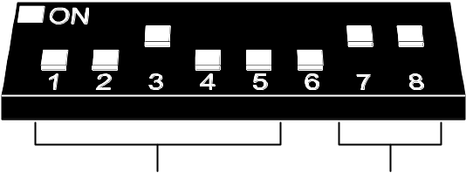

operating mode:
INTEGRA control panel
address:
4

Fig. 7. Example of setting the DIP-switches.

Communication with the control panel is only effected by means of the communication bus. This way is used for transmission of information on violations of detectors, tampers and troubles of wireless devices, as well as for control of operation of wireless devices. Table 6 shows how the terminals of the controller communication bus should be connected to the communication bus terminals of the INTEGRA alarm control panels.

 |  | ACU-100 controller terminals
 |  | COM | +12V | CLK | DAT
Panel terminals | INTEGRA 24/INTEGRA 32 | COM | +EX  or  AUX | CK | DT
Panel terminals | INTEGRA 64/INTEGRA 128 | COM | +EX1 | CK1 | DT1
Panel terminals | INTEGRA 64/INTEGRA 128 | COM | +EX2 | CK2 | DT2
Table 6.

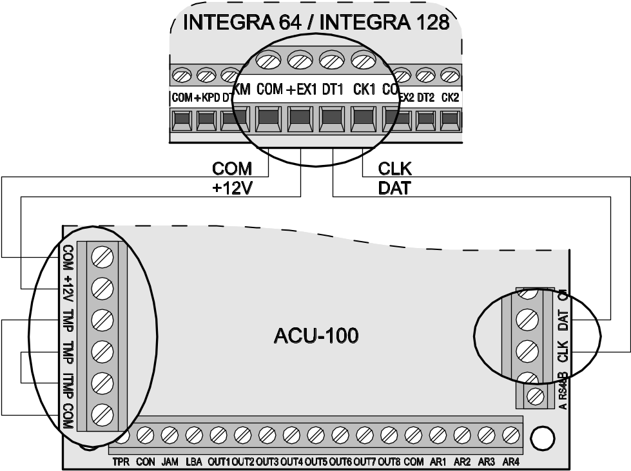
Fig. 8. Example of connecting the ACU-100 controller to the INTEGRA control panel.

Having connected the ACU-100 controller to the control panel, start the expander identification function in the panel. In the process of addition or removal of the wireless devices, it must be borne in mind that during controller identification the INTEGRA series control panels register the zones and outputs by groups of 8. Therefore, it is important at the registration of wireless devices in the controller to maintain continuity, i.e. to avoid spaces in the list, which will eventually reduce the number of available inputs in the panel. For example, if 9 wireless devices were initially registered in the controller, but item 7 was later deleted from the list, the control panel will assign 2x8 zones to the controller, although just 8 devices will be physically connected to it (see Table 7). In case of the devices which will not only occupy the outputs but the zones as well, it is recommended that they be added to the system first, so as to maintain the continuity of using both the zones and the outputs. Table 7 presents a situation in which the first output of the siren has found itself in position 8, and the second output in position 9. As a result, 16 outputs have been reserved in the system (the eight output in the first group of 8 outputs, and the first output in the second group of 8 outputs).

ACU-100 |  |  | INTEGRA 64/128
 |  |  | zones |  | outputs
It. | List of devices |  | No. | Device | No. | Device
1 | detector APD-100 | 8 | 17 | APD-100 detector | 17 | unused/unavailable
2 | APD-100 detector | 8 | 18 | APD-100 detector | 18 | unused/unavailable
3 | AMD-100 detector | 8 | 19 | AMD-100 detector | 19 | unused/unavailable
4 | AMD-100 detector | 8 | 20 | AMD-100 detector | 20 | unused/unavailable
5 | AMD-101 detector | 8 | 21 | AMD-101 detector | 21 | unused/unavailable
6 | ^ | 8 | 22 | AMD-101 detector | 22 | unused/unavailable
7 |  | 8 | 23 | unused/unavailable | 23 | unused/unavailable
8 | ASP-105 siren | 8 | 24 | ASP-105 siren | 24 | ASP-105 siren
9 | ^ | 8 | 25 | ASP-105 siren | 25 | ASP-105 siren
10 |  | 8 | 26 | unused/unavailable | 26 | unused/unavailable
11 |  | 8 | 27 | unused/unavailable | 27 | unused/unavailable
12 |  | 8 | 28 | unused/unavailable | 28 | unused/unavailable
13 |  | 8 | 29 | unused/unavailable | 29 | unused/unavailable
14 |  | 8 | 30 | unused/unavailable | 30 | unused/unavailable
15 |  | 8 | 31 | unused/unavailable | 31 | unused/unavailable
16 |  | 8 | 32 | unused/unavailable | 32 | unused/unavailable
Table 7. An example of incorrect registration of wireless devices. The system must reserve 16 zones and 16 outputs, as well as 2 addresses for devices taking up 8 items. The controller with address 0 is connected to the first expander bus.

ACU-100 |  |  | INTEGRA 64/128
 |  |  | zones |  | outputs
It. | List of devices |  | No. | Device | No. | Device
1 | ASP-105 siren | 8 | 17 | ASP-105 siren | 17 | ASP-105 siren
2 | ^ | 8 | 18 | ASP-105 siren | 18 | ASP-105 siren
3 | APD-100 detector | 8 | 19 | APD-100 detector | 19 | unused/unavailable
4 | APD-100 detector | 8 | 20 | APD-100 detector | 20 | unused/unavailable
5 | AMD-100 detector | 8 | 21 | AMD-100 detector | 21 | unused/unavailable
6 | AMD-100 detector | 8 | 22 | AMD-100 detector | 22 | unused/unavailable
7 | AMD-101 detector | 8 | 23 | AMD-101 detector | 23 | unused/unavailable
8 | ^ | 8 | 24 | AMD-101 detector | 24 | unused/unavailable
Table 8. An example of correct registration of wireless devices. The system has reserved 8 zones and 8 outputs, as well as 1 address, for 8 devices. The controller with address 0 is connected to the first expander bus.

Sometimes, it is impossible to avoid gaps on the list of zones/outputs. This is the case when the number of zones/outputs actually used by the devices is not a multiple of 8. Avoiding the gaps is difficult or even impossible when, due to the size of the premises, a number of ACU-100 controllers are operating in the system.
Apart from assignment of zones and outputs to the controller, the panel will reserve for it an address on the expander bus. For each group of 8 zones/outputs, 1 address is reserved on the expander bus. The controller can take up from 1 to 6 addresses on the expander bus. This should be taken into account at the system design stage and the sufficient number of unoccupied addresses should be left for the controller. If, after new wireless devices are added to the controller, it turns out that further addresses are needed, but they are occupied by other devices, correct completion of the expander identification procedure will be impossible. Then it will be necessary to change the addresses of devices connected to the expander bus.
The system zones to which wireless devices are assigned can be programmed as:
- NC, NO or EOL – depending on the type of device, the zone will provide information about detector violation, power failure, etc.
- 2EOL/NC or 2EOL/NO – depending on the type of device, the zone will provide information about detector violation, power failure, etc., and, additionally, about tampers.
Changing the wireless detectors from passive to active state takes place simultaneously with arming the partition to which the zone with wireless detector belongs. After disarming, the detectors will re-enter the passive state. It does not refer to the 24hr zones. The wireless detectors assigned to those zones remain always in the active state. Additionally, the Always active option can be enabled for any wireless detector.
Do not program reversed polarity for the alarm system outputs to which wireless devices are assigned, because these devices will function in reversed mode (the inactive output will arm, and the active output will disarm).

Addressable zone expander for CA-64 control panel
Using the DIP-switches, set the suitable operating mode, address and programming mode of the ACU-100 controller.
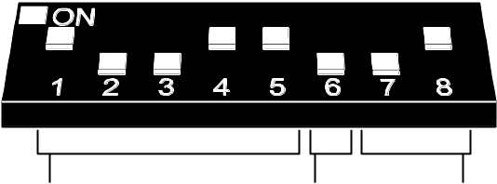

programming:
Dload10
address:
25
operating mode:
CA-64 control panel

Fig. 9. Example of setting the DIP-switches.

Communication with the control panel is effected by means of the communication bus. This way is used for transmission of information on violations of detectors and tampers of wireless devices. Control of the detectors (changeover to active/passive state), sirens (triggering alarm signal), 230 V AC controller (closing/opening the electric circuit) etc. is performed through the control inputs of the ACU-100 controller. Suitably programmed outputs of the alarm control panel should be connected to the control inputs.
Fig. 10 shows a configuration example of the ACU-100 controller working together with the CA-64 control panel. The controller communication bus is connected to the second expander bus of the control panel. The OUT9 panel low-current output has been programmed as type 42: Power supply on armed and connected to the AR1 controller control input. This input is used to toggle the wireless detectors between their passive and active state. The OUT10 panel low-current output has been programmed as type 1: Burglary alarm and connected to the AR2 controller control input. This input triggers the wireless siren. In the presented example, the controller information outputs (CON, JAM, LBA) remain unconnected. They can be connected to the control panel inputs so as to obtain in this way information on troubles related to operation of the wireless devices.
Having connected the ACU-100 controller to the control panel, start the expander identification function in it.
When interacting with the CA-64 control panel, the ACU-100 controller makes 48 wireless zones available to it. The zone numbers are assigned to the wireless devices registered in the controller according to the following principle:
zone number = 16 + number of the wireless device on the list

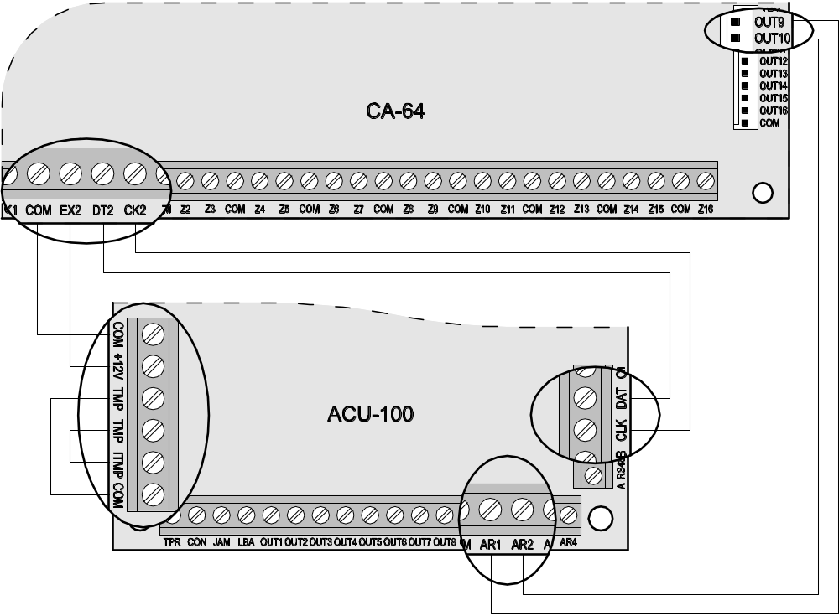
Fig. 10. Example of connecting the ACU-100 controller to the CA-64 control panel.

The system zones to which wireless devices are assigned can be programmed as:
- NC, NO or EOL – depending on the type of device, the zone will provide information about detector violation, power failure, etc.
- 2EOL/NC or 2EOL/NO – depending on the type of device, the zone will provide information about detector violation, power failure, etc., and, additionally, about tampers.
Connection of the controller to the CA-64 alarm control panel excludes the possibility to connect to it the zone expanders (CA-64 E, CA-64 EPS and CA-64 ADR) as well as the CA-64 PP zones & outputs expander with power supply.

Zone expander for CA-10 control panel
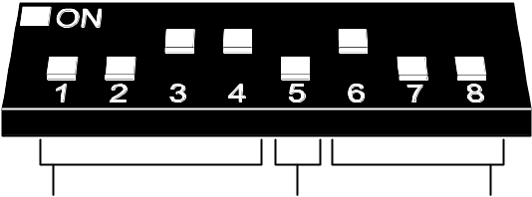

programming:
Dload10
address:
0011
operating mode:
CA-10 control panel with 1 keypad

Fig. 11. Example of setting the DIP-switches.

Using the DIP-switches, set the suitable operating mode, address and programming mode of the ACU-100 controller. To determine the operating mode you should take into account the number of keypads installed in the system. Depending on the number of keypads, the controller makes it possible to expand the system by 2, 4 or 6 wireless zones (see Table 9), the status of which (violations and tampers of the wireless devices assigned to these zones) will be transmitted by means of the communication bus.

Number of keypads in the system | Connection of CLK keypad terminals to control panel terminals | Connection of CLK controller terminals to control panel terminals | Numbers of additional system zones  (zones 9 and 10 are reserved in the system for the 1st keypad zones)
Number of keypads in the system |  |  | 11 | 12 | 13 | 14 | 15 | 16
1 | CLK1 | CLK2 | output 11  in controller | output 12  in controller | output 13  in controller | output 14  in controller | output 15  in controller | output 16  in controller
2 | CLK1  CLK2 | CLK3 | zone in 2nd keypad | zone in 2nd keypad | output 13  in controller | output 14  in controller | output 15  in controller | output 16  in controller
3 | CLK1  CLK2  CLK3 | CLK4 | zone in 2nd keypad | zone in 2nd keypad | zone in 3rd keypad | zone in 3rd keypad | output 15  in controller | output 16  in controller
Table 9.

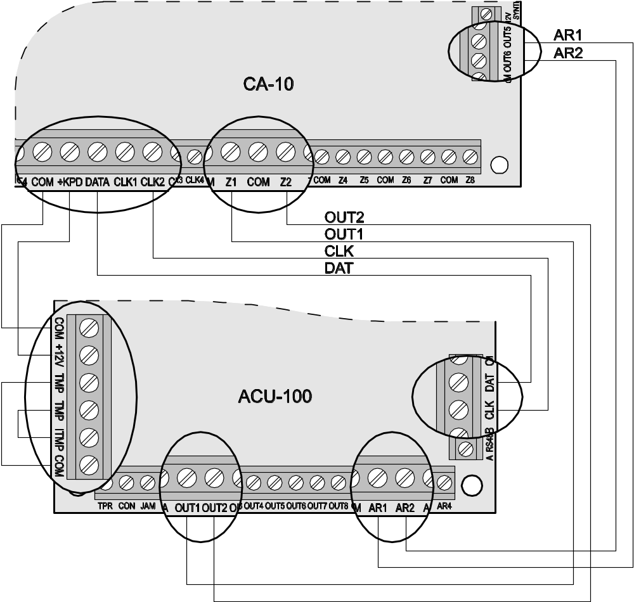
Fig. 12. Example of connecting the ACU-100 controller to the CA-10 control panel.

Control of the detectors (changeover to active/passive state), sirens (triggering alarm signal), 230 V AC controller (closing/opening the electric circuit) etc. is performed through the control inputs of the ACU-100 controller. Suitably programmed outputs of the alarm control panel should be connected to the control inputs. Additionally, it is possible to connect the first eight outputs of the controller to the control panel zones. Thus the alarm control panel can receive information from the wireless devices assigned to these outputs. Connecting the ACU-100 controller to the CA-10 control panel at the same time by means of communication bus and control panel zones will enable the system to be expanded by up to 14 wireless zones.
Fig. 12 shows an example of configuration of the ACU-100 controller interacting with the CA-10 control panel. One keypad is connected to the control panel, therefore the CLK controller terminal is connected to the CLK2 panel terminal. The zones made available by the ACU-100 controller to the control panel by means of the communication bus have in the security system numbers from 11 to 16 (controller outputs from 11 to 16). These zones should be programmed in the control panel as 2EOL/NO type. The controller outputs OUT1 and OUT2 have been connected, respectively, to the control panel zones Z1 and Z2 (thus, the total number of wireless zones in the system will amount to 8).The control panel zones to which the controller outputs have been connected should be configured as NO type. Still available are the control panel zones from Z3 to Z8. You can connect to them wire-operated devices or consecutive controller outputs as well as wireless devices assigned to them. The OUT5 control panel low-current output has been programmed as type 35: Power supply on armed mode and connected to the AR1 controller control input. This input switches the wireless detectors from passive to active state, and vice versa. The OUT6 control panel low-current output has been programmed as type 01: Burglary alarm and connected to the AR2 controller control input. This input triggers the wireless siren. In the presented example, the controller information outputs (TPR, CON, JAM, LBA) have remained unconnected. These outputs can be connected to the control panel zones so as to obtain in this way information on problems connected with operation of wireless devices.

Wireless device module interfacing with any alarm control panel
Using the DIP-switches, set the suitable operating mode of the ACU-100 controller, number of ACX-100 modules which are connected to it, as well as the programming mode.
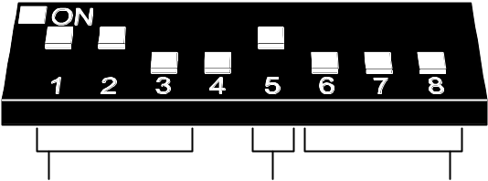

programming:
keypad
operating mode:
any control panel
number of ACX-100 modules:
3

Fig. 13. Example of setting the DIP-switches.

Communication with the control panel in this configuration is effected by means of controller outputs and inputs. The controller outputs to which the wireless devices are assigned should be connected to the control panel zones. Control of the detectors (changeover to active/passive state), sirens (triggering alarm signal), 230 V AC controller (closing/opening the electric circuit) etc. is performed through the control inputs of the ACU-100 controller. Suitably programmed outputs of the alarm control panel should be connected to the control inputs.
Shown in the example, Fig. 14, is the CA-6 alarm control panel of SATEL make, however it can be any other panel as well. The controller outputs OUT1 to OUT5 are connected, respectively, to the control panel zones Z1 to Z5 (preprogrammed as type NO). The TPR output, which informs of tampers of wireless devices and controller (TMP terminals connected to COM and ITMP terminals), is connected to the Z6 panel zone, preprogrammed as NO type, reaction type 24H Audible. The OUT4 panel low-current output has been programmed as type 35: Power supply on armed mode and connected to the AR1 controller control input. This input toggles the wireless detectors between the passive and active state. The OUT5 panel low-current output has been programmed as type Burglary alarm signaling and connected to the AR2 controller control input. This input triggers the wireless siren.

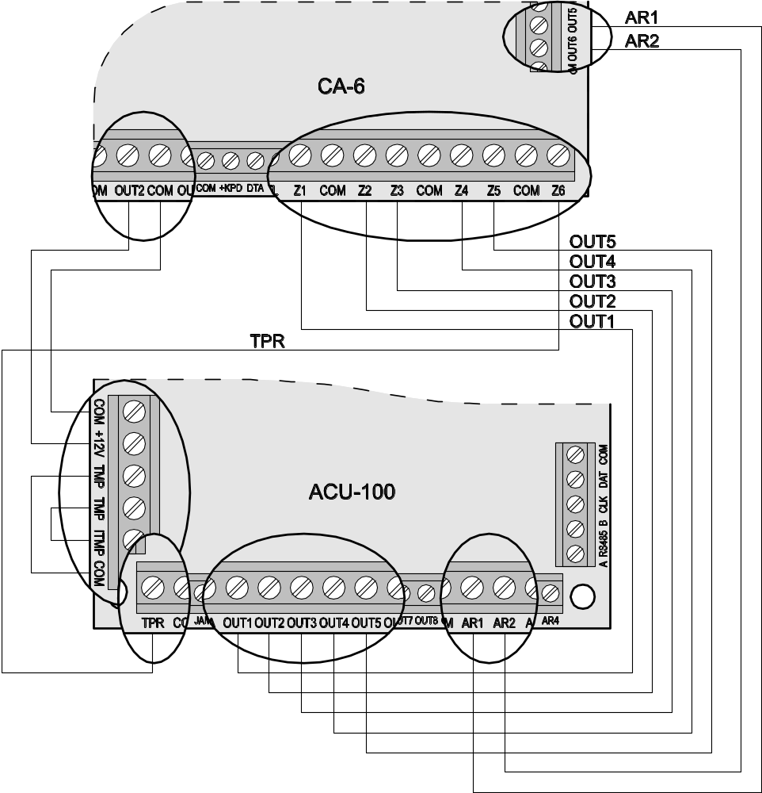
Fig. 14. Example of connecting the ACU-100 controller to the CA-6 control panel.

Programming and diagnostics
The way of programming and the access to diagnostic functions depend on the working configuration of the controller:
- interacting with INTEGRA or VERSA control panels
- keypad of alarm system in service mode;
- computer with DloadX program connected to INTEGRA control panel;
- computer with Dload10 program connected to the RS-232 port of the controller for the duration of diagnostic test.
- interacting with other control panels
- LCD keypad to be connected to the controller for the time of programming;
- computer with Dload10 program connected to controller RS-232 port for the time of programming.

LCD keypad of INTEGRA security system
In order to configure the controller using the LCD keypad follow the instructions below:
- Enter the service code, confirm with the [*] key and press the key 9 to get access to the service mode.
- Proceed to the function of programming the controller settings a (→Structure →Hardware →Expanders →Settings →controller name).
- Program the controller as required.
- Quit the service mode.

The menu of service functions for the controller interfacing with the INTEGRA control panel:
No autorst.3t.
Tamper
Response period
New device
Active mode
Filter
Configuration
Remove device
Synchronization
Test mode on
Test mode off
Diagnostics of the controller and the wireless devices registered in it is facilitated by using functions available in the user menu.
Overview of all functions – see Section Description of functions, options and commands.

LCD keypad of VERSA alarm system
In order to select the partition in which tamper alarm will be triggered if the controller is tampered or disconnected from the bus, and/or to program the response period and name, you can use the Settings function (Service mode 2. Hardware 1. Kpds & exps. 2. Settings). After selecting the controller from the list to be displayed, the programming should be conducted according to the "step by step" method.
The other programming related functions of the ABAX system are available in the ACU-100 submenu (Service mode 2. Hardware 1. Kpds & exps. 3. ACU-100):
[213#1#] 1. New device
[213#2#] 2. Config. device
[213#3#] 3. Remove device
[213#4#] 4. ACU-100 zones
[213#5#] 5. Synchronize
[213#6#] 6. Test mode on
[213#7#] 7. Test mode off
For additional information please see the manuals delivered with the VERSA control panel.

DloadX program
In order to configure the controller by means of the DloadX program proceed as follows:
- Launch the DloadX program and establish communication with the control panel (see Programming manual for INTEGRA or VERSA control panel).
- Click on the  button to open the window showing structure of the security system.
- Select the "Hardware" tab, and then highlight the wireless system controller in the list of devices.
- Program the controller.
- Having finished entering the new settings, save them in the controller by clicking on the "Write" button (the  and  buttons in the main menu of DloadX program are not intended for reading/writing the settings of the controller and wireless devices supported by it).
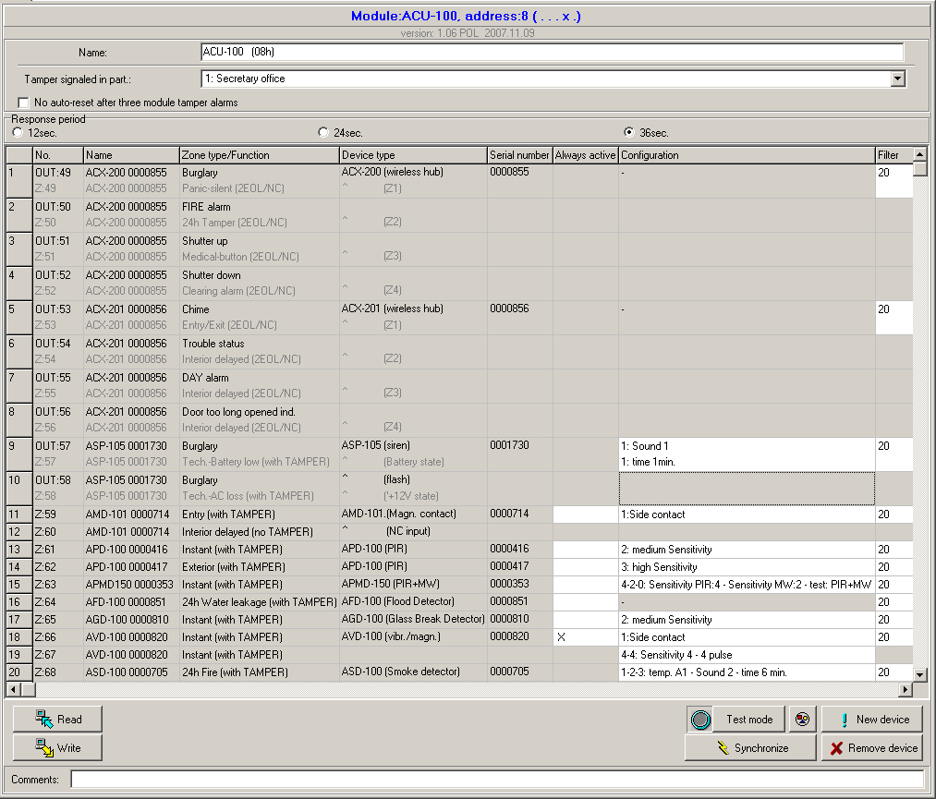
Fig. 15. Configuration of the ACU-100 controller working together with the INTEGRA control panel in DloadX program. Given under information on the module type and address is the version of its firmware. The wireless devices have been registered in the controller as recommended earlier in this manual: the devices which occupy both zones and outputs in the system were added first, while the devices taking up zones only were added after them. The radio signal level tester was added last.

Such diagnostic functions as Signal level, Communication quality and Restart communication test in the DloadX program are available in the Wireless device window.

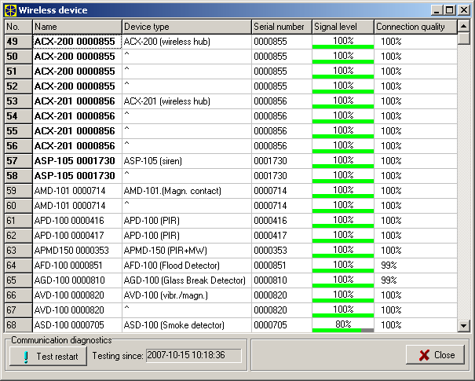
Fig. 16. DloadX program window showing signal level and quality of controller communication with wireless devices (ACU-100 controller working together with the INTEGRA control panel).

Troubles of wireless devices (no communication, low battery level, jamming) can be read out in the DloadX program in the Troubles window.

LCD keypad connected to controller
To configure the controller by means of the LCD keypad you should:
- Set the option of programming by means of LCD keypad on the DIP-switches on the controller electronics board.
- Connect the keypad to the controller (see: Connecting keypad to controller).
- Enter the service code and confirm by pressing the [#] key, to get access to the menu of controller service functions.
- Program the controller as required.
- Quit the service mode using the Service end.
- Disconnect the keypad.

Service mode of keypad connected to the controller
You can move through the menu and use the service functions by means of the following keypad keys:
❐ – scroll the functions list up;
❑ – scroll the functions list down;
◆ – enter the function/submenu;
⧫ or [*] – exit the function/submenu without making changes (some functions can only be quitted by pressing the asterisk [*] key);
[#] – enter the function/submenu; accept the data entered.

The menu of service mode in LCD keypad connected to the controller:
Service end
New device
Remove device
Device names
Serial number
Inputs
Outputs
Settings Response period
Filter
Configuration
Trouble indication
Input types
Output type
Set defaults
Tests Signal level
Communications state
Tamper state
Battery state
Jamming
Test mode
Clear memory
Synchronization
Supply voltage
Service code
Overview of all functions – see Section Description of functions, options and commands.

Dload10 program
In order to configure the ACU-100 controller or carry out diagnostics of the wireless devices by means of the Dload10 program, do as follows:
- Set the option of programming through the RS-232 port on the DIP-switches on the controller electronics board (this is not required when the controller operates in configuration of expander of wireless devices for the INTEGRA control panels).
- Connect computer to the controller (see: connecting computer to the controller).
- Launch the Dload10 program in the computer (access to the program is protected with password, which is 1234 by default and can be changed to any sequence of 16 characters).
- Open the "Communication" menu, select the "Configuration" item and indicate the computer port to which the controller is connected.
- Open the "File" menu, select "New device", and then "ACU-100".

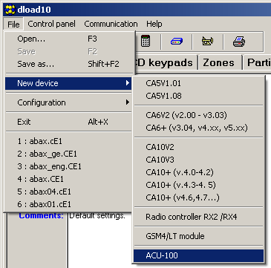
Fig. 17. Activation of the ACU-100 controller support in the Dload10 program.

- Having established communication, the program will compare identifiers in computer and controller, and if they coincide, it will read data from the controller.
- Configure the controller settings.
- After completion of entering the new settings, save them in the controller by clicking on the button.

A useful diagnostic tool in the Dload10 program is the level of signal currently received by the controller in its working radio band, which is presented as a real time diagram. It illustrates both the noise level and all registered at a particular moment signals from other radio devices operating on the same frequency band. Presented in red color are signals from wireless devices operated by the controller. To open the window showing the radio signal level, click on the button. Also the level of radio signal received by the controller from individual devices can be represented in a diagrammatic form.
Note: When the ACU-100 controller operates in configuration of expander of wireless devices for the INTEGRA series control panels, the options regarding configuration of wireless devices are not available in the Dload10 program. Available are only diagnostic functions, including diagrams illustrating the radio signal levels.
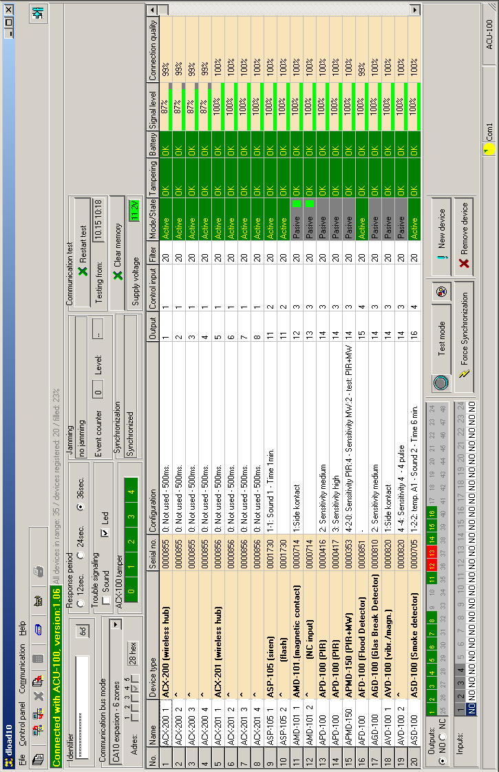
Fig. 18. ACU-100 controller operating window in the Dload10 program.

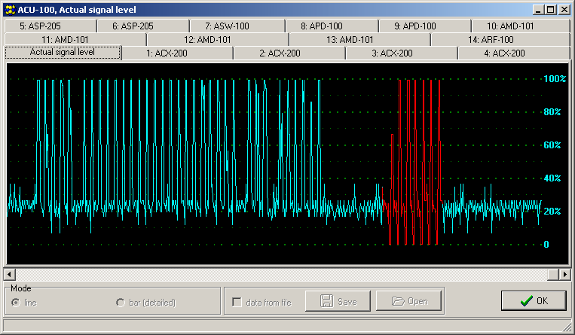
Fig. 19. Dload10 program window with a diagram of the level of radio signal received by the controller.

Description of functions, options and commands
Identifier – the identifier in the Dload10 program is intended to protect the controller against an attempt of unauthorized reprogramming. The identifier consists of 16 characters. By default, these are 0 only. They can be substituted by digits from 0 to 9 and/or letters from A to F range. The program will not establish communication with the controller, unless a valid identifier is entered. If data of the system we wish to get access to were previously saved in the computer, a window will be displayed on the screen with a list of files containing data with consistent identifier. You can choose one of these files to establish communication.
Service code – the keypad code (password) is intended for protection of the controller against an attempt of unauthorized reprogramming. By default, it has the form of 12345, but it can be changed to any sequence of 8 digits. Without entering the correct code, the controller service mode cannot be started in the keypad.
New device – this command initiates the procedure of adding new wireless devices to the system.
Remove device – this command initiates the procedure of deleting wireless devices from the system.
Device names – you can assign names to the wireless devices registered in the controller. This does not apply to the controller operating together with INTEGRA or VERSA series control panels.
Serial numbers – this service function in LCD keypad connected to the controller makes it possible to check the serial numbers of wireless devices included in the system. The serial number in DloadX and Dload10 programs is displayed in on-line mode at each device registered in the controller.
Inputs – you should select a control input for each wireless device registered in the controller. This does not apply to the controller operating together with INTEGRA or VERSA series control panels.
Notes:
- When a new wireless device is added to the system, the input 1 is indicated by default as the control input.
- When the entered input number is higher than 24, the input to control the device will be always active.
Outputs – wireless devices are assigned to particular controller outputs. This does not apply to the CA-64 (it is possible to assign the devices to outputs, but the outputs will not be used for communication with the control panel), INTEGRA and VERSA control panels.
Note: When a new wireless device is being added to the system, it is by default assigned to the output 1.
SETTINGS – calls submenu of the keypad connected to the computer.
Response period – the controller communicates with the wireless devices at specified time intervals. During those periods the controller gathers information on the status of devices and, if necessary, sends commands to the devices, e.g. switches the detectors to their active/passive state, activates/deactivates the test mode, and changes configuration of the devices. The response period may be 12, 24 or 36 seconds. The rarer the communication between the controller and wireless devices, the more wireless devices can work within each other's range. The maximum number of devices for 12s is 150, for 24s – 300, and for 36s – 450. Outside the response period, information on tampers of the devices and violations of the detectors being in their active state is sent to the controller.
Filter – it is possible to define the number of unanswered polls, after which "no communication" will be reported. You may enter the values from the range of 0 to 50. Entering the digit 0 will disable control of the device for presence in the system.
Configuration – some wireless devices (e.g. APD-100 APMD-150, AGD-100, AVD-100 and ASD-100 detectors, ASP-105 and ASP-205 sirens) make extra options available, which can be configured by radio.
Problem signaling – activation of any of the controller functional outputs (TPR, CON, JAM or LBA) can be indicated by LED or sound signal. This option is unavailable when the controller interacts with INTEGRA or VERSA series control panels.
Input types – the control inputs can be programmed as NO (normally open) or NC (normally closed). The control inputs are not used for interaction between the controller and the INTEGRA or VERSA series panels, hence this option is then unavailable.
Output type – outputs of the controller and ACX-100 modules can be programmed as NO (normally open) or NC (normally closed). The option is not available when the controller is used in conjunction with the INTEGRA or VERSA series control panels.
Set defaults – this function, which is only available in the LCD keypad connected to the controller, is used to restore the defaults.
TESTS – calls submenu of the keypad connected to the computer.
Signal level – this function, available in the LCD keypad, allows checking the level of signal received from wireless devices. The signal level is presented in percentage form. In the Dload10 program, the signal level is visualized graphically in on-line mode, with no need for calling any function. In the DloadX program, information on the signal level is shown in the "Wireless device" window.
Communication state – this function, available in the LCD keypad connected to the controller, allows you to check with which devices the communication is correct, or non-existent, or was temporarily lost. In the Dload10 program, all the communication-related information is shown in real time, with no need for calling any function. In the INTEGRA or VERSA system LCD keypad, the information on possible lack of communication is given in the user menu, Troubles submenu, and in the DloadX program, in the "Troubles" window.
Tamper state – this function, available in the LCD keypad connected to the controller, allows you to check which of the wireless devices are or were tampered with. In the Dload10 program, all the tamper-related information is given on-line, with no need for calling any function. In the INTEGRA or VERSA system LCD keypad, as well as in the DloadX program, it is possible to check the wireless device/controller for presence of tamper by using the Events function. Additionally, the information on possible tampers of wireless devices can be found in the DloadX program in the "Zones state".
Battery status – function is available in the LCD keypad connected to the controller. Depending on the type of device, the low battery message may indicate:
- low battery (detectors);
- loss of 12 V DC supply (ASP-105 siren);
- loss of 18 V AC supply (ACX-201 expander);
- discharged battery (ASP-105 siren, ACX-201 expander);
- overload of AUX1 or AUX2 supply output (ACX-201 expander).
In the Dload10 program, information on the status of battery / power supply / storage battery / supply outputs is given in on-line mode in the "Battery" column. In the INTEGRA or VERSA system LCD keypad, information on low batteries and other troubles is given in the user menu, Troubles submenu, and in the DloadX program, in the "Troubles" window.
Note: When low battery status is indicated, replace the battery within 2–3 weeks.
Jamming – this function, available in the LCD keypad connected to the controller, makes it possible to check whether the wireless system operation is not jammed by any device, which emits radio waves on the same frequency. If there was a jamming event, information is given of the fact, stating how many times and what was its amplitude. In the Dload10 program all the information on jamming is given in on-line mode, with no need for calling any function. In the INTEGRA or VERSA system LCD keypad, the information on possible jamming is given in the user menu, Troubles submenu, and in the DloadX program, in the "Troubles" window.
Test mode – activation of the test mode makes all the wireless devices indicate communication with the controller by blinking LEDs. Detectors inform on violations and tampers, using the LEDs. In the normal operating mode of the wireless devices, the signaling on LEDs is "off" for energy-saving considerations. When in the test mode, the tamper alarm signaling in sirens is disabled. After exiting the test mode, its actual termination will take place at the next response period. The test mode will be automatically exited 30 minutes after:
- it is started through the DloadX program. If the Wireless devices window is opened during this time in the DloadX program, the test mode duration will be extended (the 30-minute countdown will run from closing the window),
- termination of the service mode in the INTEGRA or VERSA control panel or the keypad connected to the controller,
- closing the Dload10 program.
Note: According to requirements of the EN50131 standard, the level of radio signals sent by wireless devices is reduced during the test mode operation.
Clear memory – this command will erase the memory, where information on tampers of wireless devices, low battery, and jamming is stored.
Restart communication test – the command, available in the Dload10 and DloadX programs only, which resets the communication test. The communication test consists in monitoring the response cycle. If during a consecutive poll a device fails to establish communication with the controller, the fact is registered and presented as impairment of communication quality. The test is carried out in the on-line mode, and its results are visualized as the Communication quality in percentage form.
Synchronization – the ACU-100 controller checks whether other wireless systems are operating within its range, and if so, it adjusts the response time accordingly. Synchronization is performed automatically on starting the controller and after each operation of addition/removal of devices supported by it. Additionally, it can be started manually with this command.
Supply voltage – function if the LCD keypad which allows the controller supply voltage level to be checked. In the Dload10, DloadX programs, the information on supply voltage is provided in on-line mode, with no need for starting any function whatever.
In/Out module tampers – information on communication of the controller with the ACX-100 input/output expansion modules, available in the Dload10 program only. Lack of communication is recognized as the module tamper.
Tamper alarm in partition [Expander tamper] – this option, available when the controller works together with the INTEGRA or VERSA control panel, makes it possible to indicate the partition where alarm will be triggered in the event of controller tamper.
No blocking after 3 tampers – option available when interacting with the INTEGRA or VERSA series control panel. The controller generates alarm on opening the tamper contact. Normally, if 3 consecutive tamper alarms are not cleared, signaling of next tamper alarms will be blocked, which prevents the same events being repeatedly saved in the control panel memory. The option allows the blocking to be disabled.
Always active – this option, available in the DloadX program, allows the detector to be permanently switched to active state.
Service end – this function ends the service mode in the keypad.

Configuration of additional parameters and options in wireless devices

DloadX or Dload10 program
Additional parameters and options are to be programmed in the "Configuration" column.

APD-100 detector
For detectors with firmware version 2.01, enter a 2-digit sequence. The first digit relates to sensitivity (see: Table 10), and the second one – to the pet immunity option (0 – option disabled, 1 – option enabled). For detectors with older firmware, enter a digit from 1 to 3, which corresponds to the selected sensitivity (see: Table 10).

Number | Detector sensitivity
1 | low
2 | medium
3 | high
Table 10.

APMD-150 detector
Enter a 3-digit sequence:
1st digit – sensitivity of infrared path: from 1 to 4 (1 – minimum; 4 – maximum),
2nd digit – sensitivity of microwave path: from 1 to 8 (1 – minimum; 8 – maximum),
3rd digit – type of operation in the test mode: 0 (signaling violation after motion is sensed by both detectors), 1 (signaling violation after motion is sensed by infrared detector) or 2 (signaling violation after motion is sensed by microwave detector).
For example, entering the values 4-4-0 means that the infrared sensitivity path has been set to 4, the microwave sensitivity path also to 4, and in the test mode the detector will signal violation (the LED will light up) after motion is sensed by both detectors.

AMD-100 and AMD-101 detectors
Enter the digit 0 (the lower reed switch) or 1 (the side reed switch) to select which of the two reed switches is to be active.

AMD-102 detector
For the magnetic contact (the first position / the first zone occupied by the AMD-102 detector), enter the digit 0 (the lower reed switch) or 1 (the side reed switch) to select which of the two reed switches is to be active.
For the roller shutter input (the second position / the second zone occupied by the AMD-102 detector), enter a sequence of two digits:
1st digit – number of pulses: from 1 to 8,
2nd digit – pulse validity: 0 (30 s), 1 (120 s), 2 (240 s) or 3 (unlimited duration – only switching over the detector from passive into active mode will reset the pulse counter).
For example, entering the values 4-2 means that the zone will be violated after registering 4 pulses, and the maximum time that can elapse between the first and the last pulse can be 240 seconds.

AGD-100 detector
Enter a digit from 1 to 3 which corresponds to the selected sensitivity for the high-frequency channel (see: Table 10).

AVD-100 detector
For the magnetic contact (the first position / the first zone occupied by the AVD-100 detector), enter the digit 0 (the lower reed switch) or 1 (the side reed switch) to select which of the two reed switches is to be active.
For the vibration detector (the second zone occupied by the AVD-100 detector), enter a 2-digit sequence:
1st digit – sensitivity: from 1 to 8 (1 – minimum; 8 – maximum),
2nd digit – number of pulses: from 0 to 7.
For example, entering the values 4-6 means that sensitivity has been set to 4, and the number of pulses to 6.

ASD-100 detector
Enter a 3-digit sequence corresponding to the selected parameters, as shown in Table 11.

1st digit |  | 2nd digit |  | 3rd digit
digit | heat sensor | digit | audible signaling | digit | signaling duration
0 | disabled | 0 | none | 1 | 1 minute
1 | A1 | 1 | sound type 1 | 2 | 3 minutes
2 | A2 | 2 | sound type 2 | 3 | 6 minutes
3 | B | 3 | sound type 3 | 4 | 9 minutes
Table 11.

For example, entering the 0-2-4 means that the heat detector has been disabled, acoustic signaling type 2 has been selected, and the signaling by means of buzzer/LEDs will last 9 minutes.

ARD-100 detector
Enter a digit from the 1 to 16 range, corresponding to the selected sensitivity (1 – minimum; 16 – maximum).

ATD-100 detector
For each position taken by the detector enter in turn:
- letter H (high temperature threshold) or L (low temperature threshold);
- numerical value corresponding to a temperature from the -30° C to +70° C range (with up to 0.5° accuracy),
- numerical value corresponding to a tolerance from the 0.5° C to 10° C range (with up to 0.5° accuracy).

ASP-105 siren
Program the acoustic signaling parameters (the first position / the first zone to which the siren is assigned), i.e. enter the two-digit sequence, according to Table 12.

1st digit |  | 2nd digit
digit | acoustic signaling | digit | signaling duration
1 | sound type 1 | 1 | 1 minute
2 | sound type 2 | 2 | 3 minutes
3 | sound type 3 | 3 | 6 minutes
4 | sound type 4 | 4 | 9 minutes
Table 12.

For example, entering the values 2-3 means that acoustic signaling type 2 has been selected and that its duration will be 6 minutes.

ASP-205 siren
Determine the signaling parameters independently for both positions / zones occupied by the siren, entering in each case a 3-digit sequence, according to Table 13.

1st digit |  | 2nd digit |  | 3rd digit
digit | signaling duration | digit | acoustic signaling | digit | optical signaling
1 | 1 minute | 0 | none | 0 | disabled
2 | 3 minutes | 1 | sound type 1 | 1 | enabled
3 | 6 minutes | 2 | sound type 2 | - | -
4 | 9 minutes | 3 | sound type 3 | - | -
Table 13.

For example, entering the values 2-0-1 means that the signaling will last 3 minutes, the acoustic signaling has been disabled, and the optical signaling enabled.

ASW-100 E and ASW-100 F controllers
Enter a digit from the 0 to 2 range, which corresponds to the selected mode of operation.

LCD keypad
In the LCD keypad of INTEGRA system, additional parameters and options of the wireless devices are to be programmed by means of the Configuration function (Service mode →Structure →Hardware →Expanders →Settings → controller name →Configuration). Having started the function, select the zone to which the wireless device is assigned and press the [#] or  key. In case of devices which take up more zones, selection of the suitable zone depends additionally on the parameter to be programmed. Having programmed the parameters, confirm the new settings with the [#] key. Automatic return to the zone selection list will follow.
In the LCD keypad connected to the controller, additional parameters and options of the wireless devices are also programmed by means of the Configuration function (Service mode →Settings →Configuration). Having started the function, select the device form the list and press [#] or . In case of devices which take up more zones, selection of the suitable zone depends additionally on the parameter to be programmed. Having programmed the parameters, confirm the new settings with the [#] key. Automatic return to the device selection list will follow.
Configuration of the wireless devices by means of the LCD keypad of VERSA system is described in the programming manual for VERSA control panels.

APD-100 detector
The  and  keys enable navigation between the programmable parameters. The  and  keys make it possible to select sensitivity within the range from 1 to 3 (see Table 10), as well as enable/disable the pet immunity option. Enabled pet immunity option is indicated by the symbol.

APMD-150 detector
The  and  keys allow you to navigate between the detector programmable parameters, and the  and  keys to modify them. The following should be programmed:
- sensitivity of the infrared path within the 1 to 4 range (1 – minimum; 4 – maximum);
- sensitivity of the microwave path within the 1 to 8 range (1 – minimum; 8 – maximum);
- manner of operation in the test mode: 0 (signaling violation after motion is sensed by both detectors), 1 (signaling violation after motion is sensed by IR detector) or 2 (signaling violation after motion is sensed by MW detector).

AMD-100 and AMD-101 detector
Use the  and  keys to select the active reed switch.

AMD-102 detector
After selecting the first position / the first zone occupied by the AMD-102 detector, use the  and  keys to indicate the active reed switch.
After selecting the second position / the second zone occupied by the AMD-102 detector, the parameters of roller shutter zone can be configured. The  and  keys allow you to navigate between the parameters, and the  and  keys to modify them. The following should be programmed:
- number of pulses within the 1 to 8 range;
- pulse validity: 30, 120 or 240 seconds, or unlimited duration (--- on the display) i.e. only switching over the detector from passive in to active state will reset the pulse counter.

AGD-100 detector
The  and  keys enable sensitivity to be selected within the 1 to 3 range (see Table 10).

AVD-100 detector
After selecting the first position / the first zone occupied by the AVD-100, the  and  keys allow you to indicate the active reed switch of the magnetic contact.
After selecting the second position / the second zone occupied by the AVD-100 detector, the parameters of the vibration detector can be configured. The  and  keys allow you to navigate between the parameters and the  and  keys to modify them. The following should be programmed:
- sensitivity within the range from 1 to 8 (1 – minimum; 8 – maximum);
- number of pulses within the range from 0 to 7.

ASD-100 detector
The  and  keys allow you to navigate between the programmable detector parameters, and the  and  keys to modify them. The following should be programmed:
- operating mode of the heat detector: you can disable the detector (thesymbol displayed) or select the detection class (A1, A2 or B) acc. to the standard EN 54-5;
- operating mode of the buzzer: you can disable the buzzer (thesymbol displayed) or select one of the three types of sound signaling;
- duration of alarm signaling by the buzzer/LED: 1, 3, 6 or 9 minutes.

ARD-100 detector
The  and  keys enable sensitivity to be selected within the range from 1 to 16 (1 – minimum; 16 – maximum).

ATD-100 detector
Use the  and  keys to navigate between the programmable parameters of the detector. Use the numeric keys to program the following:
- temperature: a value from the -30° C to 70° C range (with up to 0.5° accuracy) – to enter the preceding “-” sign, press one of the numeric keys from 3 to 9;
- tolerance: a value from the 0.5° C to 10° C range (with up to 0.5° accuracy);
- threshold type: H (high) or L (low).

ASP-105 siren
After selecting the first position / the first zone occupied by the siren, define the parameters of acoustic signaling. Use the  and  keys to navigate between the parameters and the  and  keys to modify them. The following should be programmed:
- type of acoustic signaling: a choice out of four types is provided;
- maximum duration of signaling: 1, 3, 6 or 9 minutes.

ASP-205 siren
Signaling parameters can be independently selected for both positions / zones occupied by the siren. Use the  and  keys to navigate between the parameters and the  and  keys to modify them. The following should be programmed:
- operating mode of acoustic signaling: it can be disabled (thesymbol displayed) or one out of three types of acoustic signaling selected;
- maximum duration of signaling: 1, 3, 6 or 9 minutes;
- operating mode of optical signaling: it can be disabled (thesymbol displayed) or enabled (the symbol displayed). The LCD keypad of INTEGRA system allows you to enable/disable the signaling by pressing any numerical key (the  and  keys have no effect).

ASW-100 E and ASW-100 F controllers
Use the  and  keys to select the operating mode of the ASW-100 controller.

Restoring controller default settings
The following parameters are preprogrammed by default:
- service code: 12345;
- Dload10 identifier: 0000000000000000;
- response period: 24s;
- problem signaling: LED indicator;
- no registered wireless devices.
The default (factory) settings can be restored by means of the Set default function in the keypad connected to the controller, or by way of hardware restart. In order to restore the defaults by means of the hardware restart, follow the instructions below:
- Disconnect the controller power supply.
- Disconnect the cables connected to the controller communication bus.
- Short the CLK and DAT terminals.
- Reconnect the power supply. A short while after power-up, the operating mode LED indicator will light in red. When default settings are restored, the LED color will change to green.
- Open the CLK and DAT terminals.
- Disconnect the controller power supply.
- Reconnect the cables to the controller communication bus.
- Reconnect the controller power supply.

Specifications
Operating frequency band 868.0 MHz ÷ 868.6 MHz
Number of supported wireless devices 48
Range up to 500 m (in open area)
Supply voltage 12 V DC ±15%
Standby current consumption 140 mA
Maximum current consumption 140 mA
Outputs current-carrying capacity 50 mA
Security grade according to EN50131-3 Grade 2
Environmental class according to EN50130-5 II
Operating temperature range -10 °C…+55 °C
Maximum humidity 93±3%
Complied with standards EN 50130-4, EN 50130-5, EN 50131-1, EN 50131-3, EN 50131-5-3
Electronics board dimensions 104 x 73 mm
Housing dimensions, OPU-1 A 126 x 158 x 32 mm
Weight 222 g
Name of certification body Telefication

History of the manual updates
Described in the table below are changes as compared with the manual for the ACU-100 controller with firmware in version v1.03.
Date | Firmware version | Introduced changes
2005-09 | 1.04 | - Added information on the options of programming the outputs of the controller and ACX-100 module as NO, NC type (p. 8 and 41).  - Added description of the manner to indicate active status of functional outputs (p. 9).  - Supplemented service mode menu of the LCD keypad connected to the controller (p. 37).
2006-11 | 1.05 | - Information about new wireless devices added to section on controller outputs (p. 8).  - Information added regarding new wireless devices of ABAX system: ACX-200 zone/output expander (p. 9 and 18), ASP-205 wireless indoor siren (p. 11), ASW-100 E and ASW-100 F 230 V AC wireless controllers (p. 12 and 24) and ARF-100 radio signal level tester (p. 12 and 25).  - Modified section on adding new devices to ABAX system (p. 16–18).  - Supplemented section on interaction between ACU-100 controller and INTEGRA control panels (p. 26).  - Added information on the diagnostic capability of ACU-100 controller operating in configuration of expander of wireless devices for INTEGRA series control panels, by means of Dload10 program (p. 33 and 38).  - Supplemented information on „Test mode” (p. 42).
2007-11 | 1.06 | - Supplemented description of LBA function output (p. 5, 9).  - Added information on new wireless devices of ABAX system: hard-wired zones and outputs expander with power supply ACX-201 (p. 9, 18), wireless dual motion detector (p. 10), wireless glass break detector (p. 10), wireless water flood detector (p. 10), wireless vibration and magnetic detector (p. 11) and wireless smoke and heat detector (p. 11).  - Modified section on adding new devices to ABAX system (p. 16–18).  - Added information on lowering the radio signal level during test mode operation (p. 26, 42).  - Modified and supplemented description of "Battery status" function (p. 42).
2008-07 | 2.00 | - Information on pet immunity has been added to description of APD-100 detector (p. 9).  - Information on APD-100 detector configuration has been modified and supplemented (p. 21, 43 and 46).  - Information on AMD-100 and AMD-101 detector configuration has been modified and supplemented (p. 22, 44 and 46).  - Section "Zone expander for CA-10 control panel” has been modified (p. 30).
2009-07 | 2.01 | - Added information on interaction with VERSA control panel.  - Modified section on controller control inputs (p. 6).  - Modified section on controller control outputs (p. 8).  - Added information about AMD-102 wireless magnetic contact with roller shutter input (p. 10, 22, 44 and 46).  - Added information about ARD-100 wireless reorientation detector (p. 11, 22, 45 and 47).  - Added information about APT-100 bidirectional key fob (p. 12).  - Revised section "Installation":  - subsections on detectors (p. 20), sirens (p. 22), wireless controllers (p. 24) and radio signal level tester (p. 25) have become separate subsections and all of them have been modified;  - information on installation of particular wireless devices has been deleted (it can be found in manuals of respective devices);  - description of configuration of particular devices has been moved to section "Configuration of additional parameters and options in wireless devices" (p. 43).  - Added information about the method of configuration of INTEGRA system zones to which wireless devices are assigned (p. 28).  - Added information about the method of configuration of CA-64 system zones to which wireless devices are assigned (p. 30).  - Added subsection about programming ABAX wireless system by means of VERSA alarm system keypad (p. 34).  - Added subsection about configuration of additional parameters and options of wireless devices (p. 43).
2011-05 | 3.00 | - Information on ATD-100 wireless temperature detector has been added (p. 11, 22, 45 and 47).  - Information on AMD-102, ATD-100 and AVD-100 detectors, which can take one or two positions in the list of wireless devices, has been added to section "Adding new wireless devices" (p. 16-18).  - Information on requirements of standard EN50131-3 has been added (p. 19 and 21).  - Specifications have been supplemented (p. 48).

SATEL sp. z o.o.
ul. Schuberta 79
80-172 Gdańsk
POLAND
tel. + 48 58 320 94 00
info@satel.pl
www.satel.eu


two-way
wireless
system

WIRELESS SYSTEM CONTROLLER
ACU-100
Program version 3.00

User Manual



acu100_en 05/11
druk:
50,51,0,49,48,1,2,47,46,3,4,45,44,5,6,43,42,7,8,41,40,9,10,39,38,11,12,37,36,13,14,35,34,15,16,33,32,17,18,31,30,19,20,29,28,21,22,27,26,23,24,25

