WARNING
Please read this manual carefully before use.

Changes, modifications or repairs not authorized by the manufacturer shall void your rights under the warranty.

SATEL's goal is to continually upgrade the quality of its products, which may result in alterations of their technical specifications and firmware. The current information on the introduced modifications is available on our website.
Please visit us:
http://www.satel.eu

The declaration of conformity may be consulted at www.satel.eu/ce

Factory default codes:
Service code: 12345
User 30 code: 1111

The following symbols may be used in this manual:
 - note,
 - caution.

CONTENTS
1. Introduction 3
2. Keypad description 3
2.1 LEDs presenting partition and system state 4
2.2 LEDs presenting zone status 4
2.3 Keys 5
2.4 Sound signaling 6
2.4.1 Beeps generated when operating 6
2.4.2 Beeps generated during programming 6
2.4.3 Events signaled by sounds 6
3. Operating the alarm system 7
3.1 Codes 7
3.1.1 Factory default codes 7
3.2 Arming 7
3.2.1 Arming without partition selection 7
3.2.2 Arming the selected partition 8
3.2.3 Quick arming 8
3.2.4 Arming without delay 8
3.2.5 Denial of arming 8
3.2.6 Failure of arming procedure 8
3.3 Disarming and alarm clearing 9
3.3.1 Disarming and alarm clearing without partition selection 9
3.3.2 Disarming and alarm clearing in selected partition 9
3.3.3 Viewing the zones which triggered alarm 9
3.4 Quick inspection of partition status 9
3.5 Triggering the alarm from keypad 9
3.6 Turning the CHIME on /off 10
3.7 User menu 10
3.7.1 Running the functions 10
3.7.2 “Step by step” programming method 10
3.7.3 Entering data 10
3.7.4 User functions list 12
3.8 Change own code 12
3.9 Users 12
3.9.1 Adding a user 13
3.9.2 User editing 18
3.9.3 Removing a user 20
3.10 Canceling the telephone messaging 20
3.11 Zone bypassing 20
3.11.1 Zone inhibiting 20
3.11.2 Zone isolating 21
3.12 Auto-arming deferment 21
3.13 Setting the system time and date 21
3.14 Programming the timers 21
3.14.1 Programming the weekly schedule 22
3.14.2 Programming an exception 22
3.14.3 Selecting the arming mode 23
3.15 Programming the telephone numbers to be notified 23
3.16 Programming codes to acknowledge / clear messaging 24
3.17 Checking the troubles 24
3.17.1 Trouble list 24
3.17.2 Trouble handling procedure 25
3.17.3 Trouble memory and clearing the trouble memory 25
3.18 Output control 26
3.18.1 Quick control of outputs 26
3.18.2 Controlling the outputs by means of function 26
3.19 Tests 26
3.19.1 Zone test 26
3.19.2 Output test 27
3.19.3 Checking the level / quality of radio signal 27
3.19.4 Starting the manual test transmission 27
3.19.5 Checking the current supply voltage in modules 27
3.19.6 Outputs reset 27
3.20 Service 28
3.20.1 Defining the service access rules 28
3.20.2 Defining the service access time 28

Introduction
Thank you for choosing the product offered by the SATEL Company. Wishing you full satisfaction with the choice you made, we are always ready to provide you with professional assistance and information on our products.
The SATEL Company is manufacturer of a broad range of devices dedicated for use in security alarm systems. Further information is available on our website www.satel.eu or at the points of sale offering our products.
This manual contains information on how to operate the alarm system using the LED keypad. The user manual, which describes the other methods of operating the alarm system, is available on www.satel.eu.
Operating the alarm system from the LED keypad is subject to some limitations as compared with operating the system from the display keypads (e.g. the LEDs do not allow to convey some information and some functions are not available).
It is recommended that that the installers prepare their own user manual for the alarm system installed by them. The manual must include all changes and modifications in relation to the factory default settings.
The installer should train the users in the rules of operating the alarm system.

Keypad description
The keypad is offered in two versions differing in key backlight color. Information on the color version can be found in the keypad name:
VERSA-LED-GR – green backlight,
VERSA-LED-BL – blue backlight.

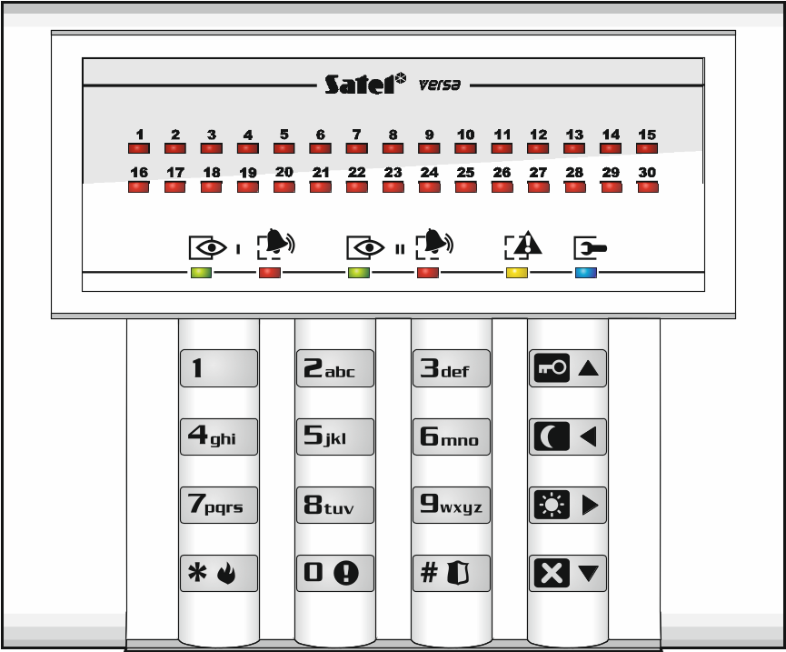
Fig. 1. VERSA-LED keypad.

LEDs presenting partition and system state

LED | Color | Description
 | green | indicates the partition state (each partition has its own LED)  ON – partition is armed  blinking – exit delay countdown is running in partition
 | red | indicates alarm or alarm memory in the partition (each partition has its own LED)  The way of presenting the information is shown graphically below. The information is presented for 2 seconds and repeated ( – LED is OFF;  – LED is ON). The higher position in the list means the higher priority of the presented status:  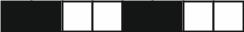 – fire alarm,   – burglary alarm,   – warning alarm,  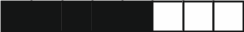 – tamper alarm,  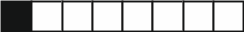 – fire alarm memory,   – burglary alarm memory,  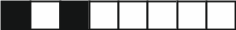 – warning alarm memory,  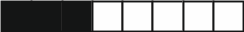 – tamper alarm memory.
 | yellow | blinking when the system requires user's attention (e.g. because of a trouble or trouble memory)  The LED goes off, if one or both partitions are armed.
 | blue | indicates the service mode  ON – service menu is available on the keypad  blinking – service menu is available on another keypad

Information about the armed state can be extinguished after a time period defined by the installer. Entering the code and pressing the  key will display again the armed state information.
If the Grade 2 global option is enabled by installer:
- the  LEDs indicate alarms only after entering the code and pressing the key,
- blinking of the  LED means that there is a trouble in the system, some zones are bypassed, or that there was an alarm.
When programming by means of the “step-by-step” method, the  and LEDs present the number of the current step (see p. 10).
When you are using the user menu or service menu, the LED is:
- blinking rapidly during navigation through the menus and submenus,
- steady on after a function is started.

LEDs presenting zone status
If the Grade 2 global option is enabled by the installer, the LEDs will only present the zone status after entering the code and pressing the key.
30 numbered LEDs provide information about the status of zones. The LED numbers correspond to the zone numbers. When the user functions are in use, the LEDs can present other information.
The way of presenting information is shown graphically below. The information is presented for 2 seconds and repeated ( – LED is OFF; – LED is ON). The higher position in the list means the higher priority of the presented status:
 – inhibited (not displayed when armed),
 – isolated (not displayed when armed),
– long violated (not displayed when armed),
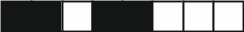 – no violations (not displayed when armed),
– first triggered alarm,
 – tampered (2EOL type zone),
– violated,
– tamper memory (2EOL type zone),
– alarm memory,
 – normal state.
Additionally, the LEDs show countdown of entry delay and exit delay in partitions (the first partition – LEDs 1-15; the second partition – LEDs 16-30). The LEDs which are ON (exit delay) or blinking (entry delay) show how much time has left to the end of countdown. A single LED means 2 seconds. If the countdown time exceeds 30 seconds, the LEDs will only start going off, when the time left is shorter than 30 seconds.

Keys
The keys bearing digits and letters enable entering the code, as well as data when the keypad is being used.
Other functions of these keys and the basic function of the other keys are described below.
 | allow to trigger the medical (aux) alarm (press and hold down for 3 seconds)
 | allow to turn on/off the CHIME signal in the keypad (press and hold down for 3 seconds)
 | allow to:  - arm in the full mode [if the system is disarmed and there is no alarm] or disarm the system and clear the alarm [if the system is armed and/or there is an alarm] (enter the code and press )  - trigger the panic alarm (press and hold down for 3 seconds)
allow to:
- open the user menu (enter the code and press )
- trigger the fire alarm (press and hold down for 3 seconds)
 | allow to arm in the full mode (see “Arming”)
 | allow to arm in the night mode (see “Arming”)
 | allow to arm in the day mode (see “Arming”)
 | allow to:  - disarm the system and clear the alarm (see “Disarming and alarm clearing”)  - quickly check the partition state (press and hold down for 3 seconds)

Sound signaling
The installer can disable the sound signaling.

Beeps generated when operating
1 short beep – pressing any number key.
3 short beeps – confirmation of:
- starting the arming procedure (there is exit delay in the partition) or arming (there is no exit delay in the partition),
- disarming and/or alarm clearing,
- selecting the partition which is to be armed or disarmed, or where alarm is to be cleared – in such a case the keypad is waiting for the code to be entered,
- turning output off,
- turning off the CHIME in the keypad, using the key.
4 short beeps and 1 long beep – confirmation of:
- turning output on,
- turning on the CHIME in the keypad, using the key.
1 long beep – denial of arming (some zones in the partition are violated or there is a trouble).
2 long beeps – incorrect code or pressing the , , , or key, if not preceded by entering code or selecting a partition.
3 long beeps – refusal to carry out a command (the user does not have the required authority level or the function is not available).

Beeps generated during programming
1 short beep – pressing any number key.
2 short beeps – entering the user menu, submenu or a function, or going to a next programming step.
3 short beeps – end of timer parameters editing, exiting the service function on pressing the key.
4 short beeps and 1 long beep – termination of the user function on pressing the key, or quitting the service mode.
2 long beeps – exiting the function on pressing the key, or an unavailable function.

Events signaled by sounds
Only installer selected events are signaled.
Duration of the alarm signaling is to be defined by the installer.
If the Grade 2 option is enabled by installer, the keypad will not signal by sounds any new troubles and alarms.
5 short beeps – zone violation (CHIME).
Long beep every 3 seconds, followed by a series of short beeps for 10 seconds and 1 long beep – countdown of exit delay (if the time is shorter than 10 seconds, only the final sequence of short beeps will be generated).
2 short beeps every seconds – countdown of entry delay.
2 short beeps every 3 seconds – signaling a new trouble.
Short beep every 0.5 seconds – warning alarm.
Continuous beep – alarm.
Long beep every second – fire alarm.

Operating the alarm system

Codes
Operating the alarm system by means of the keypad is possible after entering the code. Only some functions can be run without the code being entered.
Do not make your code available to other people.
Using an incorrect code three times may:
- trigger an alarm,
- block the keypad for 90 seconds.

Factory default codes
By default, the following codes are preprogrammed in the control panel:
user 30 code: 1111
service code: 12345
The factory default codes should be changed before you start using your alarm system (see: “Change own code”).

Arming
Completion of the steps below will start the arming procedure. The procedure ends when the exit delay time elapses (if the countdown is completed successfully, the system becomes armed – see also “Failure of arming procedure” p. 8). If the exit delay time is 0, the system becomes armed instantly.
You can change the arming mode, which means you do not have to disarm the system to set the partition to another arming mode. In the case of alarm, changing the arming mode or re-activating the same arming mode will result in clearing the alarm (it does not apply to the quick arming mode).
The day/night arming modes are available if the installer has defined which zones are to be active in this armed mode.
If exit delay is programmed for a partition, you can leave the partition through the exit route without triggering alarm after the partition arming procedure has started. The exception is when the partition is armed without exit delay.

Arming without partition selection
Enter the code, and then press:
- to arm in full mode,
- to arm in day mode,
- to arm in night mode.
The partitions to which you have access will be armed.

Arming the selected partition
  - Indicate the partition which is to be armed (press one of the keys: 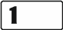 - partition 1;  - partition 2).
  - Select the arming mode (press one of the keys: - full arming; - day arming; - night arming). Backlight of the keys will start blinking, which indicates that the code must be entered.
  - Enter the code.
  - Press the key or press again the key corresponding to the selected arming mode.
When the quick arming is available, the steps 3 and 4 are skipped.

Quick arming
The installer may permit arming without entering the code.
- Indicate the partition(s) to be armed (press one of the keys: - partition 1; - partition 2;  or - both partitions).
- Select the arming mode (press one of the keys: - full arming; - day arming; - night arming).
You can switch the arming mode from the night mode to the full mode and from the day mode to the full mode without entering the code. Otherwise, you will have to enter the code – see “Arming the selected partition”.
The installer can configure the system so that the quick arming can be impossible, if there is a violated zone in the partition, or a trouble has occurred in the system.

Arming without delay
When arming the system using one of the above mentioned methods, press and hold down the arming mode selection key (, or ) for about 3 seconds. The system will become armed without delay, i.e. the delayed zones will act as instant ones (without any exit/entry delay time).

Denial of arming
The installer can configure the control panel so that initiating the arming procedure is impossible, if:
- in the partition to be armed, at least one zone that must not be violated during arming (the Priority option has been enabled for the zone by the installer) is violated,
- in the partition to be armed, at least one alarm zone is violated beyond the exit route,
- there is trouble in the system.

Failure of arming procedure
The installer can configure the alarm system in such a manner that it will not be armed, if at the moment of completing the exit delay countdown:
- there is a violated zone in partition which was not violated when the arming procedure was started,
- there is a trouble which did not exist when the arming procedure was started.

Disarming and alarm clearing
Disarming and alarm clearing are carried out in the same way, the procedures being interconnected. If the partition is armed and an alarm is triggered in it, then disarming will also mean alarm clearing.
In order to clear the alarm without disarming the partition, arm again the partition in the same mode (see: “Arming” p. 7).

Disarming and alarm clearing without partition selection
Enter the code and then press . Disarming / alarm clearing will take place in the partitions to which you have access.

Disarming and alarm clearing in selected partition
- Indicate partition which is to be disarmed and/or where alarm is to be cleared (press one of the keys: - partition 1; - partition 2).
- Press . Backlight of the keys will start blinking, which indicates that the code must be entered.
- Enter the code.
- Press or .

Viewing the zones which triggered alarm
Having cleared the alarm, you can check which zones triggered the alarm (this does not apply to the TMP zone of the control panel). The information will be available until viewing the zones or arming the system.
Enter the code, and then press in turn  . Information on the zones which triggered alarm is presented on the LEDs designated by numbers. The blinking LED means that the zone with number corresponding to that of the LED triggered alarm.

Quick inspection of partition status
If such an option is provided by the installer, pressing and holding down the key for about 3 seconds will display information on the partition state (whether it is armed and what type of arming mode is set). At the same time, the LED will come on. Information on the partition status is provided by means of LEDs 1-3 (partition 1 status) and LEDs 16-18 (partition 2 status):
- none of the LEDs is ON – partition is disarmed,
- LED 1 is ON – full armed mode in partition 1,
- LED 2 is ON – night armed mode in partition 1,
- LED 3 is ON – day armed mode in partition 1,
- LED 16 is ON – full armed mode in partition 2,
- LED 17 is ON – night armed mode in partition 2,
- LED 18 is ON – day armed mode in partition 2.
To terminate the function of partition state presentation, press . The keypad will quit the function automatically after 2 minutes.

Triggering the alarm from keypad
The installer can permit triggering alarms from the keypad. To trigger an alarm, do the following:
fire alarm – press for approx. 3 seconds,
medical (auxiliary) alarm – press for approx. 3 seconds,
panic alarm – press for approx. 3 seconds. The installer defines whether the loud panic alarm (setting off the loud alarm signal) or the silent panic alarm (without the loud signal) will be triggered.

Turning the CHIME on /off
The CHIME is five short sounds by means of which the keypad will inform you e.g. that a door / window is open, when the system is disarmed. The installer defines which zones of the alarm system can trigger the CHIME and whether it can be turned on/off by the users.
Press and hold down for about 3 seconds to turn on or off the CHIME signaling.

User menu
Enter the code and press to get access to the user menu. Which functions you can start depends on your rights, as well as status and configuration of the system.
In order to quit the function and/or user menu, press . The keypad will quit the menu automatically, if 2 minutes have elapsed since the last keypress.

Running the functions
The functions are numbered. To run a function, enter the digit or a sequence of digits, and then press . The sequences of keys which are to be pressed to run each function are presented in section “User functions list” (p. 12).
For example, to start the zone inhibiting function, enter the user menu and then press  .

“Step by step” programming method
In case of some functions (e.g. adding and editing users, configuring timers, etc.), the programming is effected by using the “step by step” method. After calling the function and selecting the item to be configured from the list, the first parameter available for programming will be displayed. After pressing , you will go on to programming another parameter (if you have entered some changes, they will be saved). After all parameters have been configured, you will either return to the selection list or exit the user menu, depending on the function. The and LEDs of the first and second partition show the number of programming step (see: table 1). Some programming steps may be sometimes not available.

Entering data
The changes entered will be saved after pressing the key. Use the key to quit the function without saving changes.

Entering digits
To enter digits, use the numeric keys. The digits are presented by means of LEDs (up to 6 digits). A single digit is presented on four LEDs – see Table 1. LEDs 1-4 present the first digit, LEDs 5-8 – the second, LEDs 9-12 – the third, LEDs 16-19 – the fourth, LEDs 20-23 – the fifth, and LEDs 24-27 – the sixth digit.

Entering hexadecimal characters
To enter digits, use the numeric keys, and to enter characters from A to F, use the and keys (keep pressing the key until the required character appears). The characters are presented by means of LEDs (up to 6 digits). A single character is presented on four LEDs – see Table 1. LEDs 1-4 present the first character, LEDs 5-8 – the second, LEDs 9-12 – the third, LEDs 16-19 – the fourth, LEDs 20-23 – the fifth, and LEDs 24-27 – the sixth character.

LED status | Digits and characters
 | 0 | 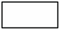 | – LED OFF
 | 1 |  | – LED ON
 | 2
 | 3
 | 4
 | 5
 | 6
 | 7
 | 8
 | 9
 | A
 | B
 | C
 | D
 | E
 | F
Table 1. The way of presenting digits and characters in binary format on LEDs.

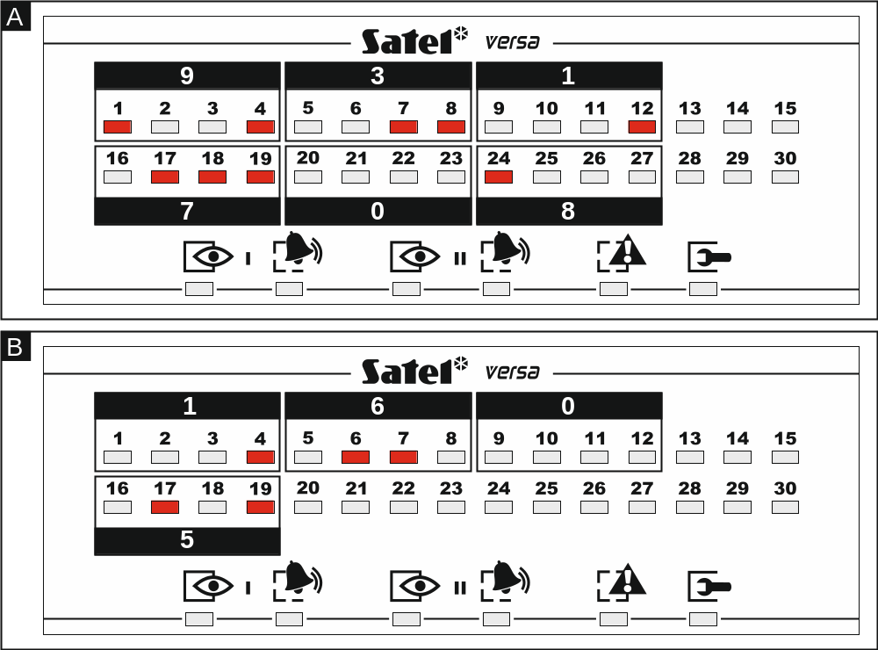
Fig. 2. Examples of presenting decimal values by means of LEDs. Example A: 931708. Example B: 1605.

User functions list
Shown in square brackets are key sequences that enable starting the given function. The functions that are only available after entering the service code have been specially highlighted (white text against black background). The access to other functions depends on the user rights. Highlighted with a frame are the functions which are available or change the operating mode, if the Grade 2 option has been enabled by the installer.

[1#] changing own code
[21#] adding new user
[22#] editing user
[23#] removing user
[3#] canceling telephone messaging
[41#] inhibiting zones
[42#] isolating zones
[61#] auto-arming deferment
[62#] programming the clock
[63#] programming the timers
[64#] programming telephone numbers to be notified
[65#] programming codes to acknowledge / clear messaging
[7#] checking troubles / checking partition, alarm, trouble status
[8#] controlling the outputs
[91#] starting zone test
[92#] starting output test
[93#] checking the level / quality of radio signal
[94#] starting manual test transmission
[99#] checking current supply voltage in modules
[90#] deactivating outputs / activating 21. Detectors resetting output
[00#] starting service mode
[01#] starting programming via telephone communicator
[03#] starting local programming
[04#] finishing local programming
[05#] defining service code access rules
[06#] defining service code access time
[07#] starting programming via Ethernet

Change own code
- Enter the user menu and press in turn .
- Enter the new code, and then press .

Users
There can be up to 30 users in the system. A person using the service code (installer / service technician), who is an additional user, has a special status, but his/her access can be limited (see: “Defining the service access rules” p. 28 and “Defining the service access time” p. 28).

Adding a user
- Enter the user menu and press in turn . Adding the user is effected by the “step by step” method, hence the programming step number is presented on the and LEDs of the first and second partitions (see: page 11, Table 1).
You can press to interrupt the procedure of adding a user. If the procedure is interrupted in step 5 or a next one (the code, user schedule and partitions have been already assigned to the user), the user will be added.
- Step 2. Entering new user code. The user number is indicated by the blinking LED designated by number. Enter the new user's code, and then press .
- Step 3. Selecting user schedule. Five installer defined schedules are available. The schedule determines the user's rights and the default operating mode of the remote control keyfobs assigned to the user (the keyfobs are added in subsequent steps). Press the key bearing the digit corresponding to the schedule which is to be assigned to the user. The LED corresponding to the selected schedule number will start blinking. Press to confirm your selection.

 | Schedule number
Right | 1 | 2 | 3 | 4 | 5
Arming | ✓ | ✓ | ✓ | ✓ | ✓
Disarming | ✓ | ✓ |  | ✓ | ✓
Alarm clearing | ✓ | ✓ |  | ✓ | ✓
Telephone messaging clearing | ✓ |  |  |  | ✓
Auto-arming defer | ✓ |  |  |  | ✓
Zone inhibition | ✓ |  |  |  | ✓
Zone isolation |  |  |  |  | ✓
Change access code | ✓ | ✓ |  |  | ✓
Users editing |  |  |  |  | ✓
Control | ✓ | ✓ |  |  | ✓
Programming |  |  |  |  | ✓
DOWNLOAD/SERWIS |  |  |  |  | ✓
Inspection | ✓ |  |  |  | ✓
Tests |  |  |  |  | ✓
DURESS |  |  |  | ✓
INT-VG access | ✓ |  |  |  | ✓
Table 2. Factory default settings of the user schedules. The installer can assign other rights to them.

Using the DURESS right code will trigger a silent alarm, which is not signaled in any way, but the alarm code will be sent to the monitoring station.
- Step 4. Selecting partitions accessible to the user. Press the key (partition 1), (partition 2) or (both partitions) to define the partitions to which the user is to have access. The LED with number corresponding to your choice will start blinking. Press to confirm your selection.
- Step 5. Adding 433 MHz keyfob. If the INT-RX-S, INT-RX or VERSA-MCU module is connected to the control panel, the user may be assigned a 433 MHz keyfob. Press in turn and (if a keyfob is to be assigned to the user) or only (if no keyfob is to be assigned to the user).
- Step 5a. Selecting 433 MHz keyfob addition method. Press (if the keyfob serial number is to be entered) or press in turn (if the serial number is to be read by the device which supports the keyfobs during transmission).
- Step 5b. Adding 433 MHz keyfob. Depending on the selected method:
  - enter the keyfob serial number and press ,
  - press twice any button on the keyfob.

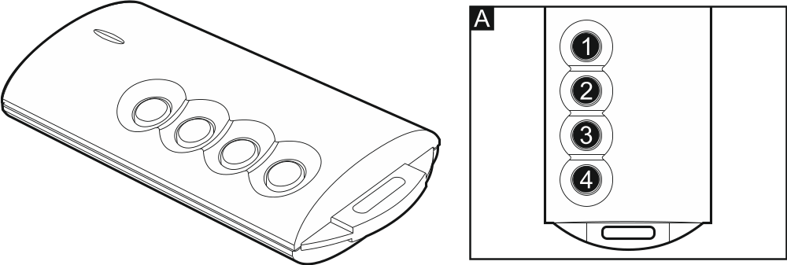
Fig. 3. T-4 keyfob [433 MHz keyfob]. A – numeration of keyfob buttons (button 5 – pressing buttons 1 and 2 simultaneously; button 6 – pressing buttons 1 and 3 simultaneously).

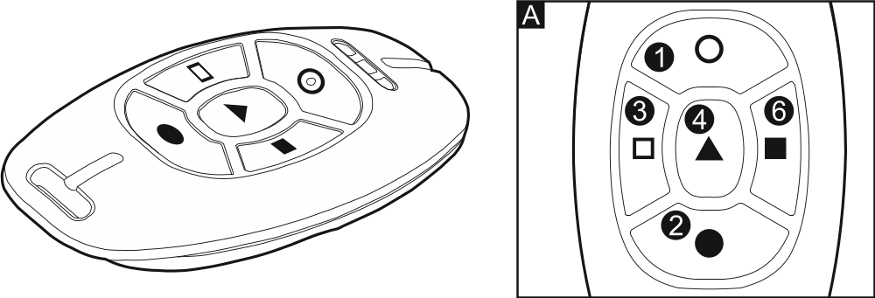
Fig. 4. MPT-300 keyfob [433 MHz keyfob] (black enclosure). A – numeration of keyfob buttons (button 5 – pressing buttons 1 and 2 simultaneously).

- Step 5c. Assigning function to 433 MHz keyfob button 1. Press to confirm the default function (defined by the installer in the user schedule) or enter the number of one of the following functions, and then press :
0. Not used
1. Zone 1 violation
2. Zone 2 violation
3. Zone 3 violation
4. Zone 4 violation
5. Zone 5 violation
6. Zone 6 violation
7. Zone 7 violation
8. Zone 8 violation
9. Zone 9 violation
10. Zone 10 violation
11. Zone 11 violation
12. Zone 12 violation
13. Zone 13 violation
14. Zone 14 violation
15. Zone 15 violation
16. Zone 16 violation
17. Zone 17 violation
18. Zone 18 violation
19. Zone 19 violation
20. Zone 20 violation
21. Zone 21 violation
22. Zone 22 violation
23. Zone 23 violation
24. Zone 24 violation
25. Zone 25 violation
26. Zone 26 violation
27. Zone 27 violation
28. Zone 28 violation
29. Zone 29 violation
30. Zone 30 violation
31. Arming partition 1 – full armed mode
32. Arming partition 1 – night armed mode
33. Arming partition 1 – day armed mode
34. Disarming / clearing alarm in partition 1
35. Arming partition 2 – full armed mode
36. Arming partition 2 – night armed mode
37. Arming partition 2 – day armed mode
38. Disarming / clearing alarm in partition 2
39. Arming partitions 1 and 2 – full armed mode
40. Arming partitions 1 and 2 – night armed mode
41. Arming partitions 1 and 2 – day armed mode
42. Disarming / clearing alarm in partitions 1 and 2
43. Loud panic alarm
44. Silent panic alarm
45. Fire alarm
46. Medical alarm

51. Output 1 activation
52. Output 2 activation
53. Output 3 activation
54. Output 4 activation
55. Output 5 activation
56. Output 6 activation
57. Output 7 activation
58. Output 8 activation
59. Output 9 activation
60. Output 10 activation
61. Output 11 activation
62. Output 12 activation

71. Output 1 deactivation
72. Output 2 deactivation
73. Output 3 deactivation
74. Output 4 deactivation
75. Output 5 deactivation
76. Output 6 deactivation
77. Output 7 deactivation
78. Output 8 deactivation
79. Output 9 deactivation
80. Output 10 deactivation
81. Output 11 deactivation
82. Output 12 deactivation

91. Output 1 switchover
92. Output 2 switchover
93. Output 3 switchover
94. Output 4 switchover
95. Output 5 switchover
96. Output 6 switchover
97. Output 7 switchover
98. Output 8 switchover
99. Output 9 switchover
100. Output 10 switchover
101. Output 11 switchover
102. Output 12 switchover
Contact the installer to obtain information on the zone types and output functions.
- Step 5d. Assigning function to 433 MHz keyfob button 2. Proceed in the same way as in Step 5c.
- Step 5e. Assigning function to 433 MHz keyfob button 3. Proceed in the same way as in Step 5c.
- Step 5f. Assigning function to 433 MHz keyfob button 4. Proceed in the same way as in Step 5c.
- Step 5g. Assigning function to 433 MHz keyfob button 5. Proceed in the same way as in Step 5c.
- Step 5h. Assigning function to 433 MHz keyfob button 6. Proceed in the same way as in Step 5c.
Pressing the key between Step 5a and Step 5h will cancel the keyfob adding, but will not terminate the user adding procedure.
- Step 6. Adding APT-100 keyfob. If the ABAX wireless system controller is connected to the control panel, the bidirectional APT-100 keyfob can be assigned to the user. Press in turn and (if a keyfob is to be assigned to the user) or only (if no keyfob is to be assigned to the user).
- Step 6a. Selecting APT-100 keyfob addition method. Press (if the keyfob serial number is to be entered) or press in turn (if the serial number is to be read by the ABAX wireless system controller during transmission).
- Step 6b. Adding APT-100 keyfob. Depending on the selected method:
  - enter the keyfob serial number and press ,
  - press twice any button on the keyfob

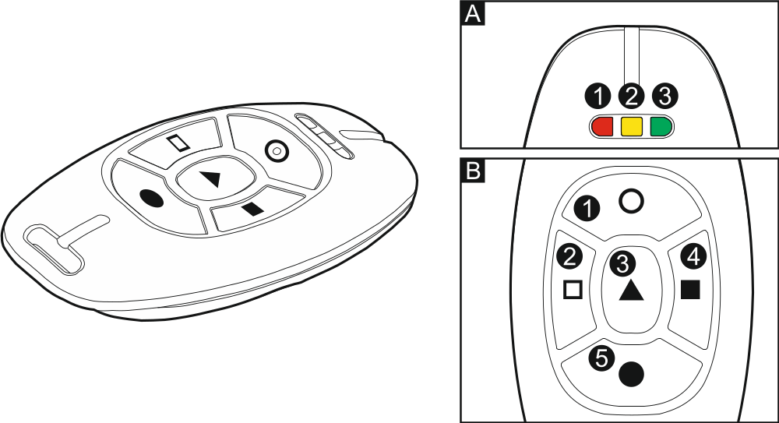
Fig. 5. APT-100 keyfob (gray enclosure). A – numeration of LEDs. B – numeration of keyfob buttons (button 6 – pressing buttons 1 and 5 simultaneously).

- Step 6c. Assigning function to APT-100 keyfob button 1. Proceed in the same way as in Step 5c.
- Step 6d. Assigning function to APT-100 keyfob button 2. Proceed in the same way as in Step 5c.
- Step 6e. Assigning function to APT-100 keyfob button 3. Proceed in the same way as in Step 5c.
- Step 6f. Assigning function to APT-100 keyfob button 4. Proceed in the same way as in Step 5c.
- Step 6g. Assigning function to APT-100 keyfob button 5. Proceed in the same way as in Step 5c.
- Step 6h. Assigning function to APT-100 keyfob button 6 (two buttons pressed simultaneously: 1 and 5). Proceed in the same way as in Step 5c.
- Step 6i. Selecting confirmation for LED 1 in APT-100 keyfob. Press to confirm the default method of confirmation (defined by the installer in the user schedule) or enter the number of one of the following functions and then press :
0. On LED is on, when the control panel has acknowledged receiving information on pressing a button
1. Output 1 state LED is on, when the selected output is active
2. Output 2 state
3. Output 3 state
4. Output 4 state
5. Output 5 state
6. Output 6 state
7. Output 7 state
8. Output 8 state
9. Output 9 state
10. Output 10 state
11. Output 11 state
12. Output 12 state
13. Arming: Partition 1 LED is ON when partition 1 is armed
14. Arming: Partition 2 LED is ON when partition 2 is armed
15. Arming: Partition 1 or 2 LED is ON when partition 1 or 2 is armed
16. Arming: Partition 1 and 2 LED is ON when partitions 1 and 2 are armed
17. Partition 1 – Full arm LED is lit when partition 1 is armed in full mode
18. Partition 1 – Night arm LED is lit when partition 1 is armed in night mode
19. Partition 1 – Day arm LED is lit when partition 1 is armed in day mode
20. Partition 2 – Full arm LED is lit when partition 2 is armed in full mode
21. Partition 2 – Night arm LED is lit when partition 2 is armed in night mode
22. Partition 2 – Day arm LED is lit when partition 2 is armed in day mode
23. Partition 1 – Alarm LED is ON when there is alarm in partition 1
24. Partition 2 – Alarm LED is ON when there is alarm in partition 2
25. Partition 1 or 2 – Alarm LED is ON when there is alarm in partition 1 or 2
26. Trouble LED is ON when there is trouble in the system

255. NOT PRESENT LED will not be used for confirmation
Contact the installer to obtain information on the zone types and output functions.
- Step 6j. Selecting confirmation for LED 2 in APT-100 keyfob. Proceed in the same way as in Step 6i.
- Step 6k. Selecting confirmation for LED 3 in APT-100 keyfob. Proceed in the same way as in Step 6i.
Pressing the key between Step 6a and 6k will cancel the keyfob adding, but will not terminate the user adding procedure.
- Step 7. Adding proximity card. If a device provided with proximity card reader is installed in the system, a proximity card can be assigned to the user. Press in turn and (if a proximity card is to be assigned to the user) or only (if no proximity card is to be assigned to the user).
- Step 7a. Selecting card addition method. Press (if the card code is to be entered) or select the device, by means of which the card code will be read. The LEDs corresponding to the addresses of devices are steady on, and the and keys allow you to select the device (the LED corresponding to the selected module will start blinking). Having selected the device, press .
- Step 7b. Adding proximity card. Depending on the selected method:
  - enter the card code (see: “Entering hexadecimal characters” p. 10) and press ,
  - bring the card twice close to the reader (displayed messages will prompt you what to do). Remember that the card number will only be sent by the proximity card arm/disarm device after the card is moved away from the reader.
Pressing the key in Step 7a or 7b will cancel the card adding.

User editing
- Enter the user menu and press in turn . User editing is effected by the “step by step” method, hence the programming step number is presented on the and LEDs of the first and second partitions (see: page 11, Table 1).
- Step 1. Selecting user whose data are to be edited. You can make your selection by using the and keys or by entering the user number (the LED designated by the number of selected user should start blinking). Having selected the user, press .
You can press to interrupt the procedure of editing a user. Any changes made in the steps ended by pressing the key will be saved.
- Step 2. Changing user code. Proceed in the same way as when adding a new user.
- Step 3. Selecting user schedule. Proceed in the same way as when adding a new user.
- Step 4. Selecting partitions accessible to the user. Proceed in the same way as when adding a new user.
- Step 5. Editing 433 MHz keyfob. Press:
  - , if you want to move on to the next step,
  - and in turn, if you want to add a keyfob (the procedure is similar to that for adding a 433 MHz keyfob to a new user, however, if the user had a keyfob before, the control panel, during assignment of functions to the buttons, will suggest the same functions as were assigned to the removed keyfob),
  - and in turn, if the user has a keyfob and you want to edit functions assigned to the keyfob buttons (the procedure is similar to that for assigning functions after a 433 MHz keyfob has been added to a new user),
  - and in turn, if you want to remove a keyfob.
Removal of the keyfob does not erase its settings (functions assigned to the keyfob).
The installer can remove all the 433 MHz keyfobs and their settings by using the Rem.RX k-fobs function (Service mode 2. Hardware 1. Kpds. & exps. 9. Rem.RX k-fobs).
- Step 6. Editing APT-100 keyfob. Press:
  - , if you want to move on to the next step,
  - and in turn, if you want to add a keyfob (the procedure is similar to that for adding the APT-100 keyfob to a new user, however, if the user had a keyfob before, the control panel, when assigning functions to the buttons and defining the rules of confirmation, will suggest the same settings as for the removed keyfob),
  - and in turn, if the user has a keyfob and you want to edit functions assigned to the keyfob buttons (the procedure is similar to that for assigning functions after an APT-100 keyfob has been added to a new user),
  - and in turn, if you want to remove a keyfob.
Removal of the keyfob does not erase its settings (functions assigned to the keyfob and rules of confirmation).
The installer can remove all the APT-100 keyfobs and their settings by using the Rem.ABAX kfbs function (Service mode 2. Hardware 1. Kpds. & exps. 8. Rem.ABAX kfbs).
  - and in turn, if the user has a keyfob and you want to edit the rules of confirmation (the procedure is similar as for defining the rules of confirmation after an APT-100 keyfob has been added to a new user).
- Step 7. Editing proximity card. Press:
  - , if you want to move on to the next step,
  - and in turn, if you want to add a card (the procedure is much similar to that for adding a card to a new user),
  - and , if you want to remove a card.

Removing a user
- Enter the user menu and press in turn .
- Select the user who is to be removed. You can make your selection by scrolling through the list of users by means of the and keys or entering the user number. Having selected the user, press .

Canceling the telephone messaging
The telephone messaging can be cancelled together with alarm clearing, if such an option is provided by the installer.
The telephone messaging is cancelled after acknowledgement of the voice messaging (see: User manual).
Enter the user menu and press in turn .

Zone bypassing
If a zone is not to trigger alarm, you can bypass it, when the partition to which the zone belongs is disarmed. Zone bypassing is useful, for example, when you want to leave a window open when the system is armed or when a detector connected to the zone is out of order and sets off false alarms.
Zone bypassing reduces the level of protection. When bypassed, the zone may enable the intruder to get inside the protected area despite the system being armed.
If a zone is bypassed because of its malfunctioning, call in the service technician immediately to repair the defect.
For security considerations, the installer may reduce the number of zones that the user will be allowed to bypass.
The zone bypassing functions can also be used to unbypass the zones (the zone inhibiting function makes it also possible to unbypass an isolated zone, while the zone isolating function makes it also possible to unbypass an inhibited zone).

Zone inhibiting
The inhibited zone will remain bypassed until disarming the partition it belongs to, or until unbypassing the zone by the user.
If the zone belongs to two partitions and is only armed when both partitions are armed, it will be unbypassed after disarming one of the partitions.
Enter the user menu and press in turn . The state of zones is illustrated by LEDs designated by numbers. The steady-on LEDs indicate which zones are inhibited or isolated. The blinking (flashing) LED means that the cursor is situated there. Use the and keys to move the cursor. The cursor may only be moved over the LEDs corresponding to the zones which can be bypassed or unbypassed. Press any digit-bearing key to change the LED status:
LED ON – the zone is to be inhibited,
LED OFF – the zone is to be unbypassed.
Press to quit the function. The zones will be inhibited/unbypassed.

Zone isolating
The isolated zone will remain bypassed until it is unbypassed by the user.
Enter the user menu and press in turn . The way of indicating the zone status and the procedure are identical to those used for zone inhibiting.

Auto-arming deferment
Partition can be armed automatically by the timer on specific days at specific time. If the installer defines the time by which the auto-arming is to be deferred, you can defer the arming.
Enter the user menu and press in turn  .

Setting the system time and date
Enter the user menu and press in turn . The currently programmed time will be presented on LEDs (see page 11 Table 1):
hour – first digit on LEDs 1-4, second – on LEDs 5-8,
minutes – first digit on LEDs 9-12, second – on LEDs 16-19,
seconds – first digit on LEDs 20-23, second – on LEDs 24-27.
Enter successively the hour, minutes and seconds, and then press . The date will be presented on LEDs:
year – only two last digits: first on LEDs 1-4, second – on LEDs 5-8,
month – first digit on LEDs 9-12, second – on LEDs 16-19,
day – first digit on LEDs 20-23, second – on LEDs 24-27.
Enter successively the year, month and day, and then press .

Programming the timers
You can program 4 timers. The timers can control partition arming mode and outputs. The timer compares the time with the control panel clock and executes the selected function at the preset time.
The installer defines which outputs will be controlled by the timers.
- Enter the user menu and press in turn . The programming is effected by using the “step by step” method, hence the programming step number will be presented on the and LEDs of the first and second partitions (see: page 11, Table 1).
- Step 1. Selecting timer to be programmed. Press in turn the suitable keys to select a timer:
- timer 1,
- timer 2,
- timer 3,
- timer 4.
- Step 2. Selecting parameters to be programmed. Press in turn the suitable keys to select a parameter:
- weekly schedule,
- exception 1,
- exception 2,
- exception 3,
- exception 4,
- partition 1 arming mode,
 - partition 2 arming mode.
Irrespective of the selected parameter, pressing the key in a subsequent step will take you back to Step 2.

Programming the weekly schedule
- Step 3. Programming timer activation/deactivation time on Monday. The parameters will be presented on LEDs (see page 11 Table 1), but only 6 out of 8 digits that can be entered. Enter the time of timer activation (hour:minutes) and/or deactivation (hour:minutes). If you want, you can only program the activation or deactivation time. Instead of the other parameter, enter the sequence 9999 then. Press to go on to the next step.
- Step 4. Programming timer activation/deactivation time on Tuesday. Proceed in the same way as in Step 3.
- Step 5. Programming timer activation/deactivation time on Wednesday. Proceed in the same way as in Step 3.
- Step 6. Programming timer activation/deactivation time on Thursday. Proceed in the same way as in Step 3.
- Step 7. Programming timer activation/deactivation time on Friday. Proceed in the same way as in Step 3.
- Step 8. Programming timer activation/deactivation time on Saturday. Proceed in the same way as in Step 3.
- Step 9. Programming timer activation/deactivation time on Sunday. Proceed in the same way as in Step 3.
- Step 10. Programming timer activation/deactivation time on every day of the week. Proceed in the same way as in Step 3. After pressing , you will be taken back to Step 2.

Programming an exception
The exception is a period when the timer will be activated/deactivated at a different time than provided for by the weekly schedule. The programming is carried out in the same way for each of the four exceptions.
- Step 3. Programming the date from which the exception will be valid. Enter the year (only the two last digits), month and day. The date is presented on LEDs (see page 11 Table 1). Press to confirm the data and go on to the next step.
- Step 4. Programming the date to which the exception will be valid. Proceed in the same way as in Step 3.
- Step 5. Programming the timer activation/deactivation time when the exception is valid. Enter the data in the same way as for programming the timer activation/deactivation in the weekly schedule. After pressing , you will be taken back to Step 2.

Selecting the arming mode
- Define whether and what arming mode is to be activated by the timer (press one of the keys: - full arming; - night arming; - day arming; - timer does not arm the partition). The LEDs indicate what selection you have made (LED 1 blinking – full arming; LED 2 blinking – night arming; LED 3 blinking – day arming; neither LED is blinking – timer does not arm the partition).
- Press . You will be taken back to Step 2.

Programming the telephone numbers to be notified
Programming the phone numbers from LED keypad is not recommended (only up to 6 characters are presented by means of LEDs; some characters are not presented at all – Table 1, page 11, contains the characters that are presented).
- Enter the user menu and press in turn .
- Press in turn the suitable keys to select the telephone number to be edited (the phone numbers to which voice messaging is not enabled are only available to the installer):
- telephone 1,
- telephone 2,
- telephone 3,
- telephone 4,
- telephone 5,
- telephone 6,
- telephone 7,
- telephone 8.
- Enter the telephone number (the available characters are presented in Table 3). You can enter up to 16 characters. Some of the characters occupy two positions (a, b, c, d, # and ). If they are used, you can enter less characters than 16.

Characters available after next keystroke
key | mode [ABC] |  |  |  |  | key | mode [abc]
 | 1 | # |  |  |  |  | 1 | #
 | 2 | B | C |  |  |  | 2 | a | b | c
 | 3 | D | E | F |  |  | 3 | d
 | 4 |  |  |  |  |  | 4
 | 5 |  |  |  |  |  | 5
 | 6 |  |  |  |  |  | 6
 | 7 |  |  |  |  |  | 7
 | 8 |  |  |  |  |  | 8
 | 9 |  |  |  |  |  | 9
 | 0 |  |  |  |  |  | 0
Table 3. Characters available in the keypad when entering telephone numbers (to change the letter case, press key).

Special character | Function description
B | switch-over to pulse dialing
C | switch-over to tone dialing (DTMF)
D | waiting for additional signal
E | 3 second pause
F | 10 second pause
 | signal  in DTMF mode
# | signal # in DTMF mode
a  b  c  d | other signals generated in DTMF mode
Table 4. Special character functions.

- Press to confirm the entered number.

Programming codes to acknowledge / clear messaging
- Enter the user menu and press in turn .
- Press in turn the suitable keys to select the telephone number for which the code to acknowledge / clear voice messaging is to be defined (the phone numbers to which voice messaging is not enabled are only available to the installer):
- telephone 1,
- telephone 2,
- telephone 3,
- telephone 4,
- telephone 5,
- telephone 6,
- telephone 7,
- telephone 8.
- Enter a 4-digit code, and then press .

Checking the troubles
When the LED is blinking, you can check what caused this signaling. Enter the user menu and press in turn .

Trouble list
Information on troubles presented on LEDs designated by numbers:
LED 1 - loss of 230 V AC power,
LED 2 - no battery / low battery,
LED 3 - no voltage on telephone line,
LED 4 - no signal / intermittent signal on telephone line,
LED 5 - OUT1 output overloaded,
LED 6 - OUT2 output overloaded,
LED 7 - KPD supply output overloaded,
LED 8 - AUX or +VR supply output overloaded,
LED 9 - problem with telephone or Ethernet reporting to Station 1,
LED 10 - problem with telephone or Ethernet reporting to Station 2,
LED 11 - jamming ABAX system wireless devices / built-in Ethernet module initialization error / Ethernet network not available / no communication with device selected for communication test (PING) / no connection to SATEL server / MAC/ID error,
LED 12 - short-circuit in communication bus,
LED 13 - control panel clock trouble,
LED 14 - control panel settings trouble,
LED 15 - violation of tamper zone (TMP zone on control panel main board or 6. 24h tamper type zone),
LED 16 - zone tamper,
LED 17 - too long zone violation,
LED 18 - no zone violation,
LED 19 - violation of 11. Detector mask or 19. Trouble type zones,
LED 20 - low battery in wireless device,
LED 21 - no communication with wireless device,
LED 22 - expander tamper,
LED 23 - no presence of expander,
LED 24 - loss of 230 V AC power in expander,
LED 25 - no battery / low battery in expander,
LED 26 - expander supply output overloaded,
LED 27 - low battery in user keyfob,
LED 28 - expander restart,
LED 29 - control panel restart,
LED 30 - trouble in control panel processor system (HSE).

Trouble handling procedure
Each trouble poses a danger to proper functioning of the alarm system and should be repaired as soon as possible. If necessary, consult the installer.
In the event of failure of the control panel processor system (HSE), when you have exited the 7. System state function by using the key, the “Make VERSA panel restart? 1=Yes” message will be displayed. Pressing the key will restart the control panel and repair the trouble.

Trouble memory and clearing the trouble memory
The installer defines whether only the current troubles are to be presented, or also those which have already ended. The keypad indicates the current troubles by steady-on LEDs, and the troubles that have ended – by blinking LEDs.
You can clear the trouble memory after quitting the function:
- Press to quit the function. The LED will start blinking rapidly.
- Press to clear the trouble memory (pressing another key will cancel clearing the trouble memory).
If the Service message after tamper alarm option is enabled in the control panel, only the installer can clear the tamper alarm memory.

Output control
Using the keypad, you can control the operation of devices connected to the outputs (e.g. to raise/lower roller blinds/shutters, turn on/off lighting or heating, etc.). The installer defines how the outputs should work (whether the output will be activated for a defined time, or it will remain active until deactivated by the user, timer, etc.).

Quick control of outputs
The installer can assign outputs to the numeric keys and allow them to be quickly controlled (without entering the code).

Quick activation of output
Press the key to which the controllable output is assigned, and then .

Quick deactivation of output
Press the key to which the controllable output is assigned, and then .

Controlling the outputs by means of function
Enter the user menu and press in turn . The status of outputs is illustrated by LEDs designated by numbers. The steady-on LEDs indicate which outputs are activated. The blinking LED indicates that that the cursor is there. Use the and key to move the cursor. The cursor can only be moved over the LEDs presenting the status of outputs that can be controlled. Press to activate the output with the number corresponding to that of the LED, or press to deactivate the output.

Tests

Zone test
The function enables checking the system zones and detectors connected to them for proper functioning.
You can test the zones for which the installer has programmed other wiring type than Not used.
Zone violation during the test will not trigger the control panel reaction, as preprogrammed for the zone.
When testing the zones, the keypad does not present the current zone state, but only indicates whether or not the zone was violated during the test.
- Enter the user menu and press in turn .
- Enter two digits to define the test duration (e.g. if the time is to be 5 minutes, press in turn and – the test may last from 1 to 15 minutes), and then press . The LEDs designated by the numbers of zones you can test will start blinking.
- Violate the selected zones (e.g. walking through the area supervised by the motion detector or opening the window supervised by the magnetic contact). The keypad should inform you that the zone has been violated (the LED designated by the zone number will go on steady). Information on the violation will be presented until the zone test is terminated.
- The test will be terminated automatically after the defined time has elapsed. You can terminate it earlier by pressing .

Output test
The function makes it possible to check proper functioning of the system outputs as well as devices connected to them.
You can always test 12 outputs.
- Enter the user menu and press in turn . The keypad indicates the output status by means of LEDs numbered from 1 to 12 (LED OFF – the output is deactivated; LED ON – the output is activated). The blinking LED means that the cursor is there. The and keys allow you to move the cursor.
- Press to activate the output, or press to deactivate the output.
- Press to terminate the function.

Checking the level / quality of radio signal
The function allows you to check:
- the quality of radio signal received by the controller from 433 MHz wireless detectors (if the VERSA-MCU controller is connected to the control panel),
- the level of radio signal received by the controller from ABAX wireless devices (if the ABAX system controller is connected to the control panel).
Enter the user menu and press in turn . The signal level / quality is illustrated by LEDs designated by numbers:
- 1-15 – wireless devices assigned to zones from 16 to 30,
- 16-30 – wireless devices assigned to zones from 1 to 15.
The more LEDs are ON, the better is the signal level / quality. When all LEDs are ON, the signal level / quality is 100%.
The device can be identified by blinking of the LED designated by the number of zone to which the device is assigned.
You can scroll through the list by using the arrow keys.

Starting the manual test transmission
Enter the user menu and press in turn . A “Manual reporting test” event will be saved to the control panel memory. The event code will be sent to the monitoring station.

Checking the current supply voltage in modules
Not all modules provide information on the current voltage.
Enter the user menu and press in turn . Information on the supply voltage of the lowest address module will be displayed. Blinking of the LED designated by the number corresponding to the module address number (for address 0, LED 30 is blinking) enables identification of the module. Depending on the module address, the supply voltage is illustrated by the LEDs numbered 1-15 (address 0 and addresses from 16 to 21) or 16-30 (addresses from 1 to 15). To determine the voltage, sum up the number of LEDs which are lit (a single LED corresponds to the voltage of 1 V). You can scroll through the list by using the arrow keys.

Outputs reset
Use the function to:
- deactivate 5. “DURESS” alarm, 14. Chime or 15. Controlled function outputs (if the cut-off time equal to 0 is programmed by the installer for such an output, the output can only be deactivated in this manner),
- deactivate for 16 seconds the 11. Fire detectors power supply function output (to clear the alarm memory of fire detectors),
- activate the 21. Detectors resetting function output.
Enter the user menu and press in turn .

Service
The functions related to control panel programming (starting local or remote programming) are described in the Programming manual.

Defining the service access rules
Enter the user menu and press in turn . The status of options related to the access to the alarm system by the person using the service code is illustrated by the LEDs designated by numbers. The LEDs lit solid indicate which options are enabled. Blinking of the LED means that the cursor is positioned there. The and keys allow you to move the cursor. You can only move the cursor onto the LEDs illustrating the available options. Press any numeric key to change the LED status (turn ON/OFF). Press to confirm the changes made and quit the function.

Description of the options
In the square brackets, the description of options presented on the LCD keypad is shown.
1 [Permanent access] – if the option is enabled, the service code can be used to get access to the alarm system at all times.
If the alarm system is to meet requirements of the EN 50131 standard for Grade 2, the service code access should be time limited.
2 [Edit users] – when the option is enabled, the person using the service code can add, edit and remove users.
3 [Arm/Dis/Clr/Bps] – when the option is enabled, the person using the service code can arm and disarm the system, clear alarms, and bypass zones (inhibit or isolate).

Defining the service access time
The function is available when the Permanent access option is disabled (see: “Defining the service access rules”).
Enter the user menu and press in turn . LEDs 1-12 will present the number of remaining hours during which you can get access to the alarm system by using the service code (see page 11 Table 1). Enter a new value from the range of 0 to 255 hours and press .


Alarm Control Panel
VERSA IP Firmware Version 1.06



INSTRUCTIONS
FOR OPERATING
CONTROL PANEL
FROM LED KEYPAD

SATEL sp. z o.o.
ul. Budowlanych 66
80-298 Gdańsk
POLAND
tel. 58 320 94 00
www.satel.eu
versa_ip_led_en 09/15
druk:
30,31,0,29,28,1,2,27,26,3,4,25,24,5,6,23,22,7,8,21,20,9,10,19,18,11,12,17,16,13,14,15



