WARNINGS
The security alarm system should be installed by qualified personnel.

Prior to installation, please read carefully this manual in order to avoid mistakes that can lead to malfunction or even damage to the equipment.

Disconnect power before making any electrical connections.

Changes, modifications or repairs not authorized by the manufacturer shall void your rights under the warranty.

The SATEL's goal is to continually upgrade the quality of its products, which may result in alterations of their technical specifications and firmware. The current information on the introduced modifications is available on our website.
Please visit us:
http://www.satel.eu

Hereby, SATEL sp. z o.o., declares that this control panel is in compliance with the essential requirements and other relevant provisions of Directive 1999/5/EC. The declaration of conformity may be consulted at www.satel.eu/ce

The following symbols may be used in this manual:
 - note;
 - caution.

Changes made to the firmware version 1.12
Keypads | Support for new keypad: INT-TSG (touchscreen keypad).
Expansion modules | Support for new module: INT-AV (audio alarm verification module).
Reporting | Capability to send events to the monitoring station over Ethernet using the UDP protocol.

CONTENTS
1. General 3
2. Features 3
3. Keypads 5
3.1 Features of keypads with mechanical keys 6
4. Expansion modules 6
4.1 Modules to be connected to the keypad bus 6
4.2 Modules to be connected to the expander bus 6
4.3 Wireless devices supported by the controller 10
5. System installation 10
5.1 Installation plan 10
5.2 Estimation of the system current consumption 11
5.3 Cabling 11
5.4 Installation of control panel mainboard 11
5.4.1 Description of the mainboard 13
5.5 Connecting devices to the keypad bus 14
5.5.1 Addressing devices connected to the keypad bus 15
5.5.2 Numeration of keypad zones 16
5.5.3 Connecting computer to the keypad RS-232 port 16
5.6 Connecting devices to the expander bus 17
5.6.1 Connecting the INT-VG or INT-AV module or CA-64 SM expander 18
5.6.2 Addressing devices connected to the expander bus 18
5.7 Connecting the detectors 18
5.7.1 End-of-line resistors 19
5.8 Connecting the sirens 19
5.9 Connecting power supply 20
5.9.1 Main power supply 20
5.9.2 Backup power supply 20
5.9.3 Control panel power-up / start-up procedure 21
5.10 First start-up of the control panel 21
5.11 Emergency procedure of the control panel start-up 22
5.12 GSM telephone start-up 23
5.13 Installation of wireless devices 24
5.13.1 Adding new wireless devices 25
5.13.2 Removing wireless devices 27
5.14 Connecting computer to the control panel 27
5.15 Connecting the external modem 28
5.15.1 Configuring settings of the modem to be connected to control panel 29
5.16 Connecting the printer 30
6. Numeration of zones and outputs in the system 31
7. Specifications 32
7.1 Control panel 32
7.2 INT-KLCD keypad 33
7.3 INT-KLCDR keypad 33
7.4 INT-KLCDL keypad 33
7.5 INT-KLCDS keypad 33
7.6 INT-KLCDK keypad 34
8. Manual update history 34

General
This manual applies to the INTEGRA 128-WRL control panel. The manual also describes keypads compatible with the control panel and other devices that may be included in the security alarm system.
The INTEGRA 128-WRL control panels meet the requirements of the following standards:
- EN 50131-1 Grade 2;
- EN 50131-3 Grade 2;
- EN 50131-6 Grade 2;
- EN 50130-4;
- EN 50130-5 Class II.

Features

System structure
- 32 partitions.
- 8 objects (subsystems).

Zones
- 8 programmable hardwired zones on the control panel mainboard:
- support for NO and NC type detectors, as well as roller shutter and vibration detectors;
- support for Single EOL and Double EOL configuration;
- programmable value of end-of-line resistors;
- several dozen zone types.
- Maximum number of programmable zones: 128.

Outputs
- 8 programmable hardwired outputs on the control panel mainboard:
- 2 high-current outputs;
- 6 low-current outputs, OC type;
- over 100 functions;
- execution of custom control functions due to the possibility of programming complex logic operations on the outputs.
- Maximum number of programmable outputs: 128.
- 3 high-current outputs on the control panel mainboard with power supply output functionality.

Communication buses
- Keypad bus for connecting up to 8 devices.
- Expander bus for connecting up to 32 devices.

Wireless devices
- Integrated wireless interface of the ABAX system to allow operation of:
- up to 48 wireless devices;
- up to 248 APT-100 keyfobs.
- Two-way encrypted radio communication in the 868 MHz frequency band

Communication
- Telephone dialer (communicator) GSM/GPRS to allow:
- events reporting;
- event messaging;
- checking the alarm system status by telephone (DTMF or SMS);
- remote control of the alarm system outputs by telephone (DTMF);
- remote control of the alarm system using SMS messages.
- Built-in GSM modem to allow remote operation and programming of the alarm system (300 bps or CSD transmission).
- Reporting events to two monitoring stations:
- several communication formats (including Contact ID and SIA);
- 4 telephone numbers (2 main + 2 backup ones);
- 9 identifiers.
- Several ways to send event codes to the monitoring station:
- GPRS transmissions (encrypted),
- SMS messages,
- GSM voice link.
- Capability of reporting events via the Ethernet (TCP or UDP), when the ETHM-1 module is connected.
- Event messaging to 16 phone numbers in the form of:
- 16 voice messages played back by an additional module (INT-VG, CA-64 SM or SM-2);
- 64 text messages defined by the installer (PAGER or SMS).

Event log
- 21503 events.
- A separate memory space to store events required by the EN 50131 standard for Grade 2.
- Saving the content of received SMS messages to the event log.
- Event log printing capability.

Users
- 8 master users (administrators).
- 240 users.
- Capability to assign to the user:
- a code,
- a proximity card (125 kHz passive transponder, which may be in the form of a card, tag, etc.),
- DALLAS iButton (chip)
- keyfob.
- Several user types.
- Authority level determining the scope of access to the system.

Additional features
- Access control functions realized by means of additional modules.
- 64 system timers to automatically:
- arm/disarm the partitions;
- control the outputs (switching the lights on/off, watering the garden, etc.).
- Partition timers (1 for each partition), to allow automatic arming/disarming.

Programming
- Local programming:
- keypad;
- computer with the DloadX program installed, connected to the control panel RS-232 port.
- Remote programming:
- computer with the DloadX program installed, communicating via modem, by means of GPRS or via the Ethernet network (optionally, if the ETHM-1 module is connected to the control panel);
- internet browser (optionally, if the ETHM-1 module is connected);
- mobile phone with suitable application installed (optionally, if the ETHM-1 module is connected ).

Mainboard
- RS-232 port (RJ type socket) to allow:
- local programming by means of a computer with the DloadX program installed;
- local system administration by means of a computer with the GuardX program installed;
- remote programming using the DloadX program via Ethernet (TCP/IP), if the ETHM-1 module is connected;
- support for external analog, GSM or ISDN modem;
- serial printer connection (for printing current events).
- Capability of the firmware updating without the need for disassembly of the control panel.
- Socket for connecting the INT-VG voice module, CA-64 SM voice synthesizers expander or SM-2 synthesizer.
- Real time clock with calendar and battery backup.
- LEDs indicating the status of outputs, battery charging system and telephone dialer.
- Electrical protection of all hardwired zones and outputs, and communication buses.
- Switching power supply with short-circuit protection, provided with a battery status supervision and low battery disconnect system.

Keypads
The INTEGRA 128-WRL control panel supports the following keypads:
INT-TSG – touchscreen keypad;
INT-KSG – LCD keypad with touch keys;
INT-KLCD – LCD keypad with mechanical keys;
INT-KLCDR – LCD keypad with mechanical keys and built-in proximity card reader;
INT-KLCDK – LCD keypad with mechanical keys;
INT-KLCDL – LCD keypad with mechanical keys;
INT-KLCDS – LCD keypad with mechanical keys.
The recommended version of the keypad firmware (provides functionality consistent with the requirements of EN 50131 for Grade 2):
  - INT-KLCD / INT-KLCDR – 1.08 (or later);
  - INT-KLCDK / INT-KLCDL / INT-KLCDS – 6.08 (or later);
  - INT-KSG – 1.02 (or later).
The keypads are available in a variety of color options for the enclosure, display and key backlight. The color variant is indicated by the additional designation in the keypad name (e.g. INT-KLCD-GR – green display and key backlight; INT-KLCD-BL – blue display and key backlight).
Features of the INT-TSG and INT-KSG keypads are described in separate manuals, delivered with these keypads.

Features of keypads with mechanical keys
- Display 2 x 16 characters with backlight.
- LEDs indicating the status of the partitions and the system.
- Backlit keys.
- Built-in sounder.
- 2 programmable hardwired zones:
- support for NO and NC detectors;
- support for Single EOL and Double EOL configuration.
- Tamper protection in 2 ways – cover removal and tearing enclosure from the wall.
- RS-232 port (PIN-5 socket) for administration of the security alarm system by means of a computer with the GuardX program installed.

Expansion modules
The expansion modules allow you to not only increase the number of available zones and outputs (wired and wireless), but also enhance the system with additional functionality.
Not all of the following modules meet the requirements of EN 50131 for Grade 2.

Modules to be connected to the keypad bus
CA-64 PTSA. Mimic board. Enables visualization of the status of the alarm system partitions and zones. The control panels support the mimic boards with electronics version 1.4 (or later) and firmware version 4.0 (or later).
ETHM-1. TCP/IP Communication Module. Enables reporting events as well as operating and programming the control panel via the Ethernet network. The recommended module version: 1.06 (or later).
INT-RS. Data converter. Makes it possible to connect the computer with the GuardX program installed in the same way as to the LCD keypad, report events through a special external device, or operate the control panel using software other than that offered by SATEL.

Modules to be connected to the expander bus
INT-RX / INT-RX-S. 433 MHz keyfobs receiver expansion module. Enables operation of the alarm system using the 433 MHz keyfobs.
INT-CR. Proximity card arm/disarm device. Enables arming / disarming and alarm clearing in many partitions by means of proximity cards, proximity tags and other passive transponders.
INT-S / INT-SK. Partition keypad. Enables arming / disarming and alarm clearing in one partition. Can perform access control functions.
INT-SCR. Multifunctional keypad. It can work as:
INT-S. Partition keypad.
INT-SCR. Partition keypad with reader. Functionality similar to that of the partition keypad.
INT-ENT. Entry keypad. The main task of the entry keypad is activation the delay for 3 Interior delayed type zones. After expiry of the time period preset on the keypad, unless the system is disarmed, the interior delayed zones will again act as instant ones.
INT-SZ / INT-SZK. Code lock. Enables performance of the access control functions.
INT-R. Universal expander for card / chip readers. Supports the proximity card readers manufactured by SATEL, readers with WIEGAND 26 interface or DALLAS chip readers. Enables performance of the access control functions.
CA-64 E Zone expander. Adds 8 programmable hardwired zones to the security system.
CA-64 EPS. Zone expander with power supply. Adds 8 programmable hardwired zones to the security system. Equipped with a built-in switching power supply.
CA-64 ADR. Addressable zone expander. Adds 48 addressable zones to the security system. Equipped with a built-in switching power supply. Control panels support the addressable zone expanders with firmware version 1.5 (or later).
CA-64 O. Output expander. Adds 8 programmable outputs to the security system. Made in three versions:
CA-64 O-OC – 8 OC type outputs;
CA-64 O-R – 8 relay outputs;
CA-64 O-ROC – 4 relay outputs / 4 OC type outputs.
INT-ORS. DIN-rail output expander. Adds 8 programmable relay outputs to the security system. The relays can control electrical devices supplied with 230 V voltage.
CA-64 OPS. Output expander with power supply. Adds 8 programmable outputs to the security system. Equipped with a built-in switching power supply. Made in three versions:
CA-64 OPS-OC – 8 OC type outputs;
CA-64 OPS-R – 8 relay outputs;
CA-64 OPS-ROC – 4 relay outputs / 4 OC type outputs.
INT-IORS. DIN-rail zone/output expander. Adds 8 programmable hardwired zones and 8 programmable relay outputs to the security system. The relays can control electrical devices supplied with 230 V voltage.
CA-64 PP. Zone/output expander with power supply. Adds 8 programmable hardwired zones and 8 programmable outputs (4 relay and 4 OC type) to the security system. Equipped with a built-in switching power supply.
ACU-100 / ACU-250. ABAX wireless system controller. Enables the alarm system to be operated using the ABAX keyfobs and the ABAX bidirectional wireless devices to be used in the alarm system.
INT-VG. Voice module. Allows remote operation of the control panel from the telephone keypad (interactive voice menu). It can store 16 voice messages for telephone messaging.
INT-VMG. Voice message generator. Plays back prerecorded messages when specified events occur in the system.
INT-AV. Audio alarm verification module. Enables remote audio alarm verification to eliminate false alarms.
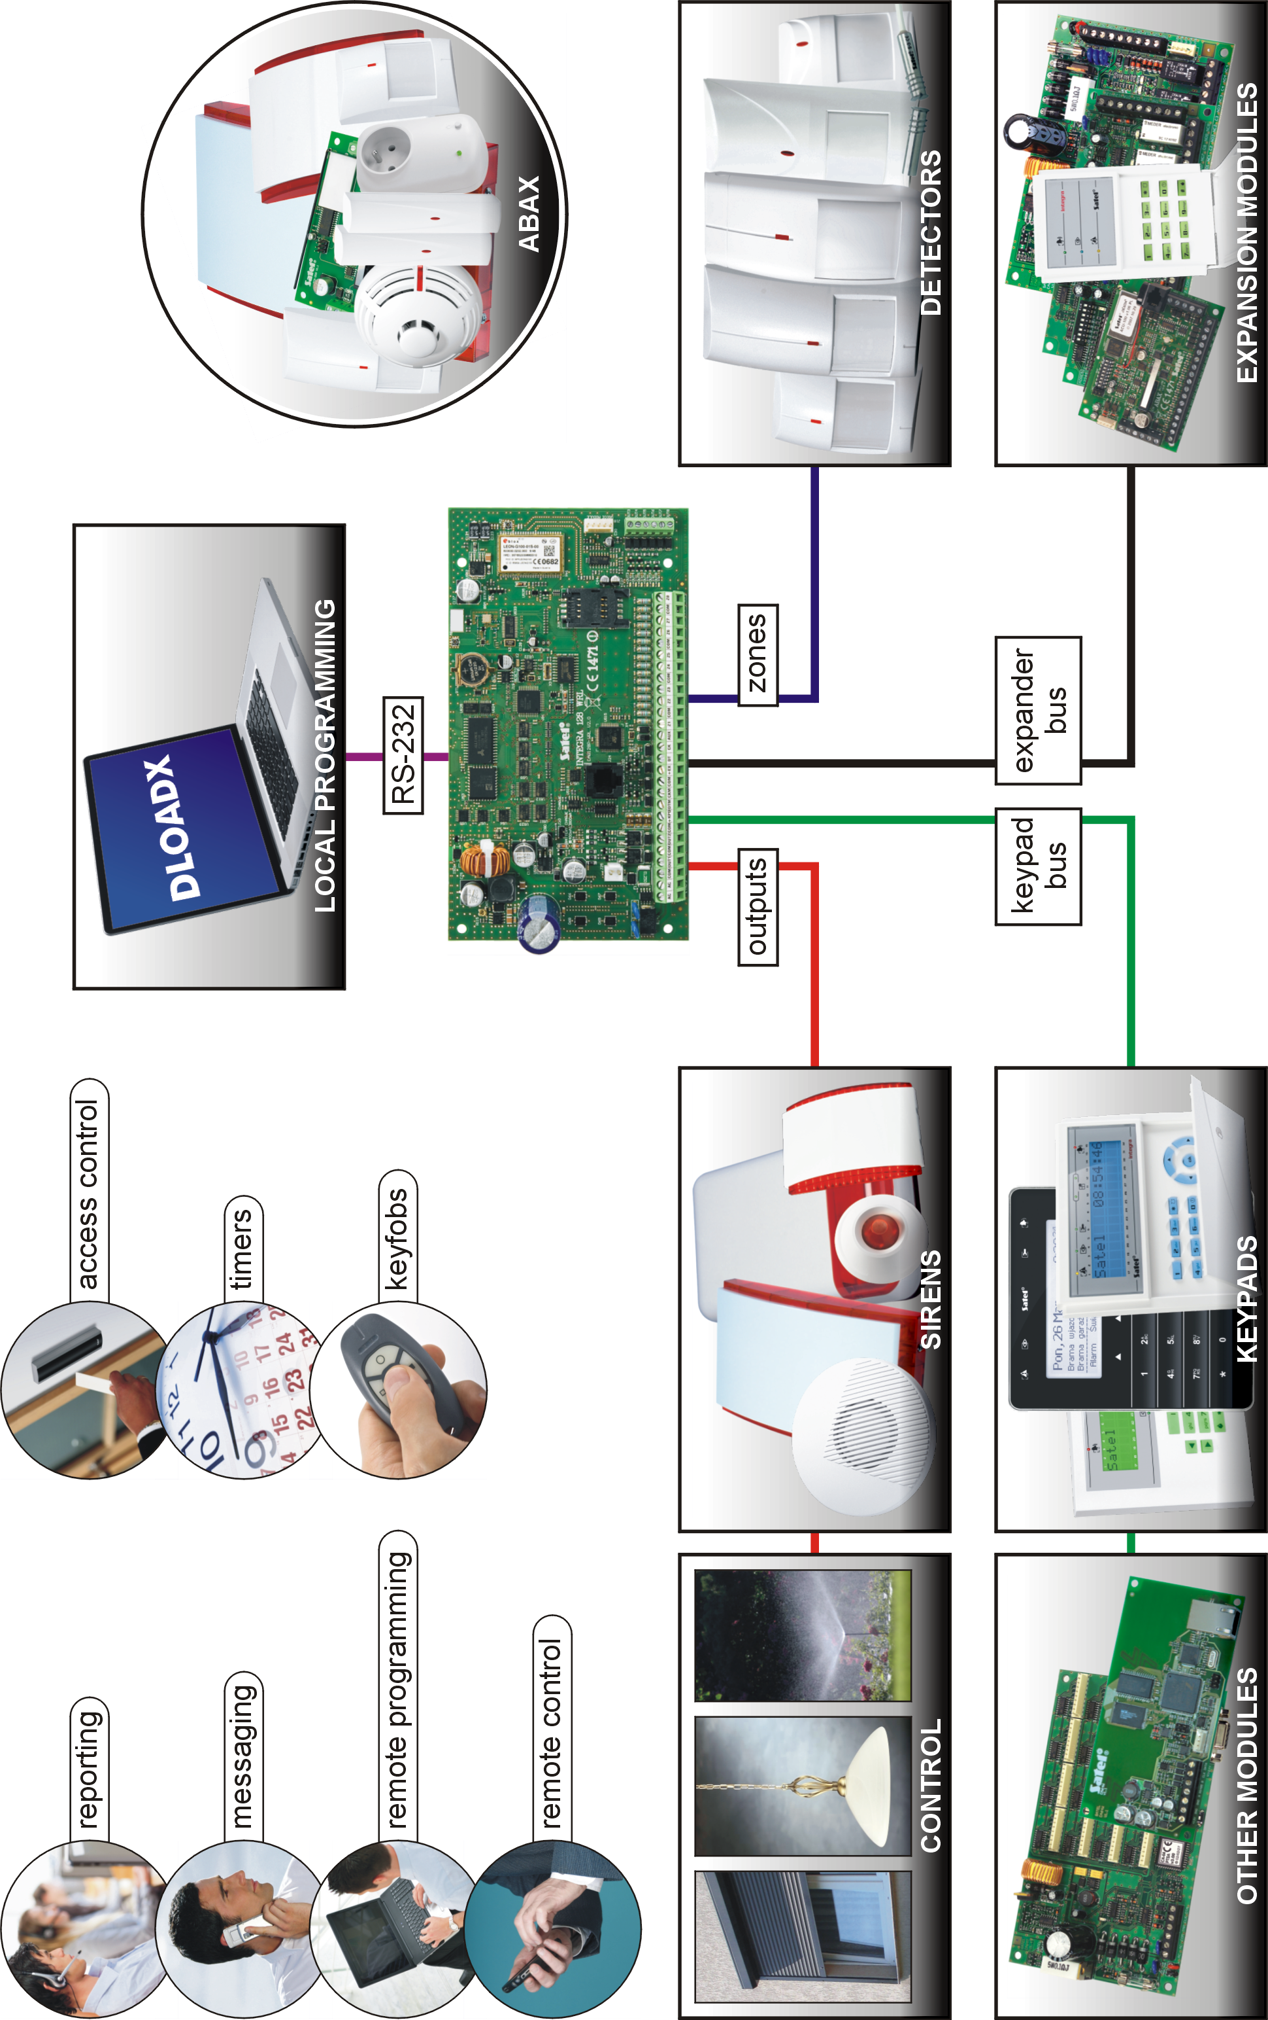
Fig. 1. INTEGRA 128-WRL security alarm system.
INT-KNX. KNX integration module. Enables interfacing of the control panel with the KNX system.

Wireless devices supported by the controller

Detectors
- AFD-100 – wireless water flood detector.
- AGD-100 – wireless glass-break detector.
- AMD-100 – wireless magnetic contact.
- AMD-101 – dual channel wireless magnetic contact.
- AMD-102 – wireless magnetic contact with input for roller shutter detector.
- APD-100 – wireless passive infrared detector.
- APMD-150 – wireless dual motion detector.
- ARD-100 – wireless reorientation detector.
- ASD-110 – wireless smoke and heat detector.
- ATD-100 – wireless temperature detector.
- AVD-100 – wireless vibration detector and magnetic contact.

Sirens
- ASP-105 – wirelessly triggered outdoor siren.
- ASP-205 – wireless indoor siren.

Other
- ACX-200 – hardwired zone / output expander.
- ACX-201 – hardwired zone / output expander with power supply.
- ARF-100 – radio signal level tester.
- ASW-100 E / ASW-100 F – 230 V AC wireless controller.

System installation
Disconnect power before making any electrical connections.
The following tools will be useful during installation:
- blade screwdriver 2.5 mm,
- Phillips screwdriver,
- precision pliers,
- flat nose pliers,
- driller c/w a set of drill bits.

Installation plan
The installation must be preceded by preparation of a plan of the security alarm system. It is advisable to draw up a sketch of the premises and mark on it all the devices that are to be included in the alarm system: control panel, keypads, detectors, sirens, expansion modules etc. When planning the installation location for the control panel and wireless devices of the ABAX system, you must take into consideration the range of radio communication. Remember that thick masonry walls, metal partitions, etc. will reduce the range of radio signal. The control panel and other alarm system components should be installed within the protected area.

Estimation of the system current consumption
At the security system planning stage you should sum up the currents consumed by all devices included in the system (control panel mainboard, keypads, additional modules, detectors, sirens, etc.). The calculation should take into account the battery charging current. If the sum of currents exceeds the maximum output current of the control panel power supply, expander with power supply or an additional power supply unit should be used.
The sum of currents consumed by the devices connected to the power supply unit (expander with power supply) must not exceed the power supply output current.
If you plan to connect devices to particular power outputs (of the control panel, expander with power supply, etc.), remember that the sum of currents consumed by these devices must not exceed the maximum current carrying capacity of those outputs.

Cabling
It is recommended that unscreened straight-through cable be used for making electric connections between devices included in the system (using the twisted-pair type of cable, e.g. UTP, STP, FTP, is not advisable).
If you use the twisted-pair type of cable, remember that the DTM and CKM / DT and CK (data and clock) signals must not be sent through one twisted-pair cable.
Select cross-section of the power supply wires so that the supply voltage drop between the power supply and the supplied device should not exceed 1 V as against the output voltage.
In order to guarantee correct functioning of the system components it is important that resistance and capacitance of the signal wires be as low as possible. When the distances between the devices are greater, several wires connected in parallel may have to be used for each signal, in order to reduce conductor resistance. This, however, may lead in consequence to an increase in conductor capacitance. Too high resistance or capacitance of the cables connecting the control panel to keypads or expansion modules can prevent the devices from working correctly (e.g. the control panel will be unable to identify devices, absence of devices will be reported, etc.). When selecting the length of cables, follow recommendations set out in sections on connection of particular types of devices.
When making the cabling, remember that there must be sufficient distance between the low-voltage wires and the 230 V AC power supply wires. Avoid running the signal cables in parallel to and in close proximity of the 230 V AC supply cables.
The cables should not run in immediate vicinity of antennas, because it could adversely affect radio communication.

Installation of control panel mainboard
The control panel mainboard contains electronic components sensitive to electric charges.
You must complete all wiring, connections and device installations before connecting the battery or applying AC mains to the control panel.
The control panel should be installed indoors, in spaces with normal humidity of air. The control panel must be protected against unauthorized access.
It is recommended that the control panel be mounted high above the floor. This will allow you to get a better range of radio communication and avoid the risk of the control panel being accidentally covered by people moving around the premises.
A 230 V AC power supply circuit with protective grounding must be available at the control panel installation place.

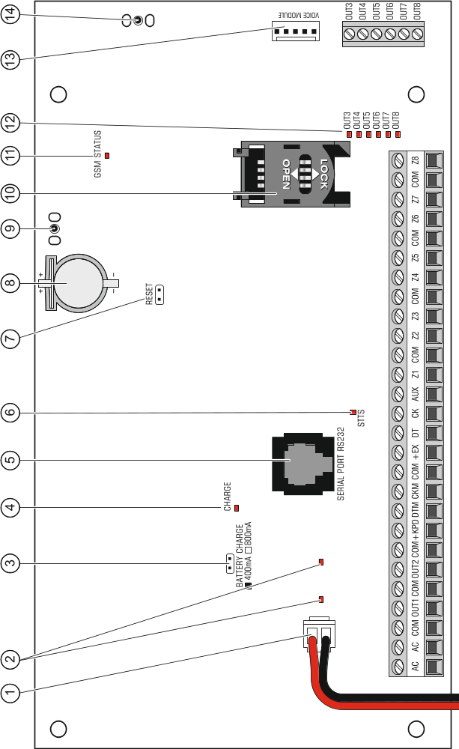

Fig. 2. Control panel mainboard (version 2.1).

Description of the mainboard
Explanations for Fig. 2:
 battery connection cables (red +, black -).
 LEDs indicating the status of high-current outputs.
 pins for setting battery charging current:
- pins shorted (jumper on) – 400 mA
- pins open (no jumper) – 800 mA
 CHARGE LED indicating the battery charging.
 RS-232 port (RJ type socket).
 STTS LED indicating the operation status of the supervision circuit of ABAX wireless system.
 RESET pins for emergency starting the control panel (see: Emergency procedure of the control panel start-up p. 21).
 lithium battery for clock and RAM backup. Its removal will result in loss of the clock settings and all data stored in RAM.
Insert the battery in its socket just before starting the control panel (but not earlier).
 socket to connect antenna for communication with ABAX wireless devices.
 SIM card socket. It is not recommended to insert the SIM card into its socket before the card PIN code has been programmed in the control panel.
 GSM STATUS LED indicating the telephone and GSM network status:
- OFF – the telephone disabled,
- ON – outgoing voice call,
- lit, getting dimmed every 0.5 second – incoming voice call,
- flashing slowly – CSD communication,
- flashing rapidly – GPRS communication
- 1, 2, 3 or 4 flashes every 2 seconds – telephone standby mode (the number of flashes indicates the signal strength).
 LEDs indicating the status of low-current outputs.
 socket for connecting the INT-VG voice module, INT-AV audio alarm verification module, CA-64 SM voice synthesizer expander or SM-2 synthesizer.
 socket for GSM/GPRS communication antenna.
Description of terminals:
AC - power supply inputs (18 V AC)
COM - common ground
OUT1...OUT2 - programmable high-current outputs (if output is not used, the 2.2 kΩ resistor should be connected between the output and common terminals)
+KPD - power supply output for powering the devices connected to keypad bus (13.6...13.8 V DC)
DTM - keypad bus data
CKM - keypad bus clock
+EX - power supply output for powering the devices connected to expander bus (13.6...13.8 V DC)
DT - expander bus data
CK - expander bus clock
AUX - power supply output (13,6...13,8 V DC)
Z1...Z8 - zones
OUT3...OUT8 - programmable low-current outputs, OC type

Connecting devices to the keypad bus
The bus wires must be run in one cable.
The distance between the keypad (or other device to be connected to keypad bus) and the control panel may be up to 300 m.
Devices installed far from the control panel may be supplied locally from a separate power source.
Supply voltage measured at the LCD keypad terminals, with the display and key backlight on, must not be lower than 11 V.

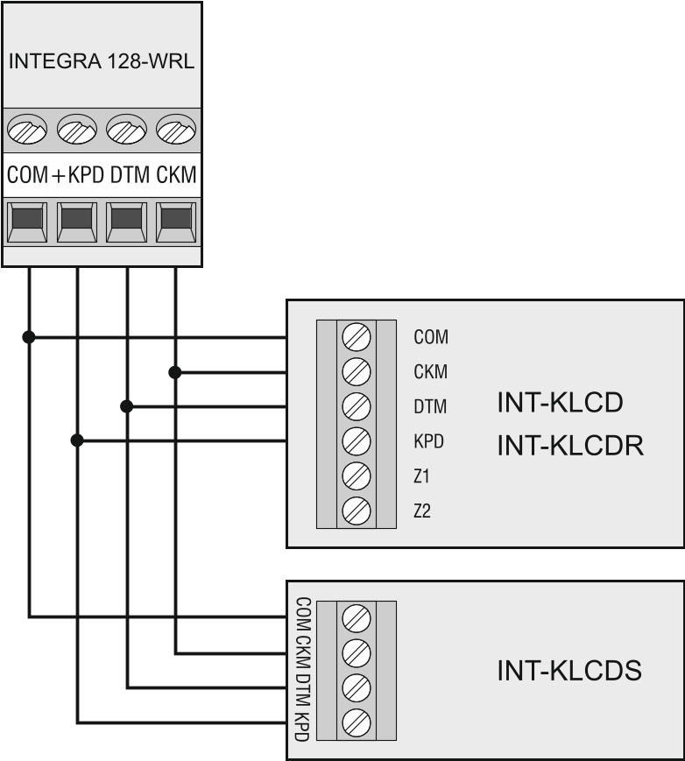
Fig. 3. Connection of keypads (other devices should be connected in a similar way).

The Table 1 shows the number of wires required for correct connection of the device to the keypad bus if the straight-through cable with conductor cross-section 0.5 mm² is used.

 | +KPD | COM | CKM | DTM
Distance | Number of wires
up to 100 m | 1 | 1 | 1 | 1
100-200 m | 2 | 2 | 1 | 1
200-300 m | 4 | 4 | 2 | 2
Table 1.

Addressing devices connected to the keypad bus
Each device to be connected to the keypad bus must have its own individual address from the 0 to 7 range. Addresses must not repeat (the control panel does not support devices having identical addresses). It is recommended that consecutive addresses be assigned starting from 0.
In keypads, the address is set by software means. By default, address 0 is set. When started with factory default settings, the control panel will support all keypads connected to the bus, irrespective of what addresses are set in them. Thus it is possible to set correct individual addresses in the keypads and perform identification of all devices connected to the bus.
In other devices to be connected to the keypad bus, the address is to be set using the DIP-switches or the pins.

Programming keypad address by means of the service function
- Enter the service code (by default 12345) and press the  key.
- Using the  or  keys, find the Service mode item in the function list and press the or  key.
- Start the Keypads addr. function (Structure Hardware Identification Keypads addr.).
- The message shown in Fig. 4 will appear on display of all keypads connected to the control panel.


n=0...7, currently set keypad address
Fig. 4. Programming the keypad address with the service function..

- Enter a proper address from the 0-7 range in the selected keypad(s). The address change will be confirmed by four short beeps followed by one long beep.
- To terminate the address change function, press the key. The function will be terminated automatically after 2 minutes from being started. Termination of the function is equivalent to restarting the keypad (return to the main service mode menu will follow in the keypad from which the function has been started).

Programming keypad address without entering the service mode
This method of address programming is particularly useful when – due to repeating addresses – the keypad support has been disabled and entering the service mode is impossible.
- Disconnect the keypad power supply (KPD) and the CKM and DTM signal wires.
- Short-circuit the keypad CKM and DTM terminals.
- Switch on keypad power supply.
- A message indicating the current address will appear on the display.
- Enter a new address. The keypad will confirm execution of the function by four short beeps followed by one long beep. If it is necessary to change the entered address, press the key (keypad restart will follow and a corresponding message will appear on the display).
- Disconnect the keypad power supply.
- Open the keypad CKM and DTM terminals.
- Connect the keypad correctly to the control panel.

Numeration of keypad zones
The address set in the keypad defines which numbers in the system will be assigned to the keypad zones (see Table 2). You can define for each keypad whether or not its zones will be used in the system. If the zone numbers of keypad and expander coincide, the keypad zones have priority (in such a case, the corresponding expander zones will not be supported).

Keypad address | Zone number in the system
Keypad address | Z1 | Z2
0 | 113 | 114
1 | 115 | 116
2 | 117 | 118
3 | 119 | 120
4 | 121 | 122
5 | 123 | 124
6 | 125 | 126
7 | 127 | 128
Table 2.

Connecting computer to the keypad RS-232 port
In some keypads, the RS-232 port makes it possible to connect a computer with the GuardX program installed (see Fig. 5). It is recommended that the straight-through unscreened cable be used for making the connection (using the twisted-pair type of cable, e.g. UTP, STP, FTP, is not advisable). The distance between computer and keypad can be up to 10 m.

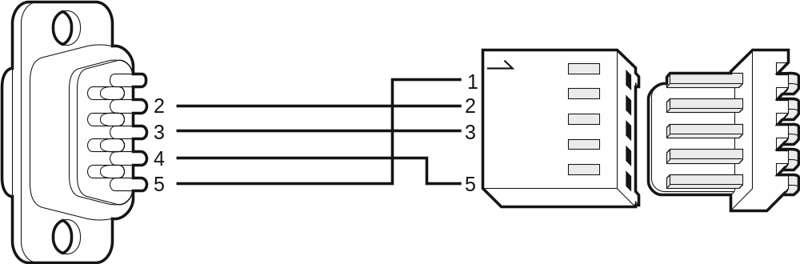
Fig. 5. Computer connection to the keypad RS-232 port. Shown on the right is the keypad interface. Shown on the left is the DB-9 female connector from soldering points side.

Activate the Communication RS option in keypads to which the computer with GuardX program is connected. Data exchange with the computer will begin automatically as soon as the GuardX program is started.

Connecting devices to the expander bus
The bus wires must be run in one cable.
The total length of the expander bus may not exceed 1000 m.
The module may be powered directly from the control panel if the distance between control panel and module does not exceed 300 m. Where the distance is greater, another source of power must be provided for the module (a power supply unit or an expander with power supply).

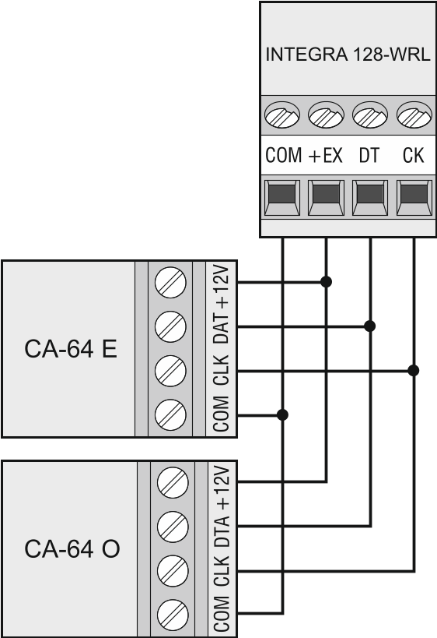
Fig. 6. Connection of modules without power supply.

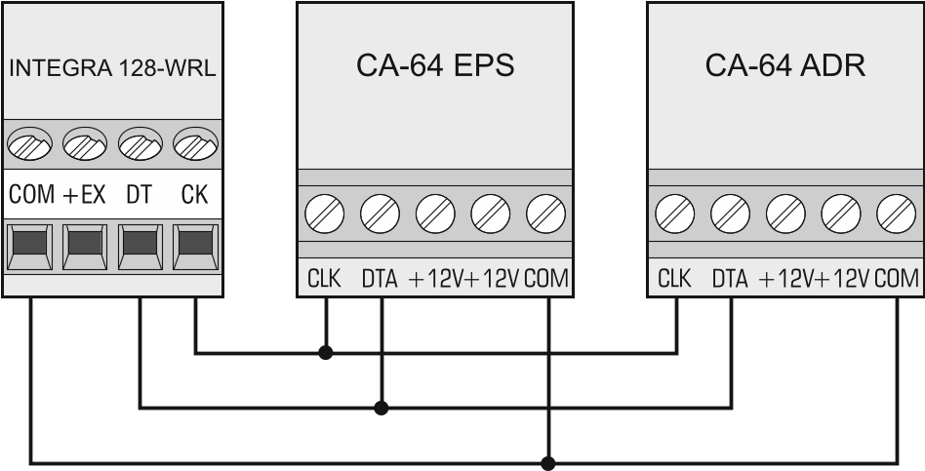
Fig. 7. Connection of modules with power supply.

The Table 3 shows the number of wires required for correct connection of the device to the expander bus if the straight-through cable with conductor cross-section 0.5 mm² is used.

 | CK | DT | COM
Distance | Number of wires
up to 300 m | 1 | 1 | 1
300 – 600 m | 2 | 2 | 2
600 – 1000 m | 2 | 2 | 4
Table 3.

Connecting the INT-VG or INT-AV module or CA-64 SM expander
When connecting the INT-VG voice module, INT-AV audio alarm verification module or the CA-64 SM voice synthesizer expander, the CLK and DTA wires only are to be connected to the bus. Each of these devices is additionally provided with the PIN5 connector, which is to be connected to the dedicated socket on the control panel electronics board.

Addressing devices connected to the expander bus
Each device to be connected to the expander bus must have its own individual address from the 0 to 31 range. The addresses of devices must not repeat (the control panel does not support devices having identical addresses). It is recommended that consecutive addresses be assigned starting from 0. In most devices, the address is set by means of DIP-switches.
The address affects numeration of zones and outputs in the system (see section Numeration of zones and outputs in the system p. 30).

Connecting the detectors
How the detector is connected to the zone must be suitable for the configuration chosen for that zone. The zones on the control panel mainboard support the following configurations:
NC – the wiring type dedicated to connecting devices with the NC (normally closed) alarm output. Opening the circuit will trigger an alarm.
NO – the wiring type dedicated to connecting devices with the NO (normally open) alarm output. Closing the circuit will trigger an alarm.
EOL – this wiring type may be used to connect devices having the NC or NO alarm output. Closing or opening the circuit will trigger an alarm.
2EOL/NC – the wiring type recommended to connect detectors having the NC alarm output and a tamper output. The zone can recognize 3 states: normal, alarm and tamper.
2EOL/NO – the wiring type similar as 2EOL/NC, but for detectors with the NO alarm output.
Roller – the wiring type dedicated to connecting roller shutter detectors.
Vibration – the wiring type dedicated to connecting vibration detectors. The zone will also accept connection of a detector with the NC alarm output (e.g. a vibration detector and a magnetic contact can be connected in parallel).
Follow output – in case of this configuration the detector should not be connected. The zone status depends only on that of the selected output (the output is not to be physically connected to the zone).

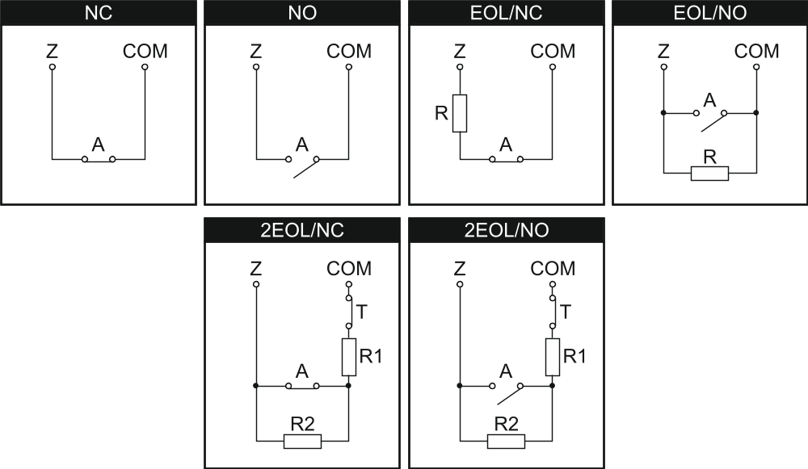
Fig. 8. The ways to connect detectors to zones. The detector outputs are designated with letters: A - alarm, T – tamper. R=R1+R2.

End-of-line resistors
The value of R1 and R2 resistors is programmable within the range from 500 Ω to 15 kΩ (the sum of preset values may not exceed 15 kΩ – see Programming manual). The factory preset values are as follows:
R1 = 1.1 kΩ;
R2 = 1.1 kΩ.
If the resistor value in the keypad or expander is not programmable, in Single EOL configuration, the 2.2 kΩ resistor is required, and in Double EOL (2EOL) configuration – two 1.1 kΩ resistors.

Connecting the sirens
If high-current output is not used, the 2.2 kΩ resistor should be connected between the output and common terminals.

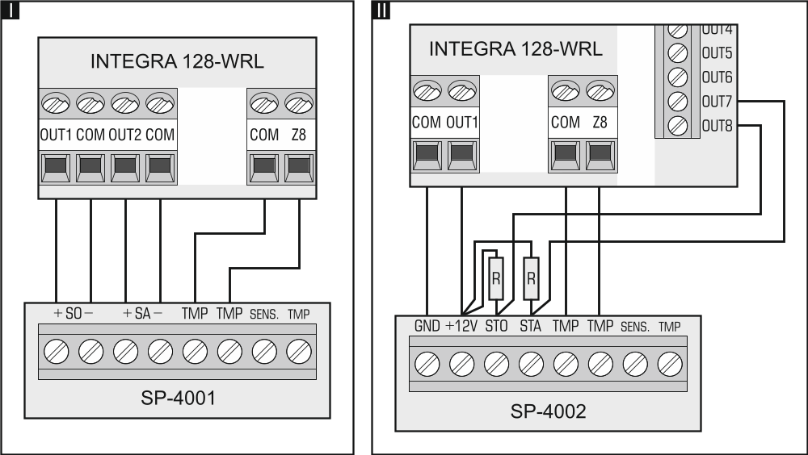
Fig. 9. The way of connecting sirens. I – siren without own power supply – alarm signaling triggered by high-current outputs. II - siren with own power supply – alarm signaling triggered by low-current outputs, the high-current serving as power supply output. The value of resistors R is 2.2 kΩ. In both cases, tamper circuit is connected to zone Z8.

Connecting power supply
Complete all wiring to the control panel before connecting AC power or the battery.
Before connecting power supply, insert the clock and RAM backup battery into its socket on the mainboard.

Main power supply
The control panel requires 18 V AC (±10%) power supply. Using a transformer of at least 40 VA power is recommended.
Never connect two devices with power supply unit to one transformer.
Before connecting transformer to a circuit from which it will be powered, make sure the circuit is de-energized.
The transformer should be permanently connected to the 230 V AC mains supply. Before you make the cabling, familiarize yourself with the electrical installation of the facility. Make sure that the circuit you choose for powering the control panel will be always alive. The power supply circuit should be protected with a proper safety device. The owner or user of the alarm system should be instructed on how to disconnect the transformer from the mains (e.g. by indicating the fuse which protects the control panel supply circuit).

Backup power supply
A 12 V lead-acid sealed battery should be connected to the control panel as a backup power source. The battery capacity must be adequately selected to match current consumption in the system. According to EN 50131 Grade 2, the battery must ensure operation of the system without mains supply for 12 hours.
Do not connect deeply discharged battery to the control panel (with voltage across unloaded terminals below 11 V). The battery should be precharged with a proper charger.
The used batteries must not be discarded, but should be disposed of in accordance with the existing rules for environment protection.
If the battery voltage drops below 11 V for longer than 12 minutes (3 battery tests), the control panel will indicate battery failure. When the voltage goes down to approx. 10.5 V, the battery will be disconnected.

Control panel power-up / start-up procedure
- Deenergize the 230 V AC circuit to which the transformer is to be connected.
- Connect the 230 V AC wires to the terminals of transformer primary winding.
- Connect the terminals of transformer secondary winding to the AC terminals on control panel electronics board.
- Connect the battery to the dedicated leads (positive terminal to RED lead, negative terminal to BLACK lead). The control panel will not start after connecting the battery alone. Included in the control panel set are adapters (matching connectors) for connection of battery with twisted cable ends, therefore the battery cable ends should not be cut off.
- Turn on 230 V AC power supply in the circuit to which the transformer is connected. The control panel will start operating.
If you have any problems with starting the control panel, enter the service mode "from the pins" and restore the factory default settings (see Emergency procedure of the control panel start-up p. 21).
The above mentioned power-up sequence (first the battery, then the 230 V AC mains) will ensure proper operation of the power supply unit and the electronic protection circuits, thus preventing damage to the alarm system components caused by installation mistakes, if any.
If the control panel power supply has to be disconnected, disconnect the mains first and then the battery. When reconnecting the power supply, observe the above mentioned sequence.

First start-up of the control panel
After the first start-up of the control panel, it is advisable to restore the factory default settings using the Clear all function ([Service code] Service mode Restarts  Clear all).
The control panel with factory settings supports all keypads connected to the bus, irrespective of the addresses set in them. However, it does not allow you to program the system. You will be able to start programming after carrying out the following operations:
- Setting individual, correct addresses in keypads (see p. 14).
- Identification by the control panel of devices connected to the keypad bus. The identification can be performed by means of:
- the keypad ([Service code] Service mode Structure Hardware Identification LCD keypads id.);
- DloadX program ("Structure" window →"Hardware" tab →"Keypads" branch →"Keypads identification" button).
- Identification by the control panel of devices connected to the expander bus. The identification can be performed by means of:
- the keypad ([Service code] Service mode Structure Hardware Identification Expanders id.);
- DloadX program ("Structure" window →"Hardware" tab →"Expansion modules" branch →"Exp. modules identification" button).
The identification function must be run every time when a new device is connected to the bus or the address of a device connected to the bus is changed.
Disconnecting the identified device from the communication bus will trigger a tamper alarm.
Any attempt to replace the identified device with another one having the same address will trigger a tamper alarm.

Emergency procedure of the control panel start-up
If the control panel fails to start properly, keypads are not supported, codes are not accepted by the control panel etc., despite all connections having been made correctly, follow the steps below:
- Turn off the control panel power supply (first disconnect the AC power, and then the battery).
- Put a jumper on the RESET pins located on the control panel mainboard.
- Turn on the control panel power supply (first connect the battery and then the AC power).
- Wait about 10 seconds and remove the jumper from the pins. The control panel will enter the service mode. The service mode menu will be displayed on the keypad with the lowest address.
If a computer with the DloadX program running is connected to the RS-232 port, the service mode will not start (it will be possible to program the control panel locally from the computer).
- Restore the factory default settings using the Clear all function (Restarts Clear all).
- Start the Keypads addr. function (Structure Hardware Identification Keypads addr.) and set individual addresses in the keypads (see p. 14).
- Identify devices connected to the keypad bus (Structure Hardware Identification LCD keypads id.).
- Identify devices connected to the expander bus (Structure Hardware Identification Expanders id.).
- Exit the service mode using the End service function.
- After a prompt appears on the keypad display whether to save the data to the FLASH memory, press the key with the number 1. By saving a copy of the settings to the FLASH memory, the control panel will be able to restore them from a backup copy if an error is detected in the data stored in the RAM memory.
- After the data are saved to the FLASH memory, the control panel will restart (the keypad display will be blank for a moment). After the restart, the control panel should work properly and you can proceed to programming the system.

GSM telephone start-up
If the control panel is to send data in GPRS technology, it is recommended that a SIM card with tariff plan for at least 10 MB of data transfer per month is used.
Having started the control panel, you can start up the GSM phone. A GSM antenna must be connected to the control panel. Support for the GSM communicator must be enabled in the control panel (Service mode Structure Hardware GSM Use GSM phone). In order to start up the GSM telephone, do the following:
- Program the SIM card PIN code. You can do so using:
- the keypad ([Service code] Service mode Structure Hardware GSM PIN code);
- the DloadX program („Structure” window →„Hardware” tab →„GSM phone” branch →„PIN” field).
- Insert the SIM card into the onboard socket (see: Fig. 10). Telephone logging into the GSM network may take a few minutes.

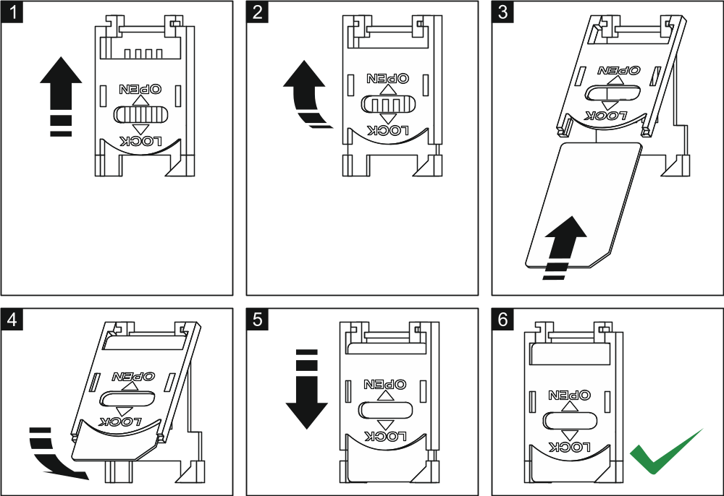
Fig. 10. Inserting the SIM card in its slot.

The user function GSM IMEI/v/sig. ([Code] Tests GSM IMEI/v/sig.) makes it possible to check the level of signal received by the antenna, individual telephone identification number and telephone version. If the signal level is equal to 0, GSM/GPRS communication is impossible. The signal level may be equal to 0 in the following cases:
- antenna not connected or incorrectly connected;
- telephone does not start up properly (e.g. no SIM card, invalid PIN code, blocked SIM card) – in such a case, the control panel should report trouble;
- GSM network out of range.

Installation of wireless devices
Having started the control panel, you can proceed to installation of the ABAX system wireless devices. Antenna for communication with the ABAX system wireless devices must be connected to the control panel.
Before installing a wireless device, check the level of radio signal received by the device from control panel and by the control panel from device at the planned installation place. The ARF-100 tester is a useful tool to check the signal level. The level of signal received by device/control panel may not be lower than 40%. If the radio signal level at the planned installation place is too low, select another installation location. Sometimes it is sufficient to move the device ten or twenty centimeters to obtain a significant improvement of signal quality. You can install the device permanently only after reaching the optimum level of radio signal.
The wireless devices must be registered to the alarm system. This can be done using the LCD keypad or DloadX program. The control panel can support up to 48 wireless devices, but some devices take up more than one position on the list. For example, after adding to the system the ACX-200 expander, which takes up 4 positions on the list of devices, the control panel will still be able to handle 44 more wireless devices. The number of positions on the list is at the same time the number of zones and, in case of some devices, also outputs which will be taken by the device in the system.
When adding and removing the wireless devices, remember that the identification function registers zones and outputs by groups of 8. Already after adding one wireless device which takes up 1 zone, the control panel will reserve 8 zones in the system for wireless devices. The LCD keypad makes it possible to select the zone to which that device will be assigned. Observe continuity, i.e. avoid leaving any gaps in the list, which will later reduce the number of available zones in the system. Remember to preserve continuity also when removing wireless devices. For example, if the devices registered in the control panel occupy 9 positions on the list, then 16 zones (2x8) are reserved in the system. After removal of the device which occupied position 7 on the list, there will still be 16 zones (2x8) reserved in the system for wireless devices, although 8 positions are actually taken up on the list of wireless devices (see: Table 4). In such a case, it is recommended that the last devices be removed from the list and then added to the system again, so as to fill up the gap in the list and reduce the number of zones reserved for wireless devices.
In case of devices which, in addition to zones, also take up outputs, it is recommended that you add them to the system first. This will allow you to maintain the continuity of use of not the zones alone, but the outputs as well. Table 4 shows a situation in which the siren first output occupies position 8, and the second output – position 9. As a result, 16 outputs have been reserved for wireless devices in the system, though actually 2 outputs are used (the eighth output in the first group of 8 outputs and the first output in the second group of 8 outputs).
In some cases, the gaps in the list of zones/outputs cannot be avoided. It applies to situation when the number of zones/outputs, which is used by the devices, is not a multiple of 8.

 |  |  | zones |  | outputs
It. | list of devices |  | No | device | No | device
1 | APD-100 detector | 8 | 17 | APD-100 detector | 17 | unused/unavailable
2 | APD-100 detector | 8 | 18 | APD-100 detector | 18 | unused/unavailable
3 | AMD-100 detector | 8 | 19 | AMD-100 detector | 19 | unused/unavailable
4 | AMD-100 detector | 8 | 20 | AMD-100 detector | 20 | unused/unavailable
5 | AMD-101 detector | 8 | 21 | AMD-101 detector | 21 | unused/unavailable
6 | ^ | 8 | 22 | AMD-101 detector | 22 | unused/unavailable
7 |  | 8 | 23 | unused/unavailable | 23 | unused/unavailable
8 | ASP-105 siren | 8 | 24 | ASP-105 siren | 24 | ASP-105 siren
9 | ^ | 8 | 25 | ASP-105 siren | 25 | ASP-105 siren
10 |  | 8 | 26 | unused/unavailable | 26 | unused/unavailable
11 |  | 8 | 27 | unused/unavailable | 27 | unused/unavailable
12 |  | 8 | 28 | unused/unavailable | 28 | unused/unavailable
13 |  | 8 | 29 | unused/unavailable | 29 | unused/unavailable
14 |  | 8 | 30 | unused/unavailable | 30 | unused/unavailable
15 |  | 8 | 31 | unused/unavailable | 31 | unused/unavailable
16 |  | 8 | 32 | unused/unavailable | 32 | unused/unavailable
Table 4. An example of how the wireless devices should not be registered. For devices taking up 8 positions, the system must reserve 16 zones and 16 outputs.

 |  |  | zones |  | outputs
It. | list of devices |  | No | device | No | device
1 | ASP-105 siren | 8 | 17 | ASP-105 siren | 17 | ASP-105 siren
2 | ^ | 8 | 18 | ASP-105 siren | 18 | ASP-105 siren
3 | APD-100 detector | 8 | 19 | APD-100 detector | 19 | unused/unavailable
4 | APD-100 detector | 8 | 20 | APD-100 detector | 20 | unused/unavailable
5 | AMD-100 detector | 8 | 21 | AMD-100 detector | 21 | unused/unavailable
6 | AMD-100 detector | 8 | 22 | AMD-100 detector | 22 | unused/unavailable
7 | AMD-101 detector | 8 | 23 | AMD-101 detector | 23 | unused/unavailable
8 | ^ | 8 | 24 | AMD-101 detector | 24 | unused/unavailable
Table 5. An example of how to correctly register the wireless devices. For 8 devices, the system has reserved 8 zones and 8 outputs.

Several ABAX systems can work within each other's range. Automatic synchronization with the wireless systems already in use is always performed at the control panel start-up, and after each operation of addition/removal of supported devices. The number of wireless devices working within each other's range depends on the Response period (see: Programming manual) and can vary from 150 to 450. The higher the response frequency, the lower the number of devices that can work within each other's range.

Adding new wireless devices
For some wireless devices, you can select whether the device will take up one or two positions (channels) on the list of devices. Depending on the device, if one position is selected:
- AMD-102 – only additional inputs (roller shutter and NC) will be supported;
- ATD-100 – you will be able to program only one temperature threshold;
- AVD-100 – only the vibration detector will be supported.

LCD Keypad
You can add wireless devices in service mode, using the New device function (Structure Hardware Expanders Settings ABAX - INTEGRA New device).
- Start the New device function.
- Enter the device 7-digit serial number and press the key. The serial number can be found on the electronics board or on the enclosure. Each ARF-100 radio signal level tester has serial number 0000500. If a device with the entered serial number is already registered, the keypad will not proceed to the next step of the procedure.
- When the "Open device tamper" command is displayed:
  - power on the ACX-200 or ACX-201 expander,
  - turn on the ARF-100 tester,
  - insert the ASW-100 E / ASW-100 F wireless controller into 230 V AC socket,
  - violate (open) the tamper contact in case of the other devices.
If the serial number of device to be added is not consistent with that previously entered, you will be informed about it by a suitable message. If this is the case, press the key and then start the device adding procedure from the beginning.
- The name and serial number of the new device will be displayed. Press the key 1 to proceed to the next step of the procedure (press another key to terminate the new device adding procedure).
- A suitable message will inform you about the option, if any, whether the device will take up one or two positions (channels) on the list of devices. Press the key 1 to select one channel or press the key 2 to select two channels.
- A list of system zones to which the device can be assigned will be displayed. Using the  and  keys, select one of them and press the key (press the key to terminate the new device adding procedure). If the device takes more than one position on the list of devices, additional zones, following the selected one, will be automatically assigned to the device.
- A message will be displayed to inform you that the expander identification function has been started.
- After identification of the devices, the keypad will display a suggested name for the zone to which the device is assigned. The name can be changed. The name will also be assigned to the output, if the device is to be assigned to the output. Press the key to save the new name. Press the key to terminate the name giving procedure (the zone will then be given a name consisting of the name and serial number of the device). If the device occupies more than one zone, this procedure is repeated for each zone.

DloadX program
You can add wireless devices in the "Structure" window, "Hardware" tab, after clicking on the „Wireless System”.
- Click on the "New device" button. The "New device" window will open.
- Enter in the appropriate field the 7-digit serial number of the device you want to add. The serial number can be found on the electronics board or on the enclosure. Each ARF-100 radio signal level tester has serial number 0000500.
- Depending on which device is to be added to the system:
  - power on the ACX-200 or ACX-201 expander,
  - turn on the ARF-100 tester,
  - insert the ASW-100 E / ASW-100 F wireless controller into 230 V AC socket,
  - violate (open) the tamper contact in case of the other devices.
If an invalid serial number is entered, it will be indicated by a suitable message. In such a case, enter the correct serial number and repeat the above mentioned step.
- The message will confirm that a new device has been added. It will be assigned to the first free zone from the pool reserved for the wireless devices. A suggested name for that zone will appear (the name is editable). The name will be also assigned to the output, if the device is to be assigned to the output. For some devices, you can also select whether the device will take up one or two positions on the list of devices.
- Click on the "OK" button to complete the procedure of adding a new device. You can cancel adding the new device by pressing the "Cancel" button. You can also press the "Next" button to immediately begin adding another wireless device.

Removing wireless devices

LCD Keypad
You can remove a wireless device in the service mode, using the Remove device function (Structure Hardware Expanders Settings ABAX - INTEGRA Remove device).
- Start the Remove device function.
- Using the  and  keys, select the zone to which the wireless device to be removed is assigned, and then press the key.
- Press the key 1 to confirm that you want to remove the device (pressing another key will take you back to the selection list).
- The device will be removed. A message on the display will inform you that the expander identification function has been started.
- After identification of the devices, you will be brought back to the list of zones to which wireless devices are assigned.

DloadX program
You can remove a wireless device in the "Structure" window, "Hardware" tab, after clicking on the „Wireless System”.
- Click on the list on the wireless device to be removed (if the device takes up some positions on the list, you can click on any of them).
- Click on the "Remove device" button. The "Confirm" window will open.
- Click on the "Yes" button. The device will be removed.

Connecting computer to the control panel
Using a computer, you can update the control panel firmware (FlashX program), program the control panel (DloadX program) and administer the security system (GuardX program). Communication is encrypted. The computer can be connected to the control panel via the RS-232 port.

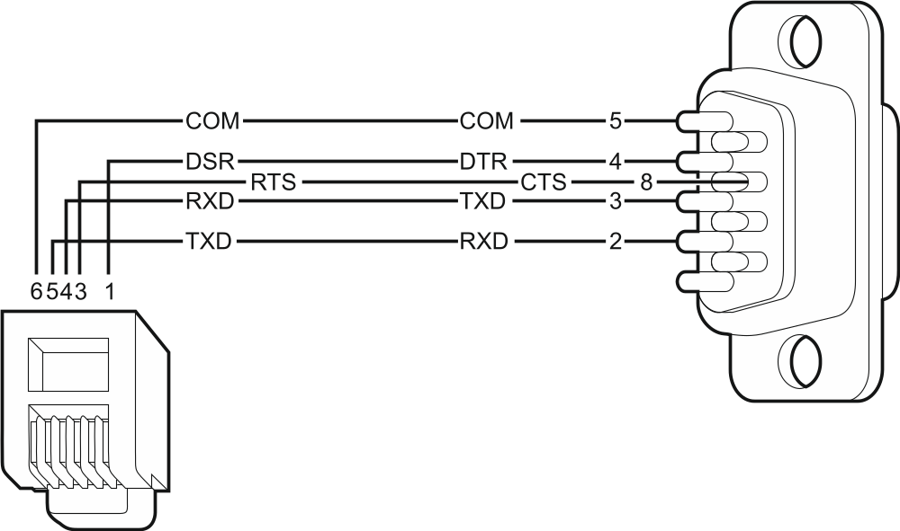
Fig. 11. Computer connection to control panel RS-232 port. Shown on the left is RJ plug to be connected into the control panel mainboard socket. Shown on the right is DB-9 female plug (solder side view). A ready cable is offered in the DB9F/RJ-KPL set.

Connecting the external modem
The external modem enables remote programming of the control panel (computer with DloadX program required) or remote administration of the security alarm system (computer with GuardX program required). The communication is encrypted.
The control panel can work with any external modem (analog, ISDN or GSM) compatible with the Hayes AT standard and equipped with an RS-232 port.

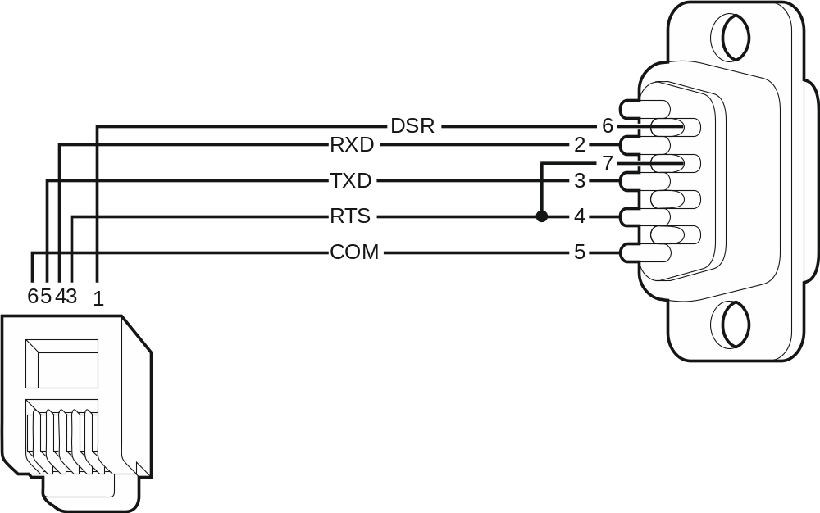
Fig. 12. Connection of the RS-232 ports of control panel and modem with the DB-9 socket. Shown on the left is RJ plug to be connected into the control panel mainboard socket. Shown on the right is DB-9 male plug (solder side view).

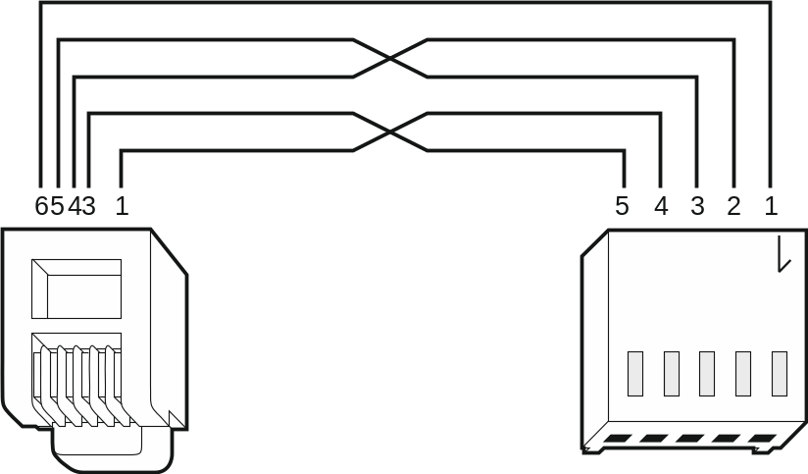
Fig. 13. Connection of the RS-232 ports of control panel and external modem with the PIN5 socket (the SATEL made ETHM-1 and GSM modules are connected in a similar way). Shown on the left is RJ plug to be connected into the control panel mainboard socket. Shown on the right is PIN5 plug. A ready cable is offered by SATEL company (RJ/PIN5).

Configuring settings of the modem to be connected to control panel
The MDM56 and MDM56 BO modems, manufactured by SATEL, do not require any configuration. The factory settings ensure correct work with the control panel.
Before connecting to the control panel, connect the modem to the computer and, using the Terminal type program, set the correct operating mode.
- Enter the at command – the modem should respond with "OK". Otherwise, enter ate1. If the modem fails to respond, check the modem connection to the computer, and make sure that the correct COM port is selected in the Terminal program settings.
- Enter the at&v command. The modem will present a list of parameters to be programmed (see example in Fig. 14). The parameter block saved as the "profile 0" (in Fig. 14 "STORED PROFILE 0") should include E1 Q0 V1 X4 &D2 &S0 and S00:000. In such a case the modem is ready for operation with the control panel.
- If any parameter is set differently, it should be modified. The parameter setting command consists of a fixed AT prefix and the desired parameter setting (e.g., if E0 V0 is included in the profile, the command for setting the proper value will be ate1v1, after which the modem will answer "OK").
- Enter the at&w0 command o save the settings in the "profile 0".
- Enter the atz command followed by at&v to check that all parameters are saved correctly. The settings in ACTIVE PROFILE should be the same as in STORED PROFILE 0 (Note: Often the STORED PROFILE contains less parameters than the ACTIVE PROFILE, which is normal).
To set the S0 modem register, use the ats0=0 command (in Fig. 14, the modem register setting is shown in a slightly different notation S00: 000).
When restarting the modem, the control panel gives the ATZ command, which sets the parameters as stored in the "profile 0". For this reason, the current setting of the parameters mentioned in it. 2 ("ACTIVE PROFILE") is irrelevant, but it is important that they be set properly in the "profile 0".

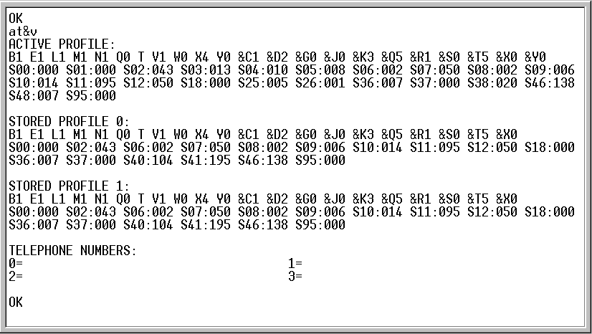
Fig. 14. Proper setting of the external modem parameters.

Connecting the printer
The control panel RS-232 port makes it possible to connect a printer provided with serial port. The control panel may print events in a “compressed" format (single event is printed in a single line containing up to 80 characters) or “extended" format, with names of zones, partitions, users and modules (then, the event is printed in two lines, when the printer with up to 80 characters per line is used; the descriptions of a single event are printed in one line with printers printing 132 characters per line).

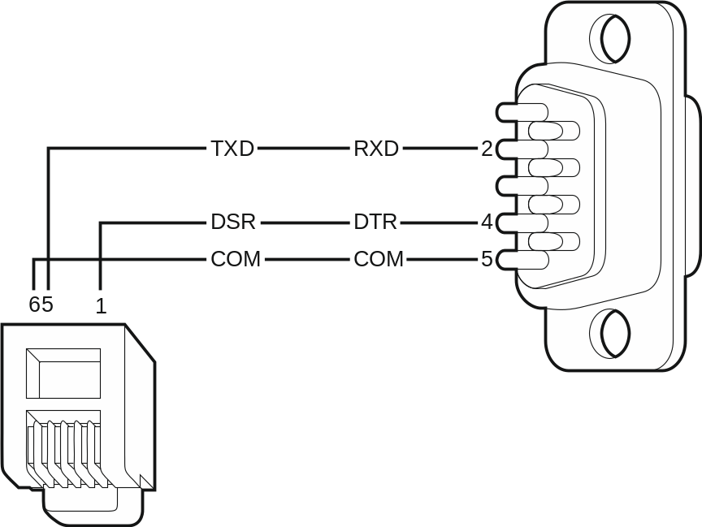
Fig. 15. Connection of printer by means of DB-9 male plug (solder side view). Shown on the left is RJ plug to be connected into the control panel mainboard socket.

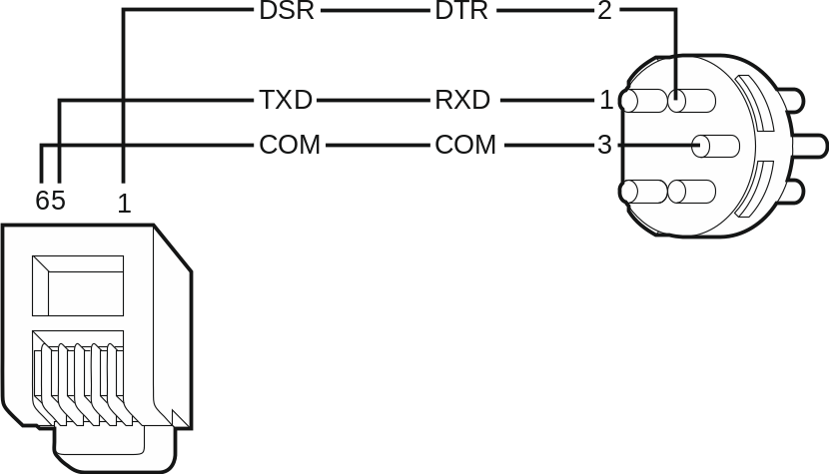
Fig. 16. Connection of printer by means of DIN 5-pin plug (solder side view). Shown on the left is RJ plug to be connected into the control panel mainboard socket.

Numeration of zones and outputs in the system
Numbers are automatically assigned to the zones and outputs:
- the hardwired zones and outputs on the control panel board are numbered from 1 to 8.
- numbers of the wireless zones and outputs supported by the INTEGRA 128-WRL control panel mainboard are set during the procedure of adding wireless devices – free and available numbers are assigned.
Numeration of wireless devices supported by the INTEGRA 128-WRL control panel mainboard need not be continuous. For example, if the system includes 8 wireless zones with numbers 17-24, to which wireless devices are assigned, and the zones 25-32 are already reserved for the expander, then adding a new wireless device will result in reservation of next 8 zones with numbers 33-40 for wireless devices. Numbering of the expander zones will remain unchanged. The same rules apply to the wireless outputs.
- the numbers of keypad zones are determined during the identification procedure, based on the keypad address (see section Numeration of keypad zones p. 15).
- the numbers of zones and outputs in expanders and ACU-100 / ACU-250 controller are determined during the expander identification procedure. The numbering is dependent on the expansion module address in the system (zones in expansion module with a lower address will be given lower numbers than the zones in expansion module with a higher address).
The control panel reserves 8 zones in the system for each identified expander. The exceptions are the CA-64 ADR expander and ACU-100 / ACU-250 controller, for which up to 48 zones can be reserved. In case of the CA-64 ADR expander, the number of reserved zones depends on the number of detectors with installed CA-64 ADR MOD module, which are connected to it. In case of ACU-100 / ACU-250, the number of reserved zones depends on the number of registered wireless devices. In both cases, the number of reserved zones is a multiple of 8.
The DloadX program allows you to change the numeration of zones and outputs in expanders ("Structure" window, "Hardware" tab, "Advanced" button for the selected expander). The changes in numeration will only be valid until you start the expander identification function again.

Specifications

Control panel
Supply voltage 18 V AC ±15%, 50-60 Hz
Recommended transformer 40 VA
Standby current consumption from AC mains 120 mA
Maximum current consumption from AC mains 300 mA
Standby current consumption from battery 280 mA
Maximum current consumption from battery 600 mA
Battery failure voltage threshold 11 V ±10%
Battery cut-off voltage 10.5 V ±10%
Battery charging current 400/800 mA
Power supply output current 2 A
Power supply output voltage range 10.5…14 V DC
Current-carrying capacity, high-current programmable outputs 2 A ±10%
Current-carrying capacity, low-current programmable outputs 50 mA
Current-carrying capacity, +KPD output 0.5 A ±10%
Current-carrying capacity, +EX output 0.5 A ±10%
Current-carrying capacity, AUX output 0.5 A ±10%
ABAX system operating frequency band 868.0 MHz ÷ 868.6 MHz
Radio communication range (in open area) up to 500 m
Number of supported wireless devices 48
Number of supported APT-100 keyfobs 248
Hardwired programmable zones 8
Maximum number of programmable zones 128
Hardwired programmable outputs 8
Maximum number of programmable outputs 128
Power supply outputs 3
Communication buses 1+1
Keypads up to 8
Expansion modules up to 32
Objects (subsystems) 8
Partitions 32
Telephone numbers for messaging 16
Voice messages 16
Text messages 64
Users + Masters 240 + 8
Timers 64
Event log 21503
Security grade according to EN50131 Grade 2
Environmental class according to EN50130-5 II
Operating temperature range -10…+55 °C
Maximum humidity 93±3%
Electronics board dimensions 192 x 106 mm
Enclosure dimensions (OPU-3P) 324 x 382 x 108 mm
Weight (incl. enclosure and accessories) 2130 g

INT-KLCD keypad
Supply voltage 12 V DC ±15%
Standby current consumption 17 mA
Maximum current consumption 101 mA
Environmental class according to EN50130-5 II
Operating temperature range -10…+55 °C
Maximum humidity 93±3%
Enclosure dimensions 140 x 126 x 26 mm
Weight 231 g

INT-KLCDR keypad
Supply voltage 12 V DC ±15%
Standby current consumption 60 mA
Maximum current consumption 156 mA
Environmental class according to EN50130-5 II
Operating temperature range -10…+55 °C
Maximum humidity 93±3%
Enclosure dimensions 140 x 126 x 26 mm
Weight 236 g

INT-KLCDL keypad
Supply voltage 12 V DC ±15%
Standby current consumption 61 mA
Maximum current consumption 147 mA
Environmental class according to EN50130-5 II
Operating temperature range -10…+55 °C
Maximum humidity 93±3%
Enclosure dimensions 145 x 115 x 26 mm
Weight 217 g

INT-KLCDS keypad
Supply voltage 12 V DC ±15%
Standby current consumption 33 mA
Maximum current consumption 151 mA
Environmental class according to EN50130-5 II
Operating temperature range -10…+55 °C
Maximum humidity 93±3%
Enclosure dimensions 114 x 94 x 23.5 mm
Weight 141 g

INT-KLCDK keypad
Supply voltage 12 V DC ±15%
Standby current consumption 30 mA
Maximum current consumption 110 mA
Environmental class according to EN50130-5 II
Operating temperature range -10…+55 °C
Maximum humidity 93±3%
Enclosure dimensions 160 x 132 x 29 mm
Weight 317 g

Manual update history
Date | Firmware version | Introduced changes
2013-08 | 1.12 | - Information on the capability to report events via Ethernet using the UDP protocol has been added (p. 4).  - Information on the new INT-TSG keypad has been added (p. 5).  - Information on the new INT-AV module has been added (pp. 7, 12 and 17).  - Note on clock / RAM backup battery has been modified (p. 12).


Alarm Control Panels
INTEGRA 128-WRL
Firmware version 1.12

INSTALLER
MANUAL

SATEL sp. z o.o.
ul. Schuberta 79
80-172 Gdańsk
POLAND
tel. + 48 58 320 94 00

info@satel.pl
www.satel.eu

integra-wrl_i_en 08/13
druk:
34,35,0,33,32,1,2,31,30,3,4,29,28,5,6,27,26,7,8,25,24,9,10,23,22,11,12,21,20,13,14,19,18,15,16,17

