WARNING
Before you start using the control panel, please read carefully this manual in order to avoid mistakes that can lead to malfunction or even damage to the equipment.
Changes, modifications or repairs not authorized by the manufacturer shall void your rights under the warranty.
The INTEGRA Plus control panels should only be connected to the analog subscriber lines. Connecting its telephone circuit to a digital network (e.g. ISDN) may cause damage to the equipment. In case of changing the analog line to the digital one, it is necessary to contact the alarm system installer.
Pay special attention if the telephone line used by the control panel is frequently busy and/or failures are reported, concerning the line and/or monitoring. Report such situations to the alarm system installer immediately.
To ensure adequate protection, the alarm security system must be in good working order, therefore SATEL recommends that it be regularly tested. The control panel is equipped with a number of self-diagnostic functions which, when properly configured by the installer, ensure control over correct functioning of the system.
The alarm security system cannot prevent burglary, assault or fire from happening, but it guarantees that in case of emergency measures will be taken to reduce the possible damage (the alarm will be signaled optically and acoustically, appropriate services will be notified, etc.), which may deter the potential burglars.

The SATEL's goal is to continually upgrade the quality of its products, which may result in alterations of their technical specifications and firmware. The current information on the introduced modifications is available on our website.
Please visit us at:
http://www.satel.eu

The declaration of conformity may be consulted at www.satel.eu/ce

Factory default codes:
Service code: 12345
master (administrator) code for partition 1: 1111

The following symbols may be used in this manual:
 - note;
 - caution.

Changes made to the firmware version 1.09
Arming | When arming a partition of With temporary block type, the user can permanently block the partition by entering the blocking time equal to 9 days 99 hours 99 minutes. Only a user having the Access to temporary blocked partitions right will be able to disarm the partition.
Event log  INTEGRA 128-WRL | The contents of SMS messages received by the control panel is recorded in the event log.

Changes made to the firmware version 1.10
System operation | A new device, the INT-VG voice module, allows remote operation of the control panel from telephone keypad (DTMF), using the interactive voice menu.
User functions | The Troubles user function name has been changed to System state.  The Temperatures function has been added to the Tests submenu to check the temperature measured by the ATD-100 wireless temperature detectors.
Alarms | A warning alarm has been added. It does not trigger loud signaling and is not reported.
Grade 2 | If the installer has enabled the Grade 2 option:  - starting the arming procedure may be impossible, or, if started, the arming procedure may fail, if some zones are violated in the partition, or there is a trouble in the system;  - LCD keypads, partition keypads, proximity card arm/disarm devices and reader expanders do not signal alarms;  - the  LEDs in keypads indicate alarms only when code has been entered and confirmed with the  key;  - the blinking  LED in keypads means that there is a trouble in the system, some zones are bypassed, or there has been an alarm;  - new access codes in the system must be composed of at least 5 characters;  - the quick arming is not possible;  - a message on the keypad display informs you that the system is armed;  - after entering the user menu by means of the service code, you will get access in the Events submenu to the Grade 2 function, which enables viewing the events required by EN 50131 for Grade 2;  - the System state user function provides information about alarms, bypassed zones, troubles and partition status (disarmed or type of armed mode).
Users | Partition keypads (INT-S, INT-SK), multifunctional keypad with proximity card reader (INT-SCR) and readers connected to reader expanders (INT-R, CA-64 SR, CA-64 DR) can be used by users with the Access to cash dispenser type of code.
Code locks | Code locks (INT-SZ, INT-SZK) allow to:  - activate the 24. MONO switch type outputs, using the MONO outputs type of code;  - change the status of 25. BI switch type outputs, using the BI outputs type of code;  - temporarily block the partition to which the expander is assigned, using the Temporary partition blocking type of code (partition can only be blocked when armed).

Changes made to the firmware version 1.11
User authorization | For the INT-KLCDR and INT-SCR keypads, authorization may be required using two identifiers: code and card.
Arming | If the system is being armed in the "full + bypasses" mode, bypasses and violations of the zones for which the Bypassed if no exit option is enabled are not checked.  If the system is being armed in the "without interior" or „without interior and without entry delay” mode, bypasses and violations of the 3. Interior delayed type zones are not checked.
User functions | A new Timers function in the Change options submenu. It allows you to program parameters of the timers whose editing is permitted by the installer.  The Clear latched outputs function allows you also to deactivate the 9. DAY Alarm and 116. Internal Siren type outputs.
SMS control  INTEGRA 128-WRL | Support for the USSD codes (retransmission to the GSM operator and forwarding the answer to the telephone number from which SMS message with the control command was sent).

CONTENTS
1. General 5
2. Technical reliability of the alarm system 5
3. Alarm system operating costs 5
4. Authorization of users 6
4.1 Authorization with two identifiers 6
4.2 Factory default codes 6
4.3 Operation under duress 7
5. Operating the alarm system by means of LCD keypad 7
5.1 Keypads description 7
5.1.1 LCD display 7
5.1.2 LED indicators 9
5.1.3 Keys 9
5.1.4 Built-in proximity card reader 10
5.1.5 Sound signaling 10
5.2 [Code] – arming / disarming menu 11
5.2.1 Arming menu 11
5.2.2 Disarming menu 11
5.3 [Code] – user menu 12
5.3.1 Functions list 12
5.3.2 Starting functions 15
5.3.3 Menu shortcuts 15
5.3.4 Entering data by means of the LCD keypad 16
5.3.5 Description of user functions 17
5.4 Arming 23
5.4.1 Full arming without partition selection 23
5.4.2 Full arming the selected partitions 23
5.4.3 Arming in the selected mode 23
5.4.4 Quick arming 24
5.4.5 Denial of arming 24
5.4.6 Failure of arming procedure 24
5.4.7 Shortening the exit delay time 24
5.5 Disarming and alarm clearing 24
5.5.1 Alarm clearing without disarming 25
5.6 Two-code arming / disarming 25
5.7 Triggering the alarm from keypad 25
5.8 Users 25
5.8.1 User types 27
5.8.2 Adding new user 27
5.8.3 Edit user 28
5.8.4 Removing a user 28
5.8.5 Adding proximity card / DALLAS iButton 28
5.8.6 Adding keyfob 29
5.8.7 Removing keyfob 30
5.9 Master users (administrators) 30
5.10 Zone bypassing 30
5.10.1 Zone inhibiting 31
5.10.2 Zone isolating 31
5.10.3 Unbypassing 32
5.11 Viewing the event log 32
5.11.1 Viewing all events 32
5.11.2 Viewing the events required for Grade 2 32
5.11.3 Viewing the selected events 32
5.11.4 Way of presenting events 33
5.12 Programming the partition timer 33
5.13 Zone testing 34
5.14 Outputs control 35
5.14.1 Controlling the MONO switch type of output 35
5.14.2 Controlling the Bi switch type of output 35
5.14.3 Controlling the Remote switch type of outputs 36
5.14.4 Controlling the roller shutter outputs 36
6. Using the partition keypad 36
6.1 Description of partition keypads 37
6.1.1 LED indicators 37
6.1.2 Keys 38
6.1.3 Built-in proximity card reader 38
6.1.4 Sound signaling 38
6.2 Functions available from the partition keypad 39
6.2.1 [Code] 39
6.2.2 [Code] 39
6.2.3 Quick arming 39
6.2.4 Triggering the alarm from keypad 39
6.2.5 Silencing the alarm sound at the keypad 40
6.2.6 Code changing 40
7. Using the entry keypad 40
7.1 LED indicators 40
7.2 Sound signaling 40
7.3 Functions available from the entry keypad 41
8. Using the code lock 41
8.1 Description of code locks 41
8.1.1 LED indicators 42
8.1.2 Keys 42
8.1.3 Sound signaling 42
8.2 Functions available from code lock 42
9. Confirming voice messaging 43
10. Call answering and telephone control 43
10.1 Answering phone calls 43
10.2 Telephone control 44
11. SMS control only INTEGRA 128-WRL 44
12. Operating the alarm system by means of keyfob 45
13. Brief description of operating the system from keypad 47

General
Thank you for choosing the product offered by the SATEL Company. Wishing you full satisfaction with the choice you made, we are always ready to provide you with professional assistance and information on our products.
The SATEL Company is manufacturer of a broad range of devices dedicated for use in security alarm systems. Further information is available on our website www.satel.eu or at the points of sale offering our products.

Technical reliability of the alarm system
The alarm system is built of technical devices, the performance of which has crucial effect on the effectiveness of the facility protection. Components of the alarm system may be exposed to various external factors, such as weather conditions (e.g. outdoor sirens and, during a storm, also other devices, as a result of atmospheric discharge which may cause harm to electrical and telephone installations) or mechanical damage. Only a routine check of the system operation makes it possible to maintain a high level of burglary protection.
The control panel is provided with a number of safeguards and automatic diagnostic features to test the system performance. Detection of irregularities is signaled by the LED on the keypad. You should immediately respond to such a signal, and, if necessary, consult the installer.
It is necessary to periodically carry out a functional test of the alarm system. Check that the control panel responds to violation of individual detectors, that their coverage areas are not obstructed, that there is a reaction to opening protected windows, and that sirens and telephone messaging work normally.
Detailed instructions on the system testing should be provided by the installer. It is recommended that the installer carry out periodic maintenance of the alarm system, when ordered by the user.
It is in the user's interest to foresee and prearrange the procedures to be followed when the control panel signals an alarm condition. It is important to know how to verify the alarm and identify its source on the basis of keypad information, and take appropriate measures, e.g., to organize evacuation.

Alarm system operating costs
The control panel can inform the users and the monitoring station about the status of protected facility. Realization of these functions by means of the phone line or GSM means financial costs. The amount of the costs incurred depends on the amount of information sent. A failure of telephone links, as well as an incorrect programming of the control panel, may result in increased costs (due to making of excessive number of calls).
Please inform the installer, which is a priority: to deliver information at any cost, or to prevent excessive costs. For example, after an event code has failed to be sent successfully to the monitoring station, the control panel may repeat attempts every few minutes to send the code or to cease the attempts to send the code until a next event occurs.

Authorization of users
Operation of the alarm system is possible after the user authorization, which allows the control panel to verify that the user is authorized to perform the given operation. The authorization can be done on the basis of:
- code,
- proximity card (125 kHz passive transponder, which can be in the form of card, tag, etc.),
- DALLAS iButton (chip),
- keyfob.
You can not assign the same identifier (code, proximity card, DALLAS iButton or keyfob) to two users.
For safety reasons, different people should not use the same identifier.
The installer can configure the panel so that it will not accept codes that contain less than three digits (e.g. 1111 or 1212) or consist of consecutive digits (3456).
The installer may permit the use of certain functions without the need for user authorization.
Using an invalid code, proximity card or DALLAS iButton three times may:
- trigger an alarm;
- block the keypad / reader for 90 seconds.

Authorization with two identifiers
The INT-KLCDR keypads and the INT-SCR multifunction keypads have a built-in proximity card reader. The installer can configure these devices so that the user has to use two identifiers for authorization: the code and the card. The function to be executed after the authorization depends on the second identifier:
- code – whether it will be confirmed by using the key or the key;
- card – whether it will be presented only or held.

Factory default codes
By default, the following codes are preprogrammed in the control panel:
Service code: 12345
master (administrator) code for partition 1: 1111
The factory default codes make it possible to assign individual codes to consecutive persons who are to use the alarm system (see: section Users p. 25).
The factory default codes should be changed as soon as possible using the Change own code function available in the user menu.
The control panel can inform the user that the code change is necessary, if the code is known to other users.
The master code should not be used on a daily basis because of the risk of its being captured. It is recommended that the administrator enter for himself an ordinary user's code.

Operation under duress
When acting under duress, the Duress type code must be used instead of the normal user code (see section User types p. 27).

Operating the alarm system by means of LCD keypad
SATEL offers the following keypads for INTEGRA Plus control panels:
INT-KSG – LCD keypad with touch keys;
INT-KLCD – LCD keypad with mechanical keys;
INT-KLCDR – LCD keypad with mechanical keys and built-in proximity card reader;
INT-KLCDK – LCD keypad with mechanical keys;
INT-KLCDL – LCD keypad with mechanical keys;
INT-KLCDS – LCD keypad with mechanical keys.
The keypads are available in a variety of color options for the enclosure, display and key backlight. The color variant is indicated by the additional designation in the keypad name (e.g. INT-KLCD-GR – green display and key backlight; INT-KLCD-BL – blue display and key backlight).

Keypads description
The INT-KSG keypad is described in a separate manual, which is delivered with the keypad.

LCD display
The display facilitates communication between the user and the alarm system, clearly indicating the system status. The functions available to the user are presented on the display. The display backlight can be used, if needed.
In standby mode, the display shows:
- in the upper line – the date and time in the format defined by the installer,
- in the lower line – the keypad name or state (status) of selected partitions (to be defined by the installer).
The installer can configure the keypad so that when you press the 9 key for approx. 3 seconds, the display will enter the partition state presentation mode. The status of partitions operated by the keypad (including those from which alarm is signaled on the keypad) is presented by means of symbols. The display will return to the standby mode after you press the 9 key for approx. 3 seconds again.
If some predefined events occur, additional messages may appear on the display (e.g. arming, disarming, auto-arm delay countdown, entry/exit delay countdown, alarm, etc.).
Entering the user code, i.e. the user authorization, will open a menu containing the functions that are available to the user. The functions are presented in two lines. The currently selected function is indicated by the arrow on the left-hand side. How the function related information is presented depends on the specific character of the given function.
The way of display backlighting is programmed by the installer.

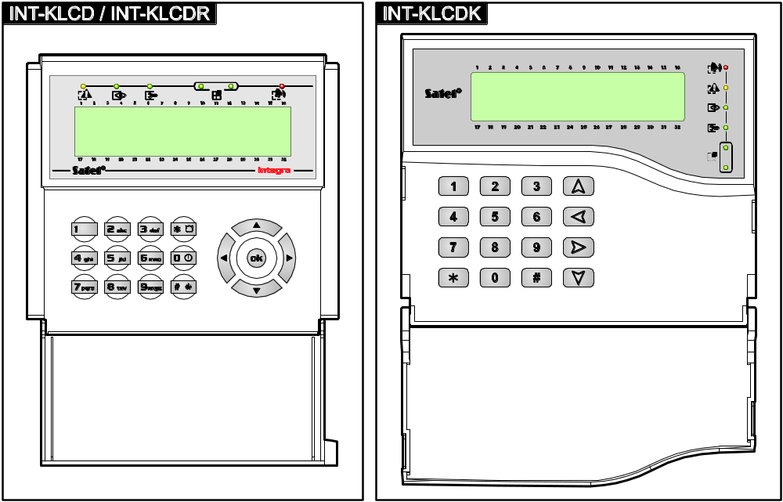
Fig. 1. Keypads with flap.

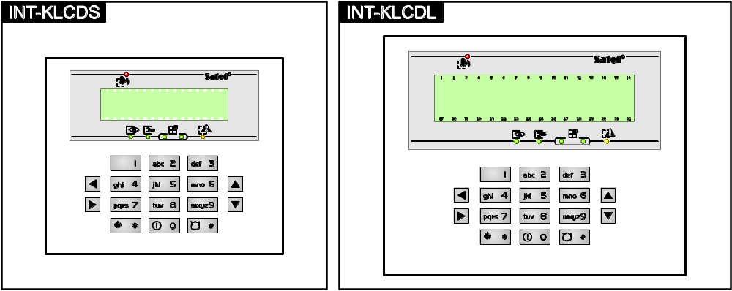
Fig. 2. Keypads without flap.

LED indicators

LED | Color | Function description
 | green | ON – all keypad operated partitions are armed  blinking – some keypad operated partitions are armed or exit delay countdown is running
 | red | ON or blinking – alarm or alarm memory
 | yellow | blinking – trouble or trouble memory
 | green | blinking – service mode is entered
 | green | if zone status is being presented or the keypad is switched to graphic programming mode (see: section Selection from the multiple-choice list p. 16), two LEDs indicate which data set is being displayed (see: table 2)
Table 1. Description of keypad LEDs.

Data type | LED |  | Information
Data type | left side/upper | right side/lower | Information
Zones/Outputs | OFF | OFF | numbers 1-32
Zones/Outputs | OFF | ON | numbers 33-64
Zones/Outputs | ON | OFF | numbers 65-96
Zones/Outputs | ON | ON | numbers 97-128
Expanders | OFF | OFF | system addresses 0-31 (00-1F HEX)
Expanders | OFF | ON | system addresses 32-63 (20-3F HEX)
Table 2. Information presented by the  LEDs.

Information about the armed state can be extinguished after a time period defined by the installer.
If the installer has enabled the Grade 2 option:
- the LEDs provide information about alarms only after the code has been entered and confirmed with the key;
- blinking of the LED means that there is a trouble in the system, some zones are bypassed, or that there was an alarm.

Keys
The keys designated with digits and letters enable entering the code and data, when using the functions available in the menu. Additionally, if you press and hold down the selected digit keys for approx. 3 seconds, you can (if the keypad has been so configured by the installer):
1 - check the state of zones;
4 - check the state of partitions;
5 - view the alarm log;
6 - view the trouble log;
7 - view the current troubles;
8 - enable/disable chime signal in the keypad;
9 - toggle the display between the standby mode and partition state display mode.
The other keys enable you to:
- enter the user menu (after entering the code);
- cancel the started operation.
or  - arm / disarm and clear alarm (after entering the code);
- start the selected function;
- confirm the entered data.
⧫    - navigate through the display (scroll through the displayed messages, functions and options, and move the cursor);
- run the installer selected functions (after entering the code).
 - trigger the fire alarm.
 - trigger the medical (auxiliary) alarm.
 - trigger the panic alarm.

Built-in proximity card reader
The INT-KLCDR keypad can be operated by means of proximity cards (proximity tags or other 125 kHz passive transponders). The installer defines which functions can be executed after presenting or holding the card.

Sound signaling

Beeps generated when operating
The installer can disable the sound signaling.
1 short beep – pressing any number key.
2 short beeps – confirmation of command execution, signaling of entering the user menu, submenu or function.
3 short beeps – signaling of:
- starting the arming procedure (if no exit delay has been programmed, this is equivalent to arming),
- disarming and/or alarm clearing;
- turning output off;
- disabling chime signal in the keypad, using the 8 key;
- toggling the display between the standby mode and the partition status presentation mode, using the 9 key;
- exiting the function and returning to the menu after confirmation of the data entered.
4 short beeps and 1 long beep – signaling of:
- turning output on;
- enabling chime signal in the keypad, using the 8 key;
- ending the function and exiting the user menu after confirmation of the data entered.
1 long beep – signaling of:
- violated/ bypassed zones when arming;
- fault of the vibration detector (10. 24h vibration type zone was not violated during the vibration detector test run upon starting the arming procedure).
2 long beeps – invalid code/card, function not available or exiting the function without confirmation of the data entered (e.g. by using the key).
3 long beeps – unavailable function.

Events signaled by sounds
Only installer selected events are signaled.
Alarms are being signaled throughout the time programmed by the installer.
5 short beeps – zone violation (CHIME).
Long beep every 3 seconds, followed by a series of short beeps for 10 seconds and 1 long beep – countdown of exit delay (if the time is shorter than 10 seconds, only the final sequence of short beeps will be generated).
A sequence of 7 beeps of diminishing duration, repeated every few seconds – countdown of auto-arming delay.
2 short beeps every seconds – countdown of entry delay.
2 short beeps every 3 seconds – signaling a new trouble.
Continuous beep – alarm.
Long beep every second – fire alarm.

[Code] – arming / disarming menu
After you enter the code and confirm it with the key:
- a message on the need to change the code or a service note may be displayed;
- alarm will be cleared – if the user is authorized to clear the alarm and there is an alarm in the system;
- one partition will be disarmed – if the user is authorized to disarm the partition, has access to only one partition operated from the keypad and that partition is armed, or has access to many partitions, but only one partition is armed;
- one partition will be armed – if the user is authorized to arm the partition, has access to only one partition operated from the keypad and that partition is disarmed;
- the arming/disarming menu will be displayed.

Arming menu
The arming menu will be displayed if:
- the user is authorized to arm the partition;
- the user has access to a number of partitions operated from the keypad;
- none of the partitions accessible to the user is armed;
- there is no alarm.
Two functions are available in the menu:
Arm all arming all partitions
Arm selected arming selected partitions

Disarming menu
The disarming menu will be displayed if:
- the user is authorized to disarm the partition;
- the user has access to a number of partitions operated from the keypad;
- at least two partitions accessible to the user are armed.
Two functions are available in the menu:
Disarm all disarming all partitions
Disarm selected disarming selected partitions

[Code] – user menu
After you enter the code and confirm using the key, the user menu will be displayed. The list of available functions depends on the user authority level, as well as the system status and configuration. In order to exit the user menu, press the key. The keypad will quit the menu automatically, if 2 minutes have elapsed since the last keypress.
Upon entering the code and confirming with the key, a message about the need to change the code or a service note may be displayed.

Functions list
The functions available after entering the service code have been highlighted with white text against black background. Highlighted with a frame are functions available to the administrators.
View clear. al. view cleared alarms from selected partition zones
System reset restore system after verified alarm
Disarm disarm selected partitions
Clear alarm clear alarm
Clear other al. clear alarm in other objects
Abort voice m. cancel telephone messaging
Arm arm selected partitions
Arm (2 codes) start two code arming
Disarm (2codes) start two code disarming
Defer auto-arm postpone the auto-arming
Set auto-arm d. set auto-arming postpone time
Arming mode select arming mode
Cancel 1st code cancel consent to two code arming/disarming
Change own code change own code
Change prefix
Prefix normal set normally used prefix
Prefix duress set duress prefix
Recall time set time to remind of the need to change prefix
Users
New user add new user
Code set code
Telephone code set telephone code
Partitions assign partitions available to the user
Type select type of code
Schedule select time schedule
Existence time set code validity time
Bypass time set bypass time
Rights assign rights
Keypads etc. assign modules available to the user
New prox. card add proximity card
Rem. prox. card remove proximity card
New DALLAS add DALLAS iButton
Remove DALLAS remove DALLAS iButton
New RX key fob add 433 MHz keyfob
Rem. RX key fob remove 433 MHz keyfob
Button 1 assign function to keyfob button 1
Button 2 assign function to keyfob button 2
Button 3 assign function to keyfob button 3
Button 4 assign function to keyfob button 4
Button 1 and 2 assign function to combination of keyfob buttons 1 & 2
Button 1 and 3 assign function to combination of keyfob buttons 1 & 3
Events (RX) set event generating rules
New ABAX keyfob add keyfob supported by ABAX system
Rem.ABAX keyfob remove keyfob supported by ABAX system
Button 1 assign function to keyfob button 1
Button 2 assign function to keyfob button 2
Button 3 assign function to keyfob button 3
Button 4 assign function to keyfob button 4
Button 5 assign function to keyfob button 5
Button 1 and 5 assign function to combination of keyfob buttons 1 & 5
Events (ABAX) set event generating rules
Confirm. (ABAX) set confirmation rules
Name program user name
Edit user edit existing user
[select user]
[list of parameters identical as in case of a new user]
Remove user remove user
Masters
New master add new master
Code set code
Rights assign rights
Keypads etc. assign modules available to the master
New prox. card add proximity card
Rem. prox. card remove proximity card
New DALLAS add DALLAS iButton
Remove DALLAS remove DALLAS iButton
New RX keyfob add 433 MHz keyfob
Rem. RX keyfob remove 433 MHz keyfob
Button 1 assign function to keyfob button 1
Button 2 assign function to keyfob button 2
Button 3 assign function to keyfob button 3
Button 4 assign function to keyfob button 4
Button 1 and 2 assign function to combination of keyfob buttons 1 & 2
Button 1 and 3 assign function to combination of keyfob buttons 1 & 3
Events (RX) set event generating rules
New ABAX keyfob add keyfob supported by ABAX system
Rem.ABAX keyfob remove keyfob supported by ABAX system
Button 1 assign function to keyfob button 1
Button 2 assign function to keyfob button 2
Button 3 assign function to keyfob button 3
Button 4 assign function to keyfob button 4
Button 5 assign function to keyfob button 5
Button 1 and 5 assign function to combination of keyfob buttons 1 & 5
Events (ABAX) set event generating rules
Confirm. (ABAX) set confirmation rules
Name set master name
Edit master edit existing master
[select master]
[list of parameters identical as in case of a new master]
Remove master remove master
Zone bypasses
Inhibit temporary zone bypass
Isolate permanent zone bypass
Set time set control panel clock
System state check troubles / check system state
Events
Selected
Select events select type of events to be viewed
Select part. select partitions from which events are to be viewed
View view selected events
View Grade2 view events required for Grade 2
All view all events
Grade2 view events required for Grade 2
Reset zones reset 43. Resetable power supply type outputs
Clr.latch.outs clear latched outputs
Fin.f.door open end door fire opening
Change options
Keypad chime enable/disable CHIME in keypad
Outputs chime block zone violation signal. on 11. Chime type outputs
Timers edit timers
Temperatures edit temperature thresholds for 120. Thermostat type outputs
Part. timers program partition timers
No exp.tamp.al. block expander tampers
Perm.serv.accs. enable/disable permanent installer access
Serv. can edit make user editing available to installer
Serv. ArmDis... make system control available to installer
Perm.DloadX acc enable/disable permanent DloadX access
DloadX IP set address of computer with DloadX program
GuardX IP set address of computer with GuardX program
Erase s.message erase service note
Tests
Partitions check current state of partitions
Zones check current state of zones
Supply voltages check module supply voltage
Radio devices check radio signal level for wireless devices
Temperatures check temperatures measured by ATD-100 detectors
Zones test
New
Burglary zones start new test for burglary zones
Fire/tech.zones start new test for fire and technical zones
View results view test results
Finish test abort test
Clear results clear test results
Battery test test battery and 60. Techn. - battery low zones
Manual tr. test start manual test transmission
Station 1A test start test transmission to station 1 – main phone number
Station 1B test start test transmission to station 1 – backup phone number
Station 2A test start test transmission to station 2 – main phone number
Station 2B test start test transmission to station 2 – backup phone number
Messaging test start messaging test
Answering test display information on answered tel. call
Prox. card test check proximity card number
CA-64 PTSA test start mimic board test
View masters view master users
Keypad name display keypad name
File in DloadX display inf. on DloadX program file with control panel data
Panel version display information on control panel firmware version
STM prg.version display inf. on ABAX syst. firmware [only INTEGRA 128-WRL]
GSM IMEI/v/sig. display information on GSM telephone [only INTEGRA 128-WRL]
IP/MAC ETHM-1 display inf. on ETHM-1 module IP address and MAC number
Modules version display information on module firmware version
Time synchron. start time synchronization
Service access set installer access time
Open door open selected door controlled by system
Outs control control outputs
Service mode start service mode
Take SM over take over service mode
Downloading
Start DWNL-RS start local programming
Finish DWNL-RS finish local programming
Start DWNL-MOD. start communication via external modem
Start DWNL-TEL start communication via 300 bps modem
Start DWNL-CSD start CSD communication [only INTEGRA 128-WRL]
Start DWNL-GPRS start GPRS communication [only INTEGRA 128-WRL]
ETHM-1 – DloadX start communication via Ethernet with DloadX program
ETHM-1 – GuardX start communication via Ethernet with GuardX program

Starting functions
- Using the  and  keys, find the required submenu or function. The currently selected submenu or function is indicated by the arrow () on the left-hand side.
- Press the  or key to enter the submenu (the  key allows to exit the submenu) or start the function.

Menu shortcuts
You can use shortcuts for quick access to some menu elements (submenus, functions). Press the suitable digit key (or combination of keys) to enter a submenu or start a function. Shown below is the list of submenus and functions available by using shortcuts. The shortcuts are shown in square brackets.
[1] Change own code
[2] Users
[21] New user
[22] Edit user
[23] Remove user
If the installer is not authorized to edit the users, the shortcuts beginning with the digit 2 will allow the installer to start the function from the Masters submenu.
[4] Zone bypasses
[41] Inhibit
[42] Isolate
[5] Events
[51] Selected events
[52] All events
[6] Set time
[7] System state
[8] Outputs control
[9] Service mode
[0] Downloading
[01] Start DWNL-RS
[02] Finish DWNL-RS
[03] Start DWNL-MOD.
[04] Start DWNL-TEL
[05] Start DWNL-CSD [only INTEGRA 128-WRL]
[06] Start DWNL-GPRS [only INTEGRA 128-WRL]
[07] ETHM-1 – DloadX
[08] ETHM-1 – GuardX

Entering data by means of the LCD keypad
Data are saved to the control panel if you press the key (in some keypads, the  key is also available, whose function is exactly the same). The key enables exiting the function without saving any changes.
Described below are general rules for entering data, however they may be different as regards some functions.

Selection from the single-choice list
Shown in the upper line of display is description of the function, and in the lower one – the currently selected item. You can scroll through the list of items, using the direction keys:  (down) and  (up). The  and  keys are not used.

Selection from the multiple-choice list
The functions that allow you to make multiple choice can be identified by an additional symbol situated at the right-hand side of the display:
– displayed item is selected / option is enabled;
– displayed item is not selected / option is disabled.
Press any numeric key to change the currently displayed symbol to another one. To scroll the list of items, use the  (down) or  (up) key.
For some functions, pressing the  or  key will switch the keypad into the graphic programming mode. The and symbols are used to present on the display the current status of up to 32 items available in the given function (these can be e.g. zones, outputs, timers, etc.). Additionally, in case of zone bypassing, the symbol is used. The  key moves the cursor to the right, and the  key to the left. If the list of items is longer than 32, pressing the  key when the cursor is placed over the last item will display the next list, and pressing the  key when the cursor is placed over the first item will display the previous list (see also description of the LEDs, p. 9). Pressing the key 0, 1 or 2 three times in the graphic mode within 3 seconds will have the following effect:
000 - the symbol will be displayed at all available items;
111 - the symbol will be displayed at all available items;
222 - reversal of the selection made: the symbol will be displayed at all items where the symbol was displayed, and the symbol where the symbol was displayed.
On pressing the  or  key, the keypad will return to the text mode.

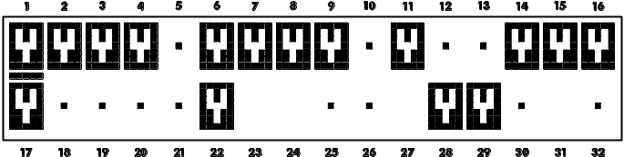
Fig. 3. Example of how information is presented in the graphic programming mode. The blank fields are not available for editing.

Entering decimal and hexadecimal values
Digits are entered by pressing the suitable keys. Characters from A to F are available under the keys with numbers 2 and 3. Keep pressing the keys until the required character appears.

Entering names

Press the particular keys until the required character appears. The characters available in the keypad are shown in Table 3. Hold down the key to display the digit assigned to the key.

Key | Characters available after next keystroke
1 | ! | ? | ' | ` |  | " | { | } | $ | % | & | @ | \ | ^ | | |  | # | 1
2 | a | b | c | 2
3 | d | e | f | 3
4 | g | h | i | 4
5 | j | k | l | 5
6 | m | n | o | 6
7 | p | q | r | s | 7
8 | t | u | v |  |  |  |  |  |  |  |  | 8
9 | w | x | y | z | 9
0 |  | . | , | : | ; | + | - |  | / | = | _ | < | > | ( | ) | [ | ] | 0
Table 3. Characters available when entering names. The lower case letters are available under the same keys (to change the letter case, press  key.

Shown on the left side in the upper line of the display is information about the letter case: [ABC] or [abc] (it will be displayed after pressing any key and will be visible for a few seconds after the last keystroke).
The  key moves the cursor to the right, and the  key – to the left. The  key deletes the character on the left side of the cursor.

Description of user functions
View cleared alarms – available, if the user did not view the violated zones after alarm clearing. It allows to check which zones triggered the alarm. After completion of the viewing, the function is no longer available.
System reset – available to the installer, if the option Required system reset after verified alarm is enabled, and a verified alarm took place. After occurrence of the verified alarm, it is necessary to reset the system by means of this function, in order to make re-arming possible.
Disarm – allows to disarm the partitions accessible to the user from the given keypad.
Clear alarm – allows to silence the alarm.
Clear other alarms – allows to silence the alarms from other partitions, to which the user has normally no access.
Abort voice messaging – terminates the telephone messaging.
The messaging can be cancelled automatically together with alarm clearing. The messaging cancellation rules are defined by the installer.
Arm – allows to arm the partitions accessible to the user from the given keypad.
Arm (2 codes) – allows to initiate arming of the partitions which require entering 2 codes.
Disarm (2codes) – allows to initiate disarming of the partitions which require entering 2 codes.
Defer auto-arming – available when auto-arming delay countdown is running. It allows to postpone by a programmed time period the auto-arming of the partition in which the auto-arming delay countdown is running. Entering just zeros will block the auto-arming function (until the next auto-arming time).
Set auto-arming delay – available when the auto-arming delay is programmed for at least one partition and the auto-arming delay countdown is not currently running in that partition. It allows to postpone by a programmed time period the auto-arming of the partition.
Arming mode – allows to select the arming mode which is to be used (the shortcut key is shown in square brackets):
[0] full arming (to be used after everybody has left the protected area);
[1] full arming + bypasses (allows the users to stay in the protected area) – the zones for which the bypassed if no exit option is enabled by the installer will remain bypassed;
[2] arming without interior (allows the users to stay in the protected area):
- interior zones (3. Interior delayed zone type) will be disarmed;
- violating the exterior zone (8. Exterior zone type) will trigger a silent alarm;
- violating another alarm zone will trigger a loud alarm.
[3] arming without interior and without entry delay (allows the users to stay in the protected area – to be used when nobody else is to enter the protected area) – this arming mode is similar to the previous one, but the delayed zones operate as the instant ones (no entry delay).
Cancel 1st code – if the partition is armed/disarmed by means of two codes and the first code has already been entered, the user can still cancel the consent to arming/disarming.
Change own code – allows the user to change his/her own code.
Change prefix – available to the administrator, if the use of prefixes in the system has been made available by the installer (the prefix length has been defined). It enables to program the prefixes and the time to remind about the need to change the prefix. Each code will have to be preceded by a prefix:
normal – for everyday use. By default, it consists of a suitable number of digits 0 (e.g. if the determined prefix length is 4, the default prefix is 0000);
DURESS – for use, when the user has been forced to enter the code. Using the code will trigger a silent alarm. By default, it consists of a suitable number of digits 4 (e.g. if the determined prefix length is 3, the default prefix is 444).
Users – the following functions are available in the submenu:
New user – allows to create a new user (see: section Adding new user p. 28).
Edit user – allows to edit the existing users (see: section Edit user p. 28).
Remove user – allows to remove the existing users (see: section Remove user p. 28).
The administrator defines whether the installer is to have access to the Users submenu (Serv. can edit option in the Change options submenu).
Masters – the submenu provides the following functions available to the installer:
New master – allows to create a new administrator.
Edit master – allows to edit the existing administrators.
Remove master – allows to remove the existing administrators.
Zone bypasses – the following functions are available in the submenu:
Inhibit – allows to temporarily bypass the zones (see: section Zone bypassing (inhibit) p. 31).
Isolate – allows to permanently bypass the zones (see: section Permanent bypassing (Isolate) p. 31).
If the Grade 3 option has been enabled by the installer, the Isolate function is only available to the installer.
Set time – allows to program the control panel clock. The data are entered in the following format:
time – hour:minute:second,
date – day:month:year.
System state – allows to view the troubles and, if the Grade 2 global option has been enabled by the installer, also the alarms and bypassed zones, as well as to check the partition status.
Events – the submenu contains functions which allow to view the events saved to the control panel memory (see: section Event log reviewing p. 32).
The content of received SMS messages is also saved to the events log of the INTEGRA 128-WRL control panel.
Reset zones – running the function will result in a temporary deactivation of the 43. Resetable power supply type outputs, thus making it possible to reset the alarm memory for detectors supplied from those outputs (e.g. fire detectors).
Clear latched outputs – allows to turn off some of the control panel outputs for which the Latch option is enabled, as well as the 9. DAY Alarm, 12. Silent alarm and 116. Internal siren type outputs.
Fin.f.door open – restores the normal operating mode in all modules executing the access control functions (in case of fire, the doors controlled by these modules may be automatically unlocked).
Change options – the following functions are available in the submenu:
Keypad chime – turns on/off the chime signal in the keypad (signaling violations of selected zones).
Outputs chime – allows to block the chime signal from selected partitions on the 11. Chime type output.
Timers – allows to program parameters of the timers controlling the 120. Thermostat type outputs, and other the timers, the editing of which is permitted by the installer.
Temperatures – allows to edit the temperature thresholds for 120. Thermostat type outputs.
Partition timers – allows to program the partition timers (see: Programming the partition timer p. 33).
No expanders tamper alarms – allows to temporarily disable the expansion module tamper supervision. In case of any problems with the expansion modules, report the fact to the installer.
Permanent service access – the option is available to the master user (administrator). If enabled, the installer has permanent access to the alarm system, which, among other things, enables the control panel to be programmed by using LCD keypad or DloadX program.
Enabling Permanent service access option will clear the installer access time programmed with the Service access function. On the other hand, programming the installer access time will disable the Permanent service access option.
Service can edit – the option is available to the master user (administrator). If it is enabled, the installer can add, edit and delete users in the administrator's object.
Service arm/disarm/clear/bypass – the option is available to the master user (administrator). If it is enabled, the installer can arm/disarm the system, clear alarms and bypass zones in the administrator object.
Permanent DloadX access – the option is available to the master user (administrator). If it is enabled, the control panel can be programmed by means of the DloadX program, irrespective of whether or not the installer has access to the alarm system.
DloadX IP – enables programming the address of the computer, on which the DloadX program is installed. The address must be set if the control panel is to initiate communication with the DloadX program through Ethernet, using the TCP/IP protocols (see: description of the ETHM-1 – DloadX function, available in the Downloading submenu). It can be entered as a name or IP address.
GuardX IP – enables programming the address of the computer, on which the GuardX program is installed. The address must be set if the control panel is to initiate communication with the GuardX program through Ethernet, using the TCP/IP protocols (see: description of the ETHM-1 – GuardX function, available in the Downloading submenu). It can be entered as a name or IP address.
Erase service message – allows the user to delete the service message.
Tests – the following functions are available in the submenu:
Partitions – allows to check the status of partitions accessible to the user and operated from the keypad. The partition status is presented by means of a symbol. The numbers placed on the glass allow you to identify the partition numbers. By factory default, the partition status is shown using the following symbols (which can be changed by the installer):
b - temporary blocked,
? - entry delay,
E - exit delay (less than 10 seconds),
e - exit delay (more than 10 seconds),
P - fire alarm,
A - alarm,
p - fire alarm memory,
a - alarm memory,
a - zone is armed,
- disarmed, not ready to be armed (violated zones),
- disarmed, ready to be armed.
Zones – allows to check the status of zones in the partitions accessible to the user and operated from the keypad. The zone status is presented by means of a symbol. The numbers placed on the glass allow you to identify the zone numbers. On starting the function, the status of zones 1-32 is displayed. Use the  and  keys to display the status of other zones (see also description of the LEDs, p. 9). By factory default, the zone status is shown using the following symbols (which can be changed by the installer):
b - zone bypass,
l - trouble "long violation",
f - trouble "no violation",
T - tamper alarm,
A - alarm,
 - zone tamper,
M - masking,
- zone violation,
t - tamper alarm memory,
m - masking memory,
a - alarm memory,
- zone OK.
Supply voltages – available to the installer. Enables checking of the supply voltage for individual expansion modules.
Temperatures – allows to check the temperatures measured by ATD-100 wireless detectors.
Radio devices – allows to check the radio signal level for ABAX system wireless devices supported by the control panel.
Zone Test – the submenu contains functions which allow to test the detectors connected to the zones (see: section Zone testing p. 34).
Battery test – available to the installer. Upon starting the function, the control panel will generate events to inform about the status of batteries of the control panel and hardwired expansion modules with power supply. Additionally, the status of 60. Tech.-Battery low type zones will be analyzed.
Manual transmission test – generates an event, which starts the procedure of event transmission to the monitoring station (a code sent with the system identifier).
Monitoring station test (1A, 1B, 2A, 2B) – allows to send a test transmission to the monitoring station (separate functions for each of the telephone numbers). When sending the transmission, messages are displayed to inform about the currently performed operation. The function is useful when starting the reporting or in case of any reporting trouble.
Messaging test – allows to test the messaging function. Upon starting the function:
- Enter the number of the telephone (consecutive number on the telephone list).
- Press the  key.
- Enter the number of voice message.
- Press the key. The control panel will call the indicated number and play back the message.
Answering test – if this function is started, information on the number of rings and going off-hook is displayed when answering the telephone call.
Proximity card test – allows to check the number of proximity card and establish to whom it belongs (if the card belongs to a user of the system).
CA-64 PTSA test – allows to test the mimic board.
View masters – available to the administrator. It makes it possible to check in which objects the master users are created.
Keypad name – allows to check the given keypad name.
File in DLOADX – displays the date and time of writing the data to the control panel by means of the DloadX program and the name of file with control panel data.
Panel version – displays information on the control panel firmware version.
STM program version – displays information on the program version of the processor used to operate ABAX system and power supply unit. only INTEGRA 128-WRL
GSM IMEI/v/sig. – allows to check the level of signal received by the GSM telephone antenna, individual identification number of the telephone, and the telephone version. The  and  keys are to be used for scrolling through the displayed information. only INTEGRA 128-WRL
IP/MAC ETHM-1 – displays the IP address and MAC number of the ETHM-1 module connected to the control panel.
Modules versions – allows to check the firmware versions for devices connected to the control panel communication buses.
Time synchronization – allows to manually start synchronization of the control panel clock and the time server. It applies to the control panel to which the ETHM-1 module is connected. The address of time synchronization server must be programmed in the control panel.
The function is unavailable, if the time synchronization is running. Automatic time synchronization takes place every day at 05:30.
Service access – available to the master user (administrator). Allows to program the time period of installer access to the alarm system. The time is programmed in hours. Programming the value 0 means the installer will have no access.
Open door – allows to unlock the door controlled by the alarm system (modules executing the access control functions) or activate the 101. Card read – expander type outputs.
Outputs control – allow to control the devices connected to the MONO switch, BI switch, Remote switch, Shutter up and Shutter down type outputs (see: section Outputs control p. 35).
Service mode – available to the installer. Initiates the service mode.
Take SM over – available to the installer. If the service mode has been initiated from another keypad, it can be "taken over", i.e. the service menu can be displayed on the keypad, on which the Take SM over function has been started.
Downloading – the following functions are available in the submenu
Start DWNL-RS – available to the installer. Enables the control panel to be programmed locally by means of the DloadX program.
Finish DWNL-RS – available to the installer. Ends the local programming of control panel.
Start DWNL-MOD. – enables remote programming through an external modem (analog, GSM or ISDN) by means of the DloadX program.
Start DWNL-TEL – enables remote programming through the built-in 300 bps modem, using the DloadX program.
Start DWNL-CSD – enables remote programming through the built-in GSM communicator, using CSD technology, by means of the DloadX program. only INTEGRA 128-WRL
Start DWNL-GPRS – enables remote programming through the built-in GSM communicator, using GPRS (General Packet Radio Service), by means of the DloadX program. only INTEGRA 128-WRL
ETHM-1 – DloadX – enables remote programming through the Ethernet (TCP/IP) by means of the DloadX program. The ETHM-1 module with firmware version 1.03 (or newer) must be connected to the control panel.
ETHM-1 – GuardX – enables remote operation and administration through the Ethernet (TCP/IP) by means of the GuardX program. The ETHM-1 module with firmware version 1.03 (or newer) must be connected to the control panel).

Arming
This section describes the operations that must be carried out by the user from the keypad in order to initiate the arming procedure. The arming procedure is ended at the running out of the exit delay time (if the procedure is ended successfully, the system becomes armed – see also Failure of arming procedure p. 24). If the exit delay time is 0, the system becomes armed instantly.
The installer can configure the alarm system so that the arming functions will not be available after tamper. A message on the display will indicate that the user must call for service. The arming functions will not be available until the service code is entered and confirmed with the key.

Full arming without partition selection
The arming without partition selection is possible when none of the partitions to which the user has access is armed and the keypad is not signaling any alarm.
- Enter the code and confirm with the key.
- When the Arm all function is displayed, press the key. The arming procedure will be initiated in all partitions which are accessible to the user and are operated by the keypad.
If the user can only arm one partition, the arming procedure will be initiated as soon as the code is entered and confirmed with the key.

Full arming the selected partitions
- Enter the code and confirm with the key.
- Using the  key, scroll through the menu until you find the Arm function.
- Press the key. A list of partitions which can be armed will be displayed.
- Using the  and  keys, find in the list the partition which is to be armed.
- Press any digit key. The symbol in the upper right-hand corner will be replaced by the symbol (see also section Selection from the multiple-choice list p. 16).
- Repeat the steps 4 and 5 for the next partitions which are to be armed.
- Having selected the partitions which are to be armed, press the key.
You can also arm the selected partitions using of the Arm selected function, available upon entering the code and confirming with the key, but only when none of the partitions accessible to you is armed and the keypad is signaling no alarm.

Arming in the selected mode
- Enter the code and confirm with the key.
- Using the  key, scroll through the menu until the Arming mode function is found.
- Press the key. A list of arming modes will be displayed (see: description of the Arming mode function, p. 18).
- Using the  and  keys, find the arming mode which is to be activated, and then press the key.
- When the Arm function is displayed, press the key. Proceed in the same way, as for the full arming of selected partitions (steps 4-7).

Quick arming
The installer can permit the arming without user authorization. The partitions indicated by the installer will be armed.
- Select the arming mode (press one of the keys: 0 – full arming; 1 – full arming + bypasses; 2 – arming without interior; 3 – arming without interior and without entry delay).
- Press the key. The arming procedure will begin.

Denial of arming
The installer can program the control panel so that the arming procedure could not be started, if:
- a zone is violated in the partition;
- there is a trouble in the system (including tamper);
- there was a verified alarm.
The keypad will inform you about the refusal to arm by means of a message specifying the cause for refusal.
If after a verified alarm the arming is impossible, the installer must be called. The arming will only be possible after the installer intervention (see: description of the System reset function, p. 17).

Bypassing violated zones when arming
If the arming procedure could not be started, and a message on the display informs you that there are violated zones, you can review the list of such zones upon pressing the 2 key. To scroll through the list, use the  and  keys. Pressing the 4 key will allow you to bypass the given zone. A message on the display will prompt you to press the 1 key to confirm that the zone is to be bypassed.

Forced arming
If the arming procedure could not be started, the displayed message can allow of the forced arming (1=Arm). On pressing the 1 key, the system will be armed despite a violated zone or a trouble.

Failure of arming procedure
If the installer has enabled the Grade 2 option, the arming procedure may end in failure. The system will not be armed, if at the end of the exit delay countdown:
- there is a violated zone in partition which was not violated when the arming procedure was started;
- there is a trouble which did not exist when the arming procedure was started.

Shortening the exit delay time
If such an option is permitted by the installer, the partition exit delay time may be shortened upon pressing in turn the 9 and keys.

Disarming and alarm clearing
Enter the code and confirm with the key (see: section [Code] – arming / disarming menu p. 11). If only selected partitions are to be disarmed (Disarm selected function), the partitions should be selected in the same way as when arming the selected partitions.

Alarm clearing without disarming
- Enter the code and confirm with the key.
- Using the  key, scroll through the menu until the Clear alarm function is found.
- Press the key.

Two-code arming / disarming
If the partition is to be armed / disarmed with 2 codes, the user entering the first code must:
- Enter the code and confirm with the key.
- Scroll through the menu using the  key until the Arm (2 codes) / Disarm (2codes) function is found.
- Press the key. Proceed in the same way as for the full arming of selected partitions (steps 3-7).
- If the installer has not set the code validity at 60 seconds, specify the code validity and confirm with the key.
Prior to expiration of the code validity, the user entering the second code must arm / disarm the partition using the:
- LCD keypad (see: section Arming or Disarming and alarm clearing);
- partition keypad ([code]);
- reader (read-in of proximity card or DALLAS iButton).
The installer can configure the alarm system so that the second code will have to be entered on another LCD keypad, partition keypad, etc.

Triggering the alarm from keypad
The installer can permit triggering alarms from the keypad. To trigger an alarm, do the following:
fire alarm – press the key for approx. 3 seconds;
medical (auxiliary) alarm – press the key for approx. 3 seconds;
panic alarm – press the key for approx. 3 seconds. The installer defines whether the loud panic alarm (setting off the loud alarm signal) or the silent panic alarm (without the loud signal) will be triggered.

Users
The users can be added, edited and removed by:
- master user (administrator);
- installer (if the Serv. can edit option is enabled by the administrator);
- user (if granted the Users editing right).
The following data can be defined for the user:
Code – a sequence of digits for authorization of the user when using keypads and code locks. The control panel supports codes consisting of 4 to 8 characters, however the installer can define the minimum length of the code.
Telephone code – a sequence of digits for authorization of the user when using the functions of telephone call answering and telephone control (see: section Call answering and telephone control p. 43).
Partitions – partitions to which the user has access (i.e. he is authorized to arm or disarm them, clear alarms etc.).
Type – see: section User types p. 27.
User schedule – parameter for the Scheduled type code (see: section User types p. 27).
Validity time – parameter for the Renewable, Temporary or Schematic type codes (see: section User types p. 27).
Blocking time – parameter for the Blocking partition type code (see: section User types p. 27).
Rights – define which functions can be used by the user. The following rights (permissions) are available:
- Arming
- Disarming
- Disarm, when other user arm [Can alw.disarm] – if the user does not have this right, he/she can only disarm the system if it was armed by him/her
- Partition alarm clearing [Alarm clearing]
- Object alarm clearing [Object al.clr.]
- Other partitions alarm clearing [Other al.clr.]
- Telephone messaging canceling [V.msg.clearing]
- Auto-arming defer [Arm deferring]
- First code for two codes partition [Enter.1st code]
- Second code for two codes partition [Enter.2nd code]
- Access temporary blocked partitions [Block p.access]
- Change access code [Code changing]
- Users editing
- Zones bypassing [Zones inhibit]
- Zone isolation [Zones isolate]
- Clock setting
- Trouble state checking [Troubles view.]
- Event log reviewing [Events viewing]
- Detectors resetting [Zones resett.]
- Options programming [Options chang.]
- Access to menu TEST [Tests]
- Downloading starting [Downloading]
- Access to BI & MONO outputs [Outs control]
- System state review in GuardX [GuardX using]
- Resetting outputs [Clr.latch.outs]
Keypads etc. – additional modules from which the user will be able to operate the system (proximity card arm/disarm devices, partition keypads, code locks, reader expanders).
Proximity cards / DALLAS chips – if the proximity card / DALLAS iButton reader is used in the system, a proximity card / DALLAS iButton can be assigned to the user, which will allow the user to operate the system by means of readers.
Keyfobs – in case of the INTEGRA 128-WRL control panel or any other control panel to which a module with keyfob support is connected (ACU-100, ACU-250, INT-RX or INT-RX-S), a keyfob can be assigned to the user, which will allow to operate the system remotely. The user may have up to 2 keyfobs: the APT-100 (supported by the ABAX system) and the 433 MHz (supported by the INT-RX or INT-RX-S modules).
Buttons – the button functions are available, if a keyfob has been assigned to the user. It is possible to assign a zone to a keyfob button or combination of buttons. The zone will be violated upon pressing the button / combination of buttons. The assigned zone should not exist physically.
Events (RX) / Events (ABAX) – if a keyfob has been assigned to the user, it is possible to define whether pressing the appropriate keyfob button will result in logging an event which informs that the keyfob has been used.
ABAX confirmation – if an ABAX system keyfob has been assigned to the user, it is possible to determine the status of which outputs will be presented on the keyfob LEDs on pressing any button.
Name – individual user name.

User types
The name as used in the keypad is shown in the square brackets. The description includes only the codes, but the information provided below applies to all identifiers assigned to the user.
Normal – basic type of user.
One-time [Single] – the user will get one-time access.
Renewable [Time renewable] – the user has access to the system for a defined period of time. The user validity time should be defined. Before the validity time expires, the control panel will prompt the user to change the code. After the code has been changed, the validity time will run from the beginning.
Temporary [Time not renew.] – the user has access to the system for a defined period of time. The user validity time should be defined. After the validity time expires, the user will have no access to the system.
Duress – code to be used in hold-up and duress situations. Use it to trigger a silent alarm and send the event code to the monitoring station.
„Mono” output operating [Mono outputs] – code for control of the MONO switch type outputs.
„Bi” output operating [Bi outputs] – code for control of the BI switch type outputs.
Blocking partition [Part.temp.block.] – the code enables access to the armed partitions. Using the code will block the armed partition(s) (the partition zones will not trigger the burglary alarm). The blocking time is defined individually for each user within the range from 1 to 109 minutes. If, however, the time of bypassing for guard round is defined for the partition and its duration is longer, the blocking will last longer.
Cash machine zones bypassing [Acces.to cash m.] – the code to be used to unblock access to the cash dispenser (the 24H Cash machine type zones will be temporarily bypassed in the partition).
Guard – using this code means having made the round (additionally, it can result in the partition being temporarily bypassed for the duration of guard round). The installer defines the modules which are used to confirm making the round and determines the time interval between successive rounds. If such a user is granted access to the partition, he/she will have the same possibilities as the Normal type user.
Scheduled – the user has access to the system as per the time schedule for a specified period of time. It is necessary to select the schedule (the schedule is programmed by the installer) and define the user validity period.

Adding new user
- Enter the code and confirm with the key.
- Press in turn the 2 and 1 keys. The list of functions to define the user parameters will be displayed.
If the service code has been entered, before the list of functions is displayed, it is necessary to specify the object in which the new user is to be created (the service code enables access to all objects).
- Using the appropriate functions, define the user's parameters.
At least one identifier, i.e. code, proximity card, DALLAS iButton or keyfob, must be assigned to the user.
The new user may not be granted a higher authority level than the person who is adding that user to the system.
- Press the key.
- When a prompt appears, asking you if the changes are to be saved, press the 1 key.
- A message will inform you that a new user has been created. Press the key to return to the User submenu.

Edit user
The user can edit the users in relation to which he/she is the superior. For example, if the user A has created the user B, and the user B has created the user C, then the user A can edit the users B and C.
The user being edited may not be granted a higher authority level than the person who is editing such a user.
- Enter the code and confirm with the key
- Press the 2 key twice. The list of users will be displayed.
- Using the  and  keys, find in the list the user who is to be edited.
- Press the key. The list of functions for defining the user's parameters will be displayed.
- Using appropriate functions, modify the user's parameters.
- Press the key.
- When a prompt appears, asking you if the changes are to be saved, press the 1 key.
- A message will inform you that the user has been modified. Press the key to return to the list of users.

Removing a user
The user can remove the users in relation to which he/she is the superior. For example, if the user A has created the user B, and the user B has created the user C, then the user A can remove the users B and C.
- Enter the code and confirm with the key.
- Press in turn the 2 and 3 keys. The list of users will be displayed.
- Using the  and  keys, find in the list the user who is to be removed.
- Press the key. A message will inform you that the user has been removed.
- Press the key to return to the list of users.

Adding proximity card / DALLAS iButton
- When adding or editing a user, run the New prox. card / New DALLAS function.
- Using the  and  keys, select how the card / iButton is to be added. The number of card / iButton can be read by a selected reader (device equipped with a reader) or entered manually.
- Press the key.
- If the number of card / iButton is to be read, read in the card / iButton twice, following the instructions appearing on the keypad display. When the read number of card / iButton is displayed, press the key.
- If the number of card / iButton is to be entered, enter it from the keypad, and then press the key.
- You will be brought back to the list of functions for defining the user parameters. Instead of the New prox. card / New DALLAS function, the Remove prox. card / Remove DALLAS function will be available. Press the key.
- When a prompt appears, asking you if the changes are to be saved, press the 1 key.
Proximity cards / DALLAS iButtons are added to the master users (administrators) in the same way.

Adding keyfob
- When adding or editing a user, run the New RX keyfob / New ABAX keyfob function (depending on which keyfob is to be added).
- Using the  and  keys, select how the keyfob is to be added. The number of keyfob can be read during transmission by a device supporting keyfobs or entered manually.
- Press the key.
- If the keyfob number is to be read, press twice the keyfob button according to the instructions displayed on the keypad. When the keyfob number is displayed, press the key.
- If the keyfob number is to be entered, enter it from the keypad, and then press the key.
- You will be brought back to the list of functions for defining the user parameters. Instead of the New RX key fob / New ABAX keyfob function, the Rem. RX key fob / Rem.ABAX keyfob function will be available. Additionally, some functions appear to allow you to configure the keyfob.
Prior to assigning the zones to buttons / combinations of buttons, consult the installer.
Numeration of the keyfob buttons and LEDs is described in section Operating the Alarm System by means of Keyfob (p. 45).
- Using the  key, find the Button 1 function in the list, and then press the key.
- Using the  and  keys, select which zone is to be violated on pressing the 1 button in the keyfob (you can also enter the zone number from the keypad), and then press the key.
- Repeat the steps 7 and 8 for other buttons / combinations of buttons which are to be used.
- Using the  key, find the Events (RX) / Events (ABAX) function in the list.
- Press the key. The list of buttons / combinations of buttons will be displayed. In the upper right-hand corner of the display, an additional symbol is located:
– pressing the button / combination of buttons is written to the event log (default setting);
– pressing the button / combination of buttons is not written to the event log.
- Define whether pressing the button / combination of buttons will be written to the event log (see: section Selection from the multiple-choice list p. 16), and then press the key.
- For the APT-100 (ABAX) keyfobs, use the  key to find the ABAX confirmat. function in the list, and then press the key.
- A list will be displayed showing the outputs which have been assigned by the installer for confirmation (maximum 8). Select up to 3 of them (see: section Selection from the multiple-choice list p. 16). Upon pressing any keyfob button, information on the status of selected outputs will be presented on the keyfob LEDs for a few seconds. Thus you can get confirmation that the function has been executed or information on the current status of the system.
The installer can define the list of outputs by means of the keypad (ABAX confirmat. function [Service mode Structure hardware Expanders ABAX confirmat.] or a computer with the DloadX program ("Keyfobs ABAX" window).
- Press the key.
- Press the key.
- When a prompt appears, asking you if the changes are to be saved, press the 1 key.
Keyfobs are added to the master users (administrators) in the same way.

Removing keyfob
- When adding or editing a user, run the Rem. RX key fob / Rem.ABAX keyfob function (depending on which keyfob is to be removed). The appropriate function is only displayed when a keyfob has already been assigned to the user.
- When the keyfob number and a prompt whether the keyfob is to be removed are displayed, press the 1 key. You will be brought back to the list of functions for defining the user parameters.
- Press the key.
- When a prompt appears, asking you if the changes are to be saved, press the 1 key.
Removal of a keyfob will not erase its settings (dependences between the buttons and zones, confirmation rules, etc.). When added to the user, the new keyfob will have the same settings as the deleted one.
The installer can remove all keyfobs, including their settings, by means of the functions available in the service mode (Structure hardware Expanders Rem.RX key fobs / Rem.ABAX keyfob).
The administrators' keyfobs are removed in the same way.

Master users (administrators)
The master users (administrators) can be added, edited and removed by the installer. There can be 1 administrator in each object. The administrator has access to all partitions in the object and also specifies how the system can be accessed by using the service code. Most of the parameters which are defined for the ordinary user can be defined for the administrator (see: section Users p. 25).

Zone bypassing
You can bypass / unbypass zones in the disarmed partitions. Violating a bypassed zone will not trigger any alarm. Bypassing the zones is useful in case of damage or failure of the detector connected to the zone, which results in malfunctioning of the alarm system (e.g. triggering false alarms).
Zone bypassing reduces the level of protection. Prior to arming, make sure that there are no accidentally bypassed zones in the partition, which might allow an intruder to get access to the protected area despite arming.
If a zone is bypassed, call in the installer (service technician) immediately to repair the defect.
For security considerations, the installer may reduce the number of zones that the user will be allowed to bypass.

Zone inhibiting
The zones can be inhibited by the users having the Zones bypassing right. The inhibited zone will be bypassed until the partition to which the zone belongs is disarmed, or until the zone is unbypassed by the user.
- Enter the code and confirm with the key.
- Press in turn the 4 and 1 keys. The list of zones will be displayed. There is an additional symbol in the upper right-hand corner of the display to inform you about the given zone status:
– the zone is not bypassed;
– the zone is inhibited;
– the zone is isolated.
- Using the  and  keys, find in the list the zone which is to be inhibited.
- Press any digit key until the symbol appears in the upper right-hand corner of the display.
- Repeat the steps 3 and 4 for the next zones which are to be inhibited.
- Press the key. A message will inform you that the zones are inhibited.
Having started the Inhibit function (step 2), you can press the  or  key to switch over the keypad to the graphic programming mode (see: section Selection from the multiple-choice list p. 16).

Zone isolating
The zones can be isolated by the users having the Zones bypassing and Zone isolation rights. The isolated zone will remain bypassed until unbypassed by the user.
- Enter the code and confirm with the key.
- Press in turn the 4 and 2 keys. The list of zones will be displayed. There is an additional symbol in the upper right-hand corner of the display to inform you about the given zone status:
– the zone is not bypassed;
– the zone is inhibited;
– the zone is isolated.
- Using the  and  keys, find in the list the zone which is to be isolated.
- Press any digit key until the symbol appears in the upper right-hand corner of the display.
- Repeat the steps 3 and 4 for the next zones which are to be isolated.
- Press the key. A message will inform you that the zones are isolated.
Having started the Isolate function (step 2), you can press the  or  key to switch over the keypad to the graphic programming mode (see: section Selection from the multiple-choice list p. 16).

Unbypassing
The zones can be unbypassed by the users having the Zones bypassing right. Proceed in the same way as when inhibiting or isolating the zones (steps 1-3), but the symbol must be shown in the upper right-hand corner of the display, if the zone is to be unbypassed upon pressing the key.

Viewing the event log
The events viewing function, when started by the administrator or the ordinary user, provides no information about:
- panic alarms;
- alarms triggered using the DURESS type code.

Viewing all events
- Enter the code and confirm with the key.
- Press in turn the 5 and 2 keys. The last event which occurred in the system will be displayed.
- Using the  key, scroll through the list of previous events.

Viewing the events required for Grade 2
If the Grade 2 option is enabled in the system, the function allowing the installer and administrators to view events required by EN 50131 for Grade 2 is available.
- Enter the code and confirm with the key.
- Press the 5 key. Functions available in the Events submenu will be displayed.
- Using the  key, scroll the menu until the Grade2 function is found.
- Press the key. The last Grade 2 required event which occurred in the system will be displayed.
- Using the  key, scroll through the list of previous events.

Viewing the selected events
- Enter the code and confirm with the key.
- Press in turn the 5 and 1 keys.
- When the Select events function is displayed, press the key. The list of event types will be displayed.
- Select which event types are to be displayed (see: section Selection from the multiple-choice list p. 16).
- Press the key. This will bring you back to the Selected submenu.
- Using the  key, scroll down the menu until you find the View function.
- Press the key. The last one of the selected events which occurred in the system will be displayed.
- Using the  key, scroll through the list of previous events.
In addition to defining the event types to be displayed, the Select part. function can also be used to indicate the partitions to which the events are to refer.
If the Grade 2 option is enabled in the system, the installer or administrator can use the View Grade2 function instead of the View function. In such a case, the events selected among those required by the EN 50131 standard for Grade 2 will be displayed.

Way of presenting events
The following information is shown in the display upper line:
- date and time of event occurrence;
- additional information on the events in shortened form, e.g. number of partition, zone, user, timer, expander, keypad, etc.
Event description is displayed in the lower line.
If no key is pressed for a few seconds, additional information on the event will be displayed, e.g. name of partition, zone, user, timer, expander, keypad, etc.. After a few seconds, the event description will be displayed again, and so on.
Pressing the  key enables the manual toggling between description of the event and additional information on the event.
Pressing the  key when the event description is displayed will allow you to see further additional information on the event, shown in a shortened form.
Using the  or  key will block the automatic toggling between description of the event and additional information on the event.
After the list of events has been scrolled through with the use of the  or  key, the automatic toggling between description of the event and additional information on the event will be restored.

Programming the partition timer
The partition timer automatically arms / disarms the partition.
- Enter the code and confirm with the key.
- Using the  key, scroll through the menu until you find the Change options submenu.
- Press the key.
- Using the  key, scroll through the menu until you find the Part. timers function.
- Press the key. The list of partitions will be displayed.
- Using the  and  keys, find in the list the partition for which the timer is to be programmed.
- Press the key.
- When the Active option is displayed, make sure it is enabled (the symbol is displayed next to the option). If it is not enabled (the symbol is displayed next to the option), press any digit key.
- Using the  key, scroll through the menu until you find the Type function.
- Press the key.
- Using the  and  keys, select the timer type:
everyday – if the partition is to be armed / disarmed at the same time every day;
weekly – if the partition is to be armed / disarmed at different times on different days of the week.
- Press the key.
- If you have selected the daily variant, the function will allow you at once to program the arming time, and upon pressing the  or  key – the disarming time. Upon confirmation with the key, you will be brought back to the list of options and functions.
- If you have selected the weekly variant, you will be brought back to the list of options and functions, where functions will appear to enable programming of the arming / disarming time for each day of the week (in the same way as for daily timer).
Programming the value 99:99 means that the partition will not be armed / disarmed.
- After the arming time has been programmed, an additional function will be displayed, which allows you to define which arming mode will be activated by the given timer. By default, the timer activates the full arming mode. If another arming mode is to be activated, run this function (for the daily timer or individually for each day of the week) and, using the  and  keys, select another arming mode. Confirm, using the key.
- Having programmed all parameters, press the key.
- When a prompt appears, asking you if the changes are to be saved, press the 1 key.

Zone testing
Within periodic inspections of the security alarm system, the detectors must be checked for proper functioning. The zone testing function will allow you to do it without triggering the reaction normally expected on violation, which is of particular importance in case of permanently armed zones.
- Enter the code and confirm with the key.
- Using the  key, scroll through the menu until you find the Tests submenu.
- Press the key.
- Using the  key, scroll through the menu until you find the Zones Test submenu.
- Press the key.
- When the New function is displayed, press the key.
- Select whether burglary zones or fire and technical zones will be tested, and then press the key.
- Select the partitions in which zones will be tested (see: section Selection from the multiple-choice list p. 16).
- Specify the test duration (maximum 25 minutes) and press the key.
- Define, whether violation of a zone is to be signaled by chime in the keypad (the signaling will be enabled upon pressing any digit key – the symbol will be displayed).
- Press the key. The zone test will start.
Beginning of the zone test in any partition will start the test mode in all ABAX system wireless devices which are used together with the control panel (the wireless detectors will signal violations by means of LEDs).
If any detectors with remote LED ON/OFF function are connected to the control panel, you can switch on the LEDs in them for the test duration (the installer can configure the control panel so that this will take place automatically at the beginning of the test).
You can terminate the zone test before expiration of the programmed time, using the Finish test function (Tests Zone Test Finish test). Up to 6 seconds can elapse between starting the function to the actual end of the test (during this the Finish test function will be still available).
- Depending on the type of tested detector:
  - magnetic contact – open and close the door or window protected by means of the magnetic contact;
  - motion detectors – pass in front of the detector;
  - other detectors – follow the manufacturer's directions for the detector testing.
- Look through the test results. To do so, enter again the Zones Test submenu (see: steps 1-5) and start the View results function. You can scroll through the list of results, using the  and  keys. Press the  or  key to switch over the display to the graphic mode, in which information is provided by means of symbols:
- zone was not violated,
- zone was violated.
Pressing the  or  key in the graphic mode will display information on another set of zones (see also description of the LEDs, p. 9).
The test results can be deleted by means of the Clear results function (Tests Zones Test Clear results).

Outputs control
If permitted by the installer, the control function can be started without user authorization, upon pressing in turn the 8 and keys.
- Enter the code and confirm with the key.
- Press the 8 key. Depending on how the control panel has been configured by the installer:
  - a group of outputs will be displayed – using the  and  keys, find the group which includes an output, and then press the key to display the list of outputs;
  - the list of controllable outputs will be displayed at once.
- Using the  and  keys, find in the list the output whose status you want to change to control the device connected to the output. The output status is presented by means of symbols:
- output inactive (disabled),
- output active (enabled).
The output status can be presented according to the zone status. The displayed symbols should then be interpreted as follows:
- zone not violated (the device controlled by output is inactive);
- zone violated (the device controlled by output is active).
The way of presenting the status of roller shutter outputs differs from how the status of other outputs is presented (see: section Controlling the roller shutter outputs).

Controlling the MONO switch type of output
When the output is inactive:
- pressing the  key will activate the output for the time programmed by the installer;
- pressing the key will allow you to program the time for which the output will be activated upon the next pressing of the key.
When the output is active, pressing any digit key will turn the output off.

Controlling the Bi switch type of output
Pressing the or  key will change over the output status. Additionally, when the output is active, pressing any digit key will turn the output off.

Controlling the Remote switch type of outputs
Depending on how the output has been programmed, pressing the or  key will activate the output for the time programmed by the installer or change over the output status. Additionally, when the output is active, pressing any digit key will turn the output off.

Controlling the roller shutter outputs
The Shutter up and Shutter down type of outputs are always programmed as consecutive and in pairs. Displayed on the list of outputs is only the name of output programmed as Shutter up. The status of outputs is presented by means of symbols:
- outputs inactive (off),
- Shutter up output active (on),
- Shutter down output active (on).
Pressing the or  key will display the cursor in the form of a horizontal line under the output status symbol. Pressing the  key will turn on the Shutter up type output (if both outputs are inactive) or turn off the Shutter down type output (if it is active). Pressing the  key will turn on the Shutter down type output (if both outputs are inactive) or turn off the Shutter up type output (if it is active). Irrespective of which output is currently active, pressing any digit key will turn the output off. When the control is finished, press the or  key to return to the list of outputs which can be controlled (the cursor under the symbol will disappear).

Using the partition keypad
The main task of the partition keypad is to arm/disarm one partition. Additionally, it offers a number of other functions, including e.g. the access control (supervision of a single door).
SATEL offers the following partition keypads:
INT-S;
INT-SK;
INT-SCR (multifunction keypad, offering the partition keypad functionality).
The keypads are available with keys backlight in various color versions. The color version is indicated by an additional letter symbol included in the keypad designation (e.g. INT-S-GR – green backlight; INT-S-BL – blue backlight).

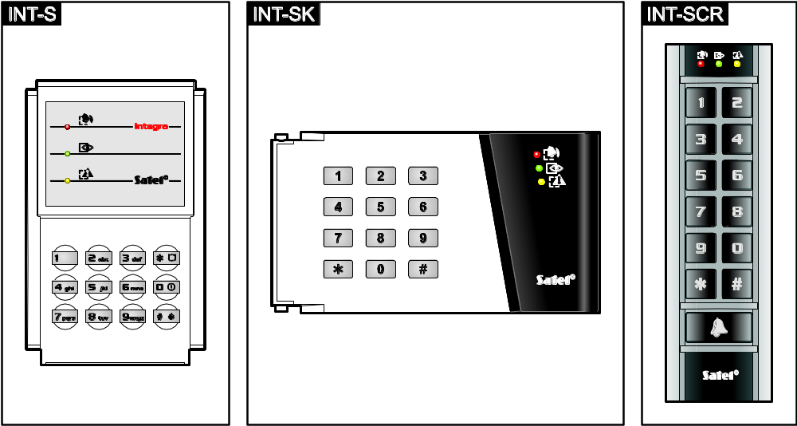
Fig. 4. Partition keypads (INT-S and INT-SK keypads are shown without flaps).

Description of partition keypads

LED indicators

LED | Color | Function description
 | green | ON – partition armed
 | red | ON or blinking – alarm or alarm memory
 | yellow | blinking – trouble or trouble memory
Table 4. Description of LEDs in partition keypads.

Information on the armed status can be extinguished after the time period defined by the installer.
If the installer has enabled the Grade 2 option:
- the LED will not inform about the alarms;
- blinking of the LED means that there is a trouble in the system, some zones are bypassed, or that there was an alarm.
The  and LEDs blinking alternately indicate that the system is waiting for the second code during the two code arming / disarming.
All LEDs blinking in turn indicate that there is no communication with the control panel.

Keys
The keys enable authorization of the user by means of code and running of the functions available from the partition keypad.
In the INT-SCR keypad, the  button is additionally available. It controls the keypad OC type output (the output is active, when the button is pressed).

Built-in proximity card reader
The INT-SCR keypad has a built-in reader which enables operation by means of proximity cards (proximity tags or other 125 kHz passive transponders). The installer determines, if the reader will be operated.
Presenting the card is interpreted in the same way as entering the code and confirming with the key. Holding the card (for approx. 3 seconds) is interpreted in the same way as entering the code and confirming with the key.

Sound signaling

Beeps generated when operating
The installer can disable the sound signaling or replace it with blinking of the keys backlight.
1 short beep – pressing any digit key, confirmation that code has been entered or card has been read.
2 short beeps – acceptance of the first code during two code arming / disarming.
3 short beeps – signaling of::
- starting the procedure of arming (if no exit delay time has been programmed for the partition, this is equivalent to arming),
- disarming and/or alarm clearing.
4 short and 1 long beeps – confirmation that the function has been executed.
3 pairs of short beeps – the user should change his/her code.
1 long beep – refusal to arm (there are violated zones in the partition or there is a trouble).
2 long beeps – unknown code/card.
3 long beeps – unavailable function.

Events signaled by sounds
Only installer selected events are signaled.
Alarms are signaled for the time programmed by the installer.
5 short beeps – zone violation (CHIME).
Long beep every 3 seconds, followed by a series of short beeps for 10 seconds and 1 long beep – countdown of exit delay (if the time is shorter than 10 seconds, only the final sequence of short beeps will be generated).
A sequence of 7 beeps of diminishing duration, repeated every few seconds – countdown of auto-arming delay.
2 short beeps every second – countdown of entry delay.
Continuous beep – alarm.
Long beeps every 2 seconds – alarm memory.
Long beep every second – fire alarm.
Short beeps every 2 seconds – fire alarm memory.
Very short beeps – door open too long.

Functions available from the partition keypad

[Code]
Depending on the user type and authority level, keypad settings and the alarm system status, entering the code and confirming with the key will result in:
- unlocking the door (activating the relay);
- disarming the partition;
- clearing alarm;
- changing over the status of 25. BI switch type outputs;
- turning on the 24. MONO switch type outputs;
- guard round confirmation;
- enabling temporary partition blocking.
Most of the abovementioned functions are available after enabling the Lock [Lock feature] option for the partition keypad. Whether the functions are available may also depend on the other keypad options (e.g. if the lock operates in the ON if partition armed [ON if part.armed] mode, most of the functions will be unavailable).

[Code]
Depending on the user type and authority level, keypad settings and the alarm system status, entering the code and confirming with the key will result in:
- initiating the partition arming procedure;
- disarming the partition;
- clearing alarm;
- changing over the status of 25. BI switch type outputs;
- turning on the 24. MONO switch type outputs;
- guard round confirmation;
- enabling temporary partition blocking;
- unblocking cash machine access.

Quick arming
The installer can permit arming without the user authorization.
- Select the arming mode (press one of the keys: 0 – full arming; 1 – full arming + bypasses; 2 – arming without interior; 3 – arming without interior and without entry delay).
- Press the key. The arming procedure will begin.

Triggering the alarm from keypad
The installer can permit triggering alarms from the keypad. To trigger an alarm, do the following:
fire alarm – press the  (INT-S) /  (INT-SK) /  (INT-SCR) key for approx. 3 seconds;
medical (auxiliary) alarm – press the 0 key for approx. 3 seconds;
panic alarm – press the  (INT-S) / 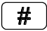 (INT-SK) /  (INT-SCR) key for approx. 3 seconds. The installer defines whether the triggered alarm will be loud (setting off the loud alarm signaling) or silent (without loud signaling).

Silencing the alarm sound at the keypad
If the keypad is signaling alarm, pressing any digit key will silence the signaling for approx. 40 seconds.

Code changing
The installer can permit the change of own code by means of the partition keypad.
- Press the 1 key for 3 seconds.
- When the and LEDs start blinking alternately, enter the old code and confirm it with the key.
- When the and LEDs start blinking alternately, enter the new code and confirm it with the key.

Using the entry keypad
The INT-SCR multifunction keypad can work in the entry keypad mode (INT-ENT). The main task of the zone keypad is activation of the delay for the 3. Interior delayed type zones. The time period during which these zones will act as delayed ones is programmable for the keypad. If more than one zone keypads are assigned to the partition, a different delay unblocking time can be programmed for each of them. After expiry of the programmed time, the interior delayed zones will again operate as instant ones.

LED indicators
Only the LED is used. Blinking of the LED indicates that the delay activation time countdown is running (disarming has no effect on the LED blinking).

Sound signaling
The installer can disable the sound signaling or replace it by blinking of keypad backlight.
During operation, the keypad can generate the following sounds:
1 short beep – pressing any digit key, confirmation that code has been entered or card has been read.
3 short beeps – confirmation of delay activation.
4 short and 1 long beeps – confirmation of the guard round or execution of the control for 24. MONO switch or 25. BI switch type outputs.
3 pairs of short beeps – the user should change his/her code.
2 long beeps – unknown code/card.
3 long beeps – activation the delay is impossible (the partition is disarmed or the delay has already been started) or the function is unavailable.
Additionally, the keypad can audibly signal the Delay activation time.

Functions available from the entry keypad
Depending on the user type and authority level, keypad settings and alarm system status, entering the code and confirming it with the or key (presenting the proximity card) will result in:
- activating the delay in partition for 3. Interior delayed type zones;
- changing over the status of 25. BI switch type outputs;
- turning on the 24. MONO switch type outputs;
- guard round confirmation.

Using the code lock
The basic task of the code lock is to execute the access control function (supervise a single door).
SATEL offers the following code locks:
INT-SZ;
INT-SZK.
The code locks are available with keys backlight in various color versions. The color version is indicated by an additional letter symbol included in the code lock designation (e.g. INT-SZ-GR – green backlight; INT-SZ-BL – blue backlight).

Description of code locks

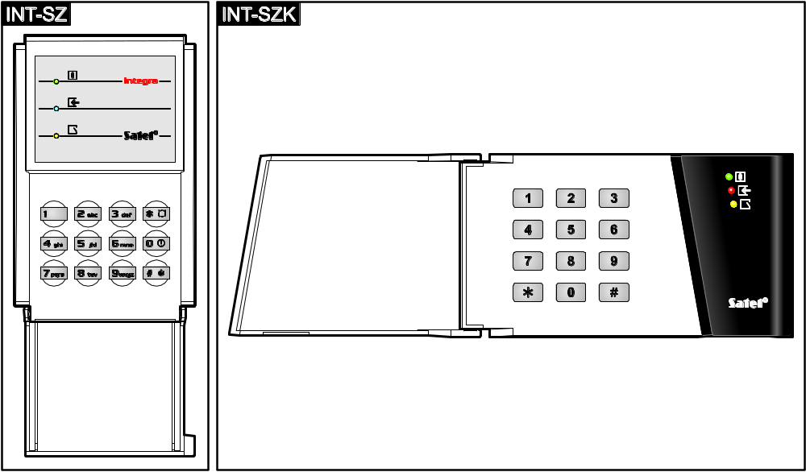
Fig. 5. Code locks.

LED indicators
LED | Color | Function description
 | green | ON – code lock is operated by the control panel
 | blue (INT-SZ)  red (INT-SZK) | ON – door unlocked
 | yellow | blinking – door open
Table 5. Description of the code lock LEDs.

All LEDs blinking in turn indicate that there is no communication with the control panel.

Keys
The keys enable user authorization by means of a code and starting of the functions available from the code lock.

Sound signaling

Beeps generated when operating
The installer can disable the sound signaling or replace it by blinking of the keypad backlight.
1 short beep – pressing any digit key or confirmation that code has been entered.
4 short and 1 long beeps – confirmation of door unlocking or execution of another function.
2 long beeps – unknown code/card.
3 long beeps – unavailable function.

Events signaled by sounds
Only installer selected events are signaled.
5 short beeps – zone violation (CHIME).
Very short beeps – door open too long.

Functions available from code lock
Depending on the user type and authority level, as well as the code lock settings, entering the code and confirming it with the or key will result in:
- unlocking the door (activating the relay);
- changing over the status of 25. BI switch type outputs;
- turning on the 24. MONO switch type outputs;
- guard round confirmation;
- enabling temporary partition blocking.
The installer can permit triggering alarms from the keypad. To trigger an alarm, do the following:
fire alarm – press the (INT-SZ) / (INT-SZK) key for approx. 3 seconds;
medical (auxiliary) alarm – press the 0 key for approx. 3 seconds;
panic alarm – press the (INT-SZ) / (INT-SZK) key for approx. 3 seconds. The installer defines whether the triggered alarm will be loud (setting off the loud alarm signaling) or silent (without loud signaling).
The installer can permit changing own code by means of the code lock. Proceed in the same way, as when changing the code by means of the partition keypad (see: p. 40).

Confirming voice messaging
The installer can configure the control panel so that confirmation of listening to the voice message be required. If there is no confirmation, the control panel can connect many times for playback of the message. Having listened to the message can be confirmed from the keypad of DTMF dialing telephone. The installer defines whether any 4-digit sequence is sufficient to confirm receipt of a voice message, or it must be a specific code. After entering of the code, the control panel will give the following information by means of sound signals:
1 short beep repeated every 3 seconds – the message has been confirmed, wait for playback of the next voice message;
4 short and 1 long beeps – the message has been confirmed, there are no more voice messages;
2 long beeps – an invalid code has been entered (the message has not been confirmed).
If the control panel is sending messages about several events and confirmation of the voice messages is required, each message should be confirmed. The first message must be confirmed before the second message can be played back, an so on.
The installer can configure the control panel so that acknowledgement of receiving the message by the user will:
- clear messaging other users;
- allow to get access to the INT-VG module voice menu.

Call answering and telephone control
The information below does not apply to the control panels to which the INT-VG module is connected.
The call answering and telephone control functions are available to the users who have the telephone code. These functions require that the DTMF dialing phone be used. The call answering function allows to get information on the partition status (armed, disarmed). Owing to the telephone control function, it is possible to control the Remote switch type outputs using the telephone.

Answering phone calls
- Establish connection with the control panel, using one of the following methods (consult the installer to learn which method is supported by the control panel):
single call – call the telephone number of control panel. The control panel will answer the call after the number of rings programmed by the installer.
double call – call the telephone number of control panel. Hang up after the number of rings programmed by the installer. Call again within three minutes. The call will be answered by the control panel immediately.
Establishing connection will be signaled by three short beeps.
- Enter the telephone code on the telephone keypad. 4 short beeps and 1 long beep will confirm that you have got access to the call answering function. If the entered code is invalid, this will be signaled by the control panel by two long beeps.
If you make a mistake when entering the code, enter the 4 digits anyway, and when the control panel signals that the code is wrong, enter the correct code.
After entering three wrong codes, the control panel will hang up.
In case of a single call, if:
- no code has been entered and the connection is terminated,
- an invalid code has been entered and the connection is terminated,
the control panel will answer no calls for the next few minutes. It enables e.g. a fax to be connected after the control panel.
- Within up to 15 seconds, enter the 2-digit partition number (e.g. 01, 07 or 15). The control panel will inform you about the partition status by means of sound signals:
3 short beeps – partition disarmed;
4 short and 1 long beeps – partition armed.
If no key is pressed on the phone for 15 seconds, the control panel will hang up.
- Upon pressing in turn the 0 and # keys on the telephone keypad, the control panel will hang up.

Telephone control
- Get access to the phone call answering function (steps 1-2 in section Answering phone calls).
- Within up to 15 seconds, press in turn the 2 and # keys on the telephone keypad. 4 short beeps and 1 long beep will confirm that you have got access to the telephone control function.
- Within up to 15 seconds, enter the 2-digit number of the remote switch (e.g. 01, 07 or 15). The control panel will inform you about the switch status change by means of sounds:
3 short beeps – the switch has been turned off;
4 short and 1 long beeps – the switch has been turned on.
The operating mode of the Remote switch type output depends on how the output has been configured by the installer.
- Upon pressing in turn the 0 and # keys on the telephone keypad, the control panel will hang up. You can also press the 1 and # keys to return to the phone call answering function.

SMS control only INTEGRA 128-WRL
The INTEGRA 128-WRL control panel can be operated by means of the SMS messages containing suitable control commands. The content of commands and the additional rules of how to use them (using the lower case and upper case letters, adding the telephone code to the content of sent SMS message, etc.) are to be defined by the installer. If appropriate control commands are programmed by the installer, the SMS messages can be used to:
- violate selected zones;
- temporary bypass selected zones;
- unbypass selected zones;
- arm selected partitions in selected mode;
- disarm selected partitions;
- clear alarm in selected partitions;
- activate selected MONO switch type outputs;
- activate selected BI switch type outputs;
- deactivate selected BI switch type outputs;
- toggle selected BI switch type outputs;
- check status of selected partitions;
- send the USSD codes to the operator of SIM card installed in the module (e.g. to check the card account status or recharge it). The answer received from the operator is forwarded in the form of SMS message to the telephone number from which the control command was sent.
When sending the USSD codes, the SMS message must have the following form:
xxxxxx=yyyy=
where "xxxxxx" is the control command and "yyyy" is the USSD code supported by the GSM network operator.
The SMS message may contain several control commands.
If correctly programmed by the installer, the control panel will confirm execution of the control commands by means of SMS messages sent to the telephone number from which the control command was received.

Operating the alarm system by means of keyfob

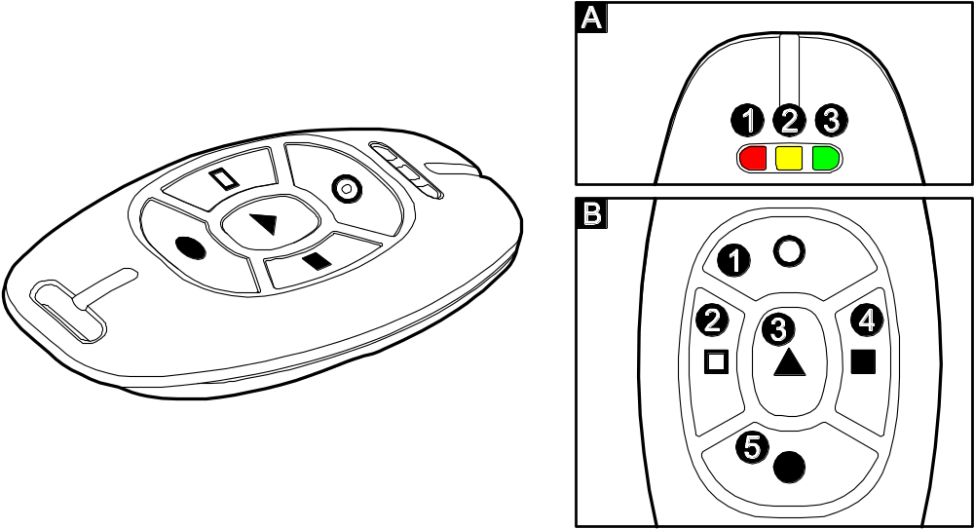
Fig. 6. APT-100 keyfob. A – numeration of LEDs. B – numeration of keyfob buttons.

For the INTEGRA 128-WRL control panel or any other control panel to which the ACU-100, ACU-250, INT-RX or INT-RX-S module is connected, you can control the system using the keyfob. The user can have up to 2 keyfobs:
- bidirectional APT-100 keyfob – supported by the ABAX system (INTEGRA 128-WRL control panel, ACU-100 controller (firmware version 2.00 or newer) or ACU-250 controller);
- 433 MHz keyfob – supported by the INT-RX or INT-RX-S module.
One keyfob enables execution of up to 6 functions. For each keyfob, functions to be executed upon pressing a button / combination of buttons, and for the APT-100 bi-directional keyfobs also information to be displayed on the keyfob LEDs, are individually assigned (see: section Adding keyfob p. 29).

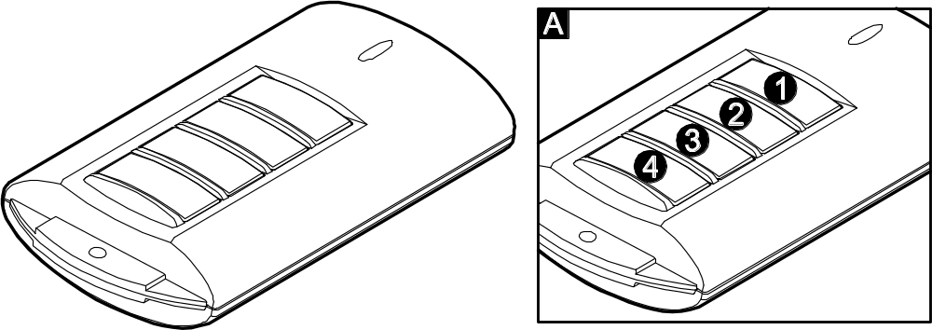
Fig. 7. T-4 keyfob (433 MHz keyfob). A – numeration of keyfob buttons.

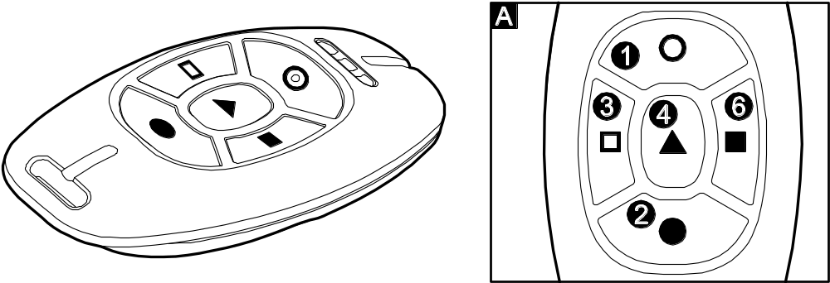
Fig. 8. MPT-300 keyfob (433 MHz keyfob). A – numeration of keyfob buttons. The button designated with digit 6 corresponds to the combination of buttons 1 and 3 in other 433 MHz keyfobs.

Brief description of operating the system from keypad
– 1. group (numbers: 1-32 / addresses 00-1F)
– 2. group (numbers: 33-64 / addresses 20-3F)
– 3. group (numbers: 65-96)
– 4. group (numbers: 97-128)
( – LED OFF; – LED ON
blinking – trouble or trouble memory / Grade 2: trouble or trouble memory, bypassed zones or alarm

ON – all partitions operated by the keypad are armed
blinking – some partitions are armed
blinking – service mode started


ON or blinking – alarm or alarm memory

[CODE] – arming / disarming / alarm clearing

Quick arming:
0 - full arming
1 - full arming + bypasses
2 - arming without interior
3 - arming without interior and without entry delay

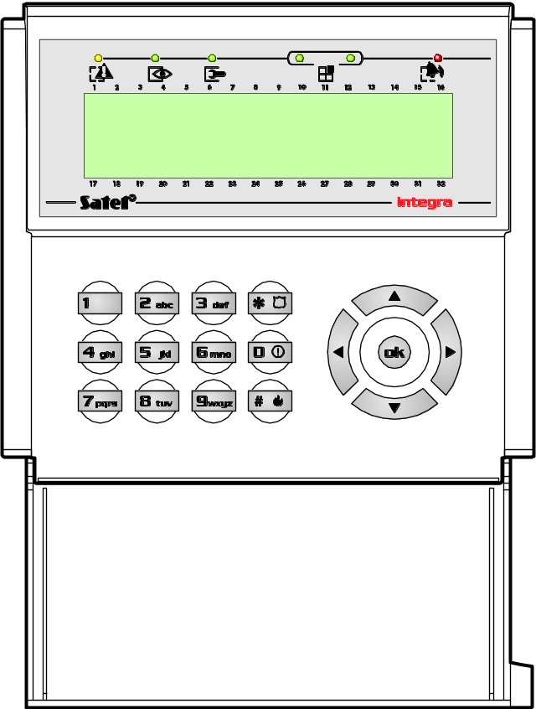

9 – end of exit delay countdown

8 – quick control of outputs
[HASŁO] – enter the user menu
User menu shortcuts:
1 Change own code
2 Users [Masters]
21 New user [New master]
22 Edit user [Edit master]
23 Remove user [Remove master]
4 Zone bypasses
41 Inhibit
42 Isolate
5 Events
51 Selected events
52 All events
6 Set time
7 System state
8 Outputs control
9 Service mode
0 Downloading
01 Start DWNL-RS
02 Finish DWNL-RS
03 Start DWNL-MOD.
04 Start DWNL-TEL
05 Start DWNL-CSD [INTEGRA 128-WRL]
06 Start DWNL-GPRS [INTEGRA 128-WRL]
07 ETHM-1 – DloadX
08 ETHM-1 – GuardX

Shortcut keys (press for approx. 3 seconds):
1 – check zone status
4 – check partition status
5 – view alarm log
6 – view trouble log
7 – view current troubles
8 – CHIME signal ON/OFF
9 – toggle display between standby mode and partition status mode
– trigger medical (aux) alarm
– trigger fire alarm
– trigger panic alarm


Alarm Control Panels
INTEGRA Firmware version 1.11

USER
MANUAL

SATEL sp. z o.o.
ul. Schuberta 79
80-172 Gdańsk
POLAND
tel. + 48 58 320 94 00

info@satel.pl
www.satel.eu

integra_u_en 12/12
druk:
46,47,0,45,44,1,2,43,42,3,4,41,40,5,6,39,38,7,8,37,36,9,10,35,34,11,12,33,32,13,14,31,30,15,16,29,28,17,18,27,26,19,20,25,24,21,22,23

