CONTENTS
1. Introduction 2
2. Front panel description 3
2.1 LED indicators 6
2.2 Buttons 8
3. Conditions signaled by the control panel / repeater panel 10
4. Operation 11
4.1 Access levels 11
4.1.1 Level 1 – all users 11
4.1.2 Level 2 – authorized users 11
4.2 Access level 1 operation 12
4.2.1 Silencing the acoustic signaling of control panel / repeater panel 12
4.2.2 Testing the signaling components of control panel / repeater panel 12
4.2.3 Checking availability of the access level 2 operation on the other panel 12
4.2.4 Using the user menu [CSP-204 / CSP-208 / PSP-204 / PSP-208] 12
4.3 Access level 2 operation 13
4.3.1 Enabling / disabling the two-stage alarm mode 13
4.3.2 Procedure in the case of alarm signaling 14
4.3.3 Deactivating / activating the sounders 14
4.3.4 Procedure in the case of fault signaling 14
4.3.5 Disablement 14
4.3.6 Testing the zones 15
4.3.7 Testing the routing outputs and sounders 15
4.3.8 Using the user menu [CSP-204 / CSP-208 / PSP-204 / PSP-208] 15
5. Using the virtual panel 16

Introduction
This manual describes how to operate the following fire alarm control panels:
CSP-104 - 4 zone conventional fire alarm control panel,
CSP-108 - 8 zone conventional fire alarm control panel,
CSP-204 - 4 zone conventional fire alarm control panel with LCD display,
CSP-208 - 8 zone conventional fire alarm control panel with LCD display.
The manual also covers remote operation of the fire alarm control panels by means of repeater panels and explains how to use the virtual panel.
Please read this manual carefully before use.

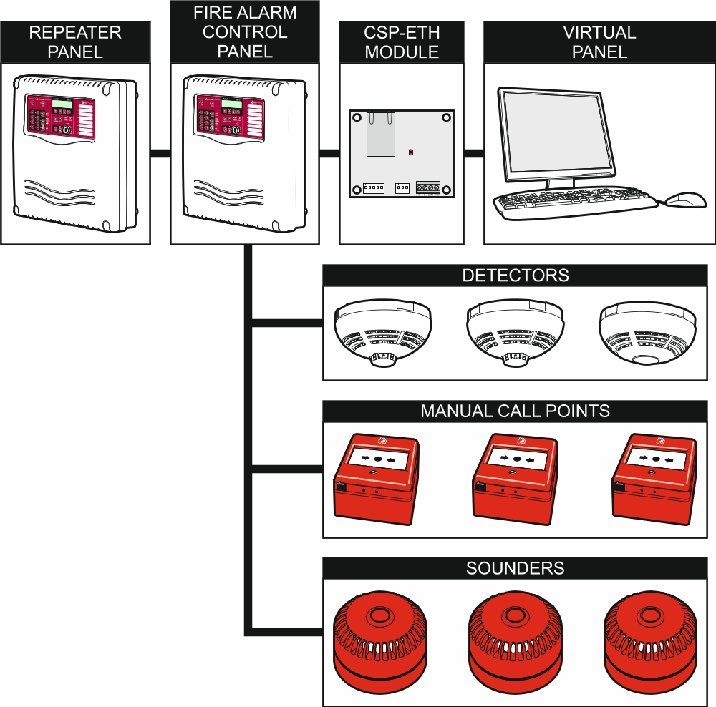
Fig. 1. Typical components included in the fire alarm system.

Front panel description
The following items are placed on the front panel of the control panel / repeater panel:
- LED indicators;
- control buttons;
- insert with zone descriptions to facilitate identification of the alarm source;
- LCD display to make easier transmission of information (only CSP-204, PSP-204, CSP-208 and PSP-208);
- key switch to enable changing the access level.

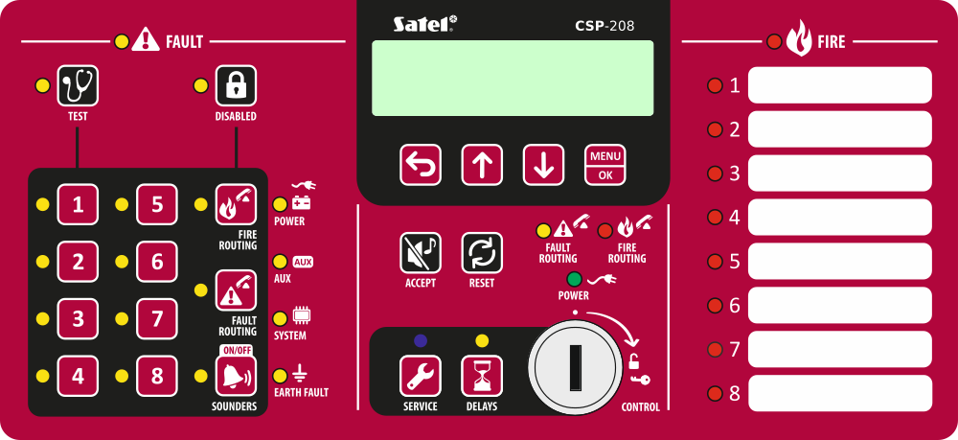
Fig. 2. Front panel of the CSP-208 control panel.

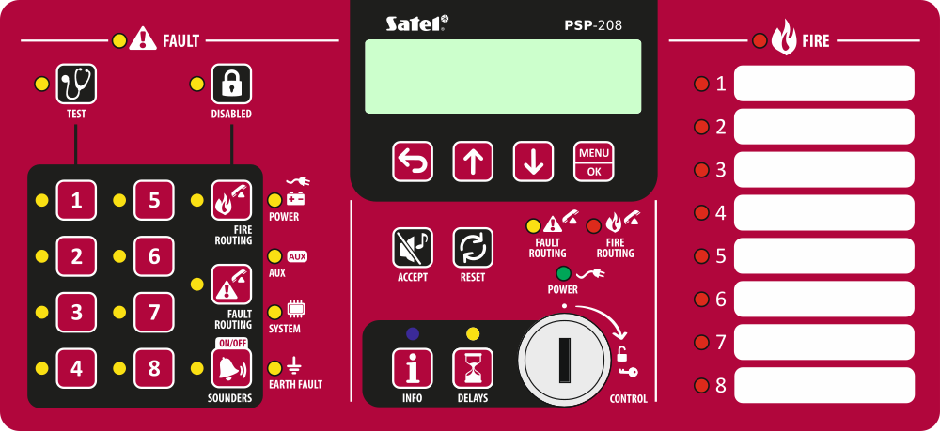
Fig. 3. Front panel of the PSP-208 repeater panel.

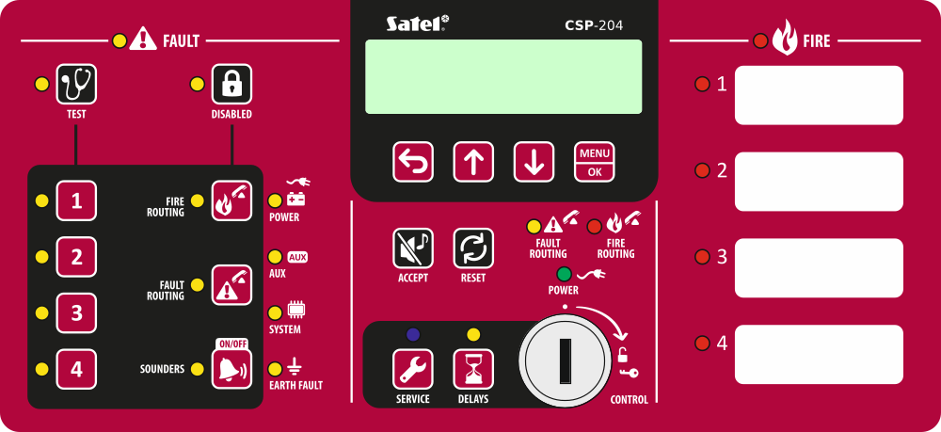
Fig. 4. Front panel of the CSP-204 control panel.

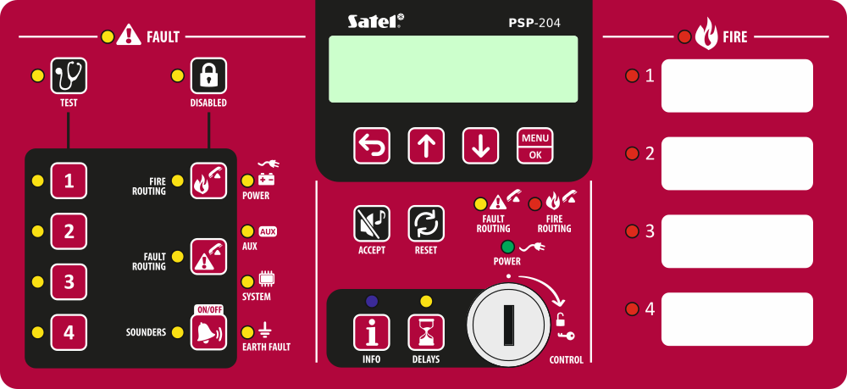
Fig. 5. Front panel of the PSP-204 repeater panel.

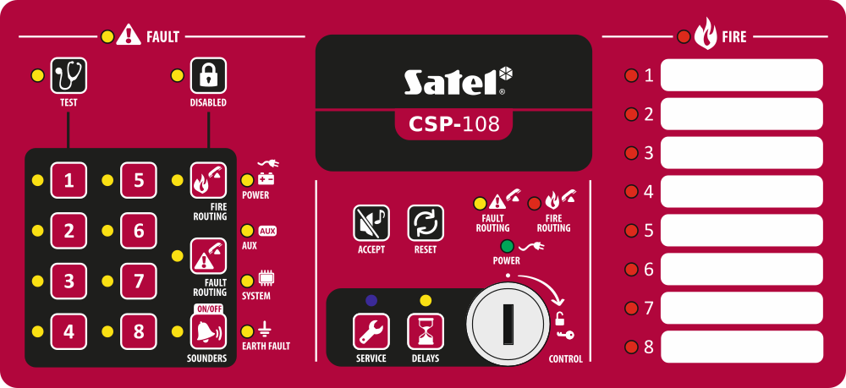
Fig. 6. Front panel of the CSP-108 control panel.

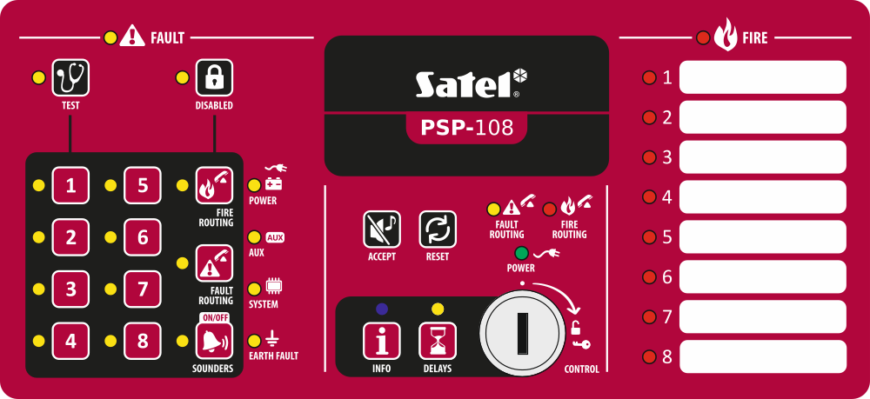
Fig. 7. Front panel of the PSP-108 repeater panel.

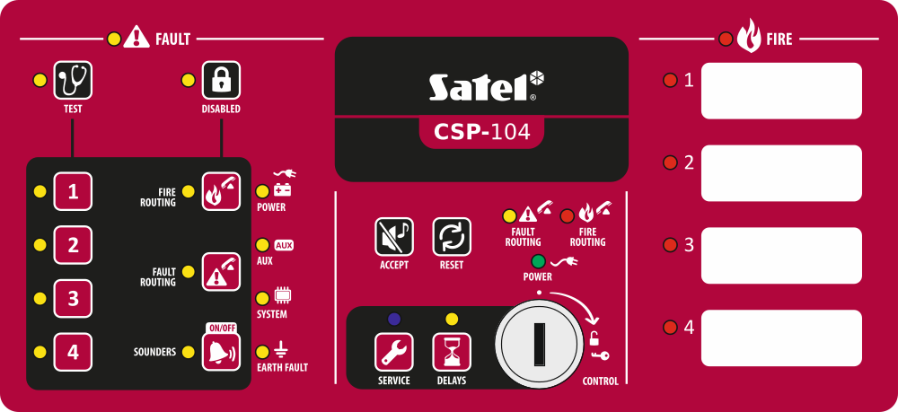
Fig. 8. Front panel of the CSP-104 control panel.

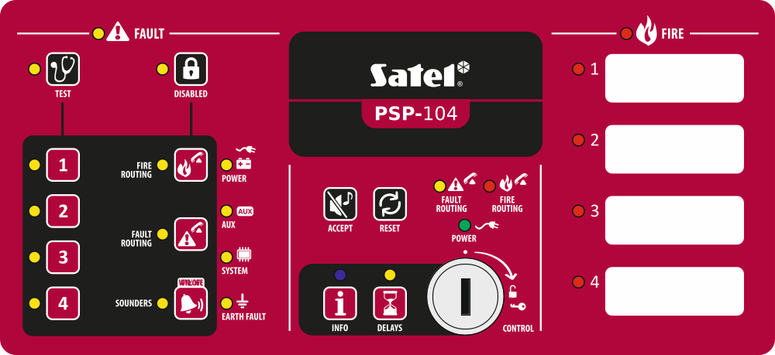
Fig. 9. Front panel of the PSP-104 repeater panel.

LED indicators
LED | Description | Color | Indications
 | fault | yellow | ON – fault  blinking – fault memory
 | test | yellow | blinking – test function is activated  ON – test of zones, sounders, fire alarm routing output or fault warning routing output is running
 | disabled | yellow | blinking – disablement function is activated  ON – zones, sounders, fire alarm routing output or fault warning routing output are disabled
 | zone 1 | yellow | blinking – zone fault (short-circuit or break)  ON – zone is disabled or is being tested
 | zone 2 | yellow
 | zone 3 | yellow
 | zone 4 | yellow
 | zone 5 | yellow
 | zone 6 | yellow
 | zone 7 | yellow
 | zone 8 | yellow
 | fire routing | yellow | blinking – output fault (short-circuit or break)  ON – output is disabled or is being tested
 | fault routing | yellow | blinking – output fault (short-circuit or break)  ON – output is disabled or is being tested
 | sounders | yellow | blinking – sounder fault (short-circuit or break)  ON – sounders are disabled or are being tested
 | power | yellow | blinking – power supply failure (loss of 230 V AC mains, missing battery, low battery, high battery resistance)
 | auxiliary devices | yellow | blinking – programmable input fault (short-circuit or break), fault signaled by a device connected to programmable input, power output fault (overload), repeater panel or CSP-ETH module not present, repeater panel fault
 | system | yellow | blinking – control panel hardware fault, microprocessor-based system fault, corrupted data in control panel memory, or alarm log overflow
 | earth fault | yellow | blinking – earth fault in one of the circuits of fire alarm system
 | fault routing | yellow | blinking – fault warning routing output is active (no confirmation of transmission)  ON – fault warning routing output is active and transmission is confirmed
 | fire routing | red | blinking – fire alarm routing output is active (no confirmation of transmission)  ON – fire alarm routing output is active and transmission is confirmed

 | power | green | ON – control panel is supplied from 230 V AC mains  blinking – control panel is supplied from a battery (no 230 V AC supply)
 | delays | yellow | ON – two-stage alarm mode is enabled (second stage alarm is delayed)
 | fire | red | blinking – fire alarm  ON – fire alarm acknowledged by the operator
 | fire in zone 1 | red | slow blinking – pre-alarm  fast blinking – first alarm  ON – next alarm
 | fire in zone 2 | red
 | fire in zone 3 | red
 | fire in zone 4 | red
 | fire in zone 5 | red
 | fire in zone 6 | red
 | fire in zone 7 | red
 | fire in zone 8 | red
Only the control panel
 | service | blue | slow blinking – access level 2  fast blinking – waiting for code entry after the  key is pressed  ON – access level 3 (programming)
Only the repeater panel
 | info | blue | slow blinking – access level 2  ON – repeater panel cannot be operated

Buttons
Button | Access level | Function
 | 1 | - starts the test of LED indicators and built-in sounder of control panel / repeater panel
 | 2 | - starts the function of testing zones, sounders, fire alarm routing output or fault warning routing output
 | 2 | - starts the function of disabling zones, sounders, fire alarm routing output or fault warning routing output

 | 2 | - after pressing the  button – disables / enables the zone  - after pressing the  button – starts / stops the zone test  - after pressing the button – the buttons 1-4 allow to enter the level 3 access code (programming)
 | 2
 | 2
 | 2
 | 2
 | 2
 | 2
 | 2
 | 2 | - after pressing the button – disables / enables the fire alarm routing output  - after pressing the button – starts a test of the fire alarm routing output
 | 2 | - after pressing the button – disables / enables the fault warning routing output  - after pressing the button – starts test of the fault warning routing output
 | 2 | - deactivates / activates sounders during a fire alarm  - after pressing the button – disables / enables the sounders  - after pressing the button – starts a test of the sounders
 | 1 or 2 | - acknowledges the alarm or fault warning and silences the acoustic signaling in control panel and repeater panel  - resets the fault memory
 | 2 | - resets the fire alarm  - resets the fault
 | 2 | - activates / deactivates two-stage alarm mode (second stage alarm delay)
Only the control panel
 | 1 | - allows to check whether level 2 operation is available on the repeater panel
 | 2 | - allows to gain level 3 access (control panel programming)
Only the repeater panel
 | 1 | - allows to check whether level 2 operation is available on the control panel's front panel

Only the control panel / repeater panel equipped with LCD display
 | 1 or 2 | - exits the menu, submenu or function and allows to perform other operations in the user menu
 | 1 or 2 | - scrolls up and allows to perform other operations in the user menu
 | 1 or 2 | - scrolls down and allows to perform other operations in the user menu
 | 1 or 2 | - opens the user menu  - enters submenus or starts functions, and allows to perform other operations in the user menu

Conditions signaled by the control panel / repeater panel
During normal operation, the green LED, described as POWER, is steadily lit on the front panel. On the display (CSP-204 and CSP-208 control panels, PSP-204 and PSP-208 repeater panels), the time and date (the upper line) and the programmed message (the lower line) are presented. The control panel and repeater panel can signal the following conditions, which result from actions taken by the operating personnel or require actions to be taken by the operating personnel.
Access level 2 – control panel – signaled by the blinking blue LED above the button. The repeater panel does not indicate that the access level 2 operation is available on the front panel of the control panel.
Access level 2 – repeater panel – signaled by the blinking blue LED above the  button. The front panel of the control panel does not indicate that the access level 2 operation is available on the repeater panel.
Second stage alarm delay – signaled by the steady-on yellow LED above the  button.

Pre-alarm – signaled by:
- slow blinking of the red LED labeled with the number of the zone which caused pre-alarm;
- sound.
Note: The pre-alarm signaling can turn into alarm signaling, if a detector is activated within 30 minutes in the dependent zone. After 30 minutes, the pre-alarm is automatically reset.
Alarm – signaled by:
- blinking / steady-on red LED described as FIRE;
- fast blinking / steady-on red LED labeled with the number of the zone which triggered the alarm;
- sound;
- message on the display [CSP-204 and CSP-208 control panels, PSP-204 and PSP-208 repeater panels]:
upper line: name of the zone which triggered alarm as the first one / consecutive number of the alarm / total number of the alarms;
lower line: name of the zone which triggered alarm as the last one / consecutive number of the alarm / total number of the alarms.
Fault – signaled by:
- ON yellow LED, described as FAULT;
- blinking yellow LED, according to the relevant trouble (see section LED indicators p. 6);
- sound.
Fault memory – signaled by blinking yellow LED, described as FAULT. The fault memory will be signaled, if the operating personnel has not acknowledged the fault using the  button and the control panel does not detect the fault any more.
Disablement – signaled by:
- steady-on yellow LED next to the button;
- steady-on yellow LED, according to the disabled element (see section LED indicators p. 6).
Zone test – signaled by:
- steady-on yellow LED next to the button;
- steady-on yellow LED next to the button labeled with number of the zone being tested.

Operation

Access levels

Level 1 – all users
The , and buttons [control panel] or the button [repeater panel] can be used. In the case of control panels and repeater panels equipped with LCD display, the , ,  and  buttons are also available, which allow to open and use the user menu (the clock programming is not available).

Level 2 – authorized users
All buttons are available for use. In order to get access at level 2, turn the key switch to position marked with the symbol.
Note: The control panel cannot be operated at the level 2 at the same time from the control panel and from the repeaters panel, hence:
- turning the control panel key switch will always result in getting access at level 2 (access level 2 on the repeater panel is automatically exited);
- getting access at level 2 from the repeater panel is impossible, if operation at level 2 is available on the control panel.

Access level 1 operation

Silencing the acoustic signaling of control panel / repeater panel
Press the button.

Testing the signaling components of control panel / repeater panel
Press and hold the button for about 3 seconds. All the LEDs should start blinking uniformly and an audible signal should be heard.

Checking availability of the access level 2 operation on the other panel

On the control panel
Press and hold the button. When the button is pressed:
- the yellow LED next to the  button is ON, if the level 2 operation is available on the repeater panel;
- a message on the LCD display [only CSP-204 and CSP-208] informs you whether the level 2 operation is available on the repeater panel.

On the repeater panel
Press and hold the button. When the button is pressed:
- the yellow LEDs next to the buttons labeled with digits from 1 to 4 are ON, if the level 2 operation is available on the front panel of the control panel;
- a message on the LCD display [only PSP-204 and PSP-208] informs you whether the level 2 operation is available on the control panel.

Using the user menu [CSP-204 / CSP-208 / PSP-204 / PSP-208]
To display the user menu, press the button. Press the button to scroll down the menu, and the button – to scroll up. Use the button to start a function indicated by the cursor. Use the button to exit the menu. After 30 seconds of idleness (no button has been pressed), the automatic menu exit will follow.
Note: If any of the LEDs indicating a fire in the zone is blinking or ON, using the user menu will be impossible.

Viewing the alarm log
After starting the function, information about the last alarm will be presented on the display:
- upper line: consecutive number of the alarm / total number of the alarms;
- lower line: time the alarm occurred.
Press the button to get additional information about the alarm. Press the button repeatedly to display the following data in the lower line:
- date the alarm occurred;
- alarm type;
- name of the zone that triggered the alarm.
Use the and buttons to scroll the list of alarms up and down. Use the button to exit the function.

Viewing the event log
After starting the function, information about the last event will be presented on the display:
- upper line: consecutive number of the event / total number of the events;
- lower line: time the event occurred.
Press the button to get additional information about the event. Press the button repeatedly to display the following data in the lower line:
- date the event occurred;
- event description;
- event description (continued);
- device the event relates to.
Use the and buttons to scroll the list of events up and down. Use the button to exit the function.

Viewing the current faults
After the function is started, the fault information is presented on the display:
- upper line: consecutive number of the current fault / total number of the current faults;
- lower line: fault description.
Press the button to get additional information about the fault. Press the button repeatedly to display the following data in the lower line:
- fault description (continued);
- device the fault relates to.
Use the and buttons to scroll the list of current faults up and down. Use the button to exit the function.

Access level 2 operation

Enabling / disabling the two-stage alarm mode
Press the button. The ON yellow LED above the button indicates that the two-stage alarm mode is enabled. Activation of detectors in the appropriately programmed zones will trigger the first stage alarm (the control panel inner alarm which does not activate e.g. the fire alarm routing output). In such a case, the operating personnel has 30 seconds to acknowledge the alarm using the button. If the button is not pressed, the second stage alarm (main alarm) will be triggered. If the button is pressed, the second stage alarm will be delayed by an additional period of time, as programmed in the control panel.
If the two-stage alarm mode is disabled (the yellow LED above the button is OFF), all the zones will trigger the second stage alarm.

Procedure in the case of alarm signaling
- Press the button to acknowledge the alarm and silence the acoustic signaling of the control panel / repeater panel. The red LED, described as FIRE, will stop blinking and will come ON. In the case of the first stage alarm, the control panel will start the countdown of verification time, which allows the operating personnel to verify that the fire really takes place. After this time elapses, the second stage alarm will be triggered, unless the alarm is cleared by the operator.
- Check which zone has triggered the alarm (respective LED blinking or ON, and in the case of control panels / repeater panels equipped with the LCD display – also information on the display).
- Go to the part of the premises in which the alarm has been reported, in order to verify whether the fire really takes place.
- If you find out a fire, proceed in accordance with the fire instructions provided for the site.
- If the alarm proves to be a false one, press the  button to clear the alarm. If the fire service (fire brigade) or other services have been notified about the fire (the second stage alarm has been triggered, which has activated the fire alarm routing output), let them know that the alarm was false. In the case of repeated false alarms in the zone, disable the zone and call the service personnel.
Note: Proceed in the similar way in the case of pre-alarm.

Deactivating / activating the sounders
If the alarm is being signaled, you can deactivate or activate the sounders. To do so, press the  button.
Note: During alarm, the sounders can be activated even when they are disabled.

Procedure in the case of fault signaling
- Press the button to acknowledge the fault and silence the acoustic signaling of the control panel / repeater panel.
- Read out the additional information related to the fault (blinking of the respective LEDs, and in the case of control panels / repeater panels equipped with the LCD display – also viewing the faults in the user menu).
- Make a note of the fault.
- Press the button to reset the fault.
- In the case of repeated fault signals, call the service personnel.
Note: Do not call the service personnel in the event of 230 V AC fault signal, if absence of mains voltage has been found out by the operating personnel.

Disablement
- Press the button. The yellow LED next to the button will start blinking.
- Select the component to be disabled:
- press the button labeled with a digit to disable the zone with the same number;
- press the  button to disable the fire alarm routing output;
- press the  button to disable the fault warning routing output;
- press the button to disable the sounders.
After pressing the button, the yellow LED next to the button will turn ON (if it is OFF) or will turn OFF (if it is ON). If the given component is to be disabled, the LED must be ON.
- Press the button to exit the disablement function.

Testing the zones
Note: When alarm is being signaled, testing the zones is impossible.
- Press the button. The yellow LED next to the button will start blinking.
- Press the button labeled with a digit corresponding to the number of the zone to be tested. The yellow LED next to the button will come on.
- Press the button. The yellow LED next to the button will stop blinking and will come ON.
- Test the zone operation. If in the zone to be tested a detector or a manual call point is activated:
- the red LED labeled with the zone number will come ON;
- the control panel’s and repeater panel’s built-in sounders will be activated;
- sounders will be activated;
- the alarm will be automatically reset after one second.
The test alarms do not activate the routing output.
- After completion of the test, press the button. The yellow LED next to the button will start blinking.
- Press the button labeled with a digit corresponding to the number of the zone which has been tested. The yellow LED next to the button will go out.
- Press the button to exit the testing function.

Testing the routing outputs and sounders
Note: When alarm is being signaled, testing the routing outputs or sounders is impossible.
- Press the button. The yellow LED next to the button will start blinking.
- Select the component to be tested:
- press and hold the button to test the fire alarm routing output;
- press and hold the button to test the fault warning routing output;
- press and hold the button to test the sounders.
When the button is pressed, the yellow LED next to the button is ON and the selected control panel component (routing output or sounders) is active.
- Release the button to finish the test.
- Press the button to exit the testing function.

Using the user menu [CSP-204 / CSP-208 / PSP-204 / PSP-208]
The way of using the menu and viewing the logs of alarms, events and current faults is described in the access level 1 operation section (p. 12). Additionally, a submenu with functions which allow you to program the control panel clock is available. To enter the submenu, and also to start the function, use the button.

Programming the clock
Separate functions are to be used to program the time and date. After the function is started, the flashing cursor will inform you which parameter is currently being edited. The and buttons allow you to change the parameter. The button moves the cursor to the right, and the button – to the left. If the cursor indicates the first edited parameter, pressing the button will exit the function. If the cursor indicates the last parameter, pressing the button will exit the function. If you have made any changes, after exiting the function you will be asked whether to save changes (use the button to go back to the function, the button – to cancel the changes, and the button – to save the changes).

Using the virtual panel
Access to the virtual panel is possible from a computer connected to the Ethernet network (TCP/IP), on which a web browser and the Java Virtual Machine are installed.
- Start the web browser.
- Enter the module IP address into the address bar and press ENTER key.
- The login page will open in the web browser. Enter the code (by default: satel) to get access to the virtual panel.

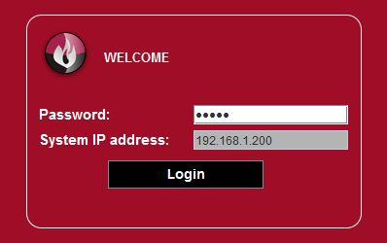
Fig. 10. Login to the virtual panel.

- The virtual panel will be displayed.

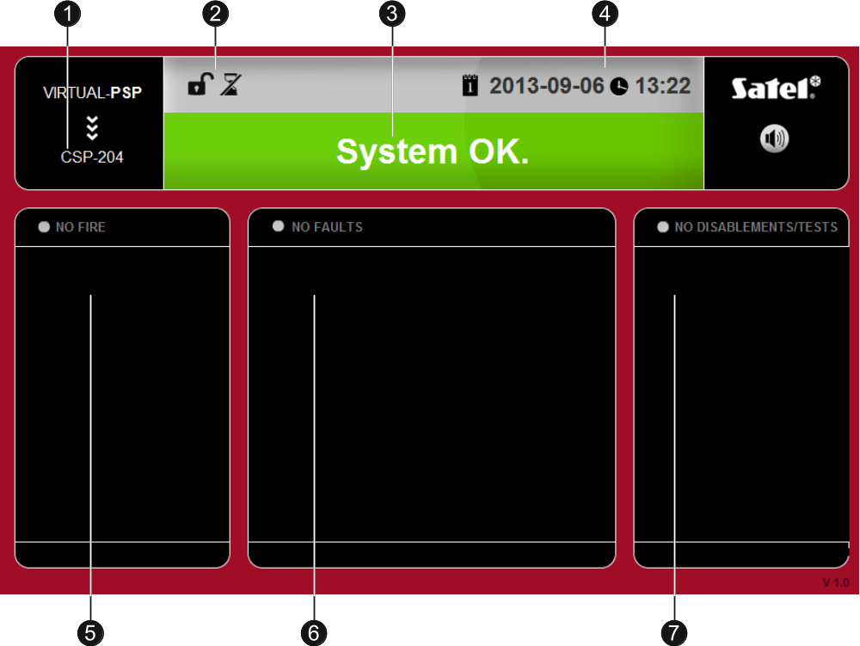
Fig. 11. Virtual panel.

 control panel type.
 icons providing information about the control panel status:
- access level 1;
- access level 2;
- two-stage alarm mode disabled;
- two-stage alarm mode enabled;
- fire alarm routing output is active;
- fire alarm routing output is active and transmission is confirmed;
- fault warning routing output is active;
- fault warning routing output is active and transmission is confirmed.
 the message providing information about the system status. All messages, sorted by their priority, are listed below (higher position = higher status priority):
- FIRE [zone name (zone number)]
- PRE-ALARM
- SERVICE
- FAULT
- SYSTEM OK
 the date and time as per the control panel clock.
 the area where information on pre-alarms and alarms is displayed. The zone name is preceded by a suitable icon:
- pre-alarm;
- alarm.
 the area where information on faults is displayed.
 the area where information on disablements and tests is displayed. The component name is preceded by a suitable icon:
- disablement;
- test.



Fire Alarm Control Panel

CSP-204
CSP-208
CSP-104
CSP-108

Operation manual


Firmware version 1.00 csp-x_o_en 05/13

SATEL sp. z o.o.
ul. Schuberta 79
80-172 Gdańsk
POLAND
tel. 58 320 94 00
info@satel.pl
www.satel.eu
druk:
18,19,0,17,16,1,2,15,14,3,4,13,12,5,6,11,10,7,8,9

