SATEL's goal is to continually upgrade the quality of its products, which may result in some changes of their technical specifications and firmware. The current information on the introduced modifications is available on our website.
Please visit us:
http://www.satel.eu

The following symbols may be used in this manual:
 - note,
 - caution.

CONTENTS
1. General 2
2. Software components 2
3. System architecture 2
4. Network requirements 3
5. Suggested hardware requirements 4
6. Installation of the ACCO NET system software 4
6.1 Installing the Debian operating system 4
6.2 Installing the server environment and ACCO NET system 17
6.3 Installing the ACCO-NT Conf / ACCO Soft program 32
7. Configuring the settings 33
7.1 ACCO Server and ACCO Soft program 33
7.2 ACCO-WEB application 33
7.3 Useful commands 34
8. Updating the ACCO NET system software 34

General
The ACCO NET access control system is designed for protection of buildings against access by unauthorized persons. The ACCO NET system is made up of software and SATEL's devices (access control panels, access control modules, expansion modules, keypads, proximity card readers, etc.).
This manual covers installation of the software which enables configuration and then management of the system. The system may include many objects with any number of access control panels. Communication with the control panels takes place via the Ethernet network.

Software components
For the ACCO NET system to operate, the Debian operating system is required. Installation of the Debian system is described further in this manual, but if it has already been installed, you may skip this section.
The software necessary for proper operation of the system is offered as an installation package which includes:
- server environment software. It is not developed by the SATEL company (addresses of websites on which licenses for each of the programs are available are given in parentheses):
- Apache (http://www.apache.org/licenses/LICENSE-2.0.html),
- PHP (http://php.net/license/3_01.txt),
- MySQL (http://www.gnu.org/licenses/gpl-2.0.html),
- Java (http://www.gnu.org/licenses/gpl-2.0.html),
- ModSecurity (http://www.apache.org/licenses/LICENSE-2.0.html),
- Fail2Ban (http://www.gnu.org/licenses/gpl-2.0.html).
Please remember to legalize the server environment required by the system.
If you have already installed these programs, you may skip installation thereof.
- ACCO NET access control system firmware:
- ACCO Server – program enabling data exchange between the access control panels, database, and the ACCO Soft and ACCO-WEB programs,
- ACCO DB – database to which all system related data are saved, including configuration and events,
- ACCO-WEB – application for remote management and operation of the system,
- ACCO-NT Conf – installation file for the network settings configuration program (for more information on the program and how it should be used, refer to the ACCO-NT control panel installation manual),
- ACCO Soft – installation file for the system configuration program.

System architecture
The ACCO NET system can be installed on one computer. Alternatively, it can be shared by multiple computer workstations, in which case distributed architecture will be used. The ACCO Soft application for system configuration can be installed on several computers. All you need to use the ACCO-WEB application for remote management of the system is the web browser running on your computer, smartphone or tablet. An example of the ACCO NET system is shown in Fig. 1.
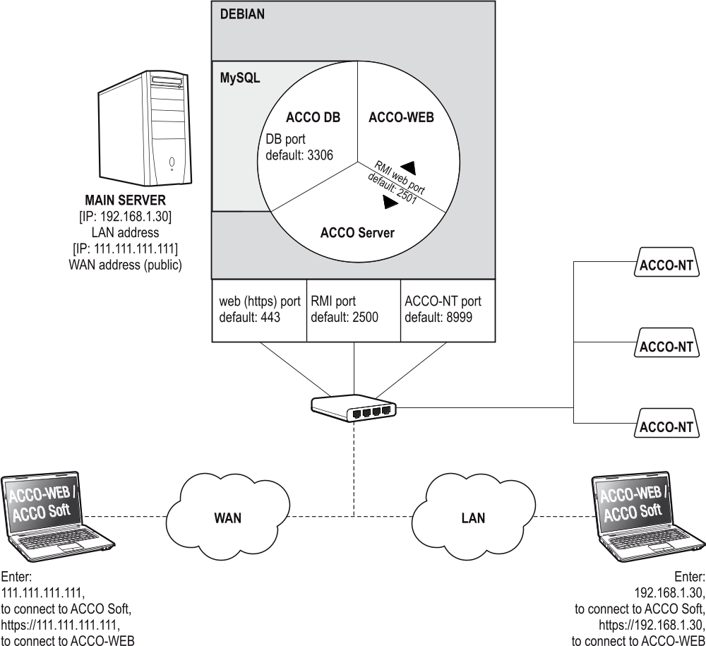
Fig. 1. An example of the ACCO NET system, in which the ACCO Server and database have been installed on one computer (the settings are shown just for illustration). The system components, which are not offered by SATEL, are shown in gray color.

Network requirements
- Internet protocol version 4 (TCP/IPv4).
- IP address for each connected ACCO-NT control panel.
- If the ACCO-WEB application is to be accessible from another subnet, the web port (https; default: 443), on which communication between ACCO Server and ACCO-WEB application is to take place, should be redirected.
- If the ACCO Soft program is to be accessible from another subnet, the following ports should be redirected:
- RMI port (default: 2500), on which communication between ACCO Server and ACCO Soft program is to take place,
- DB port (default: 3306), on which communication between ACCO Server and database is to take place.
Despite the standard encryption techniques (SSL) being used by Satel, if the ACCO NET system is connected to a public network, additional security measures must be used, including e.g. a firewall, intrusion detection and prevention systems (IDS / IPS).

Suggested hardware requirements
Hardware requirements for the computer on which the ACCO NET access control system will be installed depends on the system size:
exemplary system 1 (1 ACCO-NT control panel, 30 access control modules, 30 users)
- RAID (redundant array of inexpensive disks) level 1 (requires at least two hard drives),
- 4 GB of RAM memory,
- processor: Intel Core i3 or AMD A4,
- network card, Fast Ethernet standard,
- Debian operating system (version 7.6 or newer).
exemplary system 2 (3 ACCO-NT control panels, 100 access control modules, 300 users)
- RAID (redundant array of inexpensive disks) level 5 (requires at least three hard drives),
- 8 GB of RAM memory,
- processor: Intel Xeon or AMD Opteron,
- network card, Fast Ethernet standard,
- Debian operating system (version 7.6 or newer).
When deciding on the hard drives capacity, you should consider the following factors:
- number of events generated in the system (2 to 5 millions events will occupy 1 GB),
- number of users simultaneously running the ACCO Soft program or ACCO-WEB application,
- size of graphic files assigned to the maps,
- size of user photographs,
- length of defined names of objects, control panels, controllers, expanders, partitions and users.

Installation of the ACCO NET system software

Installing the Debian operating system
It is recommended that the Debian operating system be installed on a computer on which no other operating system is installed.
The computer(s) on which the ACCO NET system and database are to be installed must have access to the Internet.
Debian system version 7.6 or newer is required. Below, we present an example installation of the Debian operating system version 8.0.

- On the https://www.debian.org/CD/netinst/ website, select the appropriate image from among the CD “netinst” images (150-280 MB, depending on the architecture) and save it to the hard disk. Having downloaded the ISO image, burn it to a CD.
- Insert the burned CD into the computer optical disk drive. The splash screen of Debian system installer will be displayed.
- Select the “Install” command and press ENTER.
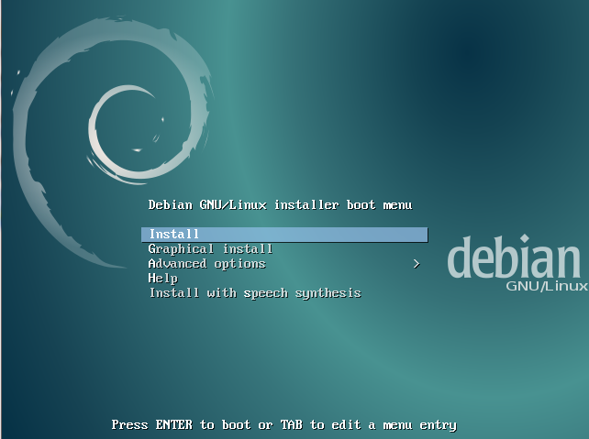
- Select the language to be used for the installation process and press ENTER.
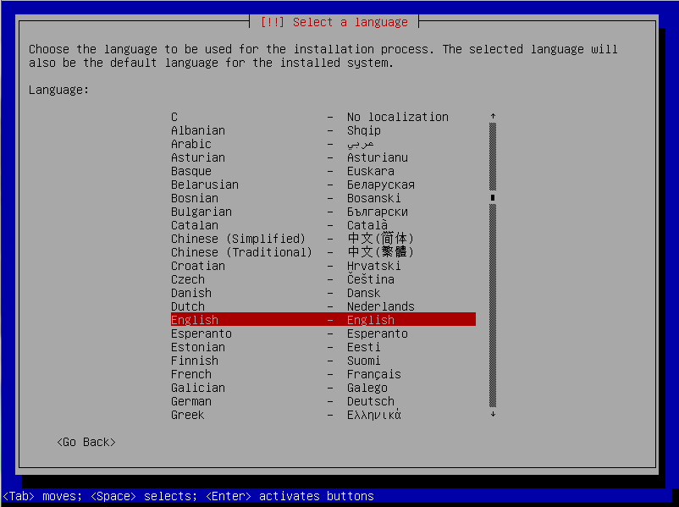
- Select the location and press ENTER.
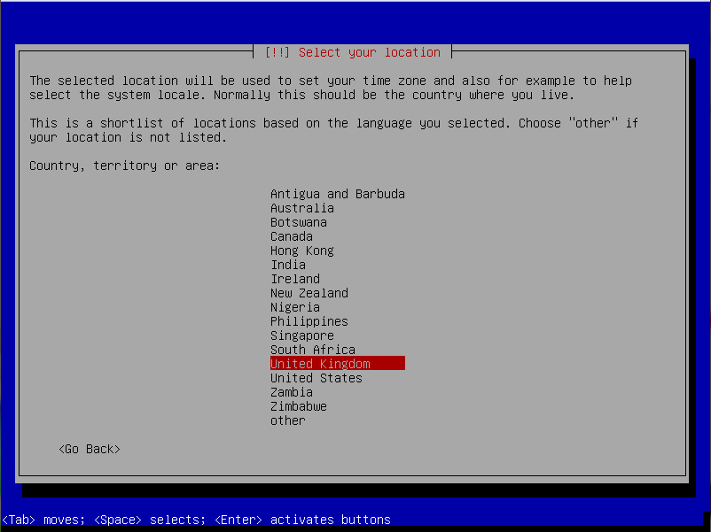
- Select the keyboard layout language and press ENTER.
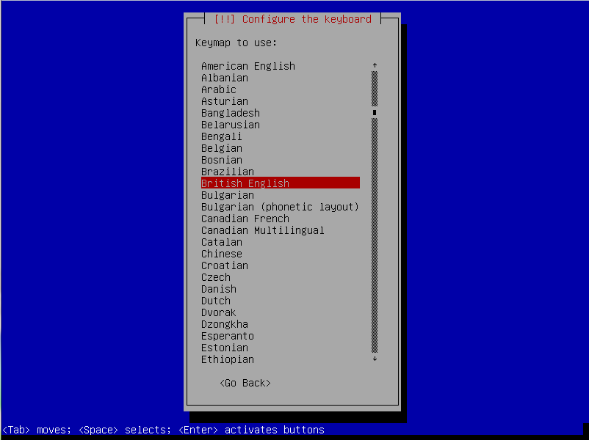
- Windows indicating the installation progress will be displayed successively.
- Enter the host name to configure the network and press ENTER.
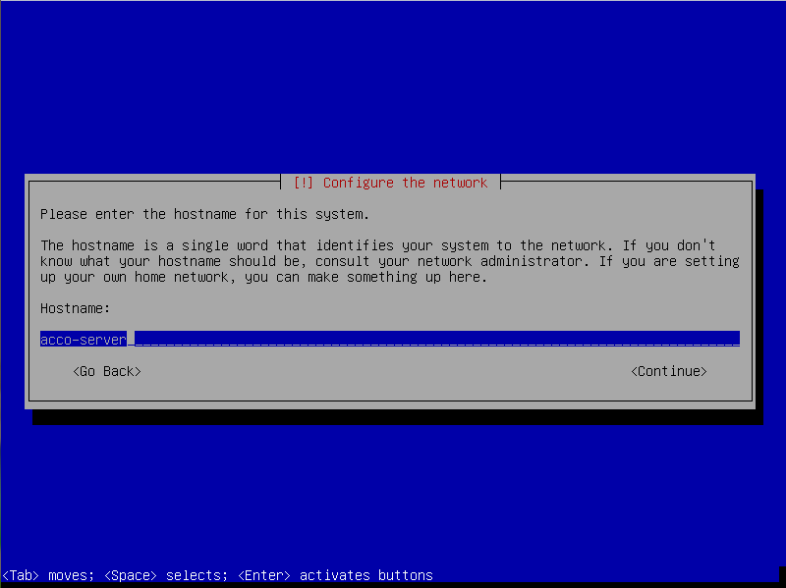
- Enter the domain name and press ENTER.
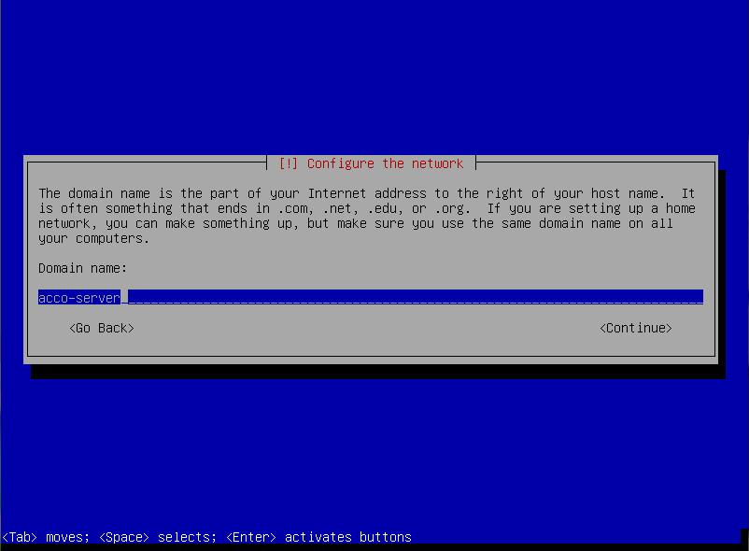
- Define the system access code for the administrator (login: root) and press ENTER.
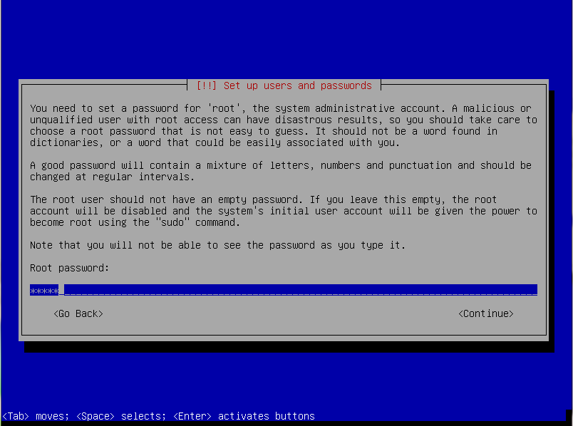
- Repeat the code and press ENTER.
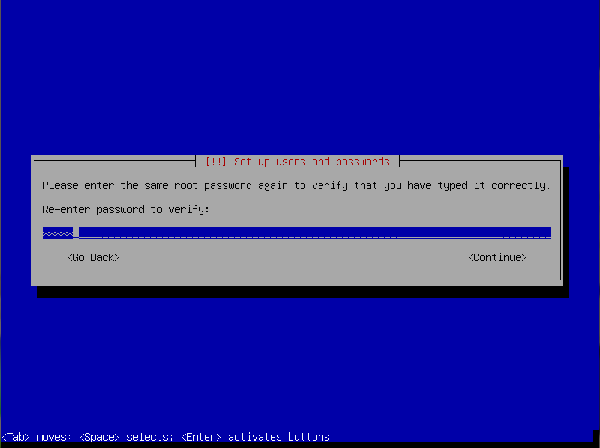
- Give a name to the user (your additional account) and press ENTER.
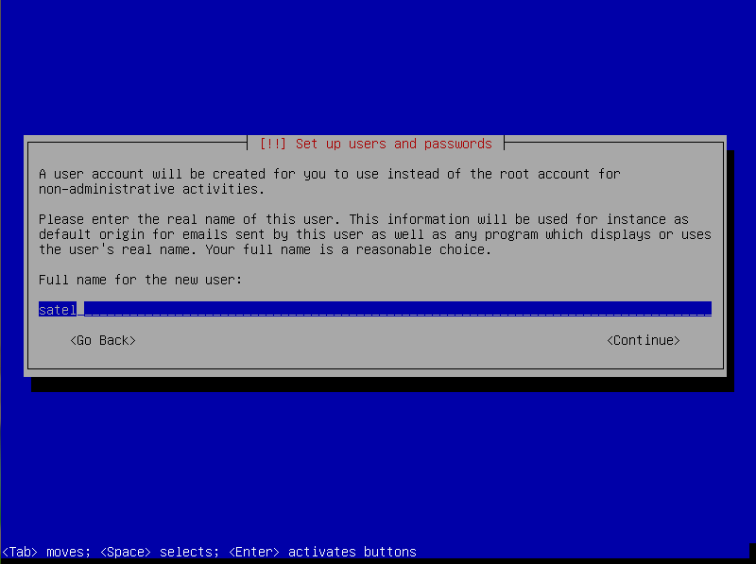
- Enter the new user code and press ENTER.
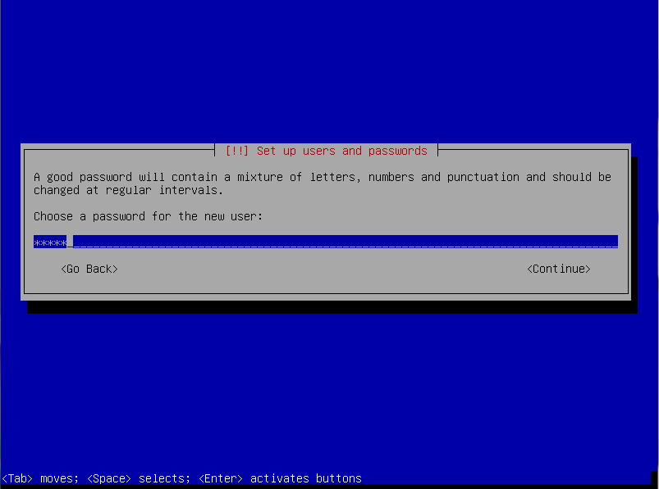
- Re-enter the code and press ENTER.
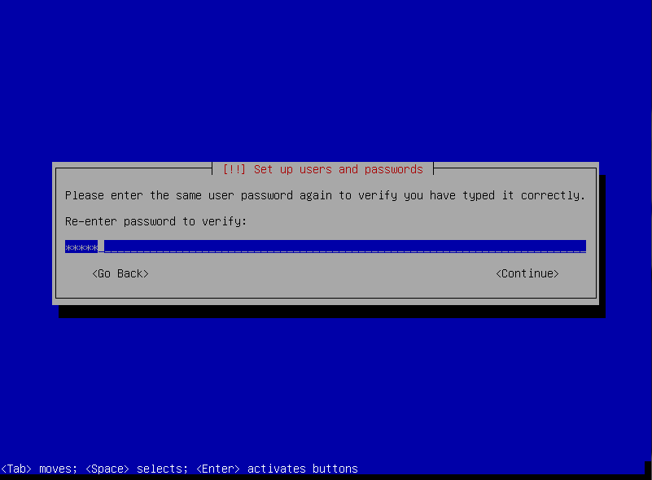
- At the disk partitioning stage, select the “Guided – use entire disk” and press ENTER.
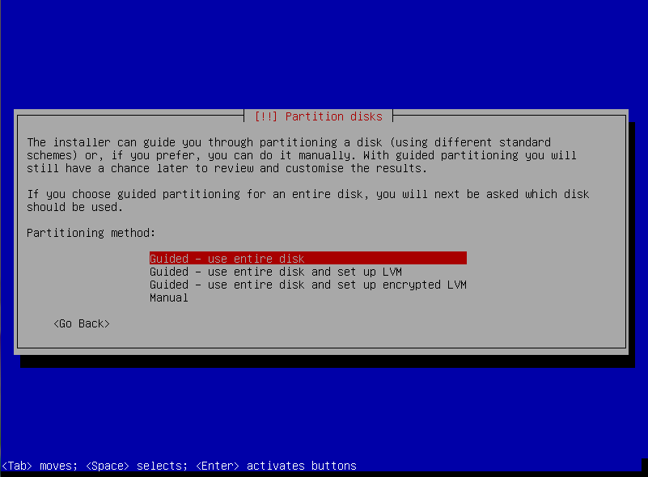
- When a command prompt to specify the disk to be partitioned is displayed, press ENTER.
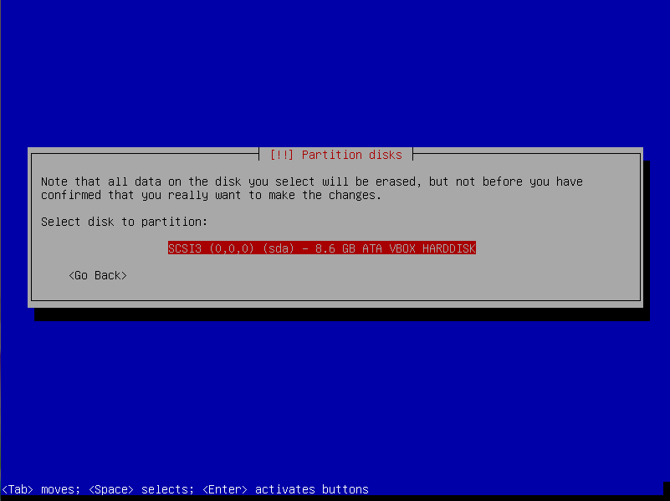
- Select the “All files in one partition (recommended for new users)” partitioning method and press ENTER.
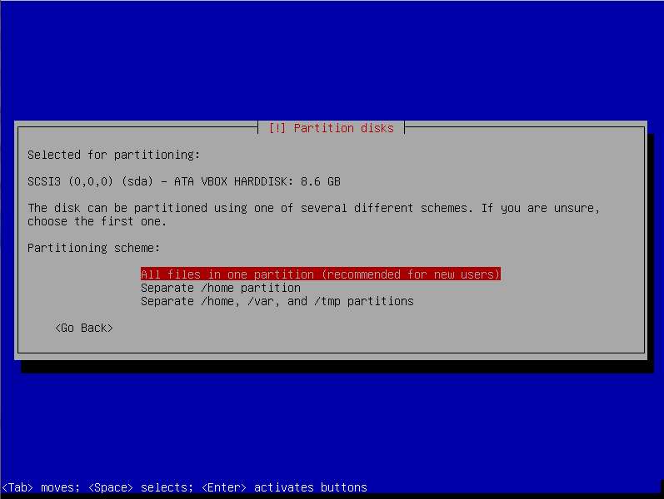
- Select the “Finish partitioning and write changes to disk” option and press ENTER.
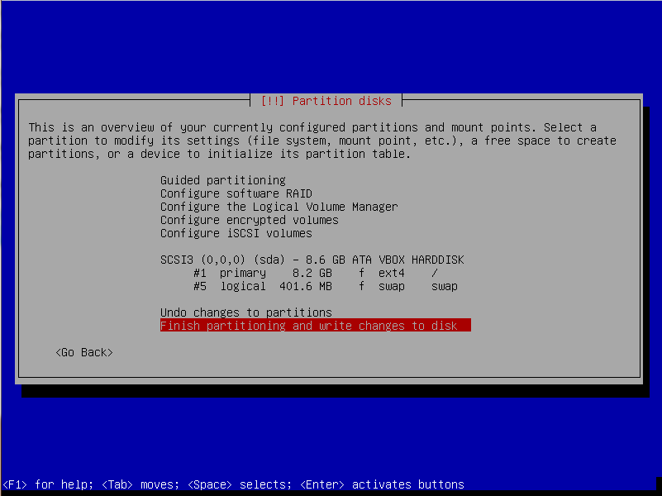
- When a prompt appears asking whether you wish to save the changes, select “Yes” and press ENTER.
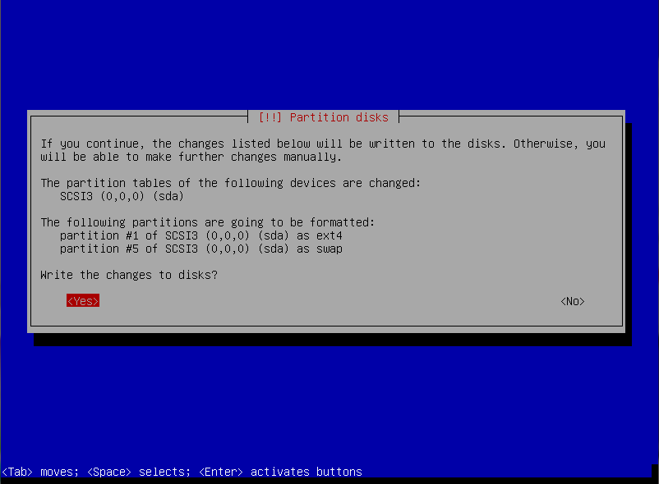
- Select the country for the http proxy server and press ENTER.
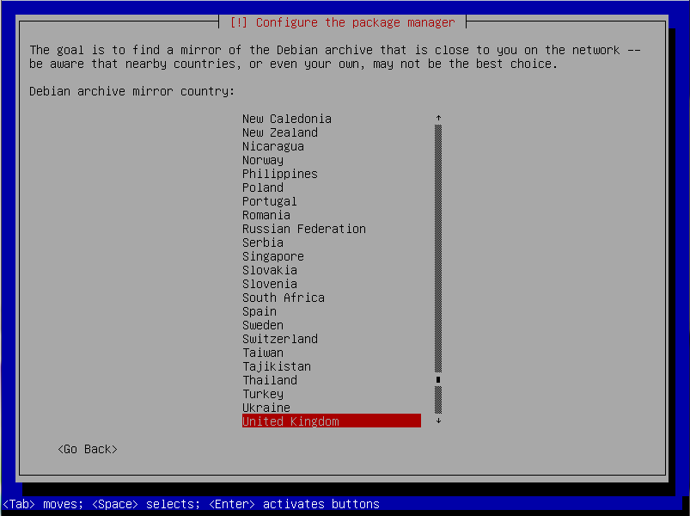
- Select the archive name for http proxy server and press ENTER.
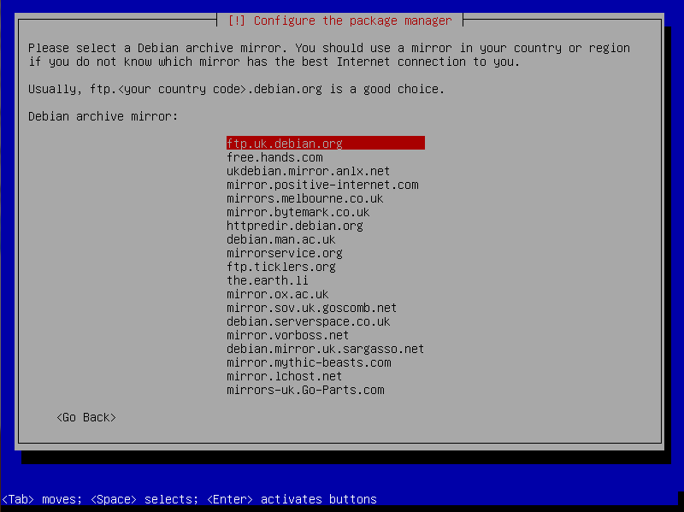
- Do not enter any http proxy related data, but select “Next” and press ENTER.
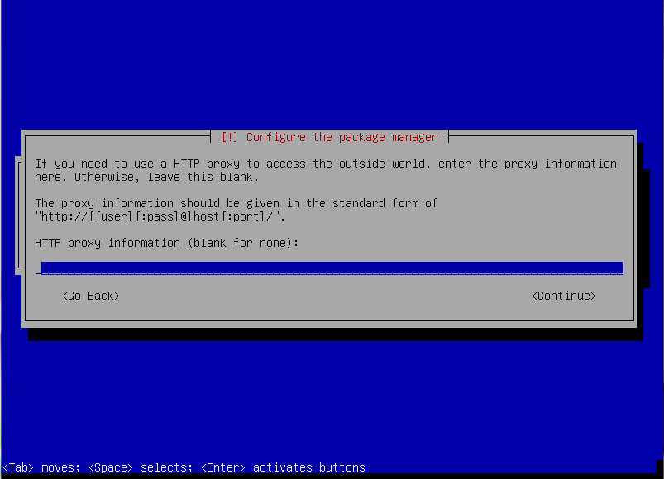
- Next windows indicating the installation progress will be displayed.
- When the “Configuration of popularity-contest package” window is displayed, select one of the available options and press ENTER.
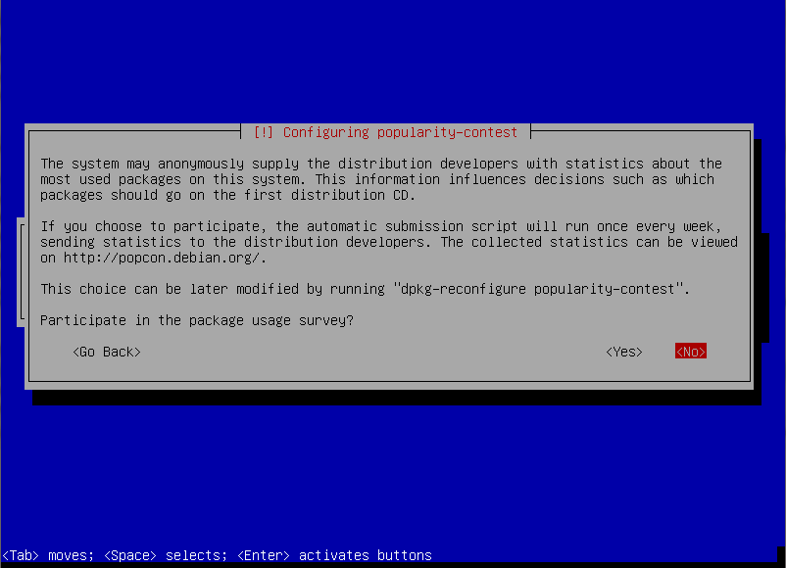
- Press repeatedly the space key to select software you want to install: “SSH server” and “Standard system utilities” (leave the other fields unselected). Then, press ENTER.
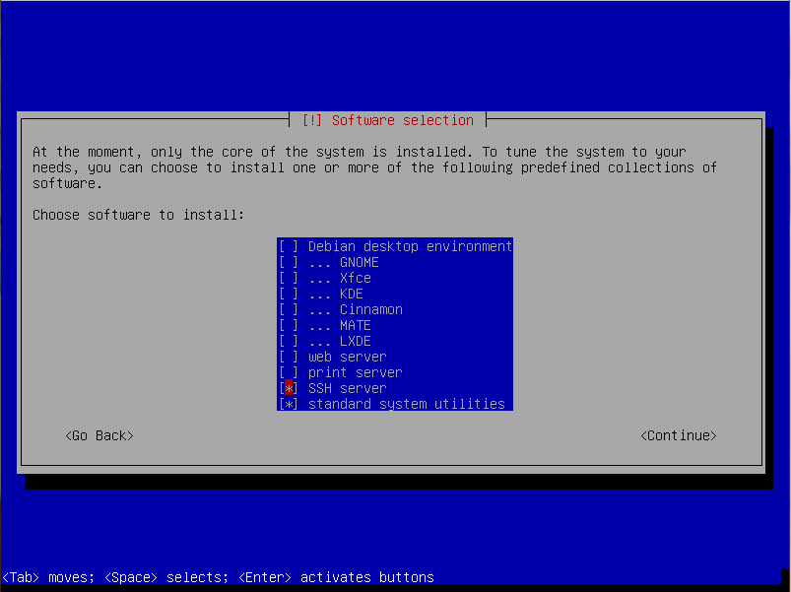
- Windows indicating the progress of installation will be displayed successively.
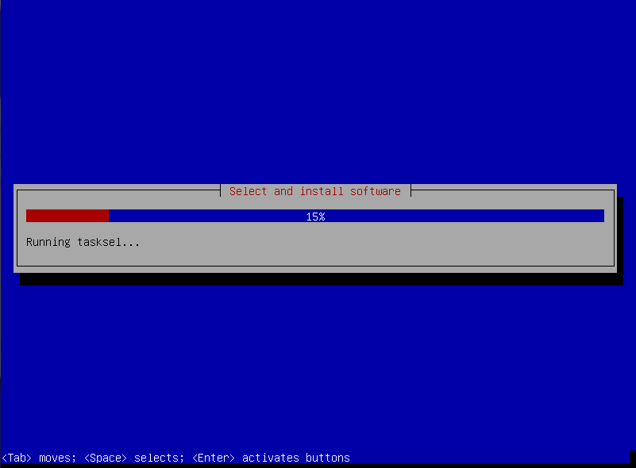
- When a prompt appears asking whether you wish to install the GRUB boot loader, select “Yes” and press ENTER.
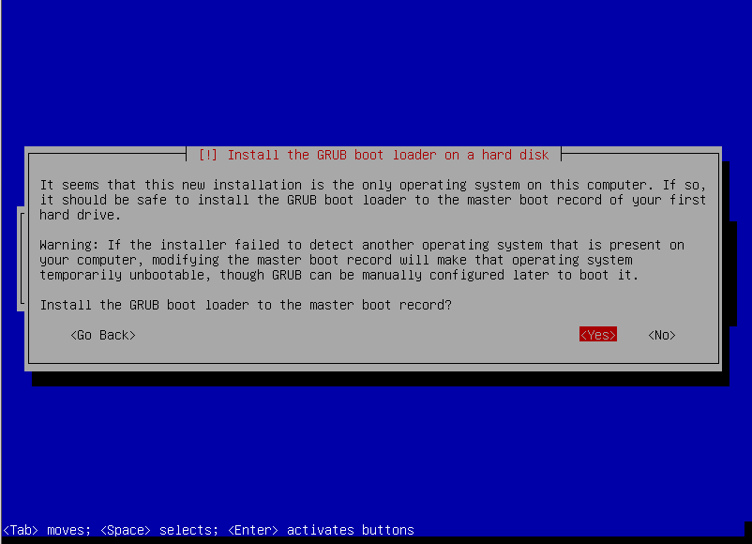
- Highlight the name of the master boot record of the first hard disk on which the GRUB boot loader will be installed and press ENTER.
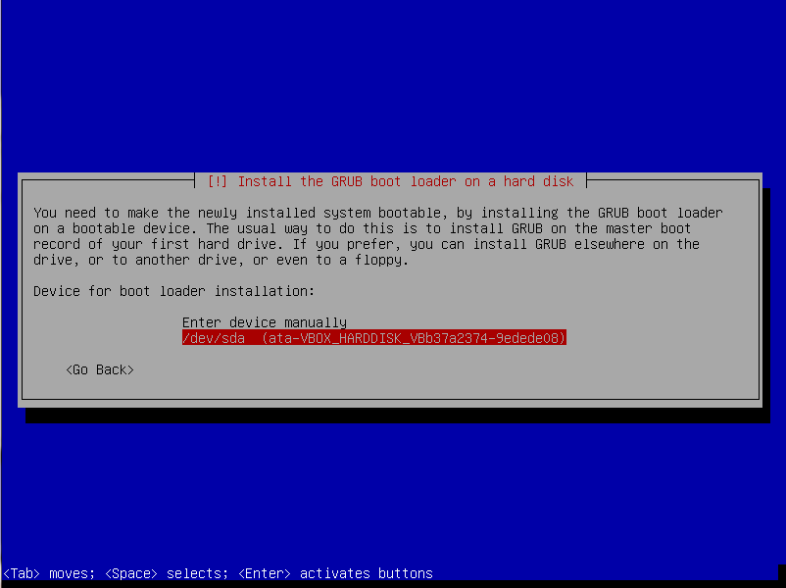
- When information on installation completion is displayed, press ENTER. Restart of the system will follow.
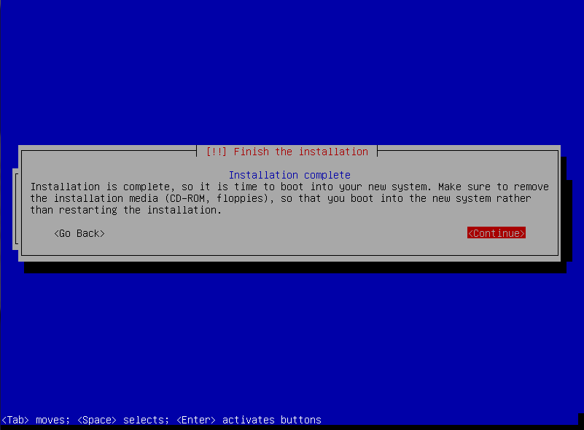

Installing the server environment and ACCO NET system
In the console window that will be displayed after the system restart, you can start installation of the ACCO NET system.
- Enter the administrator login (root) and press ENTER.
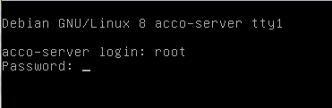
- Enter the administrator password and press ENTER.
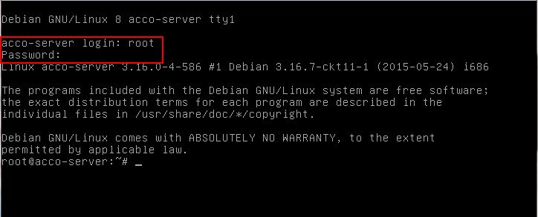
- To download the installation package of ACCO NET system, enter the command:
- for Debian operating system version 8.0:
wget http://updates.satel.pl/acco/install-debian-8.sh
- for Debian operating system version 7.6:
wget http://updates.satel.pl/acco/install-debian-7.sh
and press ENTER.
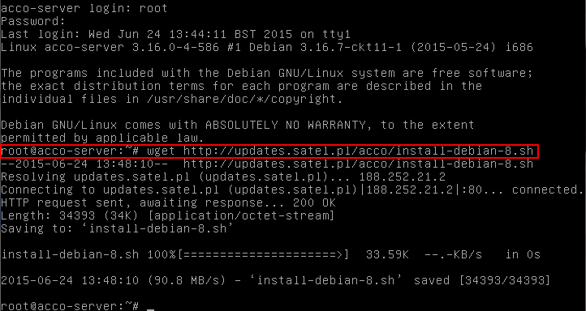
- Give permissions to run the installation package by entering the command:
- for Debian operating system version 8.0:
chmod 755 install-debian-8.sh
- for Debian operating system version 7.6
chmod 755 install-debian-7.sh
and press ENTER.
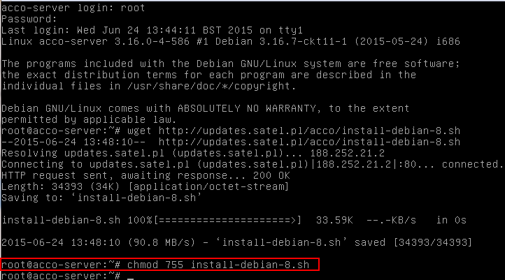
- Run the installation package by entering the command:
- for Debian operating system version 8.0:
./install-debian-8.sh
- for Debian operating system version 7.6:
./install-debian-7.sh
and press ENTER.
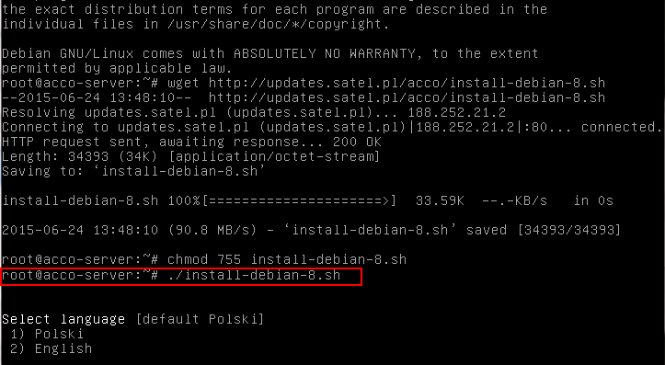
- Press the corresponding number key to select the installation language. Press ENTER (if it is to be the default language, you may press ENTER at once).
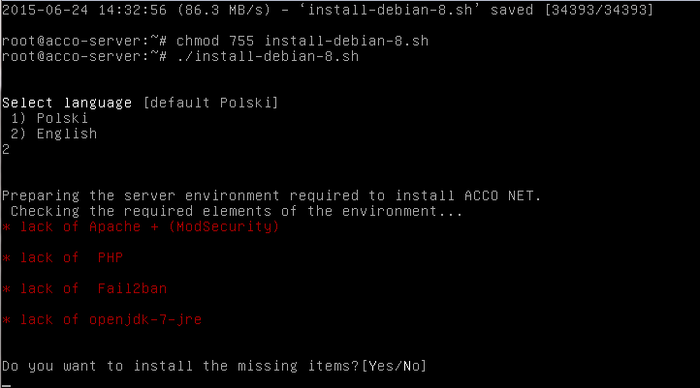
- Decide whether or not to install the missing environment components, required for ACCO NET installation. If yes, press Y. If no, press N and make the system ready for the ACCO NET installation manually.
- Information on the progress of installation will be displayed.
- Define whether the SQL base is to be installed locally or not. If it is to be installed locally, press either ENTER or Y. If you want the database to be installed on another computer, press N.
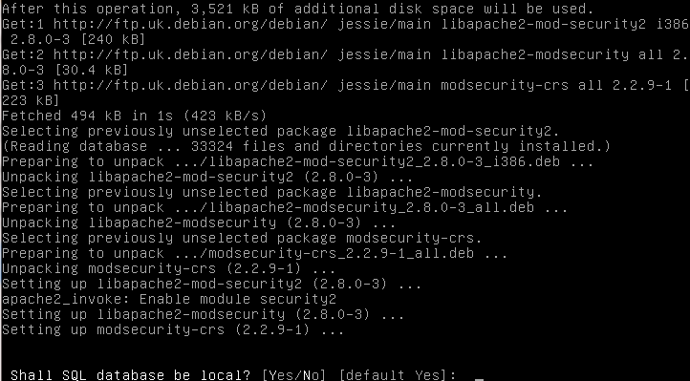
- Press the ENTER key to display the text of License Agreement for ACCO Server.
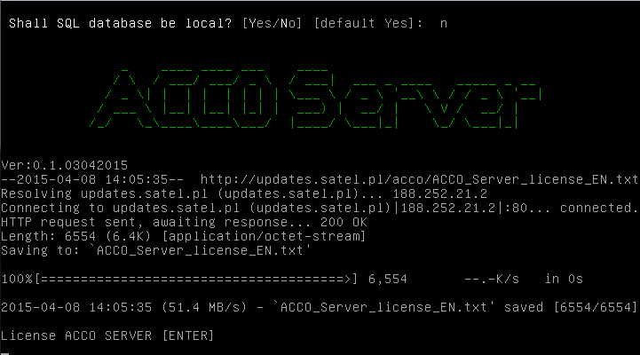
- Press the space key to display subsequent parts of the ACCO Server license agreement.
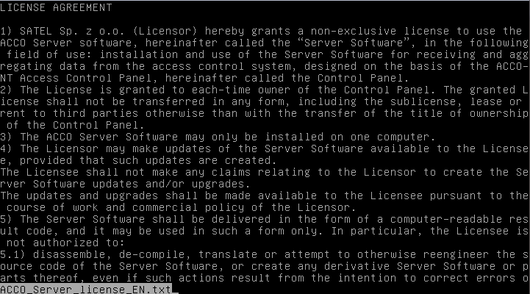
- Press Y to confirm terms and conditions of the ACCO Server license agreement.
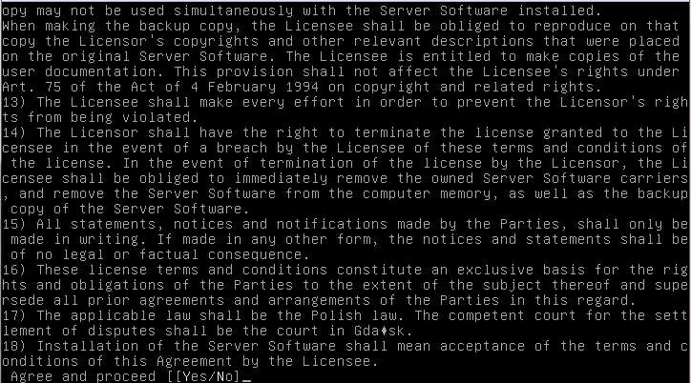
- Press the ENTER key to display the text of ACCO-WEB license agreement.
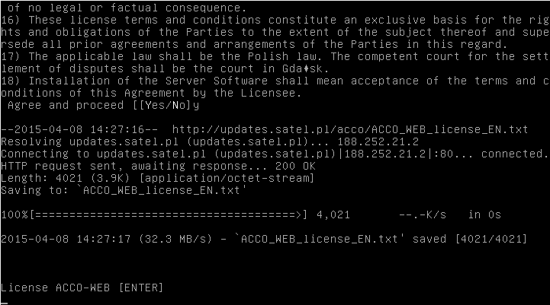
- Press the space key to display subsequent parts of the ACCO-WEB license agreement.
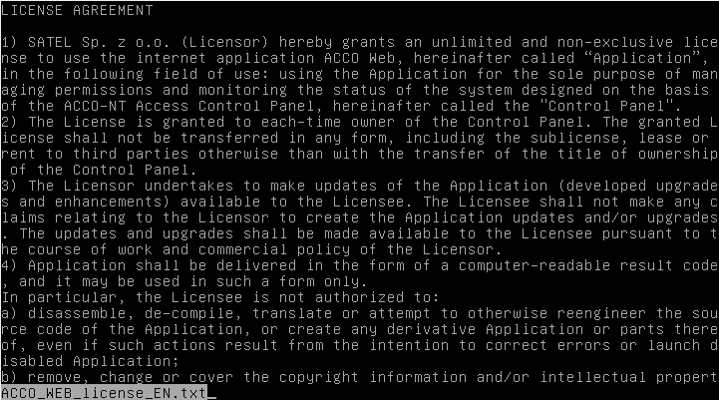
- Press Y to confirm terms and conditions of the ACCO-WEB license agreement.
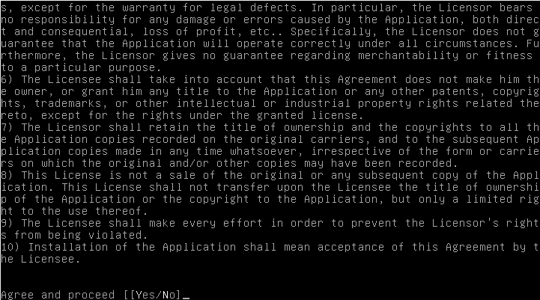
- When the list appears showing the ACCO NET system software to be installed at this stage of installation, press ENTER. The installation process will take several minutes.
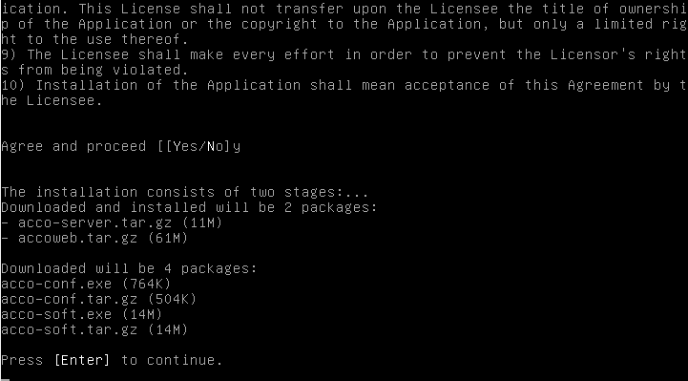
- If you have already decided that the SQL base is not to be installed locally, configure its settings. Enter the address of computer on which the database will be installed and press ENTER. The address can be entered in the IP address format (4 decimal numbers separated by dots) or as a name.
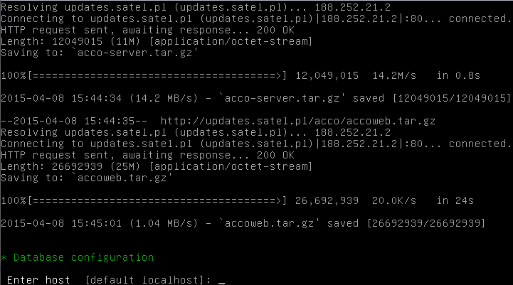
- Enter the number of port to be used for communication between ACCO Server and database (DB port) and press ENTER.
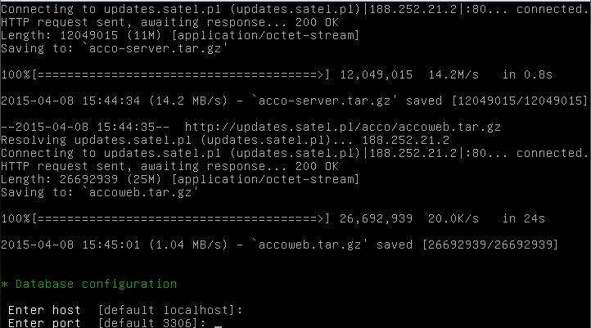
- Enter the login of administrator (root) or user having administrator rights, who will have access to the database, and press ENTER.
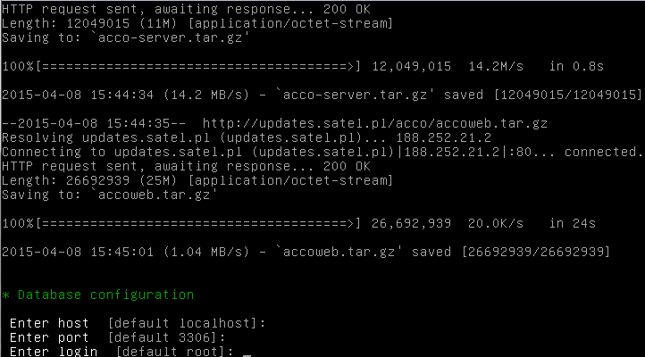
- Enter the password of administrator or user having administrator rights, who will have access to the database, and press ENTER.
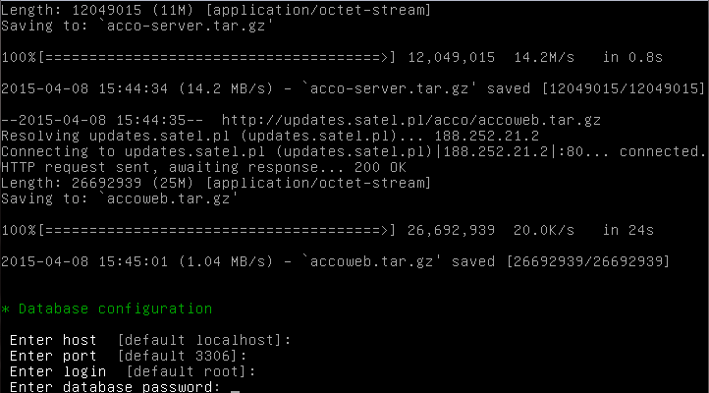
- Give a name to the database and press ENTER.
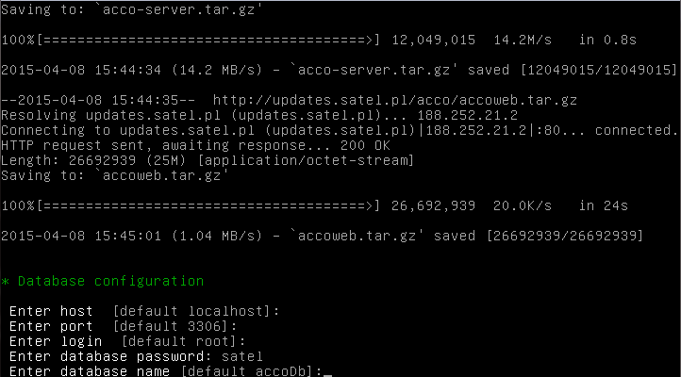
- Press the corresponding number key to select IP address of the computer on which the ACCO Server will be installed. Press ENTER.
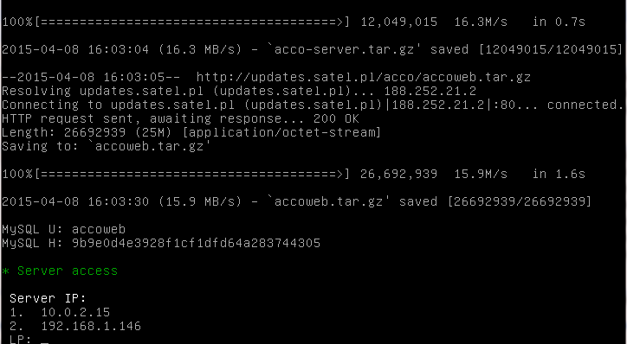
- Enter the number of port for communication between ACCO Server and ACCO-NT control panels and press ENTER.
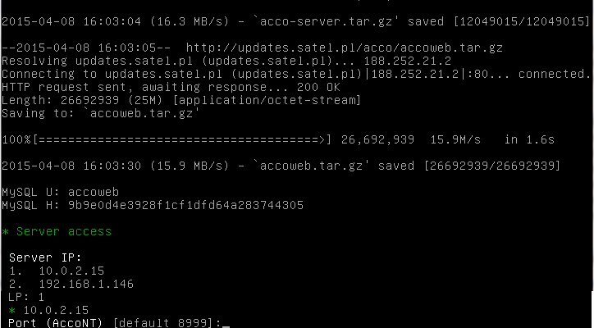
- Enter the number of port for communication between ACCO Server and ACCO Soft program (RMI port) and press ENTER.
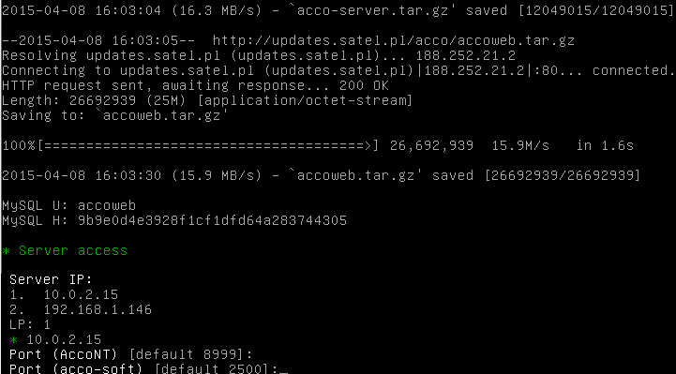
- Enter the number of port for communication between ACCO Server and ACCO-WEB program and press ENTER.
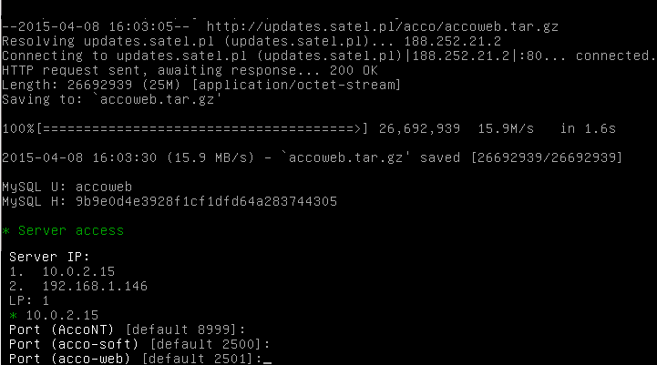
- Information on the installation progress will be displayed.
- Configure the SSL certificate settings for connection with the web server. Enter the two-letter country name (code) and press ENTER.
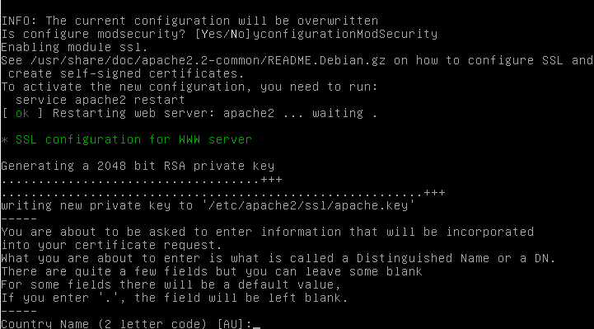
- Enter the name of state or province and press ENTER.
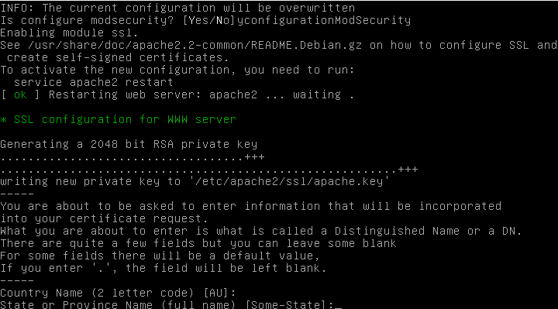
- Enter the name of locality (e.g. city) and press ENTER.
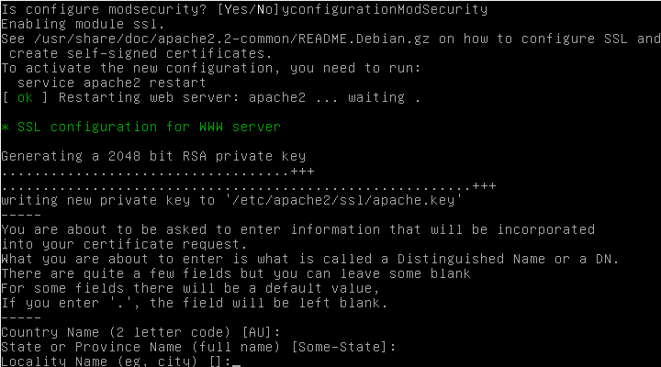
- Enter the name of organization (e.g. company) and press ENTER.
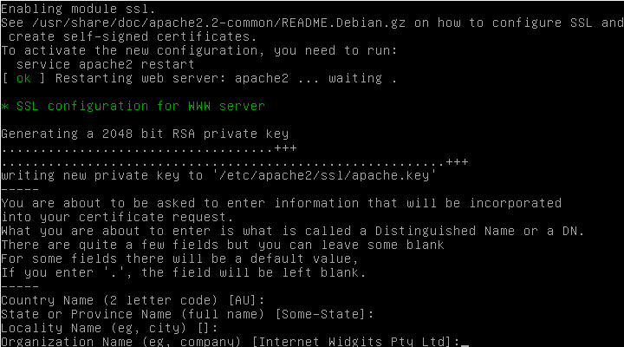
- Enter the name of organizational unit and press ENTER.
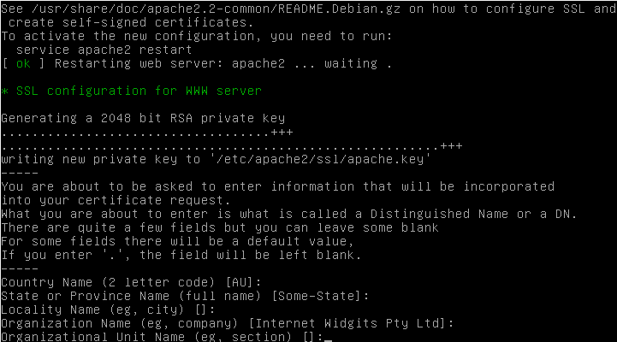
- Enter the name of computer on which the ACCO Server will be installed and press ENTER.
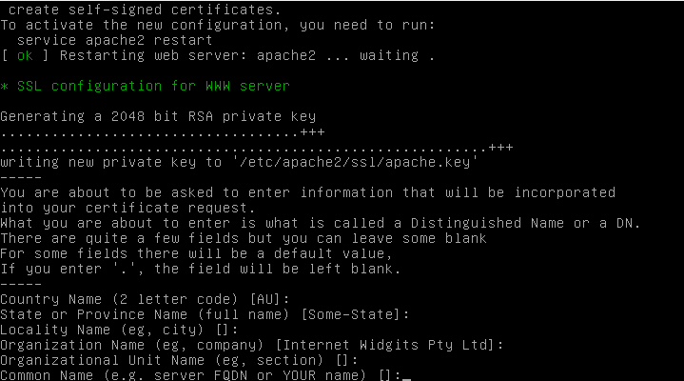
- Enter the e-mail address and press ENTER.
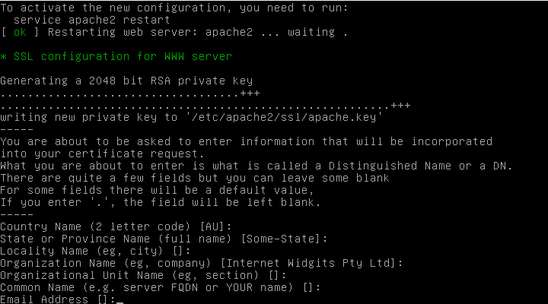
- Information on the installation progress, and then on completing the installation and launching the ACCO Server will be displayed.
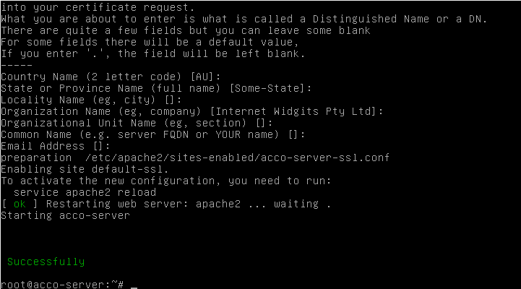

Installing the ACCO-NT Conf / ACCO Soft program
- Start the web browser. Enter the address: https://[address of the computer on which the ACCO Server is installed] and log into the ACCO-WEB application as the Administrator (default login: “admin”; default password: “admin”).
- Click on the “Programs” command in the menu on the left side of the screen. Links to the installation files of ACCO-NT Conf and ACCO Soft programs will be displayed.
- Click on the selected link to install the required program.

Configuring the settings
In the console window, you can configure the settings of ACCO Server and ACCO Soft program, as well as ACCO-WEB application.

ACCO Server and ACCO Soft program
If you wish to display the contents of configuration file of ACCO Server and ACCO Soft program, enter in the console window the following command:
cat /etc/acco/server.conf
and press ENTER.
If you wish to edit the contents of that configuration file, enter the command:
nano /etc/acco/server.conf
and press ENTER.
Presented below is the contents of ACCO Server and ACCO Soft program configuration file, based on the ACCO NET system shown in Fig. 1. In the square brackets, the meanings of individual lines are given.

dbhost=192.168.1.30 | [IP address / name of computer on which the database is installed]
dbname=accoDb | [name of database]
dbuser=accoweb | [name of user having access to the database]
dbpassword=  1db4e9f4e7d6ea6366b64e3becb6314d | [password of user having access to the database]
dbport=3306 | [number of network port (DB port) on which communication between ACCO Server and database will take place]
serverport=8999 | [number of network port on which communication between ACCO Server and ACCO-NT control panel will take place]
rmipublichost=192.168.1.30 | [public IP address / name of computer on which ACCO Server is installed]
rmiport=2500 | [number of network port (RMI port) on which communication between ACCO Server and ACCO Soft program will take place]
rmiport_www=INET:2501 | [number of network port on which communication between ACCO Server and ACCO-WEB application will take place]

ACCO-WEB application
If you wish to display the contents of configuration file of ACCO-WEB application, enter in the console window the following command:
- for Debian operating system version 8.0:
cat /var/www/html/satel/protected/config/servers.php
- for Debian operating system version 7.6:
cat /var/www/satel/protected/config/servers.php
and press ENTER.
If you want to edit the contents of that configuration file, enter the command:
- for Debian operating system version 8.0:
nano /var/www/html/satel/protected/config/servers.php
- for Debian operating system version 7.6:
nano /var/www/satel/protected/config/servers.php
and press ENTER.
Presented below is the contents of ACCO WEB application configuration file, based on the ACCO NET system shown in Fig. 1. In the square brackets, the meanings of individual lines are given.

const DATABASE_NAME = ‘accoDb’ | [name of database]
const DATABASE_IP = ‘localhost’ | [IP address / name of computer on which the database is installed]
const DATABASE_USER = ‘accoweb’ | [name of user having access to the database]
const DATABASE_PASSWORD = ‘1db4e9f4e7d6ea6366b64e3becb6314d’ | [password of user having access to the database]
const RMI_IP = ‘192.168.1.30’ | [IP address / name of computer on which ACCO Server is installed]
const RMI_PORT = ‘2501’ | [number of network port on which communication between ACCO Server and ACCO-WEB application will take place]

Useful commands
Commands entered in the console window may facilitate management of the ACCO NET system (having entered a command, press ENTER):
- to check the ACCO Server program status:
service acco-server status
- to stop the ACCO Server program:
service acco-server stop
- to start the ACCO Server program:
service acco-server start
- to check the current versions of programs installed (ACCO Server, ACCO-WEB):
- for Debian operating system version 8.0:
./install-debian-8.sh version
- for Debian operating system version 7.6:
./install-debian-7.sh version

Updating the ACCO NET system software
- Log in as the administrator in the console window (login: root).
- Enter the sequence of commands:
- for Debian operating system version Debian 8.0:
rm install-debian-8.sh ; wget http://updates.satel.pl/acco/install-debian-8.sh ; chmod 755 install-debian-8.sh ; ./install-debian-8.sh update
- for Debian operating system version 7.6:
rm install-debian-7.sh ; wget http://updates.satel.pl/acco/install-debian-7.sh ; chmod 755 install-debian-7.sh ; ./install-debian-7.sh update
and press ENTER.
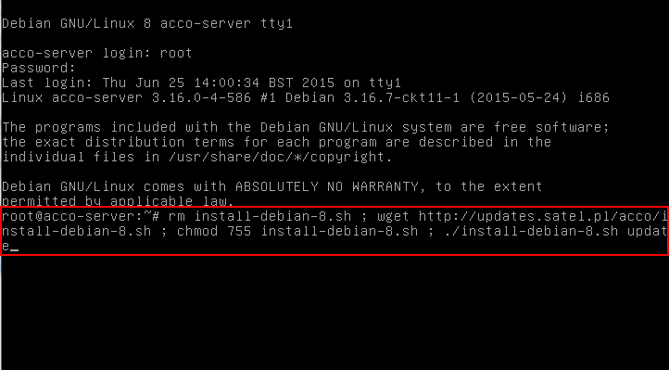
- Press the corresponding number key to select the installation language and then press ENTER (if it is to be the default language, you may press ENTER at once).
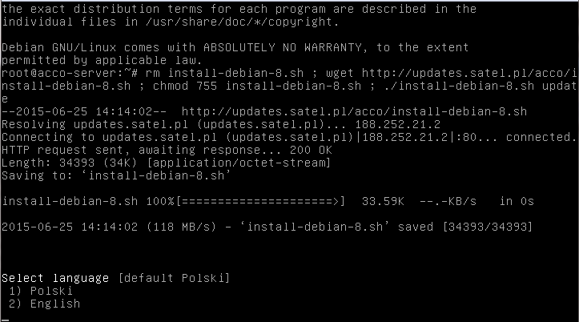
- Information on your version and the new version of ACCO-WEB application will be displayed. Click Y to update the application.
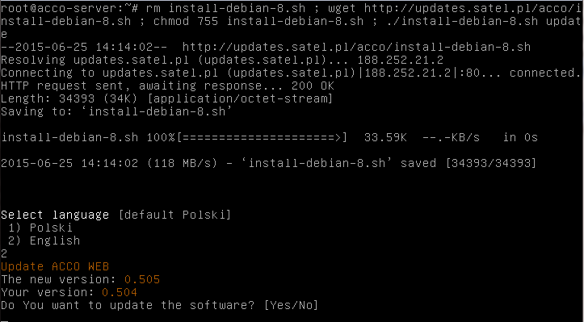
- Information on your version and the new version of ACCO Server will be displayed. Click Y to update the ACCO Server.
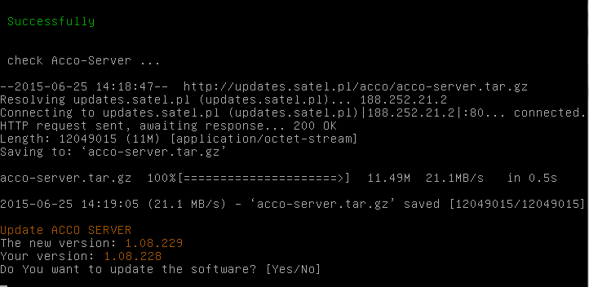
- Having updated the ACCO-WEB and ACCO Server, you can update the ACCO-NT Conf and ACCO Soft programs. To do this, start the web browser.
- Enter the address: https://[ address of computer on which ACCO Server is installed].
- Log into the ACCO-WEB application as the Administrator (default login: “admin”; default password: “admin”).
- Click on the “Programs” command in the menu on the left side of the screen. Links to the installation files will be displayed.
- Download the updated installation files.



Access Control System
ACCO NET

Installation Manual

acco_net_i_en 04/16

SATEL sp. z o.o.
ul. Budowlanych 66
80-298 Gdańsk
POLAND
tel. +48 58 320 94 00
www.satel.eu
druk:

