SATEL's goal is to continually upgrade the quality of its products, which may result in some changes of their technical specifications and firmware. The current information on the introduced modifications is available on our website.
Please visit us at:
http://www.satel.eu

The following symbols may be used in this manual:
 - note;
 - caution.

Changes made to firmware version 1.30
Users | “Clear” button to remove the filter and display the list of all data on the page.  List  User parameters:  - E-mail,  - Phone.  Groups  Data of user groups can be exported to file.  Functionality:  - Outputs Activation.
Access Schemes | In all tabs:  - “Clear” button to remove the filter and display the list of all data on the page.  - Data can be exported to file.
Events | Events from the INTEGRA or INTEGRA Plus alarm systems are saved to the database of ACCO NET system and displayed on the event list (integration).  Additional event-related information can be displayed.  “Clear” button to remove the filter and display the list of all data on the page.  Data in the event list table:  - Source.  Default event filtering (events from the last 3 months can be seen).  Event type in the filter by type field (integration):  - INTEGRA.
Presence | “Clear” button to remove the filter and display the list of all data on the page.  Preview  Number of present / absent users displayed.  “Presence preview” summary list can be exported to file.  Calendars  In all tabs:  - Data can be exported to file.  In the “Daily schedules” tab, a field has been added to allow you to modify the time scale on the diagram.  Rules  Presence rules can be exported to file.
Maps | The status of alarm system partitions, zones and outputs is presented on the map (integration).  Integrated partitions of the alarm system can be armed / disarmed (integration).  Zone status presented in graphical form.  Door status presented by using colors.  Zone related information presented on hovering cursor over the zone:  - number of people currently staying in the zone,  - current zone status.
Management | In all tabs:  - “Clear” button to remove the filter and display the list of all data on the page.  The list can be filtered by zone status in the “Zones” tab.  Additional information related to the control panel presented on the control panel status page, in the “Control panels” tab.  Additional information related to the controller presented on the controller status page, in the “Controllers” tab.
CONTENTS
1. General 6
2. First-time login to the ACCO-WEB application 6
2.1 Changing default password 7
3. Description of the ACCO-WEB application 8
3.1 Main menu of the ACCO-WEB application 8
3.2 Status bar of the ACCO-WEB application 9
3.2.1 List of troubles / alarms 10
3.3 Managing users 10
3.3.1 User list 11
3.3.1.1 Table with the list of users 11
3.3.1.2 “Add new user” window 13
3.3.1.3 User editing page 14
3.3.1.4 Deleting user 28
3.3.1.5 Filtering users 29
3.3.1.6 Exporting users 31
3.3.2 User groups 31
3.3.2.1 Table with user groups 32
3.3.2.2 “Add new users group” window 32
3.3.2.3 Adding user group 33
3.3.2.4 User group editing page 33
3.3.2.5 Deleting user group 38
3.3.2.6 Deleting several user groups 39
3.3.2.7 Filtering user groups 39
3.3.2.8 Exporting user groups 39
3.3.3 Access to objects 40
3.3.3.1 Table with object list 40
3.3.3.2 Filtering data 41
3.3.3.3 Exporting data from table 42
3.4 Access Schemes 43
3.4.1 “Access calendars” tab 43
3.4.1.1 List of access calendars 43
3.4.1.2 “Add calendar” window 45
3.4.1.3 Creating access calendar 45
3.4.1.4 Filtering access calendars 45
3.4.1.5 Exporting access calendars 45
3.4.2 “Weekly schedules” tab 46
3.4.2.1 List of weekly access schedules 46
3.4.2.2 “Add new weekly schedule” window 47
3.4.2.3 Creating weekly access schedule 48
3.4.2.4 Editing weekly access schedule 48
3.4.2.5 Filtering weekly access schedules 49
3.4.2.6 Exporting weekly access schedules 49
3.4.3 “Daily schedules” tab 50
3.4.3.1 List of daily access schedules 50
3.4.3.2 Creating daily access schedule 52
3.4.3.3 Editing daily access schedule 53
3.4.3.4 Exporting daily access schedules 54
3.4.4 Editing access calendar 54
3.4.4.1 Assigning weekly access schedule to one week 55
3.4.4.2 Assigning weekly access schedule to several weeks 55
3.5 Events 56
3.5.1 Event list 56
3.5.1.1 Table with event list 56
3.5.2 Filtering events 58
3.5.3 Exporting events 59
3.6 Presence 60
3.6.1 Presence preview 60
3.6.1.1 Filtering “Presence preview” summary list 61
3.6.1.2 Creating “Presence preview” summary list 62
3.6.1.3 Exporting the “Presence preview” summary list 62
3.6.1.4 “User” window 63
3.6.2 Presence reports 63
3.6.2.1 Table with the list of users 64
3.6.2.2 Presence report – filtering 65
3.6.2.3 Detailed user presence report 66
3.6.2.4 Generating a presence report 68
3.6.3 Calendars 68
3.6.3.1 “Presence calendars” tab 68
3.6.3.2 Exporting presence calendars 70
3.6.3.3 “Weekly schedules” tab 70
3.6.3.4 “Daily schedules” tab 74
3.6.3.5 Exporting daily presence schedules 78
3.6.3.6 Editing presence calendar 78
3.6.4 Presence rules 80
3.6.4.1 List of presence rules 81
3.6.4.2 Filtering presence rules 82
3.6.4.3 “Add rule” window 82
3.6.4.4 Creating presence rule 82
3.6.4.5 Editing presence rule 82
3.6.4.6 Filtering presence rules 84
3.6.4.7 Exporting presence rules 84
3.7 Maps 84
3.7.1 Zones 85
3.7.2 Doors 87
3.7.3 ACCO – Inputs 88
3.7.4 ACCO – Outputs 89
3.7.5 INTEGRA – Zones 90
3.7.6 INTEGRA – Outputs 90
3.7.7 Camera 91
3.8 Management 92
3.8.1 “Doors” tab 92
3.8.1.1 Table with the list of door supervision controllers 92
3.8.1.2 Filtering door supervision controllers 93
3.8.2 “Zones” tab 93
3.8.2.1 Table with list of zones 94
3.8.2.2 Filtering zones 94
3.8.3 “Control panels” tab 95
3.8.3.1 Table with the list of control panels 95
3.8.3.2 Filtering control panels 95
3.8.3.3 Control panel status 96
3.8.4 “Controllers” tab 96
3.8.4.1 Table with the list of controllers 97
3.8.4.2 Filtering controllers 97
3.8.4.3 Controller status 97
3.9 Settings 99
3.9.1 Editing parameters 99
3.10 Programs 99
3.11 System operations 100

General
The ACCO-WEB Internet application is intended to be used for management and remote operation of the ACCO NET access control system. It is installed automatically with the other programs of the ACCO NET access control system. All you need to use this application is a web browser installed on your computer.
The ACCO-WEB application runs trouble-free, if used with the following updated browsers: Google Chrome (version 46 or newer), Mozilla Firefox (version 41 or newer), Internet Explorer (version 11 or newer) and Edge.

First-time login to the ACCO-WEB application
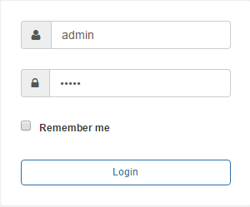
Fig. 1. ACCO-WEB login window.

- Start your web browser.
- Enter the address: https://[address of the computer on which the ACCO-WEB application has been installed, in the form of IP address (4 decimal numbers separated by dots) or as a domain name].
Logging in to the ACCO-WEB application is secured by means of the SSL protocol. A message about untrusted certificate for the page will be displayed in the browser window until you accept the SSL certificate or put a registered certificate on the computer on which the ACCO-WEB application has been installed.
If the application fails to open correctly in the Internet Explorer browser, check that the address you have entered is on the “Websites you've added to Compatibility View” list. To do this, open the “Tools” menu and select “Compatibility View Settings”. If the address you have entered in the browser is included in the list of websites for which compatibility view is enabled in the browser, remove the address. Do not enable the following options: “Display intranet sites in Compatibility View” and “Use Microsoft compatibility lists”. Click on the “Close” button.
- Log into the ACCO-WEB application as the Administrator (by default: login “admin” and password “admin”).
After the user's login to the application, if:
- a new version of the ACCO-WEB application is available,
- another user is configuring the ACCO NET system settings,
respective messages will be displayed on the page.
If the language of the ACCO Server program is different from that of the ACCO-WEB application, some messages in the app may be displayed in the language set for ACCO Server.

Changing default password
Change the factory default access password for the application before you start using the system.
- On the users' list, click on the Administrator name.
- On the page that will open, click on the “Access to program” button.
- Click on the “Change password” button.

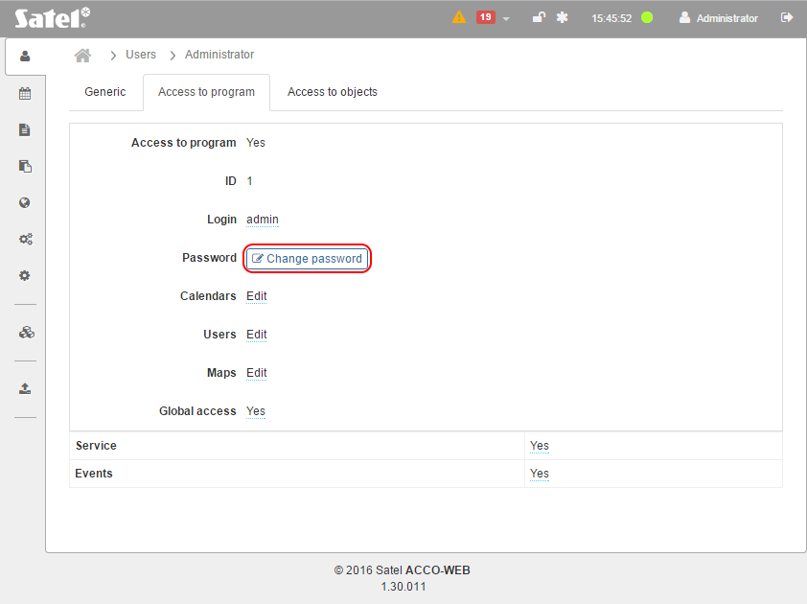
Fig. 2. The “Access to program” tab that allows you to change the Administrator password.

- In the window that will open, enter new password, re-enter it, and then click on the “Save” button to confirm the changes you made.
- In the menu on the left, click on “System operations” →“Save changes”.
After three failed attempts to login to the ACCO NET system made during 10 minutes, access to the system will be blocked for 1 minute for the IP address of the computer from which login attempts have been made. For detailed information on the blocking, refer to the system logs.

Description of the ACCO-WEB application

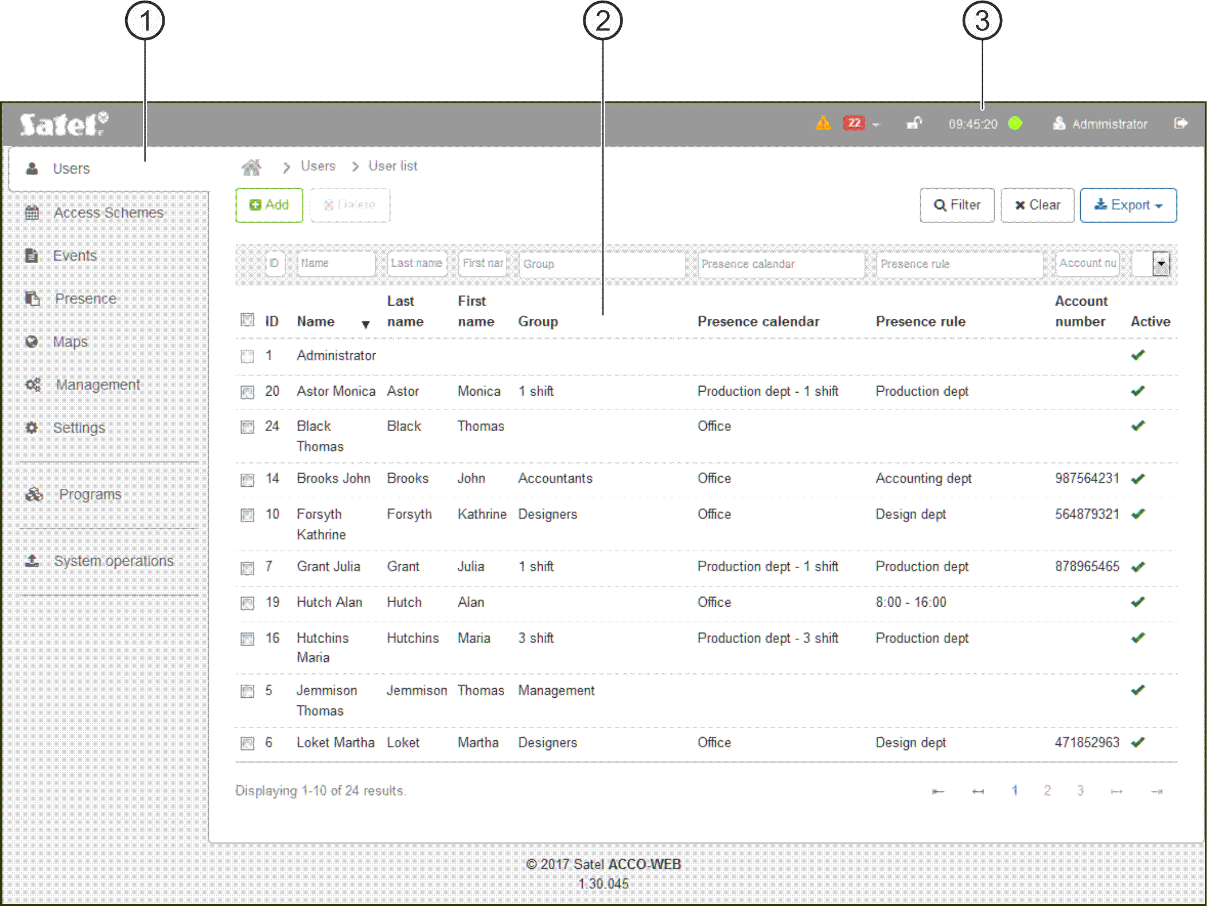
Fig. 3. Main window of the ACCO-WEB application.

 main menu.
 page.
 status bar.

Main menu of the ACCO-WEB application
Depending on the set resolution / size of the browser window, the main menu of the application can be presented by means of icons with or without description:
 | Users | List
 |  | Groups
 |  | Access
 | Access Schemes
 | Events

 | Presence | Preview
 |  | Report
 |  | Calendars
 |  | Rules
 | Maps
 | Management
 | Settings
 | Programs (for Administrator only) | ACCO-NT Conf
 |  | ACCO Soft
 | System operations | Save changes
 |  | Undo changes

Status bar of the ACCO-WEB application

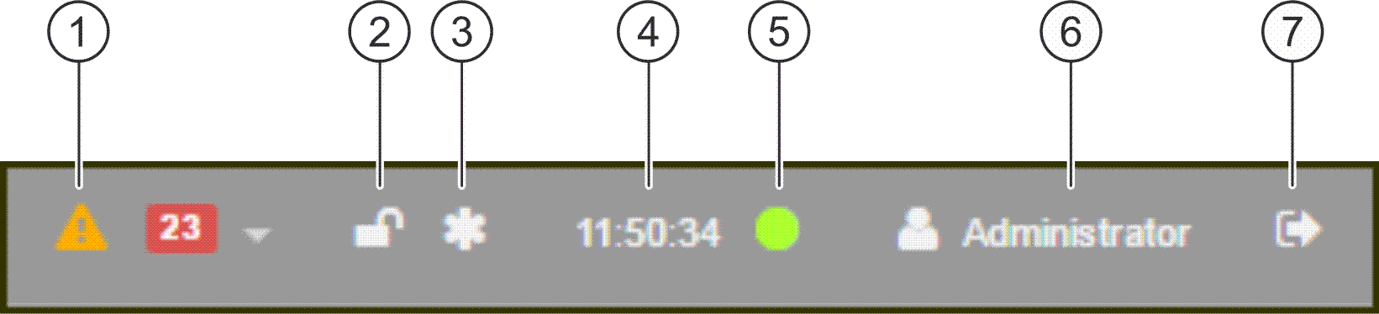
Fig. 4. Status bar of the ACCO-WEB application.

Explanations for Fig. 4:
 icon indicating the current troubles / alarms in the system. Their number is shown next to the icon. To display the list of troubles / alarms, click on the button (see: “List of troubles / alarms”).
 database status icon:
– database available.
– database locked. When you hover the cursor over the icon, information will be displayed that editing has been started by another user. After the other user saves the data, the database will be unlocked (and the icon will disappear).
 icon indicating that some changes have been introduced by a logged in user, but not saved yet.
 time according to ACCO Server clock.
 icon indicating the status of connection between ACCO-WEB application and ACCO Server:
– green color – communication OK (server online);
– red color – no communication (server offline).
The connection is checked every 10 seconds.
 name of logged in user.
 logout button.

List of troubles / alarms
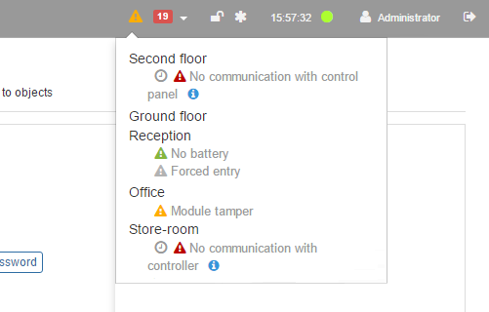
Fig. 5. An example of the list of current troubles in the system.

The window displays in the form of a list the names of devices included in the access control system. Under the name of device where trouble / alarm occurred, a respective message will be shown. Additionally, the following icons may be displayed:
– alarm (white exclamation mark on red background),
– trouble (white exclamation mark on orange background),
– confirmed alarm / trouble (white exclamation mark on green background),
– alarm / trouble memory (white exclamation mark on gray background).
At some messages, other icons may show up. Hover the cursor over them to display:
– date and time of event transmission by the ACCO Server;
– additional information on alarm / trouble.
You can acknowledge trouble / alarm. To do so, click on the listed device in which trouble / alarm occurred. You will be taken to the page showing the selected device status. Click on the button at the given trouble / alarm to acknowledge the trouble / alarm.

Managing users
In the ACCO NET system, up to 65 thousand users can be registered. You can assign 8 thousand users to one ACCO-NT control panel or to one zone. The ACCO-WEB application allows you to add, edit, group and delete the users.
New users can be added by a user having the “Users – Edit” right. How to create a user – see section ““Add new user” window”.
At the first-time login to the application, only one user is registered in the system under the “Administrator” name and with ID 1 number, which has all rights but no access code.
You cannot remove from the system or restrict program rights of the ID 1 number user.
Remember to assign access code to the ID 1 number user so that he/she can use the doors.
All the user data are saved to the database.

User list
Buttons
Add – click to open the new user adding window (see: ““Add new user” window”).
Delete – click to delete the selected user(s). The button is available when the box next to at least one user is checked.
Filter – click to filter the users (see: “Filtering users”).
Clear – click to remove the filter and display the list of all users (see: “Filtering users”).
Export – click to export the user data to file (see: “Exporting users”).

Table with the list of users

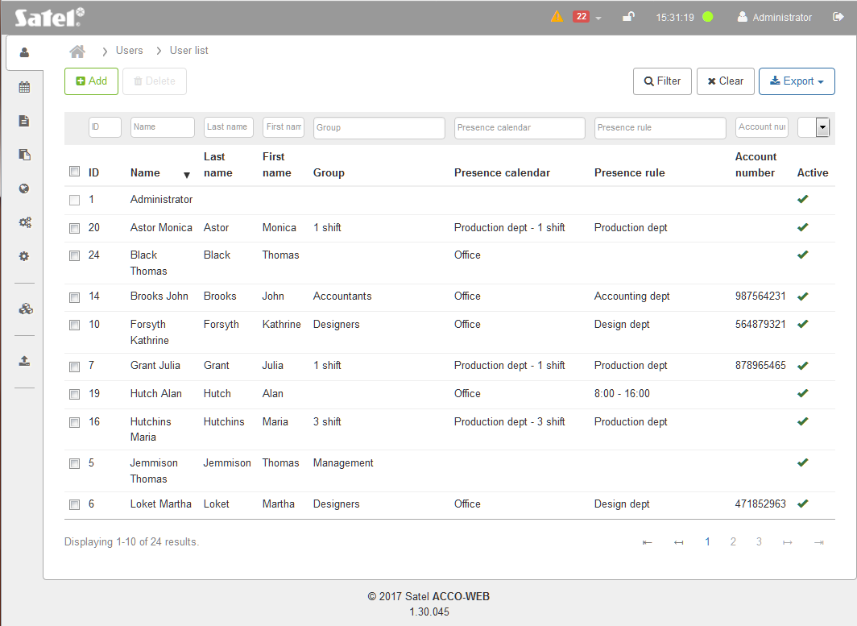
Fig. 6. User list.

ID – identification number, automatically assigned during the new user adding procedure. Check the box on the left side to select all users.
Name – individual user name. Click on it to edit the given user.
Last name – user's family name.
First name – user's given name.
Group – name of the group to which the user is assigned.
Presence calendar – name of the presence calendar that has been assigned to the user.
Presence rule – name of the presence rule that has been assigned to the user.
Account number – user's identification number, created for accounting purposes.
Active – information on whether the user is served by the ACCO NET system.
The fields above the column names allow filtering of the list (see: “Filtering users”).
Click on the name of a column to sort the user data by the column name.
If the user list is too long to fit on one page, buttons are displayed to facilitate navigation through the pages.

“Add new user” window
Settings as – select the user whose settings are to serve as pattern for the new user. The new user will be assigned to the same group as the pattern, will have the “Present” option enabled in the same zones, and the same access calendars, presence calendars and times of access to the selected doors will be assigned to him.
If the user is not to be created based on another user's pattern, press the F5 key and then click on the “Add” button.
Last name – enter the user's last name.
First name – enter the user's first name.
Name – individual user name. It will be generated automatically after entering the user's last name and first name, but you can also enter here any name you like. The name may comprise up to 16 characters. This field is required.
Group – select a group to which the user will be assigned. For a user not assigned to any group, the “Not assigned” information is displayed in this field. If no group has been created, only this item will be available.
Presence calendar – select one of the available presence calendars to indicate for how long the user shall stay in the zones defined in the presence rule assigned to him (see: ““Presence calendars” tab”).
Account number – enter the user identification number for accounting purposes.
E-mail – enter the e-mail address of the user.
Phone – enter the telephone number of the user.
Description – in this field, you can enter additional description of the user.
Access from – define from when the user will have access to the selected doors.
Access to – define to when the user will have access to the selected doors.
Active – user status. If the option is enabled, the user is served by the ACCO NET system. If the option is disabled, information about the user and his rights will not be sent to the controllers. The user, despite the “Present” option being enabled in the defined zones (see: ““Access to objects” tab”), will have access nowhere.
Save – click to create a user and start editing his data (see: “User editing page”).
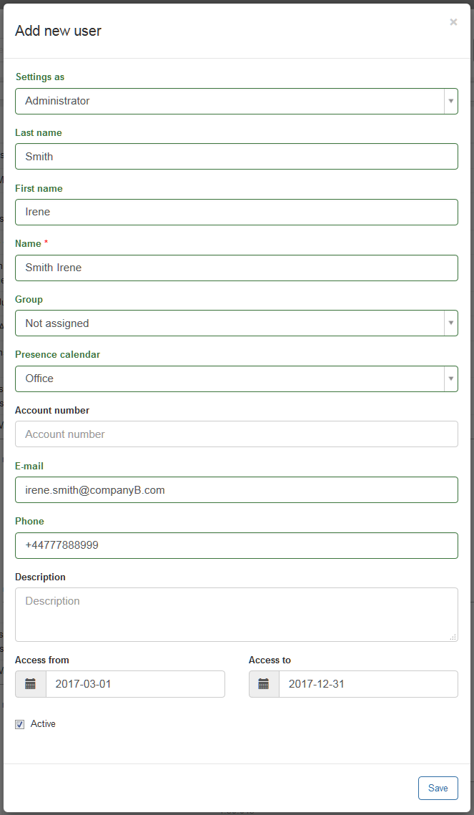
Fig. 7. New user adding window.

User editing page
The page on which you can configure the data of selected user will open after clicking on:
- the “Save” button when creating a user,
- the name of selected user on the user list.
You can edit all the user parameters, except the ID number.

“Generic” tab

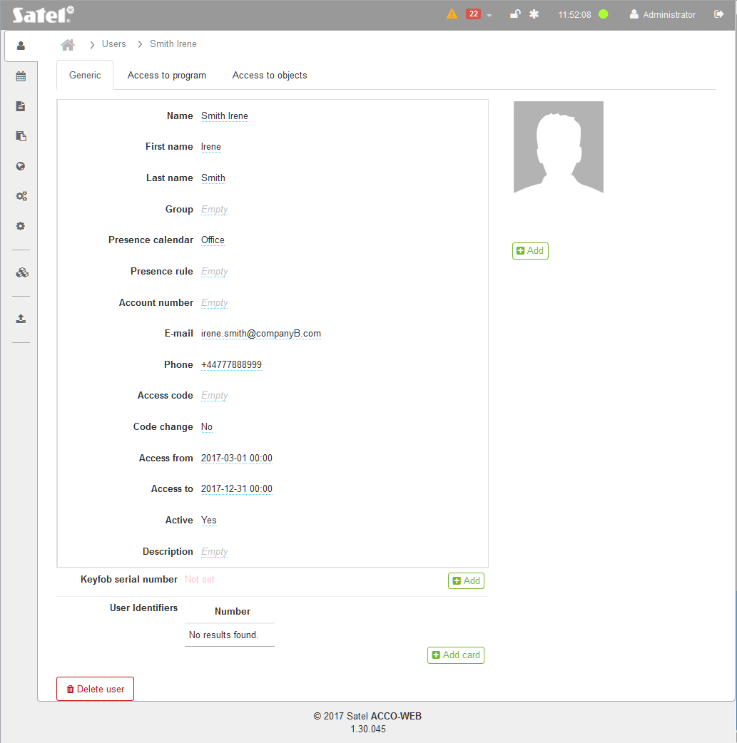
Fig. 8. An example of user's “Generic” tab.

In the fields which have not been defined, the “Empty” information will be displayed. To edit individual parameters, click on the defined value or the “Empty” text. Depending on the type of parameter, you can fill in the field manually or select data from the drop-down menu. During editing, the following icons are available:
– click to remove text from the field.
– click to confirm the entered data.
– click to finish editing without changing the data.
Additionally, you can define the following parameters:
Presence rule – select one of the available presence rules (see: “Presence rules”).
Access code – in this field, you can enter a sequence of 8 to 12 digits which grants the user access to the door. After entering, the code remains visible until the user data page is refreshed.
Code change – determine whether the user should change the code. If so, the user will be prompted to change the code when using the LCD keypad (2 short beeps repeated three times and accompanied by a displayed message).
The code can be changed only using the LCD keypad connected to the module assigned to the zone in which the “Present” option is enabled for the user.
Keyfob serial number – identification number of the keyfob.
Add – click to add a keyfob. The “Assign keyfob” window will open (see: “Adding keyfob – manually entering serial number” and “Adding keyfob – reading serial number during transmission”).
Delete – click to remove a keyfob. When a prompt is displayed asking you whether to remove the keyfob, click “OK”.
Change – click to change a keyfob. The “Change keyfob” window will open (see: “Change keyfob”).
Edit – click to edit settings and configure buttons of keyfob. The “Edit keyfob” window will open (see: “Edit keyfob”).
User Identifiers – list of proximity cards (passive transponders in the form of cards, tags, etc., which grant the user access to the doors) / DALLAS iButtons (smart electronic keys with unique and permanent codes that grant the user access to the doors) which are assigned to the user.
Add card – click to add a card/ ibutton. The “Add card” window will open (see: “Adding card / iButton – manually entering serial number”, “Adding card / iButton – reading serial number during transmission” and “Adding card by means of CZ-USB-1 reader”). The button is not available, if 4 identifiers have already been assigned to the user.
– click to remove a card / iButton. When a prompt is displayed asking you whether to remove it, click “OK”.
The cards / iButtons can be sorted by importance, those situated at the top of the list having the highest priority. In order to place the identifier at the selected position on the list, indicate the identifier number or the icon next to it and move the selected identifier up or down the list to the required position. Place the other cards / iButtons in the same way.
If communication between the ACCO-NT control panel and the controller supervising the given door is lost, the user will only have access to that door by using the highest priority card / iButton.
No card added by using the Wiegand interface reader is supported by the ACCO-KLCDR keypads.
The iButtons (DALLAS chips) can only be assigned to the users who use the doors operated by the iButton readers connected to the ACCO-KPWG-PS and ACCO-KPWG modules.
Buttons
Delete user – click to remove user. When a prompt is displayed asking you whether to remove the user, click “OK”.

Adding keyfob – manually entering serial number
- Click on the “Add” button.
- In the window that will open, enter the serial number of the keyfob to be added in the “Number” field.
- Click on the “Save” button. The window will close and the number of added keyfob will show up in the “Keyfob serial number” field.
- In the menu on the left side, click on “System operations” →“Save changes”.

Adding keyfob – reading serial number during transmission

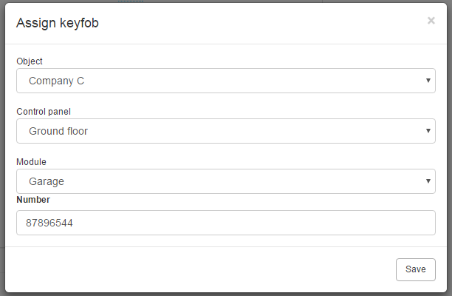
Fig. 9. Keyfob adding window.

- Click on the “Add” button.
- In the window that will open, select the object, control panel and the keyfob expansion module.
- When the message is displayed, press any button of the keyfob to be added.
- After the serial number of the keyfob is displayed, click on the “Save” button. The window will close and the keyfob number read out during transmission will be displayed in the “Keyfob serial number” field.
- In the menu on the left side, click on “System operations” →“Save changes”.

Change keyfob
- Click on the “Change” button.
- In the window that will open, in the “Number” field, the number of keyfob assigned to the user will be visible.
- If you want to change the keyfob serial number manually, highlight the number of old keyfob in the “Number” field and enter the number of new keyfob instead.
- If you want to swap the keyfob reading the serial number of new keyfob during the transmission, select the object, control panel and keyfob expansion module in the respective fields. When the message is displayed, press any button on the new keyfob. The new keyfob serial number will be displayed in the “Number” field.
- Click on the “Save” button. The window will close and the new keyfob serial number, read out during the transmission, will be displayed in the “Keyfob serial number” field.
- In the menu on the left side, click on “System operations” →“Save changes”.

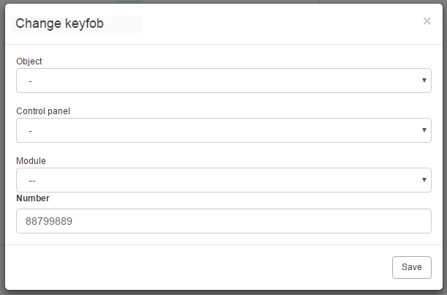
Fig. 10. Keyfob changing window.

Edit keyfob

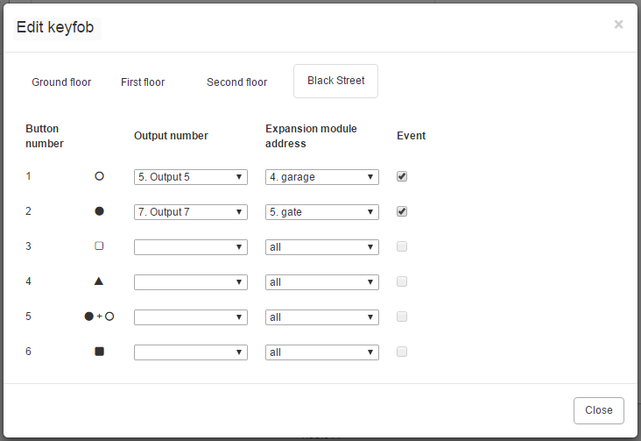
Fig. 11. Keyfob settings editing window.

Click on the “Edit” button to display the “Edit keyfob” window. Depending on the number of ACCO-NT control panels present in the system, in the upper part of the window:
- control panel tabs can be seen, if there are less than 10 control panels,
- “Control panel” button is displayed, if there are 10 or more control panels.
Select the control panel whose output has been programmed as “Keyfob” and to which an expander supporting keyfobs is connected (to do this, click on the tab or button).
Button number – select the keyfob button number.
Output number – select one of the available outputs which will be turned on using the keyfob button.
Expansion module address – indicate address of the IN-RX-S expander, within the operating range of which the selected keyfob button will work.
Event – select this option, if, after using keyfob button, an event is to be generated.
Close – click on the button to confirm the entered data.

Adding card / iButton – manually entering serial number
- Click on the “Add card” button.
- In the window that will open, in the “Number” field, enter the serial number of the card / iButton to be added.
- Click on the “Save” button. The window will close and the serial number of the added card / iButton will be displayed on the “User Identifiers” list.
- In the menu on the left side, click on “System operations” →“Save changes”.

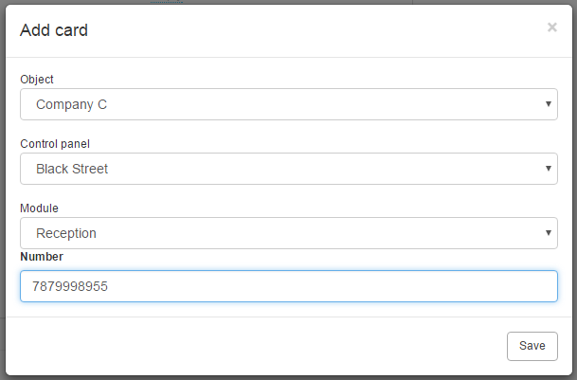
Fig. 12. Identifier adding window.

Adding card / iButton – reading serial number during transmission
- Click on the “Add card” button.
- In the window that will open, select the object, control panel and module with keypad or reader, by means of which the card / iButton will be read in.
- When the message is displayed, present the card / touch the iButton to the keypad or reader.
- After the serial number of the card / iButton is displayed in the “Number” field, click on the “Save” button. The window will close and the serial number of the card / iButton, which was read out during transmission, will be displayed in the “User Identifiers” list.
- In the menu on the left side, click on “System operations” →“Save changes”.

Adding card by means of CZ-USB-1 reader
- Connect the CZ-USB-1 reader to the USB port on the computer.
- When the reader LED comes on, click on the “Add card” button.
- In the window that will open, set the cursor in the “Number” field.
- Present the card to the reader.
- After the serial number of the card is displayed in the “Number” field, the window will close. When read out, the serial number of the card will be displayed on the “User Identifiers” list.
- In the menu on the left side, click on “System operations” →“Save changes”.

User picture
Add – click to assign a picture to the user. The “Edit picture” page will open with the following buttons available: “Add picture from file” and “Add picture from camera” (see: “Adding a picture from file” and “Adding a picture from camera”).
Delete – click to remove a user picture. When a prompt is displayed asking you whether to remove it, click “OK”.

Adding a picture from file

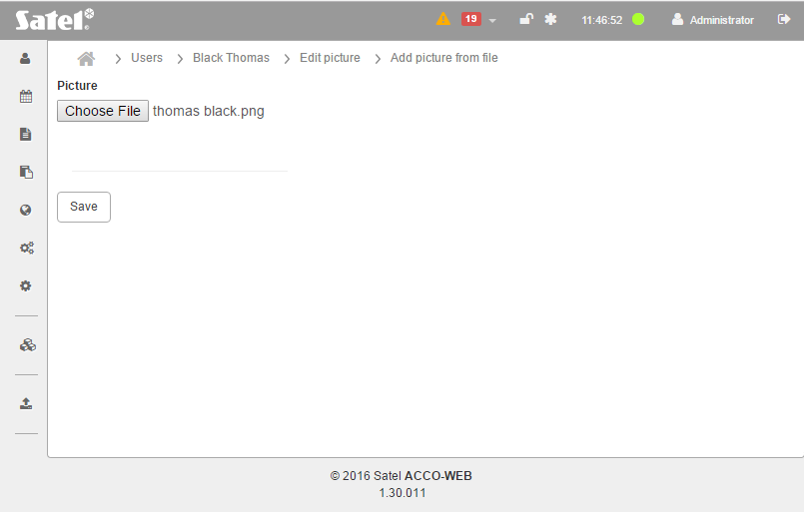
Fig. 13. Adding picture from file.

Add picture from file – click to open the “Add picture from file” page, where you can assign a picture from file available on the computer. To do this:
- Click on the “Choose File” button.
- In the window that will open, indicate the access path to the image file. You can choose a file in JPG, GIF or PNG format.
- When the access path shows up in the field on the page, click on the “Save” button. The picture will be displayed on the user home page.

Adding a picture from camera
Add picture from camera – click to open the “Add picture from camera” page, where you can take a picture and assign it to the user. To do this:
- In the window that will open, grant permission for access to the camera to the Internet website with ACCO-WEB application.
- When the image sent from camera is displayed, set the suitable frame and click on the “Save” button. The picture will be displayed on the user home page.
The “Configure” button is used for configuration of the Adobe Flash Player program settings.
If you want to take more pictures using the camera, it is advisable to grant permission for permanent access to the camera to the Internet website with ACCO-WEB application. To do this for the currently connected camera, you can use the “Configure” button. Alternatively, you can use the Flash Player program and define for selected websites privacy settings related to the access to other cameras. If this is the case, you will find the detailed procedure at the following address: http://www.macromedia.com/support/documentation/en/flashplayer/help/settings_manager06.html.

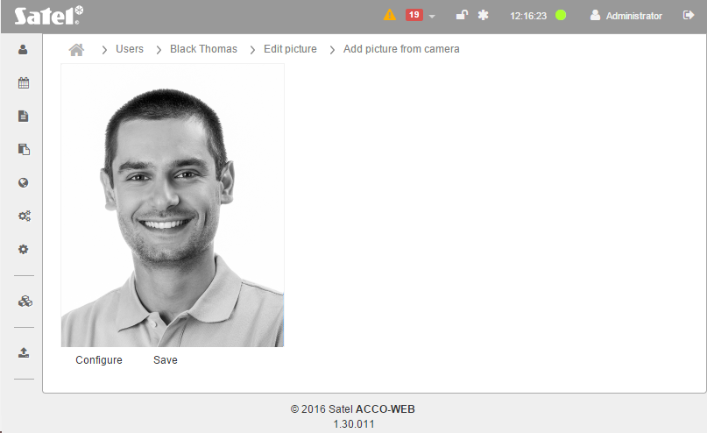
Fig. 14. Adding a picture from camera connected to the computer.

“Access to program” tab
Access to program – by default, the user has no access to the program (“Grant access to program” button is displayed).
Grant access to program – click to give the rights for system configuration and management to the user. Fields will be displayed to define the parameters which enable configuration of the system.
Take away the access to program – click to revoke the user rights for configuration and management of the system.
If you grant program access to a user, fields will be displayed where you can define the parameters which enable configuration and management of the system. Depending on the parameter type, you can fill in the field manually or select data from the drop-down menu. During editing, the following icons are available:
– click to remove text from the field.
– click to confirm the entered data.
– click to finish editing without data change.

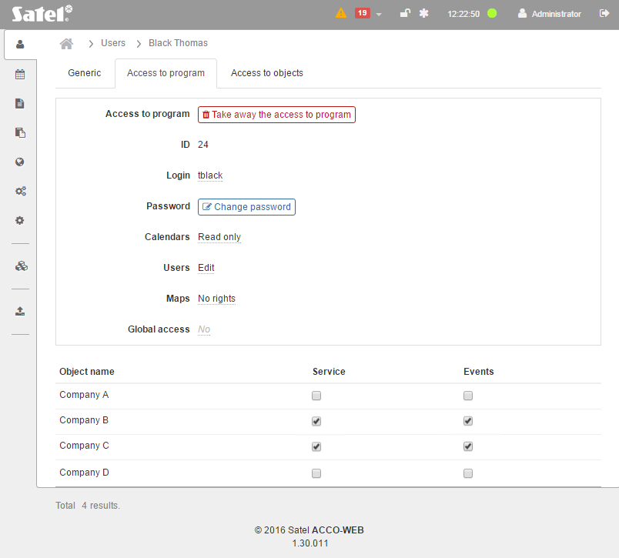
Fig. 15. An example of user’s “Access to program” tab.

ID – user's identification number.
Login – name to be used to login to the ACCO Soft program and ACCO-WEB application. It is created automatically after adding a user. You can change it.
Password – the password that authorizes you to login to the ACCO Soft program and ACCO-WEB application. Click on the “Change password” button, to give a password to the user. In the window that will open (see: Fig. 16), enter the new password (a sequence of at least 8 alphanumeric characters), and then re-enter it. Use the “Save” button to confirm the changes you made.
When entering, the password is not visible.

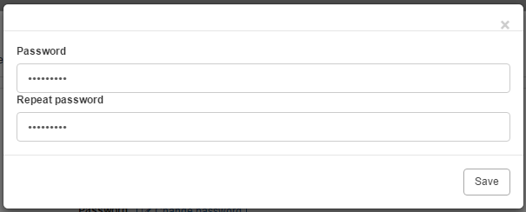
Fig. 16. User password changing window.

Calendars – select one of the following options and click on :
No rights – the user will have no access to the access calendars and access schedules.
Read only – the user will be able to review the access calendars and access schedules.
Edit – the user will be able to edit the access calendars and access schedules.
Users – select one of the following options and click on :
No rights – the user will have no access to the users' data.
Read only – the user will only be able to review the users' data.
Edit – in the ACCO-WEB application, the user will be able to edit all the user related parameters. In the ACCO Soft program, the “Import” button will be active to allow you to import the user data from external files.
Maps – select one of the following options and click on :
No rights – in the ACCO-WEB application, the user will have no access to the maps; in the ACCO Soft program, the “Maps” button will be inactive.
Read only – in the ACCO-WEB application, the user will be able to review the maps and control from their level the zones where the user is present and the doors supervised by controllers assigned to those zones. In the ACCO Soft program, the “Maps” button will be inactive.
Edit – in the ACCO-WEB application, the user will be able to review the maps and control the zones and doors from the maps level; in the ACCO Soft program, the user will be able to edit all the map related parameters.
Global access – you can select “Yes” or “No” (use the button to confirm your selection). If you select “No”, the following options can be checked for each object:
Service – system configuration and administration right,
Events – events viewing, filtering and exporting right.
If you select “Yes”, you can give the “Service” and “Events” rights for all the objects to the user.

“Access to objects” tab
If the user is assigned to a group, a message will be displayed at the top of the page to inform you of the fact. If this is the case, you can only use the “Reset” function (see description of the option in section ““Zones” tab”). The other parameters can only be edited for the whole group to which the user belongs. If you remove the user from the group, you can grant access to selected objects to this user.

“Zones” tab

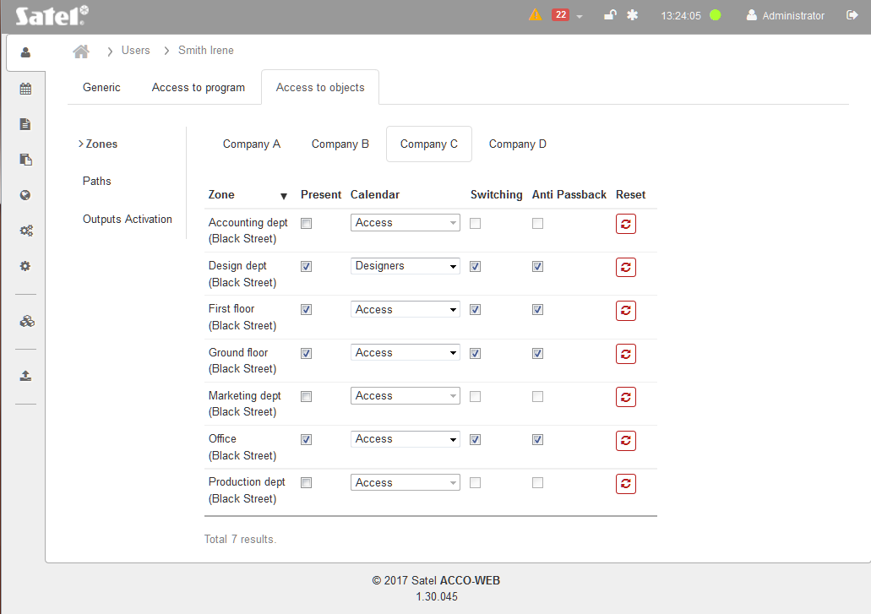
Fig. 17. An example of the “Zones” tab in user's “Access to object” tab.

Depending on the number of objects in the system:
- object tabs can be seen, if there are less than 10 objects,
- “Object” button is displayed, if there are 10 or more objects.
Select the object the access to which you want to grant to the user (to do this, click on the tab or on the button). The following parameters will be displayed:
Zone – list of zones of the given object. You can sort the zones by their names. Displayed under the zone name in brackets is the name of the control panel to which the given zone is assigned.
Present – if you check the box, the user will be added to the zone (to be granted access, the user must have an access calendar assigned).
Calendar – click on the symbol of drop-down menu. A list of all created access calendars will be displayed. Select one of them to specify the rules for user access to the doors.
Switching – check the box, if the user is to be able to unblock and block the doors in the zone.
Anti Passback – check the box, if you want to prevent the identifier from being passed back by the user who has already got access to other people so that they can be granted access. The user will not be able to enter the zone, if information has been logged into control panel memory that the user already entered the zone, without any information that he/she left it.
If the door status is not monitored, operation of this function is limited to logging the event.
Reset – click on to reset the “Anti-Passback” function.

“Paths” tab

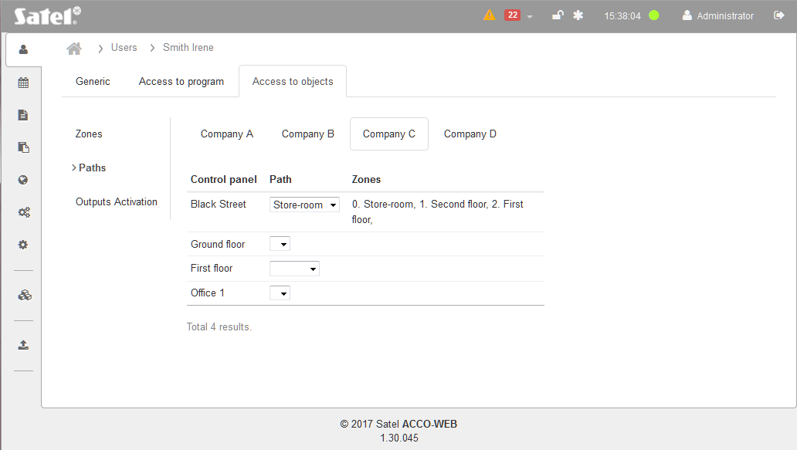
Fig. 18. An example of the “Paths” tab in user's “Access to object” tab.

The path (pathway) is a route which the user has to take to move around the premises.
Depending on the number of objects in the system:
- object tabs can be seen, if there are less than 10 objects,
- “Object” button is displayed, if there are 10 or more objects.
Select the object whose path(s) you want to assign to the user (to do this, click on the tab or button). The following parameters will be displayed:
Control panel – list of control panels assigned to the selected object.
Path – path assigned to a user. Click on the drop-down menu symbol. The list of all paths defined for the selected control panel. Select one of them.
Zones – list of zones included in the specified path.
If you want to assign a path to the user, the user must have the “Present” option enabled for the zones included in the path to be assigned and the user must have access to these zones (i.e. a corresponding access calendar assigned).

“Outputs Activation” tab

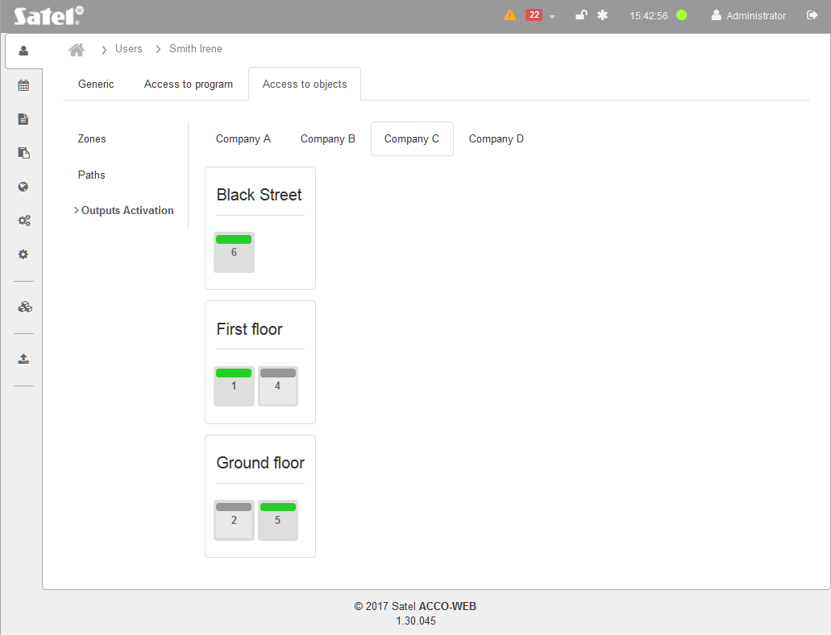
Fig. 19. An example of the “Outputs Activation” tab in user's “Access to objects” tab.

Activation of the outputs assigned to the user takes place after the user is granted access to a zone / the zones with the “Activation of outputs” option enabled. The function can be used e.g. when turning on / off the light by using a terminal.
Depending on the number of objects in the system:
- object tabs can be seen, if there are less than 10 objects,
- “Object” button is displayed, if there are 10 or more objects.
Select the object to which the control panel, whose output(s) you want to assign to the user, belongs (to do this, click on the tab or button). If the user has the “Present” option enabled in any of the control panel zones and has access to the doors supervised by the controllers in that zone (a corresponding access calendar is assigned), a list will be displayed that contains:
- name of the control panel in which one of the outputs has been programmed as “Activation by access”,
- name of the zone that was selected when programming the output (if all zones were selected, the zone name is not displayed),
- icon symbolizing this output and indicating its number:
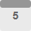 – unassigned output,
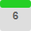 – assigned output.
Click on the output icon, to assign an output to the user.

Editing user data
- In the table with the list of users, click on the name of user whose data you want to edit. This will open the “Generic” tab on the user data editing page.
- If you want to program a parameter which has not been defined yet, click on “Empty”. If you want to edit a parameter which has already been defined, click on its value. Fill in the field manually or select the appropriate option from the drop-down menu.
- If you want to assign a keyfob to the user, add it according to the procedure described in section “Adding a keyfob – manually entering the serial number” or “Adding a keyfob – reading the serial number during transmission”.
- If the user is to use a proximity card / iButton, add it according to the procedure described in section: “Adding a card / iButton – manually entering the serial number”, “Adding a card / iButton – reading the serial number during transmission” or “Adding a card by means of CZ-USB-1 reader”.
- Optionally, you can add a picture of the user (see: “Adding a picture from file” and “Adding a picture from camera”).
- If the user is to be authorized to manage and configure the system, select the “Access to program” tab and, on the page that will open, define the parameters, as required (see: ““Access to program” tab”).
- In order to specify the rules of the user's moving around the premises, go to the page where you can edit his data and select the “Access to objects” tab. On the page that will open, define the appropriate parameters in particular tabs (see: ““Access to objects” tab”).
- In the menu on the left side, click on “System operations” →“Save changes”.

Deleting user
- In the table with user list, select the user to be removed.
- Check the box next to the selected user.
- Click on the “Delete” button above the table with the list of users.
- When a prompt is displayed asking you whether to delete the user, click “OK”.
The filtering function makes it easier to find a user (see: “Filtering users”).
It is possible to delete several users at the same time. To do so, check the box at the selected users and click on the “Delete” button above the table with the list of users. When a prompt is displayed asking whether to delete the selected users, click “OK”. Save the changes you made.

Filtering users

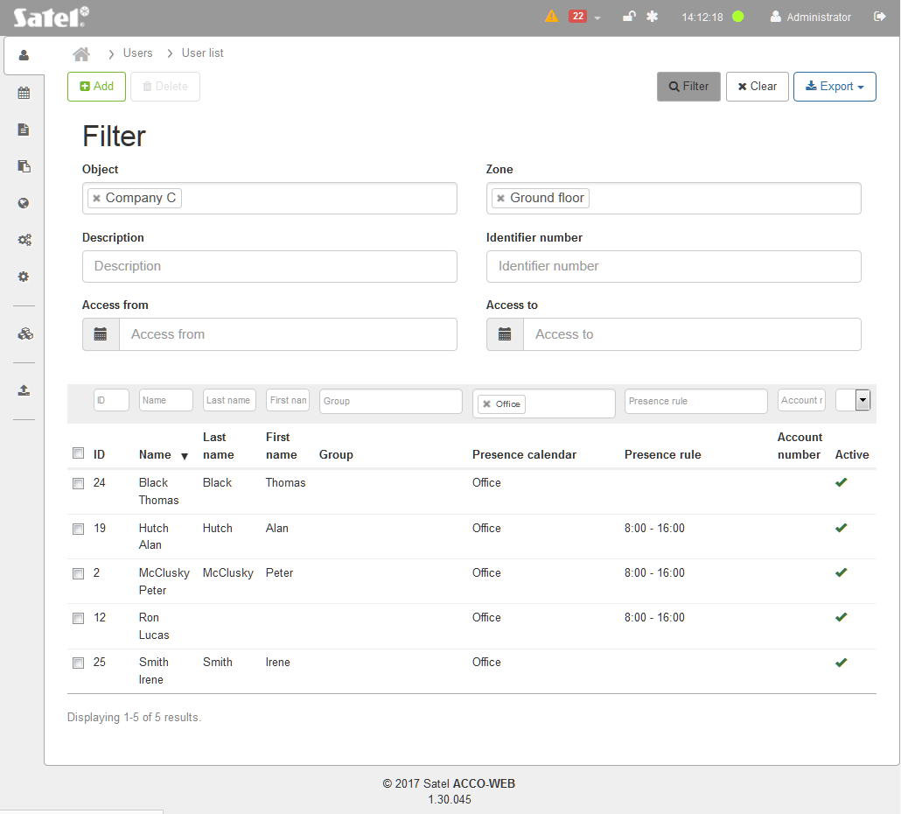
Fig. 20. An example of the list of users filtered according to the defined criteria.

The fields above the column names allow filtering the list.
ID – click on the field, enter the digit(s) of the identification number of the user you want to find and press ENTER.
Name – click on the field, enter in whole or in part the name of the user you want to find and press ENTER.
Last name – click on the field, enter in whole or in part the last name of the user you want to find and press ENTER.
First name – click on the field, enter in whole or in part the first name of the user you want to find and press ENTER.
Group – click on the field to display the list of user groups. You can enter the group's name in whole or in part to further filter the list. You can select one, several or all groups. Press ENTER.
Presence calendar – click on the field to display the list of defined presence calendars. You can enter the calendar name in whole or in part to further filter the list. You can select one, several or all calendars. Press ENTER.
Presence rule – click on the field to display the list of defined presence rules. You can enter the rule name in whole or in part to further filter the list. You can select one, several or all rules. Press ENTER.
Account number – click on the field and enter in whole or in part the identification number (created for accounting purposes) of the user you want to find. Press ENTER.
[empty field] – click on the field to display the list of options for the “Active” column: [empty], No and Yes. Select one of the options to specify the search criteria and Press ENTER.
Click on the “Filter” button to display additional fields for filtering:
Object – click on the field to display the list of objects. You can enter the object's name in whole or in part to further filter the list. You can select one, several or all objects. Press ENTER.
Zone – click on the field to display the list of zones You can enter the zone name in whole or in part to further filter the list. You can select one, several or all zones Press ENTER.
Description – click on the field and enter the text describing the user you want to find. Press ENTER.
Identifier number – click on the field and enter the number of card / iButton assigned to the user you want to find. Press ENTER.
Access from – click on the field and select in the calendar that will be displayed the date indicating from when the user you search for has access to the selected doors. Press ENTER.
Access to – click on the field and select in the calendar that will be displayed the date indicating till when the user you search for has access to the selected doors. Press ENTER.

Table with the list of filtered users
The table with the list of users meeting the defined criteria contains the following data:
ID – user identification number. Check the box on the left side to select all users.
Name – user name.
Last name – user family name.
First name – user given name.
Group – name of the group the user is assigned to.
Presence calendar – presence calendar assigned to the user.
Presence rule – presence rule assigned to the user.
Account number – user identification number created for accounting purposes.
Active – information whether the user is served by the ACCO NET system.
You can click on a column name to sort the user data by the column name.
If the list of users meeting the defined criteria is too long to fit on one page, buttons are displayed to allow you navigation through the pages.
If you remove the filter, the fields under the column names will go blank, the additional filtering fields will be hidden and the full list of users will be displayed on the page.

Deleting user from the list
- In the table with the list of filtered users, select the user to be deleted.
- Check the box to the left of the indicated user.
- Click on the “Delete” button above the table with the list of users.
- When a prompt appears asking you whether to delete the user, click “OK”.

Exporting users
You can export the user data to file. Data of all users or the filtered users alone are exported. Click on the “Export” button and select in what format the user data will be exported. You can choose from CSV, XML, XLSX and PDF format. In the dialog box, select the program in which the file will be opened, or indicate the location in which the file will be saved.

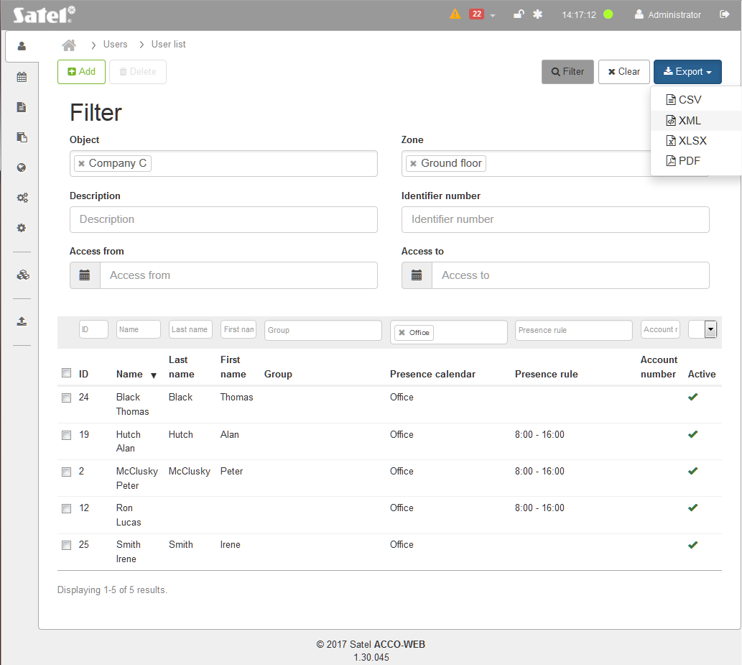
Fig. 21. An example of exporting the data of filtered users.

User groups
Buttons
Add – click to display the “Add new users group” window (see: ““Add new users group” window”).
Delete – click to delete the selected group(s). The button is available when the box next to at least one group is checked. Using the button will move the users assigned to this group to the category of users not assigned to any group.
Clear – click to remove the filter and display the list of all user groups (see: “Filtering user groups”).
Export – click to export the data of user groups to file (see: “Exporting user groups”).

Table with user groups
ID – identification number assigned automatically during the new group adding procedure. Check the box on the left side to select all groups.
Name – individual name of user group. Click on it to edit the given group.
Description – additional description of the group.
The fields above the column names allow filtering of the list (see: “Filtering user groups”).
Click on a column name to sort the data of user groups by the column name.
If the list of user groups is too long to fit on one page, buttons are displayed to allow you navigation through the pages.

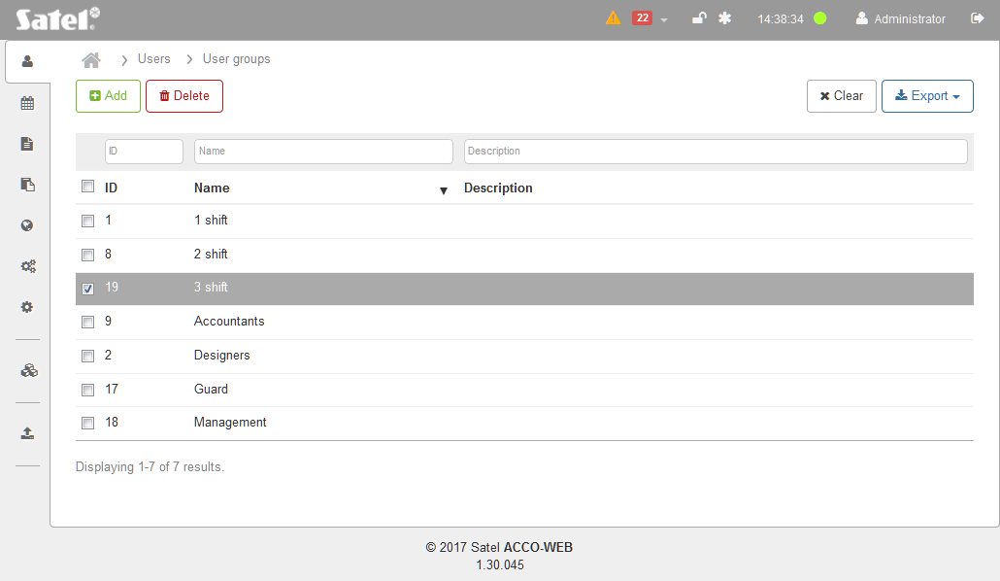
Fig. 22. User groups.

“Add new users group” window
Name – enter the name of the user group to be added. The field is required.
Description – in this field, you can enter an additional description of the group.
Save – click to create a group and start editing its data (see: “User group editing page”).

Adding user group

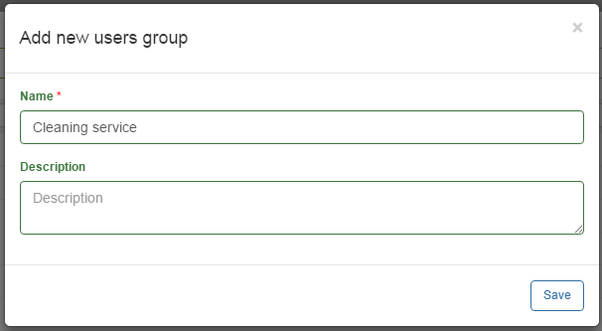
Fig. 23. User group creating window.

- Click on the “Add” button. A window will open to allow you to create a user group.
- Enter the name of the group to be created.
- Optionally, you can add a description of the group to be created.
- Click on the “Save” button. A page will open where you can edit parameters of the created group (see: “User group editing page”).
- In the menu on the left side, click on “System operations” →“Save changes”.

User group editing page
The page where you can edit data of the selected user group will be displayed after you click on the:
- “Save” button when creating the group,
- name of the selected group on the list of user groups.

“Generic” tab

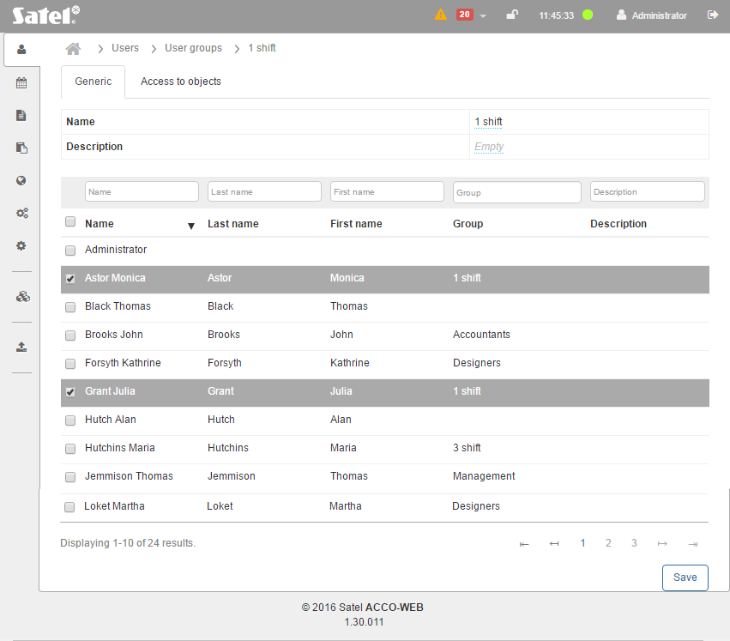
Fig. 24. An example of the “Generic” tab for user group.

In the undefined fields, the “Empty” text will be displayed. To edit individual parameters, click on the defined value or the “Empty” information. Depending on the parameter type, you can fill in the field manually or select data from the drop-down menu. During editing, the following icons will be available:
– click to remove text from the field.
– click to confirm the entered data.
– click to finish the editing without data change.
The tab displays a table with the list of all users. It contains the basic user data: name, last name, first name, the group the user is assigned to, and description. The users assigned to the group being edited are highlighted in gray.
The fields above the column names allow filtering of the list (see: “Filtering users”).
You can click on a column name to sort the user data by the column name.
If the user list is too long to fit on one page, buttons are displayed to allow you to navigate through the pages.

Adding user to a group
- In the table with user list, check the box next to the user(s) you want to assign to the group. The selected users are highlighted in gray.
If you want to select all users, check the box next to the “Name” header.
- Click on the “Save” button at the bottom of the page.
- The indicated users will be assigned to the group.
- In the menu on the left side, click on “System operations” →“Save changes”.

Deleting user from a group
- In the table with user list, uncheck the box next to the user(s) you want to delete from the group.
- Click on the “Save” button at the bottom of the page.
- The indicated users will be deleted from the group.
- In the menu on the left side, click on “System operations” →“Save changes”.

“Access to objects” tab

“Zones” tab
Depending on the number of objects in the system:
- object tabs can be seen, if there are less than 10 objects,
- “Object” button is displayed, if there are 10 or more objects.
Select the object to which you want to grant access to the indicated user group (to do this, click on the tab or button). The following parameters will be displayed:
Zone – list of zones for the given object. You can sort them by name. Displayed under the zone name in brackets is the name of the control panel to which the given zone is assigned.
Present – if you check the box, the users assigned to the group will be added to the zone (assign them an access calendar so that they can get access).
Calendar – click on the drop-down menu symbol. The list of all created access calendars will be displayed. Select one of them to specify rules of access to doors for the users assigned to the group.
Switching – check the box if the users belonging to a group are to be able to unblock and block the doors in the zone.
Anti-Passback – check the box if you want to prevent the identifier from being passed by the group users which have already got access to other people so that they can get access too. The users will be unable to enter the zone, if information that they have already entered the zone was written to the control panel memory, while no information appeared that they have left the zone.
If the door status is not controlled, the “Anti-Passback” feature is limited to saving the event.
Reset – click on to reset the “Anti-Passback” feature.

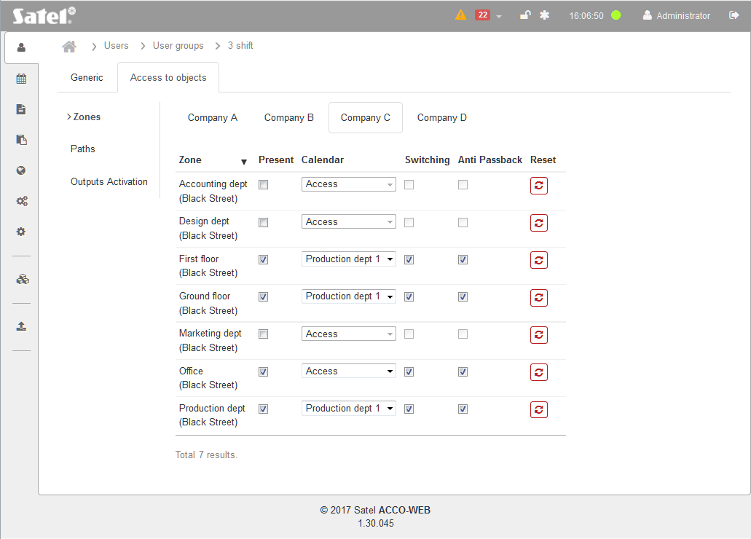
Fig. 25. An example of the “Zones” tab in the “Access to object” tab for a user group.

“Paths” tab
The path (pathway) is a route which the users assigned to the group have to take to move around the premises.
Depending on the number of objects in the system:
- object tabs can be seen, if there are less than 10 objects,
- “Object” button is displayed, if there are 10 or more objects.
Select the object whose path(s) you want to assign to the user group being edited (to do this, click on the tab or button). The following parameters will be displayed:
Control panel – list of control panels assigned to the selected object.
Path – path assigned to the user group. Click on the drop-down menu symbol. This will display the list of all paths defined for the selected control panel. Select one of them.
Zones – list of zones included in the specified path.
If you want to assign a path to some users belonging to a group, the “Present” option must be enabled for the group and the group must have access (corresponding access calendar assigned) to the zones included in the path to be assigned.

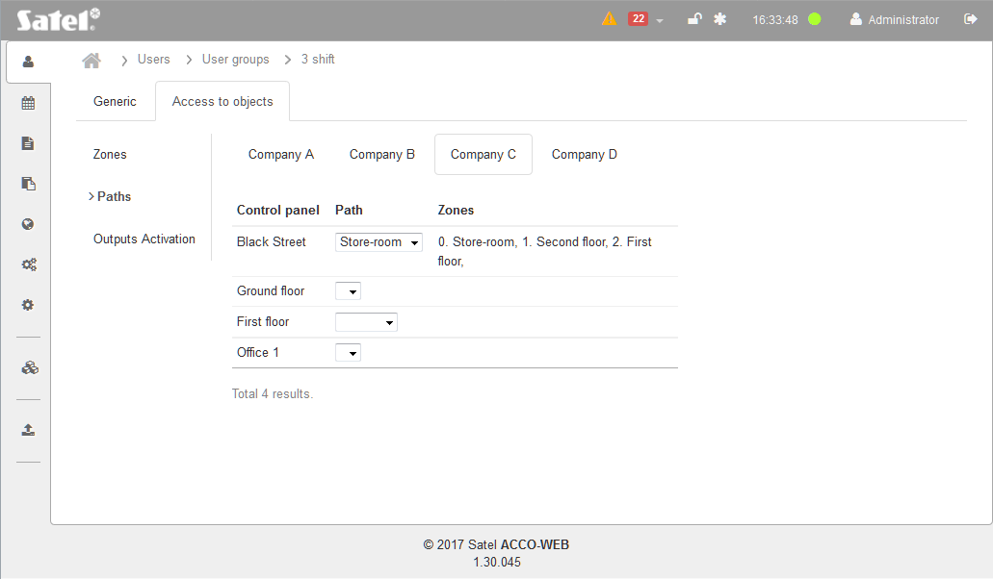
Fig. 26. An example of the “Paths” tab in the “Access to object” tab for a user group.

“Outputs Activation” tab
The outputs assigned to a user group are activated when the user belonging to the group gets access to the zone(s) with the “Activation of outputs” option enabled.
Depending on the number of objects in the system:
- object tabs can be seen, if there are less than 10 objects,
- “Object” button is displayed, if there are 10 or more objects.
Select the object to which the control panel, whose output(s) you want to assign to the user group, belongs (to do this, click on the tab or button). If the users have the “Present” option enabled in any of the control panel zones and have access to the doors supervised by controllers in that zone, a list will be displayed that contains:
- name of the control panel, one of the outputs of which has been programmed as “Activation by access”,
- name of the zone that was selected during programming of the output (if all zones were selected, the zone name is not displayed),
- icon denoting that output and indicating its number:
– output not assigned,
– output assigned.
Click on the output icon to assign the output to the user group being edited.

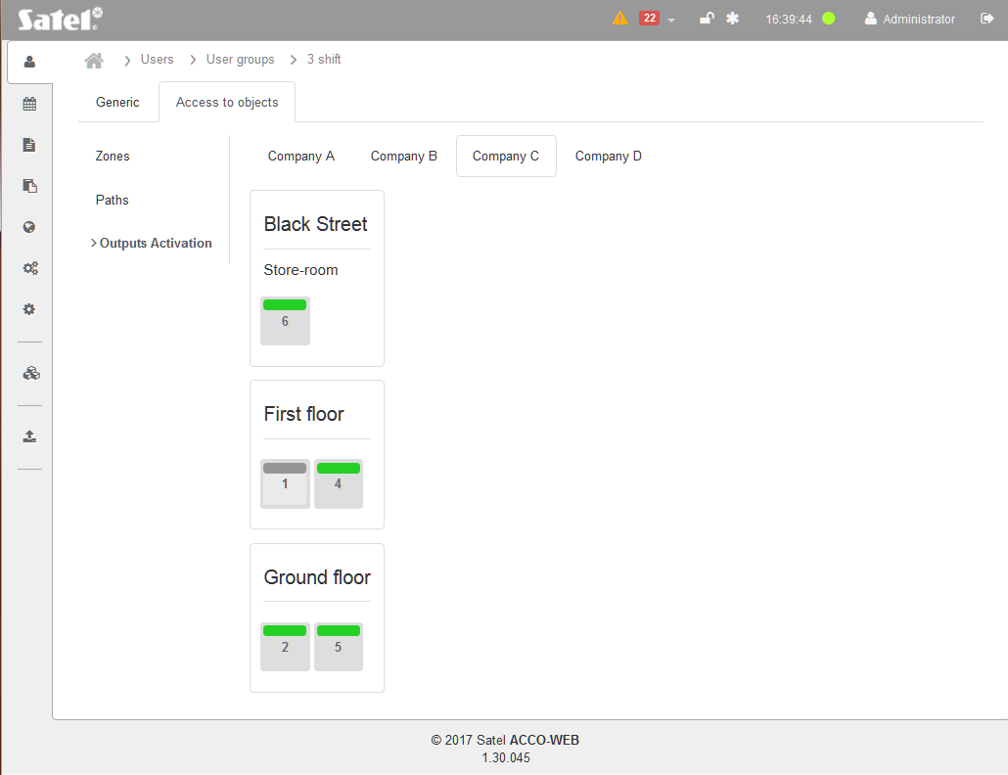
Fig. 27. “Outputs Activation” in the “Access to objects” tab for a user group (example).

Editing user group
- In the table with the list of user groups, click on the name of group whose data you want to edit. This will open the “Generic” tab on the group data editing page.
- If you want to program a parameter which has not yet been defined, click on “Empty”. If you want to edit a parameter which has already been defined, click on its value. Fill in the field manually or select the appropriate option from the drop-down menu.
- Assign users to the group (see: section ““Generic” tab”).
- Go to the “Access to object” tab.
- In the “Zones” tab, grant the rights of access to the selected premises to the users belonging to the group (see: ““Zones” tab”).
- In the “Paths” tab, specify the rules of movement around the selected premises for the users belonging to the group (see: ““Paths” tab”).
- In the “Outputs Activation” tab, assign outputs to the users belonging to the group (see: ““Outputs Activation” tab”).
- To end the procedure of editing the user group data, click on “System operations” →“Save changes” in the menu on the left side.

Deleting user group
- In the table with the list of user groups, check the box next to the group to be deleted.
- Click on the “Delete” button above the table with the list of groups.
- When a prompt is displayed asking you whether to delete the group, click “OK”.
- In the menu on the left side, click on “System operations” →“Save changes”.
The column filtering function makes it easier to find a user group (see: “Filtering user groups”).

Deleting several user groups
- In the table with list of user groups, check the boxes next to the groups to be deleted.
- Click on the “Delete” button above the table with the list of groups.
- When a prompt is displayed asking you whether to delete the selected groups, click “OK”.
- In the menu on the left side, click on “System operations” →“Save changes”.

Filtering user groups

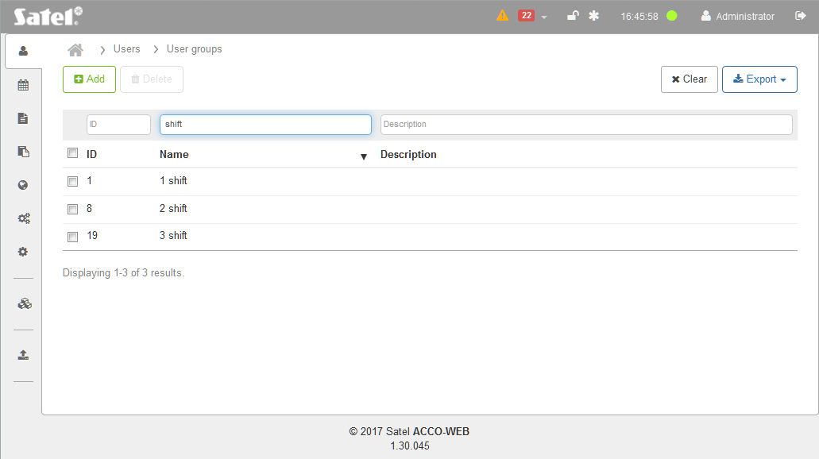
Fig. 28. An example of the list of user groups filtered according to defined criteria.

The fields above the column names allow you to filter the list. Click on a field and enter:
ID – digit(s) of the identification number of the user group you want to find and press ENTER.
Name – the name of user group you search for and press ENTER.
Description – text describing the user group you want to find and press ENTER.
If you remove the filter, the fields under the column names will go blank and the full list of user groups will be displayed on the page.

Exporting user groups
You can export the data of user groups to file. Data of all groups or the filtered groups only can be exported. Click on the “Export” button and select the format in which the data will be exported. You can choose from CSV, XML, XLSX or PDF formats. In the dialog box, select the program in which the file will open, or indicate the location where the file will be saved.

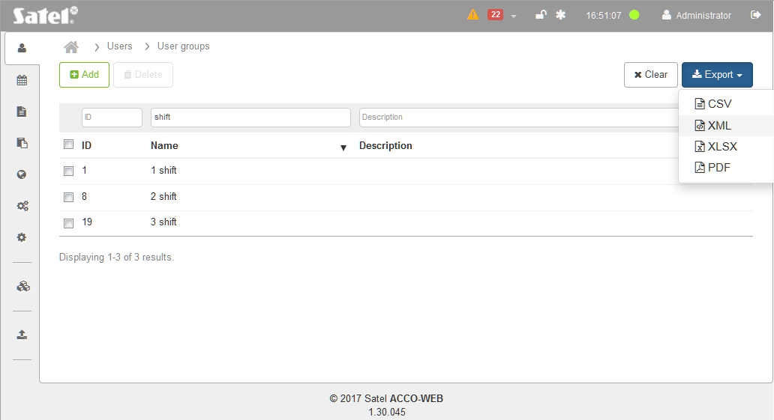
Fig. 29. An example of exporting the data of filtered user groups.

Access to objects
The page shows information about the objects and the users which have access to them.
Buttons
Clear – click to remove the filter and display the list of all objects and users who have access to them (see: “Filtering data”).
Export – click to export to file the access data (see: “Exporting data from table”).

Table with object list
Object – name of the object in which the zone is located.
Zone – name of the zone to which the user has access.
Group – name of the group to which the user is assigned. Click on the given group to edit it.
Calendar – name of the access calendar that is assigned to the user.
Name – individual user name. Click on it to edit the given user.
Last name – user's last name.
First name – user's first name.
You can click on a column name to sort the data by the column name.
If the data do not fit on one page, buttons are displayed to allow you navigate through the pages.

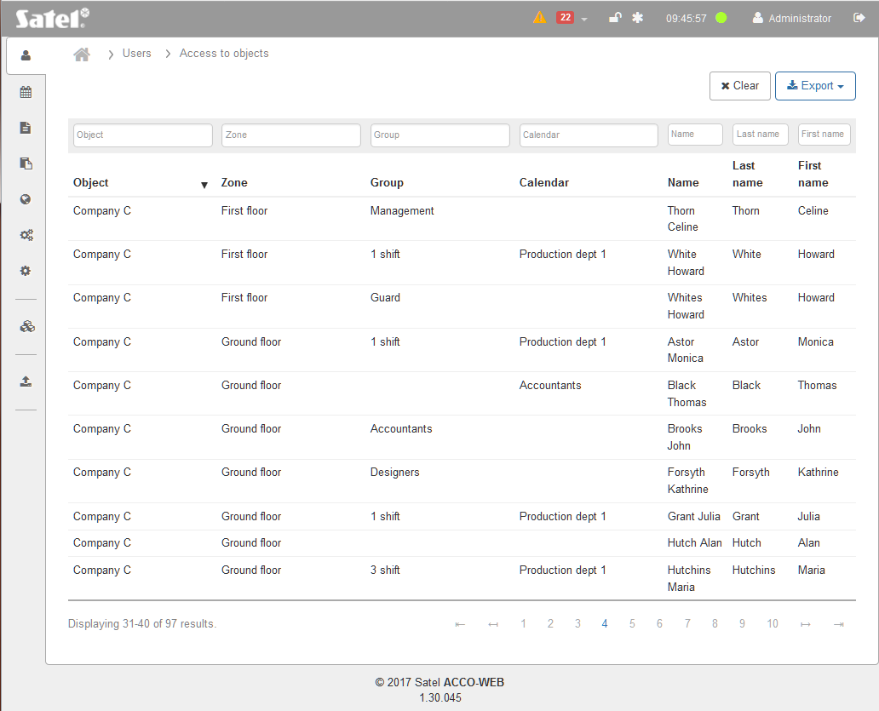
Fig. 30. Table showing information on the objects and the users who have access to them.

Filtering data
The fields above the column names allow filtering of the list.
Object – click on the field to display the list of objects. To further filter the list, enter the object name in whole or in part. You can select one, several or all objects. Press ENTER.
Zone – click on the field to display the zone list. To further filter the list, enter the zone name in whole or in part. You can select one, several or all zones. Press ENTER.
Group – click on the field to display the list of user groups. To further filter the list, enter the group name in whole or in part. You can select one, several or all groups. Press ENTER.
Calendar – click on the field to display the list of access calendars. To further filter the list, enter the calendar name in whole or in part. You can select one, several or all calendars. Press ENTER.
Name – click on the field and enter in whole or in part the name of the user you want to find and press ENTER.
Last name – click on the field and enter in whole or in part the last name of the user you want to find and press ENTER.
First name – click on the field and enter in whole or in part the first name of the user you want to find and press ENTER.

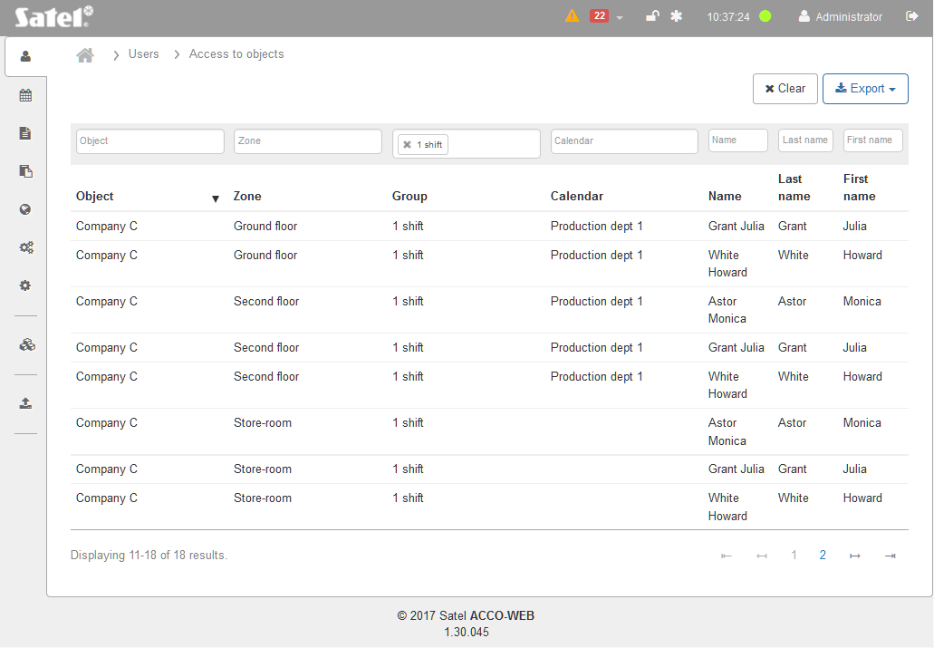
Fig. 31. An example of data filtered according to the defined criteria.

If you clear the filter, the fields under the column names will go blank and the full list of objects and users which have access to them will be displayed.

Exporting data from table
The data displayed in the table can be exported to file. You can export the data of all users or filtered users. Click on the “Export” button and select the format in which the data will be exported. You can choose from the CSV, XML and XLSX formats. In the dialog box, select the program in which the file will be opened, or indicate the location where the file will be saved.

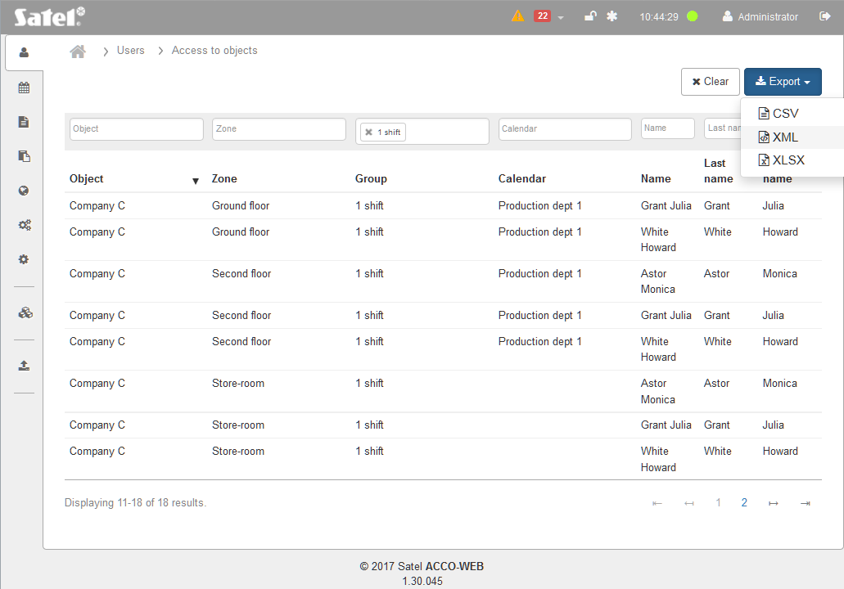
Fig. 32. An example of exporting filtered data.

Access Schemes

“Access calendars” tab
The access calendars define the rules for getting access to the zones. They are created based on the weekly access schedules, daily access schedules and time slots. 254 access calendars can be created. Two additional calendars are already defined: “Access” (the user can always unlock the door) and “No access” (the user can’t unlock the door).
One access calendar is to be assigned to each user. Thus you will define when the user will have access to the doors.

List of access calendars
Buttons
Add – click to display the “Add calendar” window (see: ““Add calendar” window”).
Delete – click to delete the selected access calendar(s). The button is available after the box next to at least one calendar is checked.
Removal of the access calendar which has been assigned to the user(s) will automatically disable the “Present” option. The user(s) will not have the right of access to the zone any more.
Clear – click to remove the filter and display the list of all access calendars (see: “Filtering access calendars”).
Export – click to export the access calendars to file (see: “Exporting access calendars”).

Table with list of access calendars

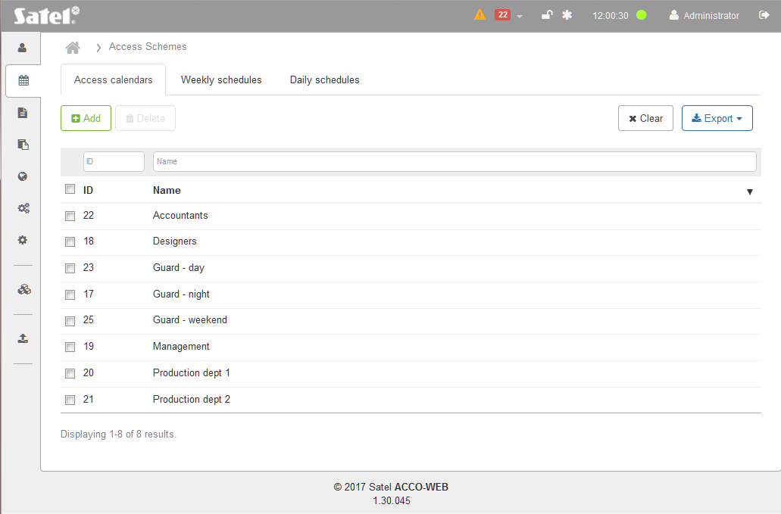
Fig. 33. An example of the list of access calendars.

The table contains the following data:
ID – identification number assigned automatically when adding a new calendar. Check the box on the left side to select all calendars.
Name – individual name of the access calendar. Click on it, if you want to edit the given calendar.
To sort the calendars by the name of the column, click on the column name.
If the calendar list is too long to fit on one page, buttons are displayed that allow you to navigate through the pages.

“Add calendar” window

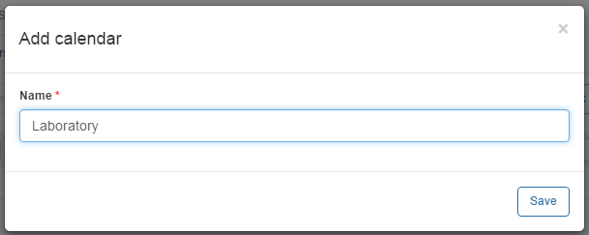
Fig. 34. Access calendar adding window.

Name – enter the calendar name. This field is required.
Save – click to add a new calendar.

Creating access calendar
- Click on the “Add” button. The calendar creating window will open.
- Enter the name of calendar to be created.
- Click on the “Save” button. This will open a page where you can edit the newly created calendar (see: “Editing access calendar”).
- To complete the calendar adding procedure, click on “System operations” →“Save changes” in the menu on the left side.

Filtering access calendars
The fields above column names allow filtering of the list.
ID – click on the field and enter the digit(s) of the identification number of the calendar you want to find and press ENTER.
Name – click on the field, enter the name of the calendar you want to find and press ENTER.
If you clear the filter, the fields under the column names will go blank and the full list of access calendars will be displayed on the page.

Exporting access calendars
You can export the list of access calendars to file. Data of all calendars or the filtered calendars only can be exported. Click on the “Export” button and select the format in which the calendars will be exported. You have the CSV, XML, XLSX and PDF formats to choose from. In the dialog box, select the program in which the file will be opened or indicate the location where the file will be saved.

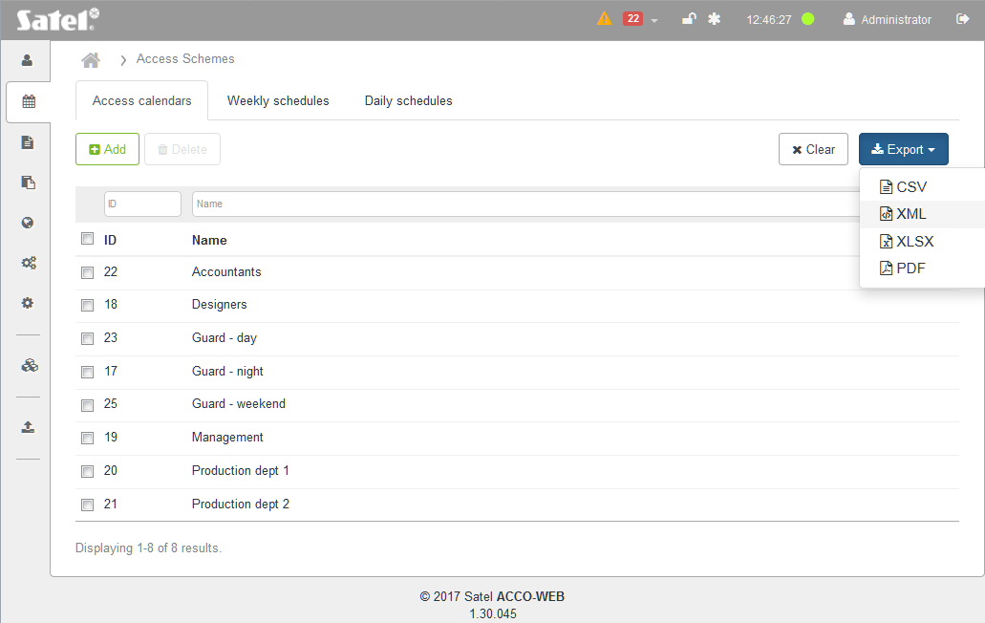
Fig. 35. An example of exporting access calendars.

“Weekly schedules” tab
The weekly schedules define the user's access to the door during a one week period. They are created by selecting appropriate daily schedules for each day of the week. 254 weekly access schedules can be created. Two additional schedules are already defined: “Access” (the user can unlock the door during the whole week) and “No access” (the user can’t unlock the door during the whole week).

List of weekly access schedules
Buttons
Add – click to display the “Add new weekly schedule” window (see: ““Add new weekly schedule” window”).
Delete – click to delete the selected weekly access schedule(s). The button is available after the box next to at least one schedule is checked.
Removal of the weekly access schedule which has been assigned to the access calendar will automatically assign “Access” in its stead.
Clear – click to remove the filter and display the list of all weekly access schedules (see: “Filtering weekly access schedules”).
Export – click to export the weekly access schedules to file (see: “Exporting weekly access schedules”).

Table with list of weekly access schedules
The table contains the following data:
Name – individual name of the weekly access schedule. Click on the name to edit it.
If you want to select all schedules, check the box next to the “Name” header.
Days of the week – name of the daily access schedule assigned to the concrete day.
When editing, the following icons are available:
– click to confirm the entered data.
– click to end editing without changing any data.
– click to remove the value from the field.
To sort schedules by the name, click on the column name.
If the list of schedules is to long to fit on one page, buttons are displayed to allow you to navigate through the pages.

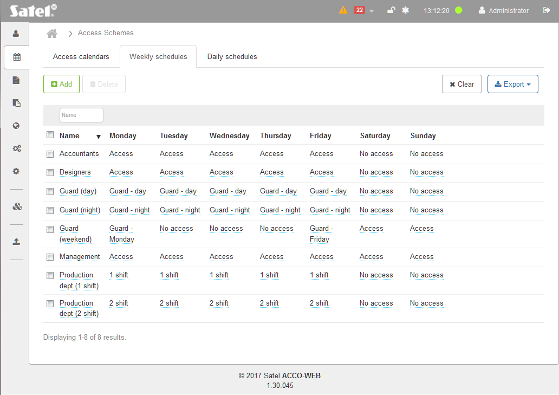
Fig. 36. An example of the list of weekly access schedules.

“Add new weekly schedule” window
Name – enter the name of weekly access schedule. The field is required.
Save – click to add a new weekly access schedule.

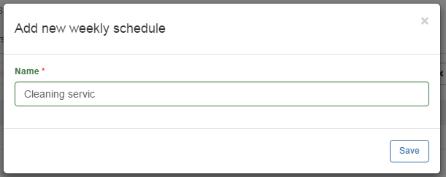
Fig. 37. Weekly access schedule adding window.

Creating weekly access schedule
- Click on the “Add” button. The schedule creating window will open.
- Enter the name of the weekly access schedule to be added.
- Click on the “Save” button. The added schedule will be displayed in the list of weekly access schedules.
- An “Access” daily schedule will be automatically assigned to each day of the week. You can edit the schedules for individual days (see: “Editing weekly access schedule”).
- To end the schedule creating procedure, click on “System operations” →“Save changes” in the menu on the left side.

Editing weekly access schedule
- In the table with list of weekly access schedules, click on the name of schedule you want to edit.
- If you want to change the name, enter a new name and click on .
- If you want to change the daily schedule assigned to the selected day of the week, click on the schedule name and then on the drop-down menu symbol.
- The list of all defined daily access schedules will open. Select one of the schedules and click on .
- Change in the same way the daily schedules assigned to the other days of the week.
- To end the schedule creating procedure, click on “System operations” →“Save changes” in the menu on the left side.

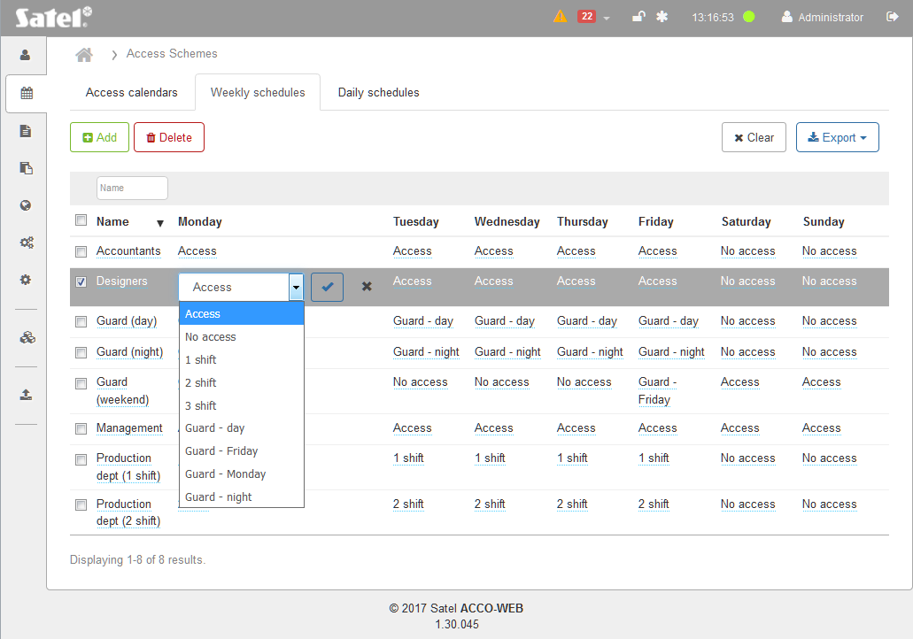
Fig. 38. An example of editing the weekly access schedule.

Filtering weekly access schedules
The field above the “Name” column allows you to filter the list.
Name – click on the field and enter in whole or in part the name of the schedule you want to find and press ENTER.
If you clear the filter, the field under the column name will go blank and the full list of weekly access schedules will be displayed.

Exporting weekly access schedules
You can export the list of weekly access schedules to file. Data of all schedules or the filtered schedules only can be exported. Click on the “Export” button and select the format in which the schedules will be exported. You have the CSV, XML, XLSX and PDF formats to choose from. In the dialog box, select the program in which the file will be opened or indicate the location where the file will be saved.

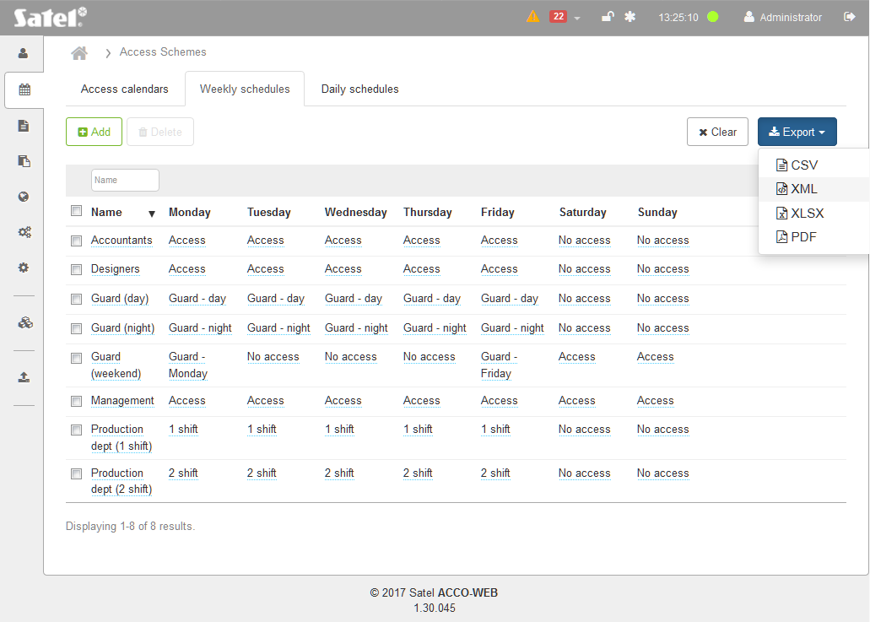
Fig. 39. An example of exporting weekly access schedules.

“Daily schedules” tab
The daily schedules define the user access to the door during a 24-hours' period. They are created based on time slots. 254 daily access schedules can be created. Two additional schedules are already defined: “Access” (the user can unlock the door 24 hours a day) and “No access” (the user can’t unlock the door 24 hours a day).

List of daily access schedules
Buttons
Add – click to add a new daily access schedule (see: “Creating daily access schedule”).
Delete – click to remove the selected daily access schedule(s). The button is available after the box next to at least one schedule is checked.
Removal of the daily access schedule which has been assigned to the weekly schedule will automatically assign “Access” in its stead.
– click if the list of daily access schedules is to be displayed in graphic form. In this display mode you can view and delete the schedules, as well as edit their names and time ranges.
– click if the list of daily access schedules is to be displayed in tabular form. In this display mode you can add, edit, view and delete the schedules.
[minutes] – in the case of the list of schedules in graphical form this field allows you to modify the time scale on the diagram. Click on the drop-down menu symbol to select the number of minutes.
Clear – click to remove the filter and display the list of all daily access schedules (see: “Filtering daily access schedules”).
Export – click to export the daily access schedules to file (see: “Exporting daily access schedules”).
When editing the parameters, the following icons are available:
– click to confirm the entered data.
– click to end editing without changing any data.
– click to delete the value from the field.

Table
The table with the list of daily access schedules contains the following data:
Name – individual name of the daily access schedule. Click on the name to edit it.
If you want to select all schedules, check the box next to the “Name” header.
Time slots 1-10 – time within 24-hours' period, during which the user can have access. Click on the field with defined time or on “Empty” at the selected time slot. Enter from when (hour and minutes) to when (hour and minutes) access will be granted and click on .
To sort the schedules by name, click on the column name.

Filtering daily access schedules
The field above the “Name” column allows filtering of the list.
Name – click on the field and enter in whole or in part the name of the schedule you want to find and press ENTER.
If you clear the filter, the field under the column name will go blank and the full list of daily access schedules will be displayed.

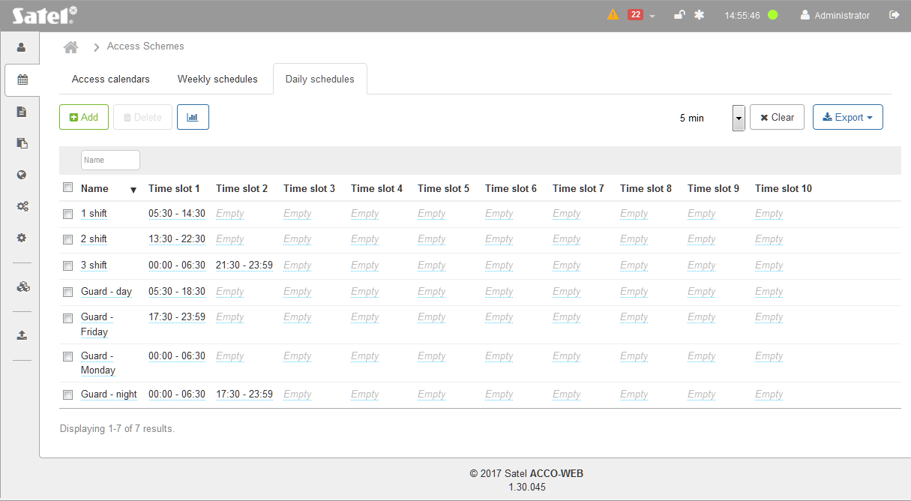
Fig. 40. An example of the list of daily access schedules in tabular form.

Graphic form

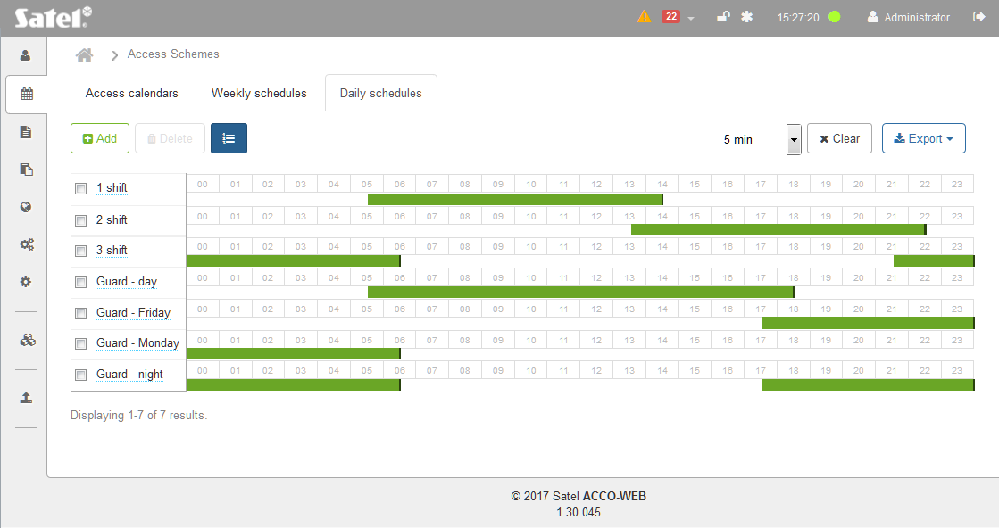
Fig. 41. An example of the list of daily access schedules in graphic form.

[schedules] – the list of daily access schedules is displayed on the left side. Click on the schedule name to edit it.
[time range] – presented in the form of a green rectangle. It indicates from when (hours and minutes) to when (hours and minutes) the user can get access within a 24 hr period of time. Click on the rectangle and hold down the left mouse button to edit the time range. Click in the middle of the rectangle to move it. Click on the left or right edge of the rectangle to make it longer / shorter.
[minutes] – this field allows you to modify the time scale on the diagram. Click on the drop-down menu symbol to select the number of minutes.

Creating daily access schedule
- Click on the “Add” button. The “Add new daily schedule” window will open (see: Fig. 42).

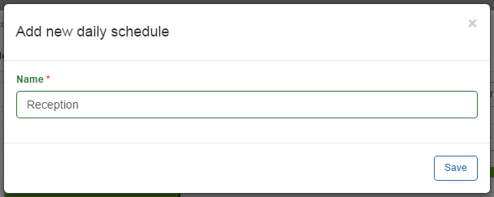
Fig. 42. Daily access schedule adding window.

- Enter the name of the daily access schedule.
- Click on the “Save” button. The added schedule will be displayed in the list of daily access schedules.
- You can add time slot(s) to the created schedule (see: “Editing daily access schedule”).
- In the menu on the left side, click on “System operations” →“Save changes”.

Editing daily access schedule
The schedule can be edited, if the schedules are displayed in tabular form.
- In the table with list of daily access schedules, click on the name of schedule you want to edit.
- If you want to change the name, enter a new name and click on .

Adding time slot
- Click on the first available “Empty” field.
- Enter from when (hour and minutes) to when (hour and minutes) it is to be possible to get access and click on .
- In the menu on the left side, click on “System operations” →“Save changes”.

Editing time slot
- Click on a field with defined time for the time slot.
- Enter new values and click on .
- In the menu on the left side, click on “System operations” →“Save changes”.

Deleting time slot
- Click on a field with defined time for the time slot.
- Click on and then on .
- In the menu on the left side, click on “System operations” →“Save changes”.

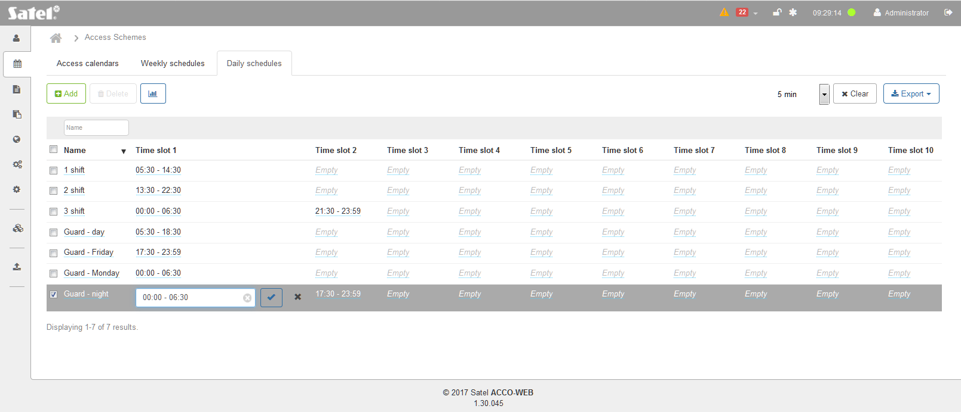
Fig. 43. An example of editing the daily access schedule.

Exporting daily access schedules
You can export the list of daily access schedules to file. Data of all schedules or the filtered schedules only can be exported. Click on the “Export” button and select the format in which the schedules will be exported. You can choose from CSV, XML, XLSX and PDF formats. In the dialog box, select the program in which the file will be opened or indicate the location where the file will be saved.

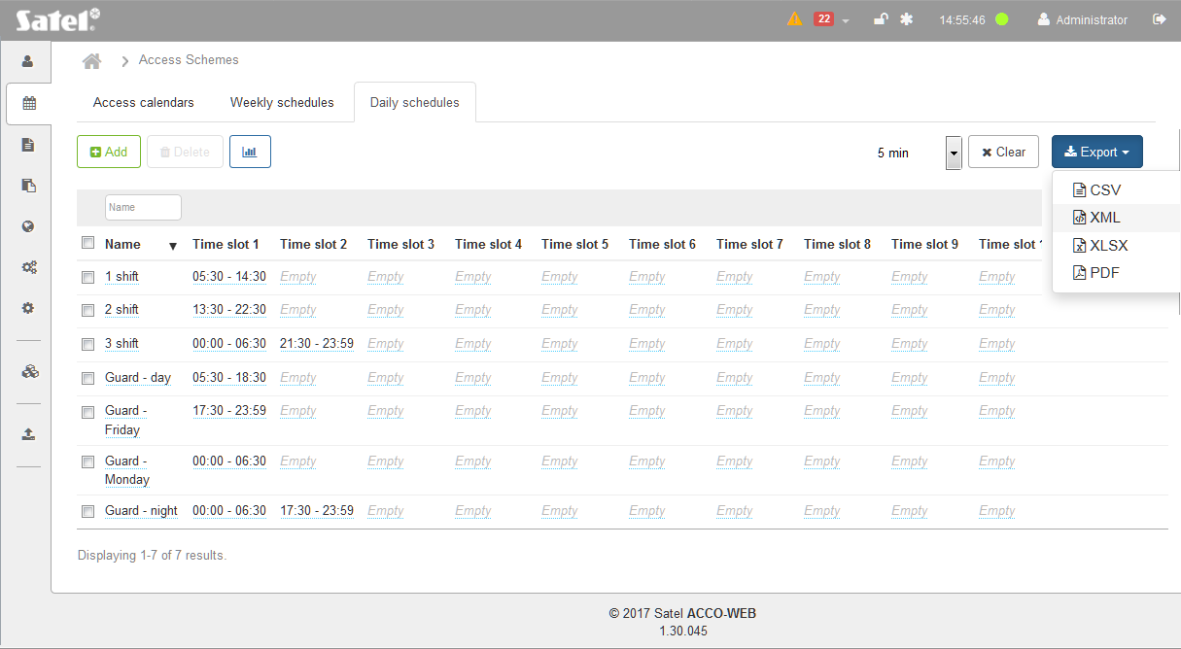
Fig. 44. An example of exporting daily access schedules.

Editing access calendar
- On the “Access schedules” page, select the “Daily schedules” tab.
- Create a daily access schedule according to the procedure described in section “Creating daily access schedule“.
- Select the “Weekly schedules” tab.
- Create a weekly access schedule according to the procedure described in section “Creating weekly access schedule”.
- Select the “Access calendars” tab.
- In the table with list of access calendars, click on the name of calendar you want to edit. A page will open that allows you to edit the calendar. By default, the calendar provides for full user access during all days of the week.
- If you want to change the calendar name, click on it.
- Enter a new name and click on .

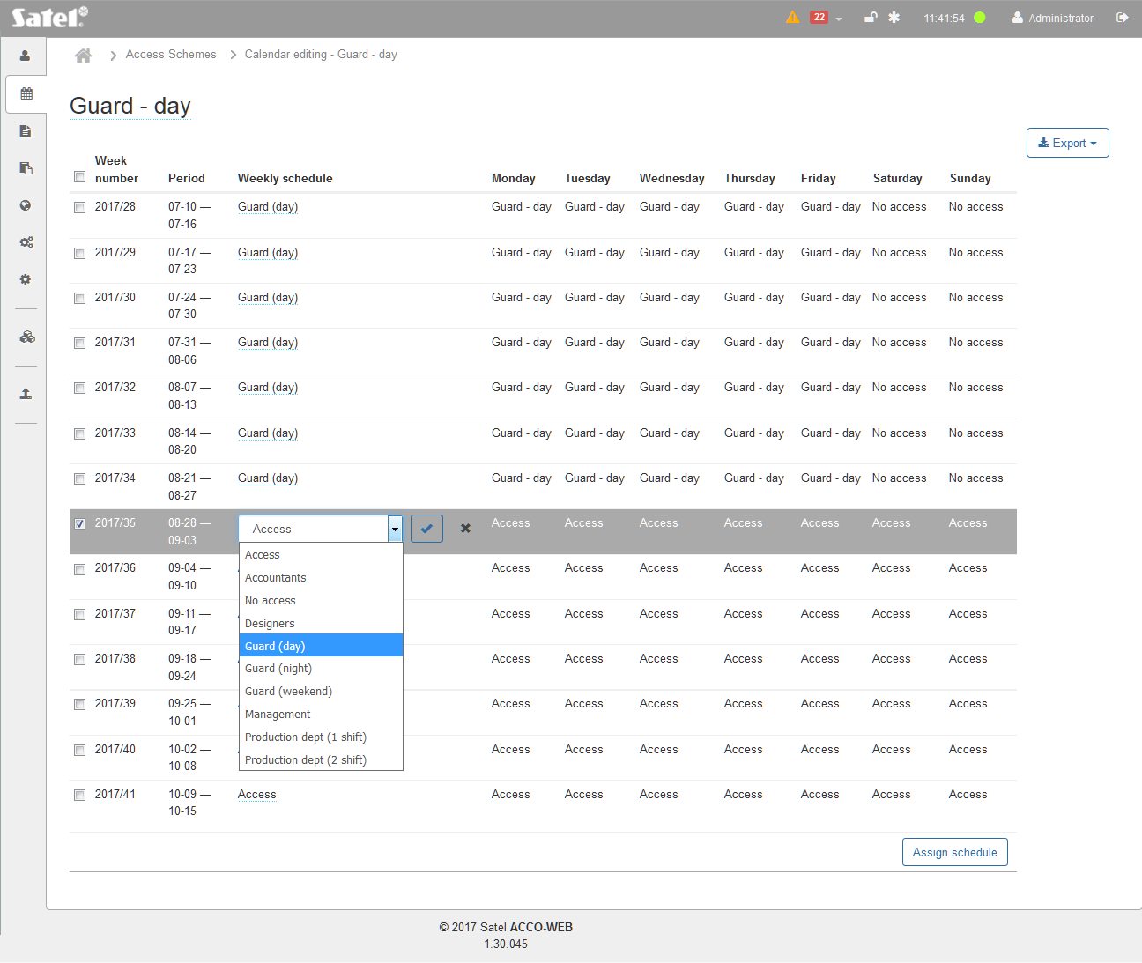
Fig. 45. An example of editing access calendar.

Assigning weekly access schedule to one week
- In the “Weekly schedule” column, click on the name of the schedule assigned to the selected week, and the on the drop-down menu symbol.
- The list of all defined weekly access schedules will be displayed. Select one of the schedules and click on .
- In the menu on the left side, click on “System operations” →“Save changes”.

Assigning weekly access schedule to several weeks
- Select the required weeks and click on the “Assign schedule” button at the bottom of the page.
If you want to select all weeks, check the box next to the “Week number” header.
- In the “Assign schedule” window (see: Fig. 46), click on the drop-down menu symbol.
- The list of all defined weekly access schedules will be displayed. Select one of the schedules and click on the “Save” button.
- In the menu on the left side, click on “System operations” →“Save changes”.

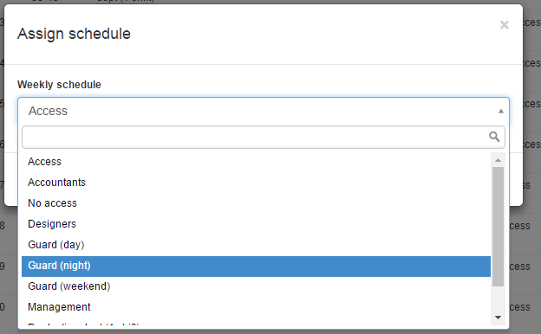
Fig. 46. An example of the window allowing weekly access schedule to be assigned to selected weeks.

Events
Over 24 thousand events can be saved to the memory of access control module. Up to 100 thousand events from each controller and about one million events from the control panel can be saved to the microSD memory of the control panel. After these limits are reached, the events are overwritten. From the control panel, the events are sent in real time to the server, which saves them to the database.
If the ACCO NET system is integrated with alarm systems, events from the alarm systems are saved to the memory of alarm control panels and to the database of the ACCO NET system.
The saved events can be used for presence recording.

Event list
Buttons
Details – click to display additional information on the events generated in the alarm control panels.
Refresh – click to automatically update the list of events displayed in the window.
Clear – click to remove the filter and display the list of current events (see: “Filtering events”).
Export – click, if you want to export events to file (see: “Exporting events”).

Table with event list
Events are displayed in descending order, i.e. the latest at the top, the oldest at the bottom.
The table with event list contains the following data:
Date – date when the event occurred.
Time – time when the event occurred.
Source – name of the event source. It can be the ACCO NET system, ACCO-NT access control panel, ACCO-KP controller or INTEGRA alarm control panel (if the ACCO NET system is integrated with the alarm system).
Event – event description.
User – user name.
Object – name of the object the event refers to.
Control panel – name of the control panel the event refers to.
Entry zone – name of zone in which the terminal serving as the entry to the given zone was used.
Exit zone – name of zone in which the terminal serving as the exit from the given zone was used.
Controller name – name of module the event refers to.
Controller – name of module the event refers to.
Exit zone – name of zone in which the terminal serving as the exit from the given zone was used.
Entry zone – name of zone in which the terminal serving as the entry to the given zone was used.
Object name – name of the object the event refers to.
Control panel name – name of the control panel the event refers to.
Details – additional information on the event.
The fields above the column names allow filtering of the list (see: “Filtering events”).
To sort the event related data by the column name, click on the column name.

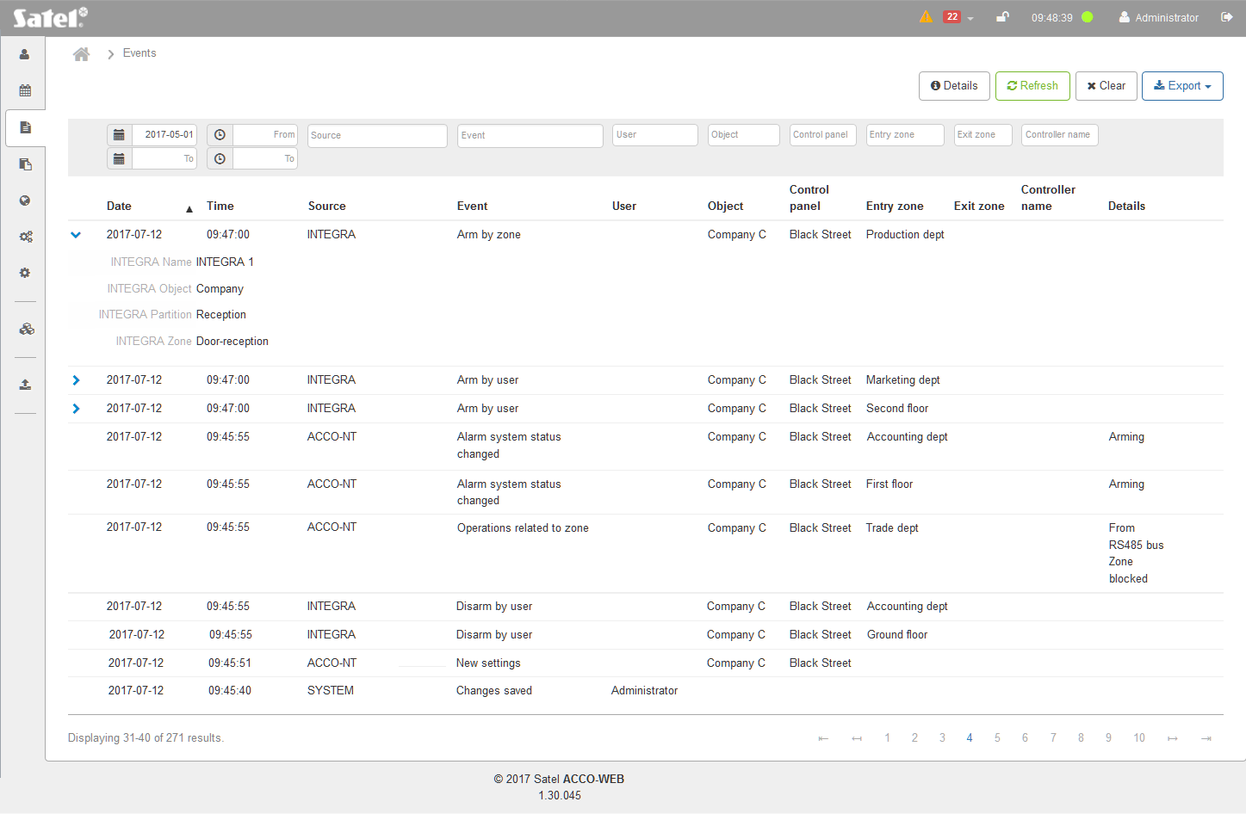
Fig. 47. An example of event list.

If the event list is too long to fit on one page, buttons are displayed to enable you navigation through the pages.

Filtering events

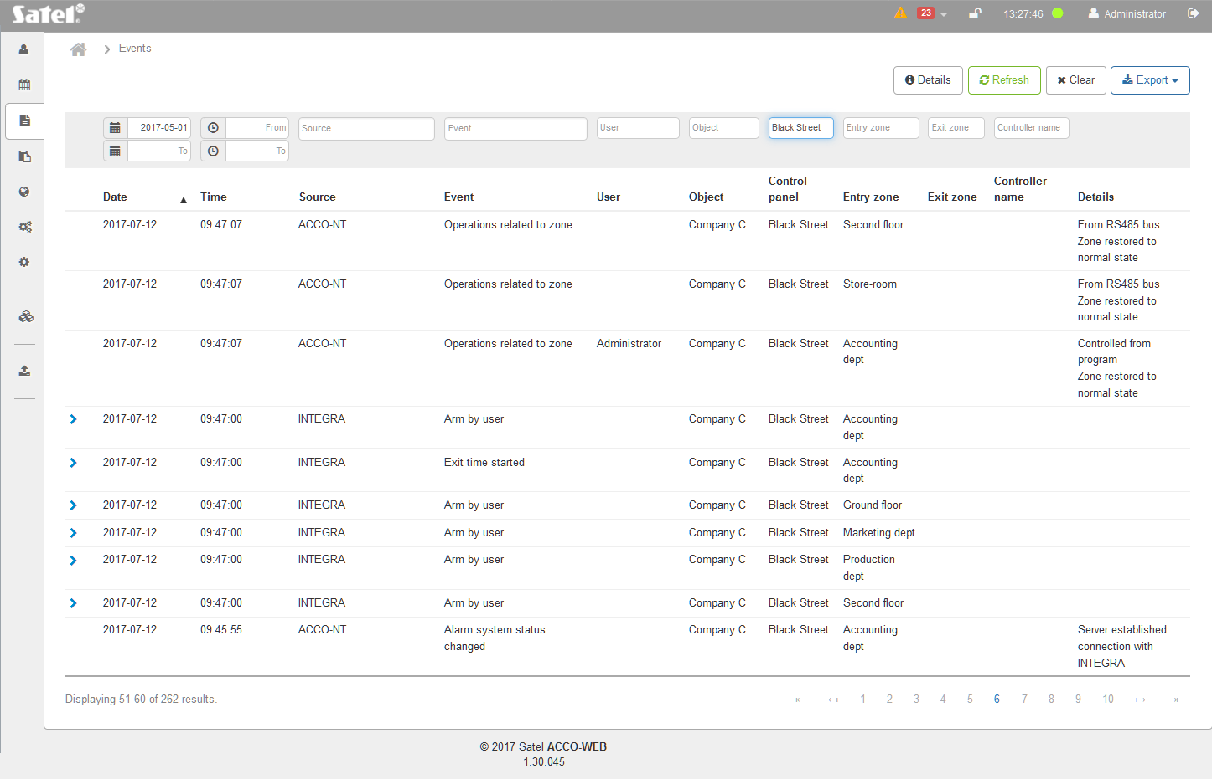
Fig. 48. An example of the list of events filtered according to defined criteria.

From [date] – by default, the first day of the month three months before the current month is displayed. Therefore, you can see events from the last 3 months on the page. If you want events that occurred after another day to be displayed, click on the field. In the calendar that will open, select the specific date and press ENTER.
To [date] – click on the field to display the calendar. If you want events that occurred before a specified day to be displayed, select the specific date and press ENTER.
From [hour] – click on the field and enter hour, minutes and seconds, if you want events that occurred after a specified time to be displayed and press ENTER.
To [hour] – click on the field and enter hour, minutes and seconds, if you want events that occurred before a specified time to be displayed and press ENTER.
Source – click on the field to display the list of sources the events come from. Click on the source name to add the source to the field. You can add any number of sources in this way. Alternatively, you can enter the source name into the field manually and choose from those suggested by the program. Press ENTER.
Event code – click on the field to display the list of event types divided into 4 groups: “System”, “ACCO-NT” “ACCO-KP” and “INTEGRA”. Click on the event type to add it to the field. In this way, you can add any number of event types. You can also enter manually the type name in the field and select from the types suggested by the program. Press ENTER.
User – click on the field, enter in whole or in part the user name and press ENTER.
Object – click on the field, enter in whole or in part the object name and press ENTER.
Control panel – click on the field, enter in whole or in part the control panel name and press ENTER.
Entry zone – click on the field, enter in whole or in part the name of entry zone and press ENTER.
Exit zone – click on the field, enter in whole or in part the name of exit zone and press ENTER.
Controller name – click on the field, enter in whole or in part the controller name and press ENTER.
Exit zone – click on the field, enter in whole or in part the name of exit zone and press ENTER.
Entry zone – click on the field, enter in whole or in part the name of entry zone and press ENTER.
Object name – click on the field, enter in whole or in part the object name and press ENTER.
Control panel – click on the field, enter in whole or in part the control panel name and press ENTER.
If you clear the filter, the fields under the column names will go blank and the list of current events will be displayed on the page.

Exporting events

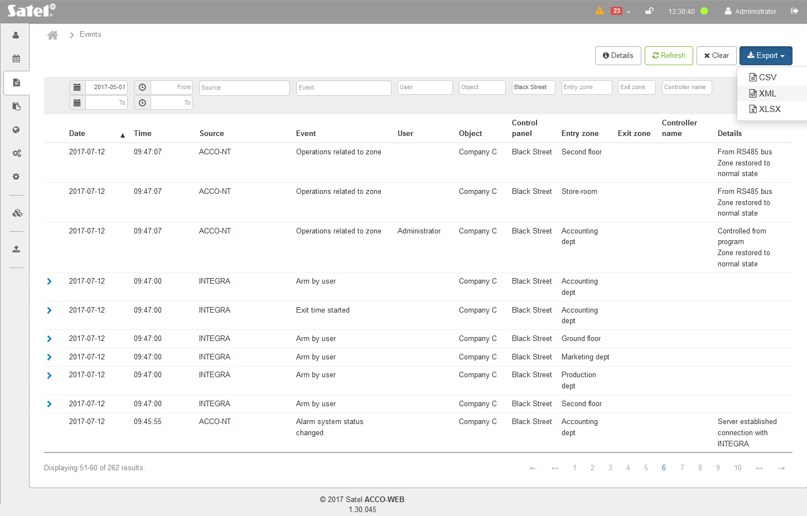
Fig. 49. An example of exporting events.

The event list can be exported to file. The last 10 thousand events or the currently displayed (filtered) events will be exported. Click on the “Export” button and select in what format the events will be exported. You can choose from CSV, XML i XLSX format. In the dialog box, select the program in which the file will be opened, or indicate the location in which the file will be saved.

Presence

Presence preview
This page makes it possible to check who is present and who is not, and whether the users stay where they should. Additionally, clicking on the table row which corresponds to the user will display information on how the user presence is to be monitored (see: ““User” window”).
Buttons
– click, if all users are to be displayed in the list.
Present – click, if present users are to be displayed in the list. Next to the button name, the number of present users is shown in brackets.
Absent – click, if absent users are to be displayed in the list. Next to the button name, the number of absent users is shown in brackets.
Refresh – click for the data displayed in the list to be updated automatically.
Clear – click to remove the filter and display the list of all users (see: “Filtering “Presence preview” summary list”).
Export – click if you want to export the list of users (see: “Exporting the “Presence preview” summary list”).
The list contains the following data:
Date – date when the last event confirming the user presence was generated.
Time – hour and minutes when the last event confirming the user presence was generated.
Name – user's name.
Zone – name of the zone in which the user currently stays.
Object – name of the object in which the zone where the user currently stays is located.
Group – name of the group to which the user is assigned.
Presence calendar – name of the presence calendar assigned to the user.
Presence rule – name of the presence rule assigned to the user.
Status – information whether the user is present or absent.
You can click on a column name to sort the users' data by the column name.
If the list is too long to fit on one page, buttons are displayed to allow you to navigate through the pages.

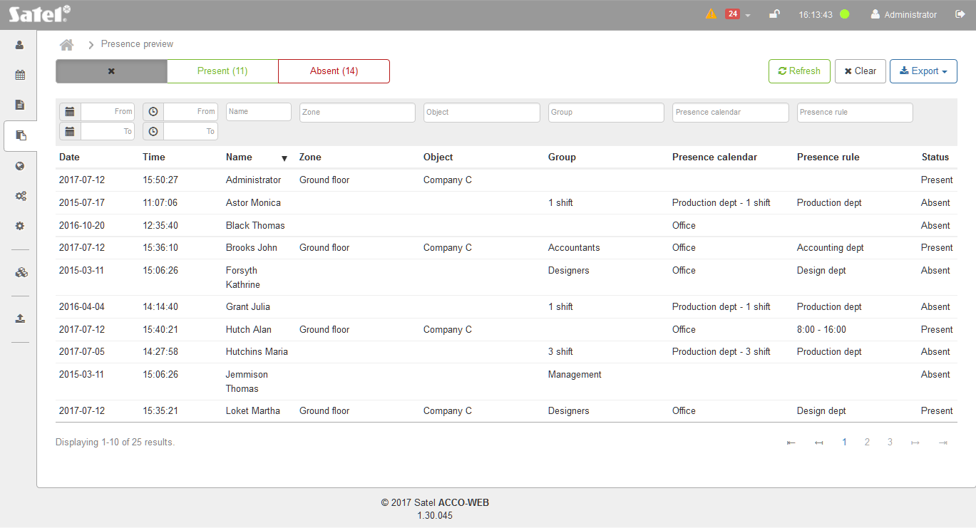
Fig. 50. “Presence preview” list.

Filtering “Presence preview” summary list
The fields above column names allow filtering the list.
From [date] – click on the field to display the calendar. If you want to find the users present after a specified day, select the specific date and press ENTER.
To [date] – click on the field to display the calendar. If you want to find the users present before a specified day, select the specific date and press ENTER.
From [hour] – click on the field and enter the hour, minutes and seconds, if you want to find the users present after a specified point of time. Press ENTER.
To [hour] – click on the field and enter the hour, minutes and seconds, if you want to find the users present before a specified point of time. Press ENTER.
Name – click on the field and enter in whole or in part the name of the user for whom you search in the list and press ENTER.
Zone – click on the field to display the list of zones. You can enter in whole or in part the zone name to further filter the list. You can select one, several or all zones. Press ENTER.
Object – click on the field to display the list of objects. You can enter in whole or in part the object name to further filter the list. You can select one, several or all objects. Press ENTER.
Group – click on the field to display the list of user groups. You can further filtrate the list by entering the group name in whole or in part. You can select one, several or all groups. Press ENTER.
Presence calendar – click on the field to display the list of defined presence calendars. You can further filtrate the list by entering the calendar name in whole or in part. You can select one, several or all calendars. Press ENTER.
Presence rule – click on the field to display the list of defined presence rules. You can further filtrate the list by entering the rule name in whole or in part. You can select one, several or all rules. Press ENTER.
If you clear the filter, the fields under the column names will go blank and the full list of users will be displayed.

Creating “Presence preview” summary list
- Select which users are to be included in the summary (“Present” and “Absent” buttons).
- Click on the “Refresh” button, if the data displayed in the summary are to be updated automatically.
- Depending on which data are to be displayed in the summary, filter the users.
The new users added to the system will be displayed in the summary after refresh of the “Presence preview” page.

Exporting the “Presence preview” summary list

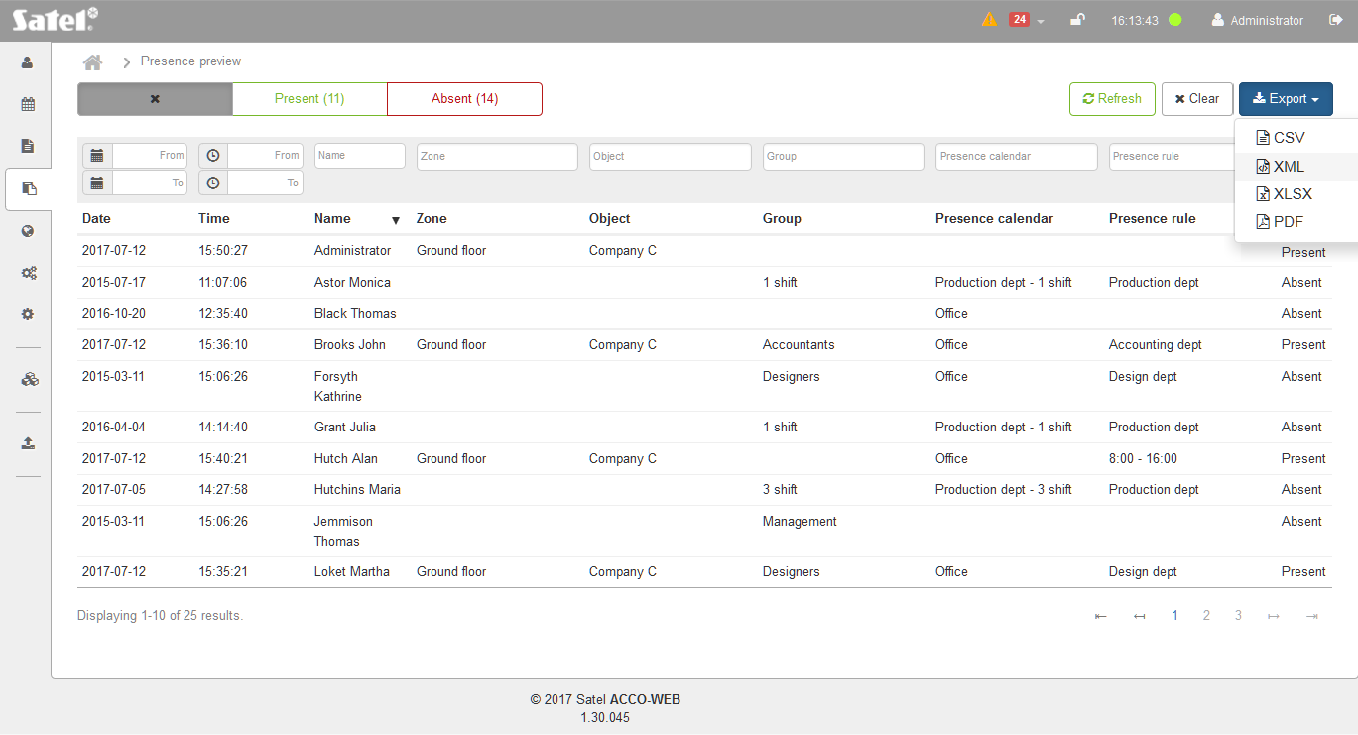
Fig. 51. An example of exporting the “Presence preview” list.

You can export the “Presence preview” summary list to file. Data of all users or the filtered users only can be exported. Click on the “Export” button and select the format in which the list will be exported. You can choose from CSV, XML, XLSX and PDF formats. In the dialog box, select the program in which the file will be opened or indicate the location where the file will be saved.

“User” window

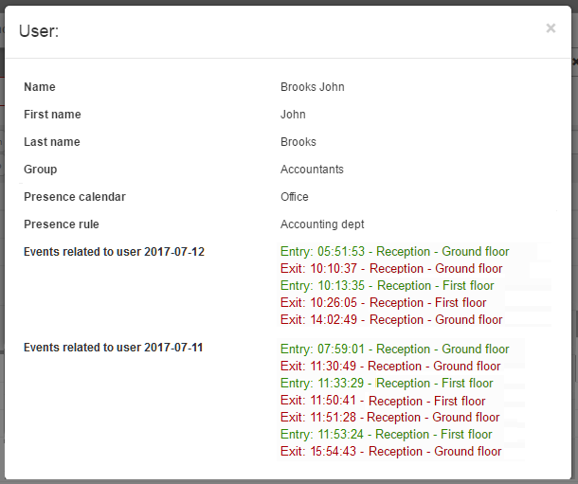
Fig. 52. “User” window in the “Presence preview” summary list.

Name – user name.
First name – user's given name.
Last name – user's family name.
Group – name of the group to which the user is assigned. Click on it to edit the given group.
Presence calendar – name of the presence calendar assigned to the user. Click on it to edit the given presence calendar.
Presence rule – name of the presence rule which is used for user presence control. Click on it to edit the given presence rule.
Events related to user – list of events generated on that day and on the previous day and related to the user presence in the zones where the “Present” option is enabled for the user. Color of the displayed events indicates that:
black – the user has moved from on zone to another,
red – the user has left zone and entered area not covered by access control system,
green – the user has entered zone from area not covered by zone access control system.

Presence reports
The presence report provides information on the time spent by the users on the premises. You can generate reports with the data of all users, filtered users or a single user.
Buttons
Clear – click to remove the filter and display the list of all users (see: “Presence report – filtering”).
Export – click to generate a presence report. After the drop-down menu opens, select the format in which the users' data will be exported. You can choose from the CSV, XML and XLSX formats. In the dialog box, select the program in which the file will be opened or indicate the location in which the file will be saved.

Table with the list of users

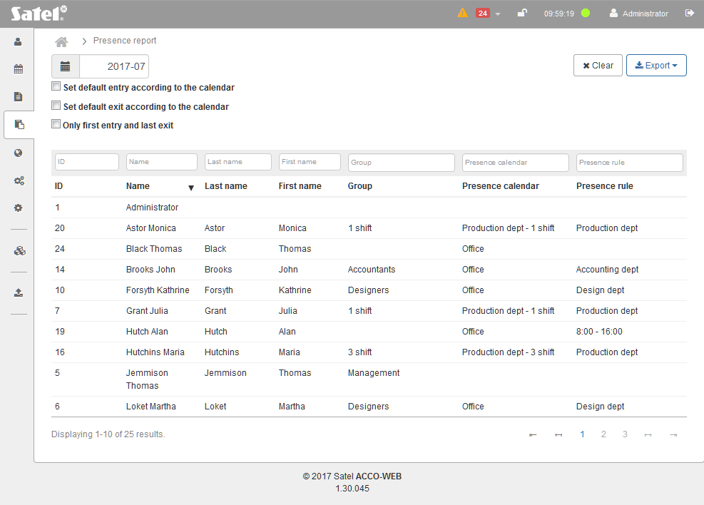
Fig. 53. User list on “Presence report” page.

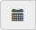 – click on the field to select the month of the year for which the report is to be generated.
Set default entry according to the calendar – enable this option if the default entry time according to the presence calendar is to be used.
Set default exit according to the calendar – enable this option if the default exit time according to the presence calendar is to be used.
Only first entry and last exit – enable this option if you want the time of user presence throughout the day to be counted without considering any breaks from work.
If there is no information about the first entry / the last exit of the user, the default entry / exit time will be used by the program. The default entry and exit times are defined by the given user presence calendar. The default entry time will be used by the application when there is no information about user's entry, and the default exit time when there is no information about user's exit.
The table with user list contains the following data:
ID – user's identification number.
Name – user's name.
Last name – user's last name.
First name – user's first name.
Group – name of the group to which the user is assigned.
Presence calendar – name of the presence calendar which has been assigned to the user. Click on it, if you want to assign another presence calendar to the user.
Presence rule – name of the presence rule which is used for the user's presence control.
The fields above the column names allow filtering of the list (see: “Presence report – filtering”).
To sort the user data by the column name, click on the column name.
If the user list is too long to fit on one page, buttons are displayed to allow navigation through the pages.

Presence report – filtering
ID – click on the field and enter the digit(s) of identification number of the user you want to find and press ENTER.
Name – click on the field and enter in whole or in part the name of the user you want to find and press ENTER.
Last name – click on the field and enter in whole or in part the last name of the user you want to find and press ENTER.
First name – click on the field and enter in whole or in part the first name of the user you want to find and press ENTER.
Group – click on the field to display the list of user groups. To further filter the list, enter the group name in whole or in part. You can select one, several or all groups. Press ENTER.
Presence calendar – click on the field to display the list of defined presence calendars. You can enter the calendar name in whole or in part to further filter the list. You can select one, several or all calendars. Press ENTER.
Presence rule – click on the field to display the list of defined presence rules. To further filter the list, enter the rule name in whole or in part. You can select one, several or all rules. Press ENTER.
If you clear the filter, the fields under the column names will go blank and the full list of users will be displayed.

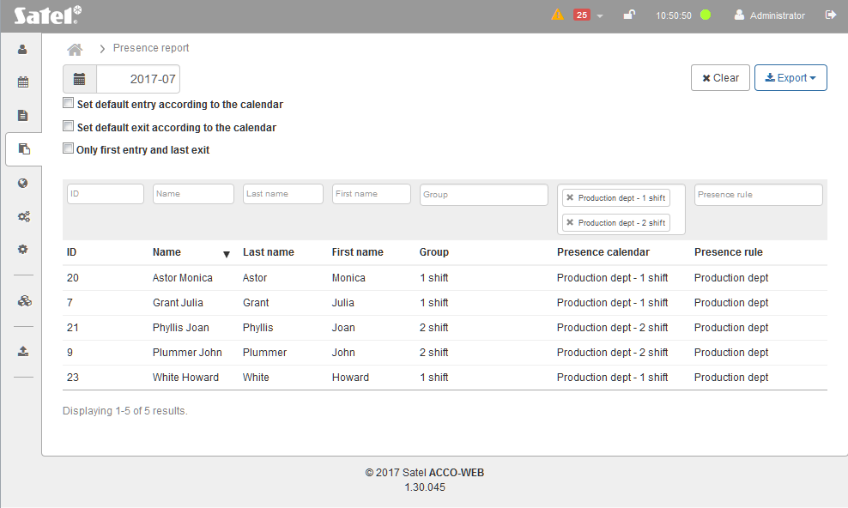
Fig. 54. An example of the list of users filtered according to criteria defined on the “Presence report” page.

Detailed user presence report
Presented on the page is detailed information on selected user presence.
Date – day, month, year (day of the week).
Hours to be worked – number of hours to be worked on the given day according to the presence calendar assigned to the user.
Hours worked – number of hours of user presence on the premises on the given day according to the access control records.
Difference – difference between the number of hours to be worked and the number of hours of presence. The information is displayed in green when the number is equal to 0 or its value is positive. On the other hand, when the difference is a negative number, the information is displayed in red.
Details – click to display the user details:
- time slots assigned to the user,
- list of events generated on the given day, recording the hours of user entries and exits (the entries are shown in green and the exits in red),
- the number of hours during which the user was present on the premises.
Summation – under the summary list, information is displayed to tot up the time the user is to work and the time the user has actually worked.

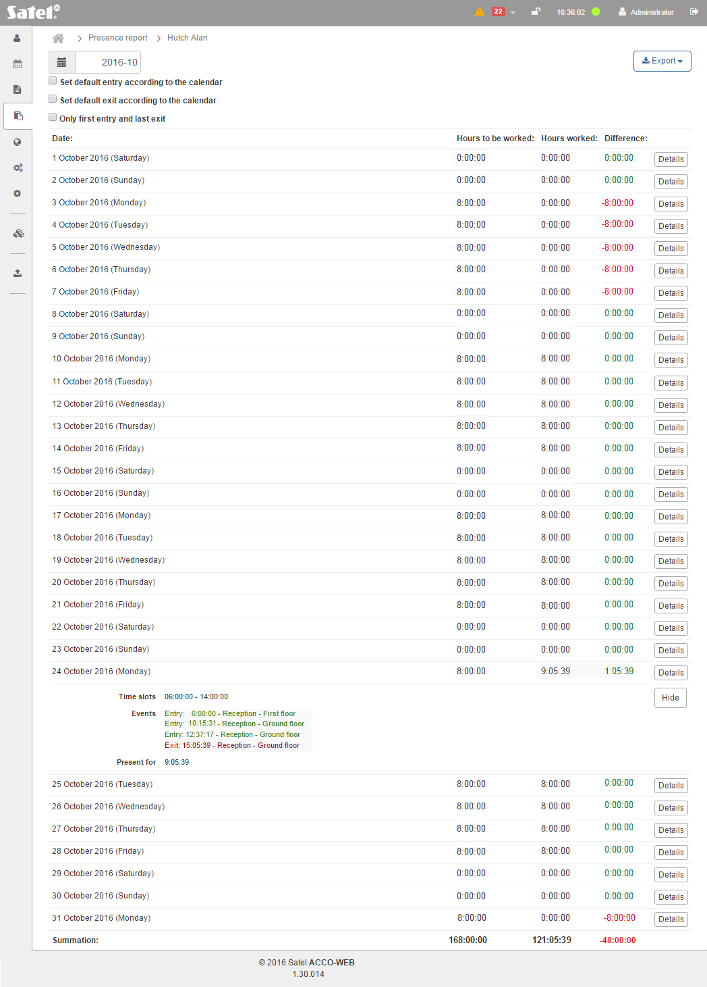
Fig. 55. An example of presence report.

Generating a presence report
- If you want to generate a presence report containing the data of all users, define the month of the year for the report.
- If you want to generate a presence report containing the data of selected users, filter the user list as described in section “Presence report – filtering”. When the list of users meeting the defined criteria is displayed, define the month and year for the report.
- If the report is to include only a selected user, click the user name on the list of users. A detailed presence report of the indicated user will be displayed. Specify the month and year of the report.
- If the users can enter or exit the premises without recording this fact by the access control, enable the “Set default entry according to the calendar” and “Set default exit according to the calendar” options. The default times of entry to or exit from the premises are defined in the presence calendar of the given user. The application will use the default entry hour, if there is no information on the user's entry, and it will use the default exit hour, if there is no information on the user's exit.
- If the report is to include only the time of users' presence during the day without taking into account any breaks from work, enable the “Only first entry and last exit” option.
- Click on the “Export” button. The drop-down menu will be displayed.
- Select the format in which the user data will be exported.
- In the dialog box, select the program in which the file will be opened, or indicate the location in which the file will be saved.

Calendars

“Presence calendars” tab
The presence calendars specify on which days of the week and in what hours the users should stay in the zones defined in the presence rules assigned to them. The calendars are created on the basis of weekly presence schedules, daily presence schedules and time slots.
You can assign one of the calendars to each user. In this way, you will define the time during which the user should stay in the specified zones.

List of presence calendars
Buttons
Add – click to display the “Add calendar” window (see: ““Add calendar” window”).
Delete – click to delete the selected presence calendar(s). The button is available after the box next to at least one calendar is checked.
Clear – click to remove the filter and display the list of all presence calendars (see: “Filtering presence calendars”).
Export – click to export the presence calendars to file (see: “Exporting presence calendars”).

Table with list of presence calendars
The table contains the following data:
ID – identification number assigned automatically during the new calendar adding procedure. Check the box on the left side to select all calendars.
Name – individual name of the presence calendar. Click on it to edit the given calendar.
To sort the calendars by the column name, you can click on the column name.

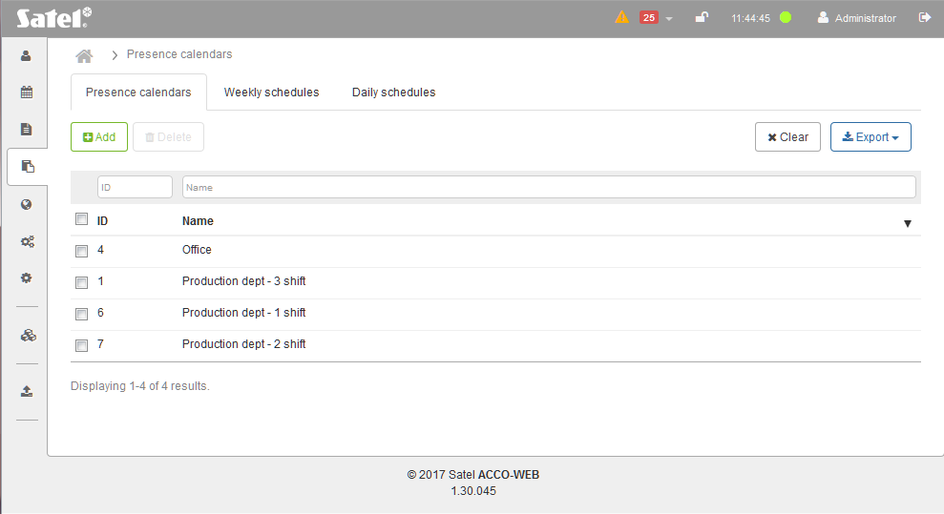
Fig. 56. An example of list of presence calendars.

“Add calendar” window

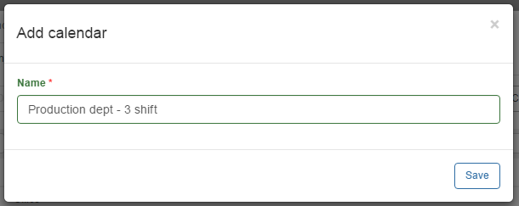
Fig. 57. Presence calendar adding window.

Name – enter the calendar name. This field is required.
Save – click to add a new calendar.

Creating a presence calendar
- Click on the “Add” button. The calendar creating window will open.
- Enter a name for the calendar to be created.
- Click on the “Save” button. This will open the page on which you can edit the created calendar (see: “Editing presence calendar”).
- If you want to end the calendar adding procedure, click on “System operations” →“Save changes” in the menu on the left side.

Filtering presence calendars
The fields above column names allow filtering the list.
ID – click on the field and enter one or more digits of the identification number of the calendar which you want to find and press ENTER.
Name – click on the field and enter the name of the calendar you want to find and press ENTER.
If you clear the filter, the fields under the column names will go blank and the full list of presence calendars will be displayed.

Exporting presence calendars
You can export the list of presence calendars to file. Data of all calendars or the filtered calendars only can be exported. Click on the “Export” button and select the format in which the calendars will be exported. You can choose from CSV, XML, XLSX and PDF formats. In the dialog box, select the program in which the file will be opened or indicate the location where the file will be saved.

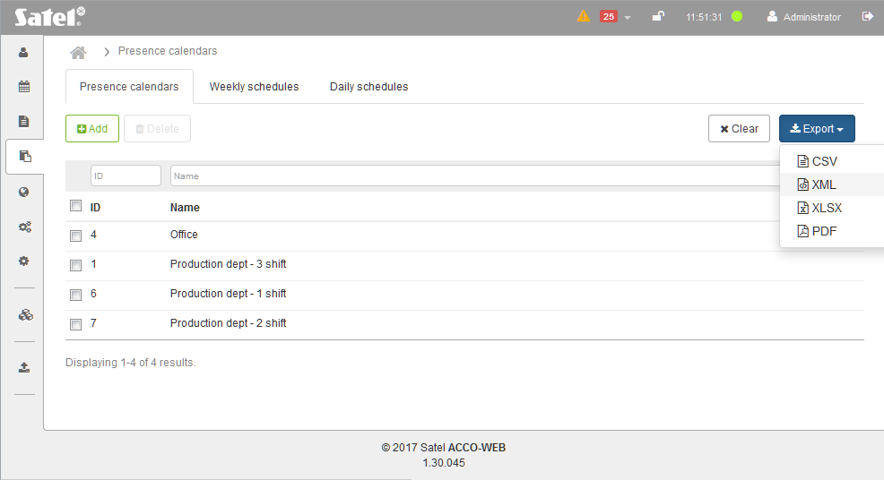
Fig. 58. An example of exporting presence calendars.

“Weekly schedules” tab
The weekly presence schedules define on which days of the week the user should stay in the specified zones. The weekly schedules are created by selecting the suitable daily schedules for each day of the week.

List of weekly presence schedules
Buttons
Add – click to display the “Add new weekly schedule” window (see: ““Add new weekly schedule” window”).
Delete – click to delete the selected weekly presence schedule(s). The button is available after the box next to at least one schedule is checked.
Removal of the weekly presence schedule which has been assigned to the presence calendar will automatically assign “Day off” in its stead.
Clear – click to remove the filter and display the list of all weekly presence schedules (see: “Filtering weekly presence schedules”).
Export – click to export the weekly presence schedules to file (see: “Exporting weekly presence schedules”).

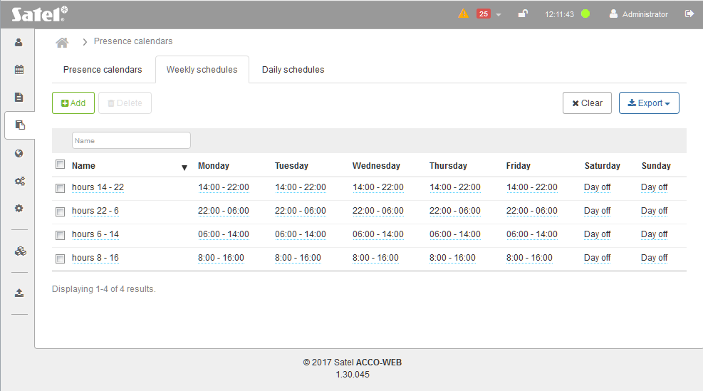
Fig. 59. An example of the list of weekly presence schedules.

Table with list of weekly presence schedules
The table contains the following data:
Name – individual name of the weekly presence schedule. Click on the name to edit it.
If you want to select all schedules, check the box to the left of the “Name” header.
Days of the week – name of the daily presence schedule assigned to the specific day.
When editing parameters, the following icons are available:
– click to confirm the entered data.
– click to end the editing without changing any data.
– click to delete the value from the field.
To sort the schedules by name, click on the column name.
If the list of schedules is too long to fit on one page, buttons are displayed to allow you to navigate through the pages.

“Add new weekly schedule” window

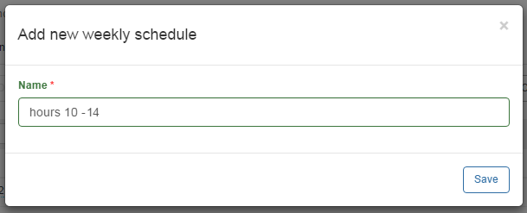
Fig. 60. Weekly presence schedule adding window.

Name – enter a name for the weekly presence schedule. The field is required.
Save – click to add a new weekly presence schedule.

Creating weekly presence schedule
- Click on the “Add” button. The schedule creating window will open (see: Fig. 60).
- Enter a name for the weekly presence schedule to be added.
- Click on the “Save” button. The added schedule will be displayed in the list of weekly presence schedules.
- A “Day off” daily schedule will be automatically assigned to each day of the week. You can edit the schedules for individual days (see: “Editing weekly presence schedule”).
- If you want to end the schedule creating procedure, click on “System operations” →“Save changes” in the menu on the left side.

Editing weekly presence schedule
- In the table with list of weekly presence schedules, click on the name of schedule you want to edit.
- In you want to change the name, enter a new name and click on .
- If you want to change the daily schedule assigned to the selected day of the week, click on the schedule name and then on the drop-down menu symbol.
- The list of all defined daily presence schedules will be displayed. Select one of the schedules and click on .
- Change in the same way the daily schedules assigned to the other days of the week.
- Click on “System operations” →“Save changes” in the menu on the left side to end the schedule editing procedure.

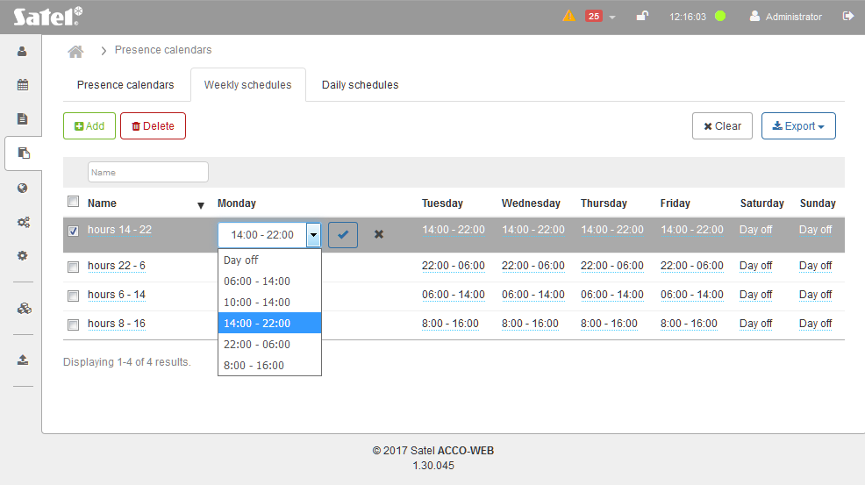
Fig. 61. An example of editing weekly presence schedule.

Filtering weekly presence schedules
The field above the “Name” column allows filtering of the list.
Name – click on the field and enter in whole or in part the name of the schedule you want to find and press ENTER.
If you clear the filter, the field under the column name will go blank and the full list of weekly presence schedules will be displayed.

Exporting weekly presence schedules
You can export the list of weekly presence schedules to file. Data of all schedules or the filtered schedules only can be exported. Click on the “Export” button and select the format in which the schedules will be exported. You can choose from CSV, XML, XLSX and PDF formats. In the dialog box, select the program in which the file will be opened or indicate the location where the file will be saved.

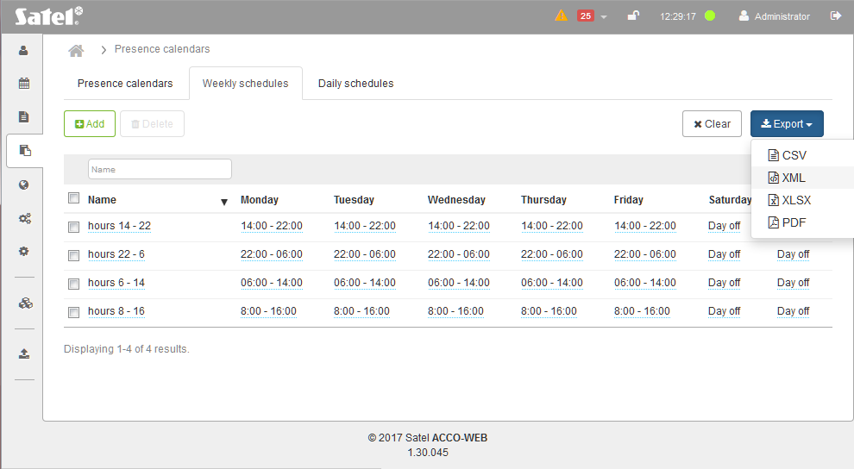
Fig. 62. An example of exporting weekly presence schedules.

“Daily schedules” tab
The daily presence schedules define on what rules the user should stay in specified zones during the 24-hour period. The daily schedules are created based on time slots. Each of them must include at least one time slot.

List of daily presence schedules
Buttons
Add – click to add a new daily presence schedule (see: “Creating daily presence schedule”).
Delete – click to delete the selected daily schedule(s). The button is available after the box next to at least one schedule is checked.
Removal of the daily presence schedule which has been assigned to a weekly schedule will automatically assign “Day off” in its stead.
– click if the list of daily presence schedules is to be displayed in the graphic form. In this display mode, you can view and delete schedules as well as edit their names and time ranges.
– click if the list of daily presence schedules is to be displayed in the tabular form. In this display mode, you can add, edit, view and delete the schedules.
[minutes] – for the list of schedules in graphical form, the field allows you to change the time scale on the diagram. Click on the drop-down menu to select the number of minutes.
Clear – click to remove the filter and display the list of all daily presence schedules (see: “Filtering daily presence schedules”).
Export – click to export the daily presence schedules to file (see: “Exporting daily presence schedules”).
When editing parameters, the following icons are available:
– click to confirm the entered data.
– click to end editing without changing any data.
– click to delete the value from the field.

Table

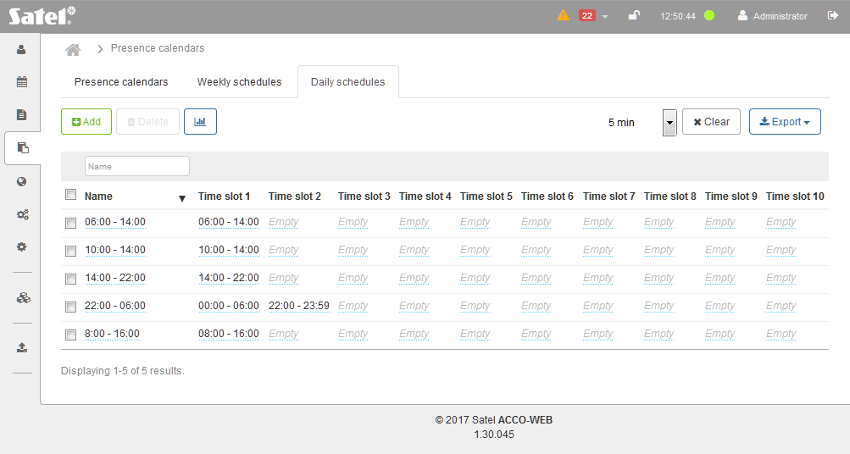
Fig. 63. An example of the list of daily presence schedules in tabular form.

The table with the list of daily presence schedules contains following data:
Name – individual name of the presence daily schedule. Click on the name to edit it.
If you want to select all schedules, check the box next to the “Name” header.
Time slots 1-10 – time within a 24-hour period when the user should stay in the specified zones. At the selected time slot, click on the field with defined time, or on “Empty”. Enter from when (hour and minutes) to when (hour and minutes), the user should stay in the zones defined in the presence rule assigned to it and click on .
To sort the schedules by name, click on the column name.

Filtering daily presence schedules
The field above the “Name” column allows filtering of the list.
Name – click on the field and enter in whole or in part the name of the schedule you want to find and press ENTER.
If you clear the filter, the field under the column name will go blank and the full list of daily presence schedules will be displayed.

Graphic form

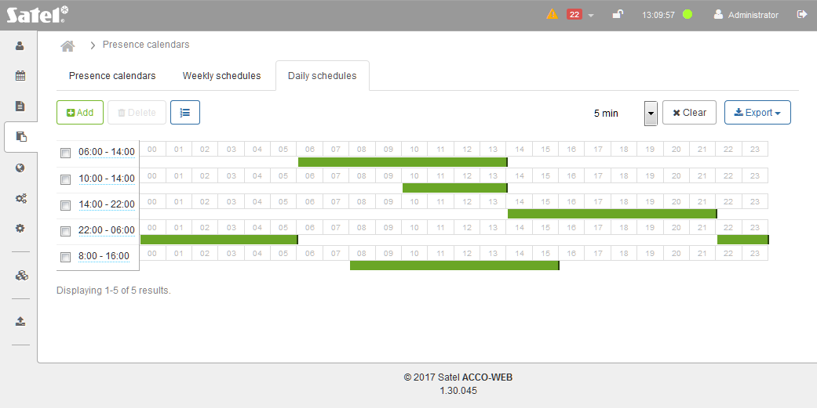
Fig. 64. An example of the list of daily presence schedules in graphic form.

[schedules] – the list of daily presence schedules is displayed on the left side. Click on the schedule name to edit it.
[time range] – presented in the form of green rectangle. It indicates from when (hours and minutes) to when (hours and minutes), within a 24 hour period, the user should stay in the designated zones. Click on the rectangle and hold down the left mouse button to edit the time range. To drag the whole rectangle, click in the middle of it. Click on the left or right edge of the rectangle to make it longer or shorter.

Creating daily presence schedule
- Click on the “Add” button. The “Add new daily schedule” window will open (see: Fig. 65).

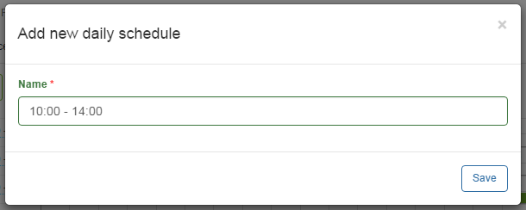
Fig. 65. Daily presence schedule adding window.

- Enter the name of the daily presence schedule.
- Click on the “Save” button. The added schedule will be displayed in the list of daily presence schedules.
- You can add time frame(s) to the created schedule (see: “Editing daily presence schedule”).
- In the menu on the left side, click on “System operations” →“Save changes”.

Editing daily presence schedule
The schedule is editable, if the schedules are displayed in tabular form.
- In the table with list of daily presence schedules, click on the name of schedule you want to edit.
- If you want to change the name, enter a new name and click on .

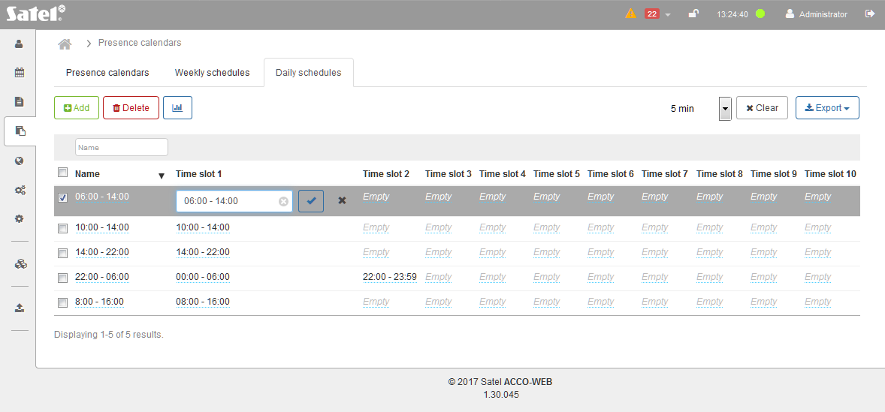
Fig. 66. An example of editing daily presence schedule.

Adding time slot
- Click on the first available “Empty” field.
- Enter from when (hour and minutes) to when (hour and minutes) getting access is to be possible and click on .
- In the menu on the left side, click on “System operations” →“Save changes”.

Editing time slot
- Click on the field with time defined for the time slot.
- Enter new values and click on .
- In the menu on the left side, click on “System operations” →“Save changes”.

Deleting time slot
- Click on the field with time defined for the time slot.
- Click on and then on .
- In the menu on the left side, click on “System operations” →“Save changes”.

Exporting daily presence schedules
You can export the list of daily presence schedules to file. Data of all schedules or filtered schedules only can be exported. Click on the “Export” button and select the format in which the schedules will be exported. You can choose from CSV, XML, XLSX and PDF formats. In the dialog box, select the program in which the file will be opened or indicate the location where the file will be saved.

Fig. 67. An example of exporting daily presence schedules.

Editing presence calendar
- On the “Presence calendars” page, select the “Daily schedules” tab.
- Create a daily presence schedule according to the procedure described in section “Creating daily presence schedule”.
- Select the “Weekly schedules” tab.
- Create a weekly presence schedule according to the procedure described in section “Creating weekly presence schedule”.
- Select the “Presence calendars” tab.
- In the table with list of presence calendars, click on the name of calendar you want to edit. A page will open to allow you to edit the calendar. By default, all days in the calendar are days off throughout the week.
- If you want to change calendar name, click on it.
- Enter a new name and click on .
- Click on the field next to the icon to define the year for which you want to define the presence rules in selected zones.
- If you select the current year, you can use the “Hide past” button to hide the weeks that have already passed.

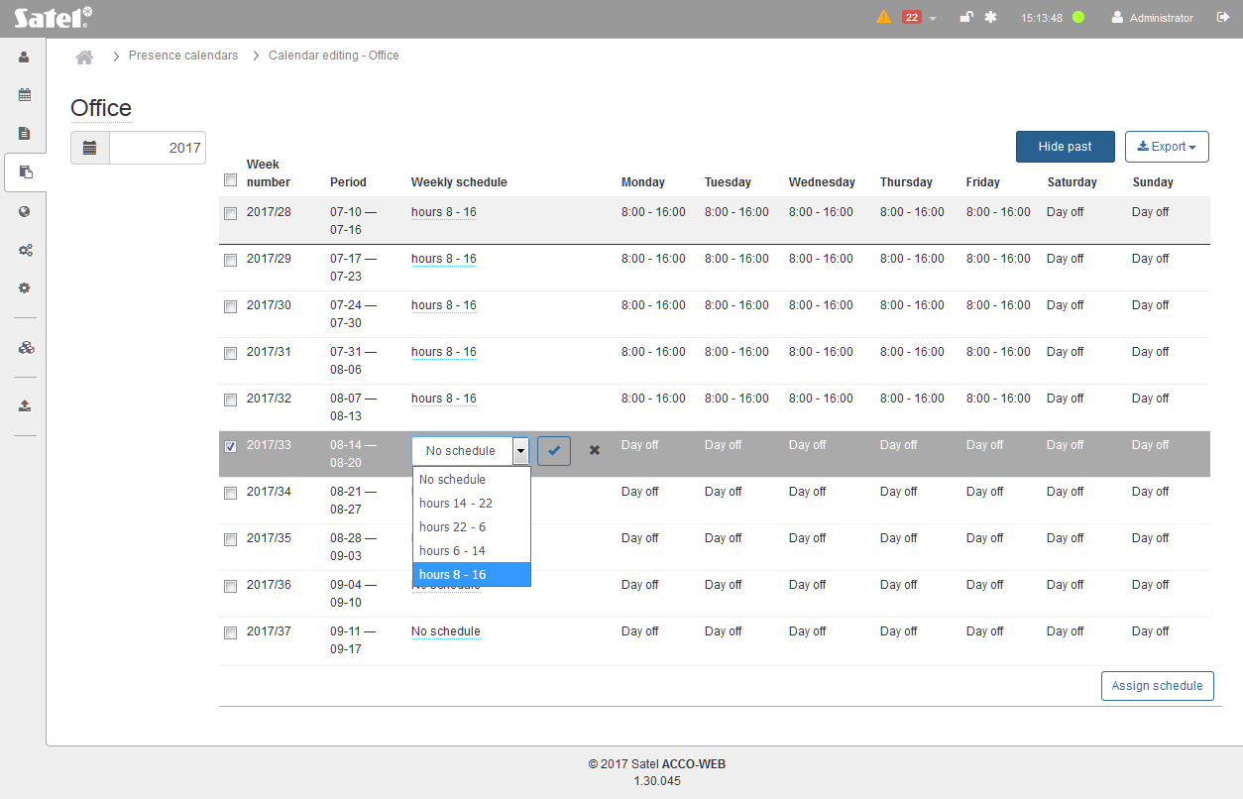
Fig. 68. An example of editing presence calendar.

Assigning weekly presence schedule to one week
- In the “Weekly schedule” column, click on the name of the schedule assigned to the selected week and then on the drop-down menu symbol.
- The list of all defined weekly presence schedules will be displayed. Select one of the schedules and click on .
- In the menu on the left side, click on “System operations” →“Save changes”.

Assigning weekly presence schedule to several weeks
- Select the required weeks and click on the “Assign schedule” button at the page bottom.
If you want to select all weeks, check the box next to the “Week number” header.
- In the “Assign schedule” window (see: Fig. 69), click on the drop-down menu symbol.
- The list of all defined weekly presence schedules will be displayed. Select one of them and click on the “Save” button.
- In the menu on the left side, click on “System operations” →“Save changes”.

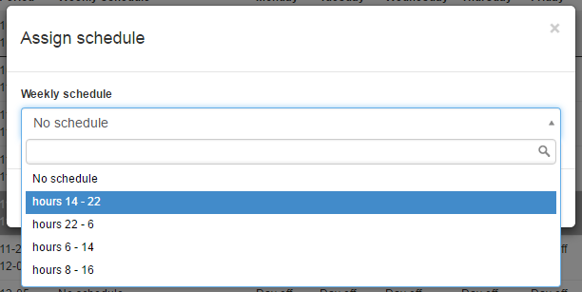
Fig. 69. The window allowing a weekly presence schedule to be assigned to selected weeks.

Presence rules
Presence rules determine the zones where the user should stay so that the system can record the user's presence.
The created presence rules may be used when generating the presence report.

List of presence rules

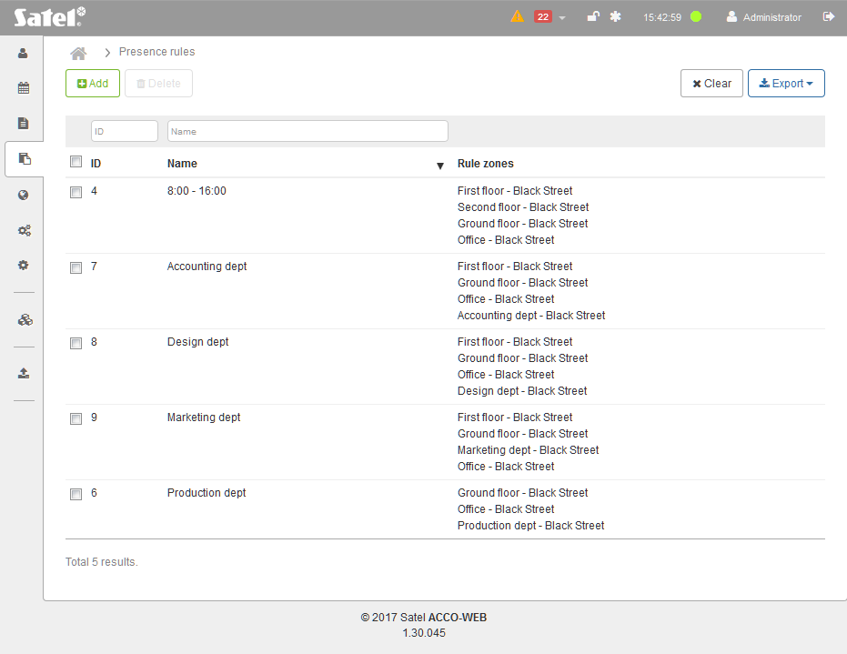
Fig. 70. An example of list of presence rules.

Buttons
Add – click to display the “Add rule” window (see: ““Add rule” window”).
Delete – click to delete the selected presence rule(s). The button is available after the box next to at least one rule is checked.
Clear – click to remove the filter and display the list of all presence rules (see: “Filtering presence rules”).
Export – click to export the presence rules to file (see: “Exporting presence rules”).

Table with list of presence rules
The table contains the following data:
ID – identification number assigned automatically during the new rule adding procedure. Check the box on the left side to select all rules.
Name – individual name of the presence rule. Click on it to edit the given rule.
Rule zones – zone assigned to a presence rule.
When editing parameters, the following icons are available:
– click to confirm the entered data.
– click to end the editing without changing any data.
– click to delete the value from the field.
To sort the rules by the column name, click on the column name.

Filtering presence rules
The fields above column names allow filtering of the list. Click on the field and enter:
ID – digit(s) of the identification number of the rule you want to find and press ENTER.
Name – name of the rule you want to find and press ENTER.

“Add rule” window

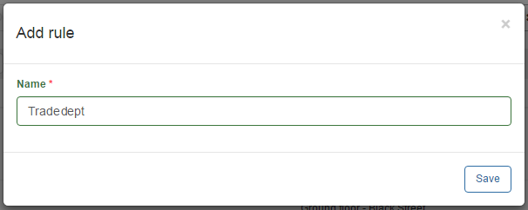
Fig. 71. Presence rule adding window.

Name – enter the name of presence rule. This field is required.
Save – click to add a new rule.

Creating presence rule
- Click on the “Add” button. The rule creating window will open.
- Enter the name of rule to be created.
- Click on the “Save” button. This will open the page on which you can edit the created rule (see: “Editing presence rule”).
- In the menu on the left side, click on “System operations” →“Save changes”.

Editing presence rule
- In the table with list of rules, click on the name of rule you want to edit. A page will open to allow you to edit the rule (see: Fig. 72).
- If you want to change a rule name, click on it.
- Enter a new name and click on .

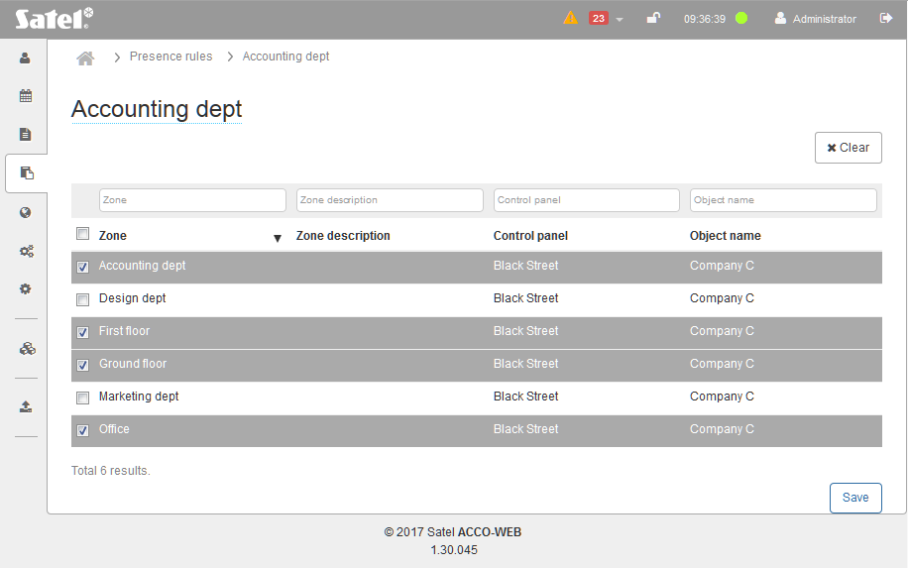
Fig. 72. An example of editing presence rule.

Assigning zone to presence rule
The displayed data can be filtered or sorted (see below).
- In the table with data, check the box next to the zone(s) you want to be assigned to the rule. The selected zones will be highlighted in gray.
If you want to select all zones, check the box next to the “Zone” header.
- Click on the “Save” button at the bottom of the page.
- The indicated zones will be assigned to the rule.
- In the menu on the left side, click on “System operations” →“Save changes”.

Deleting zone from presence rule
- In the table with data, check the box next to the zone(s) you want to be deleted from the rule.
- Click on the “Save” button at the bottom of the page.
- The indicated zones will be deleted from the rule.
- In the menu on the left side, click on “System operations” →“Save changes”.

Filtering data
Buttons
Clear – click to remove the filter and display the list of all zones.
The fields above column names allow filtering of the list. Click on the field and enter:
Zone – in whole or in part the name of zone you want to find and press ENTER.
Zone description – in whole or in part the description of zone you want to find and press ENTER.
Control panel – in whole or in part the name of control panel you want to find and press ENTER.
Object name – in whole or in part the name of object you want to find and press ENTER.

Sorting data
You can click on a column name to sort the displayed data by the column name.

Filtering presence rules
The fields above column names allow filtering of the list. Click on the field and enter:
ID – digit(s) of the identification number of the rule you want to find and press ENTER.
Name – name of the rule you want to find and press ENTER.
If you clear the filter, the fields under the column names will go blank and the full list of presence rules will be displayed.

Exporting presence rules
You can export the list of presence rules to file. All rules or the filtered rules only can be exported. Click on the “Export” button and select the format in which they will be exported. You can choose from CSV, XML, XLSX and PDF formats. In the dialog box, select the program in which the file will be opened or indicate the location where the file will be saved.

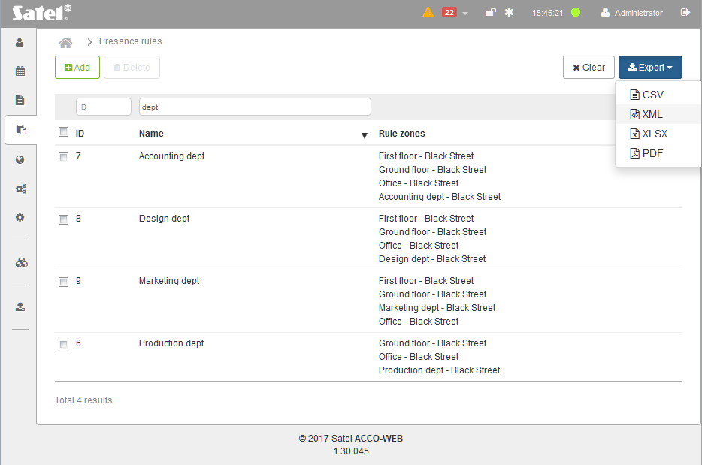
Fig. 73. An example of exporting presence rules.

Maps
You can monitor in real time the status of individual system components that are placed on the map.
The list of maps will be displayed in tree form. It illustrates the defined dependencies between the maps. The “+” character at the given map means that a next map has been or next maps have been embedded in it.
A click on the map name on the list will display in a new window the contents of image file assigned to the map. Click on the symbol of embedded map to display it. The embedded map will be displayed in the same window.
From the level of a map, also an embedded one, you can supervise the status of zones, doors as well as inputs and outputs of the ACCO NET system, and also the status of integrated partitions of the INTEGRA or INTEGRA Plus alarm control panels. You can also display the image from the web camera, installed in the protected premises.

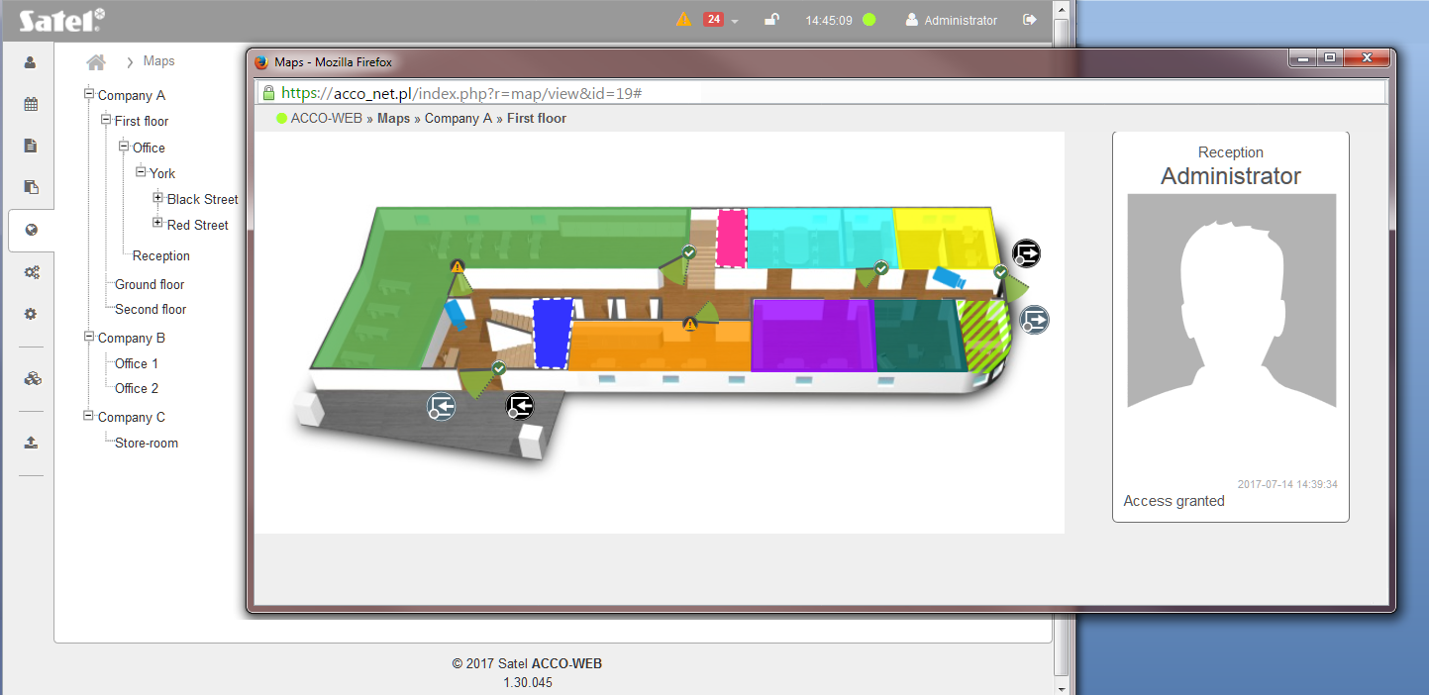
Fig. 74. Window with map image against the background of map list.

Using the map you can:
- block / unblock zones or doors,
- unlock one or all doors in a zone,
- restore control of the status of doors and zones,
- view images from web cameras installed on the premises,
and, when the ACCO NET system is integrated with the alarm systems, you can:
- arm the integrated partitions of alarm system by blocking the zones of ACCO NET system,
- disarm the integrated partitions of alarm system by restoring control in the zones of ACCO NET system.
Enabling the “Show user photography” option in ACCO Soft (see: ACCO Soft manual) will display in the map window a sequence of photos of the users whose actions would generate door related events. Under each photo, you can see information on the time when the event took place, and below it – description of the event.

Zones
The zone is presented as a color shape illustrating the controlled area. Hovering the cursor over the zone will display:
- name of the zone,
- number of people currently staying in the zone (shown in square brackets),
- current status of the zone (zone controlled, zone unblocked, zone blocked, armed, entry delay, exit delay < 10 s, exit delay > 10 s, mixed, alarm in the zone, fire in the zone – for detailed description of the statuses, refer to the ACCO Soft manual).
Clicking on the zone will open a window with the zone data (as described above) and with the following functions:
Unlock – click to unlock all doors in the zone.
Block – click to permanently lock all doors.
Unblock – click to permanently unlock all doors.
Restore the control – click to restore the control for all doors.
Additional information on the status of zones on the map is provided in graphical form:
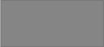 | zone controlled (no patterns)
 | zone unblocked (vertical stripes)
 | zone blocked (intersecting diagonal lines)
 | armed (intersecting diagonal lines with red border)
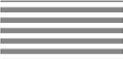 | entry delay (horizontal stripes)
 | exit delay (crosses)
 | mixed (diagonal stripes)
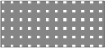 | alarm in the zone (blinking squares)
 | fire in the zone (blinking circles)

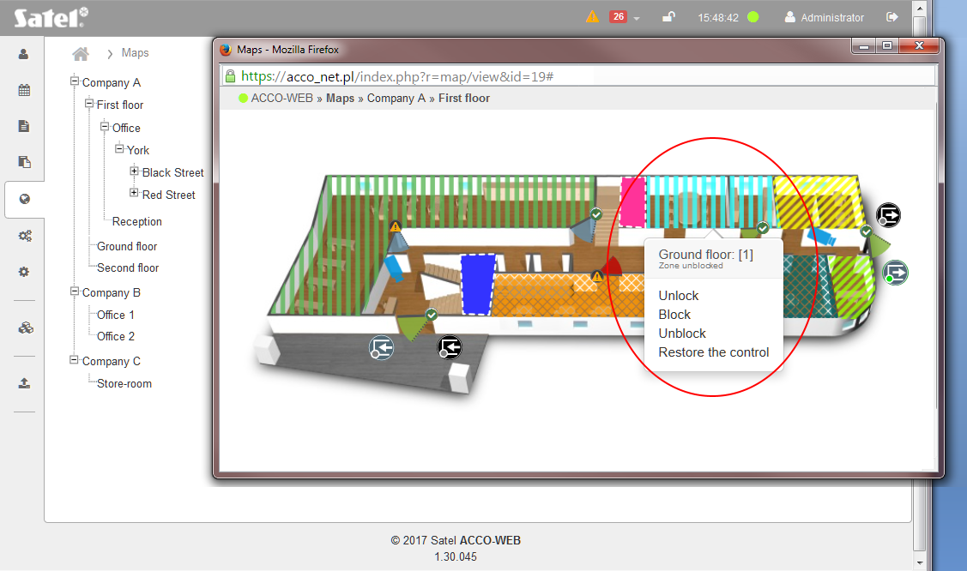
Fig. 75. A zone on map.

Doors
The door is presented on the map by means of the  symbol with different icons (the icons and the symbol colors depends on the door status, as described below). A click on the icon will display the name of controller supervising the given door and a window with the following functions:
Unlock – click to unlock the door.
Block – click to permanently lock the door.
Unblock – click to permanently unlock the door.
Restore the control – click to restore the door status control.
Details – click to display a window with real-time information on the door supervising controller:
Power supply state – value of controller supply voltage.
Communication quality – percentage ratio of the amount of data sent (from control panel to module) to the amount of data received (by control panel from module).
Module type – controller type.
Alarms – list of alarms that occurred in the controller.
Troubles – list of troubles that occurred in the controller.

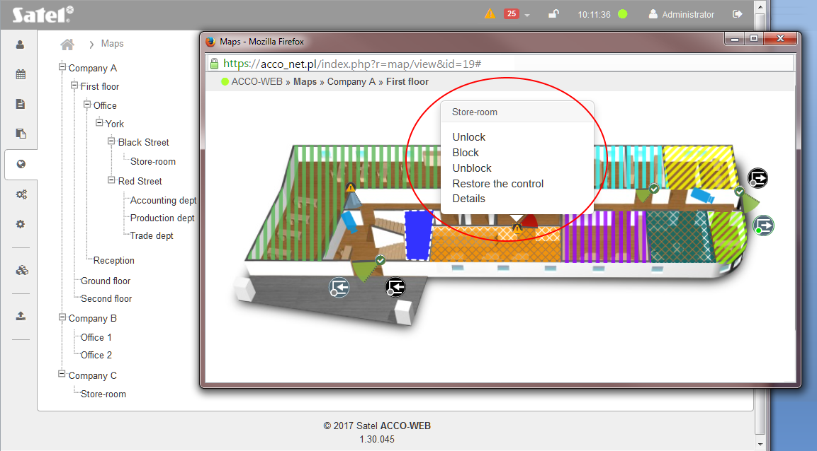
Fig. 76. A door on map.

The door symbol on map can convey the following information by means of:
- colors:
– door controlled;
 – door blocked;
 – door unblocked;
- icons:
 – alarm (white exclamation mark on red background);
 – trouble (black exclamation mark on yellow background);
 – everything OK. (white symbol on green background).
Blinking icon means that information on door status is being updated.

ACCO – Inputs
Inputs of the system ACCO NET (ACCO-NT control panel or expander connected to the control panel) are presented on the map by the symbol (the color depends on the input status). Hovering the cursor over the input symbol will display the device name and the input name. Color has the following meaning:
(green) – input active,
(gray) – input inactive.

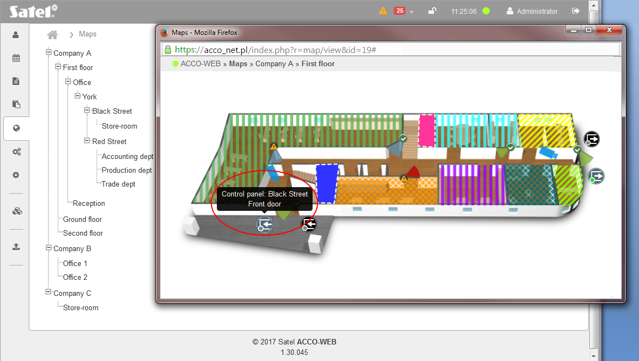
Fig. 77. An input of the system ACCO NET on map.

ACCO – Outputs

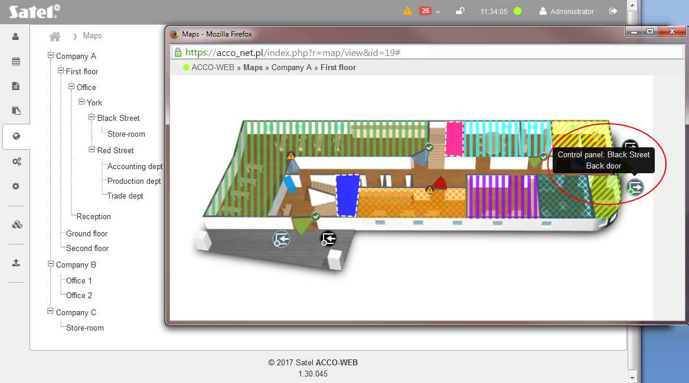
Fig. 78. An output of the ACCO NET system on map.

Outputs of the system ACCO NET (ACCO-NT control panel or expander connected to the control panel) are presented on the map by the symbol (the color depends on the output status). Hovering the cursor over the output symbol will display the device name and the output name. Color has the following meaning:
(green) – output active,
(gray) – output inactive.

INTEGRA – Zones
Zones of the alarm system (INTEGRA and INTEGRA Plus control panels or expanders connected to them) are presented on the map by the symbol (its color depends on the zone status). Hovering the cursor over the zone symbol will display the alarm system name and the zone name. Color has the following meaning:
(green) – zone active,
(gray) – zone inactive.

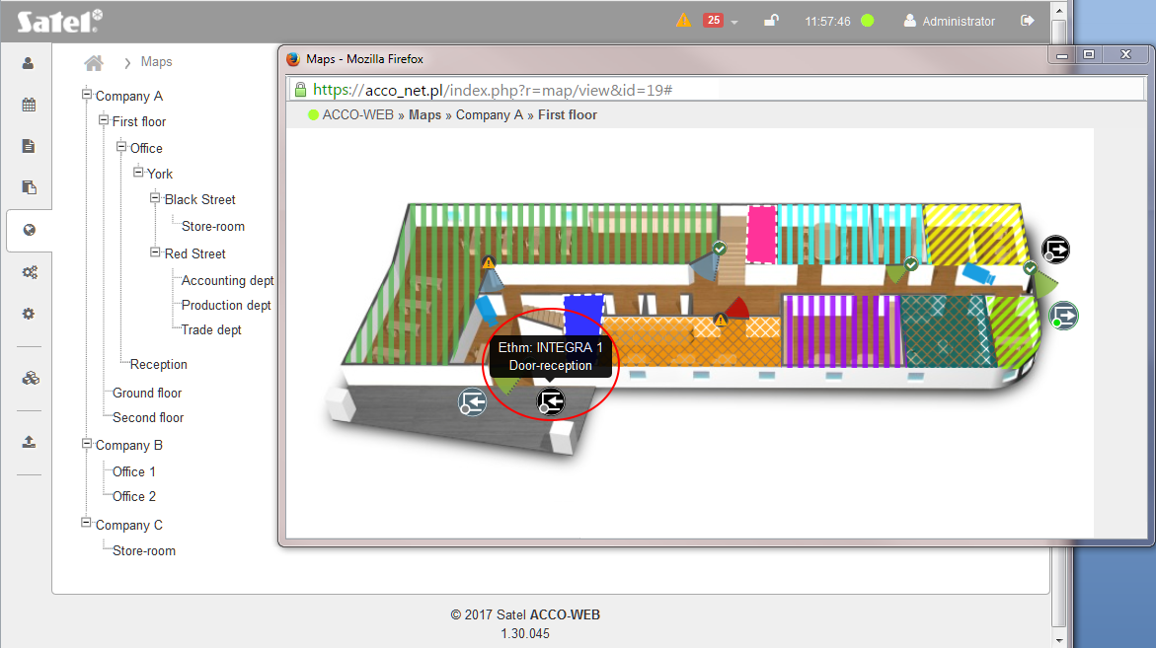
Fig. 79. A zone of the alarm system on map.

INTEGRA – Outputs
Outputs of the alarm system (INTEGRA and INTEGRA Plus control panels or expanders connected to them) are presented on the map by the  symbol (its color depends on the output status). Hovering the cursor over the output symbol will display the alarm system name and the output name. Color has the following meaning:
 (green) – output active,
(gray) – output inactive.

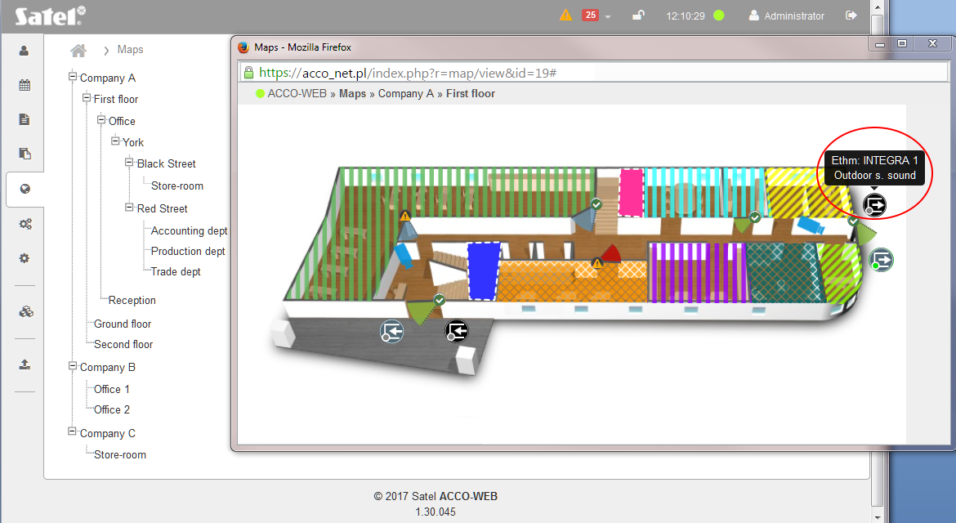
Fig. 80. An output of the alarm system on map.

Camera

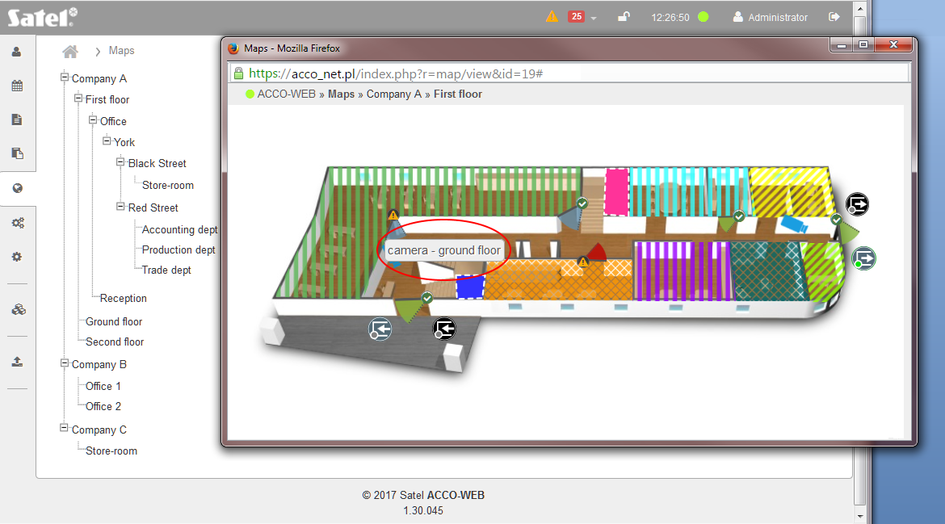
Fig. 81. A camera on map.

Camera is presented on the map by symbol. Hovering cursor over the symbol of camera will display its name. Click on it to see the preview image from the camera.

Management
You can unlock, block, unblock and restore the control of a single door or all doors in the zone. Additionally, you can control the state of control panels and controllers as well as acknowledge troubles and alarms which took place in the devices.

“Doors” tab
Buttons
Unlock – click to unlock the door(s) supervised by selected controllers.
Block – click to permanently lock the door(s) supervised by selected controllers.
Unblock – click to permanently unlock the door(s) supervised by selected controllers.
Restore the control – click to restore control of door(s) supervised by selected controllers.
Clear – click to remove the filter and display the list of all controllers supervising the doors (see: “Filtering door supervision controllers”).

Table with the list of door supervision controllers
Door – individual name of the controller. To select the controller, check the box next to the controller name.
If you want to select all controllers, check the box next to the “Door” header.

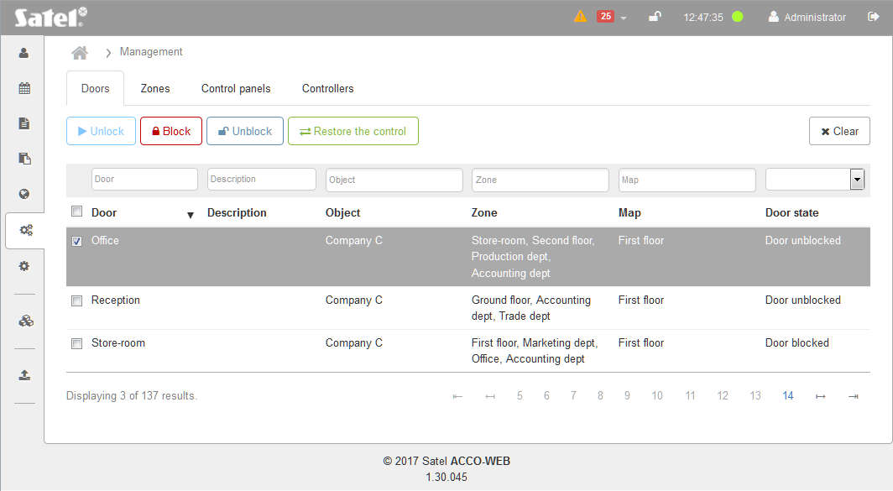
Fig. 82. “Doors” tab on the “Management” page.

Description – description of the controller.
Object – name of the object in which the controller is located.
Zone – name of the zone to which the controller is assigned.
Map – name of the map on which the door supervised by the selected controller has been put.
Door state – information on the current status of the door supervised by the selected controller.
You can click on a column name to sort the controller data by the column name.
If the list of controllers is too long to fit on one page, buttons are displayed to allow you to navigate through the pages.

Filtering door supervision controllers
The fields above column names allow filtering of the list.
Door – click on the field, enter the name of door supervision controller you want to find and press ENTER.
Description – click on the field, enter the text describing the controller you want to find and press ENTER.
Object – click on the field to display the list of objects. You can enter the object's name in whole or in part to further filter the list. You can select one, several or all objects. Press ENTER.
Zone – click on the field to display the list of zones. To further filter the list, enter the zone name in whole or in part. You can select one, several or all zones. Press ENTER.
Map – click on the field to display the list of maps. To further filter the list, enter the map name in whole or in part. You can select one, several or all maps. Press ENTER.
[door state] – click on the field to display the list of possible door statuses. Select one of them and press ENTER.
If you clear the filter, the fields under the column names will go blank and the full list of controllers supervising the doors will be displayed.

Fig. 70. “Doors” tab on the “Management” page.

“Zones” tab
Buttons
Unlock – click to unlock the door(s) in selected zones.
Block – click to permanently lock the door(s) in selected zones.
Unblock – click to permanently unlock the door(s) in selected zones.
Restore the control – click to restore the control of door(s) in selected zones.
Clear – click to remove the filter and display the list of all zones (see: “Filtering zones”).

Table with list of zones

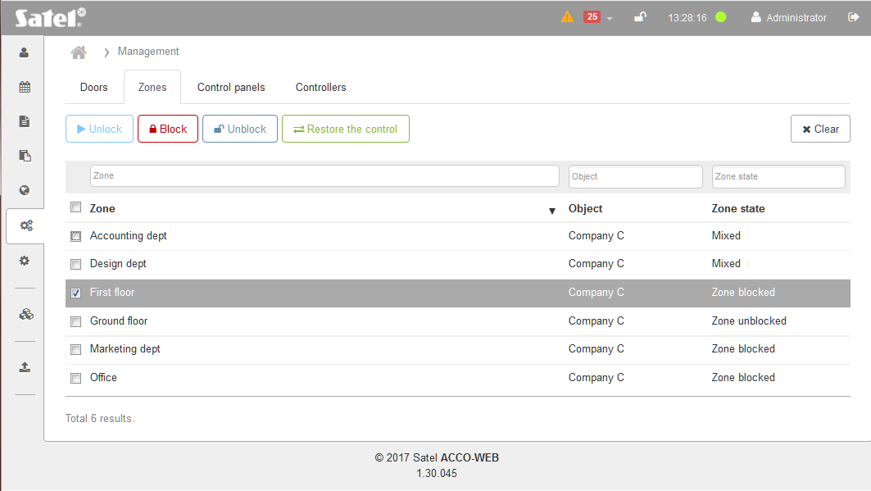
Fig. 83. “Zone” tab on the “Management” page.

Zone – individual zone name. To select a zone, check the box next to the zone name.
If you want to select all zones, check the box next to the “Zone” header.
Object name – name of the object in which the zone is located.
Zone state – information on the current status of the zone.
Click on a column name to sort the zone data by the column name.

Filtering zones
The fields above column names allow filtering of the list. Click on the field and enter:
Zone – click on the field, enter the name of zone you are searching for and press ENTER.
Object name – click on the field to display the list of objects. You can enter the object's name in whole or in part to further filter the list. You can select one, several or all objects. Press ENTER.
Zone state – click on the field to display the list of possible zone statuses. Select one of them and press ENTER.
If you clear the filter, the fields under the column names will go blank and the full list of zones will be displayed.

“Control panels” tab

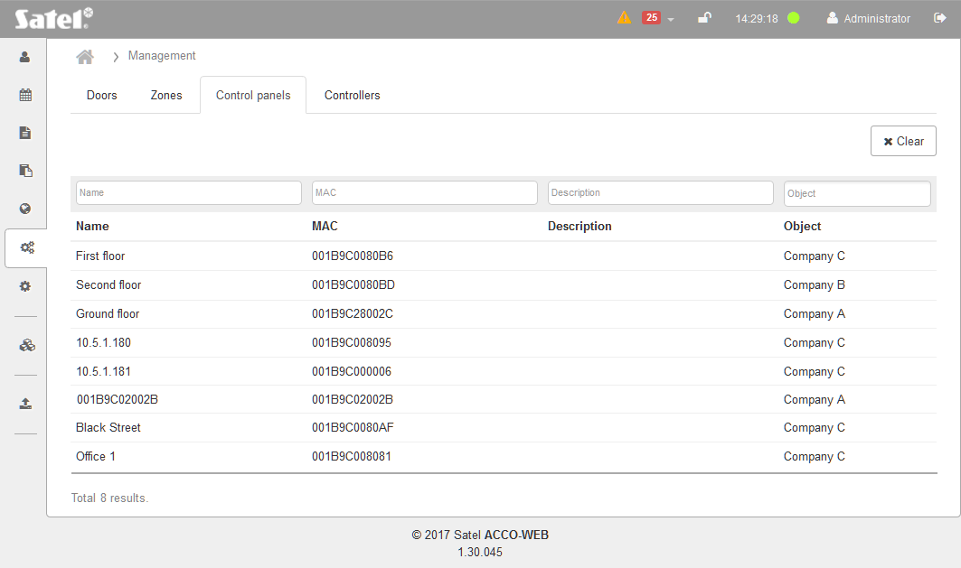
Fig. 84. “Control panels” tab on the “Management” page.

Buttons
Clear – click to remove the filter and display the list of all control panels (see: “Filtering control panels”).

Table with the list of control panels
Name – individual name of the control panel. Click on it if you want to open the page with information on the current status of the control panel and supply (see: “Control panel status”).
MAC – identification number of the Ethernet (MAC) network card of control panel. Click on it if you want to open the page with information on the current status of the control panel and supply (see: “Control panel status”).
Name – individual name of the control panel.
Description – description of the control panel.
Object name – name of the object to which the control panel is assigned.
You can click on a column name to sort the control panel data by the column name.

Filtering control panels
The fields above column names allow filtering of the list. Click on the field and enter:
Name – click on the field, enter the name of the control panel you want to find and press ENTER.
MAC – click on the field, enter the identification number of the Ethernet (MAC) network card of the control panel you want to find and press ENTER.
Name – name of the control panel you want to find and press ENTER.
Description – click on the field, enter the description of the control panel you want to find and press ENTER.
Object name – click on the field to display the list of objects. You can enter the object's name in whole or in part to further filter the list. You can select one, several or all objects. Press ENTER.
If you clear the filter, the fields under the column names will go blank and the full list of control panels will be displayed.

Control panel status
The page displays control panel data, including the name, MAC, description, firmware version, its build date, as well as information on the control panel supply status, including the voltage and current strength values. Additional icons / buttons indicate:
- status of communication between control panel and ACCO Server:
– green color – communication OK,
– black color – no communication;
- control panel troubles.
The icons have the following meaning:
- – everything OK (white symbol on green background),
- – click to acknowledge the trouble (white exclamation mark on red background),
- – trouble acknowledged (white exclamation mark on dark gray background),
- – click to acknowledge the trouble memory (white exclamation mark on orange background),
- – click to confirm the acknowledged trouble memory (white exclamation mark on dark gray background).

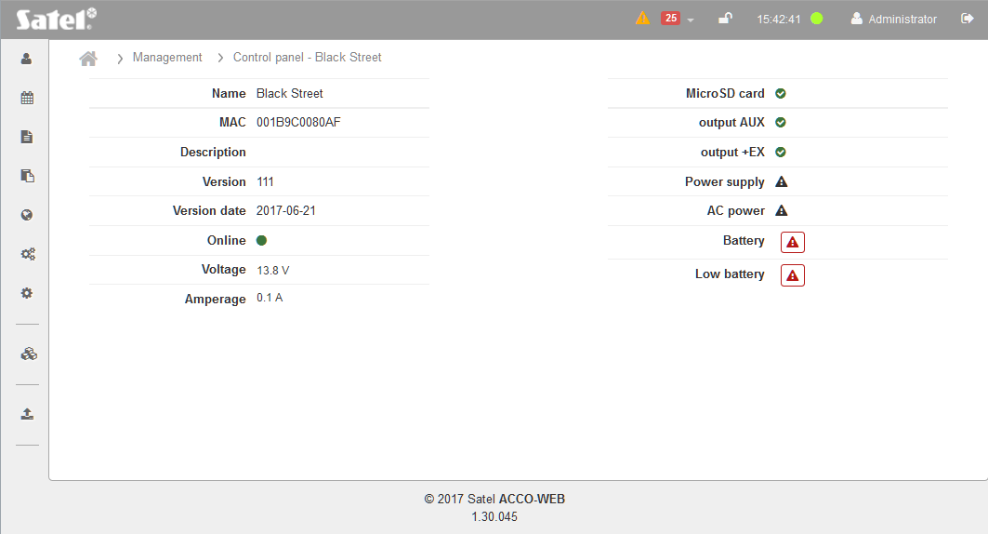
Fig. 85. An example of control panel status in “Control panels” tab on “Management” page.

“Controllers” tab
Buttons
Clear – click to remove the filter and display the list of all controllers (see: “Filtering controllers”).

Table with the list of controllers
Name – individual controller name. Click on it to go to the “Controller status” page.
Description – description of the controller.
Object – name of the object in which the controller is located.
You can click on a column name to sort the controller data by the column name.
If the list of controllers is too long to fit on one page, buttons are displayed to allow you to navigate through the pages.

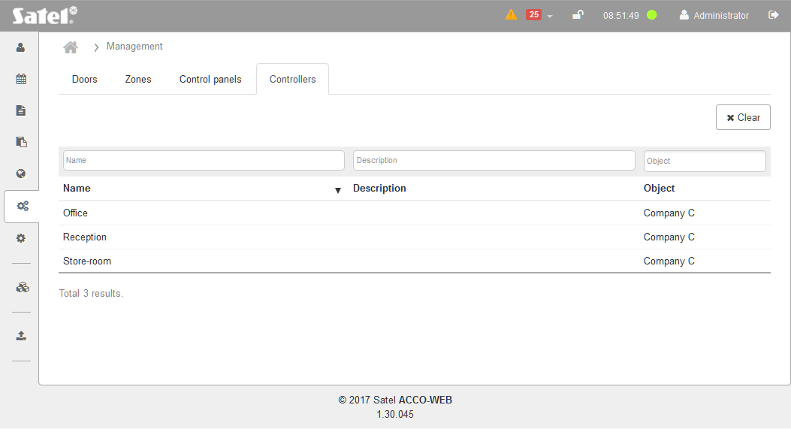
Fig. 86. “Controllers” tab on “Management” page.

Filtering controllers
The fields above column names allow filtering of the list. Click on the field and enter:
Name – click on the field, enter the name of the controller you want to find and press ENTER.
Description – click on the field, enter the description of the controller you want to find and press ENTER.
Object – click on the field to display the list of objects. You can enter the object's name in whole or in part to further filter the list. You can select one, several or all objects. Press ENTER.
If you clear the filter, the fields under the column names will go blank and the full list of controllers will be displayed.

Controller status
The page displays the following controller data:
- name,
- serial number,
- description,
- firmware version and build date,
- current value of the controller supply voltage,
- information on the communication quality (current percentage ratio between the amount of data sent from the control panel to the module and the amount of data received by the module from the control panel).
Additional icons indicate:
- controller alarms,
- controller troubles,
- emergency situations.
The icons have the following meaning:
- – no alarm / trouble (white symbol on green background).
- – click to acknowledge alarm / trouble (white exclamation mark on red background).
- – alarm / trouble acknowledged (white exclamation mark on green background).
- – click to acknowledge alarm / trouble memory (white exclamation mark on gray background).
- – click to confirm the acknowledged alarm / trouble memory (white exclamation mark on dark gray background).

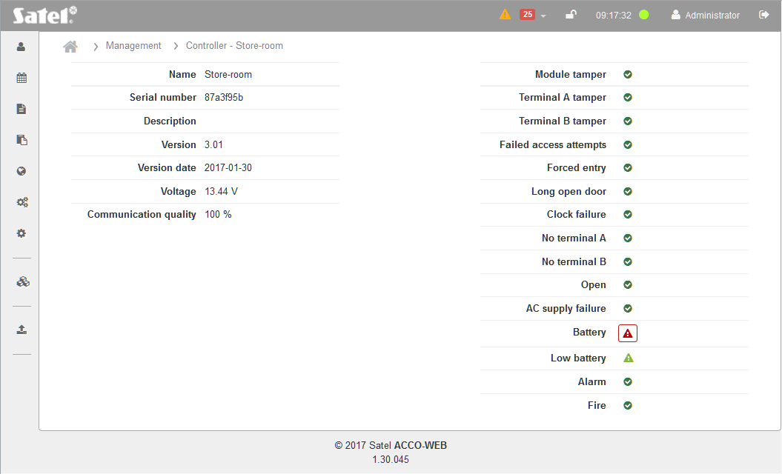
Fig. 87. An example of controller status in the “Controllers” tab, “Management” page.

Settings

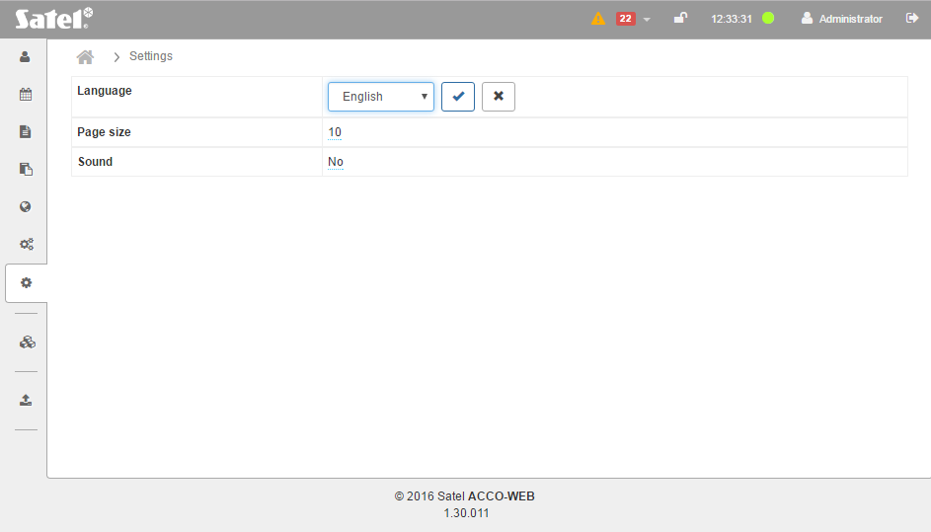
Fig. 88. The page for defining the settings of the application.

Language – you can select language of the application.
Page size – you can define the number of items displayed on one page in all lists and tables of the application. You can set a value from 5 to 100.
Sound – you can enable / disable audible signaling of troubles and alarms.

Editing parameters
- Click on a parameter and then on the drop-down menu symbol.
- Select the required value and click on .
- Click on “System operations” →“Save changes” in the menu on the left side to save the changes made.
When editing parameters, the following icons are available:
– click to confirm the entered data.
– click to end editing without changing any data.
– click to delete the value from the field.

Programs
The ACCO-WEB application enables the Administrator to update the programs:
ACCO-NT Conf – program for configuration of network settings of access control panel (see: ACCO-NT control panel installer manual),
ACCO Soft – system configuration program (see: ACCO Soft program user manual).
- Click “Programs” in the menu on the left side of the screen. Links to the installation files of ACCO-NT Conf and ACCO Soft programs will be displayed.
- Click on the selected program link and save the installation file to disk.
- Run the installation file and follow the prompts that will be displayed.

System operations
Click “System operations” in the menu on the left side. Two functions will be displayed:
Save changes – click to save the changes you made.
Undo changes – click to cancel all changes that have been made since the last saving.



ACCO-WEB
Internet Application
for management and remote operation of
ACCO NET access control system
User Manual

acco-web_en 04/17

SATEL Sp. z o.o.
ul. Budowlanych 66
80-298 Gdańsk
POLAND
tel. + 48 58 320 94 00
www.satel.eu
druk:
70,71,0,69,68,1,2,67,66,3,4,65,64,5,6,63,62,7,8,61,60,9,10,59,58,11,12,57,56,13,14,55,54,15,16,53,52,17,18,51,50,19,20,49,48,21,22,47,46,23,24,45,44,25,26,43,42,27,28,41,40,29,30,39,38,31,32,37,36,33,34,35

