Before you start programming, please read carefully this manual in order to avoid mistakes that can lead to malfunction or even damage to the equipment.

SATEL aims to continually improve the quality of its products, which may result in changes in their technical specifications and software. Current information about the changes being introduced is available on our website.
Please visit us at:
https://support.satel.pl

Hereby, SATEL sp. z o.o. declares that the radio equipment type PERFECTA 64 M is in compliance with Directive 2014/53/EU. The full text of the EU declaration of conformity is available at the following internet address: www.satel.pl/ce

Service code: 12345

The following symbols may be used in this manual:
 - note,
 - caution.

CONTENTS
1. Introduction 3
2. Programming from the keypad 3
2.1 Starting the service mode 3
2.2 Starting the service mode “from pins” 3
2.3 Service mode indication 4
2.4 Navigating through the menu and running functions 4
2.4.1 Using the arrow keys 4
2.4.2 Using the number shortcuts 4
2.5 Data editing 5
2.5.1 Selection from the single-choice list 5
2.5.2 Selection from the multiple-choice list 5
2.5.3 Entering decimal values 5
2.5.4 Entering hexadecimal values 5
2.5.5 Programming telephone numbers 6
2.5.6 Entering names 6
2.6 Hiding the service mode 6
2.7 Exiting the service mode 6
3. Programming in the PERFECTA Soft program 6
3.1 Description of the PERFECTA Soft program 7
3.1.1 Menu bar in the PERFECTA Soft program 7
3.1.2 Side menu 9
3.1.3 Additional menu 9
3.2 Establishing connection between the program and the control panel 12
3.2.1 Local connection 12
3.2.2 Remote connection: SATEL server 13
3.2.3 Remote connection: PERFECTA>>PERFECTA Soft 13
4. Hardware 14
4.1 Mainboard 14
4.2 GSM phone 18
4.3 Keypad 20
4.3.1 State display 25
4.4 ABAX°2 wireless system controller 27
4.4.1 Specific character of the operation of ABAX 2 wireless devices 32
4.5 Keyfobs module 35
4.6 Zone module 35
4.7 Output module 36
4.8 Proximity card arm/disarm device 37
5. Partitions 38
5.1 Partition settings 38
6. Zones 39
6.1 Zone settings 40
6.2 Zone types 42
6.3 Wireless detector [MICRA] 43
6.3.1 MICRA wireless detector and zone settings 43
7. Outputs 43
7.1 Output functions 44
7.2 Output settings 45
7.3 Quick control of outputs 46
7.4 MSP-300 siren 46
8. Communication 47
8.1 SATEL server 47
8.2 Direct connection to PERFECTA Soft 48
9. Reporting 48
9.1 Reporting settings 48
9.1.1 Station 1 / Station 2 49
9.1.2 Test transmissions 51
9.1.3 Events selection 52
10. Messaging 52
10.1 Messaging settings 52
10.1.1 Phones 52
10.1.2 AUDIO messaging 53
10.1.3 AUDIO messages 53
10.1.4 SMS messaging 54
11. SMS control 54
11.1 SMS control settings 55
12. Thermostats 55
12.1 Thermostat settings 56
12.1.1 Rules for programming the thermostat settings 57
13. Timers 57
13.1 Timer settings 58
13.1.1 Rules for programming the timer settings 59
14. Control panel firmware update 59
14.1 Local update 59
14.2 Remote update 59
14.2.1 Remote update settings 60
14.2.2 Procedure of remote update for control panel firmware 61
15. Users 61
15.1 User list 61
15.1.1 Adding a user 62
15.1.2 Deleting a user 62
15.1.3 Adding a proximity card 62
15.1.4 Deleting a proximity card 63
15.2 User schedules 63
15.2.1 User schedule settings 64
15.3 Keyfobs 65
15.3.1 Adding a keyfob 66
15.3.2 Deleting a keyfob 67
15.3.3 Default keyfob settings 67
16. Restoring the factory settings 67
16.1 Restoring factory settings from keypad 68
16.2 Restoring factory settings from PERFECTA Soft program 68
17. Manual update history 68

Introduction
You can configure the PERFECTA M alarm system by using:
- a computer running the PERFECTA Soft program (locally or remotely),
- a keypad.
You can configure all the settings in the PEFECTA Soft program. Not all settings can be configured using the keypad.
The control panel can be configured when the Active option is enabled in the Service access submenu (see: User manual).
As required by the standards, the service access after completion of the installation has to be limited by the administrators.
Names of parameters and options from the PERFECTA Soft program are used in this manual. At the description of each parameter or option, you will find one of the following data in square brackets:
- name of the function which is used for programming a parameter or option on the keypad,
- name of a parameter or option from the keypad.

Programming from the keypad
The functions used for programming the alarm system settings are available in the service mode menu.
The following manual includes instructions on how to use the wired PRF-LCD keypad and the wireless PRD-LCD-WRL / PRF-LCD-A2 keypad. The other keypads have:
- different key types (in touchscreen keypads the keys are available only when the terminal is displayed),
- different LED indicators or no LEDs at all (in the INT-TSH2 keypad there are status icons instead of LEDs).
If you bear in mind the differences, you can use those keypads to configure the system.
When the control panel is running in service mode, tamper alarms are not generated.

Starting the service mode
- Enter the service code (by default: 12345) and press . User menu appears.
- Press .
- When the cursor shows the Service mode function, press . Service menu will be displayed (the cursor will show the End SM function).

Starting the service mode “from pins”
If entering the service mode in the normal way is not possible (the control panel does not support keypads, does not accept the service code, etc.), you can use the emergency procedure, so-called, starting “from pins”.
- Power off the control panel (first disconnect the AC power, and then the battery).
- Put a jumper on the RESET pins on the control panel mainboard.
- Power on the control panel (first connect the battery and then the AC power).
- Wait a few seconds (until LEDs next to the RESET pins stop flashing) and remove the jumper from the RESET pins. The control panel will enter the service mode. The service mode menu will be displayed on the wired keypad with the lowest address.
If there is no wired keypad in the alarm system or there is no communication with the wired keypads (e.g. when the communication bus is shorted), you can get access to the service mode menu from the wireless keypad with the lowest address. Press any key on this keypad within 30 seconds of removing jumper from the RESET pins.
The service mode menu will not be displayed, if the Disable Service Mode option is enabled in the control panel. The “Factory settings ? 1=Yes” message will be displayed on the keypad with the lowest address. You can press  to restore the factory default settings. The service mode menu will not be displayed until the factory settings are restored.

Service mode indication
The service mode is indicated on the keypads by the  LED. The LED is steady ON on the keypad on which the service mode menu is displayed, and is flashing on the other keypads. Additionally, the service mode can be signaled audibly, after the appropriate option is enabled.

Navigating through the menu and running functions
To navigate throughout the menu, you can use the arrow keys or number shortcuts. You can also combine the two methods. The cursor shows the submenu you can enter / function you can run.

Using the arrow keys
- Use the  or key to find the required submenu.
- Press  or to open a submenu (use the  key to go back to the main menu).
- Repeat the steps 1 and 2 until the required function is found.
- Press or to run the function.

Using the number shortcuts
Submenus and functions are numbered (you can find the numbers in the List of service functions document).
- Use the number keys to enter the number (use the key to erase the last digit).
- The menu item designated by this number will be displayed (use the key to go back to the main menu).
- Press or to open a submenu or run a function.
If the cursor indicates End SM and you want to quickly run a function, enter its number and press or . For example, to run the device identification function, press successively  .
If the cursor indicates an item different from End SM, any digit you enter will be added at the end of the number by which the item displayed in the menu is designated. New digits are always added at the end of the number displayed (only the End SM function is not numbered). For example, if the cursor indicates a menu item with the 31 (31.EOL) number, pressing  in turn will display the 3132 (3132.Zn.32 EOL) item, not the 32 (32.Sensitivity) item. To display the 32 (32.Sensitivity) item, you should press (to move the cursor down) or (to erase 1 and add 2).
If you remember the submenu/function number and you want to avoid mistakes, press before entering the number.

Data editing
The editing method depends on the type of data. Having completed the editing, press to save the changes. If you want to exit the function without saving the changes, press .

Selection from the single-choice list
In the lower line of the display, the currently selected item is presented. You can scroll the list using the and keys.

Selection from the multiple-choice list
In the lower line of the display, one of the items you can choose from is presented. You can scroll the list using the and keys. The following symbol is situated in the upper right corner of the display:
– displayed item is selected / option is enabled,
– displayed item is not selected / option is disabled.
Press any number key to change the currently shown symbol for another one.
Press or to enter the graphic mode.

Graphic mode
In the graphic mode you can see on the display the state of up to 32 items simultaneously. These can be zones, outputs, options, etc. The state is represented by the same symbols as in the basic mode. No symbol means that this item is unavailable and cannot be edited. The numbers around the display will help you identify the item. For items 33-64, the cursor is the flashing symbol. This makes it easier to recognize which items are displayed.
Use the or key to move the cursor. When the cursor is on the item you want to edit, press any number key. A different symbol will be displayed.
In the graphic mode you can quickly change the status of all available items:
- if you press  3 times within 3 seconds, the symbol will be displayed for all items,
- if you press 3 times within 3 seconds, the symbol will be displayed for all items,
- if you press 3 times within 3 seconds, you will switch all the items to the opposite state (all the symbols will switch to , and the symbols will switch to ).
If you press when the cursor is on the last available item, the state of the next 32 items will be displayed. If you press when the cursor is on the first available item, the state of the previous 32 items will be displayed.
Press or to exit the graphic mode and return to the basic mode.

Entering decimal values
To enter digits, use the number keys. Use the and keys to move the cursor. In some functions, the key deletes the character on the left side of the cursor.

Entering hexadecimal values
To enter digits, use the number keys. To enter the A, B and C characters, use the key, and to enter D, E and F, use the key (keep pressing the key until the required character appears). Use the and keys to move the cursor. The key deletes the character on the left side of the cursor.

Programming telephone numbers
To enter digits, use the number keys. To enter the +, *, # characters, use the key (keep pressing the key until the required character appears). Use the and keys to move the cursor. The key deletes the character on the left side of the cursor.

Entering names
The characters that can be entered by using the keys are presented in Table 1. Keep pressing the key until the required character appears. Long press the key to display the digit assigned to it.
Shown on the right side in the upper line of the display is information about the letter case: [ABC] or [abc] (it will be displayed after pressing any key and will be visible for a few seconds after the last keystroke).
Use the and keys to move the cursor. The key deletes the character on the left side of the cursor.

Key | Characters available after next keystroke
 | ! | ? | ' | ` |  | " | { | } | $ | % | & | @ | \ | ^ | | |  | # | 1
 | a | b | c | 2
 | d | e | f | 3
 | g | h | i | 4
 | j | k | l | 5
 | m | n | o | 6
 | p | q | r | s | 7
 | t | u | v |  |  |  |  |  |  |  |  | 8
 | w | x | y | z | 9
 |  | . | , | : | ; | + | - |  | / | = | _ | < | > | ( | ) | [ | ] | 0
Table 1. Characters available when entering names. The upper case letters are available under the same keys (to change the letter case, press ).

Hiding the service mode
You can hide the service mode by using the 09.Hide SM function. The control panel will remain in the service mode, but the service mode menu will not be displayed. The function can be useful e.g. when you have to leave the keypad, but you want to prevent unauthorized personnel from getting access to the service menu in the meantime. To get access to the menu again, proceed in the same way as when entering the service mode.

Exiting the service mode
Keep pressing until the cursor indicates the SM end function, and then press .

Programming in the PERFECTA Soft program
You can download the PERFECTA Soft program from the www.satel.pl website.
Required program version: 2.00 (or newer).
Communication between the program and the control panel is encrypted. The control panel can be programmed locally or remotely. Remote programming is only possible after the cellular communicator settings have been configured (see “GSM phone” p. 18).

Description of the PERFECTA Soft program
Access to the program can be password protected (see ““Configuration” window” p. 12).

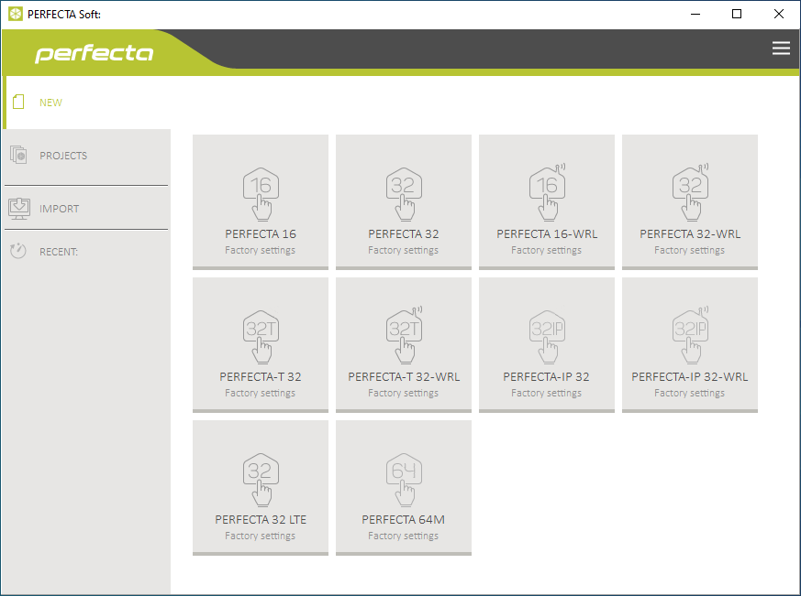
Fig. 1. PERFECTA Soft window when the program is run for the first time.

Menu bar in the PERFECTA Soft program
The menu bar is displayed in the top part of the program window. Appearance of the menu bar depends on the contents presented in the window.

Menu bar in the “Projects” tab

Fig. 2. Appearance of the menu bar when the “Projects” tab is displayed.

The search field is displayed on the menu bar. If you want to find a project file, click on the search field and start entering characters. The current view will be filtered out, based on the text entered.

Buttons
click, if the files are to be sorted by name (the arrow next to the button indicates whether the files from A to Z or from Z to A are displayed)
click, if the files are to be sorted by the time they were saved to disk (the arrow next to the button indicates whether the files are displayed in the descending or ascending order)
click, if the information about files is to be presented in brief version
click, if the information about files is to be presented in full version
click to display additional menu.

Appearance of the menu bar when displaying the control panel data

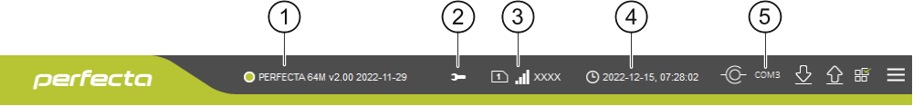
Fig. 3. Appearance of the menu bar after establishing connection with the control panel.

 type of alarm control panel and firmware version.
 icon displayed when the control panel is running in the service mode.
 information about the SIM card used, cellular signal level and operator of the cellular network used by the control panel communicator.
 date and time according to the control panel clock.
 information on the way of communication with the alarm control panel:
COMn [n – number of computer COM port] – local connection,
TCP – remote connection (data transmission via cellular network).

Buttons
click to display the list of troubles. The button is shown when the control panel is indicating a trouble or trouble memory.
click to write computer clock time to the control panel.
click to establish connection to the control panel. The button is displayed when the program is not connected to the control panel.
click to finish connection to the control panel. The button is displayed when the program is connected to the control panel.
click to read data from the control panel.
click to write data to the control panel.
click to display information on the status of partitions, zones, outputs etc. The button is active after connection to the control panel is established.
click to display additional menu.

Side menu
The side menu is displayed on the left side of the program window. Appearance of the menu depends on the contents presented in the window.

The side menu before the control panel data are displayed
New – click to display the “New” tab.
Projects – click to display the “Projects” tab.
Import – click to import the file with control panel settings.
Recent – the list of recently opened files. Click on the name of the file to open it.

“New” tab
The tab displays the files with default settings of the PERFECTA series control panels.

“Projects” tab
The tab displays the files saved to the computer disk, containing data of the PERFECTA series control panels.

The side menu after the control panel data are displayed
After the file with control panel data is opened or connection with the control panel is established, the side menu will display buttons which open the tabs used for configuration of the control panel settings.

Additional menu
The additional menu is displayed after you click on . Appearance of the menu depends on the contents presented in the window.
Open – click to display the “Projects” tab.
Save – click to save the control panel data to the computer disk.
Export – click to export the file with control panel data.
Convert – click to convert the control panel data for the needs of another PERFECTA LTE control panel.
Connection – click to open the “Connection” window.
Configuration – click to open the “Configuration” window.
About – click to display information about the PERFECTA Soft program.
Licence agreement – click to show the license agreement.

“Connection” window
In the window, you can choose how connection with the control panel is to be established:
- if the control panel is to be programmed locally from the computer connected to the RS-232 (TTL) port on the control panel, select “Local connection”,
- if the control panel is to be programmed remotely (data transmission via cellular network) by using the SATEL server, select “Remote connection: SATEL server”,
- if the control panel is to be programmed remotely (data transmission via cellular network), but the control panel is to connect directly to the program, select “Remote connection: PERFECTA>>PERFECTA Soft”.

Local connection

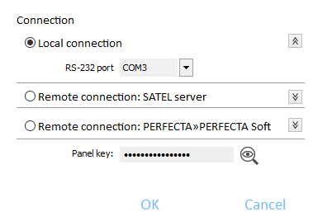
Fig. 4. “Connection” window: local connection settings.

RS-232 port – COM port of the computer through which communication with the RS-232 (TTL) port of the control panel is to take place.
Panel key – identifier of the control panel. It must be identical to that programmed in the control panel (see p. 47).

Remote connection: SATEL server

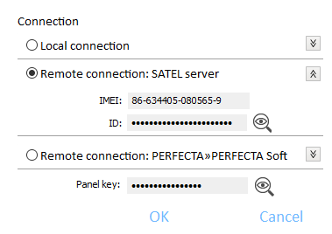
Fig. 5. “Connection” window: settings for establishing connection through SATEL server.

IMEI – individual identification number of the control panel cellular communicator.
ID – individual identification number of the control panel for the purposes of communication through the SATEL server (see: p. 47).
To check the IMEI number and ID number on the keypad, use the 7.IMEI/ID function (enter the user menu and press in turn).
If the control panel was programmed locally before, the IMEI number and ID number will be read from the control panel data.
If the control panel was previously used in another alarm system, delete the old ID number. To do so, you can use the 6.ID change user function if the control panel is connected to the SATEL server. After the old ID number is deleted, a new one will be assigned to the control panel. PERFECTA Control applications which use the old ID will not be able to connect to the control panel.
Panel key – identifier of the control panel. It must be identical to that programmed in the control panel (see p. 47).

Remote connection: PERFECTA>>PERFECTA Soft
TCP/IP port – number of the TCP port used for direct communication between the control panel and the computer with PERFECTA Soft program via cellular network (data transmission).
Panel key – identifier of the control panel. It must be identical to that programmed in the control panel (see p. 47).

Common settings
Panel key – identifier of the control panel. It is used for all connection methods. It must be identical to that programmed in the control panel (see p. 47).

Buttons
OK – click to confirm the changes.
Cancel – click to close window without saving changes.

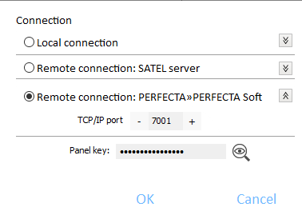
Fig. 6. “Connection” window: settings for direct connection via cellular network.

“Configuration” window

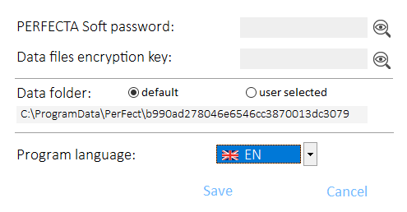
Fig. 7. “Configuration” window.

PERFECTA Soft password – if you want to protect the program against unauthorized access, you can enter the password.
Data files encryption key – if you want the files saved to disk to be additionally encrypted, enter the file encryption key. Opening the files in another PERFECTA Soft program without entering the valid key will be impossible.
Data folder – you can choose whether the control panel data files are to be saved to the default folder or a folder selected by you.
Program language – you can select a program language. The program will restart after the language is changed

Buttons
Save – click to save changes.
Cancel – click to close window without saving changes.

Establishing connection between the program and the control panel
Establishing connection is possible, if an identical Panel key has been programmed in the control panel and in the program, except for the control panel with factory settings.

Local connection
- Connect the control panel RS-232 (TTL) port with the computer port (for example, by means of the USB-RS converter offered by SATEL).
- Open the file with control panel data (the file with default settings (“New” tab) or the file saved on the computer disk (“Projects” tab)).
- Configure the settings required to establish local connection (see ““Connection” window” p. 9).
- Click on the menu bar.
- A window will open with information that connection has been established and a prompt to read the data.
- Click “Yes”.

Remote connection: SATEL server
The PERFECTA Soft conn. via SATEL server allowed option must be enabled in the control panel (see “SATEL server: p. 48). By default, this option is disabled.
- Open the file with control panel data (the file with default settings (“New” tab) or the file saved on the computer disk (“Projects” tab)).
- Configure the settings required to establish connection via cellular network through the SATEL server (see ““Connection” window” p. 9).
- Click on the menu bar.
- A window will open with information that connection has been established and a prompt to read the data.
- Click “Yes”.

Remote connection: PERFECTA>>PERFECTA Soft
The computer running the PERFECTA Soft program must have a public IP address.
- Open the file with control panel data (the file with default settings (“New” tab) or the file saved on the computer disk (“Projects” tab)).
- Configure the settings required to establish direct connection via cellular network (see ““Connection” window” p. 9).
- Click on the menu bar.
- The program will wait for connection being established by the control panel. The control panel will make an attempt to establish connection after starting the function from the keypad or receiving an SMS message.

Establishing connection after the function is started from the keypad
Address of the computer running the PERFECTA Soft program and the number of port used for communication must be programmed in the control panel (see “Direct connection to PERFECTA Soft” p. 48).
- Ask the authorized user to start the PERFECTA Soft function (the function is available in user menu).
- After the control panel connects to the computer, a window will open with information that connection has been established and a prompt to read the data.
- Click “Yes”.

Establishing connection after receiving SMS message
A control command, after receiving of which the control panel will make an attempt to establish connection, must be programmed in the control panel (see “Direct connection to PERFECTA Soft” p. 48).
The SMS message can be sent from a phone whose number is saved on the control panel (see “Phones” p. 53).
- Send an SMS message with the following content to the number of SIM card currently used by the control panel:
xxxx (xxxx – control command that initiates establishing connection with the PERFECTA Soft program) – the control panel is to connect to the computer whose address has been programmed in the control panel,
xxxx=aaaa:p= (xxxx – control command that initiates establishing connection with the PERFECTA Soft program; aaaa – address of the computer running the PERFECTA Soft program; p –TCP port) – the control panel is to connect to the computer whose address has been given in the SMS message and use for communication the TCP port given in the SMS message.
- After the control panel connects to the computer, a window will open with information that connection has been established and a prompt to read the data.
- Click “Yes”.

Hardware
The control panel has a built-in cellular communicator. To the control panel communication bus, you can connect additional devices that will be needed in the alarm system (keypads, ABAX 2 controller, zone modules, output modules, etc.). You can connect the PERFECTA-RF module to the control panel communication connector. If the ACU-220 / ACU-280 controller or the PERFECTA-RF module is connected to the control panel, wireless keypads can be installed in the system.

Mainboard

Clock
Dayligth saving time [061.DST] – the control panel can automatically adjust the clock settings due to a change from the summer time to the winter time and vice versa. The following correction schemes are available:
- no correction,
- according to the European Union rules,
- according to the United States' rules,
- correction by 1 hour according to dates,
- correction by 2 hours according to dates.
Summer time from [062.Summer from] / Winter time from [063.Winter from] – if the control panel clock is to be corrected by 1 or 2 hours according to dates, you should enter the dates (day, month) after the clock is changed to the summer time (moved forward) or to the winter time (moved back).
Clock correction [065.RTC adjust.] – if accuracy of the control panel clock is insufficient, its settings can be automatically corrected (by up to ±127 seconds per week).
When testing the clock for accuracy, the synchronization function must be disabled.

Time synchronization
NTP server [NTP server time] – if this option is enabled, the control panel clock is synchronized with the time server.
GSM network [GSM network time] – if this option is enabled, the control panel clock is synchronized with the time of cellular network operator.
If the NTP server and GSM network options are enabled at the same time, synchronization with the cellular network time has priority. The clock will only be synchronized with the time server if synchronization with the cellular network time fails.
Time zone [064.Timezone] – difference between the universal time (UTC) and the zone time. The parameter is required, if the control panel clock is to be synchronized.

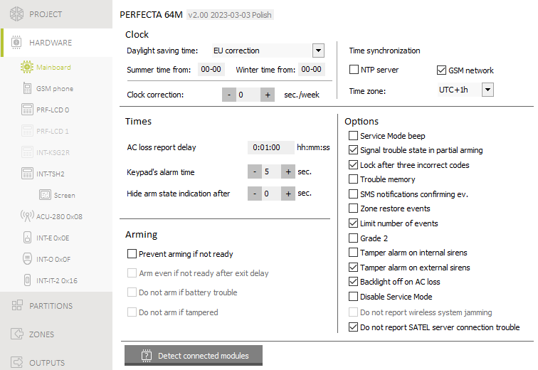
Fig. 8. “Mainboard” tab.

Times
AC loss report delay [123.Max.AC loss] – time during which the control panel must be without AC power before the AC power trouble is saved to the event log and reported to the monitoring station. If you program 0, AC power trouble will neither be saved to the event log nor reported to the monitoring station.
Keypad's alarm time [124.Al.duration] – duration of alarm signaling on keypads.
Hide arm state indication after [125.Suppr.arm] – time counted from the moment of partition arming, after which the LED on keypad indicating the partition armed status goes off. If value 0 is programmed, the LED will be ON always when the partition is armed.

Arming
Prevent arming if not ready [Check if ready] – if this option is enabled, the control panel will perform a check during arming for any problems that may prevent arming the system. These include:
- a zone with enabled Priority option is violated in the partition,
- the 3. Instant, 4. Double knock, 5. 24h Burglary, 7. 24h Panic, 8. 24h Panic silent, 9. 24 Medical or 10. 24h Fire type zone is violated in the partition,
- the 3. Instant, 4. Double knock, 5. 24h Burglary, 7. 24h Panic, 8. 24h Panic silent, 9. 24 Medical or 10. 24h Fire type zone or a zone with enabled Priority option is bypassed in the partition,
- there is a tamper in the partition,
- there is a trouble in the system.
The control panel checks the conditions twice:
before starting the arming procedure – the control panel will not start the arming procedure, if any problems occur (the keypad provides a forced arming option – see User manual),
after finishing the exit delay countdown – the system will not be armed (the arming procedure will end in failure), if there are any problems, which did not occur before starting the exit delay countdown.
If the option is enabled and a zone of the 0. Entry/Exit, 1. Entry/Exit final or 2. Internal type is violated at the moment the exit delay countdown expires and the partition is armed, a warning alarm will be triggered. If the partition is not armed after exit delay countdown expires, the warning alarm will not be triggered.
Arm even if not ready after exit delay [Arm ExDly w.trbl] – if this option is enabled, the control panel will not check conditions after finishing the exit delay countdown (it will only check the conditions before starting the arming procedure). The option is available, when the Prevent arming if not ready option is enabled.
Do not arm if battery trouble [BAT low = no arm] – if this option is enabled, forced arming will be impossible in the event of battery trouble. The option is available, when the Prevent arming if not ready option is enabled.
Do not arm if tampered [Tamper = no arm] – if this option is enabled, forced arming will be impossible in the event of tamper. The option is available, when the Prevent arming if not ready option is enabled.

Options
Service Mode beep [SM sounds] – if this option is enabled, the service mode will be audibly signaled on the keypad.
Signal trouble state in partial arming [Trbl.in part.arm] – if this option is enabled, the keypad does not indicate trouble after all partitions whose state is indicated by the keypad are fully armed. If the option is disabled, the keypad does not indicate trouble after just one of the partitions whose state is indicated by the keypad is armed in any mode. Depending on the keypad type, trouble is indicated by a LED or an icon.
Lock after three incorrect codes [3wrng.codes=blk.] – if the option is enabled, after entering an incorrect code three times, the keypad will be blocked for 90 seconds. Entering an invalid code again will prolong the locking.
Entering an invalid code three times may trigger alarm (cf. the keypad Alarm 3 incorrect codes option).
Trouble memory [Troubles memory] – if this option is enabled, the control panel will also provide information about troubles that do not exist anymore. You can clear the trouble memory by using keypad (when exiting the trouble review function), PERFECTA Soft program or PERFECTA CONTROL application. Additionally, the option affects the audible indication of trouble on the keypad:
- option disabled – the trouble is audibly indicated until restore,
- option enabled – the trouble is audibly indicated until review by using the 7.Troubles user function (the user must press to quit the function) or trouble memory clearing by using the PERFECTA Soft program or PERFECTA CONTROL application.
SMS notifications confirming ev. [Messaging events] – if this option is enabled, information about sending SMS notification is saved in the event log.
Zone restore events [Restore events] – when this option is enabled, information about zone restore is saved in the event log, if zone triggered alarm.
Limit number of events [Events limitat.] – if the option is enabled, events from the same source are saved into the event log 3 times only. This option does not apply to the alarms from zones.
Grade 2 [Grade 2] – if the option is enabled, the system operates in accordance with the EN 50131 standard requirements for Grade 2, i.e.:
- the keypad does not audibly signal alarms and troubles/troubles memory,
- the  LEDs on the keypad indicates alarms only after the user enters the code and presses ,
- the  LED on the keypad goes off after just one of the partitions is armed in any mode,
- the flashing LED in keypad means that there is a trouble in the system, some zones are bypassed, or there has been an alarm,
- the keypad does not display alarm messages,
- the keypad display cannot be switched over to the system preview mode,
- troubles cannot be viewed without entering the code (using the key).
- the quick arming from keypad (without entering the code) is not available,
- new access codes in the system must be composed of at least 5 digits,
- partial entering of the code is interpreted as entering an incorrect code,
- the keypad will be blocked after entering an incorrect code three times (cf. Block after three incorrect codes option),
- during arming, the control panel checks for problems that prevent arming (cf. Prevent arming if not ready option),
- Arm even if not ready after exit delay, Do not arm if battery trouble and Do not arm if tampered options are interpreted as disabled,
- control panel gives information about past troubles (cf. Trouble memory option),
- loss of communication with SATEL server will cause a trouble (cf. Do not report a SATEL server problem option),
- tamper of zone or expander can only be signaled by the external siren when the partition to which the zone or expander belong is armed,
- the number of alarms from the 7. 24h Panic and 8. 24h Panic silent zones is not limited (Auto-reset 3 option is ignored),
- arming is impossible, if the 6. 24h Tamper zone is violated (cf. Priority option),
- the warning alarm feature is enabled and the warning alarm is being signaled for at least 30 seconds (cf. Warning time),
- countdown of Entry delay, Delay and Delay activation time is running for up to 45 seconds,
- AC power loss will cause a trouble condition if it lasts longer than 10 seconds (it has no effect on the operation of the 19. Trouble status type output, which is activated immediately after AC power is lost),
- AC loss report delay can be up to 60 minutes.
Tamper alarm on internal sirens [Tmp.on int.siren] – if this option is enabled, the 1. Internal siren output is additionally activated after triggering tamper alarm.
Tamper alarm on external sirens [Tmp.on ext.siren] – if this option is enabled, the 1. External siren output is additionally activated after triggering tamper alarm.
Backlight off on AC loss [No AC=no bcklght] – if the option is enabled, the backlight in hardwired keypads is automatically switched off in case of 230 VAC power loss.
Disable Service Mode [Block SM] – if this option is enabled, the emergency procedure of entering the service mode (“from pins”) is not available (it can only be used if factory default settings of the control panel are restored).
Do not report a SATEL server problem [No SATEL trouble] – if this option is enabled, loss of communication with the SATEL server will not be reported.
Do not report wireless system jamming [No jamm. trouble] – if this option is enabled, jamming of the MICRA wireless system will not be reported. This option is available if the PERFECTA-RF module is connected to the control panel.

Buttons
Detect connected modules – click to identify the devices connected to the control panel’s communication bus and communication connector.

GSM phone

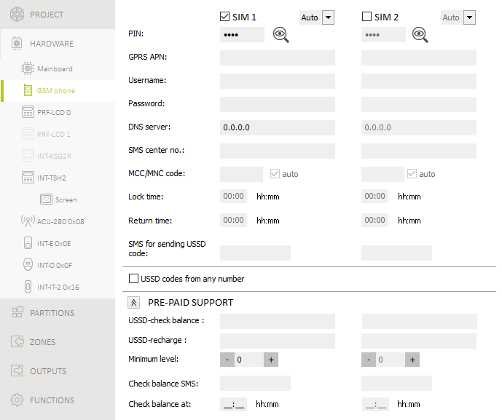
Fig. 9. “GSM phone” tab.

SIM 1 [SIM1] / SIM 2 [SIM2] – if this option is enabled, the given SIM card is supported by the control panel. Disable the option, if the given card is not to be used. Disabling the option will prevent unnecessary reporting of troubles related to that card.
[Preferred network type] – the type of network to which the SIM card is to log in:
Auto – 2G or 4G network (default settings).
2G – only 2G network.
PIN [612.PIN / 622.PIN] – PIN code of the SIM card.
If you enter a wrong PIN code, a trouble will be reported after using it. After 255 seconds the control panel will retry to use the PIN code. After the third attempt to use a wrong PIN code, the SIM card will be blocked. To unblock the card, enter the PUK code using the keypad (see User manual).
GPRS APN [613.APN / 623.APN] – access point name for Internet connection.
Username [614.USR / 624.USR] – user name for Internet connection.
Password [615.PWD / 625.PWD] – password for Internet connection.
DNS server [616.DNS / 626.DNS] – IP address of DNS server to be used by the control panel.
The Internet connection settings you can obtain from the cellular network provider.
SMS center no. [617.SMS centre / 627.SMS centre] – telephone number of the short message service center. It is used as a connecting link when sending SMS messages. If the number has been saved by the operator to the SIM card memory, it need not be programmed. Otherwise, if the control panel is to send SMS messages, it must be entered. The number must be suitable for the operator of network in which the SIM card is registered.
MCC/MNC code [618.MCC/MNC / 628.MCC/MNC] – codes of the operator of cellular network to which the SIM card is to log in. Enter in turn:
- MCC (Mobile Country Code) – country code,
- MNC (Mobile Network Code) – operator code.
If you enter no code, the control panel will log into the network of SIM card operator. Keep in mind that entering incorrect data may render logging into the cellular network impossible.
auto [Auto MCC/MNC] – if this option is enabled and the control panel cannot log into the cellular network of operator defined by means of the MCC/MNC code, it will log into the available cellular network.
Lock time [63.Block SIM1 / 65.Block SIM2] – the time during which switch-over to the other SIM card is impossible. The time is counted from the moment of switch-over to the given card. For reporting, the transmission paths programmed as subsequent ones, if they require switch-over to the other card, will be skipped during the lock time countdown. Entering the value 0 means that instant switch-over to the other SIM card is possible.
Return time [64.Restore SIM1 / 66.Restore SIM2] – the time after which the other SIM card is to be used. Entering the value 0 means that automatic switch-over to the other SIM card will not take place.
If two SIM cards are to be used, one of them must be treated as the priority card. It is recommended that return time equal to 0 be programmed for it.
SMS for sending USSD code [111.USSD SIM1 / 112.USSD SIM2] – control command that will be sent in the SMS message together with USSD code. The control panel will run the USSD code and send the response received from the operator to the phone number from which the SMS message with control command was sent. You can enter up to 8 alphanumeric characters (digits, letters and special characters). You can use spaces, but at least one character must be different from space.
It is not advisable to use the advanced functions available due to the USSD service if menu is presented in response to the entered code.
The command content must be different from that of the other control commands programmed in the control panel.
The control command for sending USSD codes can be used for sending SMS messages through the control panel.
USSD codes from any number [USSD any tel.] – if this option is enabled, the control command for sending USSD codes or checking balance of the SIM card account can be sent from any phone. If this option is disabled, only from the phone the number of which is saved on the control panel (see “Phones” p. 53).

Pre-paid support
USSD-check balance [681.USSDchkSIM1 / 682.USSDchkSIM2] – the USSD code which is used to check balance of the SIM card account. If the code has been programmed, the user can check e.g. the account balance by using keypad.
USSD-recharge [683.USSDtopSIM1 / 684.USSDtopSIM2] – the USSD code which is used to top up the SIM card account. If the code has been programmed, the user can top up the account by using keypad. Enter $ where the top-up code is to be entered.
Minimum level [685.Min.cr.SIM1 / 686.Min.cr.SIM2] – the minimum amount of funds on the SIM card account. If the amount of funds drops below the minimum level:
- trouble will be reported,
- where the SIM card account balance is checked automatically by the control panel, information on the account balance will be sent as an SMS message to the numbers of phones for which the SMS forw. option is enabled (see “Messaging” p. 52).
Check balance SMS [113.Chk.credit1 / 114.Chk.credit2] – the control command which can be sent in an SMS message to check the SIM card account balance. You can enter up to 8 alphanumeric characters (digits, letters and special characters). You can enter spaces, but at least one character must be different from the space.
The command content must be different from that of the other control commands preprogrammed in the control panel.
Check balance at [687.hh:mm SIM1 / 688.hh:mm SIM2] – time at which the control panel will check the SIM card account balance every day.

Keypad
Most of the information in this section applies to the PRF-LCD keypad. For description of the settings for the other keypads, please refer to the manuals of those keypads.
Name [28.Names] – individual name of the keypad (up to 16 characters).
Alarm in part. [22.Partitions] – the partition in which alarm will be triggered in the event of keypad tamper (opening of enclosure or loss of communication).

Options
Show partition 1 status [Show part.1] – if this option is enabled, the keypad indicates the status of partition 1 (display / LED indicators / audible signal).
LED set: I [I LED set part.1] – if you select this option, the I-labelled LEDs indicate the status of partition 1.
LED set: II [II LED set part1] – if you select this option, the II-labelled LEDs indicate the status of partition 1.
Show partition 2 status [Show part.2] – if this option is enabled, the keypad indicates the status of partition 2 (display / LED indicators / audible signal).
LED set: I [I LED set part.2] – if you select this option, the I-labelled LEDs indicate the status of partition 2.
LED set: II [II LED set part2] – if you select this option, the II-labelled LEDs indicate the status of partition 2.
Show partition 3 status [Show part.3] – if this option is enabled, the keypad indicates the status of partition 3 (display / LEDs / audible signal).
LED set: I [I LED set part.3] – if you select this option, the I-labelled LEDs indicate the status of partition 3.
LED set: II [II LED set part3] – if you select this option, the II-labelled LEDs indicate the status of partition 3.
Show partition 4 status [Show part.4] – if this option is enabled, the keypad indicates the status of partition 4 (display / LEDs / audible signal).
LED set: I [I LED set part.4] – if you select this option, the I-labelled LEDs indicate the status of partition 4.
LED set: II [II LED set part4] – if you select this option, the II-labelled LEDs indicate the status of partition 4.
Quick arm - partition 1 [Quickarm part.1] – if this option is enabled, the user can arm partition 1 from the keypad without using code.
Quick arm - partition 2 [Quickarm part.2] – if this option is enabled, the user can arm partition 2 from the keypad without using code.
Quick arm - partition 3 [Quickarm part.3] – if this option is enabled, the user can arm partition 3 from the keypad without using code.
Quick arm - partition 4 [Quickarm part.4] – if this option is enabled, the user can arm partition 4 from the keypad without using code.
Show code entering [Show code enter.] – if this option is enabled, entering the code is presented on the keypad display by asterisks.
Quick control [Quick control] – if this option is enabled, the users can control the outputs by using the number keys. The 15. Controlled outputs must be assigned to the keys (see: “Quick control of outputs” p. 47).
Key 7 - troubles review [Troubles review] – if this option is enabled, the user can view the troubles by pressing and holding the key for 3 seconds.
Key 8 - chime on/off [Chime on/off] – if this option is enabled, the user can turn on / off the CHIME signal by pressing and holding the key for 3 seconds.
Key 9 - change disp. mode [Disp.mode change] – if this option is enabled, the user can switch the keypad between the normal mode and the system preview mode by pressing and holding the key for 3 seconds.
Define the types of information to be displayed in the system preview mode. You can only do it in the PERFECTA Soft program (see: “State display” p. 25).
Alarm 3 incorrect codes [3 wrng codes al.] – if this option is enabled, entering incorrect code three times will trigger the alarm.

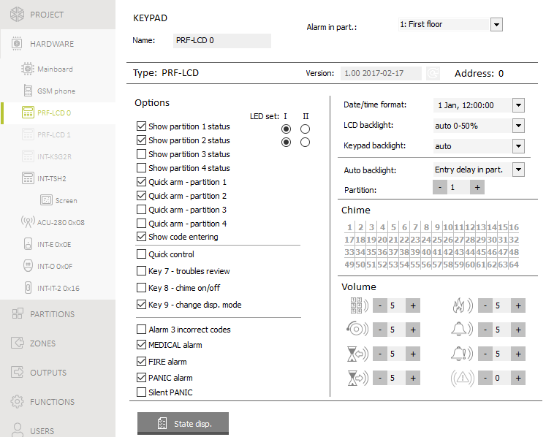
Fig. 10. PRF-LCD keypad settings.

MEDICAL alarm [Medical alarm] – if this option is enabled, the user can trigger a medical alarm by pressing and holding the key for 3 seconds.
FIRE alarm [Fire alarm] – if this option is enabled, the user can trigger a fire alarm by pressing and holding the key for 3 seconds.
PANIC alarm [Panic alarm] – if this option is enabled, the user can trigger a panic alarm by pressing and holding the key for 3 seconds.
Silent PANIC [Silent panic] – if this option is enabled, the panic alarm triggered from the keypad will be a silent one, i.e. the keypad will not indicate it, there will be no audible signal, but the alarm will be reported to the monitoring station. The silent panic alarm is useful when the control panel is sending events to the monitoring station, but unauthorized persons should not be aware of the alarm being triggered. The option is available, if the PANIC alarm option is enabled.

Display and keys
Date/time format [210.ClockFormat] – mode of presentation of time and date on the display.
LCD backlight [26.LCDbacklight] – mode of keypad display backlighting.
Keypad backlight [27.KEYbacklight] – mode of keypad keys backlighting.
Backlighting of the display and keys on the wireless keypad works differently than that on the wired keypad (see PRF-LCD-WRL keypad manual).
Auto backlight [29.Autolight] – if the backlight of display or keys goes on automatically, you can define whether and what event will additionally turn on the backlighting:
Not present – backlighting will be turned on only by pressing any key.
Zone violation – backlighting will be turned on additionally in the event of zone violation (select the zone) You can select zones 1-32 (zones 33-64 do not turn on backlighting).
Entry delay in part. – backlighting will be turned on additionally in the event of starting the entry delay countdown in the partition (select the partition).
If the entry delay in partition is to turn on backlighting, the keypad must indicate the partition status (see: options Show partition status and LED set).
If the LED set indicates the status of not only the partition you selected but of other partitions as well, backlighting will also turn on when the entry delay countdown is started in the other partitions.
The Auto backlight parameter is not available for the wireless keypad.

Chime
The keypad can audibly signal violation of selected zones.
The wireless keypad signals the CHIME from zones not more frequently than once every 30 seconds. In the inactive mode, the CHIME from zones is only signaled if Wake-up duration is different from 0.

Volume
[251.Keys] – volume level of the beeps generated during keypad operation (key pressing, confirmation of performed operation, etc.).
[252.Chime] – volume level of the beeps generated after zone violation (CHIME).
[253.Entry delay] – volume level of the entry delay signaling.
[254.Exit delay] – volume level of the exit delay signaling.
[255.Fire alarm] – volume level of the fire alarm signaling.
[256.Burg.alarm] – volume of the burglary, panic and medical (auxiliary) alarm signaling.
[257.Warn.alarm] – volume of the warning alarm signaling.
[258.New trouble] – volume of the trouble signaling.

Wireless keypad PERFECTA 32-WRL LTE
For the wireless keypad, additional settings are available.

PRF-LCD-WRL
Filter [1272.Filter] – the time counted from receiving of the transmission from the keypad. After it has elapsed and no other transmission is received, lack of communication with the keypad will be reported. You can enter 0 or hours from 1 to 48. If you enter 0, you will disable the device presence control.
Wake-up duration [213.Wake up] – maximum length of time for which the keypad can be woken up automatically (applies to the keypad powered by the batteries). If you enter a value different from 0:
- the keypad will be woken up automatically when entry or exit delay countdown has begun, the system has been armed, or alarm has been triggered,
- the CHIME from zones will also be signaled when the keypad is in the sleep mode.
If you enter 0, the keypad will not be woken up automatically.
If the Wake-up duration is different from 0, the keypad will be awaiting for transmissions with information on events. As a result, the energy consumption will be growing and the battery life will be considerably reduced.
The Wake-up duration is the maximum time, i.e. if the event signaling takes less time, the sleep mode will be resumed in the keypad earlier.
It may take a few seconds for the keypad to wake up after the event occurred.
Wireless keypad initial greeting [218.Connect msg] – message displayed on the PRF-LCD-WRL keypad after wake-up. The message is the same for all PRF-LCD-WRL keypads.

PRF-LCD-A2
Additional settings of the PRF-LCD-A2 keypad can only be configured in the PERFECTA Soft program.
Wake-up duration – maximum length of time for which the keypad can be woken up automatically (applies to the keypad powered by the batteries). If you enter a value different from 0:
- the keypad will be woken up automatically when entry or exit delay countdown has begun, the system has been armed, or alarm has been triggered,
- the CHIME from zones will also be signaled when the keypad is in the sleep mode.
If you enter 0, the keypad will not be woken up automatically.
If the Wake-up duration is different from 0, the keypad will be awaiting for transmissions with information on events. As a result, the energy consumption will be growing and the battery life will be considerably reduced.
The Wake-up duration is the maximum time, i.e. if the event signaling takes less time, the sleep mode will be resumed in the keypad earlier.
It may take a few seconds for the keypad to wake up after the event occurred.
Wireless keypad initial greeting – message displayed on the PRF-LCD-A2 keypad after wake-up. The message is the same for all PRF-LCD-A2 keypads.
Card reader – if this option is enabled, the card reader is supported.
If the card reader is not to be used, disable the Card reader option. This will reduce the keypad’s power consumption. If the keypad is powered by the batteries, this will prolong the battery life.
Presence control – if this option is enabled, the keypad presence is being monitored. If there is no transmission from the keypad for 20 minutes, missing keypad will be reported.

Buttons
 – click to add the wireless keypad.
 – click to delete the wireless keypad.

Proximity cards
Settings for using proximity cards are available for the PRF-LCD-A2 keypad.
Arming – methods to arm the system using the proximity card:
card read – if you select this option, the system will be armed when you bring the card close to the keys.
card hold-down – if you select this option, the system will be armed when you bring the card close to the keys and hold for about 3 seconds.
In the keypad service menu, use the Prox.card – arms option to define the method of arming with card (option enabled = card read; option disabled = card hold-down).
Card hold-down control outputs [216.Card c.out.] – outputs the user can control by using the proximity card. Bringing the card close to the keys and holding for about 3 seconds will switch the output. Select the 15. Controlled type outputs. It is possible to control the outputs using the proximity card if the card read arming method is selected.

State disp. – click to open the “State disp.” window.

State display

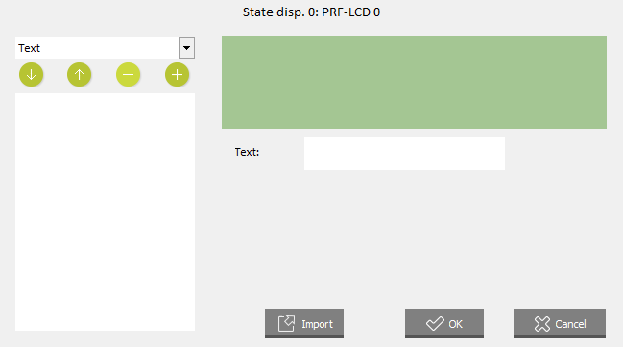
Fig. 11. “State disp.” window.

[Item] – in this field you can select the item you want to place on the display. Click to drop down the list of available items, then click the item you want to select. Click to add the selected item to the display.
Text – text of your choice.
Partition state – symbol that indicates the partition state. After you add the item, select the partition (click to drop down the list of partitions, then click the partition whose state is to be shown on the display).
Zone state – symbol that indicates the zone state. After you add the item, select the zone (click to drop down the list of zones, then click the zone whose state is to be shown on the display).
Output state – symbol that indicates the output state. After you add the item, select the output (click to drop down the list of outputs, then click the output whose state is to be shown on the display).
Temperature – information on temperature from an ABAX 2 wireless device. After you add the item:
- select the zone to which the ABAX 2 device is assigned (click to drop down the list of zones, then click the zone to which the ABAX 2 device is assigned),
- decide if the temperature is to be displayed in degrees Celsius or Fahrenheit.
Day (digit) – number of the day of the month made up of one or two digits.
Day (2 digits) – number of the day of the month made up of two digits (numbers 1-9 will be preceded by 0, e.g. 01).
Day of week – name of the day of the week abbreviated to three letters.
Month (digit) – number of the month made up of one or two digits.
Month (2 digits) – number of the month made up of two digits (numbers 1-9 will be preceded by 0, e.g. 01).
Month (name) – name of the month abbreviated to three letters.
Year (2 digits) – last two digits of the year.
Year (4 digits) – year in full.
Hour – number of hours made up of one or two digits.
Hour (2 digits) – number of hours made up of two digits (numbers 1-9 will be preceded by 0, e.g. 01).
Minutes – number of minutes made up of one or two digits.
Minutes (2 digits) – number of minutes made up of two digits (numbers 1-9 will be preceded by 0, e.g. 01).
Seconds – number of seconds made up of one or two digits.
Seconds (2 digits) – number of seconds made up of two digits (numbers 1-9 will be preceded by 0, e.g. 01).
colon (blinking) – blinking colon to separate items.
Keypad number – name given to the keypad.
Power measuring – information on the power consumption of the appliance connected to the ASW-200 smart plug. After you add the item, select the output to which the ASW-200 plug is assigned (click to drop down the list of outputs, then click the output to which the ASW-200 plug is assigned).
If you want to add space between the item, add the Text type item and enter space.
– click to move down the item selected in the field below ([List of displayed items]).
– click to move up the item selected in the field below ([List of displayed items]).
– click to delete the item selected in the field below ([List of displayed items]).
– click to add the item selected from the list above ([Item]). The item will be displayed in the field below ([List of displayed items]).
[List of displayed items] – list of items displayed in the system preview mode is presented in this field. The items are displayed in the same sequence as they are presented on the list (top to bottom). To change the sequence, use the and buttons.
[Display preview] – display preview shows how the items are arranged.
OK – click to confirm the changes and close the window.
Import – click to import system preview settings from another keypad.
Cancel – click to close the window without saving the changes.

ABAX°2 wireless system controller
The settings of the ABAX 2 wireless system controller (ACU-220 / ACU-280) and the ABAX 2 wireless devices can only be configured in the PERFECTA Soft program. The settings are stored in the controller. Before you make any changes, click on the “Read” button. To save the changes you made, click “Write”. The ABAX 2 controller and wireless devices settings are not read / saved when you click / on the menu bar.

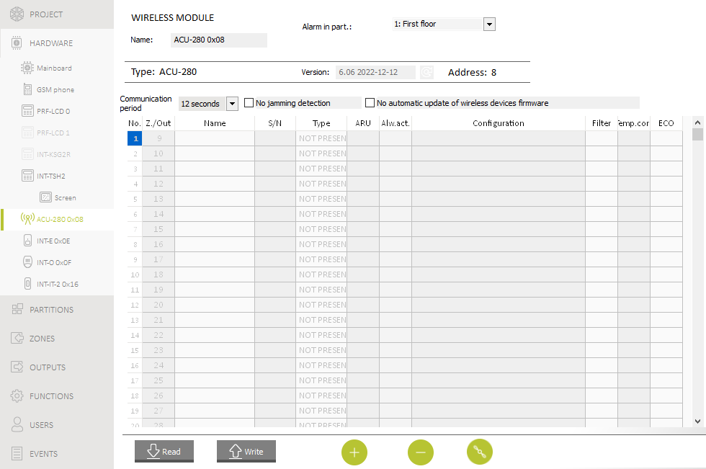
Fig. 12. Settings of the ABAX 2 system controller.

Name – individual name of the module (up to 16 characters).
Alarm in part. – partition where alarm will be triggered in the event of module tamper.
Communication period – time interval at which wireless devices are to communicate with the controller. You can select 12, 24 or 36 seconds. During periodical communication, the devices inform the controller about their status, and the controller sends commands to the devices (switches the detectors into active/passive mode, starts/ends test mode, changes configuration of the devices, etc.). The communication period has effect on the level of energy consumption by wireless devices. The less frequent is the communication, the lower is the energy consumption. For the battery-operated devices it means longer battery life. Moreover, when the communication takes place less frequently, more wireless devices can work within each other's operating range.
If you enable the ECO option for a wireless device, periodical communication between that device and the controller will take place every 3 minutes (the Communication period parameter will have no effect on the device operation).
Some information and commands need to be sent immediately. Therefore, additional communication takes place when the device reports tamper, when the detector reports alarm, etc.
No jamming detection – if this option is enabled, the controller will not detect radio communication jamming.
No automatic update of wireless devices firmware – if this option is enabled, the firmware of wireless devices registered in the controller is not updated automatically.

ABAX 2 wireless devices
The wireless keypads form a separate category of devices. A separate pool of positions is provided for them in the controller. Therefore, the keypads are not presented on the list of ABAX 2 wireless devices.
No. – position number on the list of devices in the controller.
Z./Out – number of the zone/output to which the wireless device is assigned.
Name – name of the zone to which the wireless device is assigned.
S/N – serial number of the wireless device.
Type – type of the wireless device.
ARU – parameter available for the wireless device, if the ARU-200 radio signal repeater is registered to the controller. It defines whether the device is to communicate with the controller directly or via the selected ARU-200 radio signal repeater (several ARU-200 radio signal repeaters can be registered to the controller).
Alw.act. – the option is available for most of the wireless detectors. If enabled, the detector is permanently switched over to the active mode.
The battery life time in the detectors switched permanently into the active mode is shorter than in those which are periodically switched to the passive mode.
Configuration – for some devices you can configure additional settings.
ACD-220 – wireless curtain detector.
Sensitivity – detection sensitivity. You can select: low, medium or high.
ADD-200 – wireless outdoor dusk and temperature detector. For the dusk detector you can configure:
Sensitivity – detection sensitivity. You can select a number from 1 to 16 (1 – minimum; 16 – maximum).
For the temperature detector you can configure the temperature threshold settings:
Temperature threshold – threshold type. You can select:
H – high (alarm when the temperature rises above the threshold temperature by a value equal to or higher than the tolerance),
L – low (alarm when the temperature drops below the threshold temperature by a value equal to or higher than the tolerance).
Temperature – threshold temperature. You can enter a value from -30°C to 70°C (with accuracy to 0.5°).
Tolerance – difference between the threshold temperature and the temperature at which the detector reports alarm. You can enter a value from 0.5°C to 10°C (with accuracy to 0,5°).
AGD-200 – wireless glass-break detector.
Sensitivity – detection sensitivity. You can select: low, medium or high.
AMD-202 – wireless magnetic contact with input for roller shutter detector. The following settings are available for the roller shutter input:
Pulses number – number of pulses after which the roller shutter input will trigger alarm. You can select a number from 1 to 8.
Counting time – time in which pulses must be detected so that the roller shutter input reports alarm. You can select 30 seconds, 120 seconds, 240 seconds or “---“ (unlimited time).
AOCD-260 – wireless outdoor dual technology curtain detector.
PIR sensitivity – PIR sensor sensitivity. You can select a number from 1 to 4 (1 – minimum; 4 – maximum).
MW sensitivity – microwave sensor sensitivity. You can select a number from 1 to 8 (1 – minimum; 8 – maximum).
AOD-210 – wireless outdoor dual technology motion detector.
PIR sensitivity – PIR sensor sensitivity. You can select a number from 1 to 4 (1 – minimum; 4 – maximum).
MW sensitivity – microwave sensor sensitivity. You can select a number from 1 to 8 (1 – minimum; 8 – maximum).
Dusk det. sensitivity – dusk sensor sensitivity (detection threshold). You can select a number from 1 to 4 (1 – minimum; 4 – maximum).
APD-200 – wireless passive infrared detector.
Sensitivity – detection sensitivity. You can select: low, medium or high.
APD-200 Pet – wireless passive infrared detector with pet immunity up to 20 kg.
Sensitivity – detection sensitivity. You can select: low, medium or high.
APMD-250 – wireless dual technology motion detector.
PIR sensitivity – PIR sensor sensitivity. You can select a number from 1 to 4 (1 – minimum; 4 – maximum).
MW sensitivity – microwave sensor sensitivity. You can select a number from 1 to 8 (1 – minimum; 8 – maximum).
Test mode – operation in the test mode:
PIR & MW – alarm after motion is detected by both sensors,
PIR – alarm after motion is detected by PIR sensor,
MW – alarm after motion is detected by microwave sensor.
ARD-200 – wireless reorientation detector.
Sensitivity – detection sensitivity. You can select a number from 1 to 16 (1 – minimum; 16 – maximum).
ART-200 – wireless radiator thermostat.
Temp. measurement – sensor that provides information on temperature. You can select internal (built-in thermostat sensor) or the zone to which an ABAX 2 device with temperature sensor is assigned.
Controlling thermostat – control panel thermostat whose settings are used by the ART-200 radiator thermostat.
Temp. T1 (econ.) – information on temperature T1 set for the controlling thermostat.
Temp. T2 (comf.) – information on temperature T2 set for the controlling thermostat.
Shutdown output – alarm system output that shuts down the remote switching of the thermostat operating mode. When the output is activated, the Manual setting of the valve position / temperature mode is enabled.
ASD-250 – wireless smoke detector.
Alarm from other detectors – if this option is enabled, the detector signals alarm from other ASD-250 detectors.
Transmit alarm – if this option is enabled, the detector sends alarm to other ASD-250 detectors.
ASP-200 – wireless outdoor siren.
Signaling time – maximum time of signaling. You can select: 1, 3, 6 or 9 minutes.
Sound – type of acoustic signaling. You can select one of four sounds described in Table 2.
1 | Two sound frequencies (1450 Hz/2000 Hz) alternating within 1 second. | 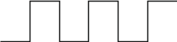
2 | Sound with rising frequency (from 1450 Hz to 2000 Hz) within 1 second. | 
3 | Sound with smoothly rising and falling frequency (1450 Hz – 2000 Hz – 1450 Hz) within 1 second. | 
4 | Sound with falling frequency (from 2000 Hz to 1450 Hz) within 1 second. | 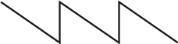
Table 2. Types of acoustic signaling available for the ASP-200 siren.
ASP-215 – wireless indoor siren. You can configure the signaling parameters for both positions occupied by the siren (which enables two different types of signaling to be programmed):
Signaling time – maximum time of signaling. You can select: 1, 3, 6 or 9 minutes.
Sound – type of acoustic signaling. You can select NOT PRESENT (signaling disabled) or one of three sounds described in Table 3.
Optical signaling – if this option is enabled, the optical signaling is triggered.
1 | Two sound frequencies (1450 Hz/2000 Hz) alternating within 1 second.
2 | Sound with rising frequency (from 1450 Hz to 2000 Hz) within 1 second.
3 | Sound with falling frequency (from 2000 Hz to 1450 Hz) within 1 second.
Table 3. Types of acoustic signaling available for the ASP-215 siren.
ASW-200 – 230 VAC smart plug.
Operating mode – way to control the device connected to the plug. You can select:
0 – only remote control.
1 – remote or manual control.
2 – remote or manual control but with option to manually block the remote control.
ASW-210 – flush-mounted wireless two-channel 230 VAC controller. For each position occupied by the controller, you can configure:
Operating mode – way to control the device connected to the relay output. You can select:
0 – only remote control.
1 – remote control or with a monostable switch connected to the controller input.
2 – remote control or with a bistable switch connected to the controller input.
ATD-200 – wireless temperature detector. For both positions occupied by the detector, you can configure the temperature threshold settings (which enables two different temperature thresholds to be programmed):
Temperature threshold – threshold type. You can select:
H – high (alarm when the temperature rises above the threshold temperature by a value equal to or higher than the tolerance),
L – low (alarm when the temperature drops below the threshold temperature by a value equal to or higher than the tolerance).
Temperature – threshold temperature. You can enter a value from -30°C to 70°C (with accuracy to 0.5°).
Tolerance – difference between the threshold temperature and the temperature at which the detector reports alarm. You can enter a value from 0.5°C to 10°C (with accuracy to 0,5°).
ATX-230 – hardwired zone expander: NC and roller shutter. For the roller shutter input, the following settings are available:
Pulses number – number of pulses after which the roller shutter input will trigger alarm. You can select a number from 1 to 8.
Counting time – time in which pulses must be detected so that the roller shutter input reports alarm. You can select 30 seconds, 120 seconds, 240 seconds or “---“ (unlimited time).
AVD-200 – wireless shock detector and magnetic contact. For the shock detector, you can configure:
Sensitivity – detection sensitivity. You can select a number from 1 to 8 (1 – minimum; 8 – maximum).
Filter – the number of consecutive communication periods without connection between the device and the controller after which loss of communication with the device will be reported. You can enter values from 0 to 50. If you enter 0, you will disable the check for device presence.
Temp.corr. – you can correct the temperature information sent by the device by up to ±3.5°C.
ECO – if this option is enabled, periodical communication with the device takes place every 3 minutes. Thus the battery life can be extended up to four times.
If you enable the ECO option for:
detector – delay between arming / disarming and switching the detector operating mode (active / passive) can be up to three minutes,
ASP-215 siren – delay in starting / stopping the signaling can be up to three minutes.

Buttons
Read –click to read data from the controller.
Write – click to save data to the controller.
– click to display information. This button is available when it is necessary to identify devices after a wireless device has been added / deleted.
– click to add the wireless device.
– click to delete the wireless device.
 – click to start the test mode. When the system is running in the test mode:
- detector LEDs are enabled,
- tamper signaling in the sirens is blocked.
 – click to end the test mode.
As required by EN 50131, the level of radio signal sent by wireless devices is lowered when the system is running in the test mode.
The command to start/end the test mode is sent during periodical communication, i.e. with delay whose duration depends on the frequency of periodical communication.
The test mode will be disabled automatically 30 minutes after:
- exiting the controller settings,
- closing the PERFECTA Soft program.

Specific character of the operation of ABAX 2 wireless devices
When programming the alarm system zones and outputs to which the wireless devices are assigned, you must take into account the specific character of operation of individual devices.

ABAX 2 wireless detectors
The zone to which a wireless detector is assigned is activated when the detector reports alarm (select the appropriate zone type). If a detector tamper is to trigger the tamper alarm, program the zone as 2EOL/NC or 2EOL/NO.
Operation of the detector is affected by the state of partition to which the zone belongs:
partition disarmed – the detector operates in passive mode. This operating mode prolongs the battery life. Detector informs the controller about its status during periodical communication (only the tamper information is sent immediately).
partition armed – the detector operates in active mode. Detector informs the controller about alarm or tamper immediately.
Switching the detector from passive mode to active and vice versa takes place during periodical communication. It results in a delay whose duration depends on the frequency of periodical communication (with the ECO option enabled, delay can be up to 3 minutes).
Detectors assigned to the zones that are always armed are permanently in the active mode.
For most detectors, you can enable the Always active option.
According to the EN 50131-3 standard all ABAX 2 system Hold-Up devices must be always in active mode.
The battery life in the detectors switched permanently to the active mode is shorter than in those which are periodically switched to the passive mode. However, if the specific character of a detector or its installation place is such that the number of alarms is low, switching the detector permanently into the active mode will not have a significant effect on the battery life.

ABAX 2 wireless sirens
Turning on the output to which the wireless siren is assigned will trigger the signaling. Depending on the siren:
ASP-200 – the first output controls the acoustic signaling, the second – the optical signaling. Thanks to a high-capacity battery, the siren can receive transmissions from the controller at any time. Therefore, the commands to start/stop signaling are sent to the siren immediately.
ASP-215 – both outputs can control the acoustic and optical signaling. This enables two different, independently triggered types of signaling to be configured. The outputs can control separately the acoustic and optical signaling or trigger other signaling for different alarms (e.g. burglary and fire). Given its low-capacity battery, the siren can receive transmissions from the controller during periodical communication only. Therefore, the commands to start/stop signaling are sent to the siren during periodical communication. Consequently, the operating time of outputs controlling the siren should be longer than the communication period.
The signaling will stop after the maximum signaling time expires, even if the output is still active.
The zones to which the wireless siren is assigned are activated in the following cases (select the appropriate zone type):
ASP-200 – first zone: starting the acoustic signaling; second zone: starting the optical signaling.
ASP-215 – both zones: starting the signaling.
If the siren tamper is to trigger tamper alarm, program the zone as 2EOL/NC or 2EOL/NO.
The tamper information is sent immediately. Other types of information are sent during periodical communication.
Signaling of tamper alarm (on opening the tamper switch in the siren) continues for:
ASP-200 – the maximum duration of signaling programmed for the siren (programmed sound type and optical signaling),
ASP-215 – 3 minutes (type 1 sound and optical signaling).
Tamper signaling is blocked:
  - when the control panel is running in service mode,
  - when the ABAX 2 system is running in test mode,
  - for 10 minutes after connecting the battery (ASP-200),
  - for 40 seconds after installing the battery (ASP-215).
It enables installation work to be carried out. Opening the tamper switch will not trigger signaling, but information on tamper will be sent. The command to block / unblock the signaling in relation to starting / ending the test mode or the service mode is sent during the response time.

Wireless expanders of hardwired zones and outputs
You can configure the alarm system zone / output to which expander zone / output is assigned in much the same way as hardwired zones / outputs. You must, however, keep in mind the following rules for zone sensitivity:
- from 20 ms to 140 ms – expander supports all programmed values,
- above 140 ms – expander supports only some values: 400 ms, 500 ms, 700 ms, etc. every 200 ms (the programmed value is rounded up to that supported by the expander).
The EN50131-3 standard requires that zones must react to signals lasting more than 400 ms. Therefore, select 400 ms when programming sensitivity of the alarm zones.
Information on the state of zones and commands to change the state of outputs are sent immediately. Zone settings are sent during periodical communication.
If communication with the controller is lost, all previously activated outputs will be deactivated after 20 communication periods.
If the ACX-220 expander is powered from a SATEL power supply connected to the APS connector, the low battery information provided by the control panel means:
first zone – power supply overload,
second zone – low battery,
third zone – AC mains loss.

Smart plug / 230 VAC wireless controller
Turning on the output to which the plug / controller is assigned turns on the relay controlling the 230 VAC circuit (turns on the device connected to the plug / controller).
The zone to which the plug / controller is assigned is activated when:
- operating modes 1 and 2: the relay controlling the 230 VAC circuit is turned on,
- operating mode 0: the plug button is pressed / the controller input is activated.
Select the appropriate zone type.
If the ASW-210 controller occupies one position on the list of wireless devices, only the first controller input (SW1) is supported and the state of both relays changes simultaneously.

Wireless radiator thermostat
The thermostat operates as defined by the settings of the selected control panel thermostat (see: “Thermostats” p. 56). Select the controlling thermostat while programming the ART-200 thermostat settings. When the controlling thermostat’s first temperature threshold (temperature T1) is active, the ART-200 thermostat operates in the Economy temperature mode. When the controlling thermostat’s second temperature threshold (temperature T2) is active, the ART-200 thermostat operates in the Comfort temperature mode.
While programming the ART-200 thermostat settings, you can select an output that will disable the capability to switch between operating modes as described above. If this output is turned on, the thermostat operates in the Manual setting of the valve position / temperature mode. The thermostat can only be controlled manually then. If this output is turned off, the thermostat operates as defined by the controlling thermostat settings.
If the Edit without code option is enabled in the control panel thermostat settings, the user will not be able to control the ART-200 thermostat manually (the thermostat keys will be blocked).
The zone to which the ART-200 thermostat is assigned is active when the radiator valve is open (set in position other than fully closed). When the zone is in normal state, the valve is fully closed (it is 0% open). If tamper alarm is to be triggered whenever the anti-freeze protection is activated (when temperature drops below 5°C), program the zone as 2EOL/NC or 2EOL/NO.
Information on the position of the valve and the anti-freeze protection being activated is sent during periodical communication.
Controlling the thermostat is impossible when the following errors occur: F01 – problem with changing the valve position, F02 – wrong calibration, F03 – low battery. The errors will be indicated as no communication with the thermostat.

Radio signal repeater
The first zone to which the radio signal repeater is assigned is activated in the event of 230 VAC mains loss (select the appropriate zone type).
The second zone to which the radio signal repeater is assigned is activated in the event of battery trouble (select the appropriate zone type).
If tamper of the radio signal repeater is to trigger tamper alarm, program the zone as 2EOL/NC or 2EOL/NO.

Keyfobs module

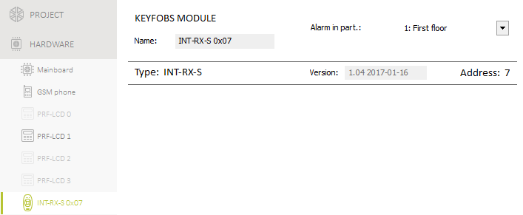
Fig. 13. Tab with 433 MHz keyfobs receiver expansion module settings.

Name [287.Ex.07 name] – individual name of the module (up to 16 characters).
Alarm in part. [227.Ex.07 part] – partition in which alarm will be triggered in the event of module tamper.

Zone module

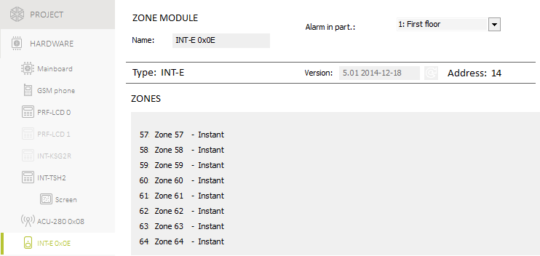
Fig. 14. Zone expander settings.

Name [28.Names] – individual name of the module (up to 16 characters).
Alarm in part. [22.Partitions] – partition in which alarm will be triggered in the event of module tamper.
AC loss report delay [23.Max.AC loss] – time during which the module must be without AC power before the AC power trouble is saved to the event log and reported to the monitoring station. If you program 0, AC power trouble will neither be saved to the event log nor reported to the monitoring station. The parameter applies to the module with power supply.

Output module

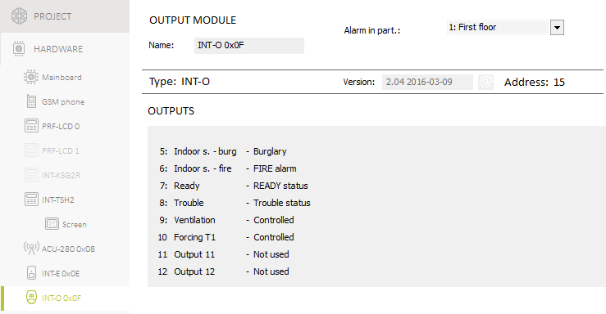
Fig. 15. Output expander settings.

Name [2815.Ex.0F name] – individual name of the module (up to 16 characters).
Alarm in part. [2215.Ex0F part] – partition in which alarm will be triggered in the event of module tamper.
AC loss report delay [2315.AC.0F loss] – time during which the module must be without AC power before the AC power trouble is saved to the event log and reported to the monitoring station. If you program 0, AC power trouble will neither be saved to the event log nor reported to the monitoring station. The parameter applies to the module with power supply.

Proximity card arm/disarm device

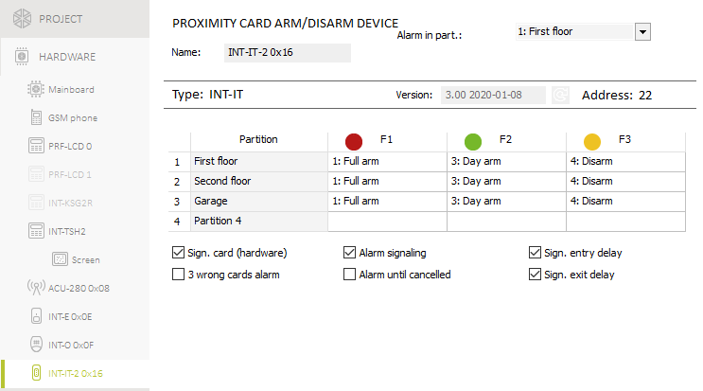
Fig. 16. Proximity card arm/disarm device settings.

Name [28.Names] – individual device name (up to 16 characters).
Alarm in part. [22.Partitions] – partition in which alarm will be triggered in the event of device tamper.

Controlling partitions
Partition – partition name.
F1 [2140.LED R p.1 / 2141.LED R p.2 / 2142.LED R p.3 / 2143.LED R p.4] – the function to be run in the partition, if the card is moved away from the device when the red LED is ON:
none [No Arm/Disarm] – no function,
Full arm – full arming,
F2 [2144.LED G p.1 / 2145.LED G p.2 / 2146.LED G p.3 / 2147.LED G p.4] – the function to be run in the partition, if the card is moved away from the device when the green LED is ON (mode A):
none [No Arm/Disarm] – no function,
Full arm – full arming,
Night arm – night arming,
Day arm – day arming,
Disarm [Disarm] – disarming.
F3 [2148.LED Y p.1 / 2149.LED Y p.2 / 2150.LED Y p.3 / 2151.LED Y p.4] – the function to be run in the partition, if the card is moved away from the device when the yellow LED is ON (mode B):
none [No Arm/Disarm] – no function,
Full arm – full arming,
Night arm – night arming,
Day arm – day arming,
Disarm [Disarm] – disarming.
In the PERFECTA Soft program, right-click on the field to select a function from the list.

Options
Sign. card (hardware) [Hardware signal.] – if the option is enabled, the card code reading or the LED turning ON is signaled by the device with a single beep (the code is sent to the control panel after removal of the card and only then the device is audibly signaling its reaction to the code reading).
3 wrong cards alarm [3 wrng cards al.] – if the option is enabled, using an unknown card three times will trigger an alarm.
Alarm signaling [Timed alarm sign] – if the option is enabled, the device is audibly signaling alarms during the Keypad’s alarm time.
Alarm until cancelled [Alm.until clear] – if the option is enabled, the device is audibly signaling alarms until they are cleared.
Sign. entry delay [Entry delay sig.] – if the option is enabled, the device is audibly signaling the entry delay countdown.
Sign. exit delay [Exit delay sign.] – if the option is enabled, the device is audibly signaling the exit delay countdown.

Partitions
The partition is a separated area within the premises protected by the security alarm system. The subdivision into partitions enables arming/disarming the system only in part of the protected area, as well as limiting access to some portion of the premises to selected users. You can create 4 partitions.

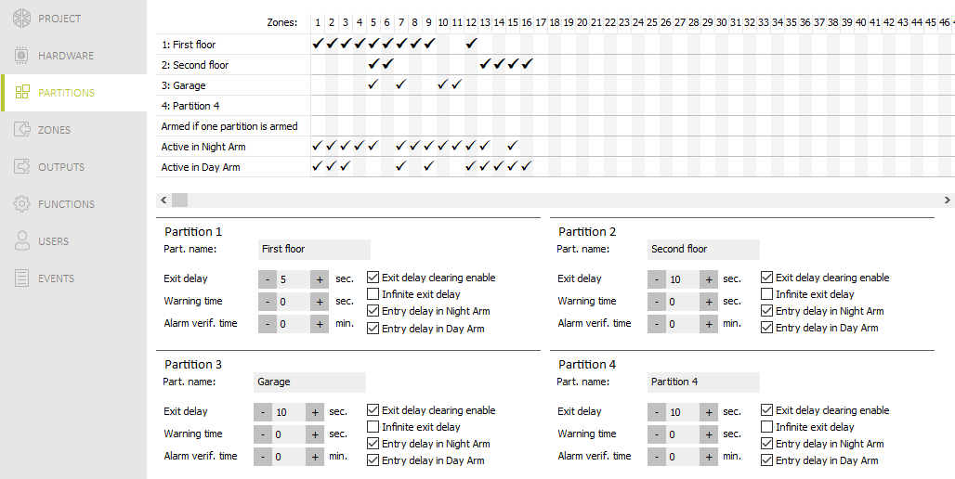
Fig. 17. “Partitions” tab.

Partition settings
Part. name [18.Names] – individual name of the partition (up to 16 characters).
Exit delay [13. Exit delay] – time counted from the moment of starting the procedure of partition arming. It allows the user to leave the protected area without triggering alarm. You can enter from 0 to 255 seconds. Entering zero 0 means no exit delay time.
The exit delay countdown can be terminated from the keypad (see: Exit delay clearing enable option) or zones of the 1. Entry/Exit final, 16. Exit Delay Terminator or 17. Shunt Lock type.
Warning time [14.Warn.delay] – duration of the warning alarm. You can enter from 0 to 255 seconds. Entering any value different from 0 means enabling the warning alarm feature. The alarm alerts the user that he or she has forgotten to disarm the partition or made mistakes when arming the partition. The warning alarm is triggered when:
- Entry delay time has elapsed (see: p. 41),
- Delay time has elapsed (see: p. 42),
- 3. Instant or 4. Double knock zone triggered alarm when Entry delay countdown was running,
- 0. Entry/Exit, 1. Entry/Exit final or 2. Internal type zone is violated at the moment when the exit delay countdown expires and the partition is armed (see description of Prevent arming if not ready p. 15 and Priority options p. 42).
The warning alarm can be signaled by keypad or 2. Internal siren type output. It is not reported. If the partition is not disarmed during the warning alarm, the burglary alarm will be triggered.
Alarm verif. time [15.Verif.delay] – time for verification of the alarm. You can enter from 0 to 255 minutes. Entering any value different from 0 means activation of the burglary alarm verification function. The verification consists in checking whether another zone will trigger the burglary alarm within the defined period of time. If so, the verified alarm will be generated. Alarms from the 0. Entry/Exit, 1. Entry/Exit final, 2. Internal, 3. Instant, 4. Double knock or 5. 24h Burglary zones are verified. The time is counted from the moment of alarm triggering by this type of zone.
Exit delay clearing enable [Fin.exit delay] – if this option is enabled, the users can terminate the exit delay countdown from the keypad (the , or key is to be pressed and hold down for about 3 seconds).
Infinite exit delay [Infinit.ex.delay] – if this option is enabled, the exit delay time is infinite. It can be terminated:
- on violation of the 1. Entry/Exit final, 16. Exit Delay Terminator or 17. Shunt Lock type zones,
- after pressing and holding down for 3 seconds the , or keys on the keypad (when the Exit delay clearing enable option is enabled).
If the exit delay countdown is not terminated, the partition will not be armed.
Entry delay in Night Arm [Entry del. night] – if this option is enabled, there is entry delay when the partition is armed in night mode. If this option is disabled, there is no entry delay when the partition is armed in night mode.
Entry delay in Day Arm [Entry del. day] – if this option is enabled, there is entry delay when the partition is armed in day mode. If this option is disabled, there is no entry delay when the partition is armed in day mode.

Zones
A zone can be assigned to one or several partitions. If the zone is assigned to several partitions, you can decide if just one of the partitions needs to be armed for the zone to be armed or all of the partitions need to be armed.
The system supports the following zones:
- hardwired – on the control panel PCB and in expanders. The number of available hardwired zones is determined by the control panel during the identification procedure.
- wireless – if the PERFECTA-RF module or the ACU-220 / ACU-280 controller is connected to the control panel, after wireless devices are added. The number of available wireless zones depends on the number of wireless devices (up to 64 MICRA wireless detectors or 48 ABAX 2 wireless devices) registered in the system.
- virtual – zones which do not physically exist, but can be controlled from the keyfob.

Zone settings
Name [38.Names] – individual name of zone (up to 16 characters).
Wiring type [31.EOL] – type of detector and the method of its connection:
No detector – no detector is connected to the zone,
NC – the zone supports a detector of NC (normally closed) type,
NO – the zone supports a detector of NO (normally open) type,
EOL – the zone supports a detector of NO or NC type with EOL resistor in the circuit,
2EOL/NO – the zone supports a detector of NO type with two EOL resistors in the circuit,
2EOL/NC – the zone supports a detector of NC type with two EOL resistors in the circuit,
Roller – the zone supports a roller shutter detector,
Vibration – the zone supports a shock detector (also NC type detector).
Opening the Vibration circuit for 200 ms or longer – irrespective of the programmed number of pulses and sensitivity (see below) – will result in a zone violation. This solution enables a magnetic contact to be connected in series with the shock detector.
Sensitivity [32.Sensitivity] – depending on wiring type:
NO, NC, EOL and 2EOL – the time during which the zone must be violated, so that it can be noted by the control panel. The sensitivity is programmed in milliseconds. You can enter values from the 20 ms to 5100 ms range.
Vibration – the shock whose duration is equal to or longer than the defined time will cause violation of the zone. You can enter values from the 5 ms to 160 ms range (every 3 ms).

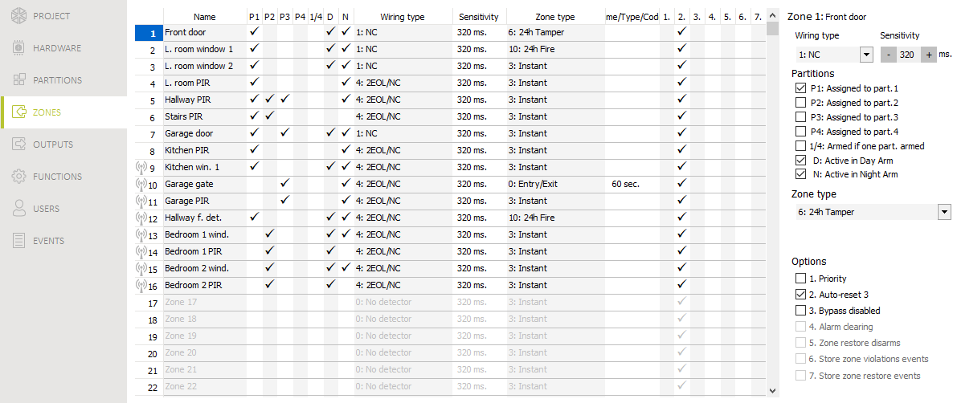
Fig. 18. “Zones” tab.

Pulses [32.Sensitivity] – the number of pulses/shocks after which the zone will be violated. The parameter applies to the Roller and Vibration wiring configurations. For the Vibration wiring configuration you can enter values from 0 to 7 (for the value 0, the shocks will not be counted, the Sensitivity parameter only being taken into account). For the Roller wiring configuration you can enter values from 1 to 8.
Time [32.Sensitivity] – the time during which the defined number of pulses must be detected (Pulses parameter) for the zone to be violated. The parameter applies to the Roller wiring configuration. You can program:
30 s (keypad: press ) – the time counted from detecting the pulse. After the time has elapsed, the pulse counter will be reset.
120 s (keypad: press ) – similarly as in the event of 30 s.
240 s (keypad: press ) – similarly as in the event of 30 s.
for arming / disarming (keypad: press ) – the pulses are counted when the partition is armed or disarmed. Arming / disarming will reset the pulse counter.
Assigned to part. 1 [361.P.1 zones] – if the option is enabled, the zone is assigned to partition 1.
Assigned to part. 2 [362.P.2 zones] – if the option is enabled, the zone is assigned to partition 2.
Assigned to part. 3 [363.P.3 zones] – if the option is enabled, the zone is assigned to partition 3.
Assigned to part. 4 [364.P.4 zones] – if the option is enabled, the zone is assigned to partition 4.
Armed if one part. armed [367.Act.OnePart] – the option for the zones assigned to several partitions. If the option is enabled, the zone is armed when one of the partitions is armed. If the option is disabled, the zone is armed when all partitions are armed.
Active in Day Arm [365.Day active] – if the option is enabled, the zone is armed when the day armed mode is activated.
Active in Night Arm [366. Night act.] – if the option is enabled, the zone is armed when the night armed mode is activated.
Entry delay [34.Entry delay] – the time by which alarm from the zone of 0. Entry/Exit or 1. Entry/Exit final type will be delayed. It is counted from the moment of zone violation. During the countdown, the zones of 2. Internal type act as delayed ones. You can enter from 0 to 255 seconds. Programming 0 will make the zone act as an instant one.
Delay [34.Entry delay] – the time by which alarm from the zone of 2. Internal type will be delayed. It is counted from the moment of zone violation. You can enter from 0 to 255 seconds. Programming 0 means that the zone will act as an instant one.
Waiting time [34.Entry delay] – the time during which the 4. Double knock type zone has to be violated again for the alarm to be triggered. It is counted from the first violation of the zone. You can enter from 0 to 255 seconds. Programming 0 means that the Waiting time is 30 seconds.
Delay activation time [34.Entry delay] – the time during which the 2. Internal type zones act as delayed ones. It is counted from the moment of violation of the 18. Entry Route Enabling type zone. You can enter from 0 to 255 seconds.
Arming mode [39.Arm mode] – the armed mode activated by violating the zones of 13. Arm/Disarm or 14. Arm type. You can select full, day or night armed mode.
Trouble code [35.Trouble code] – violating of the 19. Trouble type zone can generate event that will be reported.
Priority [368.Priority] – if the option is enabled, starting the arming procedure is impossible when the zone is violated. If the option is enabled for a zone of the 0. Entry/Exit, 1. Entry/Exit final or 2. Internal type and the zone is violated at the moment the partition exit delay countdown expires and the partition is armed, a warning alarm will be triggered. If the partition is not armed after exit delay countdown expires, the warning alarm will not be triggered.
Auto-reset 3 [369.3 alarms] – if the option is enabled, the zone can trigger up to 3 alarms. As long as the alarm is not cleared or the partition is not armed/disarmed, violations of the zone will not trigger any alarm.
Bypass disabled [370.Bps disable] – if the option is enabled, the user cannot bypass the zone.
Alarm clearing [374.Alarm clear] – an option for the 13. Arm/Disarm and 15. Disarm zone types. If the option is enabled, together with disarming, the alarm is cleared. Violation of the 15. Disarm type zone will also clear the alarm, when the system is not armed.
Zone restore disarms [371.Shnt.disarm] – an option for the 17. Shunt lock zone type. If the option is enabled, the zone restore will disarm the partition.
Store zone violations events [372.Viol.event] – an option for the 12. No alarm action zone type. If the option is enabled, the zone violation is saved to the event log.
Store zone restore events [373.Rest.event] – an option for the 12. No alarm action zone type. If the option is enabled, the zone restore is saved to the event log.

Zone types
0. Entry/Exit – when the Exit delay countdown is in progress, zone violation will trigger no alarm. When the partition is armed, zone violation will start the Entry delay countdown. The user have to disarm the partition before the Entry delay expires, otherwise, the alarm will be generated. This zone type is normally used for the detectors protecting entrances/exits (e.g. front doors).
1. Entry/Exit final – acts similarly as 0. Entry/Exit, but the Exit delay countdown will be terminated as soon as the zone is restored.
2. Internal – when the Entry delay or Delay activation time countdown is in progress, zone violation will start the Delay countdown. The user have to disarm the partition before the Delay expires, otherwise, the alarm will be generated. When the partition is armed, but neither Entry delay nor Delay activation time countdown is running, zone violation will trigger alarm. This zone type is normally used for indoor motion detectors and internal door protection detectors.
3. Instant – when the Exit delay countdown is running or the partition is armed, zone violation will trigger alarm. This zone type is normally used for outdoor motion detectors and window protection detectors.
4. Double knock – when the partition is armed, violating a zone will result in logging the event and starting the Waiting time countdown. If the zone is violated again when the countdown is running, alarm will be triggered.
5. 24h burglary – zone violation will trigger burglary alarm. Use this zone type for the detectors which should be always active (e.g. glass break detectors).
6. 24h tamper – zone violation will trigger tamper alarm and trouble will be reported. Use this zone type for tamper protection.
7. 24h panic – zone violation will trigger panic alarm. Use this zone type for the panic buttons.
8. 24h panic silent – zone violation will trigger silent panic alarm. It is not indicated by the keypads, but the event code can be sent to the monitoring station. Use this zone type for the panic buttons.
9. 24h medical – zone violation will trigger medical (auxiliary) alarm. Use this zone type for the help call buttons.
10. 24h fire – zone violation will trigger fire alarm. Use this zone type for the fire detectors.
11. Detector mask – zone violation will report trouble (detector masking). Use this zone type for detectors with an anti-masking output.
12. No alarm action – zone violation will not trigger directly any reaction of the control panel. The zone can be used to control outputs.
13. Arm/Disarm – when the partition is disarmed, violation of the zone will start arming procedure in the partition. When the partition is armed, zone violation will disarm the partition.
14. Arm – when the partition is disarmed, zone violation will start the partition arming procedure.
15. Disarm – when the partition is armed, zone violation will disarm the partition.
16. Exit delay terminator – violation of the zone ends the partition exit delay countdown.
17. Shunt lock – violation of the zone ends the partition exit delay countdown. If the Zone restore disarms option is enabled, the zone restore will disarm the partition.
18. Entry route enabling – when the partition is armed, zone violation will start the Delay activation time countdown. During the Delay activation time countdown, the zones of 2. Internal type act as delayed ones.
19. Trouble – zone violation will result in trouble. You can select the type of trouble (see Trouble code parameter). Zone restore means the trouble restore.

Wireless detector [MICRA]
If the PERFECTA-RF module is connected to the control panel, additional settings are available for the zones.
Type – type of the wireless detector.
Serial no. – serial number of the wireless detector.
Filter [1272.Filter] – time counted from the moment of receiving a transmission from the detector. After it has elapsed and no other transmission is received, trouble will be reported.

Buttons
– click to add the wireless detector.
– click to delete the wireless detector.

MICRA wireless detector and zone settings
The zone to which the wireless detector is assigned is activated when the detector reports alarm (select the appropriate zone type). If a detector tamper is to trigger the tamper alarm, program the zone as 2EOL/NC or 2EOL/NO.
The information on tamper and tamper restore is sent by the detector in real time.
How alarm information is sent depends on the detector operating mode:
normal – the detector sends information on alarm and alarm restore in real time (the zone status corresponds to the detector status),
energy save (available in some detectors) – after sending alarm information, the detector will not send any further alarm information for 3 minutes (the zone is active for 2 seconds after receiving alarm information).

Outputs
The system supports the following outputs:
- hardwired – on the control panel PCB and in the expanders.
- wireless:
- PERFECTA-RF module connected to control panel: 4 outputs,
- ACU-220 / ACU-280 controller connected to control panel: up to 48 outputs.

Output functions
0. Not used
1. External siren – output activated by triggering burglary, panic or fire alarm. In the event of the fire alarm, the output is pulsating.
2. Internal siren – output activated by triggering burglary, panic, fire or warning alarm. In the event of the fire alarm, the output is pulsating.
3. Burglary – output activated after alarm is triggered by the 0. Entry/Exit, 1. Entry/Exit final, 2. Internal, 3. Instant, 4. Double knock or 5. 24h Burglary zone.
4. Fire alarm – output activated by triggering fire alarm from keypad or by the 10. 24h Fire zone.
5. DURESS alarm – output activated by using a code with Duress right.
6. Panic alarm – output activated by triggering panic alarm from keypad (loud or silent), by the 7. 24h Panic or 8. 24h Panic silent zone.
7. MEDICAL alarm – output activated by calling medical help from keypad or by the 9. 24h Medical zone.
8. Alarm – not verified – output activated by triggering unverified alarm.
9. Alarm - verified – output activated by triggering verified alarm.
10. Tamper alarm – output activated by triggering tamper alarm.
11. Fire detectors power supply – power output for fire detectors with automatic alarm verification. The output is deactivated for 16 seconds after violation of the 10. 24h Fire zone. If, after reactivation of the output, the zone will be violated again, fire alarm will be triggered.
12. Power supply on armed – power output for the detectors which should not operate when the system is disarmed. The output is active when the system is armed (it will be activated as soon as the exit delay countdown starts).
13. Zone violation – output activated by zone violation.
14. Chime – output activated by zone violation, if the zone is disarmed.
15. Controlled – output activated / deactivated by using zones, timers, keypad etc.
16. READY status – output is active, when the system is ready for arming (no zone is violated).
17. Exit delay status – output is active, when Exit delay countdown is running.
18. Armed status – output is active, when the system is armed.
19. Trouble status – output is active, when there is a trouble in the system.
20. Arm/alarm status – output is active, when the system is armed (continuous mode) or when there is alarm (pulsating mode).
21. Detectors reset – output is used to reset the alarm memory in detectors. It is activated on:
- starting the exit delay countdown (if the exit delay is 0 – on arming),
- starting the 3.Outputs reset user function.
22. Service mode status – output is active, when the control panel is running in service mode.
23. Arm status (reported) – output is active, when the system is armed and information about arming has been sent to the monitoring station (if reporting is disabled, the output is active when the system is armed).
24. Thermostat – output is turned on, when at least one of the thermostats that control the output is on. The output is turned off, when all the thermostats that control the output are off.

Output settings

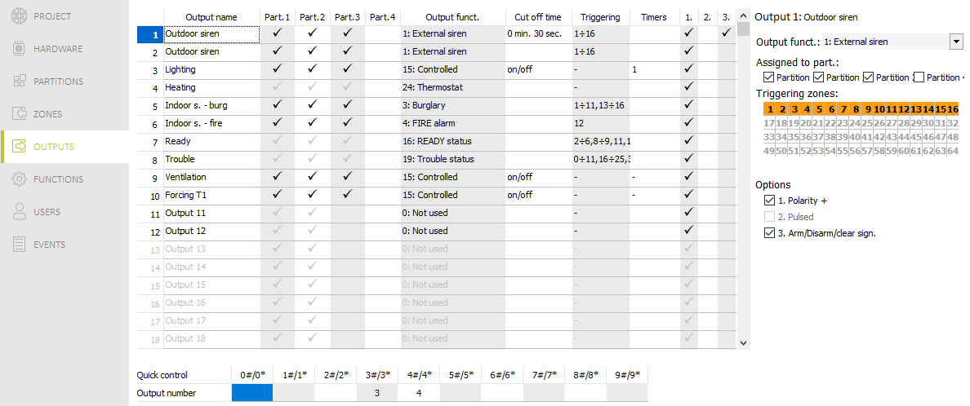
Fig. 19. “Outputs” tab.

Output name [48.Names] – individual name of the output (up to 16 characters).
Cut off time [42.Duration] – time during which the output is active. Entering 0 changes the operation mode of some outputs:
- outputs activated by triggering alarm will remain active until the alarm is cleared,
- 5. DURESS alarm and 14. Chime outputs will remain active until starting the 3.Outputs reset user function,
- 13. Zone violation output will be active when the zone is violated,
- 15. Controlled output will remain active until repeated zone violation, stopping timer or deactivating from keypad, etc.
Triggering zones [43.Zones] – the zones whose status has effect on the output status.
Arming modes [43.Zones] – arming modes which affect the output status.
Troubles [43.Zones] – troubles during which the output is active.
Partition 1 [451.P.1 outputs] – if this option is enabled, the output is controlled by events related to partition 1 (alarm in partition 1, clearing alarm in partition 1 etc.).
Partition 2 [452.P.2 outputs] – if this option is enabled, the output is controlled by events related to partition 2 (alarm in partition 2, clearing alarm in partition 2 etc.).
Partition 3 [453. P.3 outputs] – if this option is enabled, the output is controlled by events related to partition 3 (alarm in partition 3, clearing alarm in partition 3 etc.).
Partition 4 [454. P.4 outputs] – if this option is enabled, the output is controlled by events related to partition 4 (alarm in partition 4, clearing alarm in partition 4 etc.).
Polarity + [455.Polarity(+)] – the option defines how the outputs will operate (see the table below). If the option is disabled, the output is inverted. The option does not apply to wireless outputs.

 | “–” terminal of high-current output / low-current output
 | option enabled  (normal polarity) | option disabled  (reverse polarity)
output inactive | disconnected from ground | shorted to ground
output active | shorted to ground | disconnected from ground
Table 4. Mode of output operation depending on the Polarity + option.

Pulsed [456.Pulsed] – if this option is enabled, the output is pulsating when it is active. The option does not apply to the 1. External siren, 2. Internal siren, 11. Fire detectors Power supply and 20. Arm/alarm status outputs. The option does not apply to wireless outputs.
Arm/Disarm/clear sign. [457.Arm/Dis/Clr] – if this option is enabled, the output will signal:
- starting the arming procedure (if the exit delay time is 0, the system is armed immediately) – 1 pulse,
- disarming – 2 pulses,
- clearing alarm – 4 pulses,
- denial of arming or arming procedure failure – 7 pulses.
The signaling is triggered if a keyfob or zone is used to arm / disarm the system or clear alarm. Pulse duration is about 0.3 second. Option for the 1. External siren, 2. Internal siren, 3. Burglary, 4. FIRE alarm, 5. DURESS alarm, 6. PANIC alarm, 7. MEDICAL alarm, 8. Alarm - not verified, 9. Alarm - verified and 10. Tamper alarm outputs.
Triggering timers [44.Timers] – timers that control the output (starting the timer activates the output). The parameter refers to the 15. Controlled output.
Thermostats [49.Thermostats] – thermostats that control the output (turning on the thermostat activates the output). The parameter refers to the 24. Thermostat output.

Quick control of outputs
If the quick control of the outputs 15. Controlled is to be available in keypads, the outputs of this type must be assigned to the corresponding keypad keys. One output can be assigned to each number key.

MSP-300 siren
If the PERFECTA-RF module is connected to the control panel, additional settings are available for the 13-16 ouputs.
Serial no. – serial number of the wireless siren.
If a wireless siren is assigned to the output, additional parameters and options are available (outputs 13-16).
Filter [1272.Filter] – time counted from the moment of receiving transmission from the siren. After it has elapsed and no other transmission is received, trouble will be reported.
Signaling [1275.Al.signal.] – alarm signaling mode.
Arm/Disarm beep [1276.Acknowled.] – signaling mode for arming/disarming etc. (cf. Arm/Disarm/clear sign. option).
Tamp. in part. [1274.Out.tamper] – partition in which alarm will be triggered in the event of siren tamper.

Buttons
– click to add the wireless siren.
– click to delete the wireless siren.

Communication
Panel key [01.PERFECTA key] – identifier of the alarm control panel. You can enter up to 16 alphanumeric characters (digits, letters and special characters). You can enter spaces, but at least one character must be different from the space. Do not program the same key for different control panels. Communication between the PERFECTA Soft program and the control panel is only possible, when the program key and the control panel key are identical.
For the control panel with factory default settings, the PERFECTA Soft program will generate a random key that must be written to the control panel.
ID – individual identification number for the purpose of communication via the SATEL server. It is assigned automatically by the SATEL server. The control panel will connect to the SATEL server if you enable the PERFECTA Soft conn. via SATEL server allowed or PERFECTA Control conn. via SATEL server allowed option.
If the control panel was previously used in another alarm system, delete the old ID number. To do so, you can use the 6.ID change user function if the control panel is connected to the SATEL server. After the old ID number is deleted, a new one will be assigned to the control panel. PERFECTA CONTROL applications which use the old ID will not be able to connect to the control panel.

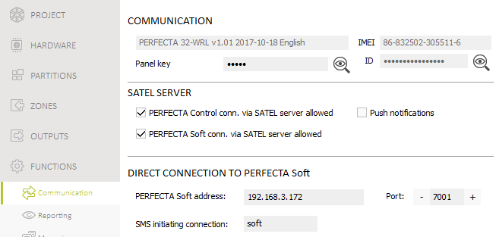
Fig. 20. “Communication” tab.

SATEL server
PERFECTA Control conn. via SATEL server allowed [PERFECTA CONTROL] – if this option is enabled, it is possible to establish connection between the PERFECTA CONTROL application and the control panel through the SATEL server.
Push notifications [PUSH messages] – if this option is enabled, the PERFECTA CONTROL application can provide information about alarm system events by means of push notifications.
PERFECTA Soft conn. via SATEL server allowed [PERFECTA Soft] – if this option is enabled, it is possible to establish connection between the PERFECTA Soft program and the control panel through the SATEL server.
Make sure that the SIM card tariff plan is suited to the requirements of communication via the SATEL server (connection to the server is active at all times).

Direct connection to PERFECTA Soft
PERFECTA Soft address [041.Address] – address of the computer running the PERFECTA Soft program. It must be a public address. You can enter the IP address or domain name.
Port [042.Port] – number of the TCP port used for direct communication between the control panel and the computer with PERFECTA Soft program via cellular network (data transmission). You can enter values from 0 to 65535 (0=disabled).
SMS initiating connection [115.PERF.Soft] – control command which will be sent in SMS message to initiate communication between the control panel and the PERFECTA Soft program. You can enter up to 8 alphanumeric characters (digits, letters and special characters). You can enter spaces, but at least one character must be different from the space.
The command content must be different from that of the other control commands preprogrammed in the control panel.
In the SMS message, you can include address of the computer the control panel is to connect to, and the number of TCP port which is to be used for communication.

Reporting
The control panel can send event codes to the monitoring station by using the following transmission paths:
- GPRS/LTE (data transmission via cellular network),
- SMS messages (control panel gets no acknowledgement of event code receipt),
- GSM voice channel (the use of this transmission path is not recommended because of distortions that may occur when sending the event codes).

Reporting settings
Reporting [Monitoring] – if the option is enabled, the control panel can send event codes to the monitoring station.
Reporting mode [72.Stations] – defines how event codes are to be sent to the monitoring stations:
Station 1 or station 2 – the control panel will make an attempt to send the event code to station 1 and, if unsuccessful, to station 2.
Station 1 only – the event codes are only sent to station 1.
Station 2 only – the event codes are only sent to station 2.
Station 1 and Station 2 – the event codes are sent to both stations.

Station 1 / Station 2
Reporting format [738.Format / 758.Format] – format in which event codes are sent to the monitoring station:
CID – all codes – event codes are sent in Contact ID format. All events are sent to the monitoring station.
CID – selected codes – event codes are sent in Contact ID format. Only selected events are sent to the monitoring station.
SIA – all codes – event codes are sent in SIA format. All events are sent to the monitoring station.
SIA – selected codes – event codes are sent in SIA format. Only selected events are sent to the monitoring station.

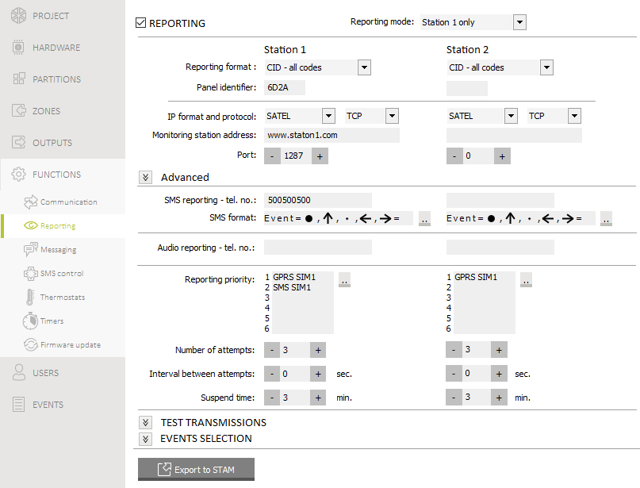
Fig. 21. “Reporting” tab.

Panel identifier [731.Identifiers / 751.Identifiers] [732.SIA prefix / 752.SIA prefix] – identifier of the control panel for reporting purposes. It allows the monitoring station to determine from the events are sent. For the Contact ID format, it consists of 4 hexadecimal characters (digits or letters from A to F). For the SIA format, it consists of 6 hexadecimal characters (digits or letters from A to F). Additional characters are to be put at the beginning (to enter them on the keypad, use the 732.SIA prefix / 752.SIA prefix function). If the identifier only consists of the digits 0, events are not sent.
Send names [Names in SIA] – if the option is enabled, in the SIA format, the name of event source (zone, user, etc.) will also be sent, in addition to the event code.
National char. [National chars] – if this option is enabled, you can send in the SIA format not only ASCII characters but national characters as well.
IP format and protocol [UDP] [SIA-IP] – for GPRS/LTE reporting, you must define:
- format: SATEL or SIA-IP (SIA DC-09 standard).
- protocol: TCP or UDP.
Monitoring station address [736.Address / 756.Address] – address of the monitoring station for GPRS/LTE reporting. You can enter either the IP address or the domain name.
Port [737.Port / 757.Port] – number of the port used for communication between the control panel and the monitoring station during GPRS/LTE reporting. You can enter a value from 0 to 65535 (0=disabled).
SMS reporting - tel. no. [735.Tel.(SMS) / 755.Tel.(SMS)] – phone number of the monitoring station for SMS reporting.
SMS format [741.SMS format / 761.SMS format] – SMS format for SMS reporting. It must be defined as required by the monitoring station. The SMS message format, preset by default in the control panel, corresponds to the default settings of the STAM-2 monitoring station (firmware version 1.2.0 or newer) for the Contact ID format.
Audio reporting - tel. no. [734.Tel.(AUDIO) / 754.Tel.(AUDIO)] – phone number of the monitoring station for AUDIO reporting (GSM voice channel).
Reporting priority [733.Priority / 753.Priority] – if sending an event code to the monitoring station using one transmission path fails, the control panel can use another transmission path. You must specify the order of using different transmission paths by the control panel. A successful send of the event code to the monitoring station will terminate the procedure (except for the test transmissions). The following transmission paths are available:
GPRS SIM1 – data transmission via cellular network, SIM1 card,
GPRS SIM2 – data transmission via cellular network, SIM2 card,
SMS SIM1 – SMS message, SIM1 card,
SMS SIM2 – SMS message, SIM2 card,
AUDIO SIM1 – GSM voice channel, SIM1 card,
AUDIO SIM2 – GSM voice channel, SIM2 card.
The control panel will only use the transmission paths for which priority is specified (they are included in the list defining the order of using transmission paths).
In the case of SMS reporting, the control panel gets no acknowledgement of receiving the event codes by the monitoring station, hence this transmission path should be used as the last one.
The switch-over from one SIM card to the other one requires time (for example, to log onto the network), so it is better to use up all the transmission paths available for one SIM card.
The switch-over from one SIM card to the other is affected by the Lock time and Return time parameters (see: “GSM phone” p. 18).
Number of attempts [747.Repetitions / 767.Repetitions] – the number of attempts to send an event. If all attempts fail, the control panel will suspend reporting. You can program from 1 to 15 attempts.
Interval between attempts [748.Interval / 768.Interval] – time between subsequent attempts to send an event. You can program up to 240 seconds. If you program 0, the next attempt will be made immediately.
Suspend time [746.Suspen.time / 766.Suspen.time] – the time for which reporting is suspended, when all attempts to send the event through all provided transmission paths have failed. The control panel will retry to send the event after this time expires or a new event occurs. You can program up to 30 minutes. If you program 0, the next attempt to send the event will only be made after a new event occurs.

Advanced
SATEL station key [739.STAM key / 759.STAM key] – a sequence of characters for encrypting data sent to the monitoring station via cellular network. You can enter up to 12 alphanumeric characters (digits, letters and special characters). In the PERFECTA Soft program, you can enable the hex option, if you want to enter 24 hexadecimal characters (digits or letters from A to F).
GPRS key [740.GPRS key / 760.GPRS key] – a string of characters, which is used to identify the control panel for the purpose of GPRS/LTE reporting. You can enter up to 5 alphanumeric characters (digits, letters and special characters). In the PERFECTA Soft program, you can enable the hex option, if you want to enter 10 hexadecimal characters (digits or letters from A to F).
SIA-IP account number [742.SIA-IP acct / 762.SIA-IP acct] – a string of characters, which is used to identify the control panel for the purpose of reporting in SIA-IP format. You can enter up to 16 hexadecimal characters (digits or letters from A to F).
SIA-IP key [743.SIA-IP key / 763.SIA-IP key] – a sequence of characters for encrypting data sent in the SIA-IP format. You can enter up to 16 alphanumeric characters (digits, letters and special characters). In the PERFECTA Soft program, you can enable the hex option, if you want to enter 32 hexadecimal characters (digits or letters from A to F).
Encryption [SIA-IP encrypt.] – if the option is enabled, the data being sent are encrypted, and the date and time are sent with event code (the monitoring station can program the date and time in the control panel). Option for SIA-IP format.
Send date & time [Timestamp SIA-IP] – if the option is enabled, the date and time are sent with event code (the monitoring station can program the date and time in the control panel). Option for SIA-IP format. It is available, when the Encryption option is disabled.
SIA-IP test report period [744.SIA-IP test / 764.SIA-IP test] – in the case of reporting in the SIA-IP format, an additional transmission can be sent at specified intervals to check communication with the monitoring station. You can program a number of days, hours, minutes and seconds between the transmissions. Entering zeros only means that no additional transmission will be sent.

Test transmissions
The test transmission is sent using all transmission paths included in the list that defines the order of using transmission paths (cf. Reporting priority parameter).
At [791.At] – if the test transmission is to be sent regularly at a specified time, you must define every how many days and at what time. As for the number of days, 0 is interpreted as 1 (test transmission will be sent every day).
When armed [793.Armed] – if the test transmission is to be sent at regular intervals when the system is armed, define every how many days, hours and minutes.
When disarmed [792.Disarmed] – if the test transmission is to be sent at regular intervals when the system is disarmed, define every how many days, hours and minutes.
Test transmissions regardless of events [Independ.test] – this option refers to the test transmissions sent at regular intervals (see When armed and When disarmed parameters). If this option is enabled, the time is counted from the last test transmission. If the option is disabled, the time is counted from the last transmission, irrespective of whether it was a test transmission, or a code of another event was sent.

Events selection
If the CID – selected codes or SIA – selected codes reporting format is selected, define which events are to be sent to the monitoring station.

Messaging
The control panel can send notifications about alarm system events by means of:
- voice messages – the voice messages which are to be used for notification should be saved to the control panel by using the PERFECTA Soft program,
- SMS messages – the content of SMS messages is automatically generated by the control panel.

Messaging settings

Phones
In the control panel, you can enter data of 8 telephones which will be notified of events in the alarm system. At the same time, users of these phones can control the alarm system by using SMS messages.
Name [88.Names] – individual name of the telephone number (up to 16 characters).
Telephone no. [81.Numbers] – the telephone number.
SMS [83.SMS msg.] – if this option is enabled, the phone is notified by SMS messages (the SMS messaging option must be additionally enabled).

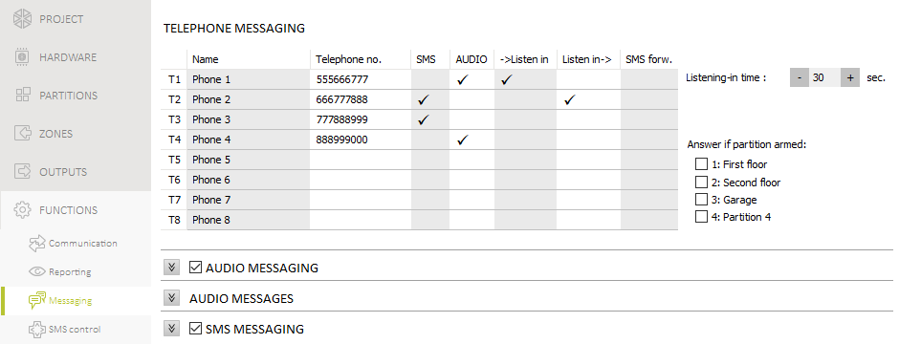
Fig. 22. “Messaging” tab.

AUDIO [82.AUDIO msg.] – if this option is enabled, the phone is notified by voice messages (the AUDIO messaging option must be additionally enabled). The control panel makes 3 attempts to notify the given phone about the event.
->Listen-in [85.Listening-in] – if this option is enabled, the given phone can be used to call the number of SIM card used to listen to what is going on in the premises.
Listen-in-> [87.List.aft.msg] – if this option is enabled, the telephone user, after the notification message is played, can listen in to what is going on in the premises.
SMS forw. [84.Unknown SMS] – if this option is enabled, unknown SMS messages received by the control panel are forwarded to the phone number (e.g. information received from the cellular network operator).
Listening-in time [86.List.durat.] – the time during which the phone users can listen in to what is going on in the premises. The time is counted from answering the call by the control panel or from playing back the voice message. If 0 has been programmed, the listening-in function will be unavailable.
Answer if partition armed [89.On arm.part.] – availability of the listening-in function can be dependent on the partition state. The control panel will receive calls:
- if no partition is selected – always (receiving calls is not restricted),
- if one partition is selected – only when this partition is armed,
- if two or more partitions are selected – only when all selected partitions are armed.

AUDIO messaging
AUDIO messaging [AUDIO messag.] – if this option is enabled, the control panel can notify the users of events by using voice messages.

Event assignment
For the events of which the control panel is to notify, you must define:
- the telephone numbers to be notified,
- the number of the voice message to be used for notification of this event.

AUDIO messages
Repeat twice [Double v.message] – if this option is enabled, voice message is played back twice.

Managing the voice messages
The PERFECTA Soft program allows you to manage the voice messages that will be used for notification. Up to 16 voice messages can be saved on the control panel. Total duration of all the voice messages must not exceed 131 seconds.
Content of the message – text of the voice message. The text entered can be converted into a voice message by using the voice synthesizer.
Duration – duration of the voice message.
Total – information on total duration of the voice messages.
 - click to play back the selected voice message.
 - click to import the .WAV or .MP3 type file which is to be used as the selected voice message.
 - click to delete the selected voice message.
 - click to convert the message text into a voice message. The link below the button displays a window in which you are to select the speech synthesizer. The synthesizer will be used for conversion of the text.
You can download the Microsoft Speech Platform 11 from the www.microsoft.com web site. Installation of the following files is required:
  - SpeechPlatformRuntime.msi (x86 i.e. 32-bit version),
  - MSSpeech_TTS_xx-XX_yyyy.msi (where xx-XX is language, and yyyy is voice).
- click to read the voice messages from the control panel.
- click to save the voice messages to the control panel.

SMS messaging
SMS messaging [SMS messaging] – if this option is enabled, the control panel can notify the users of events by using SMS messages.
SMS notifications confirming ev. [Messaging events] – if this option is enabled, information about sending SMS notification is saved to the event log.

Event assignment
The following options are available for each telephone:
Partition 1 / Partition 2 / Partition 3 / Partition 4 – if this option is enabled, the phone will be notified of events that occurred in the given partition (the events of which the phone will be notified are defined in other options).
Alarms – if this option is enabled, the phone will be notified of alarms.
Arming/disarming – if this option is enabled, the phone will be notified of arming / disarming and alarm clearing.
Zone bypasses – if this option is enabled, the phone will be notified of bypassing / unbypassing zones.
Troubles – if this option is enabled, the phone will be notified of troubles.
Used functions – if this option is enabled, the phone will be notified of the functions used.
System events – if this option is enabled, the phone will be notified of system events.

SMS control
The alarm system can be controlled by means of SMS messages containing appropriate control commands. The SMS messages should be sent to the number of the currently used SIM card. You can program 16 control commands.

SMS control settings

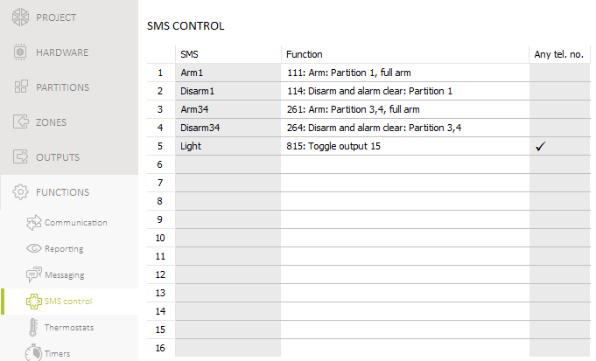
Fig. 23. “SMS control” tab.

SMS [118.SMS control] – control command which can be sent in the SMS message to run the function assigned to the command. You can enter up to 8 alphanumeric characters (digits, letters and special characters). You can enter spaces, but at least one character must be different from the space.
The content of control commands must vary. If the content of two different commands is identical, the control panel, having received the SMS messages, will execute only one function anyway.
The content of one control command must not be inserted into the content of another command.
Function [119.SMS funct.] – the function that will be started after the control panel receives an SMS message containing the control command.
Any tel. no. [1110.Any number] – if this option is enabled, the control command to run the given function can be sent from any phone. If the option is disabled, only from the phone whose number is saved on the control panel (see: “Phones” p. 53).

Thermostats
The thermostat analyzes temperature data received from the ABAX 2 wireless devices provided with temperature sensors. If the temperature drops below the set value, the thermostat will be turned on. The thermostats are used to control the 24. Thermostat type outputs (the devices connected to those outputs). You can program 8 thermostats.
The thermostat settings are used to adjust the operating parameters of the ART-200 wireless radiator thermostats.

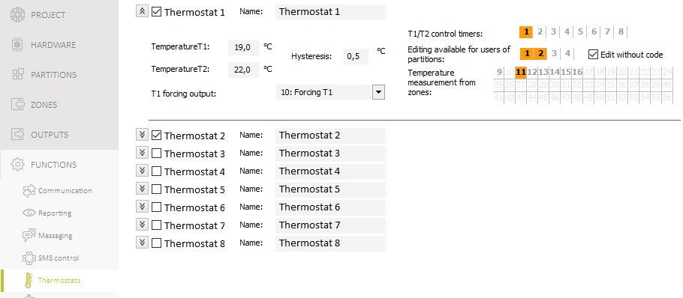
Fig. 24. “Thermostats” tab.

Thermostat settings
Thermostat n [198.Active] – if the option is enabled, the thermostat is active, i.e. it is turned on/off depending on the temperature measurement (n=thermostat number). If the option is disabled, the thermostat is inactive, i.e. it is not turned on/off.
Name [197.Names] – individual name of the thermostat (up to 16 characters).
Temperature T1 [192.Temp. T1] – first temperature threshold (economy temperature). It is active when all control timers are turned off or the forcing output is turned on. If the first temperature threshold is active, the thermostat will be turned on when the temperature drops below temperature T1 (economy temperature).
Temperature T2 [193.Temp.T2] – second temperature threshold (comfort temperature). It is active when the control timer is turned on and the forcing output is turned off. If the second temperature threshold is active, the thermostat will be turned on when the temperature drops below temperature T2 (comfort temperature).
Hysteresis [194.Hysteresis] – temperature difference between turning the thermostat on and off. The thermostat will be turned on when temperature drops below the threshold by a value higher than the hysteresis. The thermostat will be turned off when temperature reaches the threshold. Hysteresis is used to prevent the thermostat from turning on and off when temperature fluctuates.
T1 forcing output [196.Forcing outp.] – output that forces temperature T1 to be active. If the output is turned on, the first temperature threshold (economy temperature) will be active. If the output is turned off, the temperature thresholds will be controlled by timers. If the forcing output is not selected, the temperature thresholds will only be controlled by timers.
T1/T2 control timers [195.Timers] – timers used to control the temperature thresholds. If the timer is turned on, the second temperature threshold will be active (unless the forcing output is turned on).
Editing available for users of partitions [190.Editing] – partitions in which the users can edit thermostat settings using functions available in the user menu.
Edit without code [190.Editing] – if the option is enabled:
INT-TSG2 / INT-TSH2 – the Thermostat widget can be started without using the code (the widget is used to edit temperature settings for the thermostat).
ART-200 – the keys on the radiator thermostat are enabled. The user can use them to:
- change the operating mode (when the operating mode is changed manually, the radiator thermostat will not use the active temperature threshold),
- edit the temperature threshold settings (when the settings are changed in the radiator thermostat, the thermostat settings will also be changed),
- start other functions available in the radiator thermostat.
If the option is disabled:
INT-TSG2 / INT-TSH2 – the Thermostat widget cannot be started without using the code.
ART-200 – the keys on the radiator thermostat are disabled. The user cannot use them.
Temperature measurement from zones [191.Zones] – zones that provide data on temperature for the purpose of the thermostat. Data on temperature can be received from ABAX 2 wireless devices provided with temperature sensors.

Rules for programming the thermostat settings

Temperature programming rules
You can enter a value from -30°C to 70°C (with accuracy to 0.5°).
The ART-200 wireless radiator thermostat regulates temperature in the range from 5°C to 30°C.

Hysteresis programming rules
You can enter a value from 0°C to 7.5°C (with accuracy to 0.5°). If you program 0°C, the thermostat will be turned on when the temperature drops below the threshold by 0.5°C.

Timers
The timer compares the time to that of the control panel clock and executes the selected function at the programmed time. Using the timers, it is possible to control the armed mode of partitions, the 15. Controlled outputs and the thermostats. You can program 8 timers.

Timer settings

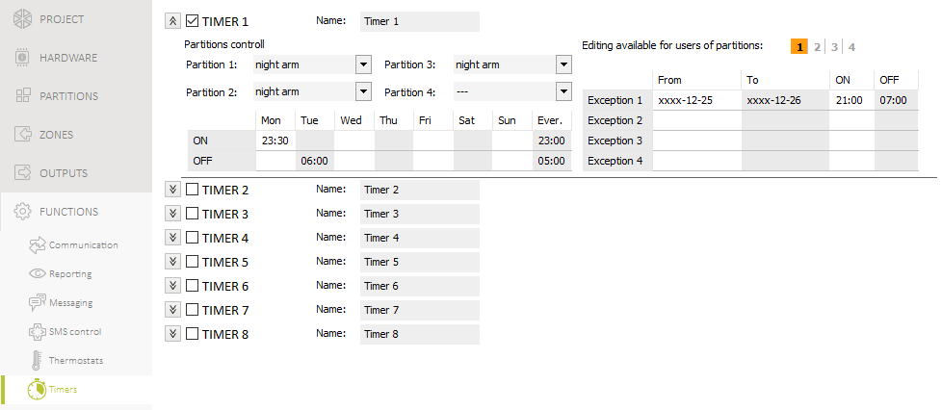
Fig. 25. “Timers” tab.

TIMER n [59.Active] – if the option is enabled, the timer is active, i.e. it is turned on / off at a set time (n=timer number). If the option is disabled, the timer is inactive, i.e. it is not turned on / off.
Name [58.Names] – individual timer name (up to 16 characters).
Partition 1 [571.Partition 1] / Partition 2 [572.Partition 2] / Partition 3 [573.Partition 3] / Partition 4 [574.Partition 4] – the arming mode that will be activated in the partition when the timer will start.
Editing available for users of partitions [50.Edit.from p.] – partitions whose users can edit timer settings from the keypad / PERFECTA CONTROL app.

Mon / Thu / Wed / Tue / Fri / Sat / Sun
You can program individual timer operating parameters for every day of the week.
ON – timer start time on the given day of the week (hour:minutes).
OFF – timer stop time on the given day of the week (hour:minutes).

Everyday
The everyday settings apply to only those days of the week for which no individual parameters have been programmed.
ON – timer start time every day (hour:minutes).
OFF – timer stop time every day (hour:minutes).

Exception
An exception is the period of time when the timer is started and stopped at times different than those defined by the settings for each day of the week and the everyday settings. 4 exceptions can be programmed for a timer.
From – the date from which the given exception applies (year-month-day).
To – the date to which the given exception applies (year-month-day).
ON – the timer start time when the exception applies (hour:minutes).
OFF – the timer stop time when the exception applies (hour:minutes).

Rules for programming the timer settings

Time setting rules
You can program only the start time or the stop time for the timer. The hour or minutes may remain undefined (e.g. if you enter a value from beyond the range, i.e. more than 23 for the hour or 59 for the minutes, it will be changed into xx). For example:
xx:45 – the timer will be started / stopped every hour throughout the day (at 0:45, 1:45 etc.),
11:xx – the timer will be started / stopped every minute between 11.00 and 11:59.

Date setting rules
You must program both dates for an exception (the date from which the exception applies and the date to which the exception applies).
You must program both dates for an exception (From and To). One or two of the date components may remain undefined (e.g. if you enter a value from beyond the range, i.e. more than 2099 for the year, 12 for the month or 31 for the day, it will be changed to letters x). For example:
xxxx-12-25 – the exception will apply from / to 25 Dec. each year,
xxxx-xx-12 – the exception will apply from / to 12th day of each month in each year,
xxxx-03-xx – the exception will apply from the beginning of March each year (same as xxxx-03-01) / to the end of March each year (same as xxxx-03-31),
2024-xx-05 – the exception will apply from / to 5th day of each month in 2024,
2024-xx-xx – the exception will apply from the beginning of 2024 (same as 2024-01-01) / to the end of 2024 (same as 2024-12-31),
2024-06-xx – the exception will apply from the 1st of June 2024 (same as 2024-06-01) / to the 30th of June 2024 (same as 2024-06-30).
As you can see from the above examples, how you interpret the dates depends on whether the unidentified value is the beginning (From), or the end (To) of the exception.

Control panel firmware update
When the firmware update is running, the control panel does not execute its normal functions.

Local update
- Download the update program for control panel firmware from www.satel.pl.
- Connect the control panel RS-232 (TTL) port with the computer port
- Run the update program for control panel firmware.
- Click on the  button.
- When a prompt window is displayed asking you whether to continue the firmware update, click “Yes”. The firmware of control panel will be updated.

Remote update
Remote update of the control panel firmware is made possible by the UpServ update server, which is included in the SATEL product portfolio.

Remote update settings
Update server [051.Address] – address of the UpServ update server. You can enter the IP address or domain name.
Port [052.Port] – number of the TCP port used for communication with the UpServ update server. You can enter values from 0 to 65535 (0=disabled).
Update server address in SMS [FW adr.from SMS] – if this option is enabled, you can enter server address and port number in the SMS message initiating the firmware download from the update server. If the message contains no address or port number, the control panel will use the preprogrammed settings.

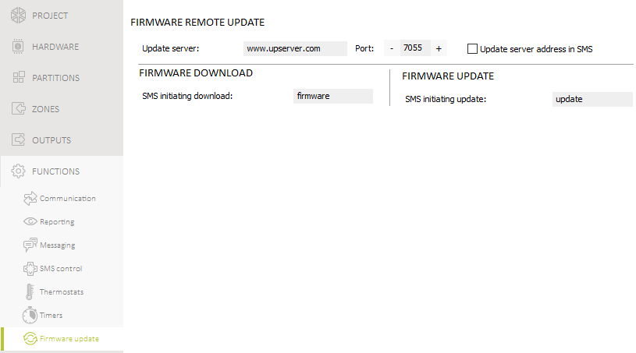
Fig. 26. “Firmware update” tab.

Firmware download
SMS initiating connection [116.Download FW] – the control command which can be sent in the SMS message to initiate firmware download from the UpServ update server. You can enter up to 8 alphanumeric characters (digits, letters and special characters). You can enter spaces, but at least one character must be different from the space.
The command content must be different from that of the other control commands preprogrammed in the control panel.
The control panel sends out an SMS notification on how the new firmware download has proceeded. The notification is sent to the telephone from which the SMS message initiating the firmware download was received.

Firmware update
SMS initiating update [117.Update FW] – the control command which can be sent in the SMS message to initiate update of the control panel firmware. You can enter up to 8 alphanumeric characters (digits, letters and special characters). You can enter spaces, but at least one character must be different from the space.
The command content must be different from that of the other control commands preprogrammed in the control panel.
The control panel sends out an SMS notification on how the firmware update has proceeded. The notification is sent to the telephone from which the SMS message initiating the firmware download was received.

Procedure of remote update for control panel firmware
The SMS messages that initiate new firmware downloading and firmware updating can only be sent from the phone whose number is saved on the control panel (see “Phones” p. 53).
- Send to the number of SIM card currently used by the control panel an SMS message containing control command to initiate firmware download from the UpServ update server. If the Update server address in SMS option is enabled in the control panel and you want the control panel to connect to an update server other than that indicated in the control panel settings, the message should look like this: xxxx=aaaa:pp= (xxxx – control command; aaaa – server address (IP address or domain name); pp – port number).
If an SMS message containing the firmware download initiating command is re-sent when the new firmware downloading is in progress, the control panel will indicate in reply the download progress (percentage value).
- Completion of the new firmware download will be indicated by the control panel with an SMS message.
- Send an SMS message containing the control command to initiate the control panel firmware update.
- Completion of the control panel firmware update will be indicated by the control panel with an SMS message.

Users
There can be 62 users in the system. To simplify the procedure of adding / editing a user, the control panel makes available:
- user schedules,
- default keyfob functions.

User list
The installer can manage the alarm system users (add / edit / delete users) in the PERFECTA Soft program.
For instructions on how to manage the users from the keypad, please refer to the user manual.
User name – individual name of the user (up to 16 characters).
Schedule – user schedule (see: “User schedules” p. 63). Right-click on the field to select a schedule from the list.
P1...P4 – fields correspond to partitions 1-4. If the symbol is displayed in the field, the user has access to the partition. If the field is empty, the user has no access to the partition. Double-click on the field to make changes.
Code – string of digits used for user authentication (4-8 digits).
Card – number of the proximity card owned by the user. Each card has a unique number used for user authentication.
Show codes – if the option is enabled, you can read the codes that have not been changed by the users. If the option is disabled, all codes are hidden (displayed as a string of asterisks).
– click to add the proximity card to the user.
– click to delete the user’s proximity card.

Adding a user
- Click on the field in the “User name” column. Enter the individual name of the user.
- Right-click on the field in the “Schedule” column. The list of user schedules will be displayed. Click on the schedule you want to assign to the user.
- Specify which partitions are to be accessed by the user. Double-click on the field in the “P1” (partition 1) column, “P2” (partition 2) column, “P3” (partition 3) column or “P4”.
- Click on the field in the “Code” column. Enter the user code.
- Click to save the changes to the control panel.

Deleting a user
- Right-click on the field in the “Schedule” column. The list of user schedules will be displayed. Click on “0: NOT PRESENT”.
- Click to save the changes to the control panel.

Adding a proximity card
You can add a proximity card in two ways: enter the card number manually or read its number using a device provided with a proximity card reader.

Entering card number manually
- Click on the field in the line with user data and in the “Card” column. Enter the card number.
- Click to save the changes to the control panel.

Reading card number
- Click on the user to whom you want to add the card.
- Click . The proximity card adding panel will be displayed.
- In the “Reader” field, select a reader device that you want to use to read the card number (a keypad provided with a reader or a proximity card arm/disarm device).
- Follow the instructions that will be displayed and bring the card close to the reader twice.
The proximity card/disarm device sends the card number only after you move the card away from the reader.
When the PRF-LCD-A2 keypad is powered by the battery, the reader works only if the keypad is woken up (when the keypad is in the sleep mode, press e.g. to wake it up).
- When the “Card read” message is displayed, click “OK”. The proximity card adding panel will close.
- Click to save the changes to the control panel.

Deleting a proximity card
- Click on the user from whom you want to delete the card.
- Click . The “Delete” window will be displayed.
- Click “Delete”. The “Delete” window will close.
- Click to save the changes to the control panel.

User schedules
The user schedule defines the user rights. The control panel offers 5 user schedules. When adding or editing a user, one of the user schedules is selected.
Changing the rights in user schedule results in a change of rights of all the users to whom that schedule was assigned.

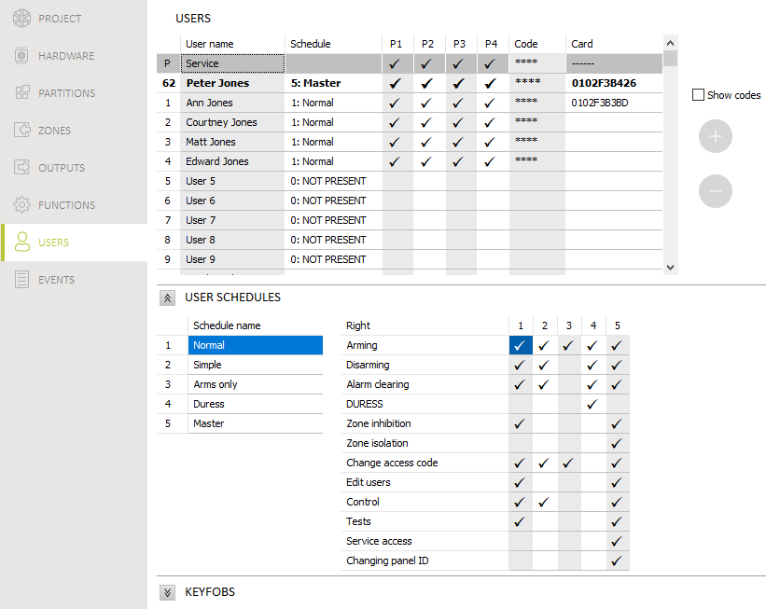
Fig. 27. “Users” tab.

User schedule settings
Schedule name [121.Schedules] – individual name of the user schedule (up to 16 characters).
Right [121.Schedules] – defines which functions are available to the user. The following rights are available:
Arming – the user can arm the system.
Disarming – the user can disarm the system.
Alarm clearing – the user can clear alarms.
DURESS – a special right that allows to define in the system a code which, if used, will trigger a silent alarm (which is signaled in no way, but the alarm code is sent to the monitoring station). The alarm will be triggered in the partition in which alarm would be triggered in the event of tamper of the keypad used for code entering.
Zone inhibition – the user can inhibit the system zones by means of the Inhibit function.
Zone isolation – the user can isolate the system zones by means of the Isolate function (the Zone inhibition right is additionally required).
Change access code – the user can change own access code (Change code function).
Users editing – the user can add, edit and delete users (Users function).
Control – the user can control the outputs by means of the Outputs ctrl. function and edit the timer and thermostat settings.
Tests – the user can view the event log, set the clock, check troubles / system state and run the functions available in the Tests submenu (except for the ID change function).
Service access – the user can run the Replace battery, Service access and PERFECTA Soft functions.
Changing panel ID – the user can run the ID change function (the Tests right is additionally required).

Keyfobs
The users can use keyfobs if one of the modules is connected to the control panel:
- ACU-220 / ACU-280 – ABAX 2 system keyfobs (APT-200),
- PERFECTA-RF – MICRA system keyfobs (MPT-350),
- INT-RX-S – 433 MHz keyfobs (MPT-350 / T-4 / T-2 / T-1).
The installer can manage the users’ keyfobs (add / edit / delete keyfobs) in the PERFECTA Soft program.
For instructions on how to manage the users’ keyfobs from the keypad, please refer to the user manual.
Name – user name.
Serial number – serial number of the keyfob. Each keyfob has a unique serial number used for user authentication.
Keyfob buttons – number of the function started on pressing the button. You can assign a different function to each keyfob button. Right-click on the field to select a function from the list. The columns are labeled with the symbols corresponding to the APT-200 and MPT-350 keyfob buttons. Refer to Table 5 to find out how to interpret the symbols if the T-4 keyfob is used.

Column label | ○ | □ | ▲ | ■ | ● | ○+●
Number of T-4 keyfob button (see: Fig. 28) | 1 | 3 | 4 | 1+3 | 2 | 1+2
Table 5. Column labels corresponding to particular T-4 keyfob buttons.

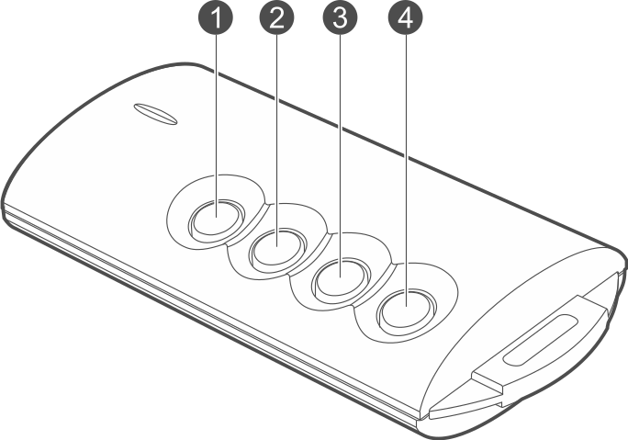
Fig. 28. T-4 keyfob and button numbers.

Event – if the symbol is displayed in the field, each use of the keyfob is saved to the event log. If the field is empty, using the keyfob is not saved to the event log. Double-click on the field to make changes.
Keyfob LEDs – operating mode of the APT-200 keyfob LED on pressing any button (the button does not need to start any function):
* - LED is ON,
[empty field] – LED is OFF,
[number] – number of the output whose state is indicated by the LED (LED is ON – output activated; LED is OFF – output deactivated).
You can select a different operating mode for each APT-200 keyfob LED. Right-click on the field to select the LED operating mode from the list. The LED settings are available if the ACU-220 / ACU-280 controller is connected to the control panel.
Read – click to read the keyfob data from the controller. The button is available if the ACU-220 / ACU-280 controller is connected to the control panel.
Write – click to save the keyfob data to the controller. The button is available if the ACU-220 / ACU-280 controller is connected to the control panel.
– click to add the keyfob to the user.
– click to delete the user’s keyfob.

Adding a keyfob
If the ABAX 2 controller (ACU-220 / ACU-280) is connected to the control panel, before you add the keyfob, click on the “Read” button to read the keyfob data from the controller (the data is not read when you click on the menu bar).
- Click on the field in the “Serial number” column next to the name of the user to whom you want to add the keyfob.
- Click . The keyfob adding panel will be displayed.
- Use the “auto” option to select the keyfob adding method:
- do not enable this option if you want to enter the keyfob serial number manually (this method is recommended when other keyfobs are used in the area, which makes it difficult to read the new keyfob’s serial number during transmission),
- enable this option if you want the keyfob serial number to be read during transmission from the keyfob.

Entering serial number manually
- Enter the keyfob serial number in the “Serial number” field.
- Press any keyfob button.
- When the “Device’s data read” message is displayed, click “OK”. The keyfob adding panel will close.
- Save the changes (click “Write” if the ABAX 2 controller is connected to the control panel / click if the PERFECTA-RF / INT-RX-S module is connected to the control panel).

Reading serial number during transmission
- Press any keyfob button.
- When the serial number will be displayed, make sure it is the serial number of the added keyfob, then press again any keyfob button.
- When the “Device’s data read” message is displayed, click “OK”. The keyfob adding panel will close.
- Save the changes (click “Write” if the ABAX 2 controller is connected to the control panel / click if the PERFECTA-RF / INT-RX-S module is connected to the control panel).

Deleting a keyfob
If the ABAX 2 controller is connected to the control panel, before you delete the keyfob, click on the “Read” button to read the keyfob data from the controller (the data is not read when you click on the menu bar).
- Click on the field in the “Serial number” column next to the name of the user from whom you want to delete the keyfob.
- Click . The “Device deleting” window will be displayed.
- Click “Delete”. The “Device deleting” window will close.
- Save the changes (click “Write” if the ABAX 2 controller is connected to the control panel / click if the PERFECTA-RF / INT-RX-S module is connected to the control panel).

Default keyfob settings
You can configure the default keyfob settings (assign functions to buttons / define operating mode of LEDs). This makes it easier to add keyfobs because each new keyfob will be automatically configured based on the default settings. The settings of each keyfob can be later customized to the user needs and rights.
Changing the default functions has no effect on the settings of keyfobs which are already added to the users.

Restoring the factory settings
You can restore the factory default settings of the control panel using the keypad or the PERFECTA Soft program.

Restoring factory settings from keypad
- Start the service mode (see “Starting the service mode” p. 3).
- Press in turn to run the 02.Factory set function.
- You will be prompted whether to restore the factory settings.
- Press to restore the factory settings.

Restoring factory settings from PERFECTA Soft program
- Click on the “Project” tab.
- Click on “Restore manufacturer settings”.
- You will be prompted whether to restore the factory settings.
- Click on “Restore” to restore the factory settings.

Manual update history
Manual version | Introduced changes
07/20 | - Information on the required version of PERFECTA Soft program has been modified (p. 6).  - Description of “AC loss report delay” mainboard parameter has been modified (p. 15).  - Description of “Grade 2” option has been updated (p. 17).  - Description of “AC loss report delay” zone expander parameter has been modified (p. 36).  - Description of “AC loss report delay” output expander parameter has been modified (p. 36).  - Description of “Reporting priority” parameter has been modified (p. 51).  - Description of “Number of attempts” parameter has been added (p. 51).  - Description of “Interval between attempts” parameter has been added (p. 51).  - Description of “Suspend time” parameter has been modified (p. 51).  - Description of user rights has been updated (p. 64).



Alarm control panel
EN

PERFECTA 64 M
Firmware version 2.00




PROGRAMMING
perfecta_64_M_p_en 01/23


SATEL sp. z o.o. • ul. Budowlanych 66 • 80-298 Gdańsk • POLAND
tel. +48 58 320 94 00
www.satel.pl
nie drukować



