WARNING
To avoid any problems during operation of this control panel, it is recommended that you familiarize yourself with this manual before you start using the equipment.
Making any construction changes or unauthorized repairs is forbidden. This applies, in particular, to modification of assemblies and components. Maintenance and/or repair operations should be performed by authorized personnel (i.e. the installer or factory service).
The control panel should only be connected to the analog subscriber lines. Connecting its telephone circuit to a digital network (e.g. ISDN) may cause damage to the equipment. In case of changing the analog line to the digital one, it is necessary to contact the alarm system installer.
Pay special attention if the telephone line used by the control panel is frequently busy and/or failures are reported, concerning the line and/or monitoring. Report such situations to the alarm system installer immediately.
To ensure adequate protection, the alarm security system must be in good working order, therefore SATEL recommends that it be regularly tested.
The alarm security system cannot prevent burglary, assault or fire from happening, but it guarantees that in case of emergency measures will be taken to reduce the possible damage (the alarm will be signaled optically and acoustically, appropriate services will be notified, etc.), which may deter the potential burglars.

CAUTION!
The security alarm system is fitted with a battery. Do not throw the used-up battery away, but recycle it as required by the existing regulations (European Directives 91/157/EEC and 93/86/eec93/86/eec).

Currently valid EC declaration of conformity and product certificates are available for downloading on the website www.satel.pl | 

CONTENTS
1. Introduction 2
2. Technical Performance of Security Alarm System 2
3. Alarm System Operating Costs 2
4. General Description 3
5. Operation 3
5.1 LED functions 4
5.2 LCD display functions 5
5.3 States signaled acoustically on the keypad 6
5.4 Events signaled on alarm outputs 7
5.5 Signaling tamper alarm 7
5.6 Signaling warning alarm 8
5.7 User codes 8
5.8 Armed mode of the control panel 9
5.8.1 Full armed mode (1)  9
5.8.2 Night armed mode (2)  9
5.8.3 Day armed mode (3)  10
5.8.4 Partition time parameters 10
5.9 Code arming 11
5.10 Quick arming 12
5.11 Disarming and alarm clearing  12
5.12 Controlling the control panel armed mode with proximity cards 13
5.13 Remote control of the control panel operation 13
5.14 Using timers in the alarm system 13
5.15 Auto-arming deferment 14
6. User Functions of "PRESS AND HOLD DOWN" Type 14
6.1 Enabling/disabling the chime signal  14
6.2 Changing the display mode  14
6.3 Fire alarm  14
6.4 Auxiliary (Medical) alarm  14
6.5 Panic alarm  15
6.6 Checking the armed mode 15
7. Direct Control of Outputs 15
8. User Functions Available After Entering Code 15
8.1 Entering changes to the user functions 19
8.1.1 Options 19
8.1.2 Numerical data 19
8.1.3 Telephone numbers 21
8.1.4 Names 22
8.1.5 Detailed description of the user functions 23
9. Using Proximity Cards for System Control 36
10. Using Remote Control Key Fob in the System 37
11. Short Description of Keypads 38

Introduction
We are happy you have chosen a product offered by SATEL and hope you will be satisfied with your choice. Please be assured that we are always ready to provide you with professional assistance and information on our products.
The SATEL Company is manufacturer of a broad range of devices dedicated for use in security alarm systems. Further information is available on our website www.satel.pl or at the points of sale offering our products.

Technical Performance of Security Alarm System
The alarm system is built of technical devices, the performance of which has crucial effect on the effectiveness of the facility protection. Components of the alarm system may be exposed to various external factors, such as weather conditions (e.g. outdoor sirens and, during a storm, also other devices, as a result of atmospheric discharge which may cause harm to electrical and telephone installations) or mechanical damage. Only a routine check of the system operation makes it possible to maintain a high level of burglary protection.
The control panel is provided with a number of safeguards and automatic diagnostic features to test the system performance. Detection of irregularities is signaled by the  [trouble] LED on the keypad. Respond to such a situation immediately and, if necessary, consult the installer.
Functional test of the alarm system must be carried out on a regular basis. Check that the control panel responds to violation of particular detectors, that fields of view of those detectors are not obstructed, that there is reaction to opening the protected doors, and that signaling devices and telephone messaging are functioning properly.
The installer will specify in detail how the system is to be checked. It is recommended that the installer carry out periodic maintenance of the alarm system at the user's request.
It is in the user's interest to foresee and prearrange the procedures to be followed when the control panels starts signaling an alarm. It is important to know how to verify the alarm and identify its source on the basis of keypad information, and take appropriate measures, e.g., to organize evacuation.

Alarm System Operating Costs
The main task of the control panel is signaling and efficient notification about alarm situations and, in the case of the reporting function, providing the monitoring station with real-time information about the protected facility status. Execution of these functions, based on the use of telephone line, entails some financial costs. Generally, the level of costs incurred by the alarm system owner depends on the amount of information the control panel must transfer to the monitoring station. A failure of the telephone links, as well as incorrect programming of the control panel, may substantially increase these costs. Such a situation usually results from an excessive number of connections made.
The installer can adjust functioning of the alarm system to the specific conditions and the type of protected premises, however it is the user who should decide if his or her priority will be to transfer information at any price, or, if some technical problems occur, the control panel will be allowed to skip some events, the reception of which has not been acknowledged by the monitoring station.

General Description
The VERSA control panel is an up-to-date, microprocessor-based control panel, designed for intruder alarm systems. It is characterized by very easy operation, legible information delivered to the user and highly reliable functioning. It is provided with a telephone communicator (dialer) which ensures voice and text messaging capability, as well as interfacing between the alarm system and the monitoring station. The control panel supports various types of modules which expand its functionality.
The control panel has been designed for such premises as: apartments, detached houses, stores, shops, kiosks, etc. Optional subdivision of the system into two fully independent or overlapping partitions, as well as three armed modes which can be enabled individually for each partition, ensure high flexibility during configuration of the system. Based on one control panel, two independent alarm systems with own detectors and sirens can be created. Such systems can be controlled by means of one common or a few separate keypads.

Operation
This manual describes the operating rules for the VERSA control panel. Basic operation of the alarm system is limited to arming / disarming and suitably responding to the information which may be signaled by the control panel.
Using the control panel keypad, it is possible to trigger special alarms (PANIC, FIRE, MEDICAL), bypass the zone lines, establish connection with the service computer, and control electrical devices, such as: electromagnetic lock, fan, lighting, etc.

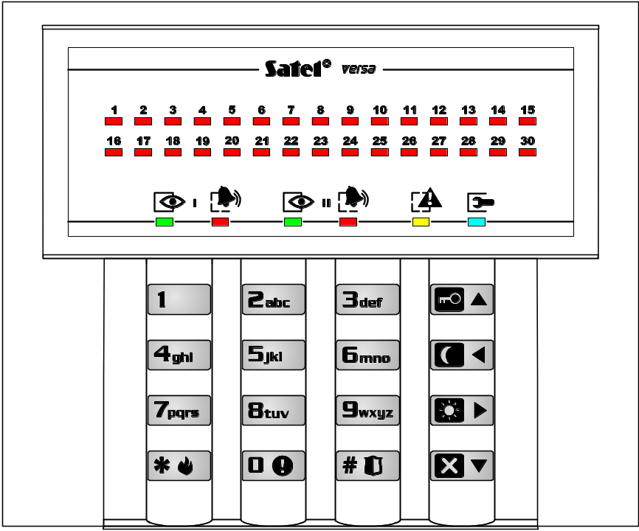
Fig. 1. View of the VERSA-LED-GR keypad.

The LED type keypad provides information on the alarm system status by means of 36 LEDs and audible signals.
The LCD type keypad provides information on the alarm system status by means of a liquid-crystal display (2x16 characters), 6 LEDs and audible signals.
Backlighting of the keys and display in the LCD keypad may be permanent or automatically activated by a keystroke or violation of the indicated zone of the control panel during the armed mode. Operation mode of the backlight is specified by the installer.

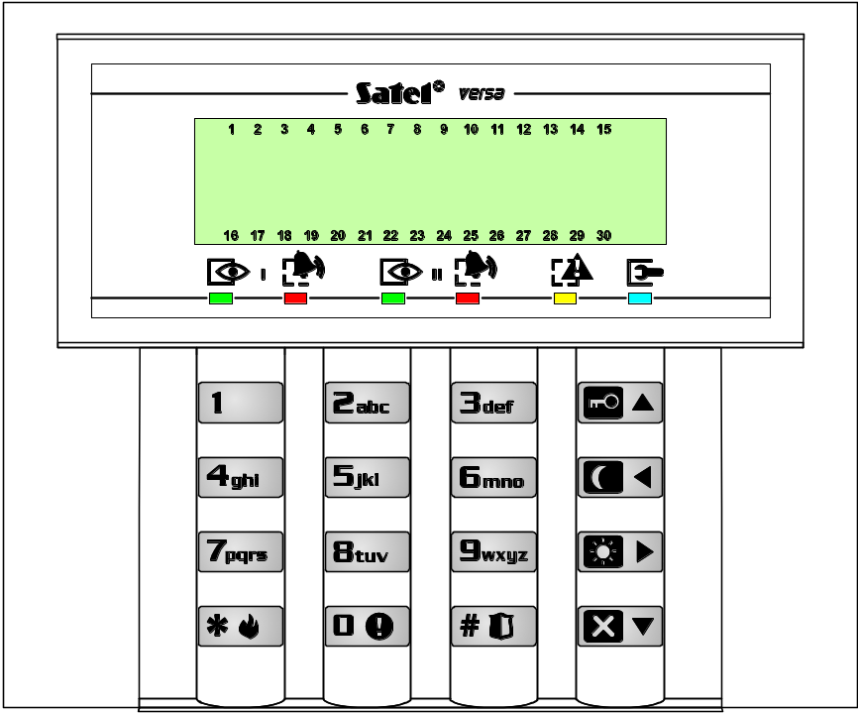
Fig. 2. View of the VERSA-LCD-GR keypad.

LED functions
The LEDs provide information on the alarm system status and are designated by the following symbols:
 | alarm (red color) – alarm indicator, separate for each partition.  - Lit – indicates burglary alarm in the partition, goes off after the alarm is cleared.  - Lit with short extinguishments – burglary alarm occurred in the partition (alarm memory).  - Blinking at a uniform rate (0.5s/0.5s) – fire alarm.  - Short blinks every 2s – fire alarm memory.  - Blinking at a uniform rate (1s/1s) – tamper alarm, tamper alarm memory.  - Blinking rapidly (0.25s/0.25s) – warning alarm; signal duration 30s.  - Blinking twice every 2s – indicates countdown of warning alarm time in partial armed mode, if the time is longer than 30 seconds.  The Alarm LED for partition II lights up together with the trouble LED after entering the programming of service function settings (the first stage of programming).
 | armed (green color) – armed mode indicator, separate for each partition.  - Lit – the partition is armed (optionally, the LED can be extinguished by the control panel after the set time from 1 to 255 seconds after arming has elapsed – service setting).  - Blinking – countdown of the partition exit delay.
 | trouble (yellow color) – trouble indicator.  - Blinking slowly – indicates that a trouble has occurred in the alarm system. The LED goes off on arming one or two partitions, on clearing the cause of trouble or after executing the current trouble check function (user function no. 7) and clearing the trouble memory.  - Blinking rapidly – the control panel has entered the user function / service function menu.  - Lit – programming the function settings or checking the armed mode.
 | service (blue color) – indicator of the control panel operation in service mode.  - Lit – service functions available from the given keypad.  - Blinking – the control panel is in service mode, programming available from another keypad.
1…30    | zone (red color, LED type keypad only) – status indicators for the system zones. Detailed information is given in the next section of this manual.

LCD display functions
At its basic status, the LCD keypad can display date and time (format to be selected by the installer) or keypad name. The following system statuses can also be indicated (the order as per the display priority – from highest to lowest):
- auto-arming delay countdown;
- entry delay countdown;
- exit delay countdown;
- alarm from zone;
- alarm in partition;
- message service " System tamper, call service".
The messages on alarms from zones or partitions are displayed at the control panel emergency status. If the alarm has been triggered from several zones, you can review the names of those zones, using the arrow keys. Information on the alarm source is visible until the alarm is cleared. The message content includes the name of zone or partition. The installer decides whether such messages will be displayed.
The LCD keypad will display the status of control panel zones after you press and hold down the key for approx. 3 sec. Numbers from 1 to 30, indicating the fields assigned to individual system zones, are situated around the LCD display. Shown below are symbols which can be displayed in those positions, as well as their meaning. The column next to the symbols contains description of the lighting mode for LEDs representing individual zones on the LED keypad. The order in the table indicates the event priority (from highest to lowest) – the highest priority symbol is always displayed for the zone.
Note:
- If, when the control panel is in armed mode, a delayed zone is violated as the first one, and then alarm is triggered by another zone, the first alarm memory will be assigned to the zone which was violated first.
- If, after violation of a delayed zone, the armed mode is disabled without triggering alarm, then the first alarm (violation) memory will be automatically cleared.

Priority | LCD symbol | LED blinking mask  – OFF, – ON | Description
1 | b |  | zone bypassed *)
2 | D |  | long violation trouble *)
3 | X |  | no violation trouble *)
4 | ! |  | memory of first violation in armed mode (the zone triggered alarm in the partition or was violated as first, but is no longer violated), the first zone is indicated individually for each partition,
5 | ○ |  | violated tamper circuit of 2EOL zone
6 |  |  | zone violated
7 | s |  | zone triggered tamper alarm (tamper memory of 2EOL zone)
8 | a |  | zone triggered alarm (alarm memory)
9 | ▪ |  | zone free (not violated)
- |  |  | (blank field) no detector type programmed for the zone – no detector
*) States to be skipped (not displayed), if the partition to which the zone belongs is armed.
Table 1. Description of signaling the status of control panel zones on the keypad.

States signaled acoustically on the keypad
The keypad can generate the following beeps:
- one short – confirmation of a keystroke;
- two short – confirmation of entering the user function programming mode;
- three short – waiting for the code after partition armed mode is selected, disabling the chime signaling on keypad (key ), disabling the controllable output;
- one long (duration approx. 1.5 s) – an attempt of arming, when the control panel is not ready for supervision (some zones with the "priority" option enabled are violated or tampered); the [trouble] LED lights up at the same time;
- two long – invalid code, unavailable function, canceled function or wrong function data, exiting the timer programming function;
- three long – code recognized, but the function called is unavailable or execution of the function is for some reason impossible at the moment;
- four short, one long – arming/disarming, exiting the service mode, correct termination of the programming function, enabling the chime signaling on keypad, activating the control panel controllable output.

Event signaling in the system:
- continuous beep – alarm;
- intermittent beep (0.25s/0.25s) – warning alarm;
- intermittent beep (0.5s/0.5s) – fire alarm;
- one long beep every 3 sec – signaling the exit delay countdown;
- two short beeps every 1.5 sec – signaling the entry delay countdown;
- two short beeps every 2.5 sec – signaling a new trouble;
- five short beeps – violation of a zone with "CHIME" option;
- a series of beeps with diminishing duration every 5 sec – auto-arming delay countdown.
The installer decides which events are to be acoustically signaled on the keypad.
Note : The last 10 seconds of exit delay countdown is signaled by a series of short beeps ended by one long beep. The purpose of this way of signaling is to indicate the moment of the countdown completion to the user.

Events signaled on alarm outputs
If the control panel armed mode is remotely controlled (e.g. by means of key fob), the installer can enable the arming/disarming and alarm clearing signals on the siren control outputs. If the output controls operation of a siren, the latter will generate short sounds (in much the same way as in the car alarm systems). The signals have the following meaning:
- one short sound – arming;
- two short sounds – disarming;
- four short sounds – alarm clearing or disarming and alarm clearing.
Additionally, the alarm outputs signal the typical situations for the alarm system:
- continuous signal – burglary alarm;
- intermittent signal 1 s/1 s – fire alarm.

Signaling tamper alarm
Since the alarm installation is watched 24 hours a day, whether the system is armed or not, violation of any component of the installation will trigger tamper alarm in the partition to which the given component is assigned. Such an alarm may be signaled only on selected sirens, which may be activated only when the control panel is in armed mode. The loud signaling mode should be set by the installer of the system.
On the LED keypad, the [alarm] LED lights up and the [trouble] LED starts blinking during the tamper alarm. On the LCD keypad, a message can be displayed, indicating the alarm source. The alarm can be caused by:
- opening the enclosure (of control panel, expander, detector, siren or keypad);
- tearing off the enclosure from the wall (mounting surface);
- damaged cable, etc.
As each of the above situations can pose a threat to the security of protected premises, the installer should be notified about the existing situation, so as to carry out inspection of the installation and repair the faults, if any.
In order to encourage the user to take action, the installer can optionally enable the options Trouble memory until review and Service message after tamper alarm. In this case, the "System tamper, call service" message will be displayed and the [trouble] LED will start blinking when the alarm is cleared on the LCD keypad. The LED keypad will also signal a trouble in the system and some LEDs may be blinking on it, if the tamper affects defined zones of the control panel. The alarm source can be determined by viewing the log of current troubles (user function no. 7).
The administrator (master) or an ordinary user can clear the alarm, but he cannot clear the service message and the trouble memory. The message after tamper alarm can only be cleared by means of the service code after the current troubles are reviewed and the trouble memory cleared by using the 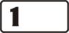 key when exiting the view function. If the cause of reported tamper is not cleared, the trouble signaling will continue and the message will not disappear.
If the Service message after tamper alarm option is not enabled by the installer, only the [trouble] LED will be blinking after the tamper alarm is cleared, and the date and time will be displayed on the LCD keypad. The user with Inspection privilege will be able to clear the trouble memory.
If the Trouble memory until review is not enabled by the installer either, the trouble signaling will end on clearing the tamper signal cause.

Signaling warning alarm
The installer can activate the Warning alarm function in the control panel. The warning alarm function is aimed at limiting the number of false alarms caused mistakenly by the user when disarming the system or moving around the premises where partial armed mode is activated. The warning alarm is especially important in systems in which suppression of armed mode information is used. If the user misses the time for disarming the system during the entry delay countdown or violates the indicated zone which is armed in the (night or day) partial armed mode of the partition, the control panel can trigger the warning alarm. The warning alarm, which is signaled on the keypad and, optionally, on the indoor siren, does not activate reporting, messaging and/or outdoor signaling.
The warning alarm procedure is as follows. On violating the entry zone, the control panel will start the entry delay countdown. If the user fails to disarm the system, the control panel will trigger acoustic signaling on the keypad (provided the signaling is active) by an intermittent signal (0.25 s/0.25 s) for 30 seconds, as well as optical signaling by the [alarm] LED. Next, the burglary alarm signaling will be set off. If the user can manage to disarm the system, the burglary alarm will not be signaled.
In case of the warning alarm in partial armed mode, the installer sets the zones which, when violated, can trigger the warning alarm in the same way as the entry zone. Different warning alarm times can be programmed for each partition (up to 255 s). If the time is not programmed, the warning alarm will last 30 seconds, as in the case of entry zone violation. Irrespective of programmed time duration, the acoustic warning alarm on keypad will last for the first 30 seconds.
Note: The warning alarm is generated only once after the system has been armed.

User codes
For everyday operation of the control panel, it is necessary to know the user code (the code is a sequence of 4 to 8 digits from the 0–9 range). Entering the code should be completed by pressing the key which corresponds to the operation you want to carry out. Details are described below in this manual.
When entering the code, the keypad may show the number of entered characters of the code. In the LCD keypad, asterisks are displayed in the lower line, illustrating the subsequent code characters, while in the LED keypad, LEDs light up in succession, starting from number 16.
The code can control one or two partitions, can have different authority levels (user schedules) and assigned name, depending on the selection made when entering a new user or editing an existing one.
To each user code (except for the service code), it is possible to assign a proximity card or another passive transponder and a key fob, which are used to control the alarm system (arm/disarm; using the key fob, you can also control the control panel outputs, trigger special alarms, activate the alarm signaling delay).

The following factory defaults are programmed in the control panel:
user code no. 30 (administrator) 1111
service code 12345

Using any of the above codes you can:
- arm the system (in one or two partitions, in one of 3 available modes);
- change the armed mode in one or two partitions;
- disarm the system in one or two partitions;
- clear alarm;
- call up the user function menu.
Notes:
- The Service code opens next menus and functions intended for the installer (Service mode).
- Disarming can be combined with simultaneous alarm clearing.
- To clear alarm without disarming the system, use the code to repeat the operation of arming the system in one of the three modes.
- The user menu gives access to number of functions described below in this manual. The user has access to the functions which he is authorized to execute at the moment.

Using the administrator's (master's) or service code enables 29 next user codes to be programmed or deleted, if they have already been programmed. Using the service code, you can delete all the user codes.
Notes:
- Code properties, grouped into the user schedules, are described in the section on creating a new user (see page 24).
- The installer can change the authority level and names of the particular user schedules.

Armed mode of the control panel
The VERSA system enables two separate or overlapping partitions to be created. The zones (detectors) belonging to both partitions can be armed as soon as one of the partitions is armed or only after both of them are armed – service setting.
Each of the partitions can be controlled separately, i.e. arming or disarming of one partition does not depend on the other partition status. If the code is to control both partitions, it can be used to arm/disarm the selected partition or both partitions simultaneously.
In order to adjust the alarm system to various situations, the VERSA control panel offers a few partition armed modes.

Full armed mode (1)
Operating mode during which the detectors connected to the control panel control the indicated partition, and violation of the protected areas is signaled by the control panel with all available means (monitoring, messaging, sirens, keypad).

Night armed mode (2)
Supervision mode during which some detectors indicated by the installer are inactive (e.g. those monitoring the sleeping room or one floor area). Violation of the active detectors results in normal reaction of the control panel, as in the full armed mode.

Day armed mode (3)
Supervision mode during which some detectors indicated by the installer are inactive (e.g. those monitoring the interior of the whole apartment). Violation of the active detectors results in normal reaction of the control panel, as in the full armed mode. Usually, the area within which movement is possible inside the protected premises (partition) with activated day armed mode is larger than with activated night armed mode.

Partition time parameters
Armed mode of the control panel is connected with the partition entry delay and exit delay times. The installer sets these time values separately for each partition.
After the partition has been armed, the user should leave the protected area. Depending on the armed mode, different areas and elements of the premises are protected. The installer should instruct the user, where he can move around after the given armed mode is activated.
From the moment of arming (irrespective of the type of armed mode), the control panel starts signaling the exit delay countdown. The card readers and keypads may generate appropriate sounds, and the  [armed] LEDs on the keypad start blinking. The LCD type keypad will display information on the time left before arming the delayed zones (the instant zones become active at once). If the exit delay countdown is running in both partitions, the keypad shows the partition in which the countdown will be finished first, and then displays the exit delay time for the partition which is not armed yet. The LED type keypad shows symbolically the time before the partition is armed, by means of LEDs. The LEDs with numbers 1-15 refer to the partition I, and the LEDs 16-30 – to the partition II. If the time before arming is longer than 30 seconds, all LEDs are lit. If the time is reduced to below 30 seconds, then one LED goes out every 2 seconds, starting from number 15 for the partition I and number 30 for the partition II.
Violation of the entry zone during the armed mode will start the entry delay countdown. Unless the partition is disarmed before expiry of the delay time, then after completion of the countdown the control panel will start signaling the warning alarm or the regular alarm, if the warning alarm function is not enabled. Violation of the instant zones, despite the entry delay countdown, may trigger the alarm. Signaling of the alarm may be delayed by the Warning alarm time, if the warning alarm function is enabled.
The entry delay countdown can be signaled, similarly as the exit delay countdown, by a suitable acoustic signal and information on the LCD keypad display. In the LED keypad, by contrast, all the LEDs (1-15 or 16-30) are blinking simultaneously during the entry delay countdown, symbolizing the time left until the partition I or II is disarmed.
Notes:
- During arming, the exit delay countdown can be finished and the delays disabled. If this is the case, violation of any armed zone (including the entry/exit and delayed ones) will trigger instant alarm. In order to activate the armed mode with disabled entry delay, enter the code and then press and hold down for approx. 3 seconds the key indicating the type of armed mode. This function is mainly used when activating the day or night armed mode.
- It is possible to change over between the control panel armed modes without disarming.
- If, prior to changing over the armed mode, the control panel was signaling alarm, then after change-over to another armed mode using the code, the alarm will be cleared. The alarm signaling can also be cleared by "re-starting" the same armed mode in which the control panel was before.
- Changing over the armed mode will start signaling of the partition exit delay time, if it was programmed and was not disabled by holding down the key. The user who remains in the premises can disable the acoustic signaling in the keypad for approx. 60s by pressing any numerical key.

Code arming
In order to arm the system, enter the code and press the key indicating the armed mode. If you make a mistake when entering the code, press the key and re-enter the code. Enter the code carefully. Entering an invalid code 3 times may trigger an alarm (option Alarm: 3 incorrect codes enabled).
If the code is correct and the arming is possible, the control panel will confirm acceptance of the command by four short beeps and one long beep and become armed. If the Exit delay has been programmed by the installer, the [armed] LED will start blinking, the buzzer will generate periodical beeps, indicating that the delay time countdown has started. The Entry/exit and Delayed zones will be armed after completion of the countdown, while the Instant zones will be armed immediately.
The installer defines duration of the Exit delay and the operating mode of acoustic signaling.

Example: arming by "VERSA" user code (digits: 83772).
Press in turn:  to activate full armed mode.
Press in turn: to activate full armed mode.
Press in turn: to activate night armed mode.
Press in turn: to activate day armed mode.

Note : Using the sequence [CODE] will only arm the system, when no partition is armed and the control panel is not signaling alarm. If any of these situations occurs, the sequence [CODE] will disarm the system and/or clear the alarm.
If the code controls both partitions, the above mentioned method will arm both partitions in the same mode. In order to arm just one partition or activate different types of armed mode in different partitions using such a code (which controls both partitions), press in turn the key with partition number and the key with armed mode type. After the partition and armed mode are selected, the backlight of keypad keys will start flashing, which indicates that the code should be entered now and the same armed mode confirmed.

Example: Arm the second partition by the "VERSA" code in the night armed mode. The code controls both partitions.
Press in turn:
In order to change the armed mode, if it is already activated, proceed exactly in the same way as during the ordinary arming.
Note : The above described method for arming a single partition is only used when the quick-arming function is not activated in the keypad. If this function has been started, then arming a single partition or changing the partition armed mode need not be confirmed by code.

The control panel may fail to arm the system, if:
- The control panel is not ready for arming: there are some installer defined zones, which cannot be violated when arming ("priority" option) and one of such zones is violeted – which is signaled by the control panel by one long beep, lighting up the [trouble] LED and displaying the names of violated zones on the LCD keypad.
If this is the case, wait a minute until all zones are free (in the LED keypad, the zone status indicator LEDs go out; in the LCD keypad, the violation symbols disappear) and reenter the code.
If some of the zones remain violated all the time (in the LED keypad, one of the LEDs is always lit, and in the LCD keypad, the symbol denoting zone violation is displayed – which may be caused e.g. by defective detectors), arming is possible after bypassing that zone (by the user function no. 4).
Note:
When viewing the violated zones, the control panel enables such zones to be quickly bypassed from the LCD keypad. In order to bypass the zone, press the  key. If the zone can be bypassed by the user, the keypad will display a message with the prompt whether the given zone is to be bypassed. Press the key to bypass the zone, and then the control panel will display information on the next violated zone, or will arm the system, if all violated zones have already been bypassed.
- A tamper has occurred in at least one of the 2EOL zones.
- The code is wrong – this situation is signaled by two long beeps.

Quick arming
Provision is made for a quick arming, without any code, by pressing in turn two keypad keys. It is possible to arm the first partition, the second partition or both partitions at the same time. The first key selects the partition, the second one – the type of armed mode.

 | PARTITION I | PARTITION II | PARTITION I and II
FULL ARMED MODE |  |  | or
NIGHT ARMED MODE |  |  | or
DAY ARMED MODE |  |  | or
Table 2. Arming without code.
Using the quick arming procedure you can change the armed mode without disarming the system. The armed mode can be changed to another one in each partition separately.
Note: Changing the armed mode without code will not clear alarm in the partition. Alarm can only be cleared, when the armed mode is changed with the use of code.

The control panel may fail to arm the system, if:
- The control panel is not ready for arming (see: description in previous section of this manual);
- the function is disabled by the installer.

Disarming and alarm clearing
If one of the partitions is armed (the [armed] LED is lit or blinking), alarming (the  [alarm] LED is lit or blinking) or armed and alarming at the same time, entering the given partition user code and confirming it with the or key will disarm the partition and/or clear the alarm. The code controlling both partitions will disarm and clear alarm in both partitions simultaneously (provided they are active). In order to disarm just one partition using such a code, entering the code must be preceded by pressing in turn the key with partition number and the disarming key.

Example: Disarm both partitions with "VERSA" code controlling both partitions.
Press in turn:
or

Example : Disarm partition II only with "VERSA" code controlling both partitions.
Press in turn:

If you make a mistake when entering the code, press the key and reenter the code. The control panel will confirm acceptance of the command by four short beeps and one long beep and extinguishment of the [armed] and/or [alarm] LED (if it is lit).
The control panel will not arm the system or clear the alarm, if the code is invalid or the user has no suitable privilege. Refusal to clear the alarm is signaled by three long beeps.

Controlling the control panel armed mode with proximity cards
The installer can install the INT-IT proximity card reader in the alarm system. The device enables one proximity card for controlling the partitions to be assigned to each user. The control extent is limited by the privileges of the given user code and settings of the device programmed by the installer. The control procedure is described below in this manual (see page 37).

Remote control of the control panel operation
The installer can install the 433MHz INT-RX key fob control expander in the alarm system. The device makes it possible to assign one remote control transmitter (key fob) to each user, to enable remote arming and disarming, clearing alarms, triggering panic, auxiliary (medical) or fire alarms, and controlling the outputs. The control extent is limited by the privileges of the given user code and settings of the module, programmed by the installer. The control procedure is described below in this manual (see page 38).
Furthermore, the installer can install any radio controller in the system, to enable remote control of the key fob, or special buttons, intended for simplified arming/disarming, triggering and clearing alarms. The control panel programmable zones can be used for this purpose. The armed mode will be always activated by means of the key fob, irrespective of the status (violation) of the control panel zones.
The installer can limit functionality of the armed mode control zone to arming only, while disarming and alarm clearing will require that a user code be used.
To facilitate the remote control of the control panel operation, the installer can enable the arm/disarm signaling by the acoustic or optical siren installed in the system. The method of remote control depends on the installed devices and settings programmed by the installer. The installer should instruct the user how the alarm system can be controlled by means of the key fob.

Using timers in the alarm system
The user has access to programming four Timers. The timer ON/OFF time is programmed separately for each day of the week and, additionally, the daily ON/OFF time is programmed. Thus each timer can have two periods of activity per 24 hours. The modules can automatically control the armed status of partitions or operation of the control panel controlling outputs. 4 time exceptions can be programmed for each timer, when the ON/OFF times will be different than usual. An exception can apply to one day or to a longer time interval.
In case of partition control, you can set the partition armed mode and the arming/disarming time. You may optionally program the arming time only, with disarming by the user or the other way round. The timer can control one or two partitions. The installer will set the so-called Timer priority option for each partition. If the option is enabled, disarming will be always done by the timer. If the option is disabled, partition will only be disarmed by the timer, if it was armed by the timer. If it was armed by the user, it will remain armed until disarmed by user.
In case of output control, the user can only change the output (timer) ON/OFF time. The numbers of controlled outputs and their operating modes are set by the installer. The output can be active throughout the entire period of timer activity, can become active for a programmed period of time or permanently (until deactivated by the user). The details of timer programming are described on page 30.

Auto-arming deferment
Automatic control of the partition armed mode is connected with the arming deferment function. The user who remains in the premises can defer the automatic arming for the time programmed by the installer, using the suitable user function (see page 30).
The installer can program the Auto-arming delay and the simple deferment option for the partition. In such a situation, the control panel warns by a suitable acoustic signal that the moment of arming is near, and the user can, during the delay time countdown, defer the arming by pressing the key twice. Arming can be deferred for time programmed by the installer. The simple deferment can be limited to one-time use. If further deferments are necessary, user code and the [6 1 #] user function must be used.

User Functions of "PRESS AND HOLD DOWN" Type
These functions are available to each user of the protected premises (without using the code). To call them up, press and hold down the appropriate key for about 3 sec (until acoustic signaling is triggered in the keypad).

Enabling/disabling the chime signal
Using this function (press and hold down the key), you can enable or disable the chime signal in the keypad (signaling violation of selected zones, when the control panel is disarmed). If execution of the function is confirmed by four short beeps and one long beep, the signaling is enabled, and if it is confirmed by three short beeps, the signaling in the keypad is disabled. The LCD keypad will additionally display a message to confirm the operation.
The installer defines which zones will generate the chime signal when violated.

Changing the display mode
The function is only available in the LCD keypad. It can switch the LCD keypad display modes between the date and time display and the graphical display of control panel zone status. Meaning of the symbols describing the status of zones is shown on page 5.

Fire alarm
The function enables fire alarm to be triggered from the keypad. The control panel initiates signaling on the keypad and on the Fire alarm, Internal siren, External siren outputs and sends the appropriate code to the monitoring station. The function may be disabled by the installer.

Auxiliary (Medical) alarm
The meaning of this alarm can be defined, depending on the needs. The function can be used for sending auxiliary alarm information to the monitoring station (it can be, for example, a signal of calling for medical assistance, as adopted in the "Contact ID" monitoring format).
The function may be disabled by the installer.

Panic alarm
The function enables panic alarm to be triggered from the keypad. The control panel initiates signaling on the alarm output, in the keypad and sends the appropriate code to the monitoring station. The function may be disabled by the installer or limited only to the LCD keypad (text message), monitoring and "PANIC alarm" output type (so-called silent panic alarm).

Checking the armed mode
The function enables checking the partition status. It is particularly useful, when the function extinguishing partition status indicator LEDs is enabled. On activating the function, the keypad will light up the [trouble] LED and display information on armed / disarmed mode.
In the LCD keypad, the message in the upper line of display refers to the partition I, and that in the lower line – to the partition II. Similarly, in the LED keypad, information referring to armed mode of the partition I is displayed in the upper line on LEDs 1-3, and the partition II – in the lower line on LEDs 16-18. The full armed mode is shown by LEDs 1 and 16, the night armed mode – by LEDs 2 and 17, and the day armed mode – by LEDs 3 and 18. If none of the LEDs 1-3 or 16-18 is lit, the corresponding partition is disarmed. Press the key to reset the armed mode information. The function may be disabled by the installer.

Direct Control of Outputs
The installer can activate the so-called "Quick control" function, which allows the user, by means of keypad keys and without using any code, to easily control the functioning of control panel outputs, and consequently, the functioning of electrical devices. One output to be controlled can be assigned to individual keypad keys from to .
Press a numerical key and the key to enable the output assigned to the given key, permanently or for a programmed time period (up to 100 minutes 39 seconds). Press the numerical key and the key to deactivate the output, if it was active.

Example : Deactivate the output 9 assigned to the key 9 and activate the output 10 assigned to the key 0.
Press in turn: to deactivate the output 9;
to activate the output 10.

User Functions Available After Entering Code
The users (including the service) have access to functions useful during everyday operation of the alarm system. For example, the timer settings or changing the service code are only available from the user function level. Having entered the service mode, the installer can program the user functions without any need for quitting this mode (service function 9).
To open the user function menu, described in this section, enter the User code and confirm it with the key. The control panel will confirm entering the user function mode (the main menu) by two short beeps and rapid blinking of the [trouble] LED. The functions are numbered, so they can be called up by entering the number from the keypad (both LED and LCD type). Having entered the user mode, press first the key with function number from the main menu, and then the key with function number from the submenu (if any). After the key is pressed, the LCD keypad will display the submenu name for two seconds, and then will open the list of functions available in the submenu. Also the LED keypad will wait 2 seconds and then it will enter the submenu.
Calling up the menu, submenu or function is acknowledged with two short beeps. In order to enter the function settings and check or change the parameter values, select the function number in the menu / submenu and press the or key. Generally, the possibility to change the settings of selected function is signaled by lighting up the [alarm] LED for the partition II and the [trouble] LED. For multi-stage functions on the LEDs designated [armed] and [alarm] for the partition I and II, the next stage number is shown in binary mode.
The user function menu is dynamic and changes depending on the user's authority level. Some functions are only available to the service, and some to the administrator only. The LCD keypad does not display the names of functions which are not available. An attempt to call up the number of function which is not available will be signaled by two long beeps, and the keypad will remain in the recently called submenu. In such a situation, by pressing the key you will enter the first available function from the given submenu. Therefore, pay special attention to the keypad audible signals during the programming.
If a parameter value you have entered during programming is too high, press the key and the keypad will display the maximum permissible value and will remain in the function waiting until the parameter is changed or re-confirmed. If, for whatever reason, the settings of the given function cannot be changed, the control panel will signal it by two long beeps and return to the basic mode.

Programming by means of the LCD keypad is easier, because of the display and the capability of text presentation. The arrow keys enable a function to be selected from the list. When you navigate through the user function menu, you can see a cursor on the left-hand side of the display, which changes, depending on the indicated menu item:
- indicates submenu name;
- indicates function name.
Having entered a submenu, you will open a next selection list, while having entered a function, you will be able to change its settings.

or - scroll through list
or - enter submenu or function
or - exit function without changing the settings
- confirm the changes and exit the function

The way of changing the settings is described further in this manual. After exiting the function, the keypad returns to its basic mode. To call up a next function, you must reenter the Code and confirm it with the key.
If, having entered the function, the user will make no change or will make a change, but will not confirm it, the keypad will return to the basic mode after 2 minutes (without saving any changes).
Shown below is a table with function numbers, function names in the LCD keypad, and a short description. The # character at the function number means that after selection of the function number you must press the key to start the function or enter the settings change menu.

Calling up the menu: CODE

Main menu number | Submenu number | Name in LCD keypad |  | Description
Main menu number | Submenu number | Main menu | Submenu | Description
0 |  | Service |  | Service related functions
0 | 0 # |  | Service mode | Entering the service mode *)
0 | 1 # |  | Start DwnlTEL | Starting telephone connection between the control panel and the service computer – the control panel will call the programmed telephone number of the service computer
0 | 3 # |  | Start DwnlRS | Starting programming the control panel with computer through RS-232 TTL port *)
0 | 4 # |  | Finish DwnlRS | Ending programming the control panel through RS-232 TTL port *)
0 | 5 # |  | Perman.sv.ac | Setting permanent access to the system for the service code **)
0 | 6 # |  | Access time | Time interval within which the installer can call up the user functions and start the service mode by means of the service code **)
1 # |  | Change code |  | Changing the user code
2 |  | Users |  | Functions related to the system users
2 | 1 # |  | New user | Adding a new system user
2 | 2 # |  | Edit user | Changing the settings of an existing system user
2 | 3 # |  | Remove user | Deleting an existing system user
3 # |  | Abort v.msg. |  | Canceling the telephone messaging
4 # |  | Bypasses |  | Bypassing the zones
5 # |  | Event log |  | Event log reviewing
6 |  | Settings |  | Settings available to the users
6 | 1 # |  | A-arm defer. | Deferment of auto-arming
6 | 2 # |  | RTC clock | Programming the date and time
6 | 3 # |  | Timers | Programming the timer settings
6 | 4# |  | Tel. numbers | Programming the telephone numbers to be notified
7 # |  | Troubles |  | Viewing the current troubles or trouble log
8 # |  | Control |  | Controlling the outputs
9 |  | Tests |  | Functions for testing the alarm system operation
9 | 1 # |  | Zone test | Functional test of the detectors connected to zones
9 | 2 # |  | Output test | Functional test of the devices controlled by outputs
9 | 3 # |  | ABAX sig.lvl. | Reading the radio signal level for ABAX devices
9 | 4 # |  | Manual MS tst | Manual start of the test transmission
9 | 5 # |  | MS1 test | Test of reporting to station 1
9 | 6 # |  | MS2 test | Test of reporting to station 2
9 | 7 # |  | VERSA version | Reading the version of control panel program
9 | 8 # |  | Expander ver. | Reading the version of connected module program
9 | 9 # |  | Supply volt. | Viewing the module supply voltages
9 | 0 # |  | Outputs reset | Deactivating the active outputs
*) Functions available after entering the service code
**) Functions available after entering the administrator code
Table 3. Main menu of user functions.
Note : The refusal to enter a submenu or a function is signaled by two long beeps, while the refusal to execute a function is signaled by three long beeps (e.g. when the function 21 is called up after all the users have already been entered).

Entering changes to the user functions

Options
Depending on the function, the control panel will make available for modification a single option or a set of options (so-called multiple choice list).

In the LCD keypad, the option status is indicated by means of a special character in the right upper corner of the display:
- option active (enabled),
- option inactive (disabled).
Press any numerical key ( - ) to toggle the option status to the opposite one. Use the keys to scroll through the list (if any) with text description. Pressing the keys will take you to the graphical mode of option display, and also will move the cursor indicating the number of option, the status of which can be changed.

In the LED keypad, the option status is indicated:
- for a single option – by brightness of the blinking LED no. 1
strong light - option active (enabled)
dim light - option inactive (disabled)
- for a set of options (lists) – by lighting of the LED with number corresponding to the option number in the list:
lit - option active (enabled)
extinguished - option inactive (disabled)
The keys move the blinking cursor, indicating the number of option, the status of which can be changed. The option status changes after any numerical key is pressed.
Having made the change, confirm the settings by pressing the key.

Numerical data
Depending on the type of function, the data can be entered in the form of decimal or hexadecimal numbers or alphanumeric characters.

LCD keypad
Data can be edited on the LCD keypad by inserting a character with simultaneous shift of all characters to the right of the insertion point. This mode is to be used when editing telephone numbers and names. Another editing mode consists in overwriting, i.e. replacing the indicated character by another one, entered from the keypad. The other characters do not change their place. Such a mode is used for editing the code, time, etc.
- the key delete the digit to the left of the cursor
- the keys shift the cursor to the right or to the left
- numerical key inserts or overwrites the character at the cursor point (depending on editing mode)
Note : When editing in the insertion mode, the last character of the number or name can be deleted, if the total number of characters, after inserting the character in the middle, exceeds the permissible number.
The Decimal numbers are entered by pressing the corresponding numerical key.

The Hexadecimal numbers consist of digits 0-9 and characters A-F (see: Table 5). To enter the digits 0-9, use the keys in the same way as for the decimal numbers, while to enter the characters A-F, use the or key, pressing it (2, 3 or 4 times) until the required character is displayed.
Number of keystrokes | Key
1 | 2 | 3
2 | A | D
3 | B | E
4 | C | F
Table 4. Way of entering the hexadecimal characters.

LED keypad
In the LED keypad, you cannot correct the values of parameter being entered. If you have made a mistake, exit the function and reenter it, so that the correct value can be entered. Three-digit numbers are displayed on LEDs 1-12, while the next digits in the longer numbers are displayed on LEDs 16-27.
LED status | Digits and characters
 | 0 |  | – LED OFF
 | 1 |  | – LED ON
 | 2
 | 3
 | 4
 | 5
 | 6
 | 7
 | 8
 | 9
 | A
 | B
 | C
 | D
 | E
 | F
Table 5. Binary mode of presentation of decimal numbers (0-9)
and hexadecimal characters (0-F) by means of LEDs.

Each digit or character is presented in binary mode on four LEDs (see: Table 5). LEDs 1-4 present the first digit of the value being programmed, LEDs 5-8 – the second, LEDs 9-12 – the third, 16-19 – the fourth, 20-23 – the fifth and 24-27 – the sixth one. The LED keypad can display up to 6 first characters and does not show any further digits in numbers consisting of more than 6 characters.
The hexadecimal numbers are entered in the same way as on the LCD keypad, using the or key.

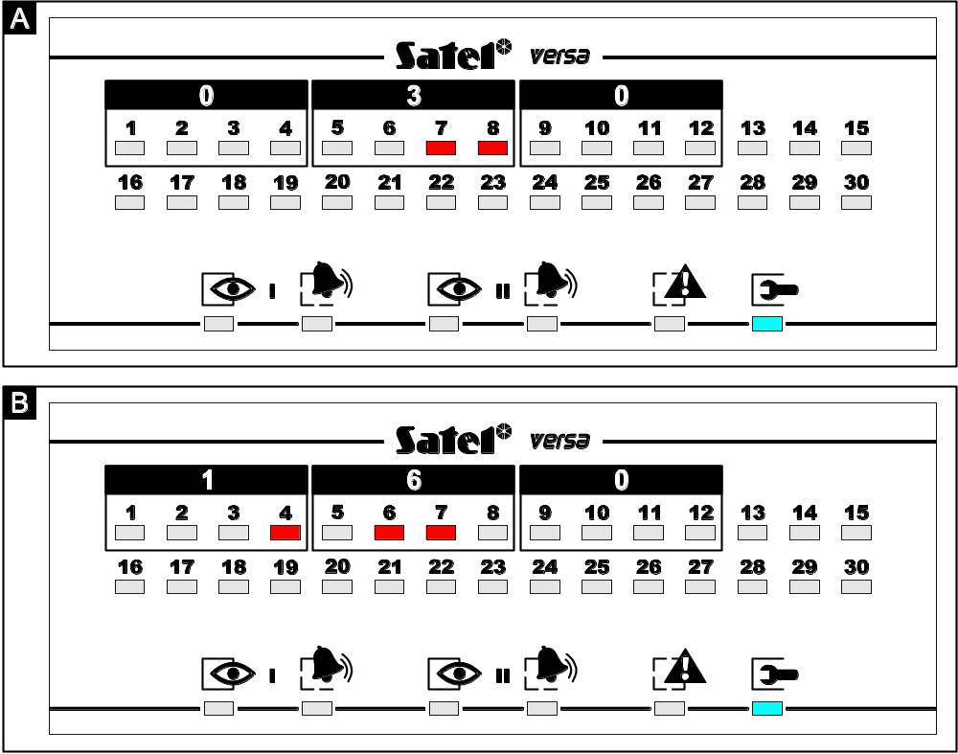
Fig. 3. Examples of presenting decimal values by means of LEDs in VERSA-LED-GR keypad. In both examples, 3-digit values are programmed. Value 30 (030) has been programmed in example A, value 160 - in example B.

Telephone numbers
The tone dialed Telephone numbers may contain special characters. The characters programmed in the telephone number have the following meaning:
B - switch to pulse dialing
C - switch to tone dialing
D - wait for additional signal
E - 3-second pause
F - 10-second pause
➲ -  signal in DTMF mode
# - # signal in DTMF mode
a, b, c, d - other signals generated in DTMF mode
Note : Some special characters (#, *, a, b, c, d) occupy two positions in the telephone number, thus reducing the maximum number of digits that can be programmed. The character A (end of telephone number) is not to be programmed.
When programming the number, the special character input mode is displayed in the upper right-hand corner. The [ABC] mode makes it possible to enter the upper case letters, while the [abc] mode – the lower case letters. To change the mode of entering characters, press the key. Shown in Table 6 are characters entered in the particular modes.

Characters available after next keystroke
key | mode [ABC] |  |  |  |  | key | mode [abc]
 | 1 | # |  |  |  |  | 1 | #
 | 2 | B | C |  |  |  | 2 | a | b | c
 | 3 | D | E | F |  |  | 3 | d
 | 4 |  |  |  |  |  | 4
 | 5 |  |  |  |  |  | 5
 | 6 |  |  |  |  |  | 6
 | 7 |  |  |  |  |  | 7
 | 8
 | 9 |  |  |  |  |  | 8
 | 0 |  |  |  |  |  | 0
Table 6. Method of programming digits and special characters in telephone numbers.

The Telephone numbers in the LED keypad can be programmed in the same way as by means of the LCD keypad. By default, on entering the telephone number programming function, the keypad is in the [ABC] mode. Press the key to change the mode from [ABC] to [abc] and vice versa, however this type of keypad does not show in which mode it currently is. It does not show characters entered in the lower case mode [abc] either.

Names
Some functions enable entering the text data (e.g. names of users, timers). Such data are entered in much the same way as in the mobile phone. Subsequent keystrokes will display letters and characters assigned to the given key. Hold down the key to enter the corresponding digit into the name.
After making a pause or going to another key, the next character is entered into the next position of the display. In the upper right-hand corner, the character input mode is shown. The key changes the letter input mode:
- [abc] – lower-case letters only
- [Abc] – first letter in the word: upper-case; the other ones: lower-case
- [ABC] – upper-case letters only
By default, editing starts in the [Abc] mode. Confirm the new name, using the key.

Key | Characters available after next keystroke
 | ! | ? | ' | ` |  | " | { | } | $ | % | & | @ | \ | ^ | | |  | # | 1
 | a | b | c | 2
 | d | e | f | 3
 | g | h | i | 4
 | j | k | l | 5
 | m | n | o | 6
 | p | q | r | s | 7
 | t | u | v |  |  |  |  |  |  |  |  | 8
 | w | x | y | z | 9
 |  | . | , | : | ; | + | - |  | / | = | _ | < | > | ( | ) | [ | ] | 0
Table 7. Characters entered by means of the keypad keys.
Name editing function is not available in the LED keypad.

Detailed description of the user functions
The description indicates, before the function name, the access path to the given function, i.e. all the characters which must be pressed on the keypad to start the function or enter its settings editing mode.

CODE Calling up the user function menu.

0 SERVICE
0 0 # Service mode Calling up the function makes the control panel enter the service mode, where the alarm system parameters can be programmed by the installer. To quit this operating mode, call up the 0 0 # (Quit SrvMod) service function. The function is only available after entering the service code.
0 1 # Start DwnlTEL Calling up the function initiates the procedure of establishing connection between the control panel and the service computer via telephone line for remote programming of the alarm system parameters and downloading of the event log. The control panel will call the programmed telephone number under which the computer should be available. The function is available to the users with administrator and service authority level.
0 3 # Start DwnlRS Calling up the function initiates the local programming of the control panel by means of the computer connected with a special cable to the control panel RS-232 TTL port. The DB9FC/RJ-KPL designated cable is manufactured by SATEL and should be available from the hardware distributor. The function is available to the service.
0 4 # Finish DwnlRS Calling up the function terminates the local connection between the control panel and the service computer. The function is available to the service.
0 5 # Perman.sv.ac Option which defines whether the alarm system is permanently available to the service, or only for a time programmed by the administrator. To change the option status, call up the function and press any numerical key. Press the key again to change the option status to the opposite one. In the LED keypad, the option status is shown by LED no. 1. Disable this option to make the Access time function available. The function is available to the administrator.
0 6 # Access time The function allows the user to program the time length during which the access will be available to the service for programming and servicing the control panel. The time count is running from the moment of exiting the function. Values from 1 to 255 hours can be programmed. Value 0 will block access to the service. After entering the function, if the access time has been preprogrammed beforehand, the keypad will display the time left until the access is blocked. Change of the time values must be confirmed. The function is available to the administrator.
1 # Change code The function allows the user to change the code. After you have entered the function, press in turn the numerical keys of the new code (from 4 to 8 digits) and confirm it.
The LCD keypad displays all the entered digits and enables code editing.
The LED keypad displays up to 6 digits of the code and offers no editing capability. If the new code consists of more digits, the 7th and 8th digit will not be visible. The function is available to the users authorized to change the code and to the service.
2 USERS The function makes it possible to manage users. It is available to the administrator and to the service. When entering a new user and editing an existing user, the keypad shows on the [armed] and [alarm] LEDs at which stage of programming the user currently is.
– LED OFF; – LED ON.
I II | Programming stage
 | Select user for editing
 | Enter user code
 | Select schedule
 | Select partitions to control
 | Add key fob
 | Add proximity card
 | Edit user name
Table 8. Indication of consecutive stages of programming the user settings by means of keypad LEDs.
2 1 # New user The function enables adding a new user to the system. After the function has been called up, the control panel will display the number of user to be entered into the system (the lowest of the available numbers) and wait until the code is entered. The next items describe the procedure of programming parameters characterizing the particular user:
- Enter the code and confirm it.
- Select the user schedule number according to Table 9 data (the LED with appropriate number will start blinking on the LED keypad) and confirm.

Schedule number | 1 | 2 | 3 | 4 | 5
Name  Right | Normal | Simple | Arms only | Duress | Master
Arming | ✓ | ✓ | ✓ | ✓ | ✓
Disarming | ✓ | ✓ |  | ✓ | ✓
Alarm clearing | ✓ | ✓ |  |  | ✓
Tel. messaging cancel | ✓ | ✓ |  |  | ✓
Auto-arming defer | ✓ |  |  |  | ✓
Zones bypassing | ✓ |  |  |  | ✓
Change access code | ✓ | ✓ |  |  | ✓
Users editing |  |  |  |  | ✓
Control | ✓ | ✓ |  |  | ✓
Programming | ✓ |  |  |  | ✓
DOWNLOAD/SERVICE |  |  |  |  | ✓
Inspection | ✓ |  |  |  | ✓
Tests | ✓ |  |  |  | ✓
DURESS |  |  |  | ✓
Key fob button functions (see: Table 12)
Button 1 | 39 | 39 | 39 | 43 | 39
Button 2 | 42 | 42 | 40 | 43 | 42
Button 3 | 53 | 53 | 41 | 43 | 53
Button 4 | 54 | 54 |  | 44 | 54
Buttons 1 and 2 |  |  |  | 44
Buttons 1 and 3 |  |  |  | 44
Table 9. Privilege assignment to particular user schedules and key fob key functions (factory default settings).
Note: The installer can change the names of schedules and privileges assigned to them.
- Assign the partition/s to be controlled and confirm (see Table 10).
Key number | Scope of control | LED indication
1 | Partition I | LED no. 1 blinking
2 | Partition II | LED no. 2 blinking
3 | Partition I and II | LED no. 3 blinking
Table 10.
Note: If a key fob control module or proximity card reader is installed in the system, the keypad in subsequent steps will enable the key fob and then the proximity card to be assigned to the user. If there are none of these devices, the LCD keypad, after confirming the partition selection, will go over to editing the user name (item j) ), and the LED keypad will exit the function.
- Make a decision about the key fob and confirm. If you select "nothing", the operation of assigning the key fob to a user will be skipped. The keypad will proceed to item f).
Key number | Selection meaning | LED indication
1 | Add | LED no. 1 blinking
2-9, 0 | nothing | LED no. 1 lit
Table 11.
- If you select "Add" (key fob), indicate whether the key fob serial number is to be entered manually, or by means of the INT-RX module. In order to read in the key fob by means of the module, press the key with digit 1 (in the LED keypad, LED no. 1 will start blinking) and confirm the selection. The press and release one of the key fob keys for the first time. If the key fob can be read into the system, the keypad will acknowledge the operation by two short beeps, and if the key fob is incorrect or it has already been added to the system, the keypad will generate three long beeps. If the key fob is correct, press the same key again.
If the number is entered manually, you should only press the confirmation key, enter the key fob number serial (which can be found on the packing) and confirm it again.
The keypad will proceed to the stage of assigning the control function to particular key fob buttons and their combinations. The installer can program default functions of the added key fob for each of the user schedules. When editing a user, the default settings can be changed. To select the function button number, use the numerical keys / arrow keys (see: Table 12). Confirm the selection.
The LCD keypad displays the function names and allows the user to scroll through the list to make his selection. If the installer enters his own names of zones and outputs, the keypad will display the entered names for the functions from 1 to 30 and from 51 to 102. The symbol of operation is shown next to the output name:
1 - activate output
0 - deactivate output
/ - switch over output

The LED keypad displays the function number (from 001 to 102) on LEDs 1-12. Using the and keys, you can scroll through list of function numbers.
Key function number | Name in LCD keypad | Notes
0 | nothing | Button inactive
1 | Zone 1 | Function assigned to zone 1
2 | Zone 2 | Function assigned to zone 2
… | … | …
30 | Zone 30 | Function assigned to zone 30
31 | Arm part.1 full | Full arming in partition I
32 | Arm part.1 night | Night arming in partition I
33 | Arm part.1 day | Day arming in partition I
34 | Dis/Clr part.1 | Disarming / Alarm clearing in partition I
35 | Arm part.2 full | Full arming in partition II
36 | Arm part.2 night | Night arming in partition II
37 | Arm part.2 day | Day arming in partition II
38 | Dis/Clr part.2 | Disarming / Alarm clearing in partition II
39 | Arm p.1&2 full | Full arming in partition I and II
40 | Arm p.1&2 night | Night arming in partition I and II
41 | Arm p.1&2 day | Day arming in partition I and II
42 | Dis/Clr part.1&2 | Disarming / Alarm clearing in partitions I and II
43 | Panic alarm
44 | Silent panic
45 | Fire alarm
46 | Medical alarm
51 | Output 1 : 1 | Activating output 1
52 | Output 2 : 1 | Activating output 2
… | … | …
62 | Output 12 : 1 | Activating output 12
71 | Output 1 : 0 | Deactivating output 1
72 | Output 2 : 0 | Deactivating output 2
… | … | …
82 | Output 12 : 0 | Deactivating output 12
91 | Output 1 : / | Toggling output 1 (changing output status to opposite)
92 | Output 2 : / | Toggling output 2
… | … | …
102 | Output 12 : / | Toggling output 12
Table 12. List of key fob button functions.
The control panel does not recognize whether the key fob has 2 or 4 buttons and will always require that 6 positions be confirmed. The LED keypad does not indicate which key is being programmed at the moment. The key fob buttons should be programmed in the following order:
LCD keypad text | Key fob button number | Key fobs  P-4, T-4 | Key fobs  P-2, T-2
Buttn.1 fun. …: | 1 | ✓ | ✓
Buttn.2 fun. …: | 2 | ✓ | ✓
Buttn.3 fun. …: | 3 | ✓ | -
Buttn.4 fun. …: | 4 | ✓ | -
Buttn.5 fun. …: | 1+2 | ✓ | ✓
Buttn.6 fun. …: | 1+3 | ✓ | -
Table 13. Order of programming the key fob buttons.
After confirmation of the key 6 function (key fob buttons 1+3), the control panel will proceed to editing the proximity card (item f)).
Note: Quitting the function by pressing the key before confirmation of the last keystroke on the key fob means canceling addition of the key fob.
- Make a decision about the proximity card and confirm it.
If you have selected "nothing", the operation of assigning the card to the user will be skipped. The LED keypad will terminate the function and the LCD keypad will go to item j).
Key number | Selection meaning | LED indication
1 | Add | LED no. 1 blinking
2-9, 0 | nothing
Table 14.
- If you have selected "Add" (the card), you should indicate, using the arrow keys, the card reader to be used for reading the card number, or proceed to entering the number manually. In the LCD keypad, the reader should be selected from the list of expanders by name (either entered or factory default one). In the LED keypad, selection should be made from among the LEDs representing the readers (the LED number corresponds to the reader address on the expander bus). The following numbers can be selected: 16, 17, 18, 19, 20, 21. The LED which corresponds to the selected reader is blinking. Lack of blinking means entering the number manually. The selection should be confirmed.
- To read in the card by means of the reader, present the card briefly (for 0.5 s) to the reader face for the first time and then remove it. If card can be read into the system, the keypad will confirm the operation two short beeps, and if the card is incorrect or it has already been added to the system, the keypad will generate three long beeps. If this is the case, another card must be read. Present the correct card again to the reader.
To enter the number manually, you must type it in from the keypad. The card number, which is saved in the hexadecimal format, can include characters from A to F (see page 19).
- The LED keypad will confirm the card red-in and completion of the function by four short beeps and one long beep, and the control panel will return to its normal operating mode.
- After reading in the card or skipping this operation, the LCD keypad will enable the option to change the default user name. The name entering procedure is described on page 22. After completion of the editing, confirm the change of user name, and the control panel will return to its normal operating mode.
2 2 # Edit user The function allows the user to change all the parameters connected with the existing user. It is available to the administrator and service.
Having started the function, use the arrow keys or numerical keys to select the user for editing. The LCD keypad will display the user name, while the LED keypad will light up LEDs with numbers corresponding to the users existing in the system. The blinking LED indicates the user selected for editing. After confirmation the selection, you should proceed through all the editing stages as when entering a new user. If a given parameter is not to be changed, press the confirmation key and proceed to the next stage of editing. At some stages the control panel provides additional selection options:
- An extra feature when editing the key fob is the option to change functions assigned to the particular key fob keys, or remove a key fob assigned to the user. Editing the key fob keys was described above in function 2 1, item e). Press one of the keypad keys:
Key number | Selection meaning | LED indication
1 | Add | LED no. 1 blinking
2 | Edit keys | LED no. 2 blinking
3 | Delete | LED no. 3 blinking
4-9, 0 | nothing
Table 15.
Adding a key fob in situation when another key fob is already assigned to the user will remove the serial number of previous key fob from the control panel memory. The control related settings will remain – they can be changed or confirmed.
After the key fob has been deleted, the control panel will go to the proximity card editing procedure which is described in function 2 1, item f).
- An extra feature when editing the card is the option to remove the card which was previously assigned to the user. The following operations can be carried out
Key number | Selection meaning | LED indication
1 | Add | LED no. 1 blinking
2, 4-9, 0 | nothing
3 | Delete | LED no. 3 blinking
Table 16.
Adding a card in situation when another card is already assigned to the user will remove the serial number of previous card from the control panel memory. The card adding procedure is described in function 2 1, item g).
After the card has been deleted, the LCD keypad will make available the option to change the default user name. The procedure of entering names is described on page 22. Confirm the names to end the function. The LED keypad will end the function immediately after the card is removed.
Note: The user cannot edit "himself".
2 3 # Remove user The function makes it possible to remove the user from the control panel memory. It is available to the administrator and service. Having started the function, use the arrow keys or numerical keys to select the user to be deleted. The LCD keypad will display the user name, while the LED keypad will light up the LEDs which correspond to the users existing in the system. The blinking LED indicates the user selected for removal. Confirm the selection to complete the function. The user cannot delete himself. The service can delete all users – in such a situation the Service code has permanent access to the system and is the only code that can control the system. The service has also permanent access in the situation, when all users with the DOWNLOAD / SERVICE right will be removed.
3 # ABORT V.MSG. Starting the function will cancel (terminate) the telephone messaging which is currently under way. The messaging can be started by triggering alarm in the system, arming/disarming, activating a zone, or a trouble occurring in the system. If it is not cancelled, then, despite the alarm is cleared, the control panel will perform the full messaging cycle, according to the programmed parameters. The installer can enable the messaging canceling option together with the alarm clearing.
4 # BYPASSES The function makes it possible to bypass the selected zones once, prior to arming. When in the armed mode, the control panel will ignore signals from the bypassed zones. Thus the partition can be armed e.g. in case of a detector failure which prevents the partition from arming (zone checked for possibility of arming), or one of the rooms can be intentionally left unsupervised. The user can bypass a zone in the partition which he can control. The way of bypassing / unbypassing a zone is the same as enabling / disabling the option described at the beginning of this chapter (see page 19). The installer can define the zones which cannot be bypassed by an ordinary user. Using the service code, it is possible to bypass any zone.
5 # EVENT LOG Calling up this function will enable (re)viewing the event log. The function is only available from the LCD keypad. The events are sorted chronologically by date and time of their occurrence. Using the arrow keys you can go to the previous/next event saved in the control panel memory. To display additional information (e.g. name of user, zone, partition, module, etc.) for some events, press the or key. Keypad will also automatically display the additional information, if no key is pressed for 5 seconds. To quit the function, press the key.
6 SETTINGS
6 1 # A-arm defer. The function makes it possible to defer the auto-arming when the partition is controlled by timer. The Deferment time is programmed by the installer. The user can defer the arming not later than when the Auto-arming delay is being signaled by the keypad. Calling the function again during the Deferment time countdown will restart the deferment time countdown.
6 2 # RTC clock The function makes it possible to program the current time and date indicated by the keypad. Correct indications of the clock are important, so that the actual course of events in the protected building can be reconstructed, if necessary.
After starting the function, the LCD keypad will display the current settings and prompt by text messages which parameters should be entered. In the first step, the time should be programmed, in the second – the date. The change of data should be confirmed.
The LED keypad, after the function has been started, will display 6 decimal digits, indicating the time at the moment of calling up the function. The data are displayed in the following format:
HHMMSS (HH – hours, MM – minutes, SS – seconds), of which the first three digits are displayed on LEDs 1-12, and the next three digits on LEDs 16-27 (see page 19). To change the hour settings, enter 6 digits and confirm the change. After confirmation, the keypad will display the next 6 digits with the following meaning:
YYMMDD (YY – two last digits of the year, MM – month, DD – day). Now you can enter the next 6 digits and change the date or exit the function without changing the date.
6 3 # Timers The function allows the user to change the settings of timers controlling the partition armed mode and/or operation of control panel control outputs. Armed mode can be programmed for each partition as well as timer/armed mode activation and deactivation time.
In the timer settings, it is possible to program only e.g. the arming/ disarming times which control the partition armed mode. Entering the numbers 99:99 in the time positions will disable the given function of the timer.
When programming the timer settings, the keypad indicates on the LEDs designated [armed] and [alarm] at which stage of the programming the user currently is.
– LED OFF; – LED ON.
I II | Programming stage
 | Select timer for editing
 | What is to be changed?
 | Change parameter settings
Table 17. Indication of successive stages of programming the Timer settings on the keypad by means of LEDs.
Having called up the function, press the key with timer number (from 1 to 4) and confirm the selection. Then select the parameter the settings of which are to changed (Table 18) and confirm.
Key number | Selection meaning | LED indication
1 | Week schedule | LED no. 1 blinking
2 | Exception 1 | LED no. 2 blinking
3 | Exception 2 | LED no. 3 blinking
4 | Exception 3 | LED no. 4 blinking
5 | Exception 4 | LED no. 5 blinking
6 | Arm. mode part. 1 | LED no. 6 blinking
7 | Arm. mode part. 2 | LED no. 7 blinking
Table 18. Selection of timer parameter to be changed (What is to be changed?).
The procedure of entering changes is described further in this chapter. After the parameter settings have been changed, the control panel returns to the stage of selecting the parameter to be changed, indicating the parameter which has just been changed. In order to proceed to programming a next parameter, press the key with its number or indicate it using the arrow key. Press the key to quit the function.

Description of changing particular parameters:
Weekly schedule
The settings refer to the timer activation/deactivation time in the normal operating mode (excluding exceptions). After entering the function, the keypad will display the current settings of the selected timer for Monday. The LCD keypad will display full information on the timer activation/deactivation time, and the LED keypad – only the first 6 digits (see page 20).
Next, you should program the timer activation/deactivation time for respective days of the week. Programming in both types of keypads is carried out in a similar way, but the LCD keypad enables corrections to be made when entering data, while the LED keypad does not. Enter 8 digits in the HHMMHHMM format, the first 4 of which refer to the timer activation time, and the next 4 – to the timer deactivation time. Programming begins from Monday. To proceed to programming the next day, press the key. If the timer is to be active everyday in the same period of time, you can program only the last position of the calendar ("Daily") and confirm it.

I II | Programming stage
 | Monday
 | Tuesday
 | Wednesday
 | Thursday
 | Friday
 | Saturday
 | Sunday
 | Daily
Table 19. Indication of successive stages of programming timer activations/deactivations on the keypad by means of LEDs.
Exception
I II | Programming stage
 | Begin exception (date)
 | End exception (date)
 | Exception arm/disarm
Table 20. Indication of successive stages of programming Exception on the keypad by means of LEDs.
Having entered the exception settings, program two dates to indicate the time interval during which the exception is to be valid. 6 digits in the YYMMDD format (two last digits of the year, month, day) are to be programmed. Each of the dates must be confirmed. On the other days, beyond the set interval, the basic timer settings will apply, as programmed within the Weekly schedule.
In the next step, the time of timer activation/deactivation should be programmed. Enter 8 digits in the HHMMHHMM format, where the first four digits mean the time of timer activation, and the next four digits – the time of its deactivation. The settings should be confirmed.

Partition armed mode
To select the armed mode, press the key as described in Table 21 and confirm the selection.
Key number | Selection meaning | LED indication
1 | Full armed mode | LED no. 1 blinking
2 | Night armed mode | LED no. 2 blinking
3 | Day armed mode | LED no. 3 blinking
4-9, 0 | Nothing
Table 21. Selecting the partition armed mode.

6 4 # Tel. numbers The function allows the user to change the telephone numbers to which voice message notifications are sent. When changing the telephone number, the user has the option to reprogram the control panel without calling the installer.
After the function has been called up, the keypad will make available a list of telephone numbers to be changed (up to 8 items). Using the numerical keys or arrow keys, select the telephone number to be changed and press . Then, enter the new telephone number and confirm the change. If the number requires entering special characters, program them according to the description on page 22.
The LED keypad will only display the first 6 digits of the number selected for change, and also the first 6 digits of the new number.
7 # TROUBLES The function enables reviewing the current troubles and clearing the trouble log. The installer can program the control panel so that it can display information on troubles even after they have been cleared until making a review and clearing the trouble log.
In the LCD keypad, using the arrow keys you can scroll through the trouble log and familiarize with the details. Descriptions of the stored troubles, the cause of which has already been cleared, are designated with the letter "P" in the right-hand upper corner of the display. On pressing the key, the control panel will display the message "Clear trouble memory? 1=Yes". Press the key to clear the trouble memory and extinguish the [TROUBLE] LED.
In the LED keypad, the troubles are presented symbolically by means of LEDs. The LED number corresponds to the type of trouble. A permanently lit LED denotes current trouble, a blinking LED – trouble memory. The meaning of LEDs is described in Table 22. Some of the LEDs serve as common trouble indicators (e.g. for zones, key fobs, expanders). To exit the function, press the key. Once the key has been pressed, the [TROUBLE] LED on the keypad will start blinking rapidly. To clear the trouble memory, press the key . Pressing another numerical key will exit the function without clearing the trouble memory.
LED number | Trouble description
1 | 230 V AC loss
2 | Control panel battery trouble
3 | Telephone line voltage loss
4 | Telephone line signal trouble
5 | OUT1 trouble
6 | OUT2 trouble
7 | KPD power trouble
8 | AUX power trouble
9 | Reporting trouble – monitoring station 1
10 | Reporting trouble – monitoring station 2
11 | Wireless system jamming
12 | Communication bus short circuit
13 | Clock loss
14 | RAM memory error
15 | Mainboard TMP open
16 | Zones – tamper
17 | Zones – long violation
18 | Zones – no violation
19 | Zones – masking
20 | Wireless device battery low
21 | Wireless device communication loss
22 | Module tamper
23 | No presence (module)
24 | AC loss (module)
25 | Battery trouble (module)
26 | Power output overload (module)
27 | Low battery (key fobs)
28 | Module restart
29 | Control panel restart
30 | HSE (processor) system trouble
Table 22. Meaning of individual LEDs during trouble review.
Note: In order to end signaling trouble no. 30 it is necessary to restart the control panel. To do so, terminate the trouble reviewing function by pressing in turn the and keys. If, after the restart, the keypad is still signaling a trouble, you must clear the trouble memory.
8 # CONTROL The function enables changing the status of "Controlled" type of outputs. After the function is started, the LCD keypad will display the list outputs which can be controlled. Using the arrow keys you can scroll through list and select the output to be controlled. Press the key to activate the output permanently or for a preprogrammed time (up to 100 minutes 39 seconds). Pressing the key will deactivate the output, if it is active.
In the LED keypad, the output to be controlled is shown by the blinking indicator. The arrow keys make it possible to move the indicator to another position to be controlled. Activating and deactivating is performed in the same way as in the LCD keypad, (keys and ). The lit LED denotes active output, and the extinguished LED - inactive. To exit the function, press .
9 TESTS A group of functions, available to the users with Tests right. Only the Zone Test function is available to the installer only.
9 1 # Zone test A function facilitating the start-up and control of the alarm system. After the function is called, the keypad will light up permanently the [trouble] LED. In the other keypads, this LED will be blinking. Indicate duration of the test (from 01 to 15 min.) and confirm. The LCD keypad will display in graphical mode the current status of zones, whereas the LED keypad will start blinking with its LEDs corresponding to the system zones. For the violated zones, the LEDs will be lit permanently. Then, proceed to carrying out the by walking around the protected premises, opening the doors, windows, etc., in order to verify the correct functioning of particular detectors and zones of the control panel. The keypad will signal each zone violation by 5 short beeps, and a symbol of given zone violation will light up on the LCD display. The symbol will be visible until the end of the test. The LED keypad will light up permanently the corresponding LED. Violation of the 24h alarm zones during the test will not trigger any alarm. The function can be terminated earlier by pressing the key.
9 2 # Output test The function makes it possible to carry out the functional check of devices connected to the control panel outputs. After calling up the function, the keypad will display information on the current status of 12 outputs.
In the LCD keypad, the active output is indicated by a large dot, and the inactive by a small one. The cursor under the symbol indicates the output selected for testing. The arrow keys enable the cursor to be moved to the next position. Pressing the key activates the selected output, and pressing the key deactivates. Moving the cursor the next position or terminating the function with the key will restore the initial status of the tested output.
In the LED keypad, the blinking LED means that the output with the given number is active (enabled). The blinking LED indicated the number of output which can be tested.
9 3 # ABAX sig.lvl. The function enables the user to check the level of radio signal received from particular devices of the ABAX system. The arrow keys make it possible to go to information on the next ABAX devices.
The LCD keypad displays information on the zone number in the system and the signal level in %. 100% means the maximum level of received signal.
The LCD keypad will light up the LED indicating the number of zone with ABAX device. The signal level is indicated on LEDs 16-30 for the zones from 1 to 15, or on LEDs 1-15 for the zones from 16 to 30. The 100% level corresponds to lighting up 15 LEDs.
9 4 # Manual MS tst This function initiates the procedure of sending the Manual trigger test report event code to the monitoring station.
9 5 # MS1 test The function is available from the LCD type keypad. It initiates the procedure of sending the Manual trigger test report event code to the monitoring station 1. During execution of the function, descriptions of the operations being currently carried out by the control panel appear on the keypad display. If any problems with monitoring occur, this function enables their cause to be detected. If the progress of monitoring is correct, it will be ended by displaying the "Event sent" message.
9 6 # MS2 test The function is available from the LCD type keypad. It initiates the procedure of sending the Manual trigger test report event code to the monitoring station 2. During execution of the function, descriptions of the operations being currently carried out by the control panel appear on the keypad display. If any problems with monitoring occur, this function enables their cause to be detected. If the progress of monitoring is correct, it will be ended by displaying the "Event sent" message.
9 7 # VERSA version The function makes it possible to check the type designation and firmware version (number and build date) of the control panel. Available from the LCD keypad only.
9 8 # Expander ver. The function makes it possible to check the type designation of the connected modules, their addresses on the expander bus and firmware version (number and build date). The arrow keys enable the user to scroll through the list of modules identified in the system. Available from the LCD keypad only.
9 9 # Supply volt. The function makes it possible to check the supply voltage for the connected modules. The keypad will display the symbol of device, its address on the modules bus and the value of measured supply voltage. Available from the LCD keypad only.
9 0 # Outputs reset The function makes it possible to deactivate the so-called latch outputs (without limitation of cut-off time) which cannot be reset by entering the CODE and (e.g. the outputs of Chime, Zone violation, Controlled, “DURESS” alarm type).
If the output of Fire detector power supply type is used in the system, using the function will deactivate such an output for 16 seconds in order to clear the alarm memory of fire detectors.

Using Proximity Cards for System Control
The control panel can work in conjunction with the INT-IT proximity card reader. By using a proximity card or another passive transponder working at frequency 125 kHz, it is possible to arm or disarm partitions and clear alarms. The reader can control one or two partitions, and a different type of armed mode can be activated for each partition (full, night, day).
Built in the reader are three LEDs (red, green and yellow) and a buzzer for audible signaling, which provide information on the system status. Operating mode of the device is programmed by the installer, who should instruct the user how to use the proximity card.
Using the reader consists in presenting the card to the reader face for a short-time (0.5 s) or longer (min. 2 s), and then removing the card from the reader. After the card is presented and held for about 2 s, the reader will light up the red LED, then after the next 2 s it will extinguish the red LED and light up the green one, then after the next 2 s it will extinguish the green LED and light up the yellow one, then after the next 2 s it will extinguish the yellow LED. Removing the card when one of the LEDs is lit will activate the armed mode according to the schedule assigned to the given LED. Removing the card when none of the LEDs is lit will not change the partition armed mode status.

Short presentation – disarming, alarm clearing
Long presentation – arming in one of the three schedules set by the installer (assigned to the LED color):
- red LED – one or two partitions fully armed
- green LED – one or two partitions armed in the mode set by the installer
- yellow LED – one or two partitions armed in the mode set by the installer
Note: In the green or yellow LED mode you can also program disarming any partition, if it was armed before presenting the card to the reader.
Meaning of the light signaling:
- red LED lit – partitions armed according to the schedule assigned to the red LED
- red and green LEDs lit - partitions armed according to the schedule assigned to the green LED
- red and yellow LEDs lit - partitions armed according to the schedule assigned to the yellow LED
- red LED lit with short extinguishments – partitions armed in a mode inconsistent with the programmed schedules
- red LED lights up briefly with short pauses – alarm or alarm memory, when none of the partitions is armed
- red LED blinking slowly (1s/1s) – alarm or alarm memory, when one or two partitions are armed (armed mode inconsistent with the schedules assigned to the green or yellow LED)
- green LED lit and red LED blinking slowly – alarm during armed mode of the partitions, consistent with the schedule assigned to the green LED
- yellow LED lit and red LED blinking slowly – alarm during armed mode of the partitions, consistent with the schedule assigned to yellow LED
- all LEDs extinguished – both partitions are disarmed or the partition not supported by the reader in none of the schedules assigned to the LED is armed
- all LEDs blinking at a uniform rate – no communication between the reader and the control panel
Meaning of the audible signaling:
- one short beep – reading the card number; a next LED lights up
- three short beeps – arming / disarming, alarm clearing
- long beeps separated by long pauses, terminated by a series of short beeps and one long beep – countdown of partition exit delay after arming
- three long beeps – refusal to execute the function
- double beeps separated by long pauses – countdown of entry delay after violation of entry zone during armed mode
- continuous beep – alarm in the partition operated by the reader
- long beeps separated by a short pause – alarm memory
- intermittent beep (0.5s/0.5s) – fire alarm
- short beeps separated by a long pause – fire alarm memory

Using Remote Control Key Fob in the System
The control panel supports the INT-RX expander which makes it possible to use in the system the remote control transmitters (key fobs), working at 433MHz frequency, which are manufactured by SATEL. The four-button key fob enables 6 different functions to be executed (keys 1, 2, 3, 4 and key combinations: 1 and 2, 1 and 3). Similarly, the two-button key fob allows the user to execute 3 different functions (keys 1, 2 and combination 1 and 2). One key fob can be assigned to each user of the system, except the service. The installer or the administrator can assign to each key fob button/ button combination a number of function (see page 27) which will be executed after the button/ button combination is pressed. Replacement of the user key fob with another one will not delete or change any settings related to the system control by the given user.
The key fob can serve as:
- arming/disarming switch,
- alarm delay enabling button,
- panic, fire, medical alarm button,
- on/off switch for electrical devices.
The installer can start the signaling of arming/disarming and alarm clearing by means of key fob on the siren.

Short Description of Keypads
trouble – signaling detection of a technical problem in the system – check by means of user function no. 7
armed (supervision)
lit – partition armed
blinking – exit delay countdown
alarm
lit – alarm in partition
blinking – alarm memory

service – signaling control panel operation in service mode:
lit – service mode available on this keypad
blinking – service mode available on another keypad

LCD display – date and time / status of supervision zones
VERSA-LCD-GR
– hold down for 3 sec to switch the display to indicating status of control panel supervision zones:
b – zone bypassed
L – long violation trouble
N – no violation trouble
! – first alarm memory
○ – violated tamper circuit of 2EOL zone
 – zone violated
t – tamper circuit of 2EOL zone triggered alarm (tamper memory)
a – zone triggered alarm (alarm memory)
▪ – zone free (not violated)
– (nothing) detector type not programmed – no detector

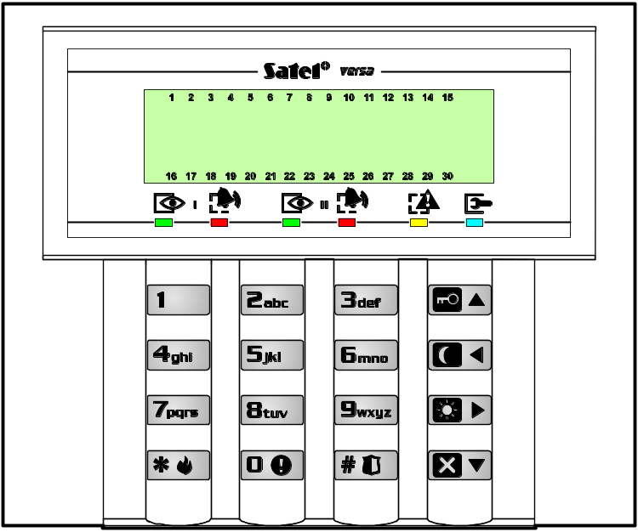

HASŁO+
- czuwanie pełne (1)
- czuwanie nocne (2)
- czuwanie dzienne (3)
- wyłączenie czuwania, skasowanie alarmu

VERSA-LED-GR
LEDs 1÷30 – lighting mode indicates status of control panel supervision zones (□ – OFF,  – ON):
□□□□□□□□ – zone
bypassed
□□□□□□ – long violation
trouble
□□□□□□□□ – no violation
trouble
□□□□□□□□ – first alarm
memory
□□ – violated
tamper circuit of 2EOL zone
 – zone
violated
□□□□□□□□□□□□□□ – memory of
2EOL zone tamper
□□□□□□□□ – zone
triggered alarm (alarm memory)
□□□□□□□□□□□□□□□□ – zone free
(not violated)

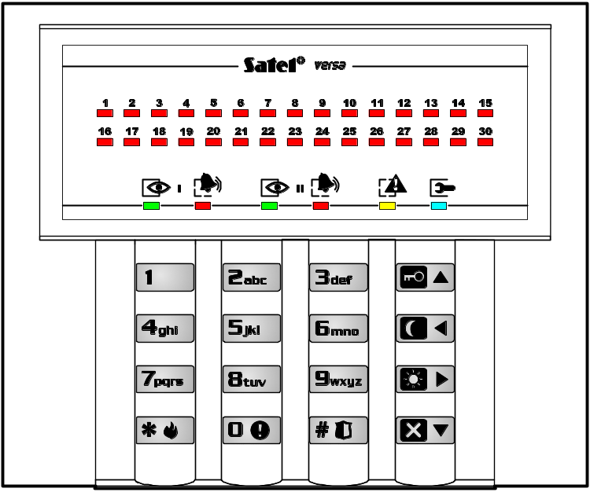

– hold down for 3 sec to trigger
PANIC ALARM
Control of partitions assigned to code:
CODE+
- full armed mode
- night armed mode
- day armed mode
- disarming, alarm clearing
Quick arming partition I:
+
- full armed mode
- night armed mode
- day armed mode
Quick arming partition II:
+
- full armed mode
- night armed mode
- day armed mode
Quick arming partition I and II:
+ or +
- full armed mode
- night armed mode
- day armed mode

– hold down for 3 sec to trigger
AUX (MEDICAL) ALARM

– hold down for 3 sec to trigger
FIRE ALARM
CODE+ – user functions:
0 Service
00# – Service mode
01# – Start telephone connection
03# – Start RS connection
04# – Finish RS connection
05# – Permanent service access
06# – Service access time
1# Change code
2 Users
21# – New user
22# – Edit user
23# – Delete user
3# Abort tel. messaging
4# Bypasses
5# Event lon
6 Settings
61# – Auto-arming deferment
62# – RTC clock
63# – Timers
64# – Telephone numbers
7# Troubles
8# Control
9 Tests
91# – Zone test
92# – Output test
93# – ABAX signal level
94# – Manual test transmission
95# – Test monitoring station no. 1
96# – Test monitoring station no. 2
97# – VERSA version
98# – Expander versions
99# – Supply voltage
90# – Reset outputs

– press twice to defer auto-arming
– hold down for 3 sec to display information on armed mode

VERSA-LED-GR:
Partition I
LED 1 ON – full armed mode
LED 2 ON – night armed mode
LED 3 ON – day armed mode
LED 1,2,3 OFF – disarmed
Partition II
LED 16 ON – full armed mode
LED 17 ON – night armed mode
LED 18 ON – day armed mode
LED 16,17,18 OFF – disarmed

– hold down for 3 sec to enable / disable chime signaling

SATEL sp. z o.o.
ul. Schuberta 79
80-172 Gdańsk
POLAND
tel. + 48 58 320 94 00
info@satel.pl
www.satel.pl



Alarm Control Panel
VERSA Program version 1.00
GDAŃSK
versa_u_en 03/09
USER
MANUAL

Druk (2 na 1):
42,43,0,41,40,1,2,39,38,3,4,37,36,5,6,35,34,7,8,33,32,9,10,31,30,11,12,29,28,13,14,27,26,15,16,25,24,17,18,23,22,19,20,21

