IMPORTANT
Before you start using the control panel, please read carefully this manual in order to avoid mistakes that can lead to malfunction or even damage to the equipment.

Changes, modifications or repairs not authorized by the manufacturer shall void your rights under the warranty.

SATEL aims to continually improve the quality of its products, which may result in changes in their technical specifications and software. Current information about the changes being introduced is available on our website.
Please visit us at:
https://support.satel.pl

The following symbols may be used in this manual:
 - note,
 - caution.

CONTENTS
1. Introduction 3
2. Front panel 3
2.1 LED indicators 3
2.2 Buttons 5
2.3 System status indication 6
3. Control 8
3.1 Access levels 8
3.1.1 Level 1 (L1) – all users 8
3.1.2 Level 2 (L2) – authorized users 8
3.2 Acoustic signaling during operation 8
3.3 User menu 8
3.3.1 Navigating the menu and starting the functions 8
3.3.2 Information on system elements 9
3.3.3 Editing data (access level 2) 10
3.3.4 User functions list 10
3.4 Control at level 1 13
3.4.1 Silencing the acoustic signaling of control panel / repeater panel 13
3.4.2 Testing the signaling components of control panel / repeater panel 13
3.4.3 Viewing the alarm log 13
3.4.4 Viewing the event log 13
3.4.5 Viewing the current faults 14
3.4.6 Viewing the disablements 14
3.4.7 Viewing the tests 14
3.4.8 Viewing the system information 14
3.5 Control at level 2 15
3.5.1 Enabling / disabling the two-stage alarm mode 15
3.5.2 Changing the control panel operating mode: Personnel present / Personnel absent 15
3.5.3 Procedure in the case of alarm signaling 15
3.5.4 Turning the sounders on / off 15
3.5.5 Procedure in the case of fault signaling 16
3.5.6 Disabling the system elements 16
3.5.7 Testing the system elements 17
3.5.8 Diagnostics 18
3.5.9 Setting the clock 19
3.5.10 Service mode 20
4. ACSP Soft program 20
4.1 Menu bar of the ACSP Soft program 20
4.2 Side menu 21
4.3 Additional menu 21
4.3.1 “Configuration” window 21
4.3.2 “Software language” window 22
4.3.3 Establishing communication with the control panel 22
4.4 Addressable elements 22
4.4.1 Input/output state 22
4.4.2 Diagnostic data 24
4.4.3 Element disablements/tests 24
4.4.4 Zone&group disablements/tests 25
4.4.5 Detector diagnostics 26
4.5 Events 27
4.5.1 “Event filter” window 28
4.6 Alarms 29
4.7 Faults 29
4.8 Special functions 30
4.9 Printouts 31
4.9.1 Configuration 31
4.9.2 Test report 32
5. VAPSP application 33
5.1 Features 33
5.2 Installing the app 33
5.3 Starting the app 33
5.4 Description 34

Introduction
This manual describes how to operate the ACSP-402 addressable fire alarm control panel. It also describes how to operate the control panel remotely by using the APSP-402 repeater panel and the VAPSP app.

Front panel

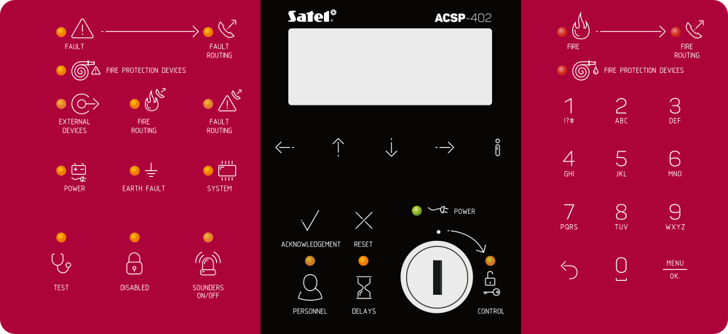
Fig. 2. Front panel of the ACSP-402 control panel.

The front panels of the ACSP-402 control panel and the APSP-402 repeater panel include the same elements:
- LEDs to indicate the system status (of the control panel and external devices).
- LCD display to:
- operate the control panel,
- display information about the fire alarm,
- display messages about disablements, tests and faults,
- view the list of current disablements, tests and faults,
- view the alarm and event log.
- Buttons to operate the control panel.
- Key switch to gain access at level 2 (see: “Access levels” p. 8).

LED indicators
The LED indicators on the control panel and the repeater panel operate in the same way. The only difference is the yellow  CONTROL LED (see: p. 5).

LED | Label [color] | Indications
 | FAULT  [yellow] | ON – fault.  flashing – fault memory.
 | FAULT ROUTING  [yellow] | ON – fault warning routing is acknowledged / test of the output for fault warning routing is started.  flashing – output for fault warning routing is active.
 | FIRE PROTECTION DEVICES  [yellow] | ON – output to control the fire protection devices is disabled or is being tested.  flashing – output to control the fire protection devices is faulty (short circuit or break).
 | AUXILIARY DEVICES  [yellow] | flashing – programmable input is faulty (short-circuit or break), device connected to programmable input reported fault, power output is faulty (overload), repeater panel / ACSP-ETH module / ACSP-RSI is not present, power source of the repeater panel is faulty.
 | FIRE ROUTING  [yellow] | ON – output for fire alarm routing is disabled or is being tested.  flashing – output for fire alarm routing is faulty (short circuit or break).
 | FAULT ROUTING | ON – output for fault warning routing is disabled or is being tested.  flashing – output for fault warning routing is faulty (short circuit or break).
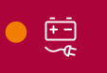 | POWER  [yellow] | flashing – power failure (loss of 230 VAC mains, no battery, low battery, high battery resistance).
 | EARTH FAULT  [yellow] | flashing – earth fault in one of the circuits of the fire alarm system.
 | SYSTEM  [yellow] | flashing – control panel hardware fault, microprocessor-based system fault, corrupted data in control panel memory, or alarm log overflow.
 | TEST  [yellow] | ON – function to test system elements is started (zones, lines, groups, sounders, inputs, outputs, etc. are being tested).
 | DISABLED  [yellow] | ON – system elements are disabled (zones, lines, groups, sounders, inputs, outputs, etc. are disabled).
 | SOUNDERS ON/OFF  [yellow] | ON – output to control sounders or sounder(s) connected to detection line are disabled or are being tested.  flashing – output to control sounders is faulty (short circuit or break) or sounder(s) connected to detection line are faulty.
 | PERSONNEL  [yellow] | ON – control panel operates in the “Personnel present” mode.
 | DELAYS  [yellow] | ON – two-stage alarm mode is enabled (second stage alarm signaling is delayed).
 | CONTROL  [yellow] | ON – access level 2 on this panel.  flashing – access level 2 on another panel.
 | POWER  [green] | ON – 230 VAC mains power is present.  flashing – no 230 VAC mains power, control panel is powered from a battery.
 | FIRE  [red] | ON – fire alarm acknowledged by the personnel.  flashing – fire alarm.
 | FIRE ROUTING  [red] | ON – fire alarm routing is acknowledged / test of the output for fire alarm routing is started.  flashing – output for fire alarm routing is active.
 | FIRE PROTECTION DEVICES  [red] | ON – activation of fire protection equipment is acknowledged / test of the output to control the fire protection equipment is started.  flashing – output to control the fire protection equipment is active.
Table 1.

Buttons

Button | Access level | Function
 | 1 | Start the preview of tested system elements (e.g. zones, lines, groups, sounders, inputs, outputs, etc.) – see: p. 15.  Start the function of testing the control panel LEDs and acoustic signaling. Press and hold for 3 seconds to start the function.
 | 2 | Start the function of testing the system elements – see: p. 17.
 | 1 | Start the preview of disabled system elements (e.g. zones, lines, groups, sounders, inputs, outputs, etc.) – see: p. 15.
 | 2 | Start the function of disabling the system elements – see: p. 17.
 | 2 | Deactivate / activate sounders during a fire alarm – see: p. 16.
 | 1 | Exit the user menu or submenu.
 | 2 | Exit the menu, submenu or function in the user menu.
 | 1, 2 | Scroll up and perform other operations in the user menu. Press and hold the button to scroll faster.
 | 1, 2 | Scroll down and perform other operations in the user menu. Press and hold the button to scroll faster.
 | 1 | Open the user menu, enter the submenu. In the alarm mode, change how the information is presented about the alarming zone(s) (zone name / zone number and information about the alarm stage).
 | 2 | Open the user menu / enter the submenu / start the function / select the option. In the alarm mode, change how the information is presented about the alarming zone(s) (zone name / zone number and information about the alarm stage).
 | 1, 2 | Change how the information is presented (short / extended) about a selected system element (e.g. zone) or an event registered by the control panel (e.g. alarm / fault). In the case of the two-stage alarm mode, information is displayed about the time remaining until the second stage alarm is indicated.  Change how the information is presented about system elements (names / addresses). Press and hold for 3 seconds to change how the information is presented.
 | 1 and 2 | Acknowledge the fire alarm / fault warning and silence the acoustic signaling in control panel and repeater panel.  Reset the fault memory.
 | 2 | Reset the fire alarm.
 | 2 | Change the “Personnel present” / “Personnel absent” control panel operating mode (changing the operating mode may result in activating / deactivating the two-stage alarm mode ( second stage alarm delay)) – see: p. 16.
 | 2 | Activate / deactivate the two-stage alarm mode (second stage alarm signaling delay) – see: p. 15.
 | 1 | Exit the user menu or submenu.
 | 2 | Exit the menu, submenu or function in the user menu.
 | 1 | Open the user menu and enter the submenu.
 | 2 | Open the user menu, enter the submenu, start the function and confirm the selected options.
Table 2.

System status indication
The control panel and the repeater panel indicate the current system status.

Quiescent condition
- The display shows date and time as well as messages programmed in the control panel (e.g. information about the system).
- Only the green  POWER LED is ON (the rest of LEDs are OFF).

Disabled condition
- The display shows the number of disablements activated in the control panel (e.g. D:001). After you enter the user menu you can check which system elements are currently disabled (access level 1 and 2), you can enable them or you can disable other system elements (level 2).
- The yellow  DISABLEMENT LED is ON.
- The yellow LED to indicate the disabled system element is ON (if the LED is assigned to the element – see: “LED indicators” p. 3).

Test condition
- The display shows the number of tests activated in the control panel (e.g. T:001). After you enter the user menu you can check which system elements are currently tested (access level 1 and 2), and you can edit the list of tested system elements (level 2).
- The yellow  TEST LED is ON.
- The yellow LED to indicate the tested system element is ON (if the LED is assigned to the element – see: “LED indicators” p. 3).

Fault warning condition
- The display shows the number of faults detected by the control panel (e.g. F:001). After you enter the user menu you can check which system elements are currently faulty (access level 1 and 2), and you can disable them (level 2).
- The yellow  FAULT LED is ON.
- The yellow LED that represents the given fault is flashing (if the LED is assigned to the fault – see: “LED indicators” p. 3).
If the yellow FAULT LED is flashing, it means the fault memory. This happens when the personnel operating the control panel failed to acknowledge the fault, and the control panel stopped detecting it.
- A sound is emitted.

Fire alarm condition
- The display shows information on the generated alarm(s).
- The red  FIRE LED is ON or flashing (see: “LED indicators” p. 3).
- A sound is emitted.

Control at level 2
The CONTROL LED:
ON – control at level 2 is available on this panel,
flashing – control at level 2 is available on another panel.

“Personnel present” operating mode
The yellow  PERSONNEL LED is ON.

Second stage alarm delay (two-stage alarm)
The yellow  DELAYS LED is ON.

Control

Access levels

Level 1 (L1) – all users
When there is no key in the key switch or the key is in the neutral position, the user has access to the following functions:
- acknowledge fire alarms and faults,
- view:
- fire alarm / fault / event log,
- tested / disabled system elements (detection lines, zones, groups, addresses [line elements], routing outputs, sounders, inputs, outputs, detectors, manual call points, remote indicators),
- information on the control panel program.
At level 1, it is possible to operate the system from the control panel and the repeater panel simultaneously.

Level 2 (L2) – authorized users
When the key switch is in the  CONTROL position, in addition to the level 1 functions, the user has access to the following functions:
- reset the fire alarm,
- turn the sounders on / off,
- switch the “Personnel present” / “Personnel absent” control panel operating mode,
- enable / disable the alarm signaling delay function,
- enable / disable: detection lines, zones, groups, addresses (line elements), routing outputs, sounders, inputs, outputs, detectors, manual call points, remote indicators,
- test: zones, groups, routing outputs, sounders, inputs, outputs, detectors, manual call points, remote indicators,
- start the diagnostic functions,
- set the control panel clock and the display contrast.
At level 2, it is possible to operate the system either from the control panel, or from the repeater panel. If the key switch is in the CONTROL position both in the control panel and the repeater panel, only the control panel user has access at level 2 (control from the control panel has the priority).

Acoustic signaling during operation
1 short beep – button pressed / function started / selection confirmed / entered data confirmed.
2 short beeps – function unavailable / refusal to execute command.

User menu

Navigating the menu and starting the functions
Table 2 shows the buttons used for menu navigation (see: “Buttons” p. 6).
The cursor  shows the submenu you can enter / function you can start / option you can select.
The user menu is hidden automatically 3 minutes after the last activity. If you want to access the menu again, press .

Information on system elements
You may notice that names and addresses are displayed when you scroll and edit the list of addressable system elements. Press and hold  for 3 seconds to change how the information is presented (see: “Buttons” p. 6).

Addressable system elements

Line elements
The address of the line element consists of the detection line symbol (L1 / L2 – loop symbol or A1 / A2 / B1 / B2 – radial circuit symbol) and the element’s reference number (e.g. L1/1 – address of the first device connected to the L1 loop).
In the MIO-400 module, each input and output is given its own address. For example: A1/3.1 – A1 radial circuit, third device connected to the radial circuit, IN1 input.

Control panel inputs and outputs
Each control panel input / output is treated as a separate addressable system element. They have the following addresses:
FP/INP1…4 – input.
FP/OUT1…8 – output.

Link identifier
If one addressable element is linked with another element of the fire alarm system, the link identifier is added to that element’s address. The first symbol of the identifier indicates the type of link:
* – element is assigned (belongs) to a zone or a signaling group,
’ – element is linked with a zone, group or addressable element.
The following signs of the identifier indicate which system element the device is linked with:
Zx – with a zone (x = zone number).
Gx – with a group (x = group number).
[address] – with an element of a given address (e.g. L2/1).
OUT – with a control panel / MIO-400 module output.
The address of the linked output is available after device information is displayed (the button) or in the ACSP Soft program.
OUT8 – with the OUT8 control panel output when the output type is “Control of fire protection equipment”.
FRE – with the FRE TX control panel output when the output type is “Control of fire protection equipment”.

Example addresses of elements with the link identifier
L1/1*Z1 – element with address L1/1 is assigned (belongs) to zone 1.
L1/6’Z1 – element with address L1/6 is linked with zone 1.
FP/INP1’Z1 – control panel input with address FP/INP1 is linked with zone 1.
L1/9*G1 – element with address L1/9 is assigned (belongs) to group 1.
L1/10.1’G1 – MIO-400 module input with address L1/10.1 is linked with group 1.
L1/8’A2/1 – element with address L1/8 is linked with a detector / side line module with address A2/1.
FP/INP1’OUT – control panel input with address FP/INP1 is linked with a control panel / MIO-400 module output (the address of the linked output you will see after device information is displayed or in the ACSP Soft program).

Editing data (access level 2)
The editing method depends on the type of data. Having completed the editing, press to confirm the changes. To exit the function without saving the changes, press  or .

Selection from the single-choice list
The 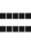 symbol indicates the currently selected item. To scroll through the list of items, press  or .

Selection from the multiple-choice list
To scroll through the list of items, press or . Depending on the type of list, the displayed symbols indicate that:
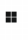 – the element is not disabled / tested or the element will not be disabled / tested,
 – the element is / will be disabled,
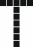 – the element is / will be tested.
Press  to change the currently displayed symbol to the other.

User functions list
Which functions are displayed on the list depends on your access level and the system status.
Alarms view the fire alarm log
Events view the event log
Faults
All view faults in the system / disable faulty elements
Lines view faulty detection lines
Routing outputs view / disable faulty routing outputs
Sounders
Convent. sounders view / disable faulty conventional sounders
Address. sounders view / disable faulty addressable sounders
Inputs
Control p. inputs view / disable faulty control panel inputs
Other inputs view / disable faulty MIO-400 module inputs
Outputs
Control p. outputs view / disable faulty control panel outputs
Other inputs view / disable faulty MIO-400 module outputs
Det. & m. call. p.
Manual call points view / disable faulty manual call points
Detectors view / disable faulty detectors
Indicators view / disable faulty remote indicators
Side lines view / disable faulty MLB-400 side line modules
Addresses view faults related to the MIO-400 module by addresses
Power view faults related to the control panel power
System view the system faults (e.g. device not configured)
Other view other faults (e.g. no communication with the printer)
Zones view zones with faulty elements
Groups view groups with faulty elements
Disablements
Preview
Lines view disabled detection lines
Zones view disabled zones / disabled elements in the zone
[select a disabled zone]
[list of disabled elements in the zone]
Groups view disabled groups / disabled elements in the group
[select a disabled group]
[list of disabled elements in the group]
Addresses view disabled elements by addresses
Routing outputs view disabled routing outputs
Sounders
Convent. sounders view disabled conventional sounders
Address. sounders view disabled addressable sounders
Inputs view disabled control panel / MIO-400 module inputs
Outputs view disabled control panel / MIO-400 module outputs
Det. & m. call. p.
Manual call points view disabled manual call points
Detectors view disabled detectors
Indicators view disabled remote indicators
Edit disable / enable system elements
[list of items the same as in the “Preview” submenu]
Add disable system elements
Active elements disable active system elements
Faulty devices disable faulty system elements
[the remaining items on the list the same as in the “Preview” submenu]
Delete enable system elements
[list of items the same as in the “Preview” submenu]
Tests
Preview
Zones view tested zones / tested elements in the zone
[select a tested zone]
[list of tested elements in the zone]
Groups view tested groups / tested elements in the group
[select a tested group]
[list of tested elements in the group]
Routing outputs view tested routing outputs
Sounders
Convent. sounders view tested conventional sounders
Address. sounders view tested addressable sounders
Inputs view tested control panel / MIO-400 module inputs
Outputs view tested control panel / MIO-400 module outputs
Det. & m. call. p.
Manual call points view tested manual call points
Detectors view tested detectors
Indicators view tested remote indicators
Edit start / end the test of system elements
[list of items the same as in the “Preview” submenu]
Add start the test of system elements
[list of items the same as in the “Preview” submenu]
Delete end the test of system elements
[list of items the same as in the “Preview” submenu]
Silent test turn the sounders on / off when testing manual call points and detectors
[select: YES / NO]
Information
Control panel
Firmware view control panel firmware version
Repeater panel
Firmware view repeater panel firmware version
Ethernet module
Firmware view ACSP-ETH module firmware version
Network
MAC address view ACSP-ETH module hardware address
IP address view ACSP-ETH module IP address
Subnet mask view the mask of the subnet in which the ACSP-ETH module is working
Default gateway view IP address of the network device through which the ACSP-ETH module communicates with devices in other networks
DNS address view IP address of the DNS server used by the ACSP-ETH module
ACSP-RSI (printer)
Firmware view ACSP-RSI module firmware version
Diagnostics
Detectors view status of detectors
By dirt
[list of detectors sorted in descending order by the level of dirt]
By smoke
[list of detectors sorted in descending order by the level of smoke]
By temperature
[list of detectors sorted in descending order by the level of temperature]
Consecutively
[list of detectors sorted in ascending order by the reference number]
Input / output st. view status of control panel / MIO-400 module inputs / outputs
Inputs
[list of control panel / MIO-400 module inputs]
Outputs
[list of control panel / MIO-400 module outputs]
LED indication start / end the MIO-400 module LED test
[select a MIO-400 module]
Control p. battery view information about the control panel battery voltage and resistance
Repeater p. battery view information about the repeater panel battery voltage and resistance
Settings
Clock
Set time program time
Set date program date
Display contrast program the LCD display contrast
Service mode enter the service mode access code

Control at level 1

Silencing the acoustic signaling of control panel / repeater panel
Press .

Testing the signaling components of control panel / repeater panel
Press and hold for 3 seconds to test the LED indicators and acoustic signaling of the control panel / repeater panel. All LEDs should start flashing and the acoustic signaling should be heard.

Viewing the alarm log
- Enter the user menu. The cursor will show the “Alarms” submenu.
- Press or . The last fire alarm will be displayed. The alarm log counter is displayed in the first line of the display (e.g. 0001/0129, where: 0001 – alarm sequence number, 0129 – total number of alarms saved to the control panel memory). Date and time of when the alarm was generated is displayed in the second line of the display. The alarm description is displayed in the following lines. If you want to change how the alarm information is presented, press or (zone name, zone number and alarm stage can be displayed).

Viewing the event log
- Enter the user menu. The cursor will show the “Alarms” submenu.
- Press . The cursor will show the “Events” function.
- Press or . The last event will be displayed. The event log counter (e.g. 0001/0929, where: 0001 – event sequence number, 0929 – total number of events saved to the control panel memory) and the event type (Alarm / Fault / Test / General) are displayed in the first line of the display. Date and time of when the event occurred is displayed in the second line of the display. The event description is displayed in the following lines. If you press , the short description of the event will be displayed.

Viewing the current faults
- Enter the user menu. The cursor will show the “Alarms” submenu.
- Keep pressing until the cursor shows the “Faults” submenu.
- Press or . The cursor will show the “All” submenu.
- If you want to view all current faults, press or . If you want to view faults reported by only one type of elements, use or to select the proper submenu, then press or .
- The last fault will be displayed. The current faults counter is displayed in the first line of the display (e.g. 001/002, where: 001 – fault sequence number, 002 – total number of current faults). The fault description is displayed in the second line of the display. The information about the faulty element is displayed in the following lines. If you want to view the extended information about the faulty element, press .

Viewing the disablements
- Press to enter the “Disablements” submenu (in the user menu).
- Use or to select the element type, then press or .
- If the next menu level is displayed, repeat step 2.
- The list of disabled elements will be displayed. The number of disabled elements is displayed in the first line of the display. The cursor shows the currently selected element. If you want to view the extended information about the selected element, press .

Viewing the tests
- Press to enter the “Tests” submenu (in the user menu).
- Use or to select the element type, then press or .
- If the next menu level is displayed, repeat step 2.
- The list of tested elements will be displayed. The number of tested elements is displayed in the first line of the display. The cursor shows the currently selected element. If you want to view the extended information about the selected element, press .

Viewing the system information
- Enter the user menu. The cursor will show the “Alarms” submenu.
- Press . The cursor will show the “Information” function.
- Press or . You will access information about the firmware version of the control panel, repeater panel and the ACSP-ETH and ACSP-RSI modules. You can also view the ACSP-ETH module’s network parameters.

Control at level 2

Enabling / disabling the two-stage alarm mode
Press DELAYS to enable / disable the two-stage alarm mode (second stage alarm mode). If the two-stage alarm mode is enabled, the yellow LED above the button is ON.
The two-stage alarm can also be enabled automatically after the control panel is set in the “Personnel present” mode and disabled after the control panel is set in the “Personnel absent” mode.

Changing the control panel operating mode: Personnel present / Personnel absent
Press PERSONNEL to set the “Personnel present” (day supervision mode) / “Personnel absent” (night supervision mode) control panel operating mode. In the “Personnel present” mode, the yellow LED above the button is ON.
The operating mode can be switched automatically:
- according to the attendance plan programmed in the control panel,
- depending on the control panel “Personnel presence” type input status,
- depending on the personnel’s access level.

Procedure in the case of alarm signaling
- Press to silence the acoustic signaling of the control panel and the repeater panel. The red FIRE LED will turn ON (stop flashing). In the case of the first stage alarm, the control panel will start counting down the time to check if the fire is actually taking place. If you fail to reset the alarm during this time, the second stage alarm will be indicated.
- On the control panel / repeater panel LCD display, check which detection zone the alarm was generated in (see: “Fire alarm condition” p. 8).
- Go to the area of the protected premises (to the zone) in which the alarm was generated to verify the danger.
- If there is a fire, proceed in accordance with the fire instructions provided for the protected premises.
- If you find there is no fire, press  to reset the alarm. If the control panel indicated the second stage alarm (which activated the fire alarm routing output), inform the fire brigade or other services that had been notified of the alarm that it was a false alarm.
If the pre-alarm has been generated, follow the same procedure.
- If false alarms are generated repeatedly, disable this zone and call the service technician.

Turning the sounders on / off
You can turn the sounders on / off, when the control panel is in the fire alarm condition. Press  SOUNDERS ON/OFF. If the sounders are turned off, the yellow LED above the button is ON.

Procedure in the case of fault signaling
- Press to acknowledge the fault and silence the acoustic signaling.
- Enter the user menu then start the “Faults” function to read the information about the current fault (see: “Viewing the current faults” p. 14).
- If you want to disable the faulty element, press or .
- Write down the fault information.
- Call the service and provide the fault information.
Each fault poses a danger to proper functioning of the fire alarm system and should be repaired as soon as possible.
Do not call the service technician if the 230 VAC power fault signaling is caused by the absence of mains voltage.

Disabling the system elements
You can disable / enable the following system elements:
- detection lines,
- zones,
- groups,
- line elements by address,
- routing outputs,
- sounders,
- inputs,
- outputs,
- manual call points and detectors,
- remote indicators,
- faulty line elements.
When you disable an element, it means that you turn it off.
- Press to enter the “Disablements” submenu (in the user menu).
- Keep pressing until the cursor shows the “Add” or “Edit” submenu.
- Press or . The submenu will be displayed.
- Use or to select the element type.
- Press or (if the next menu level is displayed, repeat the steps).
- The list of elements will be displayed. The symbols displayed on the list indicate:
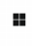 – the element is not / will not be disabled,
– the element is / will be disabled.
- Press to change the currently displayed symbol to the other.
- Press to disable / enable the elements. If at least one system element is disabled, the control panel switches to the disabled condition (see: “Disabled condition” p. 7).

Disabling faulty system elements
You can disable the faulty system elements while viewing the current faults (see: “Viewing the current faults” p. 14):
- Use or to select the faulty system element.
- Press to disable the element.
- Press to confirm that you want to disable the element (press or to quit).

Testing the system elements
You can test the following system elements:
- zones,
- groups,
- routing outputs,
- sounders,
- inputs,
- outputs,
- manual call points and detectors,
- remote indicators.
If the control panel is in the fire alarm condition, testing is impossible.
Start of the test and test activation of system elements are registered in the control panel event log.
- Press to enter the “Tests” submenu (in the user menu).
- Keep pressing until the cursor shows the “Add” or “Edit” submenu.
- Press or . The submenu will be displayed.
- Use or to select the element type.
- Press or .
- If the next menu level is displayed, repeat step 3.
- The list of elements will be displayed. The symbols displayed on the list indicate:
– the element is not / will not be tested,
– the element is / will be tested.
- Press to change the currently displayed symbol to the other.
- Press to start / end the test. If at least one system element is tested, the control panel switches to the test condition (see: “Test condition” p. 7).

Testing the zones
If the zone is tested, the manual call point or detector from the zone will not generate an alarm.
If at least one manual call point or detector belonging to the zone is disabled, testing the zone is impossible.
You can test the manual call points and detectors in the selected zone(s) for proper functioning. Check if the control panel indicates the test activation after:
- smoke / rise of temperature is detected by the detector (to test the smoke sensor, use the smoke detector test spray, to test the temperature sensor, use the heat detector tester),
- manual call point is activated (use the key to test).
If you activate the detector / call point for the purpose of testing:
- the control panel’s and repeater panel’s built-in sounders will be activated,
- information about the activated call point will be displayed on the control panel and the repeater panel for several seconds,
- sounders will be activated.
If the MLB-400 side line module belongs to the tested zone, check if the control panel reports the test activation after the conventional manual call points and detectors connected to the module are activated.

Testing the groups
If at least one sounder or remote indicator linked with the group is disabled, testing the group is impossible.
Starting the test activates the sounders and remote indicators linked with the group.

Testing the manual call points and detectors
You can test the selected manual call points and detectors for proper functioning (see: “Testing the zones”). If you want to check the functioning of the conventional manual call points and detectors connected to the MLB-400 side line module, start the module test.
The test activation of the manual call point or detector will not generate an alarm in the zone.

Testing the routing outputs / sounders / inputs / outputs / remote indicators
Starting the test activates the selected system elements (fire alarm routing output / fault warning routing output / conventional sounders / addressable sounders / control panel input / MIO-400 module input / control panel output / MIO-400 module output).

Diagnostics
Start the “Diagnostics” function to view information about:
- detectors,
- inputs / outputs of the control panel / MIO-400 module,
- control panel / repeater panel battery.
- Enter the user menu. The cursor will show the “Alarms” submenu.
- Keep pressing until the cursor shows the “Diagnostics” submenu.
- Press or . The submenu will be displayed.
- Use or to select the element type.
- Press or .

Detectors
Use or to select the sort criterion (dirt / smoke / temperature). The list will be sorted in a descending order. Press or . Information about the first manual call point or detector on the list will be displayed:
Smoke – level of smoke registered by the detector.
Dirt – level of dirt inside the detector optical chamber.
Temperature – temperature registered by the temperature sensor in the detector.
The  symbol shows the parameter by which the list is sorted.

Input / output state
Use or to select the “Inputs”, “Outputs” or “LED indication”, then press or . The list of inputs / outputs / MIO modules will be displayed.

Inputs / Outputs
Use or to select the input / output, then press to view information about its state. If you want to view the extended information about the input / output, press .

LED indication
Use or to select the MIO-400 module, then press to start the module LED test. If you want to end the test, select “Not selected” and press . If you want to view the extended information about the MIO-400 module, press .

Control panel battery / Repeater panel battery
The following information about the battery will be displayed:
- battery voltage,
- battery resistance.

Setting the clock

Setting the time
- Enter the user menu. The cursor will show the “Alarms” submenu.
- Keep pressing or until the cursor shows the “Settings” submenu.
- Press or . The cursor will show the “Clock” submenu.
- Press or . The cursor will show the “Set time” submenu.
- Press or . Time according to the control panel clock will be displayed.
- Enter the new time. The flashing  cursor indicates which digit you can currently change. Use the and buttons to move the cursor. To enter digits, use the alphanumeric keys or keep pressing or until the required digit appears.
- Press to save new time.

Setting the date
- Enter the user menu. The cursor will show the “Alarms” submenu.
- Keep pressing or until the cursor shows the “Settings” submenu.
- Press or . The cursor will show the “Clock” submenu.
- Press or . The cursor will show the “Set time” submenu.
- Press and then or . Date according to the control panel clock will be displayed.
- Enter the new date. The flashing cursor indicates which digit you can currently change. Use the or buttons to move the cursor. To enter digits, use the alphanumeric keys or keep pressing or until the required digit appears.
- Press to save the new date.

Service mode
To start the service mode you must enter the access code (gain access at level 3). The service menu will be displayed. For more information, refer to the control panel programming manual.

ACSP Soft program
The ACSP Soft program provides a number of diagnostic functions to the control panel users. You can download it from www.satel.pl.

Menu bar of the ACSP Soft program
The menu bar is displayed at the top of the ACSP Soft program window.

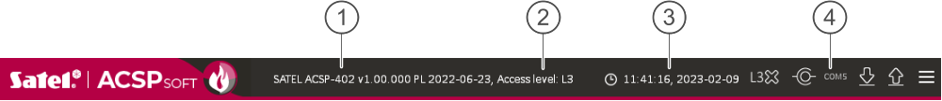
Fig. 3. Menu bar when connection is established with the control panel.

 type of control panel and firmware version.
 access level to the control panel.
 time and date according to the control panel clock.
 number of the computer port through which communication with the control panel USB port takes place.

Buttons
click to save the time in the control panel according to the computer clock.
click to establish connection with the control panel. This button is displayed when the program is not connected to the control panel.
click to disconnect from the control panel. This button is displayed when the program is connected to the control panel.
click to download data from the control panel.
click to save data to the control panel. This button is available when you have access at level 3.
click to display the additional menu.

Side menu
The side menu is displayed on the left side of the program window. Click the menu buttons to open the tabs in which you can control the state of the fire alarm system elements.

Additional menu
To open the additional menu, click .
Open – click to open the control panel data file.
Write – click to save the control panel data to file.
Configuration – click to open the “Configuration” window.
Language – click to open the “Software language” window.
About... – click to display information about the ACSP Soft program.

“Configuration” window

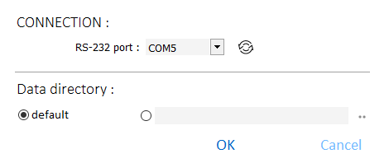
Fig. 4. “Configuration” window.

Connection
RS-232 port – the computer COM port through which communication with the control panel is to take place.
– click to refresh the list of COM ports available in the computer.

Data directory
You can choose whether the control panel data files are to be saved to the default folder or a folder selected by you.

Buttons
OK | click to save changes.
Cancel | click to close the window without saving changes.

“Software language” window

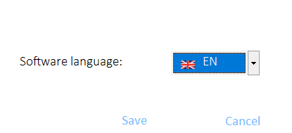
Fig. 5. “Software language” window.

Software language – you can select the program language.

Buttons
Save | click to save changes.
Cancel | click to close the window without saving changes.

Establishing communication with the control panel
- Connect the control panel USB port to the computer port.
- Start the ACSP Soft program.
- Select the computer COM port through which communication is to take place (see: ““Configuration” window” p. 22).
- Click on the menu bar.
- A window will open with information that connection has been established.
- Click “CONNECT” to confirm the connection or click “DOWNLOAD DATA” to download data from the control panel right away.

Addressable elements

Input/output state
You can check the state of inputs and outputs. The MIO-400 module inputs and outputs are displayed on the first list. The control panel inputs and outputs are displayed on the second list.
No. – reference number of the input / output.
Address – address of the input / output (see: “Addressable system elements” p. 9).
Serial no. – serial number of the MIO-400 module.
Name – input / output name.
Type – input / output type and number.
State – the icon indicates the state of input / output:
[burgundy] – input active / output turned on,
[green] – input inactive / output turned off.
Description – text description of the state.

Buttons
click to refresh information.

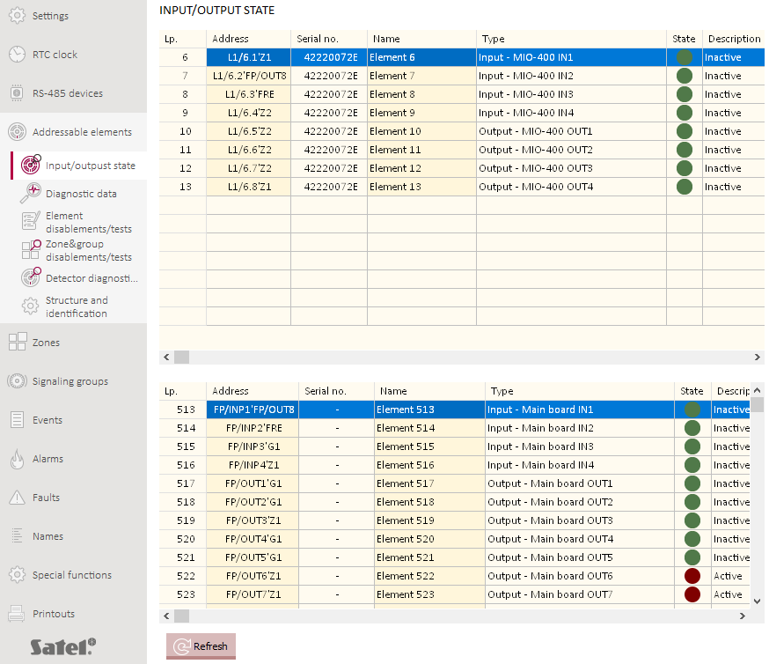
Fig. 6. “Input/output state” tab.

Diagnostic data
You can check the current operating parameters of the control panel and the repeater panel.

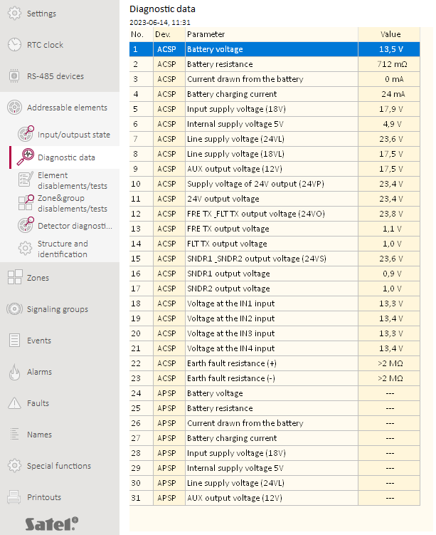
Fig. 7. “Diagnostic data” tab.

Element disablements/tests
You can check which elements of the fire alarm system are currently disabled or tested. The line elements connected to the control panel addressable detection lines are displayed on the first list. The control panel inputs and outputs, detection lines, fire routing outputs, fault warning routing outputs and outputs to control conventional sounders are displayed on the second list.
The MIO-400 conventional input / output module occupies 8 positions on the list of devices. Each module input and output is identified by the control panel as a separate addressable system element with a separate address. They can be tested and disabled separately.

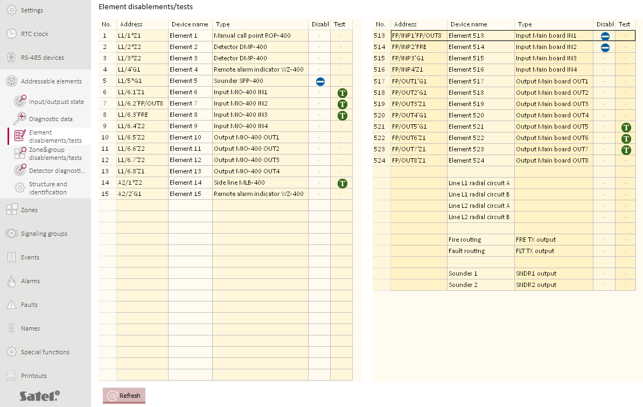
Fig. 8. “Element disablements/tests” tab.

No. – reference number of the element (line element / input / output).
Address – address of the element (see: “Addressable system elements” p. 9).
Device name – element name.
Type – element type.
Disabl. – the icon [blue] indicates that the element is disabled.
Test – the icon [green] indicates that the element is tested.

Buttons
click to refresh information.

Zone&group disablements/tests
You can check which zones and groups are currently disabled or tested.
Nr – zone / group number.
Zone name / Group name – zone / group name.
Disabl. – the icon [blue] indicates that the zone / group is disabled.
Test – the icon [green] indicates that the zone / group is tested.

Buttons
click to refresh information.

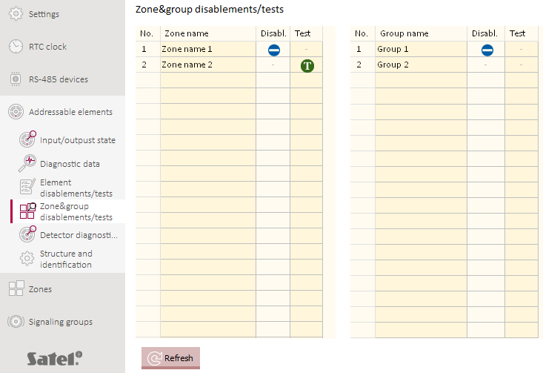
Fig. 9. “Zone&group disablements/tests” tab.

Detector diagnostics
You can check the current state of addressable detectors.

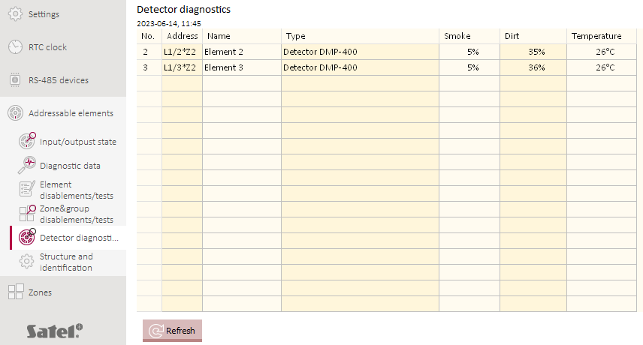
Fig. 10. “Detector diagnostics” tab.

Nr – reference number of the detector on the device list.
Address – address of the detector (see: “Addressable system elements” p. 9).
Name – detector name.
Type – detector type and trade name.
Smoke – level of smoke registered by the detector.
Dirt – level of dirt inside the detector optical chamber.
Temperature – temperature registered by the temperature sensor in the detector.

Buttons
click to refresh information.

Events
Up to 8999 event can be registered in the control panel non-volatile memory.

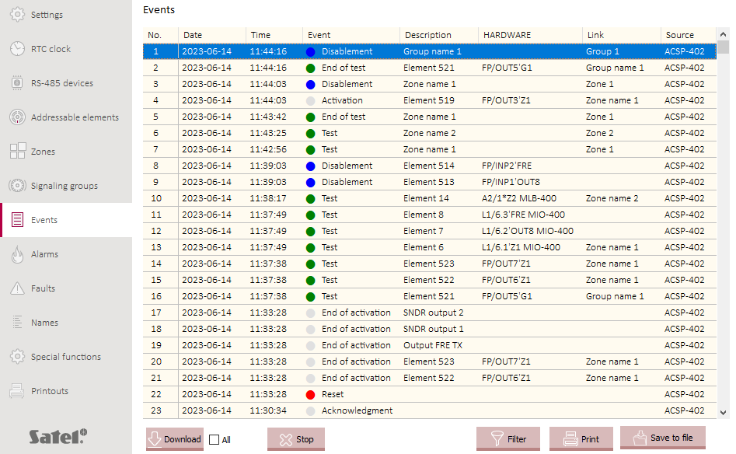
Fig. 11. “Events” tab.

The events are sorted from the newest (top) to the oldest (bottom). The following pieces of information are listed in the columns:
Date – date when the event occurred.
Time – time when the event occurred.
Event – type and description of the event. The type of event is indicated by the color of the icon:
[red] – alarm,
[yellow] – fault,
[blue] – disablement,
[green] – test,
[gray] – other event.
Description – name of the system element which generated the event (e.g. zone / line element / input / output).
Hardware – address and trade name of the element which generated the event (e.g. line element / input / output).
Link – name of the zone / group that the system element which generated the event is linked with.
Source – source of information about the event (control panel / repeater panel / ACSP-ETH module).

Buttons
click to download events from the control panel. If you enable the “All” option, all events will be downloaded from the control panel memory (normally, only those events are downloaded that occurred since the last download).
click to stop downloading events from the control panel.
click to open the “Event filter” window.
click to open the “Printout” window (see: “Printout” p. 33).
click to save the list of events to *.csv file.

“Event filter” window
You can select the events that are to be listed. You can filter events by:
- event type – event types are labelled with colors,
- date – events that occurred between the selected dates,
- text – events that contain the entered text.

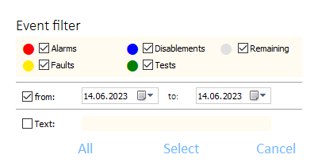
Fig. 12. “Event filter” window.

Buttons
All | click to display all events (no filtering).
Select | click to display the events that meet the filtering criteria.
Cancel | click to close the window without making changes.

Alarms
You can view the fire alarm log.

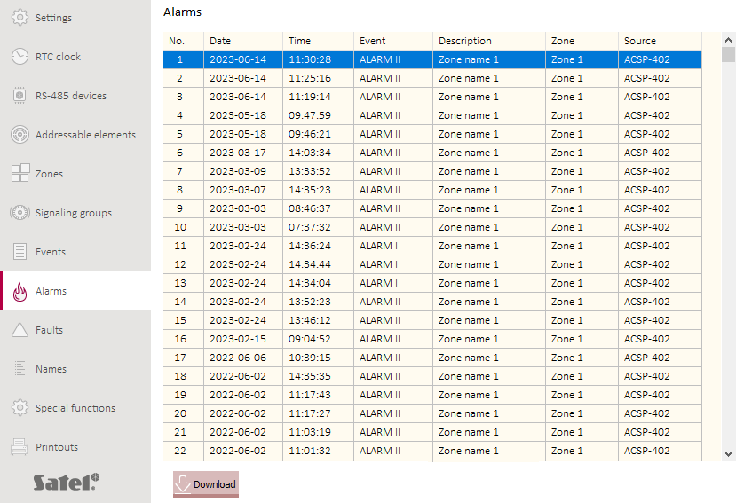
Fig. 13. “Alarms” tab.

The alarms are sorted from the newest (top) to the oldest (bottom). The following information are listed in the columns:
Date – date when the alarm was generated.
Time – time when the alarm was generated.
Event – alarm type (first stage / second stage).
Description – name of the zone in which the alarm was generated.
Zone – number of the zone in which the alarm was generated.
Source – source of information about the event (control panel / repeater panel / ACSP-ETH module).

Buttons
click to download alarms from the control panel.

Faults
You can view the list of current faults in the system.

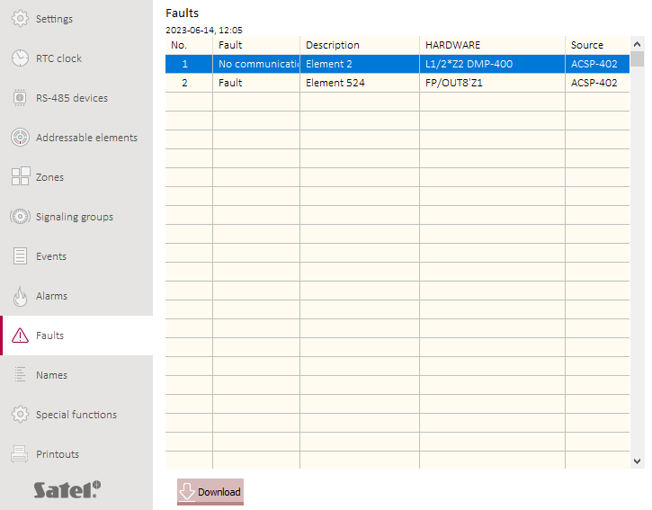
Fig. 14. “Faults” tab.

The faults are sorted from the newest (top) to the oldest (bottom). The following pieces of information are listed in the columns:
Fault – type of fault (e.g. no communication).
Description – name of the faulty system element.
Hardware – address and trade name of the faulty line element.
Source – source of information about the event (control panel / repeater panel / ACSP-ETH module).

Buttons
click to download faults from the control panel.

Special functions
You can restore the default access code to the control panel at level 3 (service mode). This function is available when you have access to the control panel at level 2.

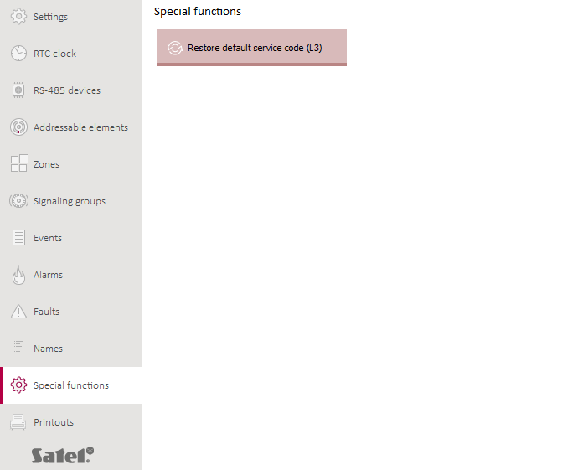
Fig. 15. “Special functions” tab.

Buttons
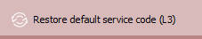 | click to restore the default access code to the control panel at level 3. The default code: 1234.

Printouts

Configuration
You can print out the fire alarm system settings. Click “Printouts”, then “Configuration”. The “Printout” window will be displayed (Fig. 16).

“Printout” window

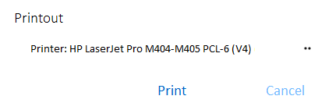
Fig. 16. “Printout” window.

Printer – name of the selected printer.

Buttons
 | click to select the printer.
Print | click to start printing.
Cancel | click to close the window.

Test report
You can print out a report of the fire alarm system tests. The report contains information about: tests running in the control panel, diagnostic data of the control panel and detectors, currently reported faults.
Click “Printouts”, then “Test report”. The “ACSP system test report” window will be displayed (Fig. 17).

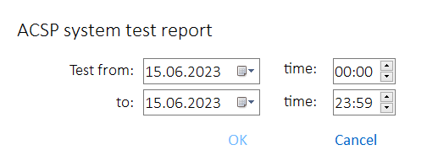
Fig. 17. The “ACSP system test report” window.

Test from – beginning of the period to be included in the report (date and time).
to – end of the period to be included in the report (date and time).

Buttons
OK | click to open the “Printout” window.
Cancel | click to close the window.

VAPSP application
The VIRTUAL APSP app is used to monitor the fire alarm system status remotely. The communication between the app and the ACSP-402 control panel is possible if the ACSP-ETH module is connected to the control panel. The module is an optional element of the system. The VAPSP app is available for mobile devices and computers (Android, iOS, Linux and Windows systems).
The communication between the app and the control panel is encrypted.

Features
- System status indication.
- Display of:
- alarm information,
- alarm and event logs,
- current faults, disablements and tests.
- Acoustic alarm signaling.
- Capability to activate in the control panel the sending of diagnostic reports.

Installing the app
You can download the app from “Google Play” (Android system devices) or “App Store” (iOS system devices) or from www.satel.pl (Windows or Linux system devices).

Starting the app

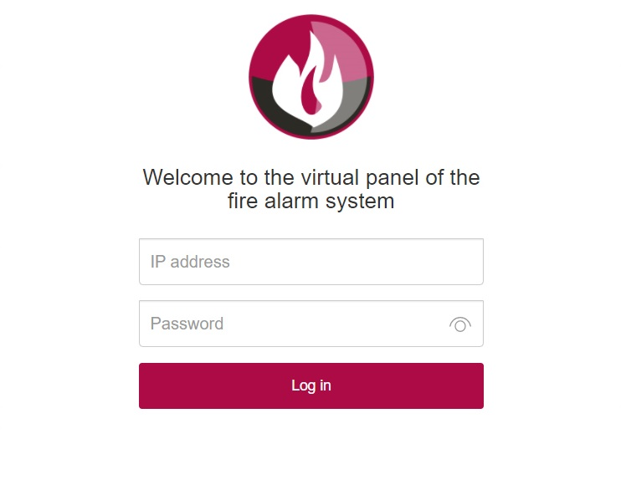
Fig. 18. Login window of the VAPSP fire alarm system virtual panel.

After you start the app, enter the following information in the login window:
- IP address of the ACSP-ETH module. If the port used for communication is different than the default 80 port, enter the port number after the IP address and the colon.
- user or service code (the codes programmed in the control panel).
If the connection is authorized by the service code, the “Diagnostics” option is available in the app (see: “Additional menu” p. 36).

Description

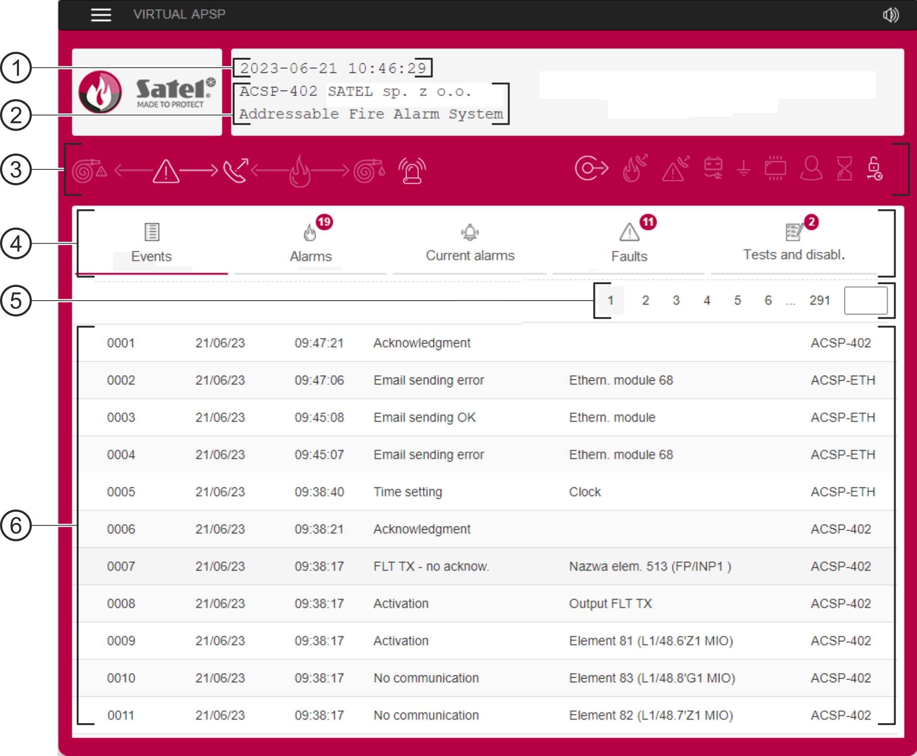
Fig. 19. VAPSP virtual panel.

date and time according to the control panel clock.
system information (programmed in the control panel).
system status bar. The icons on the bar operate similarly to their corresponding LEDs on the control panel (see: “LED indicators” p. 3).
main menu (see: “Main menu of the app” p. 36).
 navigation bar. Click / tap the page number or enter it in the field at the end of the line to go to the selected page.
 area where event / alarm log and the list of current alarms / faults / tests / disablements are displayed.

Buttons
click / tap to display the additional menu (see: “Additional menu”).
click / tap to enable / disable acoustic signaling in the device on which the app is installed (signaling is working if the sound in the device is on).

Main menu of the app
The buttons are used to navigate the tabs. The number of new and unseen events is displayed on the buttons.
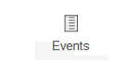 | click / tap to display the event log.
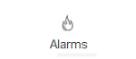 | click / tap to display the alarm log.
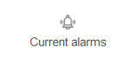 | click / tap to display information about the current alarms.
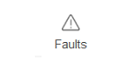 | click / tap to display information about the current faults.
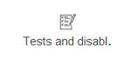 | click / tap to display the current tests and disablements.

Additional menu
To open the additional menu, click .
Diagnostics | click / tap to start the “Diagnostic reports” function in the control panel. The control panel will send a diagnostic report to the e-mail addresses programmed in the control panel. This command is displayed if you used the service code to log in.
Log out | click / tap to log out.



Fire alarm control panel
EN

ACSP-402
Firmware version 1.00



USER MANUAL
acsp-402_u_en 06/23


SATEL sp. z o.o. • ul. Budowlanych 66 • 80-298 Gdańsk • POLAND
tel. +48 58 320 94 00
www.satel.pl
nie drukować

