IMPORTANT
Before you start programming, please read carefully this manual in order to avoid mistakes that can lead to malfunction or even damage to the equipment.

SATEL aims to continually improve the quality of its products, which may result in changes in their technical specifications and software. Current information about the changes being introduced is available on our website.
Please visit us:
https://support.satel.pl

The following symbols may be used in this manual:
 - note,
 - caution.

CONTENTS
1. Introduction 3
2. Addressable elements 3
2.1 Line elements 3
2.2 Control panel inputs and outputs 3
2.3 Addresses of the system elements 4
2.4 Verification of addressable elements 4
2.5 Links between the addressable elements 4
2.5.1 Link identifier 6
3. Service mode 7
3.1 Starting the service mode 7
3.2 Indicating the service mode 8
3.3 Hiding the service mode 8
3.4 Exiting the service mode 8
4. Programming using the buttons on the control panel 8
4.1 Acoustic signaling during programming 8
4.2 Navigating the menu and starting the functions 8
4.3 Information on system elements 9
4.4 Editing data 9
4.4.1 Making a selection from the single-choice list 9
4.4.2 Making a selection from the multiple-choice list 9
4.4.3 Entering digits 9
4.4.4 Entering names 9
4.5 Programming the detection line 10
4.5.1 Adding the detection line elements 10
4.5.2 Removing the detection line elements 11
4.5.3 Linking an addressable element with another system element 11
4.5.4 Unlinking an addressable element 12
4.5.5 Changing the detection line topology 12
4.5.6 Function to verify line elements 13
4.6 Service menu 14
5. Programming in the ACSP Soft program 25
5.1 Description of the ACSP Soft program 25
5.1.1 Menu bar of the ACSP Soft program 25
5.1.2 Side menu 26
5.1.3 Additional menu 26
5.2 Establishing communication with the control panel 27
6. Settings 27
6.1 Times 28
6.2 Events signaled by WZ-400 29
6.3 L3 access code 29
6.4 Earth fault control 29
6.5 Personnel 29
6.5.1 Attendance schedule 30
6.6 Options 30
6.7 Routing outputs 30
6.8 Sounders 31
7. RTC clock 31
8. RS-485 devices 33
8.1 ACSP-ETH module 33
8.1.1 VAPSP application 34
8.1.2 NTP time synchronization 34
8.1.3 INTEGRUM 34
8.2 Printer 34
8.3 E-mail messaging 34
8.3.1 Recipients 35
8.3.2 Selection of event types 35
8.3.3 Diagnostic reports 35
9. Addressable elements 35
9.1 Dependence 37
9.2 Detector 37
9.3 Remote indicator 37
9.4 Inputs and outputs 37
9.4.1 Inputs 37
9.4.2 Outputs 39
9.5 Side line module 40
9.6 Locate device 40
9.6.1 Line supply 41
9.7 Structure and identification 42
9.7.1 Starting the identification function 43
9.7.2 Starting the verification function 43
9.7.3 Adding the detection line elements 43
9.7.4 Removing the detection line elements 44
9.7.5 Relocating the detection line elements 44
9.7.6 Cutting the loop 44
9.7.7 Connecting the radial circuits 44
10. Zones 45
10.1 Alarm variants 46
11. Signaling groups 49
12. Names 51
13. Special functions 52
14. Printouts 53
14.1 Configuration 53
14.2 Test report 53
15. Restoring the default settings 54
15.1 Restoring the default settings using the buttons on the control panel 54
15.2 Restoring the default settings in the ACSP Soft program 54

Introduction
You can configure the fire alarm system when the service mode is started in the control panel (you gained access to the control panel at level 3). To configure the system, you can use the following:
- buttons on the control panel,
- computer with ACSP Soft program installed.
Names of parameters and options from the ACSP Soft program are used in this manual. Next to the names, in square brackets, you will find one of the following information:
- name of the function used to configure the parameter or option in the service menu of the control panel,
- name of the parameter or option in the service menu of the control panel.

Addressable elements
The ACSP-402 control panel supports the following addressable elements:
- line elements (addressable devices),
- inputs and outputs.
You can create links (dependences) between the addressable elements. When elements are linked, their operation is dependent on the occurrence of certain events in the fire alarm system (see: “Links between the addressable elements” p. 4).

Line elements

Manual call points
ROP-400 – addressable manual call point.
ROP-401 – addressable manual call point for outdoor use.

Detectors
DMP-400 – addressable multisensor smoke and heat detector.
DRP-400 – addressable optical smoke detector.
DCP-400 – addressable fixed temperature / rate-of-rise heat detector.

Sirens
SPP-400 – addressable fire alarm sounder.
SPP-401 – addressable fire alarm sounder for outdoor use.

Remote indicators
WZ-400 – addressable remote indicator.

Modules
MIO-400 – conventional input / output module.
MLB-400 – conventional side line module.

Control panel inputs and outputs
IN1…4 – programmable input to supervise the operation of a device with the NO or NC type relay.
OUT1…7 – programmable relay output (potential-free).
OUT8 – programmable relay output to control the automatic fire protection equipment (potential-free with control of line continuity).

Addresses of the system elements

Line elements
The addresses are given by the control panel during the identification (see: “Installer manual”) or verification procedure (see: “Verification of addressable elements”). The address consists of the detection line symbol (L1 / L2 – loop symbol or A1 / A2 / B1 / B2 – radial circuit symbol) and the element’s reference number (e.g. L1/1 – address of the first device connected to the L1 loop).

MIO-400 conventional input / output module
In the MIO-400 module, each input and output is given its own address. For example: A1/3.1 – A1 radial circuit, third device on the radial circuit, IN1 input.

Control panel inputs and outputs
Each control panel input / output is treated as a separate addressable system element. They have the following addresses:
FP/INP1…4 – input.
FP/OUT1…8 – output.

Verification of addressable elements
If you made any changes in the detection line(s), you must start the verification function. If you made a single change (e.g. added / removed an element or swapped two elements), you can do it from the control panel (see: “Function to verify line elements” p. 13). If you made more changes, start the verification in the ACSP Soft program (see: “Starting the verification function” s. 43).
When the verification function is completed, new elements are given their addresses and some of the previously identified elements may be given a new address.
The verification function does not change the current system settings. The changes are limited to corrections that resulted from changing the element address. If the element address has been changed, it is replaced with the new one in all settings.

Links between the addressable elements
You can create links (dependences) between the addressable elements. Depending on the element type, you can assign (add) it to the zone or the signaling group or link it with the zone, group or another addressable element:
- Manual call point / Detector / Side line module – you can assign (add) the element to a zone. Activation of the manual call point / detector / module input will generate alarm in this zone.
- Acoustic sounder – you can assign (add) the element to a signaling group. The sounder will be activated when alarm is generated in the zone linked with the group (see: “Signaling groups” p. 49).
If the manual call point / detector / side line module is not assigned to a zone or the sounder is not assigned to a group, the control panel indicates a fault (“No configuration”).
- Remote indicator – you can link the element with a zone, group or other addressable element (see: Table 1). The indicator can indicate events that occurred in the zone or the group or events related to the selected element. If the indicator is not linked with a zone, a group or another element, the indicator will indicate events in the entire system (see: “Remote indicator” p. 37).
- Input (of the control panel / MIO-400 input and output module) – depending on the input type (see: “Input type” p. 37), you can link it with a zone, a group or another addressable element (for possible links see: Table 1).
- Output (of the control panel / MIO-400 input and output module) – depending on the output type (see: “Output type” p. 39), you can link it with a zone or a group (for possible links see: Table 1).
Table 1 shows the link that can be created between the addressable elements in the fire alarm system.

Addressable element | Link
Addressable element | Type of link | Linked system element / addressable element
Manual call point (ROP) | Belongs to | Zone
Detector (DMP/DRP/DCP) | Belongs to | Zone
Side line module (MLB) | Belongs to | Zone
Sounder (SPP) | Belongs to | Group
Remote indicator (WZ) | None | ---
Remote indicator (WZ) | Linked with | Zone
Remote indicator (WZ) | Linked with | Group
Remote indicator (WZ) | Linked with | Detector
Remote indicator (WZ) | Linked with | Side line module
Control panel / MIO-400 module input, depending on the input type
Fire damper | None | ---
Fire damper | Linked with | Input type:  “Fire alarm”
Routing acknowledgement | None | ---
Fault | None | ---
Fault | Linked with | Zone
Fault | Linked with | Group
School bell | None | ---
External fire alarm | None | ---
External fire alarm | Linked with | Zone
Acknowl. of fire protection equip. activation (OUT8) | Linked with | Output OUT8 type:  “Control of fire protection equipment”
Acknowl. of fire protection equip. activation (FRE TX) | Linked with | Output FRE TX type:  “Control of fire protection equipment”
Acknowl. of fire protection equip. activation | Linked with | Output type:  “Control of fire protection equipment”
Logic control | Linked with | Zone
Logic control | Linked with | Group
Evacuation | Linked with | Zone
Evacuation | Linked with | Group
Control panel / MIO-400 module output, depending on the output type
Fire alarm | None | ---
Fire alarm | Linked with | Zone
Fire alarm | Linked with | Group
No routing acknowledgment | None | ---
Fault | None | ---
Fault | Linked with | Zone
Fault | Linked with | Group
Disablement | None | ---
Disablement | Linked with | Zone
Disablement | Linked with | Group
Alarm/Fault clearing | None | ---
Control of fire protection equipment | None | ---
Control of fire protection equipment | Linked with | Zone
Control of fire protection equipment | Linked with | Group
Logic control | Linked with | Group
Evacuation | Linked with | Group
Table 1.

Link identifier
If one addressable element is linked with another element of the fire alarm system, the link identifier is added to that element’s address. The first symbol of the identifier indicates the type of link:
* – element is assigned (belongs) to a zone or a signaling group,
’ – element is linked with a zone, group or addressable element.
The following signs of the identifier indicate which system element the device is linked with:
Zx – with a zone (x = zone number).
Gx – with a group (x = group number).
[address] – with an element of a given address (e.g. L2/1).
OUT – with a control panel / MIO-400 module output.
You can check the address of the linked output in the device details (click  on the control panel) or in the ACSP Soft program.
OUT8 – with the OUT8 control panel output when the output type is “Control of fire protection equipment”.
FRE – with the FRE TX control panel output when the output type is “Control of fire protection equipment”.

Example addresses of elements including the link identifier
L1/1*Z1 – element (e.g. manual call point / detector / side line module) with address L1/1 is assigned (belongs) to zone 1.
L1/6’Z1 – element (e.g. remote indicator) with address L1/6 is linked with zone 1.
FP/INP1’Z1 – control panel input with address FP/INP1 is linked with zone 1.
L1/9*G1 – element (e.g. sounder) with address L1/9 is assigned (belongs) to group 1.
L1/10.1’G1 – MIO-400 module input with address L1/10.1 is linked with group 1.
L1/8’A2/1 – element (e.g. remote indicator) with address L1/8 is linked with a detector / side line module with address A2/1.
FP/INP1’OUT – control panel input with address FP/INP1 is linked with a control panel / MIO-400 module output (the address of the linked output is available after device information is displayed or in the ACSP Soft program).

Service mode
You can start the service mode using the buttons on the control panel:

Starting the service mode
When the service mode is started, the supervisory functions of the control panel are not performed (the repeater panel is not supported, alarms and faults are not signaled, etc.).
- Turn the key switch to the CONTROL position. The yellow  LED will turn ON.
- Press  or .
- The “Level 2” menu will be displayed on the control panel display (the cursor will show the “Alarms” submenu).
- Press .
- When the cursor shows the “Service mode” submenu, press or .
- Enter the access code using the alphanumeric keys (default code: 1234).
- Press to confirm the code.
- The service menu will be displayed (the cursor will show the “Zones” submenu).
If the control panel is connected with the ACSP Soft program, the “Service mode: ACSP Soft” message will be displayed. This means that you can only configure the system using the ACSP Soft program.

Indicating the service mode
The service mode is indicated by the flashing of the yellow CONTROL LED on the control panel. If the control panel is connected with the ACSP Soft program, the “Service mode: ACSP Soft” message will be displayed.

Hiding the service mode
The service mode is hidden automatically 10 minutes after the last activity was performed using the buttons on the control panel. If you want to access the menu again, press the button and enter the access code using the alphanumeric keys.

Exiting the service mode

Control panel
Keep pressing  or  until the cursor shows the “Exit the SM”, then press or .

ACSP Soft program
Click on the program’s menu bar. In the “Exit Service Mode” window, click YES.

Programming using the buttons on the control panel
You can configure the fire alarm system using the functions available in the service menu (see: “Starting the service mode”).

Acoustic signaling during programming
1 short beep – button pressed / function started / selection confirmed / entered data confirmed.
2 short beeps – function unavailable / refusal to execute command.

Navigating the menu and starting the functions
Table 2 shows the buttons used for menu navigation.
Button | Function
 | Exit the menu or submenu / quit without starting the function or saving changes.
 | Scroll up.
 | Scroll down.
 | Enter the submenu / start the function / select the option.
 | Return to the previous menu level / quit without saving the changes made.
 | Enter the submenu / start a function / confirm selected options.
Table 2.

The cursor shows the submenu you can enter / function you can start / option you can select.
Press and hold / to scroll faster through the menu.

Information on system elements
You may notice that names and addresses are displayed when you scroll and edit the list of system elements. Press and hold for about 3 seconds to change how the information is presented.

Editing data
The editing method depends on the type of data. Having completed the editing, press to confirm the changes. To exit the function without saving the changes, press or .

Making a selection from the single-choice list
The 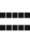 symbol indicates the currently selected item. To scroll through the list of items, press or .

Making a selection from the multiple-choice list
To scroll through the list of items, press or . The following symbols are displayed on the list:
 – item is selected / option is enabled,
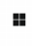 – item is not selected / option is disabled.
Press to change the currently displayed symbol to the other.

Entering digits
The flashing  cursor indicates which digit you can change. To move the cursor, use the or button (pressing right after the function is started ends the function). To enter digits, use the alphanumeric keys or keep pressing or until the required digit appears.

Entering names
The flashing cursor indicates which character you can currently change. To move the cursor, use the or button (pressing right after the function is started ends the function). The button deletes the character on the left side of the cursor. The button changes the letter case or changes letters to digits. The information displayed in the upper line, on the right side of the display, indicates the type of characters you can currently enter: ABC / Abc / abc / 123.
You can enter characters using the alphanumeric keys. Table 3 shows the available characters. Keep pressing the key until the required character appears. To use the upper case letters, press to change the letter case, then press the required letter key. Hold the button to enter a digit right away.

Button | Characters available after next keystroke
 | ! | ? | ' | ` | " | { | } | $ | % | & | @ | \ | ^ | | | # | 1
 | a | b | c | 2
 | d | e | f | 3
 | g | h | i | 4
 | j | k | l | 5
 | m | n | o | 6
 | p | q | r | s | 7
 | t | u | v | 8
 | w | x | y | z | 9
 |  | . | , | : | ; | + | - |  | / | = | _ | < | > | ( | ) | [ | ] | 0
Table 3.

Programming the detection line

Adding the detection line elements
- Start the service mode (see: p. 7). The service menu will be displayed.
- Keep pressing until the cursor shows the “Elements” submenu, then press or . The cursor will show the “All” submenu.
- Keep pressing until the cursor shows the “Add device” submenu, then press or . The “Serial number” submenu will be displayed.
- Press or , then enter the serial number of the device you want to add. You will find it on the electronics board or the device enclosure.
- Press to confirm the number.
- Press .
- When the cursor shows the “Location” function, press or . The list of detection lines will be displayed.
- Press or to select from the list the detection line to which you want to add the device.
- Press or . The list of devices connected to the line will be displayed.
- Press or to select from the list the detection line element after which you want to add the device. If you want to add it directly after the detection line terminals, select “Terminal A/B”.
- Press or . The “On a branch?” prompt will be displayed.
- Press to add the device to the main detection line or press to add the device on a branch (to quit, press ).

Removing the detection line elements
- Start the service mode (see: p. 7). The service menu will be displayed.
- Keep pressing until the cursor shows the “Elements” submenu, then press or . The cursor will show the “All” submenu.
- Keep pressing until the cursor shows the “Remove device” submenu, then press or . The list of detection lines will be displayed.
- Press or to select from the list the line to which the device is connected.
- Press or . The list of devices connected to the detection line will be displayed.
- Press or to select from the list the device you want to remove (addresses and serial numbers of the devices are displayed).
- Press or to remove the device.
- Press to confirm the changes (press or to quit).

Linking an addressable element with another system element
- Start the service mode (see: p. 7). The service menu will be displayed.
- Keep pressing until the cursor shows the “Elements” submenu, then press or . The cursor will show the “All” submenu.
- Press or . The list of addressable elements supported by the control panel will be displayed.
If you want to narrow down the list of elements to one type of devices (e.g. detectors and manual call points), instead of “All”, select the “By type” submenu. Then, select the submenu with the particular type of devices, e.g. “Det. & m. call p.”.
- Press or to select from the list the addressable element you want to link with another system element.
- Press or . Depending on the element type, the following functions may be displayed:
- “Add to zone” – if you want to add a manual call point / detector / side line module to a zone,
- “Add to group” – if you want to add a sounder to a group,
- “Link with zone” – if you want to link a remote indicator / input (of control panel / MIO-400 module) / output (of control panel / MIO-400 module) with a zone,
- “Link with group” – if you want to link a remote indicator / input (of control panel / MIO-400 module) / output (of control panel / MIO-400 module) with a group,
- “Link with element” – if you want to link a remote indicator / input (of control panel / MIO-400 module) with another addressable element.
- Press or to select the function from the list and press or . The list of system elements will be displayed. Depending on the selected function, it will be the list of zones, groups or addressable elements.
- Press or to select from the list the zone / group / addressable element with which you want to link the element.
- Press to confirm the changes.

Unlinking an addressable element
- Start the service mode (see: p. 7). The service menu will be displayed.
- Keep pressing until the cursor shows the “Elements” submenu, then press or . The cursor will show the “All” submenu.
- Press or . The list of addressable elements supported by the control panel will be displayed.
If you want to narrow down the list of elements to one type of devices (e.g. detectors and manual call points), instead of “All”, select the “By type” submenu. Then, select the submenu with the particular type of devices, e.g. “Det. & m. call p.”.
- Press or to select from the list the element you want to unlink from another system element.
- Press or . Depending on the element type, the following functions may be displayed:
- “Remove from zone” – if you want to remove a manual call point / detector / side line module from a zone,
- “Remove from group” – if you want to remove a sounder from a group,
- “Unlink” – if you want to unlink an element from a zone / group / another addressable element.
- Press or to select the function from the list and press or to unlink.
- Press to confirm the changes (press or to quit).

Changing the detection line topology
You can cut the loop to create one or two radial circuits. To create a loop, you can connect two radial circuits to each other or connect one radial circuit with the detection line terminal.
- Start the service mode (see: p. 7). The service menu will be displayed.
- Keep pressing until the cursor shows the “Lines” submenu, then press or . The cursor will show the “Detected topology” submenu.
- Press .
- When the cursor shows the “Topology change” function, press or . The list of detection lines will be displayed.
- Press or to select from the list the detection line whose topology you want to change.
- Press or . Depending on the detection line type, the “Cut the loop after” or “C. rad. c. A after” information and the list of devices connected to the detection line (loop or radial circuit A) will be displayed.
- If you want to cut the loop:
- press or to select from the list the loop element after which you want to cut the loop (if you want to cut the loop after the detection line terminals, select “Terminal A”),
- press or ,
- press to confirm that you want to cut the loop (press or to quit).
- If you want to connect the radial circuits into a loop:
- press or to select from the list the element of the radial circuit A after which you want to connect the radial circuits,
- press or . The “C. rad. c. B after” information and the list of devices connected to the radial circuit B will be displayed,
- press or to select from the list the element of the radial circuit B after which you want to connect the radial circuits (if you want to connect the radial circuit A with the detection line terminals, select “Terminal B”),
- press or ,
- press to confirm the changes (press or to quit).

Function to verify line elements
The verification of line elements is required whenever changes are made on the detection line(s). You can only start this function if you made a single change (e.g. added / removed an element or swapped two elements).
- Start the service mode (see: p. 7). The service menu will be displayed.
- Keep pressing until the cursor shows the “Elements” submenu, then press or . The cursor will show the “All” submenu.
- Keep pressing until the cursor shows the “Verify elements” submenu, then press or .
- Press to confirm that you want to start the verification function (press or to quit).
- If the function detects a change of the detection line topology, the “Topology change?” message will be displayed. If the detected topology is correct, press to confirm the changes and continue the execution of the function. If detection lines of a different topology than the connected ones have been detected, press or . Check the connections and restart the identification function.
- When the elements connected to the detection line are verified, the following message will be displayed:
- “No change” – if the function detects no changes in the detection lines topology.
- “Add element?” / “Delete element?” / “Replace element?” / “Move element?” / “Swap elements?” / “Rearrange elements?” / “Add rem. al. indic.?” / “Remove r. al. ind.?” – if the function detects a single change in the line topology. Press to acknowledge the changes (press or to quit).
- “Error” – if the function detects more than one change in the line topology. In such a case, start the verification function in the ACSP Soft program (see: “Starting the verification function” p. 43).
- Press to end the function.

Service menu
Some menu items are available only after certain conditions are met (e.g. after a device has been identified, an option has been enabled, etc.).
Zones
Zone list
[zone selected by number / name]
Name
Alarm variant
Variant 1
…
Variant 19
Variant disablement
YES
NO
Elements
Element list
[element selected by address / name]
Remove from zone
YES
NO
Add to zone
[element selected by address / name]
Remove from zone
[element selected by address / name]
Add to subzone B
[element selected by address / name]
Remove from subz. B
[element selected by address / name]
Links
Linked with zone
[element selected by address / name]
Unlink
YES
NO
Link with zone
[element selected by address / name]
Unlink
[element selected by address / name]
2-stage call point
YES
NO
Day sensitivity
Normal
High
Low
Night sensitivity
Normal
High
Low
Delete this zone
YES
NO
Add zone
[zone selected by number / name]
Delete zones
[zone selected by number / name]
Groups
Group list
[group selected by number / name]
Name
Elements
Element list
[element selected by address / name]
Remove from group
YES
NO
Add to group
[element selected by address / name]
Remove from group
[element selected by address / name]
Links
Linked with group
[element selected by address / name]
Unlink
YES
NO
Link with group
[element selected by address / name]
Unlink
[element selected by address / name]
Activat. from zones
[zone selected by number / name]
Alarm signaling
Alarm II tone
None
Tone 1
…
Tone 32
Alarm I tone
None
Tone 1
…
Tone 32
Evacuation tone
None
Tone 1
…
Tone 32
Logic control
Sum
Product
Delete this group
YES
NO
Add group
[group selected by number, max: Group 32]
Delete group
[group selected by number / name]
Lines
Detected topology
[detected detection lines]
Topology change
Line 1
[start of the topology change function – see: “Changing the detection line topology” p. 12]
Line 2
[start of the topology change function – see: “Changing the detection line topology” p. 12]
Line power
Line 1A
Power off
Power on
Line 1B
Power off
Power on
Line 2A
Power off
Power on
Line 2B
Power off
Power on
Elements
All
[element selected by address / name]
[element configuration – see: “By type” menu]
By type
Sounders
[sounder selected by address / name]
Name
Add to group
[group selected by number / name]
Remove from group
YES
NO
Inputs
[input selected by address / name]
Input name
Input type
Off
Fire damper
Routing acknowl.
Ext. device fault
School bell
Ext. fire alarm
OUT8 f. p. eq. ack
FRE TX f. p. eq. ack
F. p. equip. ack.
Logic
Evacuation
Personnel presence
F. damper control
Closing
Opening
Input polarity
NO
NC
Options
Fire routing
Fault routing
Alarm mode
One-stage
Two-stage
Delay time
0 sec [no delay]
…
10 min
Operation time
Continuous
2 sec
…
10 min
Link with zone
[zone selected by number / name]
Link with group
[group selected by number / name]
Link with output
[output selected by number / name]
Unlink
YES
NO
Outputs
[output selected by address / name]
Output name
Output type
Off
Alarm
No acknowledgment
Fault
Disablement
Reset
Fire p. eq. contr.
Logic
Evacuation
Options
[output type Alarm / Fire p. eq. contr.]
Alarm II
Alarm I
[output type No acknowledgment]
Fire routing
Fault routing
[output type Fault]
Power
Convent. sounders
Routing outputs / Other
[output type Disablement]
Convent. sounders
FRE TX output
FLT TX output
Delay time
0 sec [no delay]
…
10 min
Operation time
Continuous
2 sec
…
10 min
Link with zone
[zone selected by number / name]
Link with group
[group selected by number / name]
Unlink
YES
NO
Det. & m. call. p.
Manual call points
[manual call point selected by address / name]
Name
Add to zone
[zone selected by number / name]
Remove from zone
YES
NO
Detectors
[detector selected by address / name]
Name
R. alarm indicator
YES
NO
Add to zone
[zone selected by number / name]
Remove from zone
YES
NO
Side lines
[line in the MLB-400 module selected by address / name]
Name
Alarm mode
One-stage
Two-stage
Add to zone
[zone selected by number / name]
Remove from zone
YES
NO
Indicators
[indicator selected by address / name]
Name
Indicated states
Activity
Disablement
Fault
Link with zone
[zone selected by number / name]
Link with group
[group selected by number / name]
Link with element
[element selected by address / name]
Unlink
YES
NO
Identify elements
[start of the detection line elements identification function – see: control panel installer manual]
Verification errors
[list of errors]
Verify elements
[start of the detection line elements verification function – see: “Function to verify line elements” p. 13]
Verification errors
Add device
[start of the detection line elements adding function – see: “Adding the detection line elements” p. 10]
Remove device
[start of the detection line elements removing function – see: “Removing the detection line elements” p. 11]
Device list
Consecutively
[list of devices]
By serial number
[list of devices]
Supervisory indic.
YES
NO
Location
Status
[status of the selected device]
Select device
Consecutively
[device selected by address / name]
By serial number
[device selected by serial number]
Restore settings
YES
NO
Global settings
Acknowl. time
Verification time
X time
Y time
Personnel
By access level
YES
NO
According to sched.
YES
NO
Attendance schedule
Sunday
00:00 – 00:29
...
23:30 – 23:59]
Monday
00:00 – 00:29
...
23:30 – 23:59]
Tuesday
00:00 – 00:29
...
23:30 – 23:59
Wednesday
00:00 – 00:29
...
23:30 – 23:59
Thursday
00:00 – 00:29
...
23:30 – 23:59]
Friday
00:00 – 00:29
...
23:30 – 23:59]
Saturday
00:00 – 00:29
...
23:30 – 23:59
Variant change
YES
NO
Sensitivity change
YES
NO
Enabling delays
YES
NO
Disabling delays
YES
NO
WZ indication
Activity
None
Intermittent 1
Intermittent 2
Continuous
Disablement
None
Intermittent 1
Intermittent 2
Continuous
Fault
None
Intermittent 1
Intermittent 2
Continuous
Sounder 1
No
Alarm I(i) or II
Alarm I or II
Alarm II
Sounder 2
No
Alarm I(i) or II
Alarm I or II
Alarm II
Sounder 3
No
Alarm I(i) or II
Alarm I or II
Alarm II
FRE TX output
Input type
Transmission
No
Sounder 3
Fire p. eq. contr.
Delay time
0 sec [no delay]
…
10 min
Operation time
Continuous
2 sec
…
10 min
FLT TX output
Transmission
No
Aut. sound restore
YES
NO
Earth fault control
YES
NO
Clock
Set time
Set date
Clock correction
Summer/winter time
No time change
Acc. to EU rules
Acc. to US rules
Acc. to dates
Summer time from
Winter time from
Clock shift
1-hour shift
2-hour shift
Time zone
Message 1A
Message 1B
Message 2
Modules
Repeater panel
YES
NO
Ethernet module
Module support
YES
NO
Network
MAC address
DHCP
YES
NO
IP address
[edit, if DHCP = YES / view, if DHCP = NO]
Subnet mask
[edit, if DHCP = YES / view, if DHCP = NO]
Default gateway
[edit, if DHCP = YES / view, if DHCP = NO]
Automatic DNS
YES
NO
DNS address
INTEGRUM
INTEGRUM server
YES
NO
INTEGRUM key
INTEGRUM addr.
INTEGRUM port
VAPSP
VAPSP app
YES
NO
VAPSP password
VAPSP serv. passw.
VAPSP port
Time synchronizat.
Time from server
YES
NO
NTP server ad.
Email messaging
Email sending
YES
NO
SMTP server
SMTP port
Encryption
SSL/TLS
STARTTLS
No
Sender name
Authentication
YES
NO
Login
Password
Recipient 1
Email address
Event types
General
Tests
Disablements
Faults
Pre-alarms
Alarms
Diagnostics
YES
NO
Recipient 2
Email address
Event types
General
Tests
Disablements
Faults
Pre-alarms
Alarms
Diagnostics
YES
NO
Recipient 3
Email address
Event types
General
Tests
Disablements
Faults
Pre-alarms
Alarms
Diagnostics
YES
NO
Recipient 4
Email address
Event types
General
Tests
Disablements
Faults
Pre-alarms
Alarms
Diagnostics
YES
NO
Period
15 min
30 min
1 h
6 h
Diagnostic reports
Every month
Every quarter
Every six months
Every year
Printer
Printer support
YES
NO
Event types
General
Tests
Disablements
Faults
Pre-alarms
Alarms
Character set
Win-1250
Mazovia
L3 code change
Save changes
YES
NO
Default settings
YES
NO
Exit the SM

Programming in the ACSP Soft program
You can download the ACSP Soft program from www.satel.pl.

Description of the ACSP Soft program
In the ACSP Soft program, you can configure the fire alarm system and run diagnostics of the system. To be able to program the system, you must get access to the control panel at level 3 (see: “Starting the service mode” p. 7).

Menu bar of the ACSP Soft program
The menu bar is displayed at the top of the ACSP Soft program window.


Fig. 1. Menu bar when connection is established with the control panel.

 type of control panel and firmware version.
 access level to the control panel.
 time and date according to the control panel clock.
 number of the computer port through which communication with the control panel USB port takes place.

Buttons
click to save the time in the control panel according to the computer clock.
click to end the service mode in the control panel. This button is displayed when the control panel is running in service mode.
click to establish connection with the control panel. This button is displayed when the program is not connected to the control panel.
click to disconnect from the control panel. This button is displayed when the program is connected to the control panel.
click to download data from the control panel.
click to save data to the control panel.
click to display the additional menu.

Side menu
The side menu is displayed on the left side of the program window. Click the menu buttons to open the tabs in which you can configure the fire alarm system settings.

Additional menu
To open the additional menu, click .
Open – click to open the control panel data file.
Write – click to save the control panel data to file.
Configuration – click to open the “Configuration” window.
Language – click to open the “Software language” window.
About... – click to display information about the ACSP Soft program.

“Configuration” window

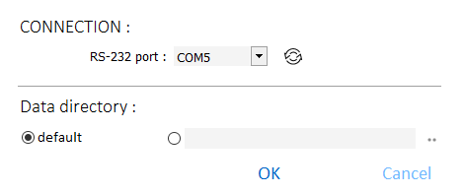
Fig. 2. “Configuration” window.

Connection
RS-232 port – the computer COM port through which communication with the control panel is to take place.
– click to refresh the list of COM ports available in the computer.

Data directory
You can choose whether the control panel data files are to be saved to the default folder or a folder selected by you.

Buttons
OK | click to save changes.
Cancel | click to close the window without saving changes.

“Software language” window

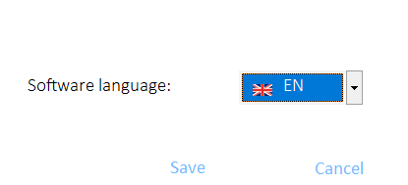
Fig. 3. “Software language” window.

Software language – you can select the program language.

Buttons
Save | click to save changes.
Cancel | click to close the window without saving changes.

Establishing communication with the control panel
- Connect the control panel USB port to the computer port.
- Start the ACSP Soft program.
- Select the computer COM port through which communication is to take place (see: ““Configuration” window” p. 26).
- Click on the menu bar.
- A window will open with information that connection has been established.
- Click CONNECT to confirm the connection or click DOWNLOAD DATA to download data from the control panel right away.

Settings
Panel – control panel type.
version – version of the control panel firmware: number and compilation date.
serial no. – serial number of the control panel.
If the APSP-402 repeater panel, the ACSP-ETH or the ACSP-RSI modules are supported by the control panel, additional fields are displayed:
Module – module type.
version – version of the module firmware: number and compilation date.
serial no. – serial number of the module.

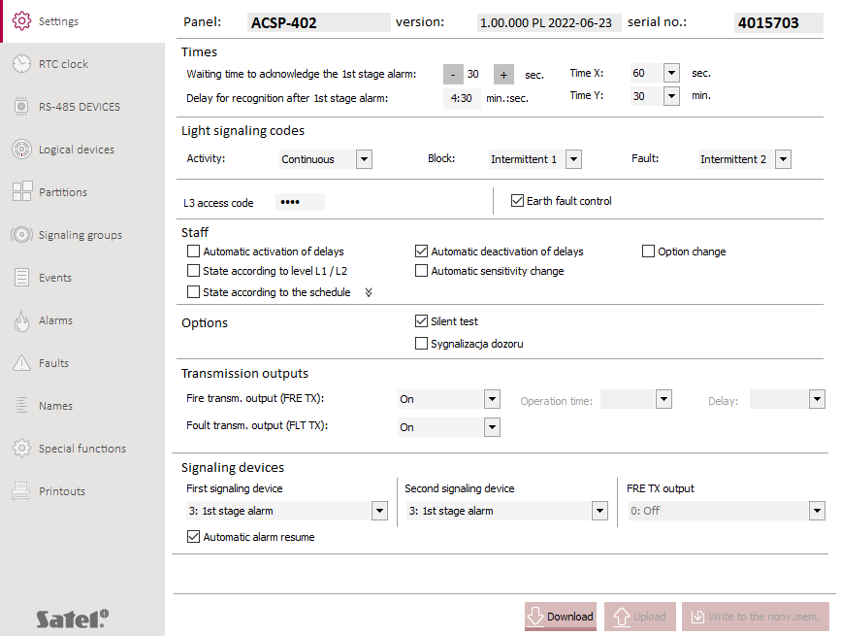
Fig. 4. “Settings” tab.

Times
Time to acknowledge the alarm [Acknowl. time] – the time used in two-stage alarm. It is counted from the moment the first stage alarm is indicated (after information is received from a detector or an input is activated). If the personnel fails to press  ACKNOWLEDGEMENT during this time, the second stage alarm is indicated. You can program from 10 to 60 seconds (by default: 30 seconds).
Time for alarm recognition [Verification time] – the time used in two-stage alarm. It is counted from the moment the personnel pressed ACKNOWLEDGEMENT after the first stage alarm had been indicated. This gives the personnel the time to verify if the fire alarm is justified. If the personnel fails to reset the alarm during this time, the second stage alarm is indicated. You can program any value from 0:00 to 9:30 (minutes:seconds). By default: 4 minutes and 30 seconds.
The sum of the times to acknowledge and to recognize the alarm cannot be longer than 10 minutes.
It is possible to delay the second stage alarm by the acknowledgement and recognition times if the two-stage alarm mode is enabled in the control panel.
Time X [X time] – the time used in the W7, W8 and W18 alarm variants (see: “Alarm variants” p. 46). It is counted from the moment the fire alarm is generated by the detector. If another detector in the zone generates an alarm during this time, the first stage or second stage alarm will be indicated (depending on the alarm variant). If no fire alarm is generate during the “Time X”, the control panel will not indicate the alarm and will reset it. You can program from 30 to 60 seconds (by default: 60 seconds).
Time Y [Y time] – the time used in the W7, W8, W15, W16 and W18 alarm variants (see: “Alarm variants” p. 46). It is counted from the preliminary alarm reset (when “Time X” is over – W7, W8 and W18 alarm variants) or from the pre-alarm generated by the detector (W15 and W16 alarm variants). If another detector generates the fire alarm during this time, the first stage or second stage alarm will be indicated (depending on the alarm variant). You can program from 5 to 30 minutes (by default: 30 minutes).

Events signaled by WZ-400
Activity / Disablement / Fault [Activity / Disablement / Fault] – you can select how you want the WZ-400 remote indicator to indicate events / disablement / fault:
Off – no indication,
Intermittent 1 – LEDs flashing slowly,
Intermittent 2 – LEDs flashing rapidly,
Continuous – LEDs ON.
For sounders, the issue of activity / disablement / fault indication is not covered by the applicable Polish regulations. To ensure compliance with those regulations, you must select:
- activity – continuous,
- disablement – intermittent 1,
- fault – intermittent 2.

L3 access code
L3 access code – string of 4 digits used as the access code to the control panel at level 3 (service mode). You can program any 4 digits in the range from 0 to 9. Click to view the code.

Earth fault control
Earth fault control – if this option is enabled, the control panel indicates when an earth fault is detected.

Personnel
Enable delay by attendance schedule [Enabling delays] – if this option is enabled, the two-stage alarm mode (second stage alarm delay) is enabled when the control panel is set in the “Personnel present” mode.
Disable delay by attendance schedule [Disabling delays] – if this option is enabled, the two-stage alarm mode (second stage alarm delay) is enabled when the control panel is set in the “Personnel absent” mode.
Variant change [Variant change] – if this option is enabled, the alarm variants depend on whether the personnel is present or absent. In the “Personnel present” mode, the programmed alarm variants are applied in the detection zones. In the “Personnel absent” mode, the W1 alarm variant (one-stage, ordinary) is applied in the detection zones. The exceptions are the detection zones in which the “Variant disablement” option is enabled (see: “Variant disablement” p. 46).
Presence by L1/L2 level [By access level] – if this option is enabled, the “Personnel present” / “Personnel absent” operating mode of the control panel changes depending on the access level. In the case of the level 1 (the key switch is in the neutral position), the control panel operates in the “Personnel absent”. In the case of the level 2 (the key switch is in the “Control” position), the control panel operates in the “Personnel present”.
If the “Enable delay by attendance schedule” option is enabled, getting access at level 2 enables the two-stage alarm mode (second stage alarm delay).
If the “Disable delay by attendance schedule” option is enabled, getting access at level 1 disables the two-stage alarm mode.
Change sensitivity by attendance schedule [Sensitivity change] – if this option is enabled, the sensitivity in the zones depends on whether the personnel is present or absent. In the “Personnel present” mode, the programmed sensitivity is applied in the zones (see: “Day sens.” p. 45). In the “Personnel absent” mode, the high sensitivity is set in all zones.
Presence by schedule [According to sched.] – if this option is enabled, the “Personnel present” / “Personnel absent” operating mode of the control panel changes depending on the attendance schedule.
/ – click to show / hide the attendance schedule.

Attendance schedule
You can decide when the control panel is to operate in the “Personnel present” mode and when in the “Personnel absent” mode. The days of the week are presented in the table rows, and the hours (with 30 minute accuracy) are presented in the columns. Double-click the field(s) at the intersection of rows and columns to select the control panel operating mode for a given time period ( [blue] – “Personnel present”, [white/yellow] – “Personnel absent”).

Options
Silent test – if this option is enabled, the acoustic sounders are not activated during the manual call point and detector tests.
Quiescent condition indication [Supervisory indic.] – if this option is enabled, the detectors indicate the quiescent condition (short flash of LED every 24 seconds).

Routing outputs
Fire routing output (FRE TX) [FRE TX output] – operating mode of the fire routing output (FRE TX):
Off – the output is not used,
On – indicating a second stage alarm condition,
Sounder – controlling conventional sounders,
fire p. eq. contr. – controlling the automatic fire protection equipment.
Operation time [Operation time] – time period when the fire routing output (FRE TX) is activated after the second stage alarm has been indicated, if the output controls the automatic fire protection equipment. You can select a time period from 2 seconds to 10 minutes or “Continuous” (if you want the output to be activated for the entire alarm condition).
Delay [Delay time] – time by which the activation of the fire routing output (FRE TX) is delayed after the second stage alarm has been indicated, if the output controls the automatic fire protection equipment. The time is counted from the moment the second stage alarm is indicated. You can select a time from 2 seconds to 10 minutes or no delay.
Fault routing output (FLT TX) [FLT TX output] – turn on the FLT TX output if the control panel is to indicate faults using the output.

Sounders
Sounder 1 / Sounder 2 / FRE TX output [Sounder 1 / Sounder 2 / FRE TX output] – mode of alarm signaling by conventional acoustic sounders connected to the SNDR1, SNDR2 and FRE TX outputs (if the output controls conventional sounders):
0: Off – output is not used to signal alarms,
1: 1st stage interm., 2nd stage continuous – the first stage and second stage alarms are signaled differently (first stage alarm – intermittent sound, second stage alarm – continuous sound).
2: 1st and 2nd stage alarm – the first stage and second stage alarms are signaled in the same way (continuous sound),
3: 2nd stage alarm – the second stage alarm signaling (continuous sound).
The “FRE TX output” is available if you selected the “Sounder” operating mode in the “Fire routing output (FRE TX)” field.
Automatic sounder restore [Aut. sound. restore] – if this option is enabled, the alarm always activates the sounders that had been turned off by the personnel using the  button.

Buttons
click to download from the control panel the settings displayed in the tab.
click to temporarily upload the settings displayed in the tab (if you fail to save the settings to the non-volatile memory, all changes will be undone when you exit the service mode).
click to save the settings displayed in the tab to the non-volatile memory.

RTC clock
Time zone [Time zone] – difference between the universal time (GMT) and the zone time.
Daylight saving time [Summer/winter time] – the control panel can automatically adjust the clock settings due to a change from the summer time to the winter time and vice versa. The following correction schemes are available:
no correction,
according to EU rules (European Union),
according to US rules (United States),
by dates [correction by 1 or 2 hours on selected days]
Clock correction [Clock correction] – if the control panel clock is not adequately accurate, the clock settings can be automatically corrected (up to ±127 seconds per week).

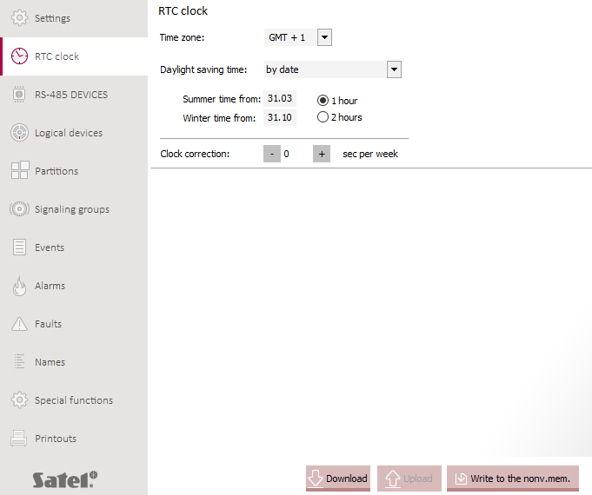
Fig. 5. “RTC clock” tab.

Buttons
click to download from the control panel the settings displayed in the tab.
click to temporarily upload the settings displayed in the tab (if you fail to save the settings to the non-volatile memory, all changes will be undone when you exit the service mode).
click to save the settings displayed in the tab to the non-volatile memory.

RS-485 devices

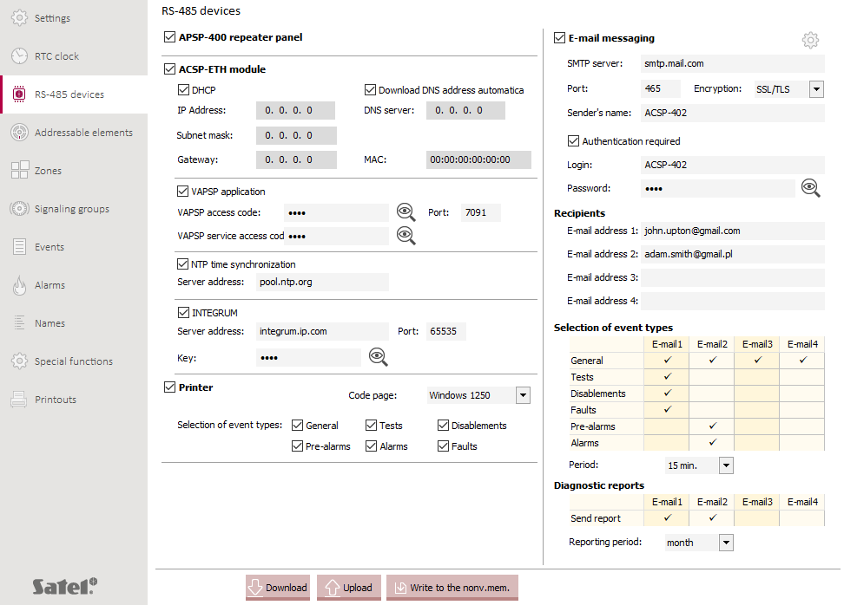
Fig. 6. “RS-485 devices” tab.

APSP-402 repeater panel – if this option is enabled, the control panel supports the APSP-402 repeater panel connected to the communication bus (APSP-402 terminals).

ACSP-ETH module
ACSP-ETH module [Ethernet module] – if this option is enabled, the control panel supports the ACSP-ETH Ethernet communication module.
DHCP [DHCP] – if this option is enabled, the ACSP-ETH module’s IP address, subnet mask and gateway are to be downloaded automatically from the DHCP server.
IP address [IP address] – IP address of the module. This field is available if the DHCP option is disabled.
Subnet mask [Subnet mask] – the mask of the subnet in which the module operates. This field is available if the DHCP option is disabled.
Gateway [Default gateway] – IP address of the network device through which devices in the local network can communicate with devices in other networks. This field is available if the DHCP option is disabled.
Download DNS address automatically [Automatic DNS] – if this option is enabled, the ACSP-ETH module is to download the DNS server IP address automatically from the DHCP server.
DNS server [DNS address] – IP address of the DNS server to be used by the ACSP-ETH module.
MAC [MAC address] – hardware address of the ACSP-ETH module.

VAPSP application
VAPSP application [VAPSP app] – if this option is enabled, the connection between the control panel and the VAPSP mobile app can be established via the ACSP-ETH module.
VAPSP access code [VAPSP password] – a string of up to 13 alphanumeric characters (digits, letters and special characters) used for authorization in the VAPSP mobile app. Click to view the code.
VAPSP service access code [VAPSP serv. passw.] – a string of up to 13 alphanumeric characters (digits, letters and special characters) used by the service technician for authorization in the VAPSP mobile app. Click to view the code.
Port [VAPSP port] – number of the port used for communication with the VAPSP mobile app. You can enter values from 0 to 65535.

NTP time synchronization
NTP time synchronization [Time from server] – if the option is enabled, the control panel clock will be synchronized with the time server.
Server address [NTP server ad.] – address of the time server. You can enter the IP address or the domain name.

INTEGRUM
INTEGRUM [INTEGRUM server] – if this option is enabled, the connection between the control panel and the INTEGRUM system (version 3.0 or newer) can be established via the ACSP-ETH module.
Server address [INTEGRUM addr.] – address of the INTEGRUM server. You can enter either the IP address or the domain name.
Port [INTEGRUM port] – number of the port used for communication with the INTEGRUM system. You can enter values from 0 to 65535.
Key [INTEGRUM key] – a string of up to 13 alphanumeric characters (digits, letters and special characters) which is used for data encryption during communication with the INTEGRUM system. Click to view the code.

Printer
Printer [Printer support] – if this option is enabled, the control panel supports the thermal printer installed in the system (via the ACSP-RSI module).
Code page [Character set] – you can select a set of characters used by the thermal printer.
Selection of event types [Event types] – you can select the types of events that are to be printed out by the thermal printer. Check the boxes next to the event types that are to be printed out.

E-mail messaging
E-mail messaging [Email sending] – if the option is enabled, the control panel can notify of events by sending e-mail messages.
– click to open the window for sending a test message to the given e-mail address.
SMTP server [SMTP server] – address of the outgoing mail server.
Port [SMTP port] – number of the outgoing mail port.
Encryption [Encryption] – the outgoing mail encryption method:
SSL/TLS – the SSL/TLS protocol is used.
STARTTLS – the STARTTLS protocol is used.
NONE – the outgoing mail is not encrypted.
Sender’s name [Sender name] – e-mail address included in the outgoing e-mail message as the sender address. If this field is blank, the name of the e-mail account will be treated as the sender address.
Authentication required [Authentication] – if this option is enabled, the SMTP server requires authentication.
Login [Login] – name of the e-mail account used for authorization by the SMTP server (login to the e-mail account).
Password [Password] – a string of up to 13 alphanumeric characters (digits, letters and special characters) used for authorization by the SMTP server.

Recipients
You can program 4 e-mail addresses to which the control panel will send notifications. The control panel can send diagnostic reports to those addresses.

Selection of event types
For each e-mail address you can select the types of event notifications that the user is to receive.
Period [Period] – time interval at which the control panel sends notifications. You can program from 10 minutes to 6 hours.

Diagnostic reports
You can select the e-mail address to which the control panel is to send the diagnostic reports.
Reporting period [Diagnostic reports] – time interval at which the control panel sends diagnostic reports. You can program from 1 month to 1 year.

Buttons
click to download from the control panel the settings displayed in the tab.
click to temporarily upload the settings displayed in the tab (if you fail to save the settings to the non-volatile memory, all changes will be undone when you exit the service mode).
click to save the settings displayed in the tab to the non-volatile memory.

Addressable elements
The line elements connected to the control panel addressable detection lines are displayed on the first device list. The MIO-400 conventional input / output module occupies 8 positions on the list. Each input and each output of the module is a separate element with its own address. The control panel inputs and outputs are displayed on the second list.
No. – reference number of the addressable element.
Address – address of the element (see: “Addresses of the system elements” p. 4).
SN – serial number of the element.
Name – name of the element.
Type – type of the element.

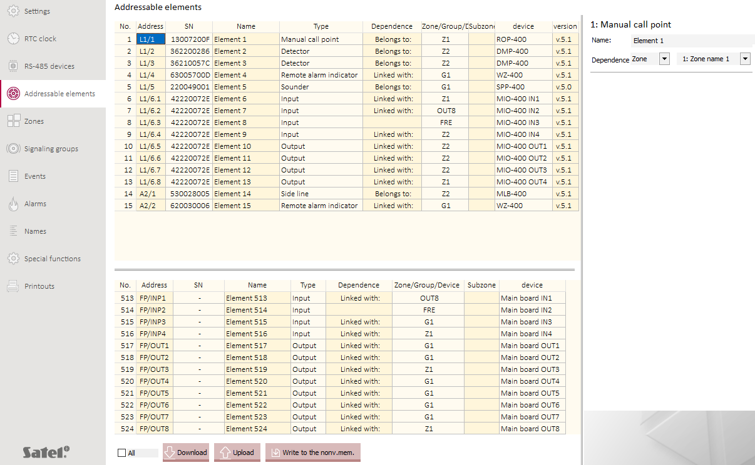
Fig. 7. “Addressable elements” tab.

Dependence – type of link (dependence) between the addressable element and other fire alarm system element(s) (see: “Links between the addressable elements” p. 4):
Belongs to: – zone / group that the element belongs to.
Linked with: – zone / group / addressable element that the element is linked with.
Zone/Group/Device – number of the zone / group that the addressable element belongs to; number of the zone / group / device that the addressable element is linked with.
Subzone – subzone that the element belongs to. A detector can belong to the subzone if the alarm variant with group coincidence is set in the zone (see: “Alarm variants” p. 46).
Device – trade name of the element.
Version – firmware version of the element.
For some addressable elements, if you select them on the list, additional configurable settings will be displayed next to the table (see: “Detector”, “Remote indicator” and “Inputs and outputs”).

Buttons
click to download from the control panel the settings displayed in the tab. If you enable the “All” option, all settings will be downloaded from the control panel memory (normally, only the changes made since the last download are downloaded).
click to temporarily upload the settings displayed in the tab (if you fail to save the settings to the non-volatile memory, all changes will be undone when you exit the service mode).
click to save the settings displayed in the tab to the non-volatile memory.

Dependence
You can link an addressable element with other fire alarm system element(s). Depending on the element type, you can add it to the zone or group or link it with the zone, group or another element (see: “Links between the addressable elements” p. 4).

Detector
Remote alarm indicator [R. alarm indicator] – if this option is enabled, the detector can support the conventional WZ-110 remote indicator.

Remote indicator
You can select the events which the WZ-400 remote indicator is to indicate. Check the boxes next to the events that are to be indicated (Activity / Disablement / Fault). The events may involve a zone, a group or a selected device (see: “Dependence” p. 37). If the indicator is not linked with a zone, a group or another element, the indicator will indicate selected events in the entire system.

Inputs and outputs
The settings described below refer to the inputs and outputs on the control panel mainboard and the inputs and outputs of the MIO-400 module.

Inputs
Input type [Input type] – you can select:
Off [Off] – the input status is not monitored.
Fire damper [Fire damper] – the input is used to supervise the fire damper. The fault indication is generated when:
- input is activated, if the control panel is in the quiescent condition,
- input is not activated, if the control panel is in the fire alarm condition.
The input can supervise the device with which it is linked. If the input is not linked with the selected device, it can supervise all fire dampers in the system.
Routing acknowledgement [Routing acknowl.] – when the input is activated, the fault warning routing / fire alarm routing is acknowledged.
Fault [Ext. device fault] – the input is used to supervise external devices. Activating the input activates the fault indication. If the input is linked with a zone or a group, it supervises the devices linked with them. If the input is not linked with a zone or a group, it supervises all external devices.
School bell [School bell] – activating the input activates the sounders.
External fire alarm [Ext. fire alarm] – activating the input generates an alarm. If the input is linked with a zone, activating the input generates an alarm in this zone. If the input is not linked with a zone, activating the input generates an alarm in all zones.
Acknowl. of fire protection equip. activation (OUT8) [OUT8 f. p. eq. ack] – when the input is activated, the activation of the automatic fire protection equipment controlled by the OUT 8 (FRE PE 1) output is acknowledged.
Acknowl. of fire protection equip. activation (FRE TX) [FRE TX f. eq. ack.] – when the input is activated, the activation of the automatic fire protection equipment controlled by the FRE TX output is acknowledged.
Acknowl. of fire protection equip. activation [F. p. equip. ack.] – when the input is activated, the activation of the automatic fire protection equipment is acknowledged.
Logic control [Logic] – the input status is the input signal for the logical function that controls the “Logic control” type outputs linked with the same group as the input (see: “Logical control” p. 50).
Evacuation [Evacuation] – activating the input activates the evacuation indication. The evacuation signal is generated by the sounders that belong to the group with which the input is linked. The evacuation signal must be defined for the group (see: “Acoustic signaling” p. 49). Activating the input also turns on the “Evacuation” type outputs that are linked with it.
The input can be linked with the outputs / sounders directly – by being linked with the group, or indirectly – by being linked with the zone that the group is linked with.
Personnel presence [Personnel presence] – when the input is active, the control panel is in the “Personnel present” mode. When the input is inactive, the control panel is in the “Personnel absent” mode.
Fire damper control [F. damper control] – you can select which fire damper status (Opening / Closing) is to be supervised by the inputs. This field is available if the “Fire damper” input type is selected.
Fault routing [Fault routing] – if this option is enabled, the fault warning routing must be acknowledged. This option is available if the “Routing acknowledgement” operating mode is selected.
Fire routing [Fire routing] – if this option is enabled, the fire alarm routing must be acknowledged. This option is available if the “Routing acknowledgement” operating mode is selected.
Delay time [Delay time] – depending on the input type:
- Fire damper – time during which the input must be active in the quiescent condition or inactive in the fire alarm condition for the control panel to indicate the fault.
- Routing acknowledgement – time counted from the moment the fault warning routing output or the fire alarm routing output is turned on. If the input is not activated during the countdown, the control panel will indicate a fault.
- Fault – time during which the input must be active for the control panel to indicate the fault.
- Acknowl. of fire protection equip. activation (FRE TX) / Acknowl. of fire protection equip. activation – time counted from the moment the output controlling the automatic fire protection equipment is turned on. If the input is not activated during the countdown, the control panel will indicate a fault.
- Logic control – time during which the input must be active for the “Logic control” type outputs linked with the input to be turned on.
- Evacuation – time during which the input must be active for the evacuation indication to be activated.
- Personnel presence – time during which the input must be active for the control panel to activate the “Personnel present” operating mode, or the time during which the input must be inactive for the control panel to activate the “Personnel absent” operating mode.
You can select a time from 2 seconds to 10 minutes or “NONE”.
Operation time [Operation time] – time during which the sounders will be turned on. It is counted from the input activation. You can select a time from 2 seconds to 10 minutes or “Continuous” (sounders are turned on for as long as the input is active). This field is available if the “School bell” input type is selected.
Alarm mode [Alarm mode] – you can select the type of alarm that will be generated when the input is activated:
One-stage – second stage alarm will be generated,
Two-stage – first stage alarm will be generated.
This field is available if the “External fire alarm” input type is selected.
Input polarity [Input polarity] – you can program the input as:
NO – activated when shorted to ground,
NC – activated when disconnected from ground.

Outputs
Output type [Output type] – output operating mode:
Off [Off] – the output is not used.
Fire alarm [Alarm] – the output is turned on when fire alarm is generated (first or second stage). If the output is linked with a zone or a group, it will be turned on when alarm is generated in the linked zone or alarm signaling is activated in the linked group. If the output is not linked with any zone or group, it will be turned on when alarm is generated in any zone.
No routing acknowledgment [No acknowledgment] – the output is turned on when the fault warning routing or fire alarm routing has not been acknowledged.
Fault [Fault] – the output is turned on when a fault is indicated. If the output is linked with a zone or a group, it will be turned on when a fault is reported in the linked zone or group. If the output is not linked with any zone or group, it will be turned on when a fault of any system element is reported.
Disablement [Disablement] – the output is turned on when a fire alarm system element is disabled. If the output is linked with a zone or a group, it will be turned on when the linked zone or group is disabled. If the output is not linked with any zone or group, it will be turned on when any system element is disabled.
Alarm/Fault clearing [Reset] – the output is turned on when alarm / fault is reset.
Control of fire protection equipment [Fire p. eq. contr.] – the output is turned on when fire alarm is generated. If the output is linked with a zone or a group, it will be turned on when alarm is generated in the linked zone or alarm signaling is activated in the linked group. If the output is not linked with any zone or group, it will be turned on when alarm is generated in any zone.
Logical control [Logic] – the output status is a result of the logical function that controls the “Logic control” type outputs. The input signals for the logical function are the statuses of the “Logic control” type inputs that are linked with the same group as the output. Depending on the logical function programmed for the group, the output is turned on when:
- any “Logical control” type output linked with the group is activated (logical sum),
- all “Logical control” type outputs linked with the group are activated simultaneously (logical product).
Evacuation [Evacuation] – the output is turned on when the “Evacuation” type input is activated and the output is linked with the input within a group.
Operation time [Operation time] – period of time during which the output is turned on. You can select a time from 2 seconds to 10 minutes or “Continuous” (the output is turned on for the entire duration of the event, e.g. alarm condition).
Delay time [Delay time] – time during which the event (e.g. alarm condition) must continue for the output to be turned on. You can select a time from 2 seconds to 10 minutes or “NONE” (the output is turned on immediately after the event occurred).
2nd stage alarm sign. [Alarm II] / 1st stage I alarm sign. [Alarm I] – you can select the alarms that are to turn on the output. The fields are available if the “Fire alarm” or the “Control of fire protection equipment” type output is selected.
Fire routing [Fire routing] / Fault routing [Fault routing] – you can select the types of routing that are to be acknowledged. When routing is not acknowledged, the output will turn on. The fields are available if the “No routing acknowledgment” type output is selected.
Power / Routing output / Local sounders / Other – you can select the faults that are to turn on the output. The fields are available if the “Fault” type output is selected.
Local sounders / FLT TX output / FRE TX output – you can select the disablements that are to turn on the output. The fields are available if the “Disablement” type is selected for the output that is not linked with the zone or group.

Side line module
You can select the type of alarm that will be generated when the conventional detector or manual call point connected to the side line module is activated:
One-stage – second stage alarm will be generated,
Two-stage – first stage alarm will be generated.

Locate device
You can specify the location of the selected device in the protected premises. Only the devices (line elements) connected to the control panel addressable detection lines are displayed on the list.

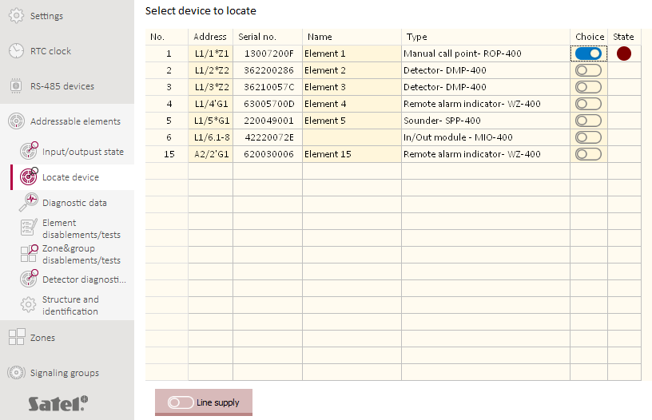
Fig. 8. “Locate device” tab.

No. – reference number of the device (line element).
Address – address of the device. If the device is linked with another element of the fire alarm system, the link identifier is added to that element’s address (see: “Link identifier” p. 6).
Serial no. – serial number of the device.
Name – name of the device.
Type – type of the device.
State – the flashing icon [burgundy] indicates the activation of the remote indicator in the device or the acoustic signaling in the acoustic sounder.

Buttons
 | click to activate the remote indicator / acoustic signaling in the device.
 | click to deactivate the remote indicator / acoustic signaling in the device.
 | click to open the “Line supply” window.

Line supply

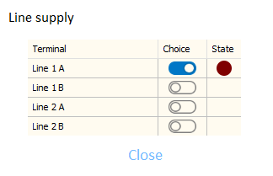
Fig. 9. “Line supply” tab.

Terminal – terminal of the control panel detection line.
State – the icon [burgundy] indicates the presence of voltage across the detection line terminals.

Buttons
click to turn on the power.
click to turn off the power.

Structure and identification

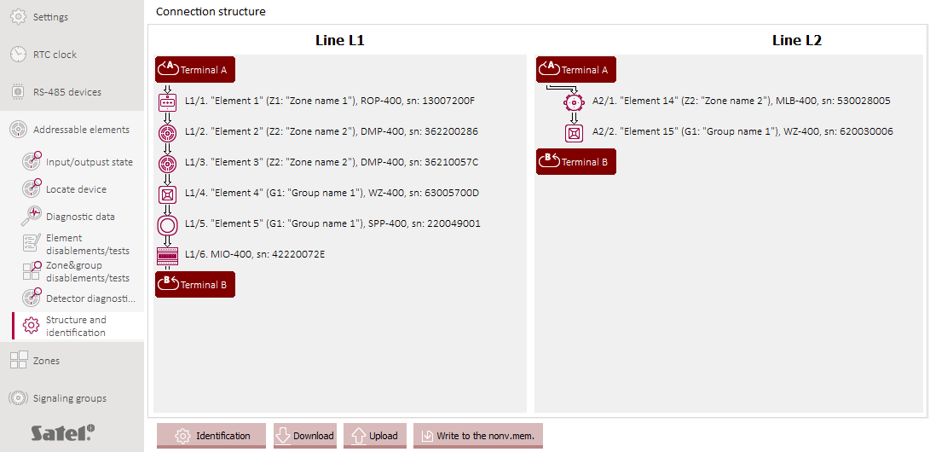
Fig. 10. “Structure and identification” tab (example structure: Line L1 – loop connected between the 1A and 1B terminals, Line L2 – radial circuit connected to the 2A terminals).

You can configure the structure of the control panel addressable detection lines:
- start the function of identification / verification of line elements,
- add / remove a detection line element,
- change the location of an element,
- change the detection line topology:
- cut the loop,
- connect the radial circuits.
Line L1 / Line L2 – detection line scheme:
– terminal A of the detection line,
– terminal B of the detection line.
The elements connected to the detection lines are represented by the following icons:
– ROP-400 / ROP-410 manual call point,
– DCP-400 / DMP-400 / DRP-400 detector,
– SPP-400 / SPP-410 acoustic sounder,
– WZ-400 remote indicator,
– MLB-400 conventional side line module,
– MIO-400 conventional input / output module.
The following details are displayed next to the icon:
- address of the element,
- name of the element,
- symbol and name of the linked system element,
- trade name of the element,
- serial number of the element.

Buttons
click to start the function of identification / verification of line elements.
click to download from the control panel the settings displayed in the tab.
click to temporarily upload the settings displayed in the tab (if you fail to save the settings to the non-volatile memory, all changes will be undone when you exit the service mode).
click to save the settings displayed in the tab to the non-volatile memory.

Starting the identification function
Addressable elements of the fire alarm system connected to the detection line will not be properly supported, unless they have been identified by the control panel. The identification of line elements is required after the control panel is first started.
The identification function resets the settings programmed in the control panel for all line elements and zones supported by the control panel.
- Click “Identification” → “Identification start”. The IDENTIFICATION START window will be displayed.
- Select the IDENTIFICATION option and click “Run”.
- When the message: “This identification mode will delete the settings of all addressable elements and zones” will be displayed, click “Run”.
- The message about a detected topology of detection lines will be displayed. If it is correct, click CONTINUE. If the detected topology is invalid, press ABORT, check the connections and restart the identification function.
- The message that the identification is completed will be displayed. The configuration scheme of the detection line will be presented in the “Structure and identification” tab.

Starting the verification function
If you made any changes in the detection line(s), you must start the verification function.
- Click “Identification” → “Identification start”. The IDENTIFICATION START window will be displayed.
- Select the VERIFICATION WITH RECONFIGURATION option and click “Run”.
- The message about a detected topology of detection lines will be displayed. If it is correct, click CONTINUE. If the detected topology is invalid, press ABORT, check the connections and restart the function.
- The message that the verification is completed will be displayed. The configuration schemes of the detection lines will be presented in the “Structure and identification” tab. All changes detected in the connection structure will be highlighted with colors.
- Click “Accept” to save the changes to the control panel memory or “Cancel” to quit the function without saving changes.

Adding the detection line elements
- Click or to download data from the control panel.
- Right-click the line element after which you want add a new device. If you want to add a device immediately after the detection line terminals, click or .
- In the context menu, click “Add”. The “Add device” window will be displayed.
- In the “Serial no.” field, enter the serial number of the device. You will find it on the electronics board or the device enclosure. The type of the added device will be displayed in the “Type” field. Click OK.
- The new device will be displayed on the scheme representing the connection structure. The addresses of the devices connected to the line after the new element will be changed. All changes in the connection structure will be highlighted with colors.
- Click or to save data to the control panel.

Removing the detection line elements
- Click or to download data from the control panel.
- Right-click the line element you want to remove.
- In the context menu, click “Remove”. The “Removing device” window will be displayed.
- Click DELETE to confirm. Click CANCEL to quit.
- The element will be removed from the scheme representing the connection structure. The addresses of the devices connected to the line after the removed element will be changed. All changes in the connection structure will be highlighted with colors.
- Click or to save data to the control panel.

Relocating the detection line elements
- Click or to download data from the control panel.
- Drag and drop the line element to change its location.
- When the pointer changes to (the element will be placed on the main line) or (the element will be placed on the branch), release the mouse button.
- The element will be placed in the new location. The addresses of the elements connected to the line will be changed. All changes on the scheme will be highlighted with colors.
- Click or to save data to the control panel.

Cutting the loop
- Click or to download data from the control panel.
- Right-click the loop element after which you want to cut the loop (if you want to cut the loop after the detection line terminals, click ).
- In the context menu, click “Separate after”.
- The loop will be separated. The addresses of the elements connected to the line will be changed. All changes on the scheme will be highlighted with colors.
- Click or to save data to the control panel.

Connecting the radial circuits
- Click or to download data from the control panel.
- Right-click the last element of the A or B radial circuit after which you want to connect the radial circuits.
- In the context menu, click “Connect with...”. The list of devices connected to the other radial circuit will be displayed.
- Click the line element after which you want to connect the radial circuits (if you want to connect the radial circuit with the detection line terminals, select “Terminal A” / “Terminal B”).
- Click or to save data to the control panel.

Zones
The detection zone is a separate area in the premises supervised by the fire alarm system. When the supervised area is divided into detection zones, it is possible to group the addressable line elements. This allows you to locate where the line elements are installed and to program a different alarm variant for each zone. The alarm variants can be specifically selected to match the conditions of each detection zone (see: “Alarm variants”). The detection zone can be divided into two subzones (A and B) for the purpose of grouping the line elements that belong to that zone. This division is used in the alarm variants with a group coincidence dedicated to zones where adverse conditions increase the risk of false alarms.
The control panel can support up to 256 detection zones. According to EN 54-2, each zone can be assigned up to 32 detectors and call points.

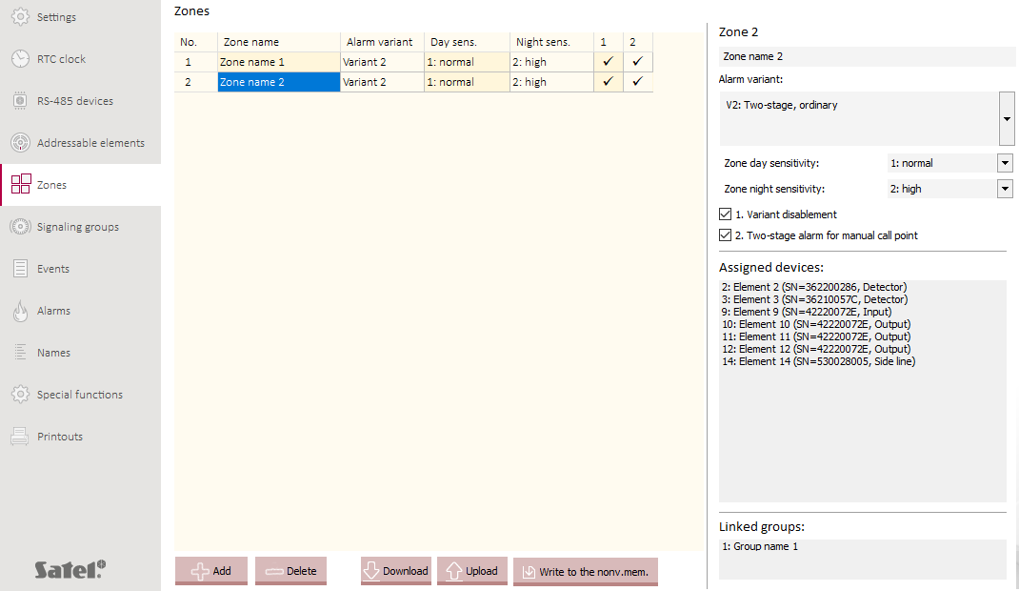
Fig. 11. “Zones” tab.

No. – individual number of the zone.
Zone name [Name] – name of the zone (up to 30 characters).
Alarm variant. [Alarm variant] – alarm variant in the zone (see: „Alarm variants” p. 46).
Day sens. [Day sensitivity] – smoke detection sensitivity of detectors in the zone, when the “Personnel present” mode is active. Available settings: normal, high or low (by default: normal).
Night sens. [Night sensitivity] – smoke detection sensitivity of detectors in the zone, when the “Personnel absent” mode is active. Available settings: normal, high or low (by default: normal).
The higher sensitivity, the lower concentration of smoke is going to generate an alarm. Higher sensitivity is recommended in the “Personnel absent” mode.
For the alarm variants “V13: One-stage, interactive” and “V14: Two-stage, interactive”, an additional fourth sensitivity level is used (detector sensitivity is higher than “High”).
Variant disablement [Variant disablement] – if this option is enabled, disabling / enabling the two-stage alarm mode (second stage alarm delay) in the control panel has no effect on the alarm variant in the zone. If this option is disabled, enabling / disabling the two-stage alarm mode (second stage alarm delay) in the control panel changes the alarm variant in the zone.
Two-stage alarm for manual call point [2-stage call point] – if this option is enabled, activating the manual call point in the zone in which the two-stage alarm is enabled will generate the first stage alarm.

Assigned devices
It is a list of addressable elements that belong to the zone or are linked with the zone. If the zone is divided into subzones, the elements are presented according to that division. Click “Assigned devices” to edit the list.

Linked groups
It is a list of groups that are linked with the zone. Click “Linked groups” to edit the list.

Buttons
click to add a zone.
click to delete a zone.
click to download from the control panel the settings displayed in the tab.
click to temporarily upload the settings displayed in the tab (if you fail to save the settings to the non-volatile memory, all changes will be undone when you exit the service mode).
click to save the settings displayed in the tab to the non-volatile memory.

Alarm variants
The following alarm variants are available in the control panel:
- one-stage – if the signals received by the control panel are interpreted as fire alarm, the second stage alarm is indicated.
- two-stage – if the signals received by the control panel are interpreted as fire alarm, the first stage alarm is indicated. If the personnel do not respond before the “Time to acknowledge the alarm” has passed, the second stage alarm is indicated. If the personnel press ACKNOWLEDGEMENT, the second stage alarm will be additionally delayed by the preset time (see: “Time for alarm recognition”). This gives the personnel the time to verify if the fire alarm is justified.
There are 19 alarm variants available in the control panel. This enables you to select such an alarm variant for the zone so that the fire can be detected at the earliest stage of its development while the risk of false alarms can be reduced.
Alarms in the detection zones are executed according to the selected alarm variant when the two-stage alarm is enabled (second stage alarm delay) in the control panel. When the two-stage alarm is disabled, alarms in all zones are executed in the V1 one-stage variant (second stage alarm is indicated right away). The exceptions are the zones in which the alarm variant disablement is enabled and the zones in which alarms are executed in variants with pre-alarm (e.g. V10). Alarms in these zones are always executed according to the selected variant.
Alarm variants are applied to fire alarms generated by detectors. Activating a manual call point generates the second stage alarm regardless of the selected alarm variant. The exceptions are the zones in which the two-stage alarm is enabled for the manual call points.
V1: One-stage, ordinary – when a detector generates a fire alarm, the control panel indicates the second stage alarm (main alarm). This variant can be applied in zones with high risk of fire (e.g. where manual call points are a reliable source of information).
V2: Two-stage, ordinary – when a detector generates a fire alarm, the control panel indicates the first stage alarm. If the personnel does not respond to the first stage alarm before the “Time to acknowledge the alarm” is over, the second stage alarm will be indicated. If the personnel respond (press ACKNOWLEDGEMENT), the second stage alarm will be delayed by additional time (see: “Time for alarm recognition”).
V3: One-stage, with single reset in the detection zone – when a detector generates a pre-alarm (preliminary alert), the control panel resets the pre-alarm. If the same or another detector generates an alarm within the next 60 seconds, the control panel indicates the second stage alarm. If no alarm is generated, the pre-alarm is considered false.
V4: Two-stage, with single reset in the detection zone – when a detector generates a pre-alarm (preliminary alert), the control panel resets the pre-alarm. If the same or another detector generates an alarm within the next 60 seconds, the control panel indicates the first stage alarm (see: variant V2). If no alarm is generated, the pre-alarm is considered false.
V5: One-stage, with time-zone dependence – when a detector generates a fire alarm in one subzone (A or B), the control panel resets the alarm. If an alarm is generated in the other subzone within the next 60 seconds, the control panel indicates the second stage alarm. If no alarm is generated in the other subzone, the fire alarm is considered false.
V6: Two-stage, with time-zone dependence – when a detector generates a fire alarm in one subzone (A or B), the control panel resets the alarm. If an alarm is generated in the other subzone within the next 60 seconds, the control panel indicates the first stage alarm (see: variant V2). If no alarm is generated in the other subzone, the fire alarm is considered false.
V7: One-stage, with warning device single reset X[sec]/Y[min] – when a detector generates a fire alarm, the control panel does not indicate it. If another detector generates an alarm within the set time (“Time X”), the control panel indicates the second stage alarm. If no alarm is generated, the fire alarm is reset. If the same or another detector generates an alarm within the set time counted from the alarm reset (“Time Y”), the control panel indicates the second stage alarm. If no alarm is generated, the alarm is considered false.
V8: Two-stage, with warning device single reset X[sec]/Y[min] – when a detector generates a fire alarm, the control panel does not indicate it. If another detector generates an alarm within the set time (“Time X”), the control panel indicates the first stage alarm (see: variant V2). If no alarm is generated, the fire alarm is reset. If the same or another detector generates an alarm within the set time counted from the alarm reset (“Time Y”), the control panel indicates the first stage alarm (see: variant V2). If no alarm is generated, the alarm is considered false.
V9: One-stage, with two-detector coincidence (type B dependency) – when a detector generates a pre-alarm, the control panel indicates it. If another detector generates an alarm within the next 30 minutes, the control panel indicates the second stage alarm. If no alarm is generated, the pre-alarm is reset and considered false.
V10: Two-stage, with two-detector coincidence – when a detector generates a pre-alarm, the control panel indicates it. If another detector generates an alarm within the next 30 minutes, the control panel indicates the first stage alarm (see: variant V2). If no alarm is generated, the pre-alarm is reset and considered false.
V11: One-stage, with a coincidence with any dependence of two detectors – when a detector generates a pre-alarm, the control panel indicates it. If the same or another detector generates an alarm within the next 30 minutes, the control panel indicates the second stage alarm. If no alarm is generated, the pre-alarm is reset and considered false.
V12: Two-stage, with a coincidence with any dependence of two detectors – when a detector generates a pre-alarm, the control panel indicates it. If the same or another detector generates an alarm within the next 30 minutes, the control panel indicates the first stage alarm (see: variant V2). If no alarm is generated, the pre-alarm is reset and considered false.
V13: One-stage, interactive – if at least two detectors in the zone detect smoke in concentration lower than the concentration level of the set sensitivity (in this variant, the sensitivity of detectors is higher than “High”), the control panel indicates the second stage alarm. If a single smoke detector detects smoke in concentration that has reached the level of the set sensitivity, the control panel indicates the second stage alarm.
V13: Two-stage, interactive – if at least two detectors in the zone detect smoke in concentration lower than the concentration level of the set sensitivity (in this variant, the sensitivity of detectors is higher than “High”), the control panel indicates the first stage alarm (see: variant V2). If a single smoke detector detects smoke in concentration that has reached the level of the set sensitivity, the control panel indicates the first stage alarm (see: variant V2).
In the zones in which, apart from the smoke detectors, other detectors are placed, applying variant 13 or 14 reduces the time needed to detect a fire without increasing the risk of false alarms.
V15: One-stage, with group-time coincidence – when a detector generates a pre-alarm in one subzone (A or B), the control panel indicates the pre-alarm. If at least one detector generates an alarm in each zone within the set time (“Time Y”), the control panel indicates the second stage alarm. If no alarm is generated, the pre-alarm is reset and considered false.
V16: Two-stage, with group-time coincidence – when a detector generates a pre-alarm in one subzone (A or B), the control panel indicates the pre-alarm. If at least one detector generates an alarm in each zone within the set time (“Time Y”), the control panel indicates the first stage alarm (see: variant V2). If no alarm is generated, the pre-alarm is reset and considered false.
V17: Two-stage, with group coincidence in order to speed up 2nd stage alarm – when a detector generates a fire alarm in one subzone (A or B), the control panel indicates the first stage alarm (see: variant V2). If detectors generate a fire alarm simultaneously in subzones A and B, the control panel indicates the second stage alarm.
V18: Two-stage, with preliminary zone reset and group coincidence in order to speed up 2nd stage alarm – when a detector generates a fire alarm, the control panel does not indicate it. If another detector generates an alarm within the set time (“Time X”), the control panel indicates the first stage alarm (see: variant V2). If no alarm is generated, the fire alarm is reset. If the same or another detector generates an alarm within the set time counted from the alarm reset (“Time Y”), the control panel indicates the second stage alarm. If no alarm is generated, the alarm is considered false. If detectors generate a fire alarm simultaneously in subzones A and B, the control panel indicates the second stage alarm.
For alarms to be executed properly in variants 15, 16, 17 and 18, it is required that at least one detector be installed in each subzone (2 or more detectors in each subzone are recommended), and that subzones be separated from each other by physical barriers.
V19: Two-stage, with two-detector coincidence in order to speed up 2nd stage alarm – if one detector generates a fire alarm, the control panel indicates the first stage alarm (see: variant V2). If more than one detector generates a fire alarm, the control panel indicates the second stage alarm.
For alarms to be executed properly in variant 19, it is required that at least 2 detectors be installed in the zone (more is recommended).

Signaling groups

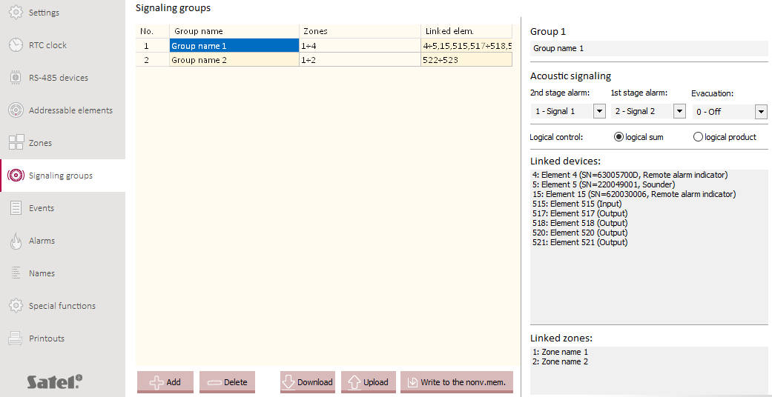
Fig. 12. “Signaling groups” tab.

The signaling group is a collection of addressable elements (acoustic sounders, remote indicators, inputs and outputs). You can create up to 32 signaling groups. It is easier to manage the elements when they are grouped.
No. – individual number of the group.
Group name [Name] – name of the group (up to 30 characters).
Zones [Activat. from zones] – number(s) of the zones linked with the group (alarm condition in the zone activates devices belonging to the group).
Linked elem. [Element list] – reference numbers of addressable system elements that belong to / are linked with the group.

Acoustic signaling
The type of acoustic signaling used for alarm conditions that may occur in the detection zone(s) (for the first stage alarm, second stage alarm and evacuation). For each alarm condition you can select a different signal type. There are 32 available tones (see: Table 4). If you select the “0 – Off” option, the alarm condition will not be indicated.

No | Acoustic signaling
No |  | Frequency Hz | Description
1 |  | 800 & 970 | 2 Hz (250 ms – 250 ms)
2 |  | 800-970 | 7 Hz (7/s)
3 |  | 800-970 | 1 Hz (1/s)
4 |  | 2850 | Continuous
5 |  | 2400-2850 | 7 Hz
6 |  | 2400-2850 | 1 Hz
7 |  | 500-1200 | 3 s sound, 0.5 s silence, repeated
8 |  | 1200-500 | 1 Hz
9 |  | 2400-2850 | 2 Hz (250 ms – 250 ms)
10 |  | 970 | 0.5 Hz (1 s)
11 |  | 800 & 970 | 1 Hz (500 ms – 500 ms)
12 |  | 2850 | 0.5 Hz (1 s)
13 |  | 970 | 0.8 Hz (250 ms / 1 s)
14 |  | 970 | Continuous
15 |  | 554 & 440 | 100 ms – 400 ms
16 |  | 660 | 3.3 Hz (150 ms)
17 |  | 660 | 0.28 Hz (1.8 s)
18 |  | 660 | 0.05 Hz (13 s / 6.5 Hz)
19 |  | 660 | Continuous
20 |  | 554 & 440 | 0.5 Hz (1 s)
21 |  | 660 | 1 Hz (500 ms – 500 ms)
22 |  | 2850 | 4 Hz (150 ms – 100 ms)
23 |  | 800-970 | 50 Hz
24 |  | 2400-2850 | 50 Hz
25 |  | 970 | 3 x 500 ms sound, 1.5 s silence, repeated
26 |  | 800-970 | 3 x 500 ms sound, 1.5 s silence, repeated
27 |  | 970 & 800 | 3 x 500 ms sound, 1.5 s silence, repeated
28 |  | 2400 | Continuous
29 |  | 990 & 650 | 2 Hz (250 ms – 250 ms) (Symphoni Tones)
30 |  | 510 & 610 | 2 Hz (250 ms – 250 ms) (Squashni Micro Tones)
31 |  | 300-1200 | 1 Hz
32 |  | 510 & 610 | 1 Hz (500 ms – 500 ms)
Table 4.

Logical control
You can select a logical function for controlling the “Logic control” type outputs. The input signal for the function is the status of the “Logic control” type inputs (the inputs may be linked with the group directly or indirectly through the zone linked with the group). You can select:
logical sum – outputs will be turned on after any “Logic control” input is activated,
logical product – outputs will be turned on after all “Logic control” inputs are activated simultaneously.

Linked devices
It is a list of addressable elements that belong to the group and elements that are linked with the group. Click “Linked devices” to edit the list.

Linked zones
It is a list of zones and subzones linked with the group. The alarm condition in the zone / subzone will activate the devices that belong to the group. Click “Linked zones” to edit the list.

Buttons
click to add a signaling group.
click to delete a signaling group.
click to download from the control panel the settings displayed in the tab.
click to temporarily upload the settings displayed in the tab (if you fail to save the settings to the non-volatile memory, all changes will be undone when you exit the service mode).
click to save the settings displayed in the tab to the non-volatile memory.

Names

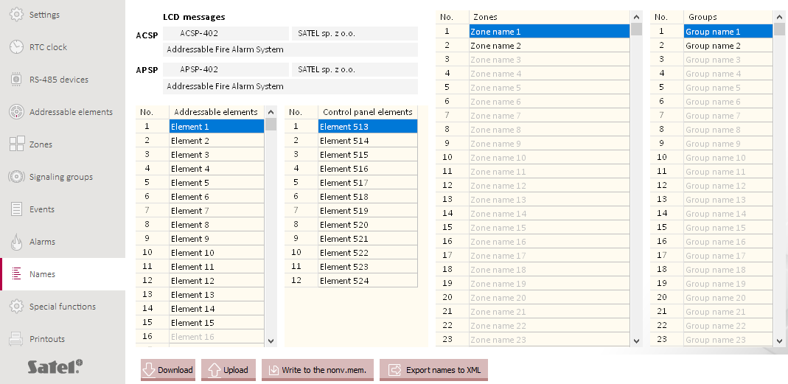
Fig. 13. “Names” tab.

LCD messages
ACSP [Message 1A / Message 1 B / Message 2] – text of the messages displayed in the second and third line of the control panel display.
APSP [Message 1A / Message 1 B / Message 2] – text of the messages displayed in the second and third line of the APSP-402 repeater panel display.

Addressable elements / Control panel elements / Zones / Groups
You can enter names of different system elements.

Buttons
click to download from the control panel the settings displayed in the tab.
click to temporarily upload the settings displayed in the tab (if you fail to save the settings to the non-volatile memory, all changes will be undone when you exit the service mode).
click to save the settings displayed in the tab to the non-volatile memory.
click to export the names of the system elements to XML file. In the window that will open, enter the file name and choose a location for the file.

Special functions

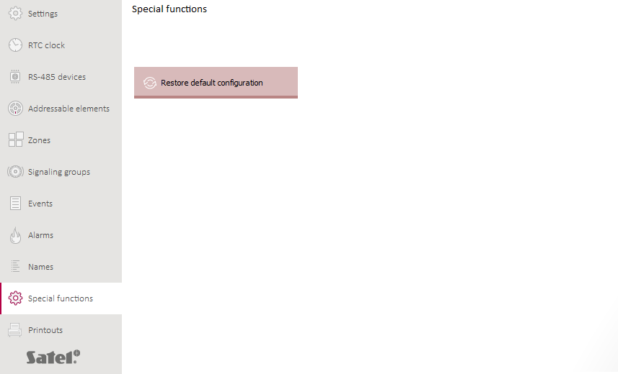
Fig. 14. “Special functions” tab.

Buttons
 | click to restore the default settings of the control panel. In the window that will open, you will be asked if you want to restore the control panel default settings.

Printouts

Configuration
You can print out the fire alarm system settings. Click “Printouts”, then “Configuration”. The “Printout” window will be displayed (Fig. 15).

“Printout” window

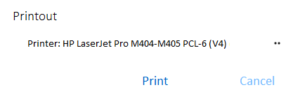
Fig. 15. “Printout” window.

Printer – name of the selected printer.

Buttons
 | click to select the printer.
Print | click to start printing.
Cancel | click to close the window.

Test report

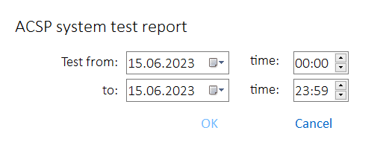
Fig. 16. The “ACSP system test report” window.

You can print out a report of the fire alarm system tests. The report contains information about: tests running in the control panel, diagnostic data of the control panel and detectors, currently indicated faults.
Click “Printouts”, then “Test report”. The “ACSP system test report” window will be displayed (Fig. 16).
Test from – beginning of the period to be included in the report (date and time).
to – end of the period to be included in the report (date and time).

Buttons
OK | click to open the “Printout” window.
Cancel | click to close the window.

Restoring the default settings
You can restore the control panel default settings using the buttons on the control panel or in the ACSP Soft program.

Restoring the default settings using the buttons on the control panel
- Start the service mode in the control panel (see: “Starting the service mode” p. 7).
- Press .
- When the cursor shows the “Default settings” function, press or .
- The “Default settings” message will be displayed.
- Press .

Restoring the default settings in the ACSP Soft program
- Start the service mode in the control panel (see: “Starting the service mode” p. 7).
- Click the “Special functions” tab.
- Click .
- In the window that will open, you will be asked if you want to restore the control panel default settings.
- Click YES.



Fire alarm control panel
EN

ACSP-402
Firmware version 1.00



PROGRAMMING
acsp-402_p_en 06/23


SATEL sp. z o.o. • ul. Budowlanych 66 • 80-298 Gdańsk • POLAND
tel. +48 58 320 94 00
www.satel.pl
nie drukować

